#### PROJECT SEPTEMBER -NOVEMBER 2020

A REPORT

ON

**Buttons In 3D Using Sculptural Effects In WIMP Interface**

BY

|  |  |
| --- | --- |
| Bir Anmol Singh | 2018A7PS0261P |
|  |  |

On Research Paper

**IMPLEMENTATION OF DYNAMIC BUTTONS- THE UI PERSPECTIVE**

Prepared for Human Computer Interaction

Course No.

BITS F364

**ABSTRACT**

3D UI design has largely remained an area of research and needs special hardware in order to give a convincing feel. Majority of the users have to work in a standard 2D interface which is not a direct mapping of the objects they use in real world. These interfaces either lack the **mapping, feedback, affordances or proper constraints** that prevent errors. In this project the aim was to use minimum resources and to serve the user interface on the easiest platform- Internet (as website). To do so perspective was leveraged in order to give 3D feel to the most familiar way of interaction in the past few decades of WIMP interface- the button. The 3D buttons were designed using **CSS box-shadow property** and using **:active pseudo class** in **CSS** to mimic the pushing and popping of a real world button. **JavaScript** was used to add sound effect to give the click feedback to the user and the 3D worlds were rendered with **skyboxing technique**. Lastly, the application is a relaxation tool to reduce stress by looking at scenically beautiful 3D world listening to soothing music in pandemic time.

**TABLE OF CONTENTS**

|  |  |
| --- | --- |
|  | Page No. |
| 1. Cover Page……………………………………………………………… 2. Abstract ………………………………………………………............... 3. Introduction ……..………………………………….............................. 4. Approach to Solution …………………………………………………. 5. Design of Solution …..………………………………………………... 6. Summary and Conclusion…………………............................................ 7. References …………………………………………………………....... | 1  2  4  6  7  12  13 |

**INTRODUCTION**

**About the Problem**

Humans live in a 3D world yet the interaction with systems has largely remained 2D. The field of 3D interaction and user interfaces has seen extensive research yet the power is still underutilized mainly because majority of them require special hardware to give a convincing feel. In the last decade, the internet has brought a lot of changes in the way people access and enjoy content. If the power of web can be used to give a 3D feel without causing motion sickness with minimum hardware requirement and by utilizing a familiar interface, 3D UIs can become the new way to interact. Majority of the users have to work in a standard 2D interface which isn’t a direct mapping of the objects they use in real world. These interfaces either lack the mapping, feedback, affordances, visibility or proper constraints that prevent errors. Already existing 3D interfaces either lack task specificity or overdo the sculpting effect that makes the UI straining to the eye and render it non intuitive. Majority of buttons- the most used WIMP element lacks proper feedback and the change of button state isn’t fully rendered by the system leading to wrong perception of the user.

Buttons being the most frequently used element and the one which is a metaphor of a real-world object makes it a suitable candidate for building with a 3D perspective. The 3D perspective is giving by adding shadows by assuming various light source angles and using shadow levels to give a sculpted effect- either outset or inset. Using a simple monitor and the mouse as a point and click input device, we use the existing WIMP interface thus ensuring generality. Adding buttons will allow users to make choices and perform actions in the interface and if the buttons are given the real life clicking feel, positioned appropriately in the local structure and mimic the real pushing of a button through 3D perspectives and sculpting effect, we will be adding flavours to the WIMP paradigm. The visibility, affordance, feedback and mapping of buttons will be the core design principle of the interface. This experience will be delivered by HTML, CSS and JavaScript as it has extensive reach due to native browser support. Thus, through this project, I intend to give an enhanced version 3D world by using skyboxing technique and making it a 3D button-oriented interface.

**Background Study**

Looking on internet for 3D worlds, I found that skyboxing is simplest way to model 3D world with user at centre and a cube generated by stitching 6 images together. Websites being the way to serve things on internet was the simplest way to spread the application to many users in order to serve them with a 3D interface. For this I had to look for reference documentations of HTML and CSS to create the static structure of the website and JavaScript to give dynamic behavior to both the website and the buttons. The perspective to the buttons needed several prototypes to be built by looking at documentation for box-shadow CSS property, to control positioning of shadow and control the colors and brightness intensity and to set the kind of perspective- inset or outset. The :active pseudo class enable to animate button on click thus giving the feel of being pushed in and pushed out. For this I had to look for webkit-animations. JavaScript’s syntax helped me add programmatic behaviour to static elements and thus allowing constraints to be placed so that unexpected behaviour is not faced. The additions of the buttons in order to maintain task specificity, while having affordance, visibility, proper domain mapping and yet managing to have generality to the parent paradigm came after reading the research papers added in references. Concepts of Neuomorphism and Skeuomorphism were also studied as they are the new 3D industry standards for the User Interfaces. The research paper allowed me to gain insight into the basic principles of interface design. These principles along with user centric design helped me in making my application.

**APPROACHING THE SOLUTION**

**3D world view:** Using Three.js - a library of JavaScript that enables the user to be in the center of a 3D world is created by placing a user inside a cuboid with 6 images of distant objects stitched together and rendered on all faces hence mimicking a feel of wrap around (skyboxing). JavaScript onDrag listeners for mouse causes hold and flick way of interaction.

**3D Buttons:** Sculpted effect given by the CSS’s box-shadow property and the clicking in feel given by the CSS :active pseudo class.

**Clicking sound for feedback:** JavaScript used to play a clicking sound (.mp3 file) placed inside an audio tag.

**Music Player:** HTML and CSS used for the design and the OnClick listeners on elements trigger JavaScript functions thus programming the behavior or elements.

The main intent has been to enhance existing street view (specific 3D domain) experience by making it surreal due to added 3D flavour to mimic a virtual reality (VR) experience on simple and generic computers.

**Linking Between Pages:** User Interface navigation design kept simple. It is an easy to grasp global structure. HTML anchor tags used to link pages

**Server:** Python used to make a simple server to enable these files to be displayed at a PC’s local port with CORS issues resolved.

**DESIGN FOR THE SOLUTION**

The design draws inspiration from Samsung’s One UI which states commonly used tools to be placed at the bottom to support reachability especially on mobile devices. Since this project’s design is also responsive-adapting to various screens, this reachability feature was kept in mind in order to minimize user effort while accessing the buttons. The local structure of the interface was kept simple with the global structure being clear and intuitive.

The application has been designed in a way to allow users experience 3D world and relax by listening to soothing music. Three different worlds have been added which can be zoomed in and out by using scroll wheel on mouse along with rotating in 3D space with help of simple left click hold a flick motion. The design has been made such that it gives you a feel of sitting on your desk and looking out of the window feeling this world. The buttons have been added to control the music player, switch views and use **neumorphic** checkboxes to give feedback. The neumorphic design allows to give a 3D effect and is the new skeuomorphism applied in user interfaces. It gives a 3D raised effect and on clicking it gets depressed into the surface the button is placed on. The **feedback** from the buttons has been enhanced by giving a real feel by adding both visual and auditory feedback. The buttons like that of music player will both get depressed on clicking, change their state and also give a clicking sound. **Affordances** have been kept in mind in order give user an intuitive way to interact by explicitly making the mouse pointer change to a clicking pointer when placed over a button giving them cues for clicking the software button built upon the metaphor of real-life buttons. Icons and text labels on buttons help user with **visibility** and also ease of use as they need not remember the function of button as it is conveyed by the icon itself. The **mapping** of button to appropriate actions has also been taken care of. Some **functions have been forced** in order to maintain consistency and prevent errors like selecting two options for one question on the feedback form.

With regards to buttons the research paper highlighted the need for special feedback so I have enabled colour changes on click plus clicking sound and the push in effect. Even disabled button appears with a grey colour and flushed with the surface so that a person knows that it is already pushed in. The paper also stated the need for affordance which is basically the object itself must highlight the way it has to be used. In this case the 3D effect is a direct complement to real world push down button thus it will have high affordance. The buttons are given colours that visually separates them from their background wherever needed. Mapping of tasks with buttons and icons present on buttons make it easy to use and understand as users are already familiar with such buttons like play and pause on the music player. Forcing functions allow the music player to operate correctly and also does not allow a user to select conflicting feedback or no feedback at all. The buttons added on the music player are neumorphic and are made so that they seem connected to the player and not just randomly floating around and cause confusion. Generally, the real-world radio has buttons of the same material which radio is made of, same concept is picked up (skeuomorphism) and material being same with 3D effect makes is neuromorphic.

The design was initially sketched out on a wireframe online followed by prototyping of various kinds of 3D effects that can be added to buttons and finally after thorough review of design.

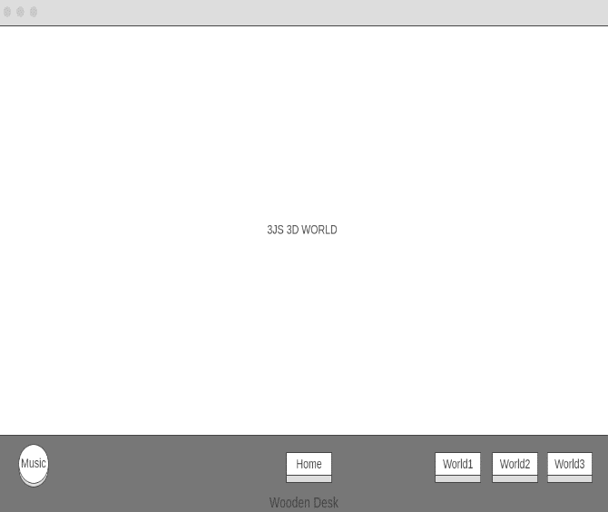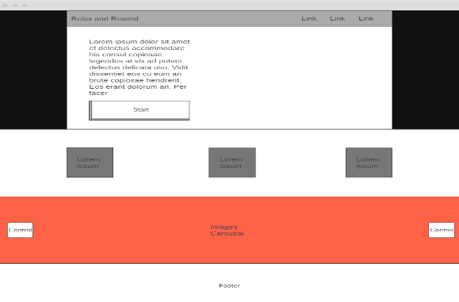

Figure 1 Wireframe

Figure 2 Wireframe

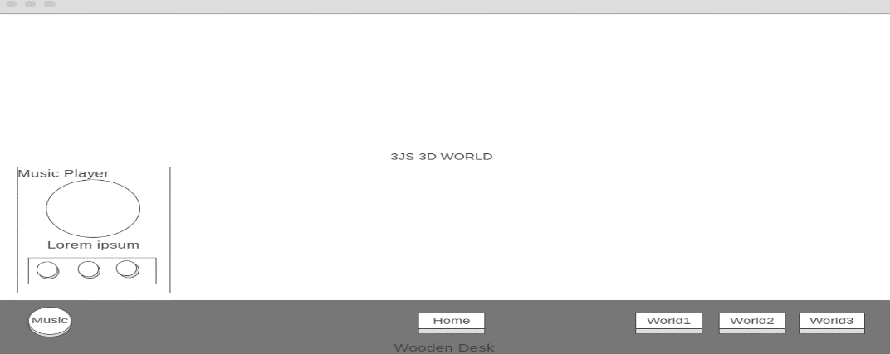

Figure 3 Wireframe



Figure 4 Prototype

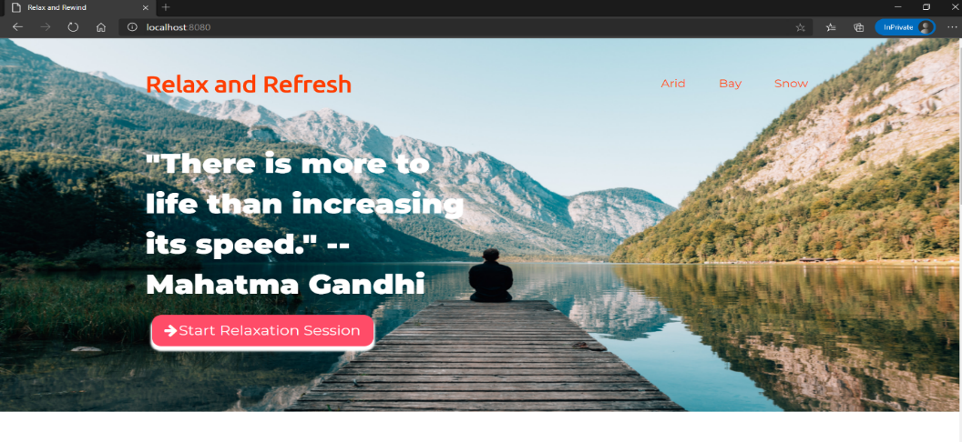

Figure 5 Landing Page

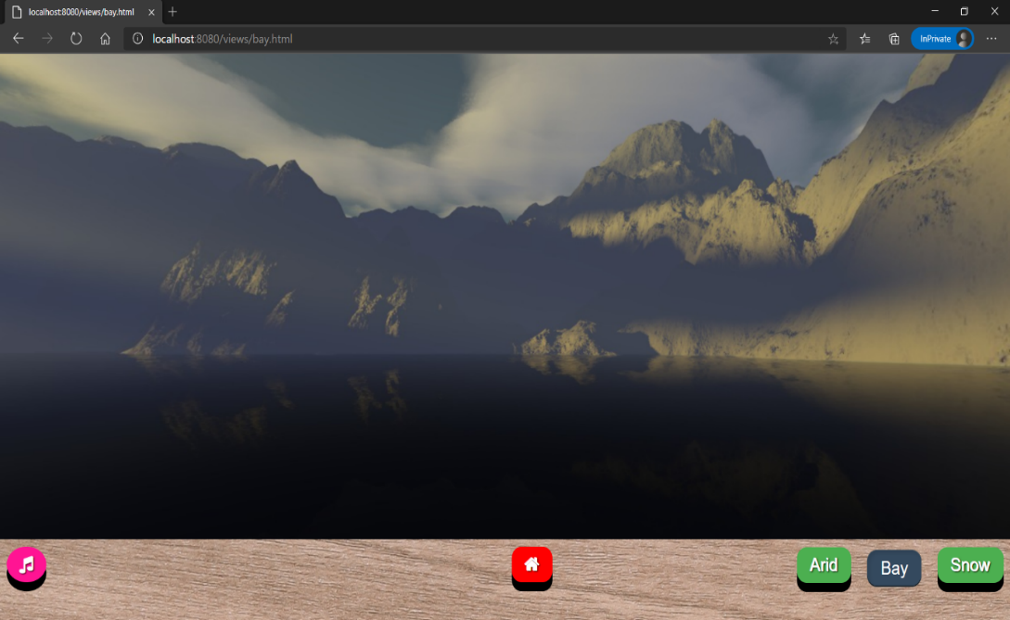

Figure 6 3D world

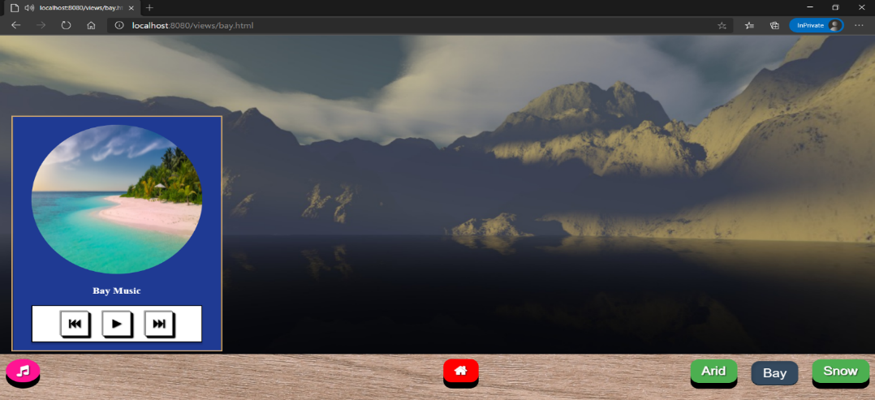

Figure 7 3D world with music player active

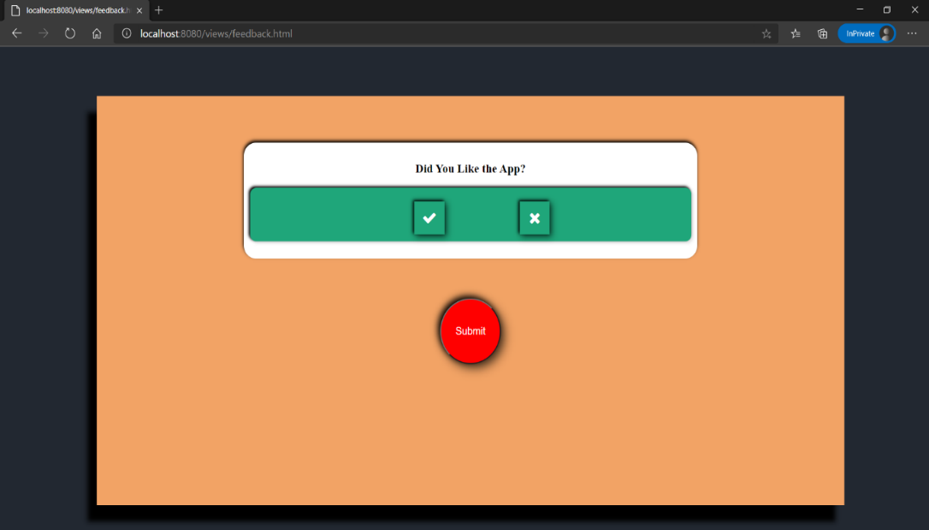

Figure 8 Feedback form

**SUMMARY and CONCLUSION**

Humans live in a 3D world yet the interaction with systems has largely remained 2D. The field of 3D interaction and user interfaces has seen extensive research yet the power is still underutilized mainly because majority of them require special hardware to give a convincing feel. Majority of the users have to work in a standard 2D interface which isn’t a direct mapping of the objects they use in real world. These interfaces either lack the mapping, feedback, affordances, visibility or proper constraints that prevent errors. Already existing 3D interfaces either lack task specificity or overdo the sculpting effect that makes the UI straining to the eye and render it non intuitive.

Buttons being the most frequently used element and the one which is a metaphor of a real-world object makes it a suitable candidate for building with a 3D perspective. Majority of buttons currently lack proper feedback and the change of button state isn’t fully rendered by the system leading to wrong perception by the user. In this project buttons were given box-shadow with various levels of opacity, colours, sizes and orientations. They were also made inset and outset type. The 3D click is mimicked by :active pseudo class which gave 3D effect with perspective and added flavours to the WIMP paradigm. The visibility, affordance, feedback and mapping of buttons were the core design principle of the interface. The constraints to prevent erroneous system states were mitigated by onClick listeners placed on buttons and these listeners also enabled to play a click sound via speakers of the user’s machine giving feedback.

**REFERENCES**

**Research references:**

* Gwizdka, J ; Implementation of Dynamic Buttons – The UI Perspective ; PDA Developers Journal ; 1996
* Doug A. Bowman, Jian Chen, Chadwick A. Wingrave, John Lucas, Andrew Ray, Nicholas F. Polys, Qing Li, Yonca Haciahmetoglu, Ji-Sun Kim, Seonho Kim, Robert Boehringer, and Tao Ni ; New Directions in 3D User Interfaces ; The International Journal of Virtual Reality ; 5(2); 2006; 3-14
* Doug A. Bowman, Ernst Kruijff, Joseph J. LaViola, [Ivan Poupyrev](javascript:void(0);) ; An Introduction to 3-D User Interface Design ; Presence: Teleoperators and Virtual Environments ; MIT Press, 55 Hayward St., Cambridge, MA, United States ; Vol. 10, No. 1 ; 2001 ; 96-108
* Billy Carlson ; Designing for Action : Best Practices for Effective Buttons ; Balsamiq Wireframing Academy

**Other References:**

* **HTML DOCUMENTATION**: <https://developer.mozilla.org/en-US/docs/Web/HTML>
* **CSS DOCUMENTATION**: <https://developer.mozilla.org/en-US/docs/Web/CSS>
* **JavaScript DOCUMENTATION**: <https://developer.mozilla.org/en-US/docs/Web/JavaScript>
* **3JS DOCUMENTATION**: <https://threejs.org/docs/>
* **Skyboxing with 3JS:** <https://threejsfundamentals.org/threejs/lessons/threejs-backgrounds.html>