**Athlete Tracking Project: Improving Sports Management with Technology**

**Harun Yahya Ünal - 210706015**

**Abstract**

Athlete tracking is an important part of sports and fitness management. It helps monitor performance, progress, and growth. This project aims to build a simple system for sports schools. By using ASP.NET, MSSQL Server, and .NET Entity Framework, the system tracks athlete progress, sessions, and payments. It has easy-to-use screens and keeps data safe.

**Introduction**

Tracking athlete performance is very useful for sports schools. It helps manage training, keep payment records, and monitor progress. Many schools do not have a good system to do these tasks easily. This project solves these problems by creating a system using modern web and database technologies. The main goal is to make it simple and helpful for decision-making.

**Related Works**

Many studies have focused on the use of technology in sports management. For example, systems like "Catapult Sports" and "STATSports" offer advanced solutions for tracking professional athletes' performance through wearable devices. However, these solutions are often expensive and complex, making them unsuitable for smaller sports schools. Other research highlights the use of web applications and databases for managing sports events and athlete data, such as the work by Smith et al. (2022), which discusses a web-based platform for amateur sports clubs. This project builds on these ideas but aims to deliver a more affordable and user-friendly solution for sports schools.

**Athlete Tracking System**

The purpose of this project is to provide a simple and efficient system for tracking athlete performance and managing sports school operations. This system is designed for instructors, admins, and students. Instructors can monitor the progress of their students, while administrators can manage session schedules, payment tracking, and user data. For students, the system offers a user-friendly interface to check their training sessions and performance metrics.

The project includes a web application that simplifies sports school management. Users can access this system through a secure login, view their specific dashboards, and interact with their assigned features. The application uses ASP.NET Core for fast performance and secure handling of data. MSSQL Server serves as the database backend, ensuring reliable and structured storage of information.

Smart features such as automated reminders for payments and progress tracking charts allow for a seamless experience. These features reduce manual workloads for the administration and make the entire process efficient and data-driven.

The project has 2 parts. These parts are given below.

**Web Application: Features for Admins, Instructors, and Students**

On the website there are three user roles that have different operation. The user can login as admin or student or instructor.

* **Admin:** Manage all sessions that are created in a branch. Follow the payment status of students.
* **Instructors:** Create and cancel a session about their specialization, list the students who are followed and add growth records for them.
* **Students:** Parents’ login information is used to login. They can access the list of sessions and can choose a session they want. They can follow their growth records with a graph.

**Database: Storing and Managing All Data**

It is the section that all data stored such as user data (admin, instructors, student), information about sessions, development records of students, branch information.

**System Architecture**

This section contains information about the architecture of the system.

**High-Level Diagram:**

In this part, the high-level diagram of the system represents below. This diagram the visualizes the architecture.

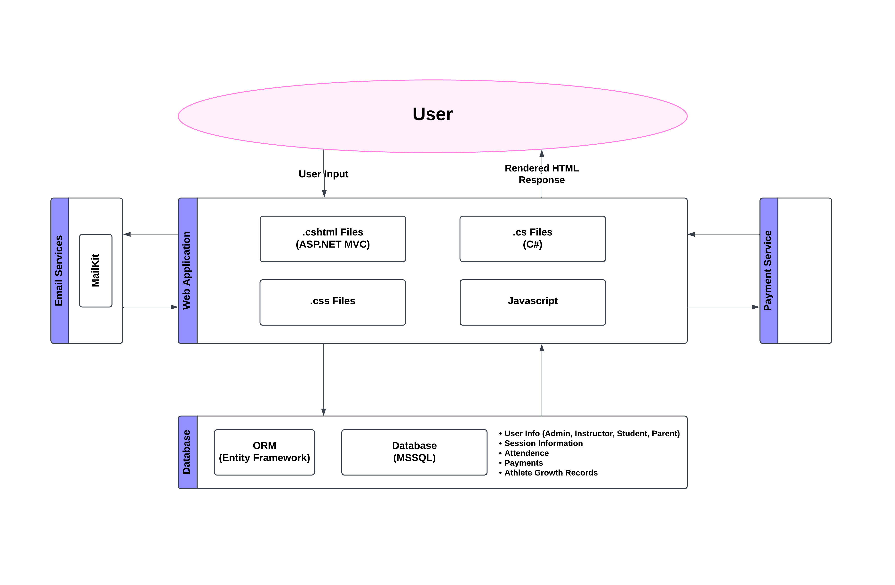

**Database:**

In this part, the database tables, its design and relations between tables are given. Below picture represents the ER model of the system’s database.

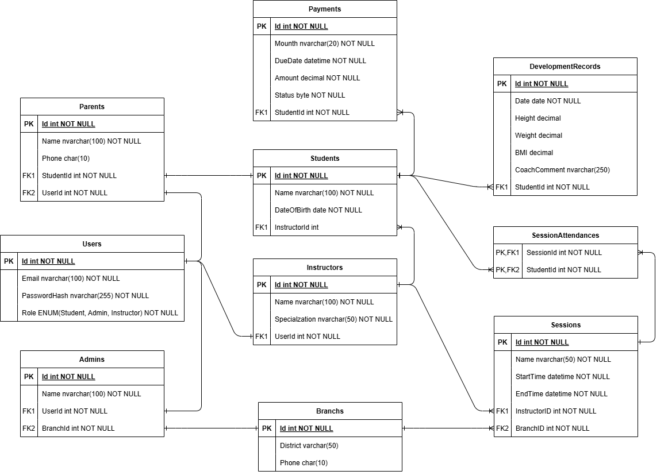

**User Interfaces:**

In this part, all sections for each user are represented below.

**SessionsPage(Student):**

**MySessionPage(Student):**

**MyRecordsPage(Student):**

**InstructorsPage(Student):**

**PaymentPage(Student):**

**MySessionsPage(Instructor):**

**AddSessionPage(Instructor):**

**MyStudentsPage(Instructor):**

**AddRecordPage(Instructor):**

**SessionsPage(Admin):**

**StudentsPage(Admin):**

**InstructorsPage(Admin):**

**BranchsPage(Admin):**

**AddBranchPage(Admin):**

**Conclusion**

The project shows how web technologies and databases help in sports management. Using ASP.NET Core and MSSQL Server makes the system fast and safe. Designing separate screens for roles makes it easier to use. Problems like keeping data updated and making the interface simple were solved with testing and feedback.

This project shows how technology can improve sports management. The system is flexible and can grow with the needs of sports schools. Future plans include adding AI for better insights and creating a mobile app.