**Employee management system**

1. Create a Laravel project

* composer create-project laravel/laravel employee-management

1. Install laravel ui and bootstrap auth

* composer require laravel/ui
* php artisan ui bootstrap –auth
* npm install & npm run dev

1. For vue

* php artisan ui vue
* npm run & npm run dev

1. Make model and migration for Employee, Country,State,City,Department

* php artisan make:model Employee –m
* php artisan make:model State –m
* php artisan make:model City –m
* php artisan make:model Department –m
* php artisan make:model Country –m

1. Create a database in mysql and migrate

* php artisan migrate

1. Add columns to each tables
2. **employees**

$table->string('last_name');

$table->string('first_name');

$table->string('middle_name')->nullable();

$table->string('address');

$table->foreignId('department_id')->constrained();

$table->foreignId('country_id')->constrained();

$table->foreignId('state_id')->constrained();

$table->foreignId('city_id')->constrained();

$table->char('zip_code');

$table->date('birthdate')->nullable();

$table->date('date_hired')->nullable();

1. **cities**

$table->foreignId('state_id')->constrained();

$table->string('name');

1. **departments**

$table->string('name');

1. **countries**

$table->char('country_code');

$table->string('name');

1. **users**

$table->string('username');

$table->string('lastname');

$table->string('first_name');

Note: **employees table** should be migrated at last since it has to include foreign keys of other tables like city_id,country_id etc.

This is how $table->foreignId(‘table_name_id’)->constrained(); works

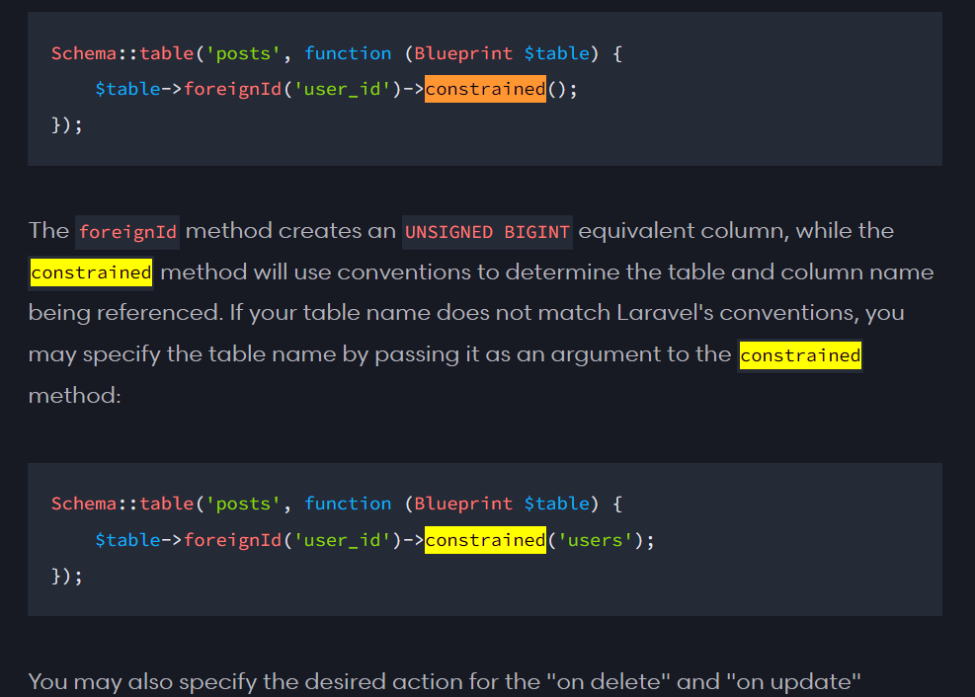

1. Add Username, First Name, Last Name to the form and make changes in model:User.phandcontroller:RegisterController.php
2. Goto startboostrap.com >SB admin 2>View source code>index.html>Raw. Select all code and copy it. Open layouts and create main.blade.php and paste the copied code.
3. Replace font awesome link with cdn.
4. Goto views/home.blade.php and change layouts.app to layouts.main
5. Set up css and javascript by fixing their paths. Note: we only need Bootstrap core javascript and Custom scripts for all pages.
6. Set up the sidebar.
7. Limit the user login if the password is wrong in LoginController

* $protected $maxAttempts = 3;
* Protected $decayMinutes = 5;

1. Create UserController in Backend folder

For Laravel with Vue(Employee Management)

1. Create EmployeeController in API directory

* php artisan make:controller Api/EmployeeController –resource

1. Add this to web.php

Route::get('{any}',function (){

return view('employee.index');

})->where('any','.*');

Whaterver wrong path you type in url it will be redirected to employee.index

1. Create employees directory in views and inside it create index.blade.php

And write following code

@extends('layouts.main')  
@section('content')  
 <div id="app">  
   
 </div>  
@endsection

1. To use the component above, we have to import app.js in layout.main.

So in the script section import app.js

<script src="{{mix('js/app.js')}}"></script>

Note: to use mix you must install npm run dev and if there is any error run npm update vue-loader.

5) Create employee folder in component and create index.vue,create.vue,edit.vue

6) Install Vue Router npm install vue-router

7) Import Vue router in app.js

import VueRouter from 'vue-router';  
Vue.use(VueRouter);

8) Creat route.js file in js directory

9) Import it in app.js

import {***routes***} from "./route";

10) Writ this too

const router = new VueRouter({  
 mode:'history',  
 routes:***routes***});

and add it to vue

const app = new Vue({  
 el: '#app',  
 router:router  
});

11) Write routes in route.js

import EmployeeIndex from './components/employee/index.vue'  
import EmployeeCreate from './components/employee/create.vue'  
import EmployeeEdit from './components/employee/edit.vue'  
export const ***routes*** = [  
 {  
 path:'/employees',name:'EmployeeIndex',component:EmployeeIndex  
 },  
 {  
 path:'/employees/create',name:'EmployeeCreate',component:EmployeeCreate  
 },  
 {  
 path:'/employees/edit/:id',name:'EmployeeEdit',component:EmployeeEdit  
 },  
  
];

12) Paste the previous index.blade.php code in index.vue and remove blade components because it will not be render. And run npm run watch.

Warning: If there is any kind of blade components. Vue will not work

13) us