Full-Stack Technology Handbook
Deep reference guide for the technology stack, patterns, tradeoffs, scaling concerns, and practical usage
Primary focus: theory, syntax patterns, decision rationale, growth challenges, and alternatives.
Project details are used only as compact examples.
Technology focus: NestJS, CQRS, Hexagonal Architecture, DDD boundaries, Prisma, PostgreSQL, Docker Compose, API Gateway, React, Vite, Axios refresh queues, React Query, Tailwind CSS, and Nginx delivery.

Contents
- 1. Technology landscape and why this stack fits the problem
- 2. System overview and deployment topology
- 3. Hexagonal Architecture and port-adapter reasoning
- 4. DDD strategic design and bounded contexts
- 5. CQRS in practice: command/query separation
- 6. NestJS as composition root and module system
- 7. Prisma and PostgreSQL usage patterns
- 8. Docker Compose for local orchestration and production-shaped development
- 9. React, Vite, Axios, React Query, and Tailwind CSS
- 10. Token refresh queue, optimistic updates, and frontend state discipline
- 11. Audit logging: why it matters and where it breaks at scale
- 12. Real scaling challenges, alternatives, and migration paths

1. Technology landscape and why this stack fits the problem
This handbook is organized around technologies and architectural procedures rather than around service implementation details. The project exists mainly as a compact reference point showing how these tools can be combined in a realistic full-stack system.
Technology | Primary use | Why teams choose it | What to watch
NestJS | Backend application framework | Clear modules, DI, guards, decorators, CQRS package | Too much framework abstraction can hide domain boundaries if discipline is weak
TypeScript | Shared language across backend and frontend | Stronger refactoring safety, explicit contracts | Loose typing or excessive any defeats the gain
Prisma | ORM and schema workflow | Fast modeling, consistent migrations, strong TS client | Complex transactional or reporting workloads may need raw SQL
PostgreSQL | Primary transactional store | Relational integrity, JSON support, indexing, mature ecosystem | Hot partitions and fan-out workloads need deliberate indexing and denormalization
Docker Compose | Local orchestration | Reproducible startup, networked services, DB isolation | Not a full production orchestrator
React + Vite | Frontend delivery | Fast dev cycle, good TS ergonomics, modern build toolchain | App structure must be curated or feature growth becomes chaotic
Axios | HTTP client with interceptors | Token handling, retry hooks, custom queue behavior | Interceptors become hard to reason about if global state is messy
React Query | Server state management | Caching, invalidation, optimistic updates, retries | Poor query key design causes stale or duplicated data
Tailwind CSS | Utility-first UI styling | Fast iteration, consistent spacing and color scales | Can become unreadable without conventions
Nginx | Static file serving and reverse proxy | High-performance asset serving, SPA routing, proxy rules | Config drift between dev and prod can hide bugs

2. System overview and deployment topology
The architecture uses one browser frontend, one API gateway, four domain services, and isolated PostgreSQL databases. This is a common progression path when a team wants domain separation without jumping directly to heavy distributed infrastructure.
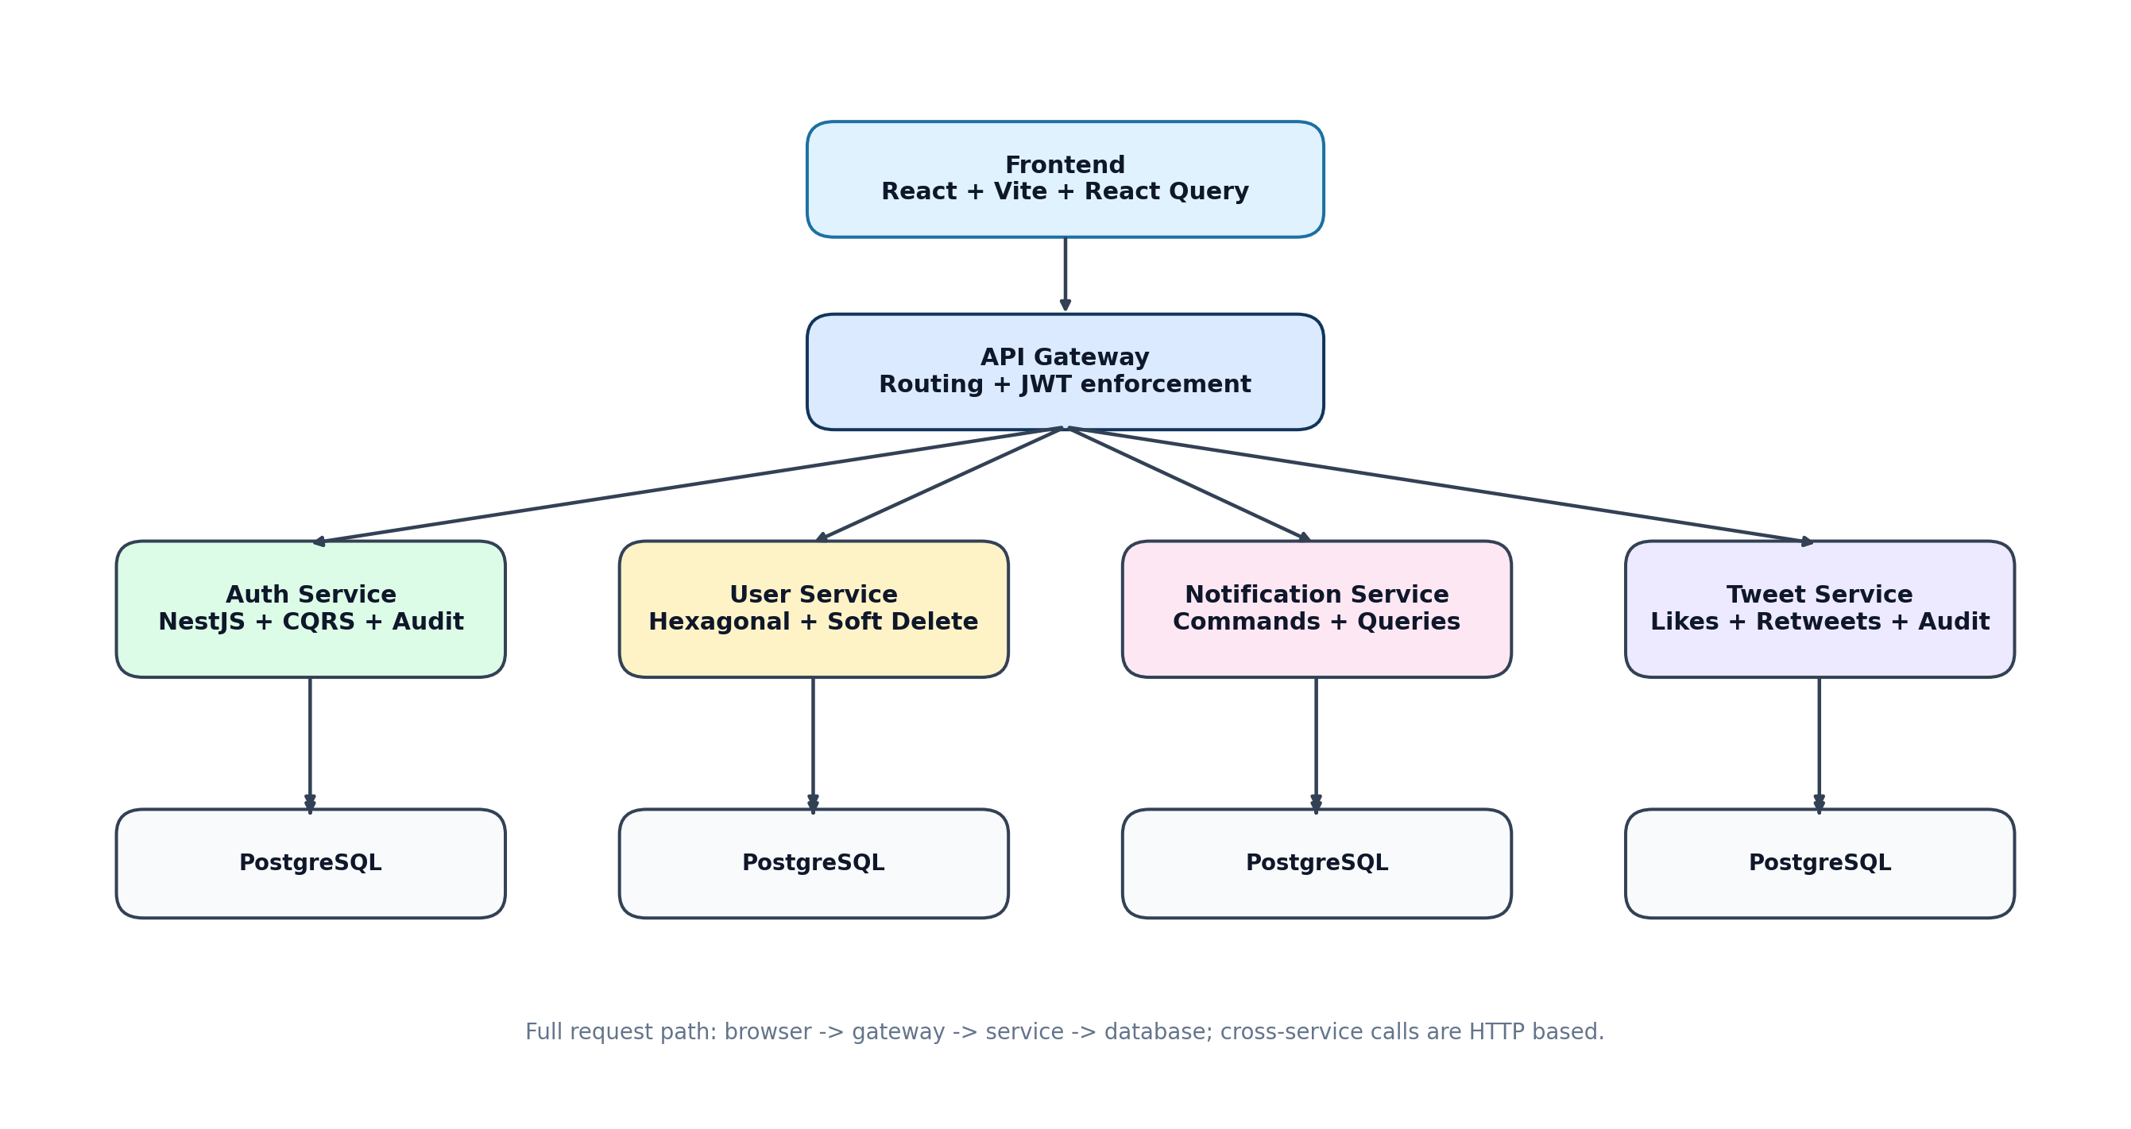
Figure 1. High-level system overview for the stack used in this repository.
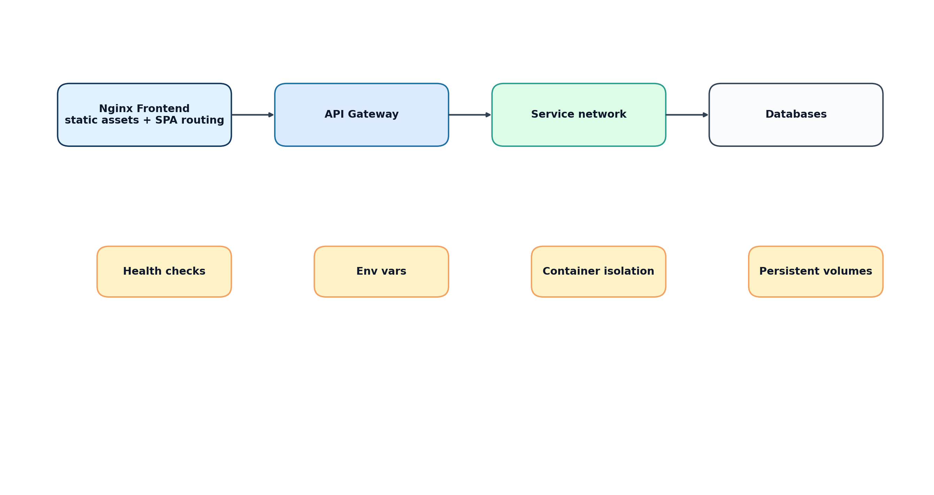
Figure 2. Deployment topology showing frontend, gateway, services, and databases.
- The API gateway provides one stable entry point for frontend traffic and centralizes routing and some authentication concerns.
- Each service owns its own data store. This avoids accidental cross-service table coupling.
- Docker Compose creates a production-shaped local environment: separate containers, service discovery, ports, and health checks.
- The pattern is intentionally operationally heavier than a monolith, so the value must come from domain separation, team autonomy, or future scale planning.

3. Hexagonal Architecture and port-adapter reasoning
Hexagonal Architecture is fundamentally about dependency direction. Business rules should not depend on delivery mechanisms or persistence mechanisms. Controllers, ORMs, and HTTP clients are replaceable adapters; the domain and use cases should remain stable as those edges change.
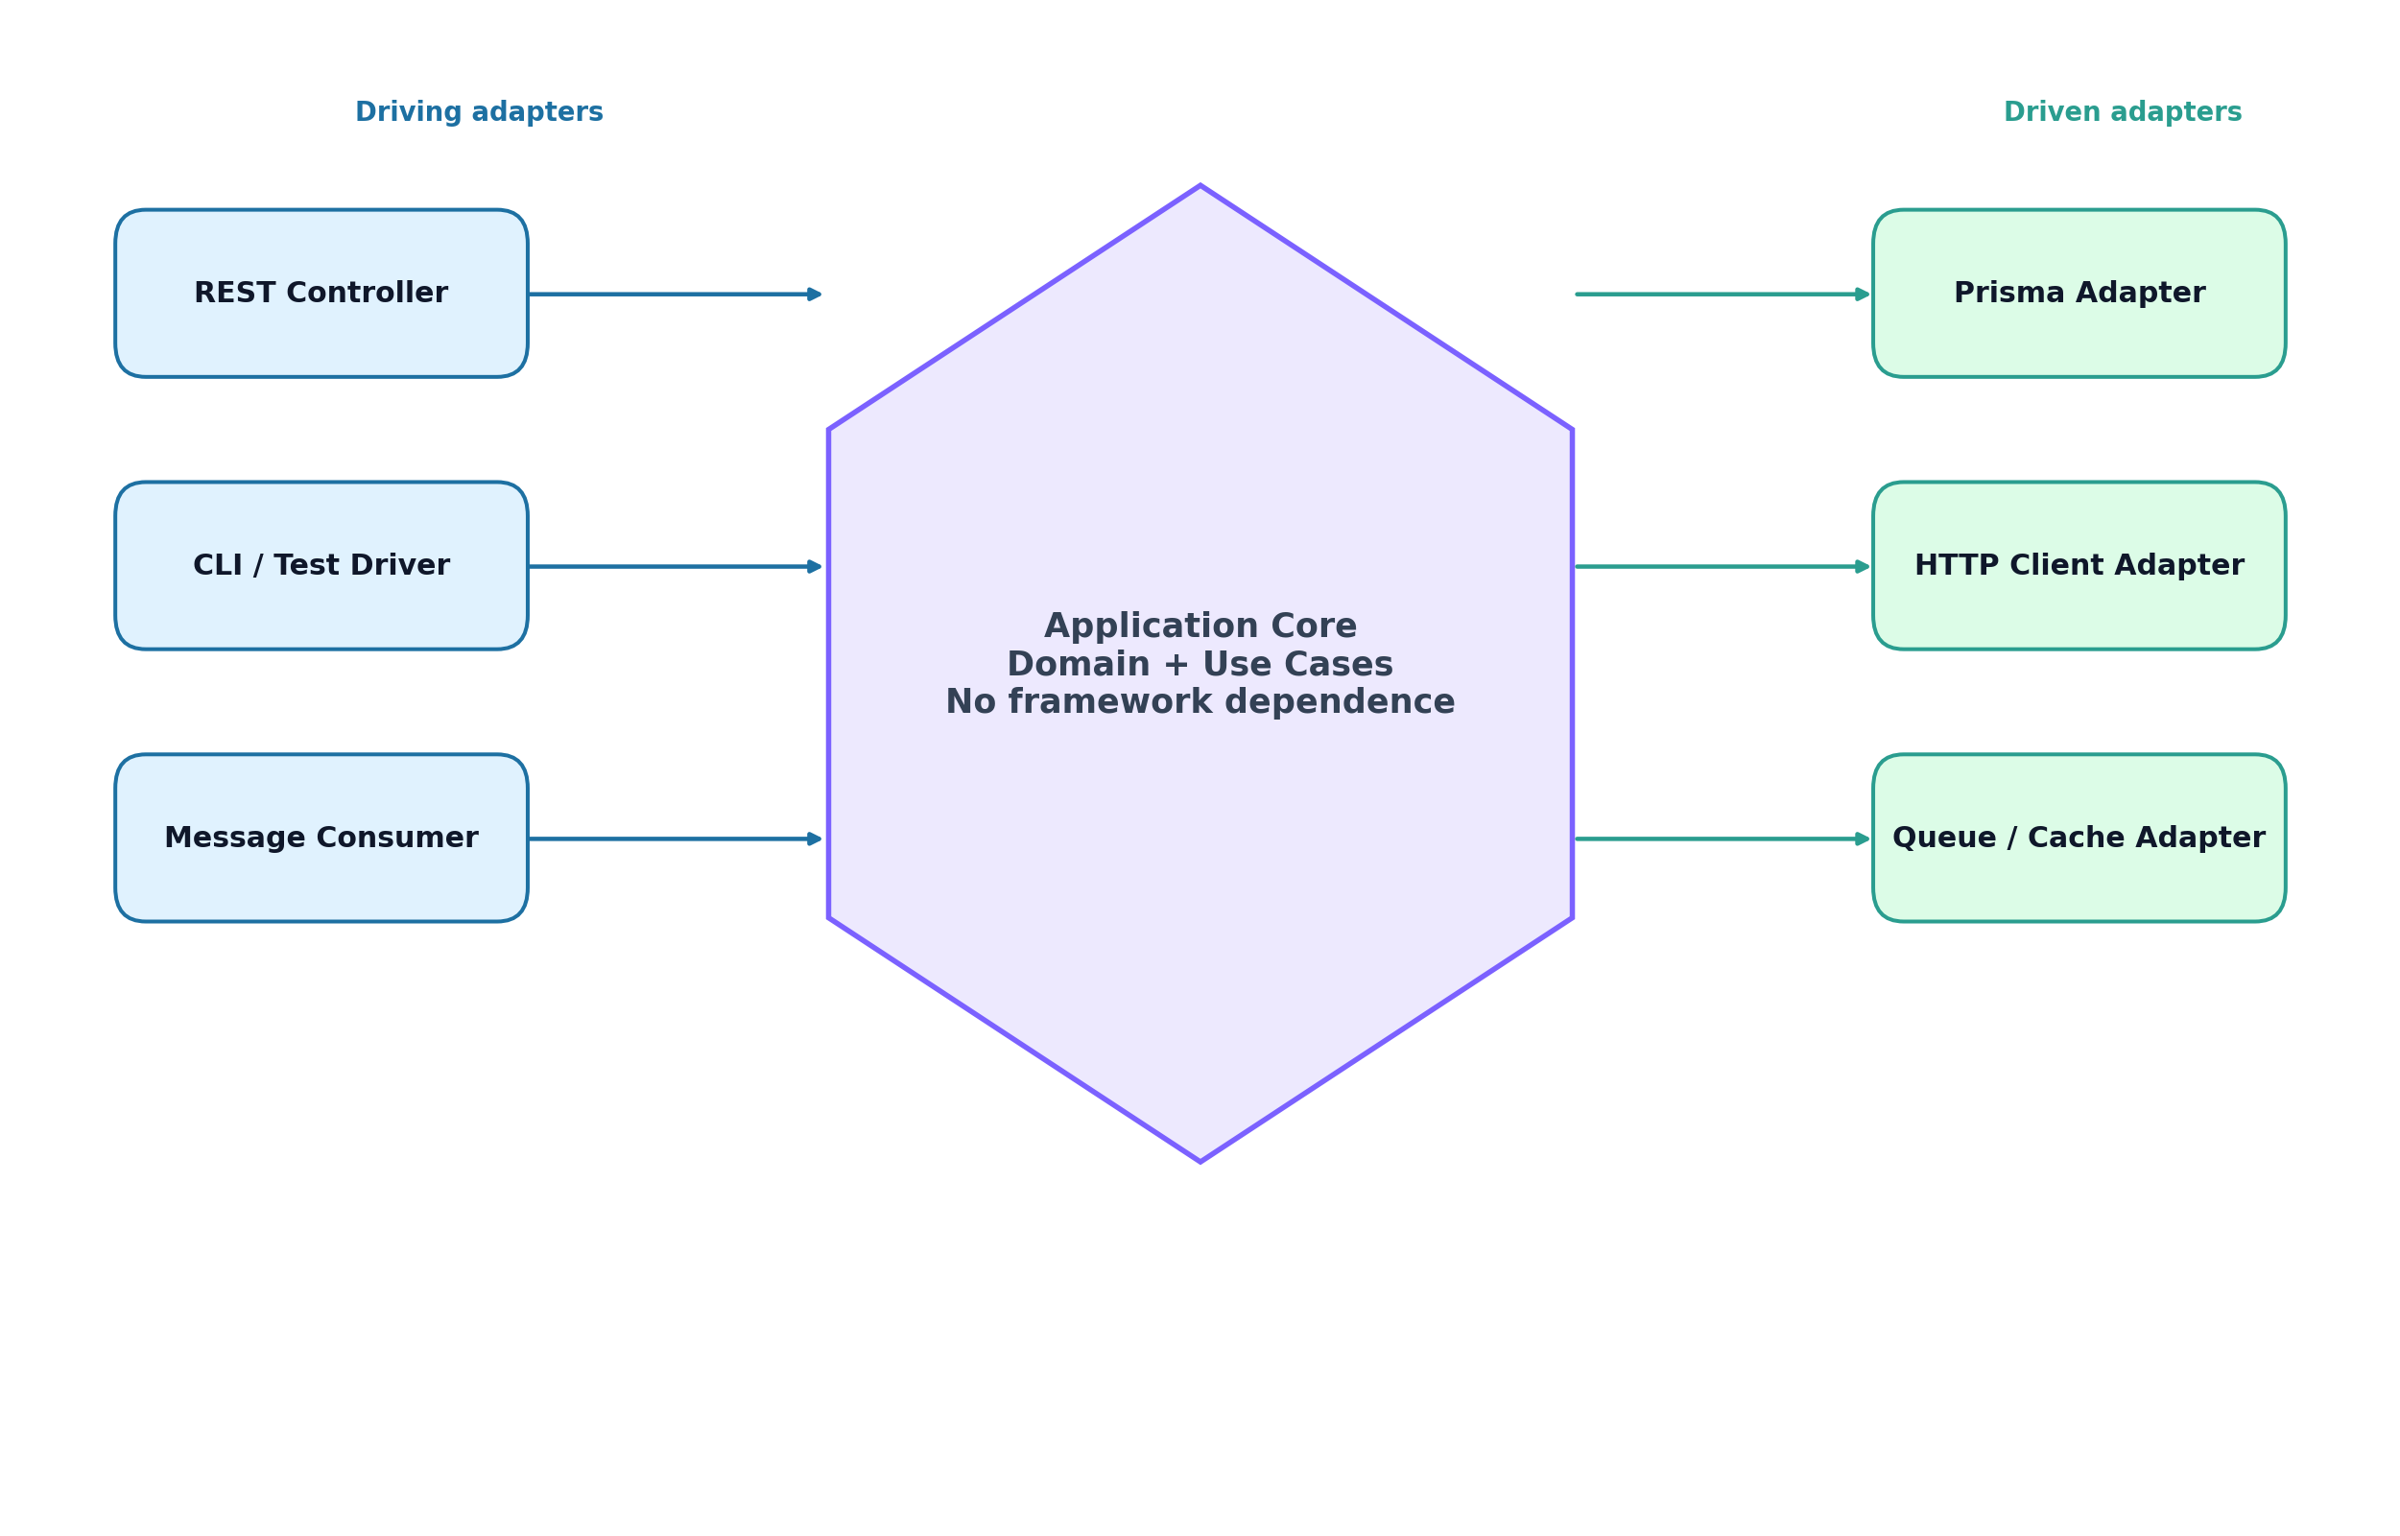
Figure 3. Hexagonal Architecture with driving and driven adapters.
- Driving adapters trigger the system: REST controllers, tests, CLI commands, message consumers.
- Driven adapters are invoked by the core: repositories, external HTTP clients, caches, queues, mailers.
- Ports define required behavior; adapters implement that behavior.
- A healthy hexagonal design makes testing cheaper because use cases can run against mocks or in-memory adapters.
Why teams use this procedure: it lowers long-term coupling, preserves domain clarity, and makes infrastructure swaps less painful. The immediate cost is more folders, more interfaces, and more discipline. The benefit appears later when requirements change.
Bigger-system challenge: many teams create ports for everything too early, producing abstraction noise. A better rule is to introduce ports where instability or external dependency boundaries are real, not everywhere mechanically.
Alternative approaches include a layered monolith, clean architecture, vertical-slice architecture, or feature modules with stricter code ownership but fewer explicit ports. In smaller systems, these can be cheaper and more maintainable.
// Minimal example: repository port syntax
export interface TweetRepository {
findById(id: string): Promise<Tweet | null>;
create(input: CreateTweetInput): Promise<Tweet>;
incrementLikes(id: string): Promise<void>;
}

4. DDD strategic design and bounded contexts
Domain-Driven Design is often misunderstood as mostly entity design. The higher-value part is strategic design: deciding where language boundaries exist, which terms are local to a context, and how contexts communicate without collapsing into one large data model.
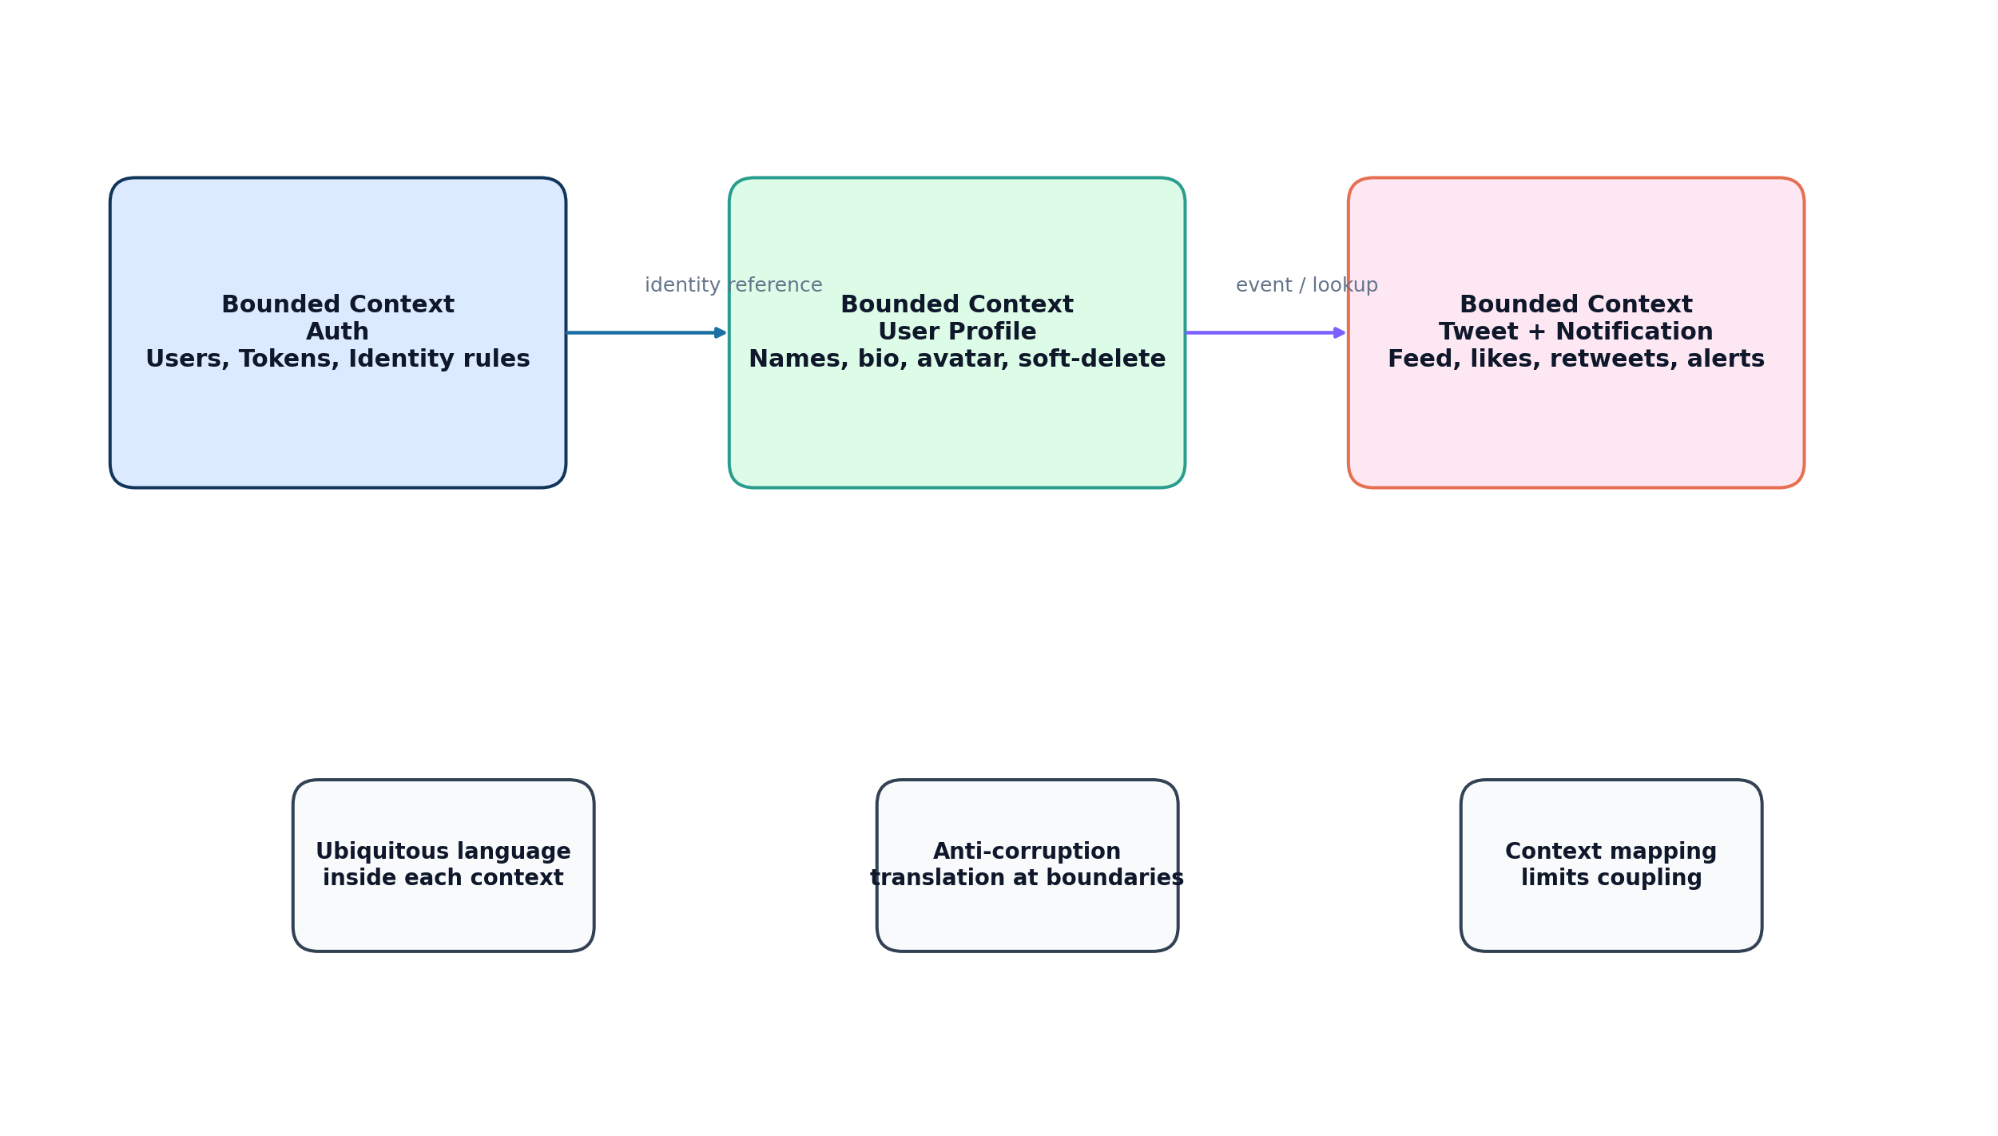
Figure 4. Strategic design concepts and bounded-context mapping.
- Auth owns credentials and tokens.
- User service owns profile concerns.
- Tweet service owns feed interactions.
- Notification service owns delivery and read state.
Why this matters: larger applications fail less from syntax and more from language collision. If one word such as user means identity record, profile, follower target, and audit actor all at once, teams start sharing tables, overloading DTOs, and breaking autonomy.
Alternative strategies include a modular monolith with bounded modules, event-driven decomposition, or domain-oriented internal packages before going to multiple deployed services.

5. CQRS in practice: command/query separation
CQRS separates state-changing operations from read operations. The key idea is not necessarily separate databases at the beginning. The useful first step is separate mental models, separate handlers, and separate reasons for change.
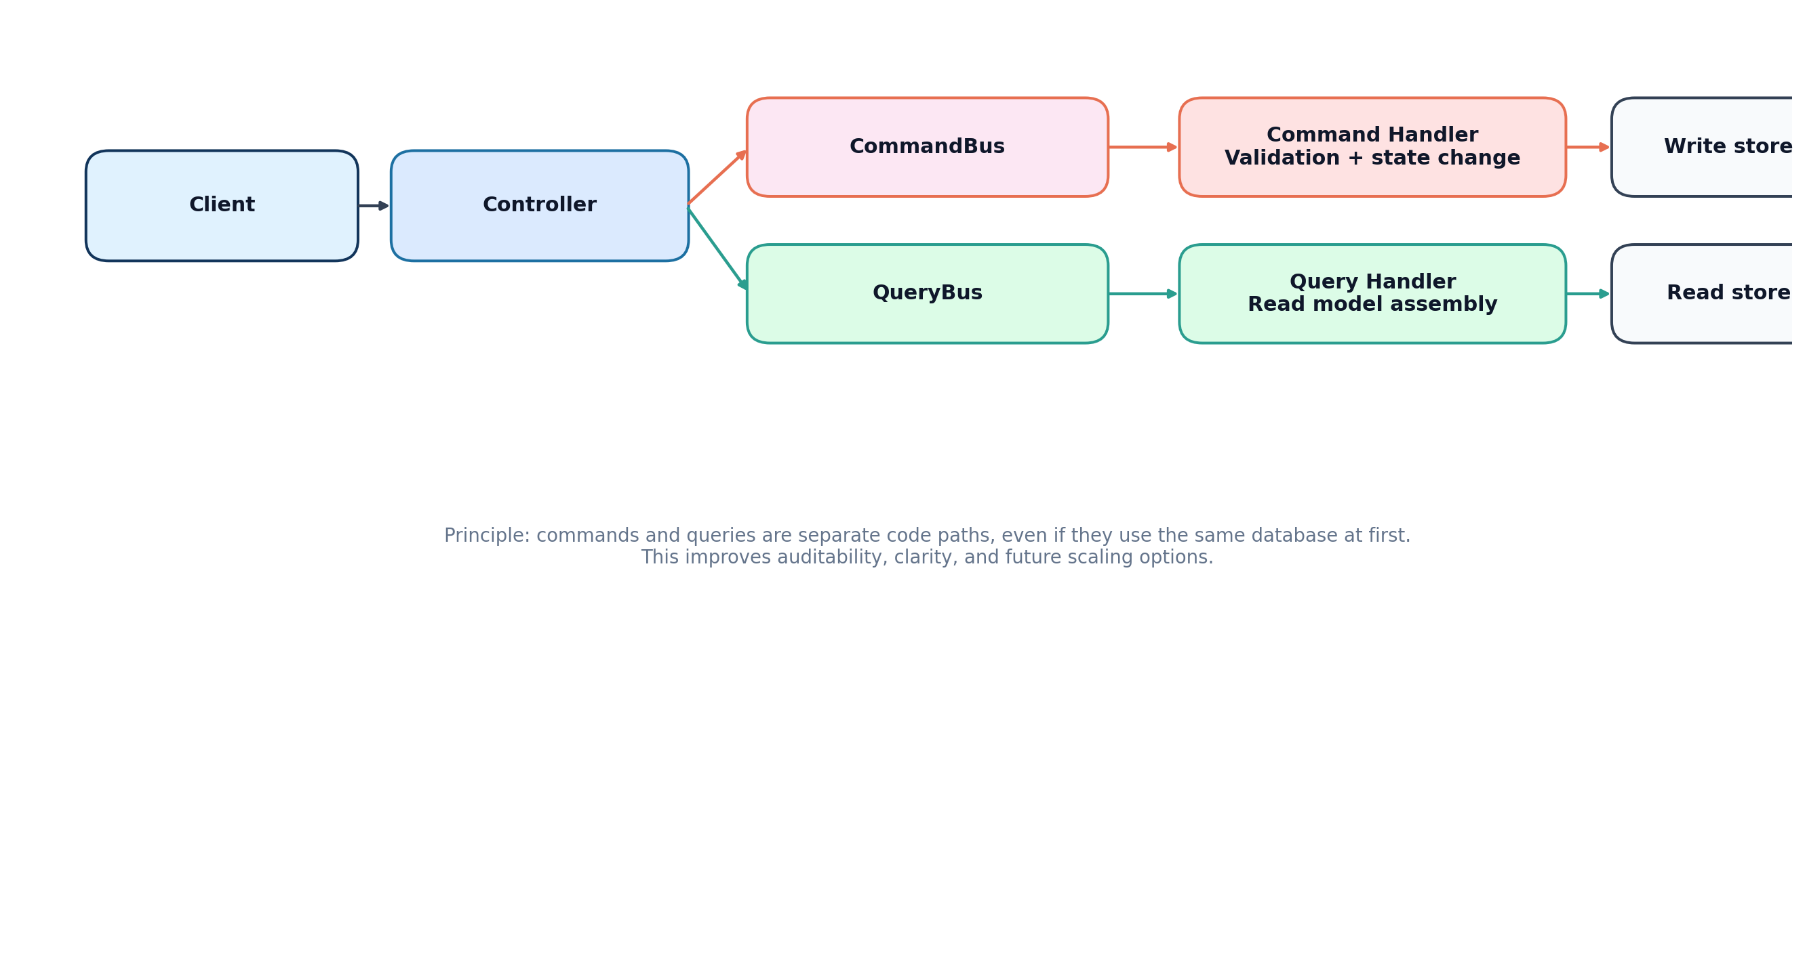
Figure 5. CQRS pattern with distinct command and query flows.
- Commands validate intent, enforce business rules, mutate state, and trigger audit logging or events.
- Queries optimize for data retrieval and presentation shape.
- When the system grows, read models can diverge from write models without rewriting the whole application structure.
Why teams use this procedure: command paths are easier to audit, queries are easier to optimize, and the codebase becomes clearer under pressure. The main risk is over-engineering if the application remains tiny.
Bigger-system challenge: once asynchronous projections are introduced, eventual consistency becomes visible to users. Teams need UX strategies for stale reads, retries, idempotency, and projection lag.
// Simple syntax contrast
class CreateTweetCommand {
constructor(public readonly userId: string, public readonly content: string) {}
}
class GetTweetQuery {
constructor(public readonly id: string) {}
}

6. NestJS as composition root and module system
NestJS is most valuable here as the composition root: module wiring, dependency injection, middleware, guards, controllers, and framework-level policies. The mistake to avoid is letting framework decorators and service classes become the domain itself.
- Use modules to express boundaries and registration, not to hide random global state.
- Use guards for transport-level access control, not for domain business rules.
- Use controllers for delivery concerns and translation between transport DTOs and application commands.
- Use NestJS CQRS package to standardize handler registration and message dispatching.
Alternative backend choices could be Express with custom structure, Fastify with manual DI, Spring Boot, ASP.NET Core, or a modular monolith without a CQRS helper package. NestJS is a productivity choice, not a mandatory architecture choice.

7. Prisma and PostgreSQL usage patterns
Prisma gives fast schema iteration and a typed client, while PostgreSQL provides durable transactional storage. Together they are a pragmatic default for CRUD-heavy and integrity-heavy systems.
Concern | Prisma strength | PostgreSQL strength | When this becomes hard
Schema evolution | Migration workflow | Transactional DDL support | Long-lived branches and drift across environments
Type safety | Generated client | Reliable underlying engine | Leaky abstractions around advanced SQL
Relations | Readable schema syntax | Foreign keys and indexes | Cross-service joins are no longer allowed by architecture
Reporting | Fast normal CRUD generation | Materialized views, SQL power | Analytical queries may outgrow ORM patterns

- Use relational integrity for data that must remain correct under failure.
- Use explicit indexes for common lookup paths such as userId, createdAt, and read state.
- Avoid cross-service database coupling even when it feels convenient.
- Expect to use raw SQL selectively for heavy reporting, feed ranking, or specialized transactional logic.
model Tweet {
id String @id @default(uuid())
userId String
content String
likesCount Int @default(0)
createdAt DateTime @default(now())
@@index([userId, createdAt])
}

8. Docker Compose for local orchestration and production-shaped development
Compose is useful because it removes hidden machine assumptions. Ports, database names, dependency order, and health checks are declared instead of remembered.
- This project uses one container per service and one database per service, plus a frontend container.
- Health checks make dependency startup more deterministic.
- Named volumes preserve database state between restarts.
- Compose is excellent for local integration and small deployments, but it is not a substitute for orchestration platforms such as Kubernetes, Nomad, or ECS when scale and rollout sophistication grow.
services:
tweet-service:
build: ./tweet-service
depends_on:
tweet-db:
condition: service_healthy

9. React, Vite, Axios, React Query, and Tailwind CSS
The frontend stack is built around fast development feedback and strong separation between UI state and server state. Vite handles build and dev speed, React structures the UI, Axios handles transport customization, React Query owns server caching, and Tailwind keeps styling consistent.
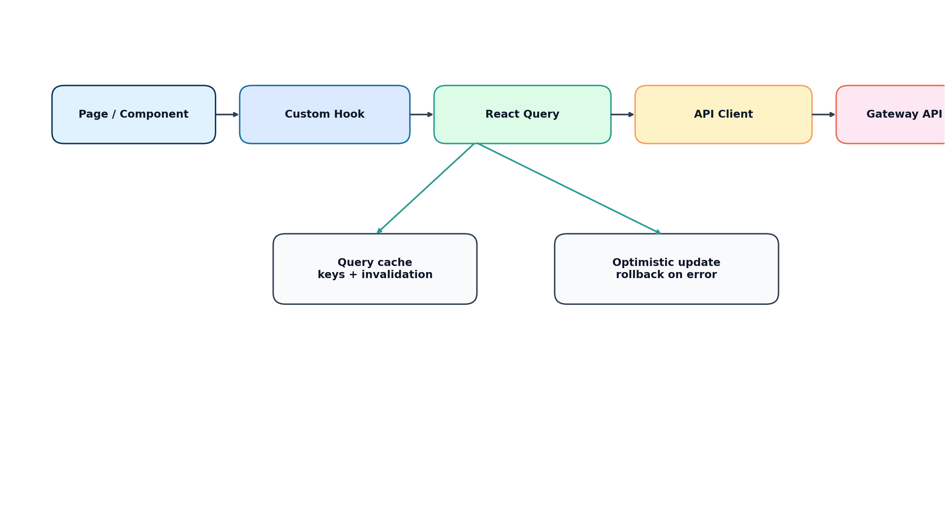
Figure 6. Frontend data flow from component to cache to gateway.
- React components should stay presentation-focused and delegate server interaction to hooks.
- Custom hooks provide reuse and guard against duplicated fetching logic.
- React Query is the source of truth for server state; local component state should only handle transient UI concerns.
- Tailwind works best when color, spacing, and layout choices are constrained by conventions rather than improvised ad hoc.
Alternative choices include Redux Toolkit Query, Zustand plus fetch wrappers, TanStack Router with loaders, Next.js for a framework-first frontend, or plain CSS modules instead of Tailwind. The chosen stack prioritizes speed and explicit control.

10. Token refresh queue, optimistic updates, and frontend state discipline
Two frontend procedures deserve special attention because they solve real operational problems: the token refresh queue and optimistic updates.
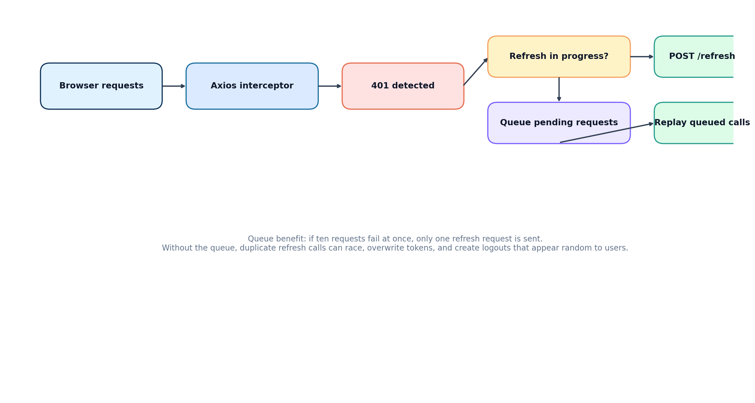
Figure 7. Axios token refresh queue for concurrent 401 responses.
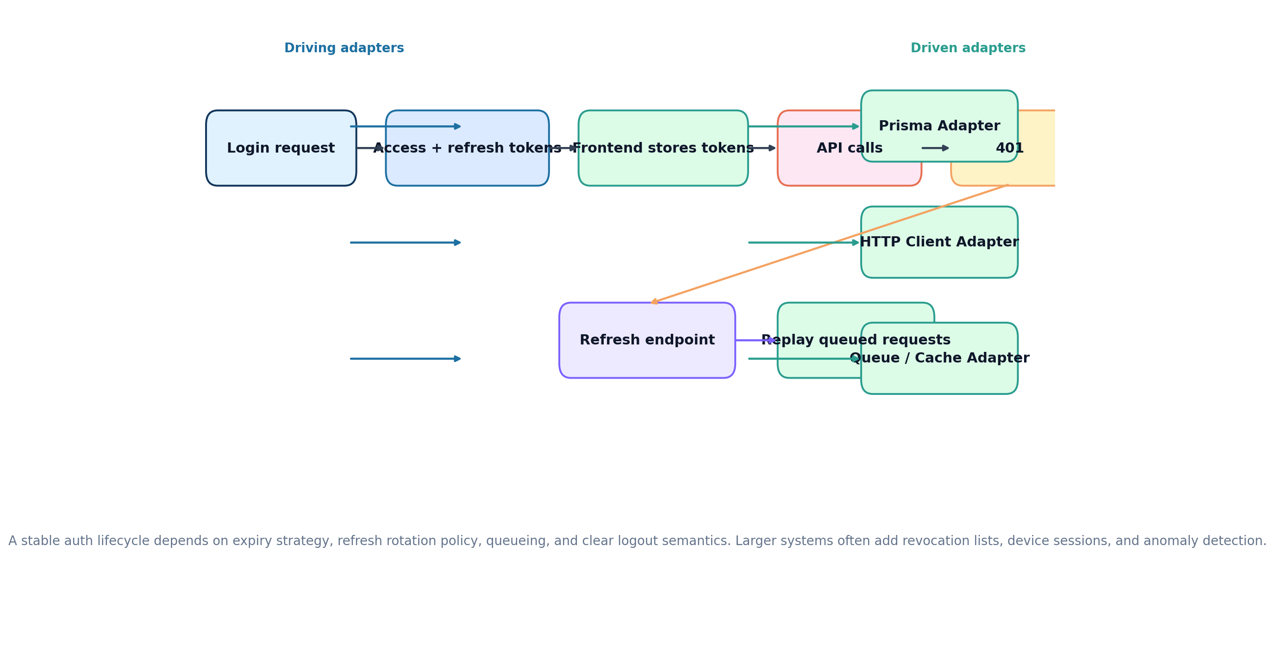
Figure 8. Authentication lifecycle from login to refresh and replay.
Why the refresh queue exists: if several API requests receive 401 at the same time, only one refresh should be in flight. The rest should wait. Without this, multiple refresh attempts can race and invalidate each other.
if (isRefreshing) {
failedQueue.push({ resolve, reject });
return;
}
Optimistic updates improve responsiveness by applying a predicted UI result before the server confirms it. This is especially useful for like buttons, unread counters, and quick toggles. The price is rollback logic if the mutation fails.
onMutate: async () => {
const previous = queryClient.getQueryData(['tweet', id]);
queryClient.setQueryData(['tweet', id], patchLikes(previous));
return { previous };
}
Bigger-system challenge: optimistic updates become harder when many views show the same entity. Teams need robust query keys, invalidation discipline, and sometimes event streams or websockets to converge state.

11. Audit logging: why it matters and where it breaks at scale
Audit logs are critical in distributed systems because ownership is separated and debugging requires evidence. They help answer who changed what, from where, and whether the action succeeded.
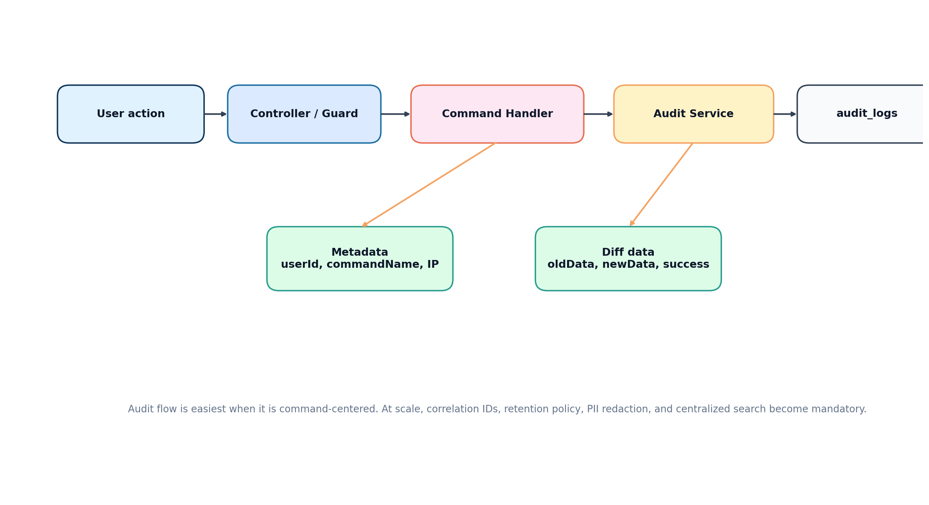
Figure 9. Audit logging flow centered around command execution.
- They support incident analysis, operational debugging, and compliance needs.
- They help verify command-side behavior independently from UI outcomes.
- They make cross-service tracing easier when combined with correlation IDs.
At larger scale, audit logging must be treated as a product of its own. Problems include storage growth, sensitive data leakage, retention rules, query cost, partial failures, and inconsistent naming between services.
Alternatives or enhancements include centralized log pipelines, outbox-based event emission, OpenTelemetry traces, append-only event stores, or dedicated audit warehouses.

12. Real scaling challenges, alternatives, and migration paths
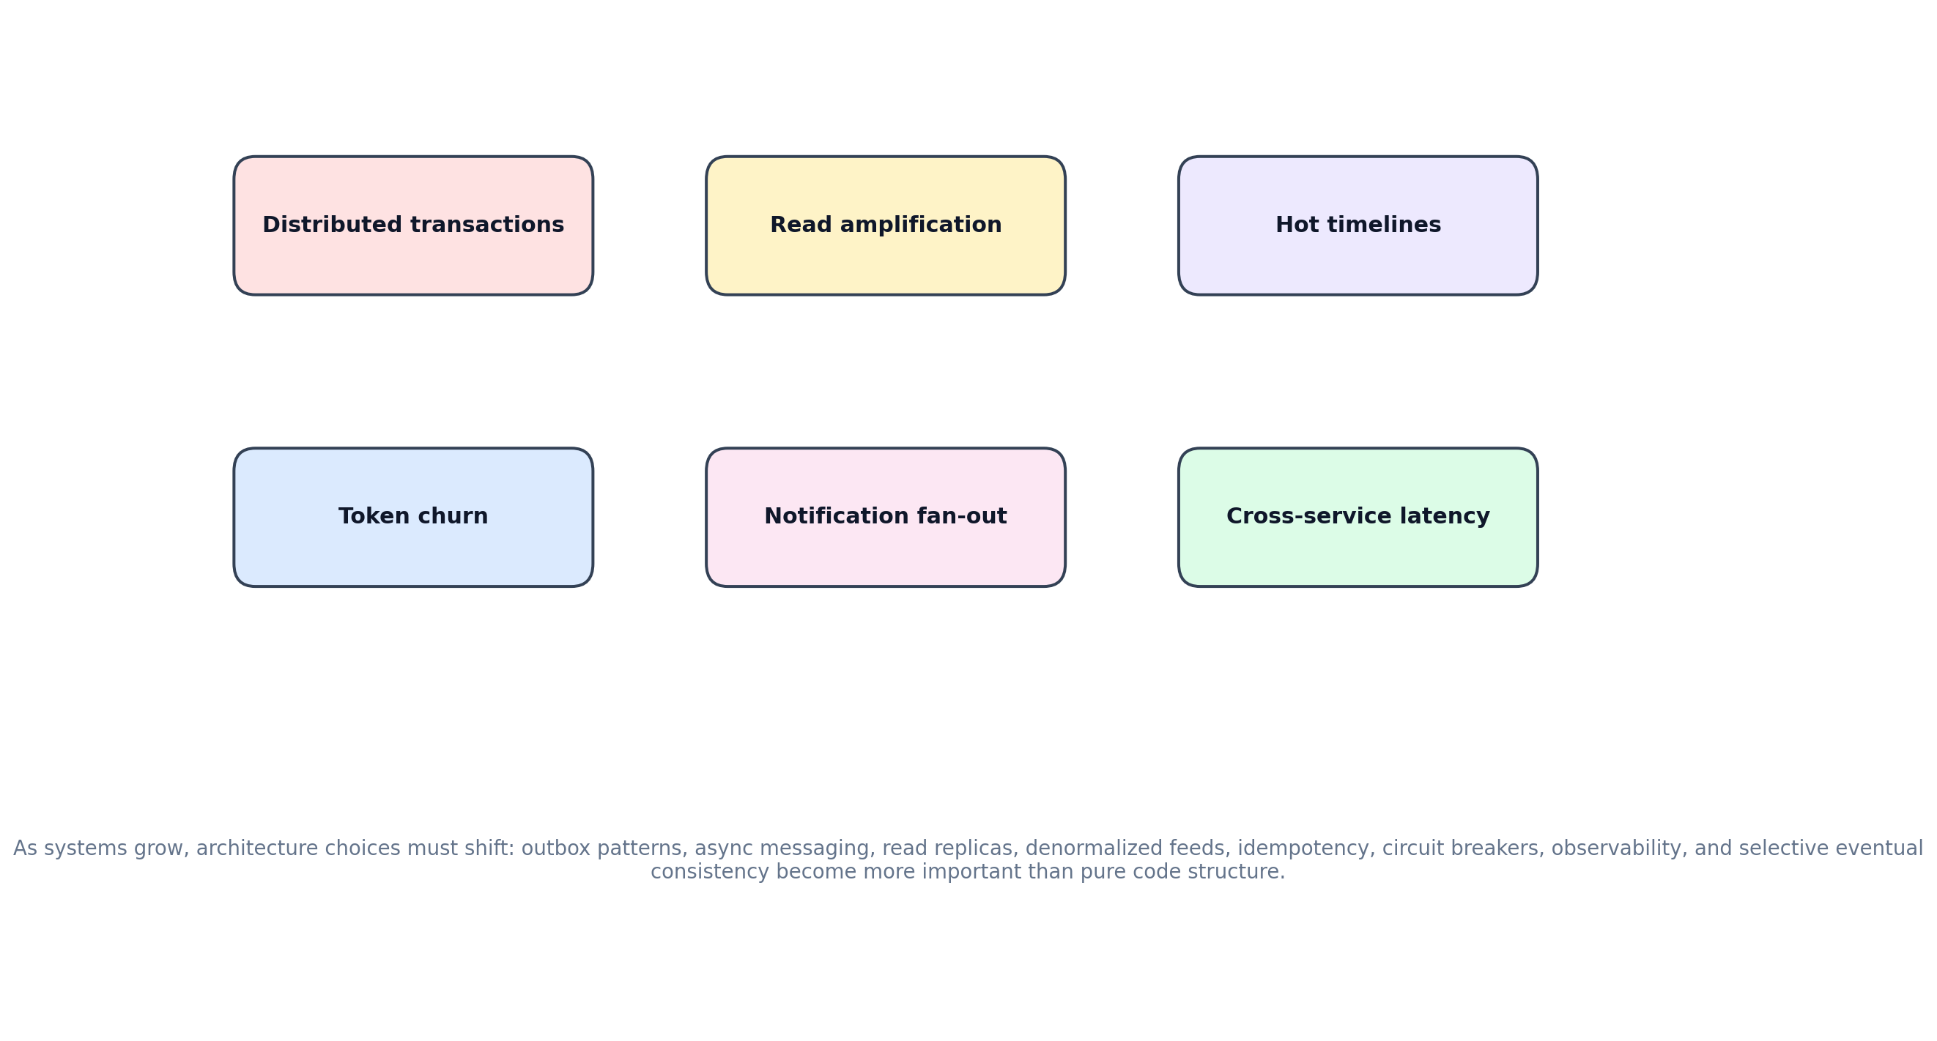
Figure 10. Common architecture stress points as the application grows.
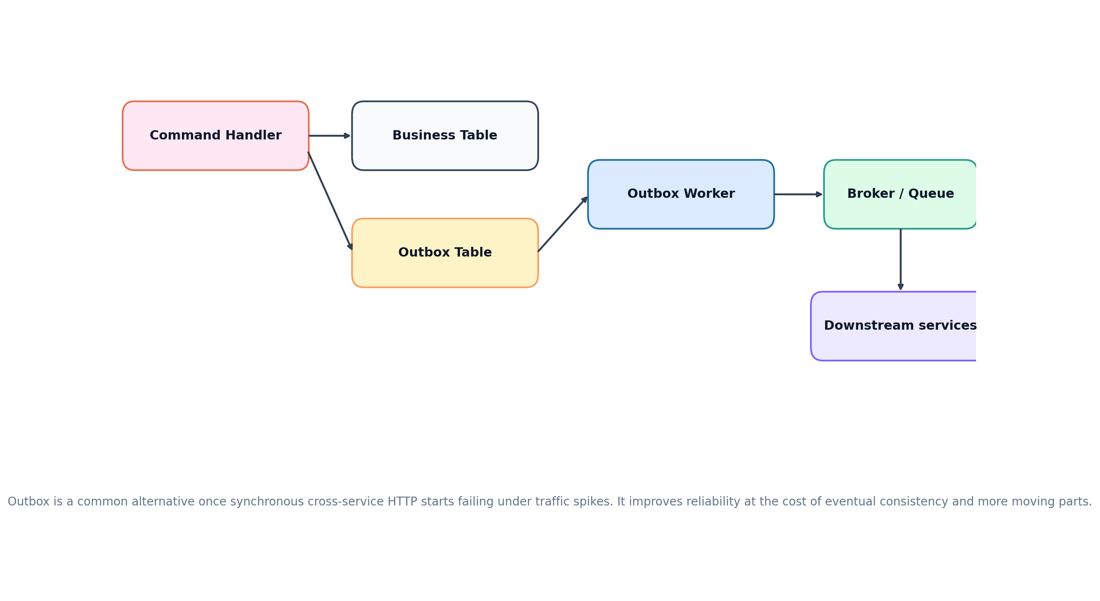
Figure 11. Outbox pattern as a common alternative to synchronous cross-service HTTP.
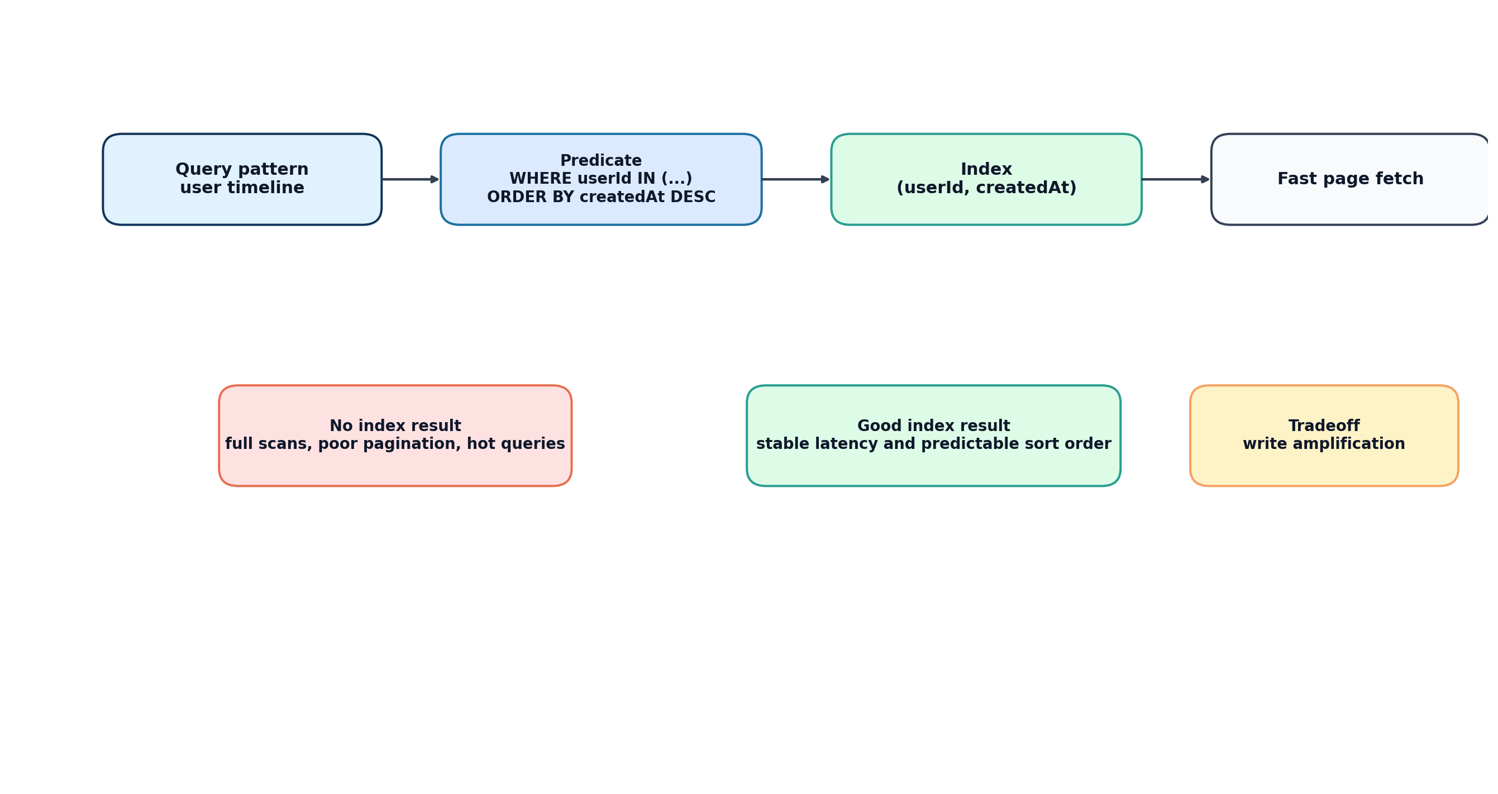
Figure 12. Query path and indexing strategy for high-frequency reads.
- Distributed transactions: once one user action spans several services, strict atomicity becomes difficult. Practical substitutes include saga orchestration, compensating actions, and idempotent retries.
- Feed and notification fan-out: naive synchronous HTTP calls degrade quickly under load. Event streams, job queues, and fan-out workers become more attractive.
- Read-model pressure: dashboards, timelines, and aggregate counts often need denormalized projections or caches.
- Operational observability: as service count grows, logs alone stop being enough. Structured logging, tracing, metrics, and correlation IDs become mandatory.
- Contract evolution: when teams deploy independently, schema and API compatibility require versioning and deprecation discipline.
A realistic migration path is usually: modular monolith -> clear internal boundaries -> separate database ownership -> split deployment units only where needed -> add async messaging and read projections for hotspots -> introduce stronger orchestration and observability.
Decision point | Current stack works well when | Consider an alternative when
Microservices | Teams or domains are meaningfully separate | Operational complexity exceeds domain benefit
CQRS | Auditability and read/write clarity matter | The app is simple CRUD with little domain logic
Prisma | CRUD and typed developer experience are top priorities | Heavy analytical SQL and advanced DB behavior dominate
React Query | Server state is dominant | Client-only workflows dominate and caching is simple
Gateway | Routing, auth policy, and aggregation belong at the edge | The frontend can talk directly and edge logic stays trivial

Appendix A. Compact syntax examples
These examples are intentionally small. The handbook is theory-heavy by design, so syntax is included only to anchor the concepts.
// NestJS CQRS handler shape
@CommandHandler(CreateTweetCommand)
export class CreateTweetHandler {
async execute(command: CreateTweetCommand) {
return this.repo.create(command.userId, command.content);
}
}
// Axios request interceptor shape
api.interceptors.request.use((config) => {
config.headers.Authorization = `Bearer ${token}`;
return config;
});
// React Query query shape
useQuery({
queryKey: ['tweets', 'timeline'],
queryFn: fetchTimeline,
});

Appendix B. Diagram inventory
- System overview
- Deployment topology
- Hexagonal architecture
- DDD strategic design
- CQRS pattern
- Frontend data flow
- Token refresh queue
- Authentication lifecycle
- Audit logging flow
- Outbox alternative architecture
- Database indexing strategy
- Scaling challenges

