
Group Assignment
CT050-3-2-WAPP
WEB APPLICATIONS
NPT2F2511IT

HAND IN DATE : 14th June 2026
HAND OUT DATE : 19th July 2026
Lecturer Name : Sandeep Shrestha

Submitted By:
Name | APU/College Number
Sameer Chaudhary | NP070342
Biraj Budhacharya | NP070147
Suprava Maharjan | NP070429
Ayus Yadav | NP070126

Aaram Education
A Comfortable, Stress-Free Learning Portal
This is a proposal presented to the Web Applications module in partial fulfilment of the requirements of the group assignment on web-based system development.

4th Semester
Techspire College

Table of Contents
Table of Contents 1
Website Title 1
1 Introduction 1
2 Project Objectives 1
2.1 Mission Statement 1
3 Audience Modelling 1
3.1 Objective Group 1
3.2 User Characteristic and Needs 1
4 Problem Statement and Proposed Solution 1
4.1 Problem Statement 1
4.2 Proposed Solution 1
5 Project Scope 1
5.1 Functional Requirements 1
5.2 Technical Requirements 1
5.3 Non-Functional Requirements 1
6 Limitations 1
7 Conclusion 1

Website Title
Aaram Education - A Comfortable, Stress-Free Learning Portal

Aaram Education is an interactive web portal which provides education to the school and college going children as well as working people at their own speed and easy comfort. Its name, Aaram, is derived from a sense of comfort and ease, which is the heart of its function: to eliminate the strain of fixed time schedules, high cost of private tutors, and the load of too much information from the learning process. Access to the site is available for guests, registered students, tutors, and administrators, and includes self-paced video lessons, downloadable notes, practice quizzes, and progress tracking. This uncluttered, straightforward interface, along with complete CRUD functionality and secure database connections, is a complete example of the web development needs outlined by the module.

1 Introduction

Aaram Education is a fully integrated, interactive, Web-based educational solution designed to provide secondary and tertiary level students, or self-motivated professionals, a fun and flexible alternative to traditional classroom-based education. The site is based on topics that are generally required for school and college exams including Maths, Science, English and Computing which are covered by short video lessons, downloadable study notes, practice tests and the opportunity for 1:1 sessions with a tutor.

The subjects are those that students often require assistance in school and college coursework: Mathematics, Science, English and Computing. Each subject is divided into mini lessons of 5 to 10 minutes long which students can fit into their small block of time breaks. Each video comes with students' notes summarising the key points which they can download and print or read later without using the internet. Each topic is accompanied by practice quizzes with instant feedback and a score, which will enable the learner to be aware of the areas that require further revision. The site also provides access to one-to-one sessions with a tutor, which is designed to help students who need additional, more individualized support who can schedule a time to discuss a topic in more detail, ask questions, and receive guidance in accordance with their own learning rate. These features are designed to be used together, to cover the entire spectrum of how a learner will use the course: video explanations for new learning; notes that can be downloaded for a quick revision; quizzes for self-testing; sessions with a tutor for when self-learning isn't enough.

The system is intended to meet the real world needs of the Web Applications module by providing a complete coverage of the concepts of building a web application through a real full stack build. On the front end, content is presented using semantic HTML5, styled with CSS3 (through external, internal, and inline stylesheets) to create a calm and readable user interface, and made interactive using JavaScript to do things like Quizzes, Form validation, and dynamically load content. On the back end, server-side scripting interacts with a relational database to maintain users, courses, and progress data via full Create/Read/Update/Delete (CRUD) operations.

2 Project Objectives

To provide a relaxing and non-distractive online learning space to allow students to progress and revisit school/college subjects at their own speed.

To create a carefully planned relational database that holds on to user profiles, courses, learning materials and progress data with full CRUD capabilities.

To develop a responsive, user friendly interface with HTML5, CSS3 and JavaScript for all screens – desktop, tablet and mobile.

To offer a secure form validation system on both the client and server side, along with a secure sign-up and logon system for students, tutors and administrators.

To use suitable multimedia (videos, notes with narration, and diagrams) to enhance understanding, but not overwhelm the learner

2.1 Mission Statement

Aaram Education's mission is to make learning so manageable it isn't stressful. We want to provide students from all backgrounds one convenient and comfortable environment for students to review and refine core subjects, monitor their own progress, and access a tutor as needed, without the travel and/or pressure associated with traditional tuition. To create a platform that is learner-centred, recognises achievable milestones with visual progress reports and provides easy-to-use tools for parents and tutors to facilitate these steps.

3 Audience Modelling

Audience modelling involves determining the actual users of Aaram Education and their expectations of the site and how it could be designed to meet these needs. Aaram Education has 5 primary groups of users and each has a different interaction with the site.

3.1 Objective Group
- Students: Students are the core of the platform and are secondary school and college students of about 13 to 24 years of age. They are at Aaram Education to study what they are missing or want to rewrite what they are learning or to prepare for exams. They also want lessons to be structured and allow them to work through at their own pace, pausing and resuming a lesson as they please, and they want to be able to take a practice quiz at the end of a lesson to check their understanding of a topic immediately.
- People leaving education at some point in the past but wishing to return to the fundamentals, either to support their own children or to undertake further study or for personal interest – aged 25 to 45 or so. They require the same relaxed and informal entry to lessons as students do, but are often given less time in which to be free, so brief lessons and well structured lesson organisation are even more important to them.
- Tutors: Subject experts like teachers or seasoned experts who sign up to the platform and share their knowledge. The tutor's job is to post videos of lessons and notes for the students, to make the quizzes for the subject and provide one to one lessons with students who book the tutor. Tutors are not only viewers of the content, they are also content creators; and the platform should provide them with easy-to-use tools to handle the content they are creating.

Non-registered Visitors: These are visitors who visit the website without registering, possibly via a search engine or a recommendation from a friend, before determining if they want to register. They can view a few free sample lessons, read the About page to learn about Aaram Education and leave a comment in the guest book without registering for an account. This is important as it is the first impression that makes a visitor a registered student.

Administrators: These are the site managers that are behind the scenes making Aaram Education run smoothly! They are responsible for accepting new tutor applications, ensuring that posted material is suitable, to moderate comments in the guest book and to manage the underlying system of accessing users and courses. They have CRUD access to all the system.

3.2 User Characteristic and Needs
While knowing who the users are is crucial, it's also essential to know how they feel about technology and what they'll be looking for on the platform to guide decisions on interface design, navigation, and features.
- Demographics: Students 13-24, working professionals 25-45, and tutors and administrators of different ages with subject and technical expertise as opposed to age range.
- Technical Proficiency – this measures the level of confidence that each group has in using websites and apps in general:
- Students: low to medium technical ability. Many are familiar with using a smartphone and social media, but not necessarily with more traditional systems; they will appreciate a simple clean layout and the ability to clearly label everything, use large and easy to read buttons, and never have to click twice to get to a lesson.
- Working Professionals: Medium technical ability. They are typically confident online, but may not have as much time as others to learn the layout of a website, so they appreciate being able to find what they are looking for without having to learn a lot.
- Tutors: They have confidence in using the regular software that they use in their daily lives, but may not be developers; they require easy-to-use, form-bas ed tools to upload materials and manage their own classes without any programming knowledge.
- Administrators: Medium to advanced technical skills, as they will need to be able to control user accounts, course content and basic site analytics via a more detailed management interface.
- Needs – what each group is seeking to come out of the platform:
- Students: A clear and logical structure to the lesson that always makes them aware of what they are going to study next; low pressure practice quizzes to learn from mistakes without fear of failure; and tutor support on their user journey – they know where to go if they get stuck.
- Working Professionals: This is similar to students, but with a focus on the flexibility to quickly get to a certain section even if it is more advanced, without having to wade through the material geared towards younger learners.
- Tutors: A simple dashboard to upload lessons and notes, create and edit quizzes and see how their students are doing, enabling them to spot the ones that may need extra support.
- Administrators: An administrative interface which allows you to add, display, edit and delete users, course content, guest book entries and provides an overall summary of site activity.

4 Problem Statement and Proposed Solution

4.1 Problem Statement

For many students today, learning support that will fit their own schedule and learning pace is a challenge. Private tuition can be costly and location specific, and some generic online teaching platforms are created to a general international syllabus and not localised for school and college syllabus. These platforms also tend to present useful content behind a cluttered interface, hard-sell tactics or complicated navigation, making the process more stressful than it should be. Moreover, very few platforms offer a straightforward and honest representation of the learner's own development and progress, and very few provide a convenient method for tutors and parents to track the learner's progress. The result is that learners who are most in need of a calm, structured and affordable environment to revise are not being provided with that environment, which means that they are not becoming more confident or achieving better results.

4.2 Proposed Solution

Aaram Education fills this void by providing a safe and clean and truly student-driven learning website. Students are able to explore courses on specific subjects, watch short video lessons, download notes and try out practice quizzes, and view their own progress automatically. Registered tutors will be able to upload and manage lesson material, create quizzes, and answer requests to tutor sessions. To ensure the accuracy of the data and privacy of the users, all registrations and submissions are checked. An administrator module includes complete CRUD (Create Read Update Delete) database functionality so that the site owner can manage users, approve new courses and keep the overall quality of the content standardized. The interface itself is designed to be quiet, not cluttered – liberally spaced, a restrained colour palette, and clear typography – to make using the site as easy as the word “Aaram” implies.

5 Project Scope

Project scope establishes exactly what Aaram Education will do, as well as what it will not do, it can be divided into functional requirements, technical requirements and non-functional requirements. Clearly defining this helps to keep the project realistic and provides a common checklist to work from for the development team.

5.1 Functional Requirements
Functional requirements are the things that each type of user can do on the site (what the system must do).
- Public Access – provides features that can be accessed by all site users, without the need of an account:
- Guests may browse through a few lessons they can access for free, view the list of subject categories and read the About and Home pages in order for them to understand what Aaram Education has to offer before committing to register.
- The guests can add their comments to the guest book that are moderated by the admin team so it can be reviewed before it is made public.
- Learning Experience – the core learning experience (available after students' registration):
- Ensure that registration and login to accounts are secure and have a profile page for students to update their personal information and password.
- A personal dashboard, serving as the student's home base, that displays the courses the student has registered for, lessons completed, quiz scores and a general progress overview that allows the student to track their progress. ◦
- Flexibility to join new courses, complete their lessons on their own time, take quizzes and receive instant feedback, download notes to study later, and arrange a one-to-one session with a tutor if necessary.
- Registered Tutor Features – tools for the subject specialist who develop and administer content:
- Allow tutors to log in and manage their own tutors' profile, in addition to the student's logon, to give them their own set of tools.
- An easy-to-use Content Management System where tutors can upload lesson videos, notes, create quizzes with correct answers and explanations, and see an analytics graph of enrolled students' progress, which notifies tutors of those who may be struggling.
- Administrator Module – back-office tools that help maintain the health of the entire platform:
- Complete CRUD (Create, Read, Update, Delete) facilities for user accounts, courses, lessons and quiz records, allowing the administrator to have full control over the content and users on the site. New tutor accounts will be pre-approved before they are published and guest book comments will be moderated to ensure the site is safe and appropriate.
- Simple analytics about site use including the number of students using it, most popular courses, and general involvement of students to give the administrator a picture of how the site is truly being utilized.

5.2 Technical Requirements
The technical requirements talk about the technologies and coding techniques to be used to implement the functional requirements above and from the user facing interface to the database that holds information behind the scenes.
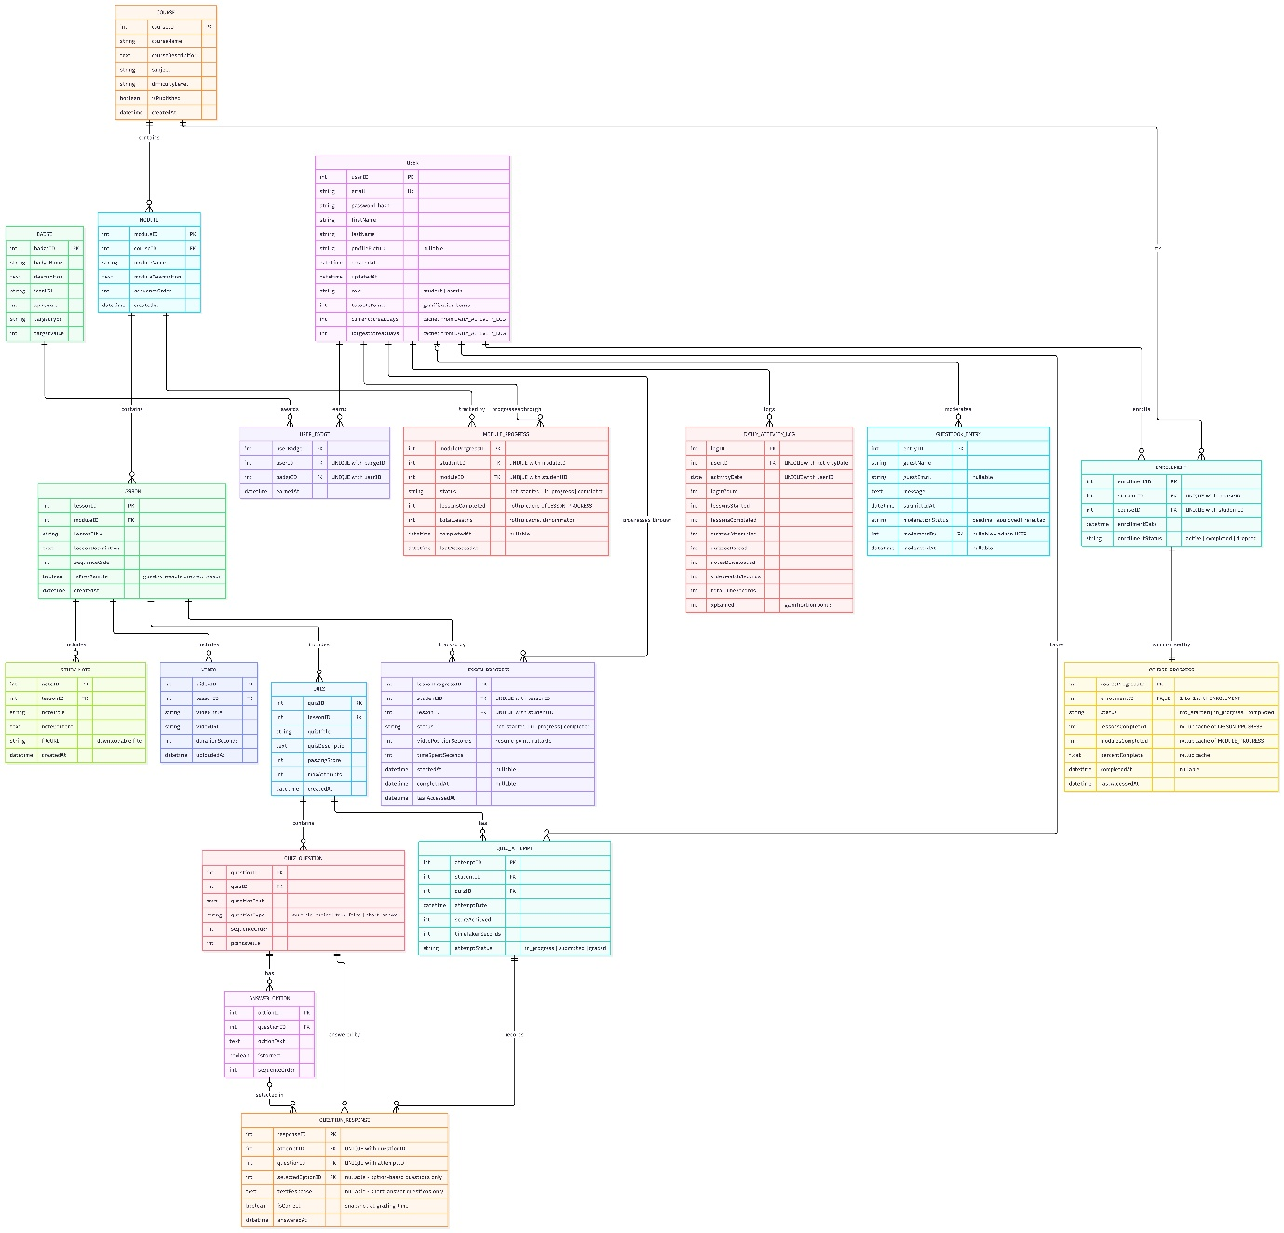
Figure 1: Entity Relationship Diagram for the Aaram Education database

- Frontend – All of the information that the user can see and interact with in their browser:
- All pages are logically structured using semantic HTML5 (for instance, using the correct heading tags, navigation elements or form elements) and are therefore easier to read by screen readers or search engines.
- Using external stylesheets (like aaram.css), internal <style> blocks and inline styling keeps the interface calm, readable and responsive, no matter what the screen size.
- JavaScript provides interactivity, including scoring a quiz as students complete it, animating progress bars, loading additional content dynamically (without a page refresh) and validating forms before the student submits them.
- Backend – server side logic that links the site to its data:
- Server-side writing scripts written in PHP or Node.js accept requests from the browser (e.g., "show me this student's dashboard") and retrieve or modify the appropriate information in the database.
- All persistent data, such as user accounts, course and lesson details, quiz results and guest book entries are stored in a MySQL relational database, which is organized into related tables to enable fast and accurate retrieval of data.
- Database Operations – the specific CRUD operations that the system needs to be able to perform:
- Insert: The process of adding new user registrations, course enrolments, quiz submissions, and comments in the guest book to the database.
- Display: Presenting and returning course listings, lesson content, student progress and quiz results in a readable format.
- Update: Change of profile information, content of courses, and Quiz marks as information changes over time. Delete: Removing inactive accounts, obsolete courses or guest book entries that an administrator has moderated out.
- Data Entry Validation – Ensuring that the information that is entered into the system is accurate and safe:
- Client-side JavaScript validation provides immediate feedback in the browser to students and tutors, before the form is submitted, if it contains a missing required field, an invalid email address, or a weak password.
- On the server, any data is validated a second time after the form has been submitted, ensuring that usernames and emails are unique and that no harmful or malformed data will be passed to the database.
- Navigation – the way that users move around the site:
- A fixed header with a clear, consistent menu, a breadcrumb trail showing where the user currently is within a course, and a footer with useful links, all repeated identically across every page so users never feel lost.
- Multimedia – supporting material to facilitate lessons:
- Each lesson is supported by appropriate short instructional videos, narration notes, and simple diagrams that are carefully selected to enhance the lesson's content, but not to overload the page and detract from the balance of the site's calm and concentrated atmosphere.
- File Organisation – the way that the project's code is organised in the background:
- Project code is organized in a consistent, predictable folder and naming structure throughout the project (index.html, styles/aaram.css, scripts/quiz.js, includes/db.php) and is easier for the entire team to navigate, maintain and extend.

5.3 Non-Functional Requirements
Non-functional requirements are not a specific feature of the system but they represent the overarching quality standards that the system will have to uphold throughout the use of whatever page or feature within the system.
- Usability: All interface elements remain composed and unobtrusive, there is appropriate labelling, adequate spacing, and the minimum number of clicks required to complete common tasks such as registering for a course, trying a quiz or the like, and the platform is genuinely easy and not stressful to use.
- Performance: Pages and videos load fast, even with slower internet connections, which means that learners are not left waiting or losing interest halfway through lessons.
- Security: All accounts are secured using secure authentication and hashed passwords, and personal details and progress information are secured so that students, tutors and parents can trust the platform with their information.
- Responsive: Designed to fit the desktop screen, tablet, and mobile screen and tested to work with various browsers allowing learners to study from any device they may have available.
6 Limitations

No Mobile App: Aaram Education will be delivered as a responsive site – no dedicated Mobile App for this phase.

In this version, the platform does not feature live video classes, but allows to request and watch pre-recorded lessons. No Payment Gateway:

This version does not accept payments; tutor sessions and premium content are planned for a future enhancement.

Limited Subject Coverage: For the initial release, a limited number of core school/college subjects are covered, with additional subjects planned for later releases.

7 Conclusion
Aaram Education is a targeted response to a real need: a place to redraft the core subjects online which is both calm and affordable and catered to the needs of the student. The site's design features a simple, distraction-free layout, along with convenient features such as course browsing, progress tracking, quizzes, tutor support, and a fully functional guest book, and directly addresses the needs of the CT050-3-2-WAPP Web Applications assignment, which include interlinked HTML5 pages, layered stylesheet application, full database CRUD connectivity, secure registration and login for multiple user types, comprehensive forms validation, and a working guest book.
This will be implemented as a true client/server system with a relational database for all the persistent data and JavaScript for a slick and responsive user interface. In addition to meeting the requirements of the assignment, Aaram Education is a realistic product concept in a small-scale that could evolve to include live tutoring, a payment gateway for premium content, and a larger subject catalogue in future versions that would expand the platform while maintaining its core focus of comfortable and stress-free learning.

