**Adding Files to the GitHub :**

* Make a commit with a message
* Create a new repository in the GitHub account with a repository name .
* Run the command by giving the repository address .

(**$ git remote add origin** [**https://github.com/Birajj2189/Git-Tutorial.git**](https://github.com/Birajj2189/Git-Tutorial.git))

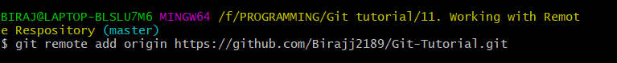

* Run the command ,

(**$ git branch -M main**)



* Run the command,

(**$ git push -u origin main**)

