**Birappa Patil**

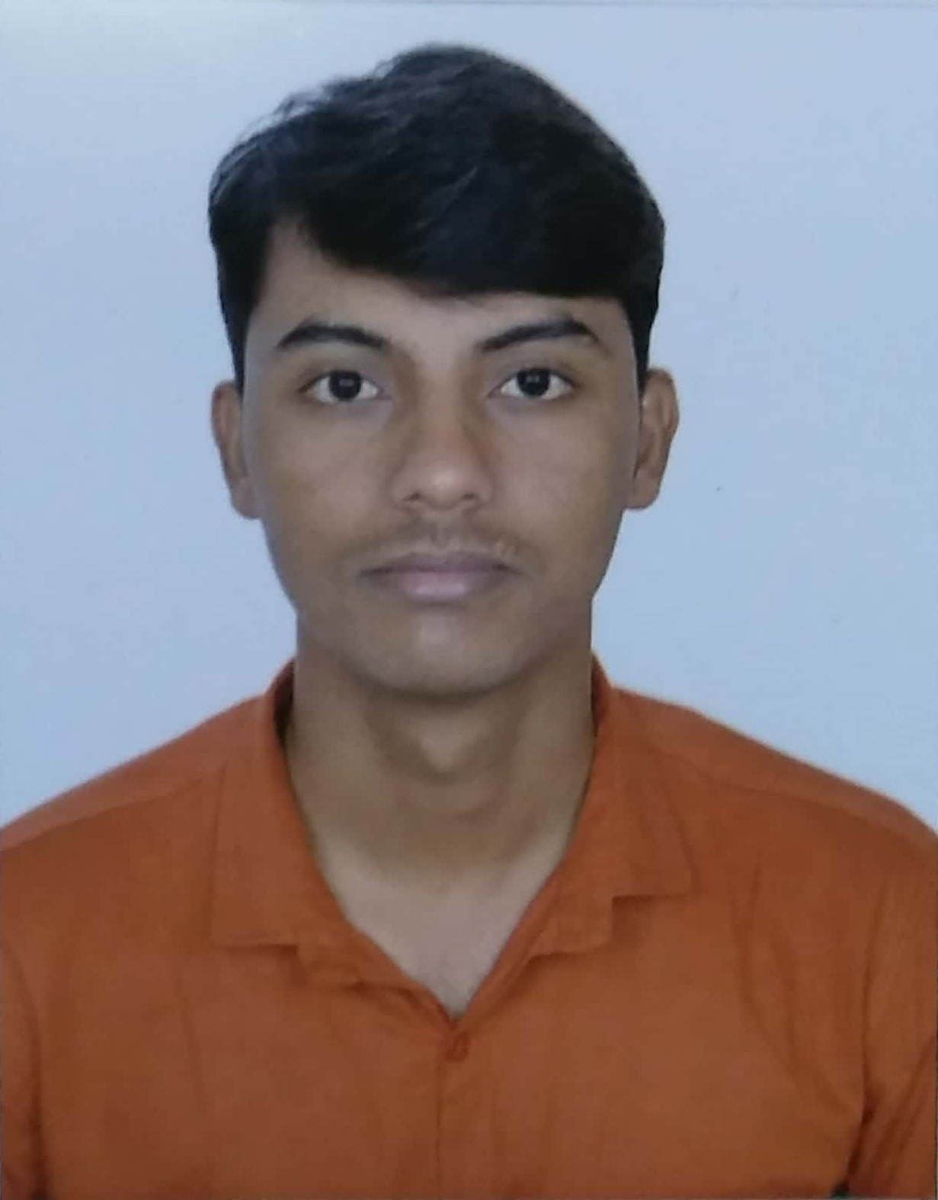

|  |  |
| --- | --- |
| **Title:** | Analyst/Software Engineer |
| **Location:** | Vite, Solapur, Maharashtra, India |
| **Languages:** | Marathi (native),Hindi (fluent),English (fluent),Kannada (conversational) |

# Experience Summary

Successful completion of full stack training given by Capgemini Technology Services India Ltd. Which gives wide variety of professional experiences. Having 3 months of experience in angular 7 as developer and working with digitalcloudplatform Capgemini internal project. Adept motivating self and passionate about learning new technologies.

**KEY SKILLS:**

* **Functional:** Team Work, Communication, Flexibility, Problem Solving, Confidence.
* **Technical: Database Technologies** – Mongo DB, Oracle 11g

**Client-Side Technologies -** Angular 7

**Server-Side Technologies** – Java 8, Spring Boot, Micro Services

**Cloud Based Technologies** – Red Hat Openshift Container Platform

# Experience

* Having 3 months of experience working with DigitalCloudPlatform Capgemini internal project as angular 7 developer.
* Developed MakeMyTrip dummy responsive web application in training period using spring boot micro service architecture, mongo db database service and angular 7 as front end application which provides user service, flight service and ticket booking service.

|  |  |  |
| --- | --- | --- |
| **01** | **Type of Industry:** | Software Development |
|  | **Project Description:** | DigitalCloudPlatform is Capgemini internal project developed for Capgemini customer which gives demo of Promotion Decision Engine, Doppleganger, Facial Recognition, IOT Predictive Maintenance, Omini-Channel Engagement, Factory Floor Inventory Management which gives idea about new technologies and new concept. |
|  | **Role/Title:** | Developer |
|  | **Project Duration:** | On going project |
|  | **Responsibilities:** | * Integration of front end with back end for Promotion Decision Engine. * Integrated all angular pages for Promotion Decision Engine. * Connected rest api for Facial Recognition dashboard. * Connected rest api for Omini-Channel Dashboard. * Fixed bugs for Promotion Decision Engine. * Fixed bugs for Facial Recognition. |
|  | **Operating Systems:** | Windows 10 |
|  | **Software / Languages:** | Angular 7 |
|  | **Special Tools:** | Visual studio code 1.30.2 |

|  |  |  |
| --- | --- | --- |
| **02** | **Type of Industry:** | Software Development |
|  | **Project Description:** | MakeMyTrip dummy responsive web application built with spring boot micro service architecture, mongo db database service and angular 7 as front end application which provides user service, flight service and ticket booking service. |
|  | **Role/Title:** | Developer |
|  | **Project Duration:** | 3 weeks |
|  | **Responsibilities:** | * Developed user and flight details micro services using spring boot. * Integrated user and flight service with mongo db data service. * Added Swagger to consume RESTful web services. * Implemented Mockito testing for user and flight service. * Registered user and flight service to the Eureka server. * Created home, sign in and sign up component in angular 7. |
|  | **Operating Systems:** | Windows 10 |
|  | **Software / Languages:** | Java 8, Spring Boot, Angular 7, Mongo DB 3.4 |
|  | **Special Tools:** | Spring Tool Suite 3.9.6, Postman, Visual studio code 1.30.2 |

# Training, Certifications & Affiliations

* Successful completion of full stack training from Capgemini Technology Services India Ltd.
* Red Hat Delivery Specialist - Container Platform Application Deployment I
* Red Hat Delivery Specialist - Container Platform Administration I
* Red Hat Delivery Specialist - Container Platform Administration II

# Higher Education

* **Bachelor’s in Computer Science and Engineering.**

Walchand Institute Of Technology, Solapur**.**

University of Solapur

06/2014 – 06/2018