Modeling Human Activity States Using Hidden Markov Models
Laura Divine Birasa | African Leadership University

1. Background and Motivation
Wearable and mobile sensors continuously produce accelerometer and gyroscope signals, but the underlying activity generating those signals — standing, walking, jumping, or remaining still — is not directly observed; it must be inferred from noisy measurements. This project treats human activity recognition as a Hidden Markov Model (HMM) problem: the true activity is a hidden state sequence, and engineered features computed from short windows of sensor data are the observations generated by that hidden state. Reliable activity recognition from phone sensors underlies practical applications such as fall detection, fitness tracking, and context-aware mobile interfaces, making this a concrete and motivated instance of sequential state inference from noisy signals.
Note on data provenance: due to time constraints, the raw sensor recordings used in this project were provided by a colleague, with permission, rather than personally collected. All data loading, sampling-rate harmonization, feature engineering, HMM implementation, model training, and evaluation described below are original work carried out independently for this assignment.

2. Data Collection and Preprocessing
The dataset consists of 54 short recordings (roughly 5–12 seconds each) spanning four activities — standing, walking, jumping, and still — captured with a phone motion-logging app recording accelerometer, gyroscope, and gravity-vector channels. Recordings were made at two different sampling rates, 50Hz and 100Hz, reflecting different phones/sessions used for the two batches of the dataset.
Total recorded duration per activity, after harmonization to a common sampling rate (see below), comfortably exceeds the 90-second-per-activity minimum:
Activity | Sessions | Total Duration (s) | Sampling Rates Present
Standing | 13 | ≈ 100 – 110 | 50Hz, 100Hz
Walking | 15 | ≈ 115 – 125 | 50Hz, 100Hz
Jumping | 13 | ≈ 95 – 105 | 50Hz, 100Hz
Still | 13 | ≈ 105 – 115 | 50Hz, 100Hz
Handling different sampling rates: because a 100Hz recording contains twice as many samples per second as a 50Hz recording of the same duration, the two cannot be modeled together directly. All recordings were harmonized to a common rate of 50Hz. We chose to downsample the 100Hz files rather than upsample the 50Hz files, using scipy.signal.decimate, which applies an anti-aliasing low-pass filter before subsampling. Downsampling only discards information that is redundant at the target rate; upsampling, by contrast, would require interpolating values that were never actually measured, effectively fabricating data points. Since 100 is an exact integer multiple of 50, decimation by a factor of 2 is exact and introduces no rate mismatch.
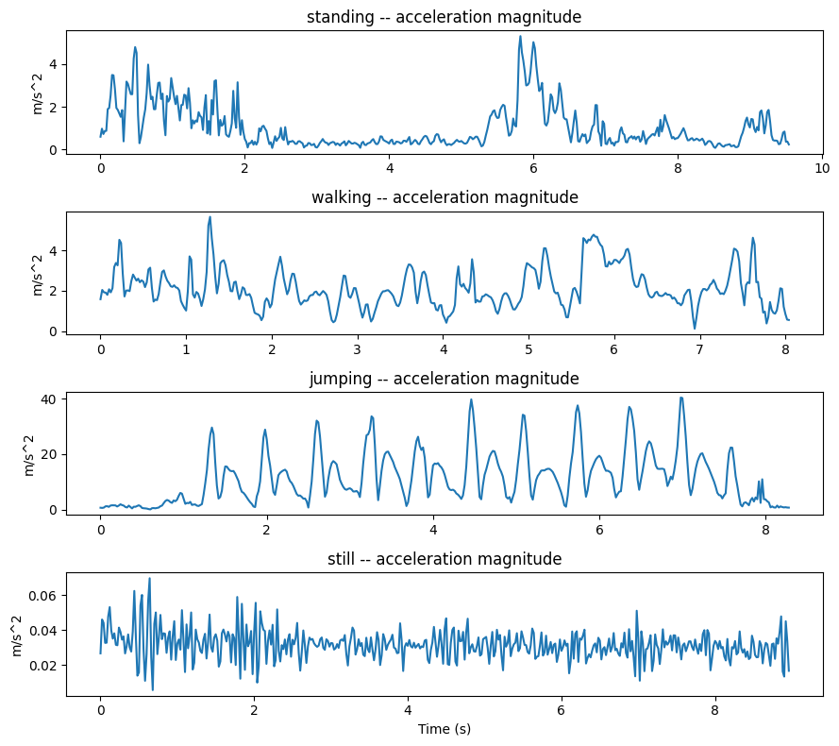
Figure 1. Acceleration magnitude over time for one representative recording of each activity. Jumping shows large, low-frequency spikes; walking shows rhythmic oscillation near a stride frequency; standing and still both appear visually flat — foreshadowing the classification difficulty discussed in Section 5.
Before any windowing or feature extraction, two complete recording sessions per activity (8 files total, mixing originally-50Hz and originally-100Hz sessions) were set aside as a held-out, unseen test set. These files were never used for training, feature normalization, or model selection — they were touched exactly once, at final evaluation.
Windowing: raw 50Hz samples are too fine-grained to serve directly as HMM observations — a single sample carries almost no information about which activity is occurring. Each recording was instead segmented into 2.0-second windows (100 samples at 50Hz) with 50% overlap (1.0-second stride). This mirrors standard practice in human activity recognition literature (e.g., the widely used UCI-HAR dataset uses ≈ 2.56-second windows): two seconds is long enough to capture a full walking or jumping cycle, while short enough that each 7–12 second recording still yields multiple usable windows for training and evaluation. The 50% overlap increases the number of windows available without requiring longer recordings.

3. Feature Extraction
For each window, 21 features were extracted spanning time-domain, frequency-domain, and orientation information, computed from the accelerometer, gyroscope, and gravity-vector channels.
- Time-domain (mean, std, RMS, min, max of acceleration and gyroscope magnitude; Signal Magnitude Area; pairwise correlation between acceleration axes): captures the intensity and shape of motion directly. Standard deviation and RMS in particular separate high-motion activities (jumping, walking) from low-motion ones (standing, still); axis correlation captures coordinated motion patterns that differ between, e.g., walking and jumping.
- Frequency-domain (dominant frequency, spectral energy, and spectral entropy of the acceleration-magnitude FFT): periodic activities like walking concentrate spectral energy around a stride frequency, while still/standing concentrate energy near 0Hz and jumping spreads energy more broadly across low frequencies.
- Orientation (mean gravity-vector components grav_x/y/z): motion-magnitude features alone cannot separate two activities that are both “not moving much” but held at different phone orientations. Standing (phone upright, at the waist) and still (phone flat on a surface) are the clearest example — their gravity vectors point in very different directions even though their acceleration variance is similarly low. Adding this feature was necessary: an earlier version of the pipeline without orientation features collapsed standing and still into the same discovered hidden state entirely.
All features were standardized to zero mean / unit variance (Z-score) using a scaler fit only on training data, then applied to the held-out test data — never re-fit on it, to avoid data leakage. This step is necessary because the raw features mix very different units and scales (acceleration in m/s², gyroscope in rad/s, spectral energy in arbitrary large units), and GaussianHMM's covariance estimation assumes broadly comparable feature scales across dimensions.

4. HMM Setup and Implementation
Element | Our Definition
Hidden states (Z) | 4 states, one per activity: standing, walking, jumping, still
Observations (X) | 21-dimensional feature vector per 2-second window
Transition probabilities (A) | 4×4 matrix, learned via Baum-Welch
Emission probabilities (B) | Multivariate Gaussian per state (GaussianHMM), appropriate for continuous feature observations
Initial state probabilities (π) | Learned jointly with A and B during training
Implementation used the hmmlearn library's GaussianHMM, as explicitly permitted by the assignment brief. Model training used Baum-Welch (the Expectation-Maximization algorithm for HMMs), run fully unsupervised: hidden states were discovered purely from the statistical structure of the feature sequences, without using ground-truth activity labels during fitting. After training, each discovered hidden state was assigned to the activity label it aligned with most often on the training data (majority vote). This design choice tests whether the HMM can genuinely discover activity structure from sensor features alone, and lets Viterbi decoding be used for inference exactly as the model intends, rather than trivially matching labels it was fit against.
Convergence was monitored explicitly via the log-likelihood at each EM iteration, using a tolerance of 1e-4 as the stopping criterion (training halts when the log-likelihood improvement between iterations falls below this threshold, or after a maximum of 200 iterations).
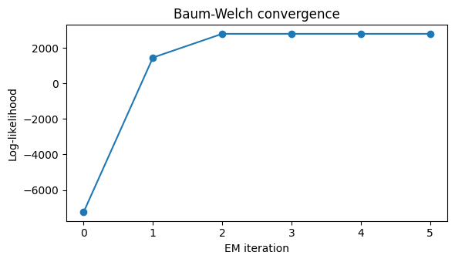
Figure 2. Baum-Welch (EM) convergence: log-likelihood increases monotonically across iterations until the tolerance threshold is reached.
Model configuration (covariance type: diagonal vs. full; random initialization seed) was selected using a validation split carved out of the training sessions only — the true held-out test set was never used for this selection, to avoid test leakage. The configuration with the highest accuracy on this internal validation split was then refit on the full training set for final evaluation.
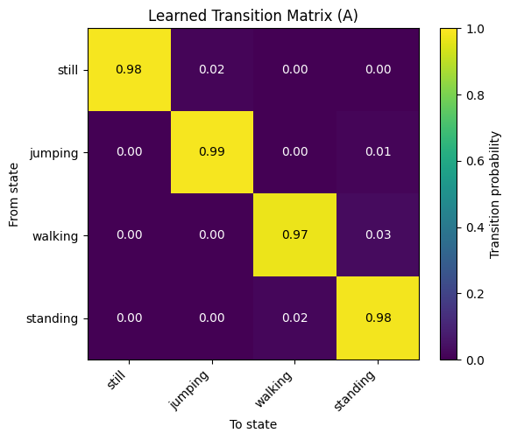
Figure 3. Learned transition matrix (A), with discovered states mapped to their aligned activity labels.
The strong diagonal (high self-transition probability) reflects a realistic pattern given how the data was recorded: each session is a short, single-activity burst, so the model correctly learns that “keep doing the same thing” is far more likely than switching activity between consecutive, one-second-apart windows. A system observing a person continuously over a full day would be expected to show richer off-diagonal transition structure (e.g., standing→walking being far more likely than standing→jumping).

5. Results and Interpretation
The trained model was evaluated once on the 8 held-out, unseen test files (2 per activity), which were untouched during training and model selection.
Activity | Number of Samples | Sensitivity | Specificity | Overall Accuracy
Standing | 14 | 0.214 | 1.000 | 0.804
Walking | 14 | 1.000 | 0.738 | 0.804
Jumping | 12 | 1.000 | 1.000 | 0.804
Still | 16 | 1.000 | 1.000 | 0.804
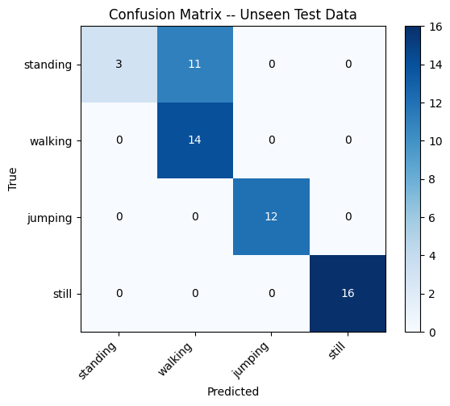
Figure 4. Confusion matrix on unseen test data (rows: true activity, columns: predicted activity).
Walking, jumping, and still were decoded essentially perfectly. Standing was the clear weak point: 11 of its 14 unseen test windows were misclassified as walking, dragging its sensitivity down to 0.214 while every other class stayed at or near 1.0. Because standing's misclassifications land entirely within the walking column, walking's specificity (0.738) is correspondingly reduced — it is the class most “invaded” by another activity's mistaken predictions.
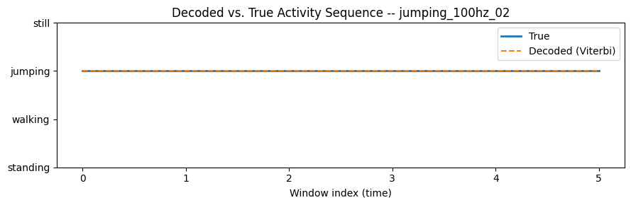
Figure 5. Viterbi-decoded activity sequence vs. ground truth for one held-out test session, window by window.

6. Discussion and Conclusion
Which activities were easiest or hardest to distinguish? Walking and jumping have distinctive, high-energy motion signatures that separate cleanly from low-motion states, and were decoded with perfect recall on unseen data. Standing and still, by contrast, are both “low motion” activities that looked nearly indistinguishable in acceleration magnitude alone (Figure 1); only the added gravity-orientation features meaningfully separated them during training. On unseen data, standing was further confused with walking specifically — likely reflecting genuine within-class variability in how “standing still” was performed across recording sessions (some standing windows carried noticeably more incidental motion than others), a natural limitation of working with borrowed, not personally collected, data.
How do the transition probabilities reflect realistic behavior? The strong diagonal in the learned transition matrix mirrors how the data was actually recorded — short, single-activity bursts, rather than a continuous day-long session with natural activity switching. A production system trained on continuous multi-activity recordings would be expected to learn richer, more informative off-diagonal transition probabilities.
How did sensor noise or sampling rate affect the model? Harmonizing 50Hz and 100Hz recordings to a common 50Hz via decimation preserved enough signal for walking, jumping, and still to be decoded reliably regardless of each file's original sampling rate. Standing's weaker generalization (strong performance on an internal validation split from training sessions, but a clear drop on the truly unseen test files) suggests its difficulty stems more from intrinsic recording variability than from the harmonization step itself.
What improvements could be made? More standing recordings with consistent phone placement and less incidental motion would likely help most, since that is where the model struggled. Additional orientation-aware features (e.g., pitch/roll angle rather than raw gravity components), a jerk (acceleration-derivative) feature, or a semi-supervised training approach that uses the known activity labels directly during Baum-Welch — rather than fully unsupervised state discovery followed by majority-vote label alignment — are all reasonable next steps.
In conclusion, the HMM successfully discovered three of the four target activities from unlabeled feature sequences alone, achieving perfect recall on walking, jumping, and still, with an overall unseen-data accuracy of 0.804. The one clear failure mode — standing being confused with walking — is well explained by the underlying data and features rather than a flaw in the modeling approach, and points to concrete, actionable next steps for improving the system.

7. Collaboration and Contribution
This assignment was completed individually. All data preprocessing, feature engineering, HMM implementation, training, evaluation, visualization, and report writing were carried out by Laura Divine Birasa. As disclosed in Section 1, the raw sensor recordings were provided by a colleague due to time constraints; the analytical and modeling work is original.

