My name is Birat Poudel. I am 20 years old, and I am from Nepal. I am interested towards making programs and these are some of the projects I made.

**First Project:**

**Description:**

It’s a Covid-19 tracker website which I created using React JS library and I have used axios API to fetch real world Covid-19 data. I have used Material UI to design the User Interface and React bootstrap to make graphs.

**Date of Creation:** 25th July 2020

**Usability:**

It’s widely being used among my friends and relatives as the user interface is clean and they can get their information quickly.

[**Website URL:**](https://covid-19-b2b01.web.app/) https://covid-19-b2b01.web.app/

**Image:**

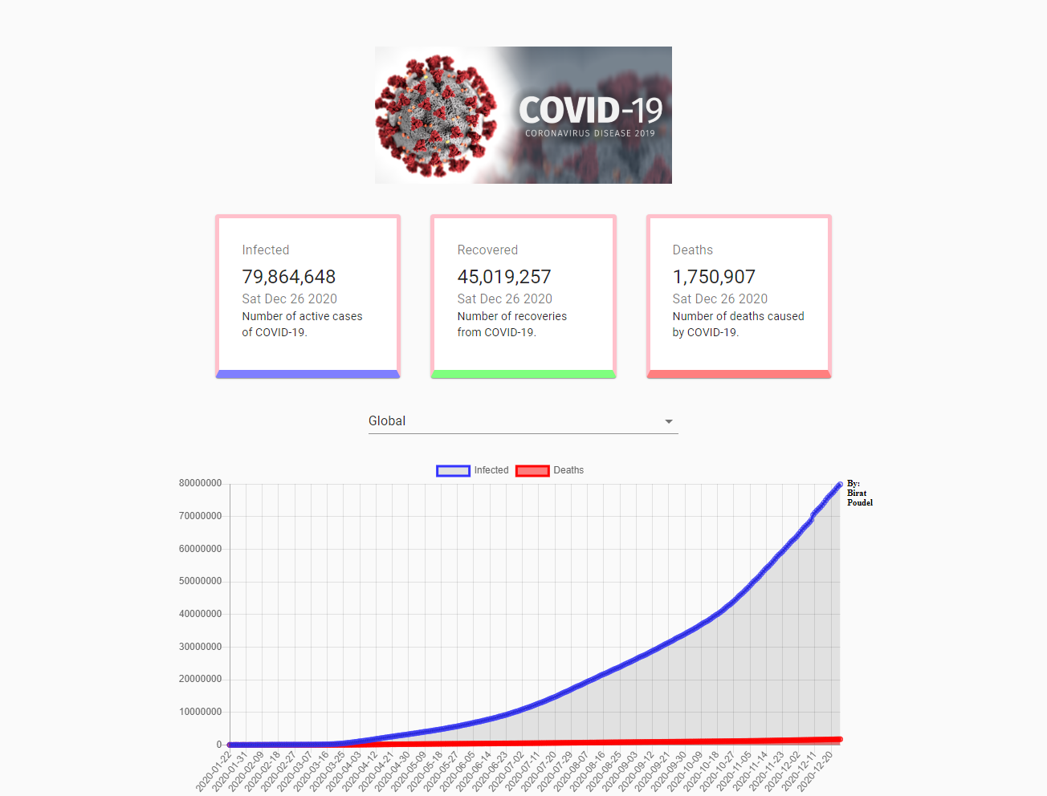

**Second Project:**

**Description:**

It’s a food recipe website (FoodX) which I made in React JS library. I have used API service of a recipe website to fetch and show my data.

**Date of Creation:** 4th August 2020

**Usability:**

This website was very useful for my mom and her friends as they learnt many new recipes and utilized their leisure time productively.

[**Website URL:**](https://foodx123.firebaseapp.com/) https://foodx123.firebaseapp.com/

**Image:**

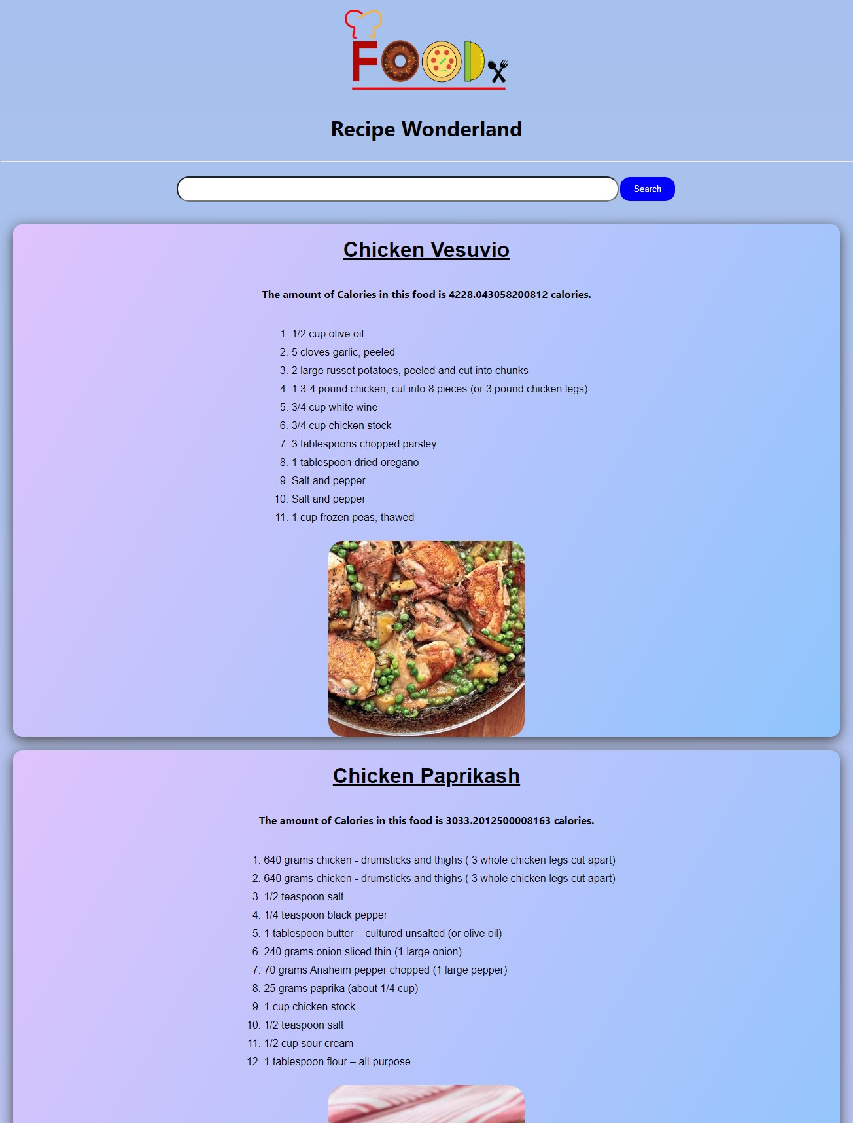

**Third Project:**

**Description:**

It’s a twitter scraping script which I created using Python. I have used Python libraries like BeautifulSoup4, Requests, etc. The script when executed scrapes the latest tweets tweeted by the users stored in the database and embeds that tweet in the discord channel.

**Date of Creation:** 25th August 2020

**Image:**

