Team Fortress 2 Twitch Integration

**Things you will need to do to set this up**

* Download Python 3.9.6
* Libraries that are used in this project.
* Adding settings to your launch options.
* I am adding the twitch key and adding the port and password.
* Customize the points for the bot (Optional).
* Bot commands.

**Downloading Python**Go to [Python.org](https://www.python.org/downloads/) and download Python 3.9.6; go through the setup, and you're done with that part.

**Libraries**First, open the Command line, then type "pip install Rcon" wait for it to install fully. Then, do it again but with this "py -3.9 -m pip install -U twitchio"

**Adding launch options**First shutdown steam then navigate to "C:\Program Files (x86)\Steam\userdata\355965976\config\localconfig.vdf" open it in a text editor, then use ctrl + f to find "440" the game id for TF2, in that you will see the launch options section, paste this intoText

-usercon -high +developer 1 +alias developer +contimes 0 +alias contimes +ip 0.0.0.0 +alias ip +sv_rcon_whitelist_address 127.0.0.1 +alias sv_rcon_whitelist_address +sv_quota_stringcmdspersecond 1000000 +alias sv_quota_stringcmdspersecond +rcon_password **PASSWORD** +alias rcon_password +hostport **PORT** +alias hostport +alias cl_reload_localization_files +net_start +con_timestamp 1 +alias con_timestamp -condebug -conclearlog"

MAKE SURE TO CHANGE THE **PORT** AND **PASSWORD**, the port should be something in between 40000 and 60000, and the password should be 12 characters long. Make sure to write both of those down as you will need them later.

**Adding the Twitch Key and port and password to Bot.py**Got to this link <https://twitchtokengenerator.com/> log in and copy the key from here:

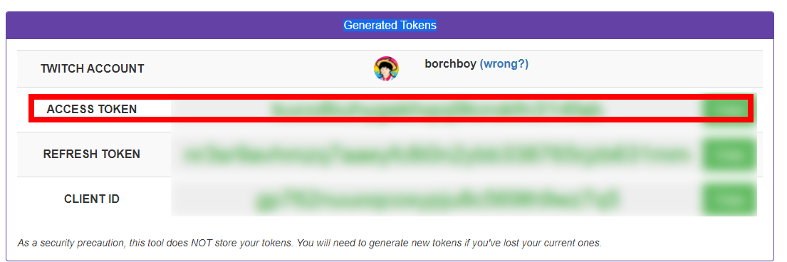

Once you have done that, go to the python file "Bot.py" edit it with a text editor. You will notice the text

# Account stuff  
tw_username = "Twitch account name"  
tw_token = 'Twitch Chat Token'

Please put your account name in "Twitch account name" and paste the token that you just copied into "Twitch Chat Token."

# Networking  
tf_ip = "127.0.0.1" # Leave this alone.  
tf_port = PORT  
tf_password = "PASSWORD"

And for this, Just put the port and password that you wrote down into their spots.

**Commands**The commands play the game.