Instruction

Table of Contents

Code Structure 2

Instruction Manual 3

Environment Configuration 8

Technical Details 9

Code Structure
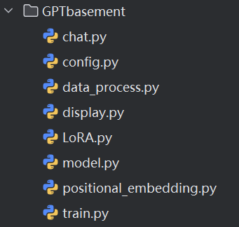
In the GPTbasement folder, it contains all the basic implementations of the Transformer-based chatbot completed with PyTorch.
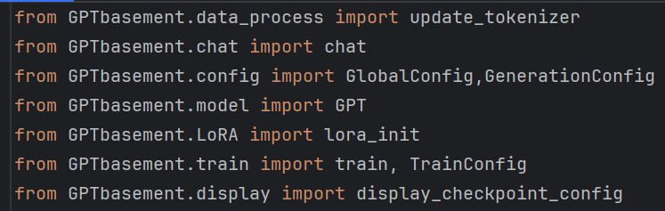
In other files (such as the main program shown above), import these basic code modules to obtain the corresponding functionality.

chat.py | Convert model output to a reader-friendly format
config.py | Global configuration parameter settings
data_process.py | Data processing functions
display.py | Model parameter display and related visualization functions
LoRA.py | Change the linear projection layers for query and value to LoRA layers
model.py | Main structure of the Transformer model
positional_embedding.py | Positional encoding (including RoPE and sinusoidal positional encoding)
train.py | Main program for model training

Instruction Manual
Specific examples: main.py, main-LoRA.py

- Use Qwen's tokenizer, and then add the four special tokens <|user|>, <|assistant|>, <|eos|>, <|pad|> using update_tokenizer.

- Use this program to filter dialogues within 100 tokens, process the data format, and generate Belle_100.json (this file already exists, in the same path as main.py).
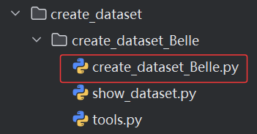

- Read the dataset Belle_100.json.
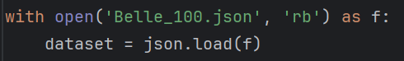

- GPT model initialization. The model needs to know the size of the tokenizer's vocabulary to prevent embedding overflow.

- Model training
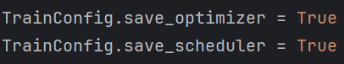
Set both parameters to True before training to automatically save the optimizer and scheduler. It is recommended to save them simultaneously, so training can be resumed if interrupted. After training is complete, these two files can be manually deleted.

For example, as shown in the figure below, the target number of training epochs for the model is 10, and 6 epochs have already been trained. (Note: The epochs set for the first time during model training will automatically become the target number of training epochs for the scheduler to use.)
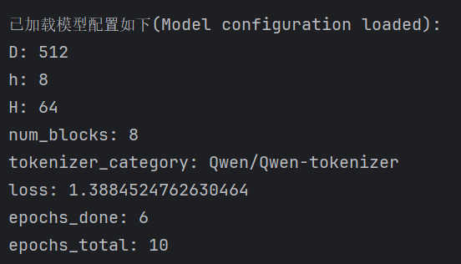
We can use the following code to resume the remaining 4 epochs.

- Parameter loading
After training is complete, the weights are already stored within the model itself. However, if we need to run without training, we will comment out the model training line of code.
In this case, we can use the code below to load the main model parameters and run the existing model directly.
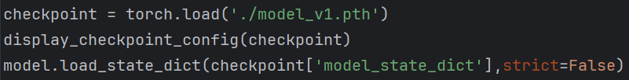

- Set the model to evaluation (non-training) mode and configure some decoding (generation) parameters.
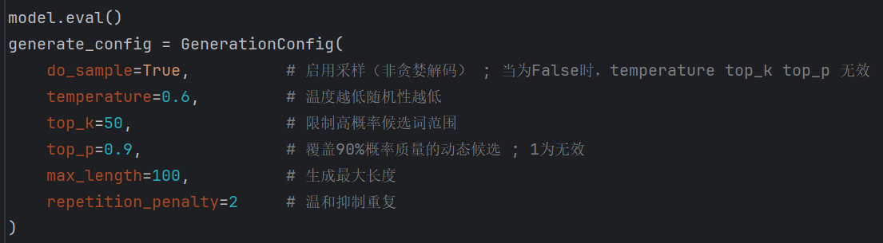

- Model execution (Model inference)

If the context parameter is None, enter the text input mode.
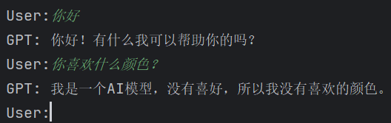

Additional content:

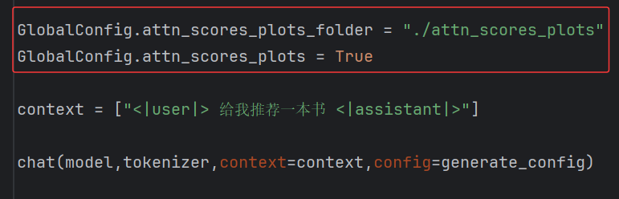
Set the content in the red box and run the model again. Note that only one prompt can be input at a time, and images of each step and each layer's attention scores can be generated in the specified folder.
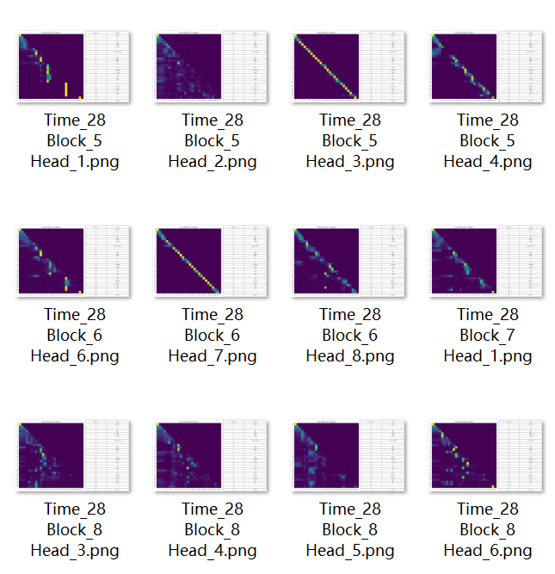
- In the main-LoRA file, set the following content, and both training and inference will enter LoRA mode. The linear projection layers for query and value will be changed to LoRA layers.
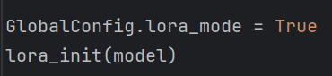
During training, the initial model parameters need to be loaded.
During inference, both the initial model parameters and the LoRA parameters need to be loaded simultaneously.
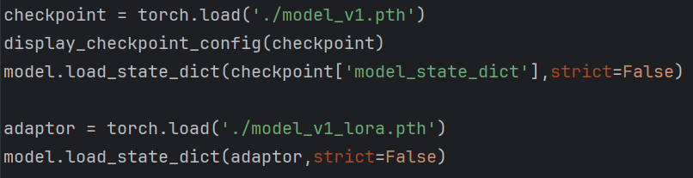

11. This model has multi-turn dialogue capability; just set this parameter to True. However, the dataset lacks sufficient multi-turn dialogue content, so the actual capability of the model is limited.
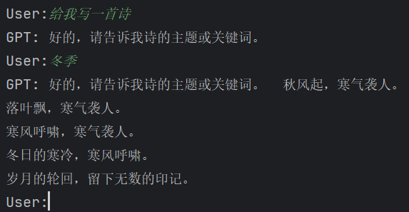
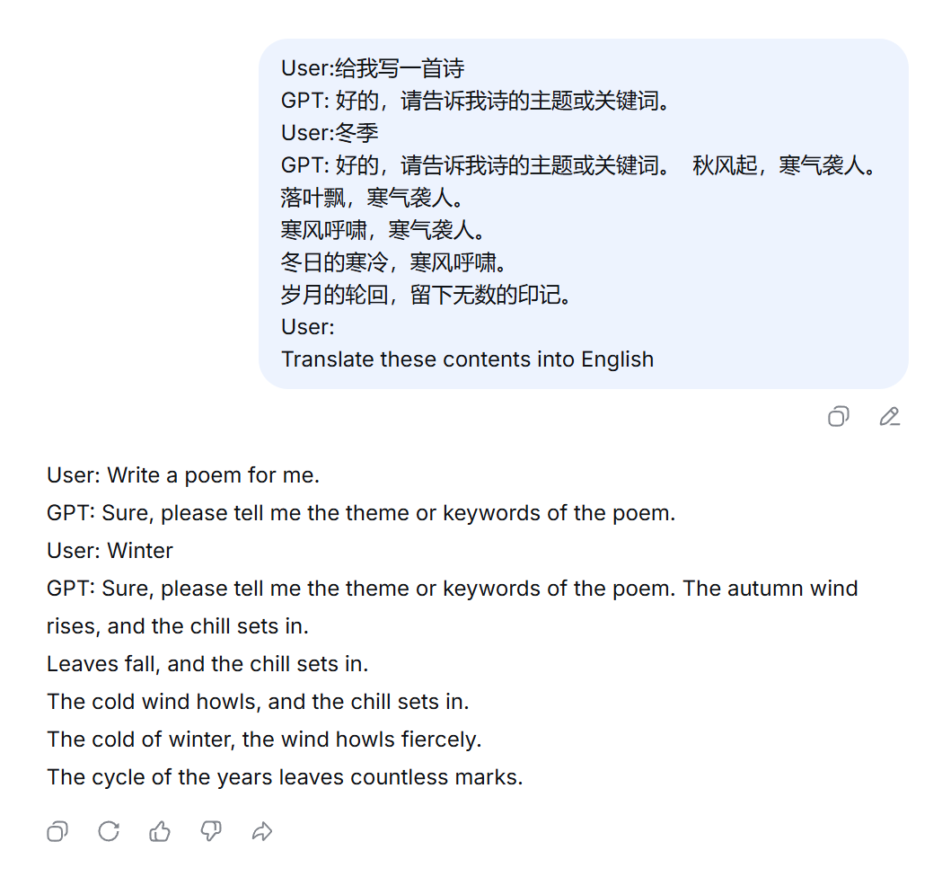
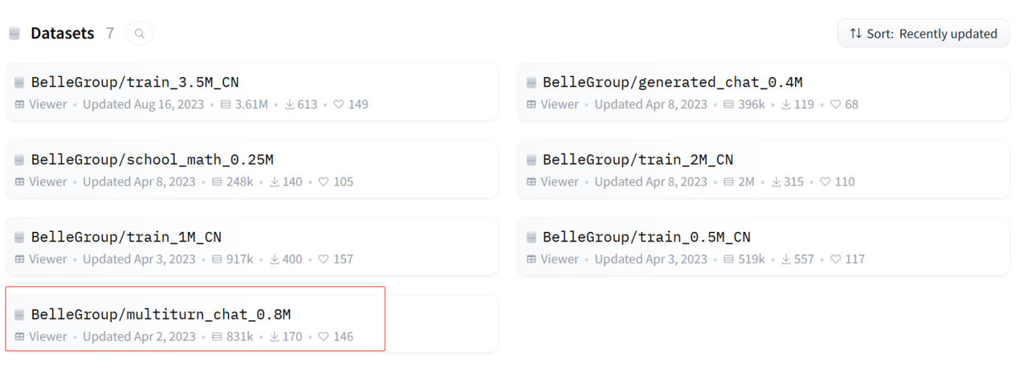
However, I haven't tried this multi-turn dialogue dataset myself. Everyone is welcome to give it a try.

Environment Configuration
torch | Matrix computation,  automatic gradient calculation
json | File reading
glob | File reading
itertools | Data processing
re | Data processing
tqdm | Training progress bar display
matplotlib | Plotting
PIL | Image processing
from transformers import AutoTokenizer | For using the Qwen tokenizer
from transformers import get_cosine_schedule_with_warmup | Cosine annealing scheduler

Note: PyTorch should be downloaded from the official PyTorch website (https://pytorch.org/) for the GPU version.
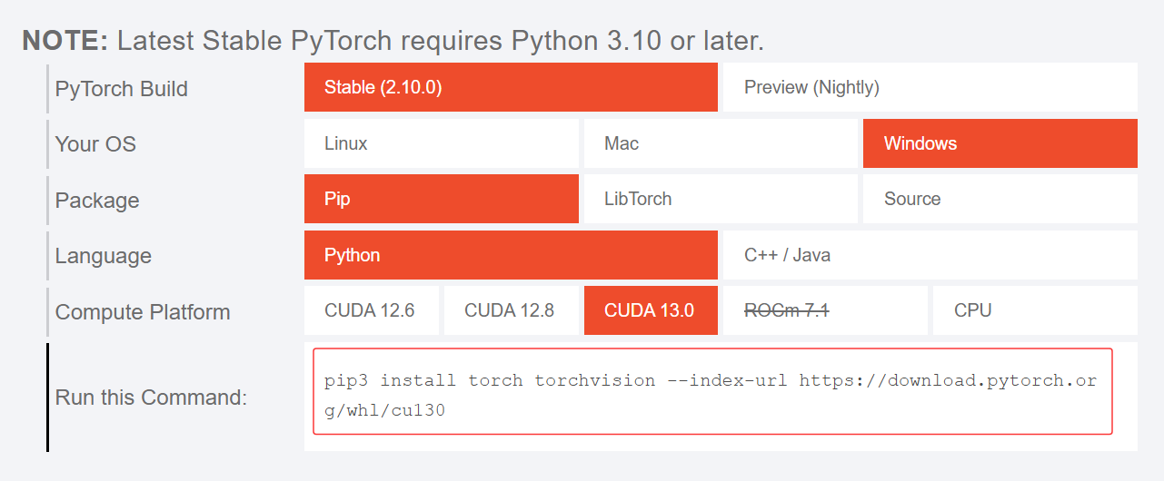

The versions of Python, torch, CUDA, cuDNN, and the graphics card model must all be compatible with each other.
The versions of other Python packages must also be compatible with each other.

Technical Details
Here, the main focus is on introducing the masking technique for attn_scores.

- Causal Mask:
Only retain the information in the lower triangular matrix of attn_scores, and set other positions to -inf. In practice, for stability, -1e9 is used.

- Special handling for dialogue mode:
<|user|> Hello <|assistant|> Hello! How can I assist you today? <|eos|>
In fact, there is no need to predict the part like "<|user|> Hello <|assistant|>". Therefore, we need to change the labels at their corresponding positions to -100. When calling cross-entropy, labels with -100 are automatically ignored and do not participate in gradient calculation, meaning they are not involved in model learning.

- Padding Mask:
During training, we need to pack multiple sentences into a batch and feed them together into the GPU for processing. These sentences themselves are of varying lengths, but the multi-dimensional matrices (i.e., tensors) accepted by the GPU must be in a regular format. In this case, we need to pad these sentences to equal length, using the special token <|pad|> as a placeholder. Similarly, their corresponding labels should also be changed to -100.

For the content mentioned above, there are more detailed examples provided in this program.
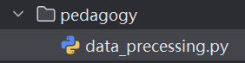
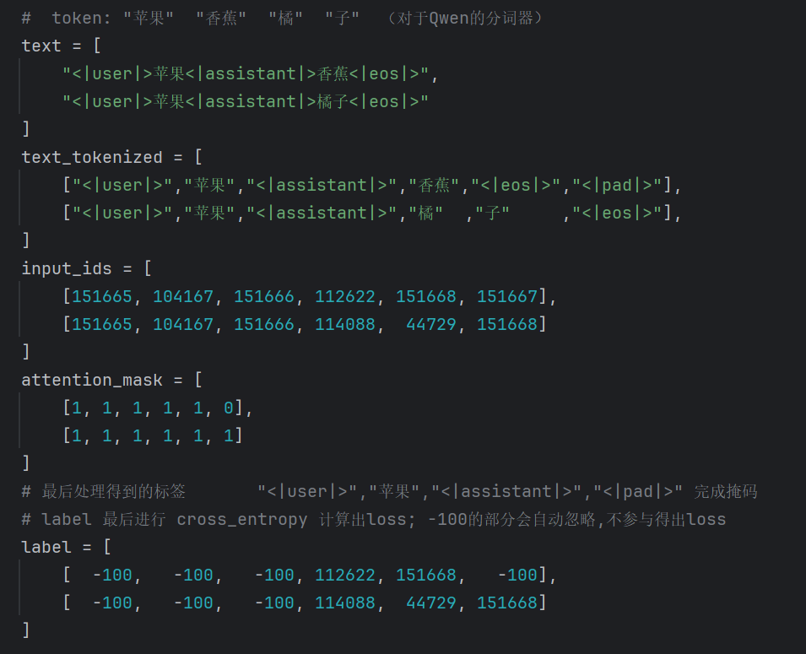
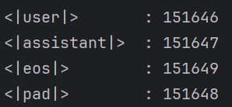
The attention_mask here is the padding mask. We need to pass it all the way to the core attention layer and combine it with the causal mask tril. As shown in the figure below:

- Inference Mode:
During inference, there is also a need to pack prompts into a batch for parallel inference. In this case, a padding mask is also required. The difference from the training phase is that during training, padding is added to the right, whereas during inference, padding is added to the left. The code for this project implements this functionality, and we will not elaborate on it further here.

- Parallelization of MHA:
The essence of multidimensional matrix multiplication is to specify a dimension for inner product, while parallelizing the other dimensions.
Taking the above figure as an example, the inner product operation occurs along the T_k dimension.

- Embedding
The essence of Embedding is still matrix transformation, which is essentially Linear.
For example, consider the token "you" with a dictionary ID of 100, and its corresponding vector is [1,1,2,2,3]. We need a linear transformation to turn [100] into [1,1,2,2,3]. This process is similar to looking up a dictionary—it is a very special type of linear transformation. In this case, nn.Embedding has specific optimizations compared to nn.Linear.
The ID of each token in the dictionary is known to us from the beginning. As for the content of the dictionary, i.e., the special linear transformation itself, it is learnable.

Acknowledgements

This project references Andrej Karpathy's project:
https://github.com/karpathy/ng-video-lecture
This project implements tokenization based on English letters and pre-trains on Shakespearean corpus to enable text continuation in the same style.

The main improvements of this project are as follows:
- Implemented SFT to equip the model with conversational capabilities.
- Implemented MHA in matrix form to improve the model's parallelization on GPU.

Karpathy's project has a companion video on YouTube:

Let's build GPT: from scratch, in code, spelled out.

