Grant Smith Ellis Court Reporting Archive
United States v. Matthew Farwell
October 9, 2026 • Opening Statements / Day 1
About this report. This document reconstructs Grant Smith Ellis's contemporaneous courtroom reporting from his posts on X. Grant-authored reporting is reproduced as retrieved and organized chronologically; editorial organization and known retrieval limitations are documented in the full Source & Editorial Notes near the end.

Court Reporting

Opening / Pre-Opening Proceedings
10:25:40 AM ET X status 2108564558327509377
Hello from inside Moakley Federal Courthouse in Boston, where I will be live posting from opening arguments in the Matthew Farwell and Sandra Birchmore case starting in the next 5 minutes.
My quiet typing skills are back in the courtroom, says Kristina Rex. [X source]
10:26:52 AM ET X status 2108564861185818964
There were 40 members of the public allowed into the courtroom for openings.
Sandra's cousin Barb, and Mizzy, were first in line for the public.
@Theemilysee, @Estey617, Towel Girlfriend and @BoozeyBeauty were all spotted in the public gallery.
We have 16 media members here. [X source]
10:27:43 AM ET X status 2108565072977252390
@TheEmilySee @Estey617 @BoozeyBeauty Farwell is sitting at the defense with his lawyers.
Farwell is in a blue suit.
Judge takes the bench and says we can all remain seated.
Jurors are coming down in a moment. [X source]
10:28:00 AM ET X status 2108565144896999816
@TheEmilySee @Estey617 @BoozeyBeauty The courtroom is full to capacity. There is not a single seat open. [X source]
10:30:23 AM ET X status 2108565743327428964
@TheEmilySee @Estey617 @BoozeyBeauty Everyone is ready. We await only the jurors.
There are 10 men and 6 women seated on the jury.
They are mostly white (14).
1 Hispanic man and 1 Asian man, as well. [X source]

Government Opening Statement
10:32:27 AM ET X status 2108566263861538835
@TheEmilySee @Estey617 @BoozeyBeauty Jurors arrive.
All stand.
The DOJ will now start their openings.
The jurors are asked to take out their personal viewing screens for the DOJ opening.
Loud bang as the screens unfold like side table storage. [X source]
10:33:52 AM ET X status 2108566622361334152
@TheEmilySee @Estey617 @BoozeyBeauty The DOJ begins with a picture of Sandra Birchmore.
Sandra was about to finish her nursing school requirements.
The evidence will show that Sandra had no idea the defendant decided she would die that night. [X source]
10:34:40 AM ET X status 2108566823838863587
@TheEmilySee @Estey617 @BoozeyBeauty The defendant knew he had a real problem because his wife was going to give birth the next day.
The evidence will show that when Farwell was a 27 year old stoughton police officer he had sex with Sandra when she was 15 years old.
That's a crime. [X source]
10:35:07 AM ET X status 2108566935206031451
@TheEmilySee @Estey617 @BoozeyBeauty But he didn't stop there.
Farwell met Sandra over the next 8 years to have sex while he was om duty.
That was a crime. [X source]
10:36:16 AM ET X status 2108567226127106552
Farwell worked hard to keep Sandra quiet.
Farwell worked hard to keep her quiet to hide his crimes.
The evidence will show that Sandra started telling people about Farwell's crimes.
Farwell knew this was a problem and Sandra was killed as a result.
The evidence will show the defendant staged Sandra's body to make it look like she died by suicide. [X source]
10:37:35 AM ET X status 2108567558643216761
Farwell tried to simulate a hanging by seating Sandra by a closet door.
The evidence will not only show that the defendant murdered Sandra Birchmore, the evidence will show why he did so.
He did so to prevent his crimes against Sandra from being reported.
He coerced her into sex when she was a child.
He abused his position as a police officer to have sex with her, and he defrauded the town of stoughton to do so. [X source]
10:39:41 AM ET X status 2108568086777344451
In the second count of the indictment, Farwell is charged with murdering Sandra's unborn baby.
The defendant met Sandra through the police explorers program when she was 12.
The jurors are shown a picture of Sandra at 12 years old in the program.
Sandra was one of the kids who needed help. She struggled in school and she needed special education services.
She was a little different than other kids.
She never knew her father, she had no siblings, and her mother was very sick.
Sandra's mother hoped she would find positive role models.
Sandra loved the police explorers program. She was enamored with police officers.
She met the defendant there. [X source]
Related court exhibit: Government Exhibit 326 — Explorers-program group photograph; treated as a likely match because Grant does not state the exhibit number. Jump to Exhibit 326
Exhibit cross-reference: Grant reports that jurors were shown a photograph of Sandra at age 12 in the Police Explorers program. Court Exhibit 326 is an Explorers-program group photograph and is reproduced in the Exhibit Appendix. Because the retrieved Grant post does not state an exhibit number, this report treats the relationship as a likely, not conclusively established, match.
10:41:38 AM ET X status 2108568575598273019
In October 2012, while Sandr was 15 and Farwell was her instructor, Farwell groomed her via a Facebook message.
Later, in 2013, while Sandra was still 15, Farwell groomed her.
He started with his fingers.
Then on April 15, 2013, he put his penis inside her. That was statutory rape. That is a crime.
There are over 40,000 messages from Sandra's phone and laptop.
Farwell said the best day of his life was taking Sandra's virginity.
"I absolutely would have fucked you in 2012" Farwell told Sandra.
She would have been 14 turning 15. [X source]
10:42:37 AM ET X status 2108568821900497383
@TheEmilySee @Estey617 @BoozeyBeauty Farwell continued to sexually abuse Sandra for years.
For all those years, Sandra would tell Farwell he was her best friend.
The defendant told Sandra to delete all of their communications from her phone to hide evidence of his crimes. [X source]
10:44:16 AM ET X status 2108569238881362260
Farwell's sexual activities involved dominating Sandra.
Hurting Sandra.
The defendant even told Sandra he loved it when Sandra tried to say no and he pinned her down.
The defendant liked to engage in rape fantasies with Sandra.
In 20 messages, Farwell talked about choking Sandra.
He would say in text;
"I'll grab your throat and say trust me, I'll do whatever I want."
Long pause for effect. [X source]
10:44:45 AM ET X status 2108569359383756947
@TheEmilySee @Estey617 @BoozeyBeauty There are at least 4 US Marshall's watching the media to make sure none of us take any pictures. [X source]
10:45:48 AM ET X status 2108569625877197060
Sandra had extreme grief in 2017, 4 years before her death, when her mother and grandmother died.
Sandra expressed sadness at that time.
Sandra's first sexual experience involved a crime and, from there, the rest of her life was impacted by her abuse.
Sandra also had sexual relationships with others, including Farwell's brother. [X source]
10:46:56 AM ET X status 2108569908132917317
@TheEmilySee @Estey617 @BoozeyBeauty While Farwell was grooming Sandra, he started a family of his own in May of 2013...just a month after taking Sandra's virginity.
By 2019, Farwell had two kids with his wife.
Sandra, for her part, wanted to have children and she wanted Farwell to be the father as early as 2019. [X source]
10:48:26 AM ET X status 2108570286148801013
As Sandra got older, she began to realize what was happening to her so she, in turn started telling people.
She told Joshua Heal.
Joshua Heal told her, in 2020, that Farwell's wife was pregnant.
Sandra told Farwell that Sandra would expose what he had been doing unless he agreed to give her a baby, too. [X source]
10:49:21 AM ET X status 2108570518123073729
@TheEmilySee @Estey617 @BoozeyBeauty Over the next several hours, Sandra told Joshua Heal that Sandra would expose Farwell and what he had been doing over the past 10 years unless Farwell gave her a baby.
Sandra, when asked what Farwell would do, said;
"Not my problem. He took my virginity before I turned 16." [X source]
10:50:47 AM ET X status 2108570880674582872
The defendant agreed to impregnant Sandra to silence her for the purpose of covering up his crimes.
Farwell had unprotected sex with Sandra on the days she was most likely co conceive, but she didn't get pregnant in October or November.
She asked Farwell to try again in December. [X source]
10:51:41 AM ET X status 2108571106130977054
@TheEmilySee @Estey617 @BoozeyBeauty In December of 2020, Farwell again had unprotected sex multiple times with Sandra.
On December 8th, Sandra found out she was pregnant.
She tried to tell Farwell all day.
He ignored her.
She then sent him a picture;
"Congrats, we are going to be parents." [X source]
10:52:43 AM ET X status 2108571365087252795
Sandra and the defendant thought he was the father of her baby.
The evidence will show that, at no point, did the defendant ever doubt that he was the father, over the course of 100s of messages.
After she texted the congrats sign, Farwell texted her;
"You are truly the worst person on the face of the earth." [X source]
10:53:50 AM ET X status 2108571644927058305
@TheEmilySee @Estey617 @BoozeyBeauty Sandra texted Farwell on December 9th that he scared her.
Sandra was 5 feet tall.
The defendant is 6 foot 4.
Farwell met up with Sandra, took her phone, shoved her and threatened her.
He never denied he was the father of her baby, and he continued to meet him for sex. [X source]
10:54:09 AM ET X status 2108571727722590663
@TheEmilySee @Estey617 @BoozeyBeauty All 16 jurors are staring directly at the prosectuor. [X source]
10:55:13 AM ET X status 2108571994065084916
@TheEmilySee @Estey617 @BoozeyBeauty On January 20, 2021 a woman who knew Sandra made a call to the Stoughton police department.
They skip the extortion and the $248 Sandra owed to the women.
DOJ focused on how dispatcher told Farwell about the call.
Farwell told the dispatcher never to mention it to anyone. [X source]
10:57:07 AM ET X status 2108572473839006084
You will see evidence that after the January 20th call, Defendant texted Sandra that the girl who made that call caused all sorts of problems.
Farwell had no idea Sandra told anyone about their sexual contact until that phone call.
"Which other friend will do something tomorrow," Farwell texted Sandra.
"12 days after that phone call to the Stoughton Police, Sandra was dead. It was no longer a question of if the defendants crimes would be exposed, it was a matter of when. The Defendant had lost control of Sandra." [X source]
10:58:10 AM ET X status 2108572736134033912
@TheEmilySee @Estey617 @BoozeyBeauty You will see that, after January 20th, Farwell did a complete 180.
He tried to make Sandra feel safe.
He tried to bring Sandra ginger ale for her morning sickness.
Then Farwell started being weird. He started looking at Sandra's bathroom and kitchen. Sandra felt it was weird. [X source]
10:58:48 AM ET X status 2108572897954402764
@TheEmilySee @Estey617 @BoozeyBeauty Farwell asked for a key and told Sandra to keep it a secret.
He looked in her closet and bathroom, but Sandra didn't know why.
8 days later, Farwell hung Sandra from that closet door. [X source]
11:00:15 AM ET X status 2108573261726368011
Sandra told 81 people she was pregnant.
She took all sorts of steps to prepare for the baby's arrival.
She had photo shoots booked, she had a venue selected for the baby shower, she worked with her doctors to prepare, she re-started medication.
She wanted to protect her unborn child.
The one person she could not protect her son from was the defendant. [X source]
11:01:12 AM ET X status 2108573500940206249
@TheEmilySee @Estey617 @BoozeyBeauty "What friend was Matthew Farwell going to run into next?"
In early February 2021, Farwell lost control.
His wife was about to give birth, a blizzard was coming in and it opened the door to a potential delay before Sandra's body was found. [X source]
11:12:50 AM ET X status 2108576429042467283
@TheEmilySee @Estey617 @BoozeyBeauty Billy Farwell was also interviewed and Fanning told him;
"We [Brian Tully's unit] need this investigation like we need a bullet in the fucking head." [X source]
Retrieval note: The 11:12:50 AM ET post replies to status 2108576217435685089, which was not returned by either supplied authenticated export. No missing wording has been reconstructed.

Post-Opening Updates
12:26:17 PM ET X status 2108594911662559590
JUST IN;
Brian Tully's state police unit will be on the federal witness stand in the Sandra Birchmore case as early as Tuesday or Wednesday of next week, as Matt Dunne will testify for the DOJ.
Will John Fanning and Tully's coverup of Sandra's death actually fall? [X source]
12:59:19 PM ET X status 2108603226568179766
Sandra Birchmore And Matthew Farwell Trial; Full Comments From Sandra's Cousin Barb Wright https://t.co/2MtcMLjwC5 [X source]

Supplemental Court-Released Material
Rough Opening Statements — Court Release: Open court-released trial materials folder
This court-released material is provided as a companion primary source. It was not used to reconstruct, alter, or complete Grant Smith Ellis's contemporaneous reporting.

Source & Editorial Notes
Primary-source rule: Report content is limited to posts authored by @GrantSmithEllis on X. Third-party reporting, aggregators, and commentary were not used to fill missing wording, chronology, or substantive details.
Retrieval: The October 9 corpus was assembled from an authenticated, date-scoped X search export and an authenticated thread export beginning with Grant's 10:25:40 AM ET courthouse post. Records were reconciled by X status ID.
Replies: Grant-authored replies are included when they continue the courtroom-reporting chain. Replies by other users are not reproduced as report content.
Chronology: Times are displayed in U.S. Eastern Time. October 9 boundaries were determined from local Eastern time rather than the raw UTC date returned by X.
Text preservation: Grant's wording, capitalization, spelling, and apparent typographical errors are preserved as retrieved. Line breaks may be normalized for document layout.
Known retrieval gap: Status 2108576429042467283, timestamped 11:12:50 AM ET, replies to status 2108576217435685089. The parent status was not returned in either supplied authenticated export. The gap is left explicit rather than reconstructed.
Post-opening scope: Two later Grant-authored posts containing substantive case/courthouse information are preserved in a separate Post-Opening Updates section. Later promotional, conversational, or non-substantive posts are not included as courtroom-report content.
Exhibit methodology: Exhibit relationships are stated only when supported by Grant's reporting and/or identifying information in the court-released exhibit. Exhibit 326 is cross-referenced as a likely match to the Explorers-program photograph Grant says was shown to jurors; Grant's retrieved post does not itself supply the exhibit number.
Supplemental court-released material: Court-released trial materials folder. This location is provided for navigation only; it was not used to reconstruct or alter Grant’s reporting.
Completeness: This compilation represents all directly located qualifying Grant-authored courtroom posts in the supplied authenticated exports. It is not represented as a forensic-complete archive of every post X may have served or retained.

Exhibit Appendix
Exhibit | Grant-reported use | Availability / access
326 | Grant reports jurors were shown a photograph of Sandra at age 12 in the Police Explorers program. Exhibit 326 is an Explorers-program group photograph; the match is likely, not conclusively established from Grant’s post. | Embedded below.

Court Exhibit 326
Navigation: Back to Exhibit 326 presentation in Grant’s reporting
Court-released one-page exhibit: Explorers-program group photograph. The court's exhibit designation is preserved in the reproduced page below.
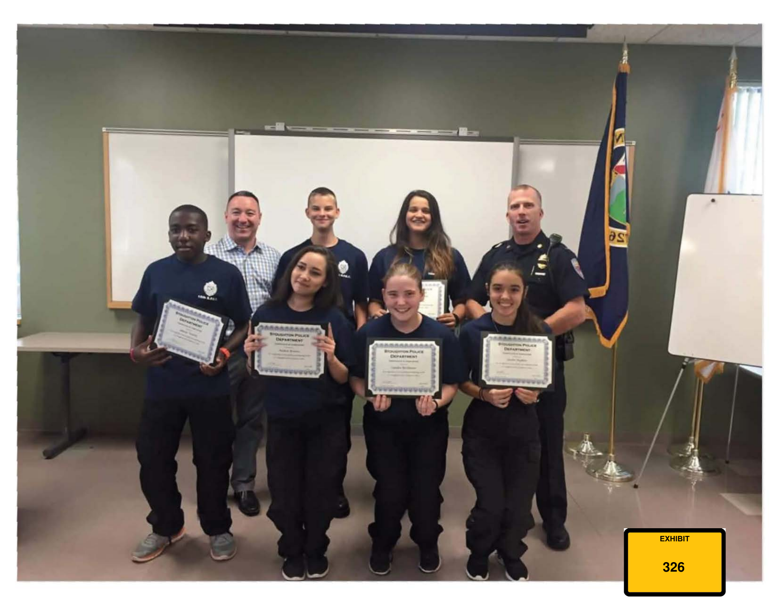
Exhibit 326 — court-released exhibit page.
——————————————————
Support the reporting
This archive is made possible by Grant Smith Ellis’s excellent on-the-ground courtroom reporting and his permission to use that work in this project. If you’ve found the reporting useful and would like to support his work directly:
Venmo · Cash App · PayPal
All donations go directly to Grant Smith Ellis; this archive is unaffiliated with and receives no proceeds from them.

