GRANT SMITH ELLIS
COURT REPORTING ARCHIVE
United States v. Matthew Farwell
October 13, 2026 | First Day of Testimony
About this report. This document reconstructs Grant Smith Ellis's contemporaneous courtroom reporting from his posts on X. Grant-authored reporting is reproduced as retrieved and organized chronologically by testimony/proceeding. Retrieval limitations and editorial treatment are documented in Source & Editorial Notes near the end.
Source account: @GrantSmithEllis

Court Reporting

Pre-Jury Proceedings
8:13:06 AM ET Hello from inside Boston's Moakley Federal Courthouse, where I am here with live-post coverage of the first day of testimony in the Sandra Birchmore and Matthew Farwell trial.
We expect an 8:45AM motion hearing as to defense openings.
3 unknown people entered with the defense. [X source]
8:37:47 AM ET Okay, we are inside the courtroom and my quiet towel typing device is active.
Let us see how this goes.
The media seats are quickly filling. Farwell has not yet arrived.
Mizzy and Barb were the first ones in the courtroom.
Peter Murphy is also here. [X source]
8:39:14 AM ET Matthew Farwell has arrived.
He is in a black suit today.
He sits looking straight forward. Now he turns to each side and discusses with defense counsel.
Farwell looks engaged with his paperwork. [X source]
8:39:54 AM ET The US Attorneys arrive.
They flash a quick smile at the Farwell defense.
We await Judge's arrival on the bench at 8:45AM. [X source]
8:42:18 AM ET My quiet towel typing device is very effective.
I notice that no one in the media section is looking at me like I am some kind of typing prodigy.
This is good news for towels.
There is one woman on the Farwell bench in the gallery. She is older, dark brown hair. She slumps. [X source]
8:42:59 AM ET The US Attorneys, Torey Cummings and Elizabeth Riley, are filing documents on a push cart that contains roughly 7-9 binders and easily 100,000 pages of material.
We still await Judge. [X source]
8:44:24 AM ET Judge enters.
All rise.
We begin.
Good morning counsel, good morning Mr. Farwell, says Judge.
Judge says she wants to always start on time. [X source]
8:46:19 AM ET Judge says she wants to address some matters.
1) The DOJ motion for further curative instructions after defense openings. Judge has read the defense response.
Judge says after considering and thinking about the opening statement by the defense, judge will allow docket 339 to the following extent;
Judge will read this instruction;
"Good morning jurors, as I told you last week, the government will begin its presentation of evidence this week. Again, counsel's opening statements were not evidence. If there were exhibits referenced in counsel's openings that are not admitted, you will not be permitted to consider them during deliberations. Also, to the extent that counsel referenced the law, only the instructions given by me, not by counsel, are what you will consider during deliberations." [X source]
8:47:34 AM ET "Counsel, as I alluded to on Friday, this case is in its infancy...I don't think more is warranted at this point but I will be listening to what counsel says as we go forward."
Two further notes;
1) There were two things Ms. Stevens that raised my eyebrows during your opening. First, arguments about reasonable doubt are clearly fair game. Arguments about a lone, or single jurors, are not allowed and they border on jury nullification. In our circuit, this is barred. [X source]
8:48:08 AM ET I encourage counsel on both sides to re-read the case law on nullification, and we are not going to have that here.
"My apologies, your honor," says defense lawyer.
"Thank you, noted," says Judge. [X source]
8:49:46 AM ET Judge says she had her eyebrows raised by the defense mentioning Farwell using "covert" means to enter Sandra's apartment by using a mask to "hide his affairs."
Judge reviewed the government motion to now admit evidence of Farwell's affairs. Judge is considering whether Farwell's defense opened the door to a more limited version of the 404 (b) evidence which is more narrow that prior scope.
Judge is still thinking about the 403 balance. We will return to that at the end of the day.
For the moment, Judge's prior ruling stands, but Judge understands the concern the DOJ is raising. [X source]
8:50:35 AM ET Judge is now talking about the updated exhibit lists now. Judge confirms these are the most up to date lists.
Yes, says the DOJ and defense counsel.
Now judge asks about still-disputed exhibits.
Judge asks if they want rulings on these today or tomorrow?
Today or tomorrow yes. [X source]
8:51:26 AM ET Judge has looked at all of the paperwork.
Judge expects, based on prior rulings, that these disputed exhibits will come in (assuming foundation).
Judge thought H of the disputed exhibits was withdrawn...is that correct?
Not being offered, correct, says DOJ.
Okay that's out, but all the other disputed exhibits, with proper foundation, will come in. [X source]
8:52:04 AM ET Judge says that once she admits an exhibit, further reference by counsel should be by number.
We won't stop to do this during the presentation of evidence, but, at the end of the day, please mark your exhibits before turning them over to the clerk. Do this each day. [X source]
8:52:51 AM ET DOJ says they can mark them now, and Judge says that is fine, as long as the exhibits are referred to as numbers (saying "f for identification" will, for example, tip judge off this is disputed. Once they are admitted, use the numbers instead). [X source]
8:53:34 AM ET There was a stipulation about toxicology. Do you expect that today?
DOJ says tomorrow.
Judge says she will read the instructions to the jury, but stipulations will be read to the jury by counsel. [X source]
8:55:44 AM ET Today, says Judge, we will see some photos of the scene that will include photos of Sandra's body.
Judge will read an instruction to the jury before doing so;
"Jurors, as we mentioned before in jury selection, I expected the government will introduce photos of Sandra Birchmore's body from the alleged crime scene and the ME's office. Some of these will be introduced today. They are graphic. I instruct you that your verdict must not be influenced by the graphic nature of the photos nor the fact that they may induce sympathy for Ms. Birchmore. Consider them only as they relate to the elements of the crime."
DOJ asks for "scene of her death" instead of "alleged crime scene."
Judge says, "I think it is the alleged crime scene."
DOJ says this will come up with Officer Cotard, who is coming before Trooper Dunne. [X source]
8:56:39 AM ET Judge notes, for the record, that the instruction that she is giving is consistent with Lyons Vs Brady (1st circuit 2012) and US Vs. Samson (1 Circuit 2007), and the state pattern instructions.
Judge notes that she received a number of filings since last Friday, some of which Judge has talked about today. [X source]
8:58:59 AM ET DOJ asking for the one new FBI witness on the list to be exempted from sequestration.
No objection.
Granted.
Judge says we are ready for the jury and we'll revisit the outstanding matters at the end of the day.
Docket 324 - sealed matter about Exhibit U-6. Judge will rule on that later.
Also, Docket 325 - this is about exhibit Y-12. Judge has a DOJ motion and will read the defense response.
The Loper motion is still pending.
A joint motion for the sealed docket was allowed. Ms. Cook with get it to both sides. [X source]
9:00:07 AM ET We have all but 1 juror. We are waiting on 1 juror.
DOJ says docket #335 is also outstanding.
This is the DOJ motion about the civil complaint.
Judge says she still needs to look at this. DOJ reviewed D's reply. The DOJ motion was #325.
The DOJ withdraws the sequestration exemption request, and the DOJ is in agreement with admission of the civil complaint. [X source]
9:01:34 AM ET Judge asks if witness lineup still the same?
DOJ says yes.
Defense says it does not foresee introducing any exhibits during the first two witnesses, but if they impeach should the documents be marked for ID?
Judge says yes that makes sense.
Judge says I note carefully if you're refreshing or impeaching.
Refreshing the witness just reads to themselves and the jury does not see it. Impeachment is different. [X source]
9:02:22 AM ET Defense says they expect testimony from the first two witnesses that will touch on motion #193 from the defense.
Defense wants to reaffirm their objection to lay opinion testimony.
Judge says that, as she said before, you can mention prior motion when you object. That's fine. [X source]
9:07:03 AM ET We are in a recess until all of the jurors arrive. [X source]
9:09:19 AM ET I'm watching Al Jazeera Arabic while we wait (with no volume).
The other reporters seem confused.
I am, indeed, a towel. [X source]
9:10:18 AM ET I did bring an extra surge protector for the press gallery, though, so now we have 16 plugs instead of just 8.
They seem pleased. [X source]
9:11:35 AM ET Brian Fogerty stands by the DOJ table with his hands in his pockets. Elizabeth Riley is at the lectern. She may be directing the first witness.
Another woman has joined the Farwell bench in the public gallery. She is middle aged, dark thinning hair. Unclear who she is. [X source]
9:11:51 AM ET Farwell has two total supporters in the courtroom.
Sandra has 40 (the max allowed). [X source]
9:13:21 AM ET Now Elizabeth Riley and Torey Cummings are standing at the lectern.
We still await the jurors (I think one juror ran into some Boston traffic). [X source]
9:15:35 AM ET No jurors yet.
Judge's law clerk walks in and out of the courtroom.
Farwell sits at the defense table with his lawyers.
The entire courtroom is full, except for the three open seats on the Farwell bench in the public gallery. [X source]
9:18:02 AM ET The head of court security is here.
I am showing off my quiet towel typing device.
There is no sound in the courtroom whatsoever.
Towel has found a silent keyboard. [X source]
9:21:06 AM ET The juror has arrived.
They will be brought down shortly, says the clerk.
Here we go. [X source]

Morning Testimony - Witness Identity Not Recovered
9:24:58 AM ET Jurors entering, all rise.
We begin. [X source]
9:26:42 AM ET Judge says good morning.
Judge gives the curative instruction after the defense opening.
Judge notes openings are not evidence, and any exhibits referenced during openings that don't come into evidence are excluded from deliberations.
Also, Judge's instructions on the law, not counsel, govern.
Heavy scolding for the defense here, but Judge does not lay that out directly for jurors. [X source]
Editorial retrieval marker: The recovered corpus is sparse between the 9:26 AM curative instruction and the next recovered testimony at 9:43 AM. No testimony has been reconstructed from outside sources.
9:43:26 AM ET Sandra had closer relationships with adults than with kids her own age.
"Did Sandra discuss her family life with you at the time?"
"Yes, Sandra adored her mom and Sandra talked about living with her aunt Darlene and her cousin. I found out Sandra's mom was a single-mom, and I bonded with her over that."
"Was Sandra's father ever in her life?"
"No."
"Did Sandra have any siblings?"
"No." [X source]
9:44:17 AM ET "Where did Sandra live at the time?"
"In an apartment with her mother, her aunt and her cousin. They had section 8. Her mom had cardiac issues. I had responded to that home a few times because Sandra's mom had medical emergencies." [X source]
10:08:19 AM ET All seven of you were from Stoughton?
Yes.
Did you know Sandra Birchmore before joining the department?
No. [X source]
10:09:01 AM ET And you started in 2013?
Yes.
And Sandra was born in 1997?
Around there, yes, I don't know her exact birthdate. [X source]
10:28:04 AM ET "So, how was Stoughton involved in the wellness check?"
"Sandra's school reached out, and the address they had on file was in Stoughton. Sandra had moved to Canton, so the wellbeing check went to Canton PD." [X source]
10:28:50 AM ET "Did you tell anyone Sandra's new address?"
"I didn't know it, so no."
"Who reported Sandra's death to you?"
"I believe it was Jennifer Sullivan. She was working dispatch that day." [X source]
10:42:35 AM ET "Did you interact with Sandra Birchmore when she was pregnant?"
"No."
"And you assumed everything was good because you didn't hear from her?"
"Yes, because I saw her at Walgreens and she was happy and excited." [X source]
10:43:17 AM ET "Where did Sandra spend Thanksgiving?"
"I don't know."
"When did Sandra spend Christmas?"
"I don't know." [X source]
11:00:59 AM ET "Did you all review every police report from Stoughton about Sandra Birchmore?"
"No, they did not pull out the reports, they asked me questions and I answered."
"Nothing further." [X source]
11:01:46 AM ET Brief re-direct.
DOJ up now;
"You said on cross that Sandra would reach out when she was in distress?"
"Yes."
"And your testimony is that she wasn't distressed on May 14, 2020?"
"Yes." [X source]

School Supervisor Testimony - Name Not Recovered
11:27:29 AM ET Matthew Farwell groomed, and abused, Sandra Birchmore on her high school prom night.
Monster. [X source]
11:41:18 AM ET "Did Ms. Birchmore use her phone a lot during work?"
"Yes, I spoke to her about her phone use during work and she got instructive feedback."
"Were there days when Ms. Birchmore called in sick?"
"Yes, she would email when she would be out." [X source]
11:41:55 AM ET "Did she follow protocol for calling out?"
"Yes."
"Did she move into a new apartment?"
"Yes, she was excited and she told me that. She told me she had cats she was excited to care for." [X source]
11:55:59 AM ET "Whenever you hire an employee you do a background check?"
"Yes."
"Would that find mental health commitments?"
"No." [X source]
11:56:20 AM ET "Was it the practice of schools to ask about that?"
"Schools run CORI checks." [X source]
12:11:43 PM ET "You said on direct that you were surprised to hear Ms. Birchmore died of suicide?"
"Yes."
"And it was because she appeared normal."
"Yes, because she appeared to be herself. She was in a good mood. She was sweet, kind and in a good mood." [X source]
12:12:25 PM ET "Is it fair to say you didn't know Sandra very well?"
"I was her supervisor for 4 months." [X source]
12:14:25 PM ET "The day after you talked to Trooper Dunne, you emailed him?"
"It was the next Monday."
"You first met with the FBI in September of 2024?"
"Yes." [X source]
12:15:23 PM ET "In June of 2024, you joined the Facebook group 'Justice For Sandra Birchmore,' isn't that true?"
"Yes."
"Did you know about the contents of that page before talking to the FBI in September 2024?"
"I didn't really read the page to begin with." [X source]
12:18:00 PM ET "You asked CPAC to be interviewed on February 5th, true?"
"Yes, I myself asked to be interviewed."
"Who was in the interview?"
"The principle, the nurse and myself."
"They didn't separate you?"
"No." [X source]
12:18:15 PM ET "Did other staff take sick days during the pandemic?"
"Yes, way more than other years." [X source]
12:18:48 PM ET Re-cross;
"You said the other staff did not ask to be interviewed?"
"Yes."
"Did Sandra have the most sick days used of any staff member?"
"No."
Nothing further. Witness done. [X source]

Canton Woods Property Manager
12:20:45 PM ET "What's your role at work?"
"I am a regional property manager."
"What was your role in 2021?"
"Property manager." [X source]
12:21:34 PM ET "What is depicted in Exhibit 6?"
"That is Canton Woods."
We now see a picture of Sandra's Apartment complex.
"Where was your office?"
"It was in building 1, which is at the bottom of the hill." [X source]
Exhibit navigation: Jump to embedded Government Exhibit 6
12:23:30 PM ET "Were you the property manager who rented the apartment to Sandra?"
"I was the property manager, but I did not personally sign the lease."
"What was her apartment?"
"Number 3307." [X source]
12:28:24 PM ET "On the walk, did you notice something about Ms. Birchmore's car?"
"Yes, I noticed the snow on her car was still intact. All of the other cars had the snow moved away from the car."
"Did you go to Ms. Birchmore's apartment?"
"Yes, I was with a Canton Police officer." [X source]
12:29:20 PM ET "What did the officer do?"
"He opened the door, I did not go in with him."
"Did you go into the apartment at any time?"
"No."
"Did the officer come out of the apartment?"
"Yes, and I told him I had a bad gut feeling and he nodded his head at me when he came out and I took that as a confirmation of my bad gut feeling. It was kind of like unspoken." [X source]
12:34:47 PM ET "When you called that person, did they identify themselves?"
"Yes."
"Did you learn information?"
"Yes."
"Did you relay that information to the Canton Police Department?"
"Yes."
"What did that person tell you?"
Objection, defense.
Judge asks, "is it a hearsay issue, counsel?"
"Counsel for defense says, "Yes, and 403."
Sidebah! [X source]
12:38:36 PM ET Sidebah is done.
DOJ asks for one follow up at sidebah.
Back to sidebah! [X source]
12:40:09 PM ET Back to DOJ direct.
"I'll let you lead here, counsel," says Judge. [X source]
12:40:42 PM ET Judge gives jurors an instruction.
This testimony will go to the completeness of the MSP investigation (or lackthereof). [X source]
12:42:07 PM ET "Is it true that the person you called told you about Sandra's involvement sexually with a Stoughton Police detective?"
"Yes."
"And did you relay that to the Canton PD?"
"Yes." [X source]
12:42:41 PM ET On February 5th, were you present when Sandra Birchmore's family came to collect her belongings?
Yes. [X source]
12:42:49 PM ET Nothing further from the DOJ. [X source]
12:42:59 PM ET Kimberly C. Stevens will do the cross here. [X source]
12:43:32 PM ET "Good morning, it's almost afternoon, Kimberly C. Stevens begins."
It is 12:43PM. [X source]
12:44:16 PM ET "How many units were there on Sandra's floor?"
"I don't recall, but maybe 8 on each side before reaching Sandra's door." [X source]
12:45:11 PM ET "How many floors were on each building?"
"Four."
"Were there units to the left and right of Sandra's unit?"
"A unit to the right, and the elevator was to the left." [X source]
12:47:15 PM ET Towel Note; Kimberly C. Stevens does a better cross than Joanne Daley.
Stevens is softer spoken, less hostile and comes across more like a grandmother.
Daley likes to argue with the witnesses. [X source]
12:47:47 PM ET Stevens is asking about the floor plan of Sandra's apartment.
It had a living room, a bedroom, a bathroom, a kitchen and a closet. [X source]
12:49:12 PM ET "Are key fobs issued to each resident?"
"Yes, and residents can also request additional fobs."
"Did Sandra have just one fob?"
"Yes." [X source]
12:50:21 PM ET "What about apartment keys, were those covered by the lease?"
"Yes."
"And the lease also covers the rent?"
"Yes, $1561 per month." [X source]
12:51:58 PM ET "Was there a camera pointed at the side door of Sandra's building?"
"No."
"Counsel, you're asking questions about something that is not admitted..."
"Oh, sorry your honor, can we admit?"
"So admitted." [X source]
12:52:27 PM ET Now we see a picture of the sidedoor. It looks like an attorney took the picture sometime in the years after Sandra's death. [X source]
12:53:25 PM ET "Where was the camera in the lobby of the building?"
"I don't recall, but probably corner of the ceiling facing the entry way."
"What did the camera look like?"
"I'm not positive. Just a standard recording camera. Maybe an older model, it was five years ago." [X source]
12:54:09 PM ET "Can you approximate the size of the camera?"
"I don't know, maybe as big as a piece of paper, maybe half the size of that." [X source]
12:54:44 PM ET "People coming and going could see the camera?"
"Yes."
"Turning to February 4th, is that the first time LEO called to ask to speak with you?"
"Yes." [X source]
12:55:20 PM ET "Was that Officer Cotard?"
"That sounds correct."
"Did he drive to speak with you?"
"Yes."
"Did he come straight to the leasing office and meet with you there?"
"Yes."
"Was he with Officer Brady?"
"I think so." [X source]
12:55:56 PM ET "Did they tell you on the phone what they were coming to see you about?"
"They told me they were calling because Sandra's work had not seen her in a few days." [X source]
12:57:10 PM ET "When they spoke with you, did they ask you if you had seen Ms. Birchmore?"
"Yes."
"When you spoke with them, you didn't tell them you had previously been concerned, right?"
"Yes."
"So no one below, beside or above expressed anything to you about Ms. Birchmore?"
"Correct." [X source]
12:57:43 PM ET "Did the police try to explore methods of getting in touch with Ms. Birchmore before knocking on the door?"
"Yes, I tried calling her. Nothing was explored other than that." [X source]
12:59:10 PM ET "When they spoke with you, did they ask you for the keys right away or did they call a supervisor?"
"I don't recall."
"Did they call Sergeant Lank?"
"I don't recall."
"Did the Canton PD walk with you to Sandra's unit?"
"Yes."
"Did they call you Ma'am? They call me Ma'am?"
"I don't recall." [X source]
12:59:36 PM ET "And you took them to unit 3307?"
"Yes." [X source]
1:00:06 PM ET We're about to see a picture of the door to Sandra's apartment as it appeared on February 4, 2021. [X source]
1:01:32 PM ET Fancy Zoom feature deployed by the defense.
We get a close look at the door handle and the lock.
"One key controlled the deadbolt and the handle?"
"Yes."
"And the officers knocked for several seconds and said they wanted to speak with Ms. Birchmore?"
"I don't recall." [X source]
1:02:02 PM ET "Did they knock or just open the door with the spare key?"
"I don't recall."
"Did you use the key or did the officers use the key?"
"I don't recall." [X source]
1:02:44 PM ET Lunch recess! See you at 2PM ET! [X source]
2:08:38 PM ET Okay, I am back in the courtroom.
I went upstairs to the overflow room because I had some medicine at lunch and I want to be respectful.
Farwell's lawyer is back on cross of the property manager. [X source]
2:10:05 PM ET "I have a much better view of Farwell's face from up in the overflow room.
I also can see the exhibits far more clearly and I can hear everything folks are saying.
Oh my God. [X source]
2:10:43 PM ET They showed a picture of Sandra's face when she was found dead.
I am glad I am in the overflow room.
I just gasped and said "oh my God."
I think the defense put up the wrong exhibit.
Oh dear God I am traumatized. [X source]
Sensitive exhibit access — Exhibits 9, 10, 11, 14, 16, 20, 21, 23, and 35: Sensitive scene/body exhibits are intentionally not embedded or previewed. Open the court-released trial materials folder (external; viewer discretion advised).
2:11:18 PM ET I cannot believe that was just put on the screen with no warning whatsoever.
I don't know if I'm ever going to be the same.
That poor girl.
Damn you, Matt Farwell. Damn you to hell. [X source]
2:12:34 PM ET People are crying in the courtroom.
I can see the entire gallery (I can't see the jury).
I can't pay attention to these questions. I am traumatized. People are crying. Someone left the overflow room in tears. [X source]
2:13:56 PM ET Michael Proctor's lawyer is in the gallery sitting near the Farwell defense bench in the public gallery.
He is the only person I can see on camera (other than Farwell) who seems unbothered by what they have just seen.
I am very very overwhelmed. I wasn't ready for that. How did the defense put that up in open court with no warning. [X source]
2:14:29 PM ET The defense asked a few questions about Sandra's family coming to collect items after the picture of Sandra's dead body (and face) was shown by accident by the defense. I am not sure if anyone has idea what was just said or asked. [X source]
2:14:55 PM ET "There are no cameras in the stairwell or hallways, correct?"
"There were not at the time."
"The only camera is the lobby camera?"
"Correct." [X source]
2:15:49 PM ET "Did the elevators go back down or stay where they were when someone would push the button?"
"I don't know."
Cross done. [X source]
2:16:20 PM ET "Did anyone from the Massachusetts state police ask you to obtain footage from before January 30th?"
"No."
"And you're not in law enforcement, right?"
"Correct." [X source]
2:16:39 PM ET "Counsel on either side, if we can just make sure we're displaying the correct exhibits?" Says Judge.
Next witness. [X source]

Officer Ensley Cotard - Canton Police Department
2:18:00 PM ET Next witness.
This is Officer Ensley Cotard from the Canton Police Department.
He has worked there for 18 years.
He is currently the school resource officer and also a patrolman. [X source]
2:18:18 PM ET "Were you working on February 4, 2021?"
"I was."
"Where?"
"Canton High School." [X source]
2:19:33 PM ET "What is a school resource officer?"
"It's a sworn police officer that focuses on juvenile intervention."
"Did you get a call on February 4th?"
"Yes from my colleague Mike Hawking regarding a wellness check on Ms. Sandra Birchmore. Mr. Hawking advised me that Ms. Birchmore, who was an educational assistant at one of their schools, had no-called and no-showed for several days." [X source]
2:21:05 PM ET "Who did you inform about going to do the wellbeing check?"
"I told my supervisor, Michael Lank, and he instructed me to go to do the well being check. I then arrived and spoke to the leasing manager. I requested her assistance to get in touch or locate Ms. Birchmore." [X source]
2:21:46 PM ET "What did Ms. Porter do then?"
"Ms. Porter made a phone call to Ms. Birchmore to see if Ms. Birchmore would answer. Then, I went with my LEO partner to Ms. Birchmore's apartment. It was number 3307. I knocked and no one answered the door." [X source]
2:23:20 PM ET "What did you do then?"
"I, and officer Brady, knocked and announced our presence."
"What did you do next?"
"I contacted dispatch, spoke to my supervisor (Lank), and then I went down to the parking lot to see if I could find Ms. Birchmore's car."
"Did you note anything about the vehicle?"
"Yes, I noticed the snow on her vehicle was slightly melted and entirely untouched. The other vehicles had no snow. Her's indicated to me that it hadn't been moved." [X source]
2:24:35 PM ET "What did you do after that?"
"We inspected the vehicle. It had a lanyard on it that confirmed it was her car. Then I told dispatch by radio that I had found Ms. Birchmore's vehicle."
"What did you do next?"
"With the assistance of Erin Porter, we used the key to enter Sandra's home."
"Was the door locked?"
"It was."
"Another patrolman arrived then?"
"Yes, there were 3 of us at that point." [X source]
2:25:38 PM ET "When did you enter Ms. Birchmore's apartment?"
"About 11:30 or so."
"Did you knock and announce?"
"Yes, we again knocked and announced."
"When you opened the door did you see anyone inside?"
"No."
"Did you see any animals?"
"I did. I saw a cat. It took off, frightened." [X source]
2:27:13 PM ET We now see a floor plan of the Canton Woods apartment complex.
We now see a zoom-in on apartment 3307.
Wow, the witness can use a touch screen to mark where he entered the apartment.
The tech is not working right but that is useful. [X source]
2:29:06 PM ET Officer Cotard overviews, with the floor plan, how he entered Sandra's apartment.
I am concerned we are about to see more intense exhibits, so I am mentally preparing myself.
The tech now works and the witness marks where he entered the apartment.
"There was a closed door. It was the bedroom door. I can mark it here." [X source]
2:29:53 PM ET "Did you open that bedroom door?"
"I did."
"Your honor, at this point I am giving the court notice as to the next exhibit."
Judge now gives the graphic exhibit instruction. This is what we were supposed to get earlier before the defense showed Sandra's dead body and face. [X source]
Sensitive exhibit access — Exhibits 9, 10, 11, 14, 16, 20, 21, 23, and 35: Sensitive scene/body exhibits are intentionally not embedded or previewed. Open the court-released trial materials folder (external; viewer discretion advised).
2:30:26 PM ET For Sandra, I will look at these images and describe them.
The world must know what was done to Sandra and her unborn baby boy. [X source]
2:31:20 PM ET "What did you see in the bedroom?"
"Upon entering the room, I saw Ms. Birchmore seated on the ground deceased by her bathroom door."
"What is this?"
"This is what I saw when I entered the room. Ms. Birchmore was seated in front of the closest door with a strap around her neck." [X source]
2:32:12 PM ET Sandra is shown laying down on the floor of her apartment. She is not seated. She is at a 70 degree angle.
She is hanging from the closest door at an angle.
There's simply no way she hung herself in that way.
I have not seen that image until now.
It is simply impossible that Sandra hung herself at that angle. Impossible. [X source]
2:33:32 PM ET We now see another exhibit.
It is a picture of Sandra at an angle. Her belly, that had her baby boy inside alive a few days prior, is exposed. Her body is lifeless and she hangs at an angle from the door of her closest.
This is disturbing in so many ways. [X source]
Sensitive exhibit access — Exhibits 9, 10, 11, 14, 16, 20, 21, 23, and 35: Sensitive scene/body exhibits are intentionally not embedded or previewed. Open the court-released trial materials folder (external; viewer discretion advised).
2:34:29 PM ET "Did you notice any blood underneath Sandra?"
"No, not underneath."
"Did you touch her body or her clothing?"
"No."
"Did you move her?"
"No."
"Did any of the other officers touch or move her?"
"No."
"Did the other two officers come into the bedroom?"
"no." [X source]
2:35:22 PM ET "Did those pictures depict Ms. Birchmore's body on February 4, 2021, as you found it?"
"Yes."
"What did you do next?"
"I told my supervisor [Lank] that we needed the OCME, the State Police and the appropriate personnel to investigate the matter." [X source]
2:36:23 PM ET "And what did you do next?"
"We called the state police?"
"Who at the state police?"
"The detectives unit?"
"And where are they located?"
"The Norfolk County District Attorney's Office."
"And why did you call them?"
"Because they have original jurisdiction over all unattended deaths."
"Are they also known as the CPAC unit?"
"Yes." [X source]
2:38:34 PM ET "About how long were you inside the apartment?"
"Not long at all, maybe 8 minutes."
"Besides opening the bedroom door, did you touch anything else in the apartment?"
"No."
"Did the state police officers arrive on the scene then?"
"Yes, I met them in the hallway outside Sandra's apartment."
"What did you do next?"
"I called Officer Hawking, I confirmed state police were on scene, I handed the scene overt to CPAC and then I left."
"Were you involved in any further investigation into this death?"
"No."
"Did you collect any evidence or interview any witnesses?"
"No."
"Get any search warrants?"
"No."
"Did you attend her autopsy?" [X source]
2:43:34 PM ET Farwell's lawyer up on cross now.
I stepped out for a second to compose myself.
I am back. [X source]
2:44:44 PM ET I like the overflow courtroom much better.
I can type very, very fast in here. [X source]
2:45:21 PM ET "Do you recall if the door to Sandra's apartment was locked?"
"Yes."
"Did you try the handle?"
"Yes."
"Did you insert the key into the deadbolt?"
"I can't recall which lock I tried first." [X source]
2:49:28 PM ET Now we see a picture of Sandra's apartment kitchen. [X source]
2:50:21 PM ET Sandra had some plates in her kitchen, and some papers on the counter. [X source]
2:52:56 PM ET "Did you enter the bathroom of Sandra's apartment?"
"I don't recall."
"Did you see inside the bathroom?"
"Yes."
"And the door was open before you got there?"
"Yes, I did not open the bathroom door." [X source]
2:53:36 PM ET Judge is now screening each exhibit very carefully before allowing the defense to show it on the big screens.
For good reason.
Kimberly C Stevens and her team are in for a bad night after that slip up earlier. I am told the main courtroom was seriously traumatized. [X source]
2:57:23 PM ET "After you secured the scene, did you contact any other school resource officers?"
"Yes, I contacted Ms. Isabelle to obtain next of kind information." [X source]
2:57:56 PM ET "Objection."
"Sustained."
"Can we be heard?" - Defense
"Not on this counsel."
"Okay, thank you, ma'am." [X source]
2:58:12 PM ET "Your honor, may I have a moment?" - Defense [X source]
2:58:58 PM ET "Sir, while you were in the apartment did you open the closest door as part of clearing the scene?"
"No."
"You didn't look inside the closest?"
"No."
"Did you see any signs of a struggle?"
"I did not." [X source]
2:59:43 PM ET "You were trained to look for signs of a struggle?"
"I was trained to check Ms. Birchmore's wellbeing."
"Were you trained to look for signs of a struggle."
"I saw a dead body."
Nothing further.
Yikes. Rough end for a cross. [X source]
3:01:23 PM ET "You were asked about signs of a struggle; you were in the apartment for 8 minutes, right?"
"Yes."
"And your job that day was what?"
"A well being check on Ms. Birchmore."
"Was it your job to investigate Ms. Birchmore's death, sir?"
"No."
"You were asked on cross examination about some disarray in the apartment?"
"Yes."
"Can we show Exhibit 29 please, which is already in evidence?"
"Yes."
"Sir, do you see moving boxes in this photo?"
"I do."
"Were you aware as to whether Ms. Birchmore had moved in the recent past?"
"I am not." [X source]
Exhibit navigation: Jump to Government Exhibit 29
Exhibit reference: Jump to Exhibit Appendix
3:01:59 PM ET "Do you see a pile of cat droppings?"
"Yes."
"Was it clear there was no one to care for the cat after Sandra died?"
"Yes, very clear." [X source]
3:02:34 PM ET "What does the box say in the picture?"
"It is a baby stroller."
Wow, Sandra had a baby stroller in her apartment.
The defense tried to make it seem like she had no such items during cross of Cotard. [X source]
3:02:49 PM ET Nothing further from the DOJ.
No re-cross. [X source]

Carlos Verissimo - Canton Woods Maintenance Supervisor
3:04:58 PM ET Next witness;
Carlos Verissimo.
He work for Canton Woods Apartment complex as a maintenance supervisor.
He has worked there for 20 years. [X source]
3:08:44 PM ET The DOJ is going through floor plans of the Canton Woods complex with Mr. Verissimo. It is taking some time to explain the various floor plans and the orientation of the rooms on Sandra's floor in her building. [X source]
3:09:52 PM ET Mr. Verissimo explains where the stairs are located, and how far one would have to talk in order to get from Apartment 3307 to get to the stairs, they would need to walk by every apartment on Sandra's floor in either direction.
I was wondering about that. Good question there from Brian Fogerty. [X source]
3:11:19 PM ET "Did one key open both locks on Sandra's apartment door?"
"Yes, one key opens both."
"Were you at work on February 4 of 2021?"
"Yes."
"At some point that day did you learn someone passed away?"
"Yes."
"You've worked there for 20 years; how, during your work, do you become familiar with the residents at your property?"
"I see them, I walk by them, I only work at that complex and I work there every day."
"Did you know Sandra Birchmore."
"No."
"Did you know who she was?"
"No."
"Had you seen her?"
"Yes." [X source]
3:12:36 PM ET "Did you learn she passed away that day?"
"Yes."
"Did you then talk to Ms. Porter and Law Enforcement about surveillance footage?"
"Yes, there was only one camera in the building and it was in the main lobby."
"What did you have to do to review the footage from that camera?"
"We have to login through a computer."
"First, who were you asked to look for on video after you learned Sandra Birchmore had died?"
"I was asked to look for the resident in 3307."
"Was that Sandra Birchmore?"
"Yes." [X source]
3:13:50 PM ET "And did you go back in that footage to determine when you had last seen Sandra Birchmore?"
"Yes."
"Then what did you do?"
"We were asked to see how many times she went in and out of the building in the recent days?"
"Were you asked to look for anyone else?"
"Yes, anyone we didn't recognize."
"Did you do that?"
"Yes."
"Did you see anyone on camera you did not recognize?"
"Yes."
"At some point did law enforcement officers come to sit with you to review this footage?"
"Yes."
"Exhibit 40 please." [X source]
3:15:18 PM ET Exhibit 40 is published.
This is the video of Sandra Birchmore arriving home at her apartment earlier in the day on February 1st, 2021.
"Who is depicted in that clip?"
"That's Sandra." [X source]
Exhibit reference: Jump to Exhibit Appendix
3:17:22 PM ET Exhibits 41 and 43 now.
These are further videos of Sandra Birchmore entering and exiting her apartment throughout the day and early evening of February 1, 2024. [X source]
Exhibit reference: Jump to Exhibit Appendix
3:19:15 PM ET Exhibit 44 now.
Exhibit 45 as well.
These are all videos of Sandra entering and exiting her apartment on the night of her death. [X source]
Exhibit reference: Jump to Exhibit Appendix
3:20:07 PM ET Now we see the motion activated clip of Matthew Farwell arriving at Sandra's apartment after 9:07PM ET.
"Did you recognize this person?"
"No."
"Did you identify this person to law enforcement?"
"Yes."
"How did you do that."
"I told 'em I didn't know that guy and I had nevah seen him before." [X source]
3:21:18 PM ET Exhibit 47 now.
This is the video of Farwell leaving Sandra Birchmore's apartment in the minutes after her murder on February 1, 2021.
"Was this the same man from the prior clip?"
"Yes." [X source]
Exhibit reference: Jump to Exhibit Appendix
3:21:44 PM ET "How long is video footage saved at the Canton Woods apartment complex?"
"30 days."
Wow! This man is a hero! [X source]
3:26:18 PM ET "What do you see in this picture of Sandra's bedroom closest?"
"Wire shelving." [X source]
3:27:46 PM ET One final house keeping matter, DOJ moves to admit exhibit 42.
Nothing further.
Cross by the defense.
It will be Joanne Daley from the podium. [X source]
Exhibit reference: Jump to Exhibit Appendix
3:28:58 PM ET "You have worked in your job for 20 years?"
"Yes."
"What are you duties?"
"I maintain the property."
"Do you interact with tenants a lot?"
"Yes. We have 158 units (and 1 model unit). There are a lot of people." [X source]
3:29:53 PM ET "Do over 500 people live in the complex?"
"Yes."
"Do you handle noise complaints?"
"No."
"Who handles that?"
"The police."
"Do you handle complaints about the thickness of the wall?"
"Yes, sometimes people say their neighbors are loud." [X source]
3:30:39 PM ET "What is your general response to complaints about the thickness of the walls?"
"I tell them that's how it was built. It was built with sheet rock." [X source]
3:31:28 PM ET "The sheet rock is in a single layer. It differs in thickness depending on the location. 5/8th and 3/4th, depending. One width is used for walls and one is used for ceilings. The wall thickness is 5/8th and the ceiling is 3/4th." [X source]
3:34:00 PM ET "How can the residents buzz people in to their apartment lobby?"
"The visitor can make a call on a keypad and it rings to the cellphone of the apartment resident. Then, the resident can press 9 on their phone to unlock the lobby door." [X source]
3:35:56 PM ET "When did you go look at the camera footage?"
"It was the 4th or the 5th of February. My property manager asked me to do so."
"Who asked you to look for someone you didn't know on the video?"
"Someone from the state or local police." [X source]
3:36:57 PM ET "When the police first talked to me, they wanted to see when the last time the resident in 3307 went into the building and then we went from there."
"Then, after that, the next request came?"
"Yes, that was for me to look back and see if I saw anyone I didn't recognize."
"How far back did you go?"
"I don't recall. We went for hours. It was me and two officers. One of them was state police." [X source]
3:37:54 PM ET "Do you recall pulling footage for the day Sandra was discovered on February 4th?"
"Yes."
"And you pulled footage of law enforcement arriving at the scene?"
"I don't think so, no."
"Did you pull up footage of OCME arriving with a gurney?"
"No."
"So if that was pulled it wasn't pulled by you?"
"Correct." [X source]
3:38:57 PM ET "You said the system held the footage for 30 days?"
"Yes."
"Do you still use that system?"
"No, we've upgraded twice since then."
"Was the system in 2021 connected to the internet?"
"No, it could not store anything on the cloud and it was not connected."
"Did you go back and save all 30 days, actually, wait, let me ask you a question, could you have downloaded all 30 days?"
"I didn't do that, I don't know if the software allows it." [X source]
3:41:13 PM ET "Can I have one moment, Your Honor?"
"You may."
"I forgot to ask you; you said the timestamp on the footage was off?"
"Yes."
"Were you aware of that issue at the time you pulled this footage?"
"Yes."
"What efforts did you make to correct the timestamp?"
"I didn't make any efforts, I just knew it was off because the time was off, and I would look at my watch and compare it to the camera. We knew it was off." [X source]
3:42:24 PM ET "Is your new system all good?"
"Yea."
"Was your old system off by different amounts on different days?"
"I don't know."
"What system did you have back then?"
"Aegis."
"Did you tell law enforcement how off you thought the time stamp was on the date you provided the footage?"
"I don't believe so, no."
"Did you observe law enforcement do anything to figure out how off that timestamp was?"
"I don't believe so." [X source]
3:43:23 PM ET "So the clock was always off, but you don't know if it was always off in the same way?"
"Correct."
"The elevators...do the elevators, when someone gets off on that floor, does it return to the lower level main floor?"
"Yes, after a few minutes." [X source]
3:44:21 PM ET "The stairs go all the way up to the top floor?"
"Yes."
Nothing further.
Re-direct.
"Sir, your interactions with law enforcement were with the state police?"
"Yes." [X source]

Trooper Matthew Dunne - Massachusetts State Police
3:45:01 PM ET "Were you aware of any other law enforcement agencies' efforts to determine the correct timestamp?"
"Not personally, no." [X source]
3:45:15 PM ET HERE WE GO.
The DOJ calls Trooper Matthew Dunne.
It begins. [X source]
3:45:25 PM ET It begins. [X source]
3:45:57 PM ET Dunne is walked in. He is in a black suit with a white under shirt. He takes the witness stand. He had a purple tie. He has blonde hair. He is sworn in.
This is intense. [X source]
3:46:22 PM ET Brian Fogerty will do the direct.
"Please state and spell your name."
"Matthew Dunne."
"Who do you work for?"
"The Massachusetts State Police." [X source]
3:47:11 PM ET "What's your rank?"
"Trooper."
"How long have you worked at the State Police?"
"11 years."
"When did you join the state police detectives unit?"
"2018."
"Was it known as CPAC?"
"Yes, previously and sometimes colloquially, but it's called SPDU now." [X source]
3:48:31 PM ET "How many troopers are in that unit?"
"We have 18-20 people, depending on how many people are in each of the four sections."
"How many troopers were assigned to death investigations in 2021?"
"I don't know, maybe 6."
"How does the chain of command work for those troopers?"
"There's a detective-lieutenantwho is in charge of the unit itself, then a first officer, then sergeant." [X source]
3:49:37 PM ET "What role does the Norfolk District Attorney's Office place in the supervision of your cases?"
"There is a very close working relationship, because we're in the same building."
"Are you familiar with other sections of the state police?"
"Yes."
"For example the state police crime lab, is that separate from the Norfolk DA's state police unit?"
"Yes."
"And crime scene services?"
"Yes, also separate." [X source]
3:51:02 PM ET "Were you on duty on February 4th, 2021?"
"Yes."
"Did you respond to an unattended death call in Canton?"
"Yes. I received a call and instructed Trooper Keefe to remain at the scene of another unattended death in Randolph to wait for the OCME. Then I instructed Trooper Tufts to meet me at the Randolph scene. Then we met there and proceeded together to the scene in Canton." [X source]
3:51:46 PM ET "How long, at that time, had you been in the Norfolk DA's State Police Deaths investigation unit?"
"Probably 4 years."
"And how long was Trooper Tufts working there?"
"He was more newly assigned...he was going to be working narcotics." [X source]
3:52:41 PM ET "Exhibit 6 please."
"What is this depicted in exhibit 6?"
"It's the Canton Wood's apartment complex."
"Where did you go first?"
"To building 3. The address was 3307." [X source]
Exhibit navigation: Jump to embedded Government Exhibit 6
3:53:25 PM ET "Did you go in the building?"
"Yes, sir."
"How did you get in?"
"Through the main door."
"Who else was on the scene?"
"When Troopers Tufts and I arrived, we met with a Patrol Sergeant and maybe one or two patrol officers by the main entrance." [X source]
3:55:45 PM ET "What did you speak with them about?"
"We would ask preliminary questions; how and why the call came in, and how the response took place?"
"With that information, where did you go? To the third floor."
"What did you observe there?"
"There was an open apartment door and Canton Officers right outside."
"What did they tell you?"
"We learned about who pronounced, what time the call came in, we were told this was a well being check from the School Resource Officer from the town of Sharon, who reached out to an SRO from the town of Stoughton, who then called Canton PD, who then entered the apartment with a key from the property manager."
"When you arrived, were there any Canton Police inside the apartment?"
"They were right by the door."
"Did any officers tell you if they had moved anything at the scene?"
"I don't think they said either way." [X source]
3:56:34 PM ET "Who is trooper Zach Clark?"
"At the time he was a trooper assigned to the crime scene services section?"
"What is crime scene services role as to unattended death scenes?"
"They come out and document the scene with high resolution photos." [X source]
3:58:42 PM ET "Did you request that crime scene services come out to the scene?"
"Yes, sir, we always make that request."
"When you entered the scene, where did you go first?"
"I don't recall. I believe I looked at the kitchenette area first, which is in as you proceed through the doorway to the left."
"Where did you go next?"
"The living room."
"Then where?"
"Probably down the hallway and to the right, because there was no where else to go."
"While you were doing this, walking through the apartment, what was Zach Clark doing?"
"He may not even have been there yet. I was training a new trooper. I was vocalizing to Trooper Tufts what I was doing to train him. This would normally be in my notes. I said here's what I'm looking for, take note of this, take note of that, and as I was doing that Detective McCourt from Canton asked if he could tag along so the three of us walked the scene together just so Trooper Tufts could understand what I was doing." [X source]
3:59:52 PM ET "I'd like you to open binder 1 and look at exhibits 9 through 39, then I am going to ask you questions about them."
"Okay."
"Do you recognize these exhibits marked 9-39?"
"Yes, I think these are Trooper Clark's crime scene services photos." [X source]
Retrospective exhibit set: Ex. 8 | Ex. 12 | Ex. 13 | Ex. 15 | Ex. 18 | Ex. 24 | Ex. 25 | Ex. 26 | Ex. 27 | Ex. 28 | Ex. 29 | Ex. 30 | Ex. 31 | Ex. 32 | Ex. 33 | Ex. 34 | Ex. 36 | Ex. 37. These available non-sensitive exhibits are included to approximate the early-trial courtroom presentation; exact day-by-day publication is not established for every image.
4:00:12 PM ET "Government moves to admit exhibits 9-39, but I don't intend to publish them all."
"They may be admitted." [X source]
4:01:53 PM ET "Counsel, given the time, I assume you're not going to publish them now."
"Yes, given the time, let's continue tomorrow."
"Sir, we'll need to continue with you tomorrow, you can step down now."
Jurors are excused.
Judge will now deal with outstanding motions from earlier, including the Farwell affair. [X source]

Post-Jury / Scheduling and Evidentiary Matters
4:02:13 PM ET "Counsel, just a few things," Judge begins. [X source]
4:02:51 PM ET "What's your lineup for tomorrow?"
"Trooper Dunne, then Leslie Davis, then Robert Kuhn, then Alicia Zimmerman, and then Donna McNamara." [X source]
4:03:51 PM ET BREAKING NEWS:
Stoughton Police Chief Donna McNamara may testify tomorrow (Wednesday) in the Matthew Farwell and Sandra Birchmore trial.
Chief McNamara is expected to be the last witness of the day.
We may not get to her testimony, and, if so, she will testify Thursday. [X source]
4:04:44 PM ET "Counsel, anything about witnesses or exhibits before we move on to other issues?"
"No."
"Okay, I would just ask that both sides be careful about exhibits that haven't been published yet. That's why I slowed you down towards the end, counsel." [X source]
4:05:00 PM ET "Please practice those things before we return with the jury tomorrow." [X source]
4:12:17 PM ET "No double teaming on witnesses. I expect to only hear from one lawyer per witness. Both sides."
"Counsel, to return to a few other matters...I am still considering the renewed motion on the 404b evidence regarding extramarital affairs. I am going to consider that further." [X source]
4:15:13 PM ET "As to timing, I assume we're not there?"
"We won't be there this week, no your honor." - DOJ
"Other motions in liminine, regarding docket 324 under deal as to U-6...as to docket 324, I am going to deny that motion for the reasons articulated in the opposition. There are too many speculative steps for it to have any probative value and I'm not sure that it does given those speculative steps but to the extent that it has any probative value that is out weighed by 403 prejudice."
"What was also pending was the government's motion regarding the wrongful death complaint, this is docket #325. Farwell response is 335. I am still reading the response. Ms. Cummings did I understand it is the DOJ's position that the response resolves the dispute?"
"Yes, your honor."
"Okay, I'll let you know on that tomorrow morning. Will that come up tomorrow?"
"Yes."
"Okay, I'll try to get back to you tomorrow."
"And Mr. Loper is in the defense case?"
Yes, your honor."
"Okay, I'll hold on the Loper motion as well then." [X source]
4:15:44 PM ET Sidebah for a clarification on the ruling as to sealed docket #324. [X source]
4:18:03 PM ET With that, we are done!
See you all tomorrow at 8:45AM!
All rise!
Done. [X source]

Post-Court Updates
4:35:34 PM ET In what was the worst moment of any federal criminal trial ever in the United States, the Matthew Farwell defense team, twice, showed a picture of Sandra Birchmore's dead body and face in open court with no warning and without court permission.
@Estey617 and @BoozeyBeauty explain what happened.
Sandra's family was so broken up they were unable to speak. [X source]
6:32:15 PM ET Game.
Set.
Match.
The unnamed woman in question is now on the DOJ witness list as to Brian Tully and John Fanning's coverup of Sandra Birchmore's murder.
It's the same woman who extorted Sandra over $248, and then called the Stoughton PD about Sandra and Farwell on 1/21/2021. [X source]

Source & Editorial Notes
Primary-source rule: Report content is limited to posts authored by @GrantSmithEllis. Secondary reporting was not used to complete missing testimony or supply missing wording.
Recovered source sets: The reconstruction was deduplicated by X status ID across the authenticated October 13 date search, authenticated timeline recovery, and thread exports. The timeline proved important because it recovered morning statuses absent from the capped date-search result.
Replies: Grant-authored replies were retained when they continue, expand, correct, or otherwise form part of his courtroom reporting. Replies by other users are not report content.
Retweets and social material: Retweets/reposts, donation solicitations, conversational replies to other users, and unrelated lunch-break encounters were excluded from the substantive chronology.
Witness headings: Headings are editorial organization. Names are used only where Grant's recovered reporting identifies the witness. Where the retrieved corpus does not establish a name, the heading says so rather than inferring identity from outside sources.
Morning non-contiguity: The morning recovery is demonstrably incomplete in places. Grant's authenticated timeline fills substantial portions of the apparent 9:21 AM-12:43 PM seam, but some stretches remain sparse. The user independently recalls a courtroom disruption that day; because Grant's recovered posts do not establish exactly which silence corresponds to that disruption, this report does not label any specific retrieval gap as a court recess or disruption unless Grant did so.
Original wording: Grant's wording, capitalization, apparent typos, and contemporaneous commentary are preserved. For example, his post describing Exhibits 41 and 43 says February 1, 2024; the archive does not silently change that date.
Graphic exhibits: Sensitive scene/body exhibits are not embedded, cropped, thumbnailed, or previewed. The sensitive/external-only set for this archive includes Exhibits 9, 10, 11, 14, 16, 20, 21, 23, 35, and 60. Court-released trial materials folder (external; viewer discretion advised).
Accidental display: Grant reported that the defense unexpectedly displayed a photograph showing Sandra Birchmore after death and that the judge subsequently cautioned counsel to display the correct exhibits. Where Grant's recovered reporting does not securely identify the accidentally displayed image by exhibit number, this archive does not guess.
Supplemental court-released material: Court-released trial materials folder. This location was supplied by the user and is listed for navigation only; it was not used to reconstruct or alter Grant's reporting in this document.

Exhibit Appendix
Only exhibits tied to the recovered reporting are described here. Admission of an exhibit is not treated as proof that it was displayed to the jury at a particular reported moment.
Exhibit | Grant-reported use / retrospective relationship | Availability / access
6 | Grant identifies Exhibit 6 as Canton Woods and reports that the jury sees a picture of Sandra Birchmore's apartment complex. | Embedded below.
8 | Apartment floor plan; included as available early-trial apartment/context material. | Embedded below; exact publication day not established from recovered reporting.
9 | Within the 9-39 crime-scene-photo range Grant reports the government moved into evidence. | Sensitive / external-only; no preview embedded. Court-released trial materials folder (viewer discretion advised).
10 | Within the 9-39 crime-scene-photo range Grant reports the government moved into evidence. | Sensitive / external-only; no preview embedded. Court-released trial materials folder (viewer discretion advised).
11 | Within the 9-39 crime-scene-photo range Grant reports the government moved into evidence. | Sensitive / external-only; no preview embedded. Court-released trial materials folder (viewer discretion advised).
12 | Available non-sensitive exhibit associated with the early-trial apartment/crime-scene set. | Embedded below; exact publication day not established from recovered reporting.
13 | Available non-sensitive exhibit associated with the early-trial apartment/crime-scene set. | Embedded below; exact publication day not established from recovered reporting.
14 | Within the 9-39 crime-scene-photo range Grant reports the government moved into evidence. | Sensitive / external-only; no preview embedded. Court-released trial materials folder (viewer discretion advised).
15 | Available non-sensitive exhibit associated with the early-trial apartment/crime-scene set. | Embedded below; exact publication day not established from recovered reporting.
16 | Within the 9-39 crime-scene-photo range Grant reports the government moved into evidence. | Sensitive / external-only; no preview embedded. Court-released trial materials folder (viewer discretion advised).
17 | Within the 9-39 range Grant reports the government moved into evidence. | Not embedded: Not available time of document creation.
18 | Available non-sensitive exhibit associated with the early-trial apartment/crime-scene set. | Embedded below; exact publication day not established from recovered reporting.
19 | Within the 9-39 range Grant reports the government moved into evidence. | Not embedded: Not available time of document creation.
20 | Within the 9-39 crime-scene-photo range Grant reports the government moved into evidence. | Sensitive / external-only; no preview embedded. Court-released trial materials folder (viewer discretion advised).
21 | Within the 9-39 crime-scene-photo range Grant reports the government moved into evidence. | Sensitive / external-only; no preview embedded. Court-released trial materials folder (viewer discretion advised).
22 | Within the 9-39 range Grant reports the government moved into evidence. | Not embedded: Not available time of document creation.
23 | Within the 9-39 crime-scene-photo range Grant reports the government moved into evidence. | Sensitive / external-only; no preview embedded. Court-released trial materials folder (viewer discretion advised).
24 | Available non-sensitive exhibit associated with the early-trial apartment/crime-scene set. | Embedded below; exact publication day not established from recovered reporting.
25 | Available non-sensitive exhibit associated with the early-trial apartment/crime-scene set. | Embedded below; exact publication day not established from recovered reporting.
26 | Available non-sensitive exhibit associated with the early-trial apartment/crime-scene set. | Embedded below; exact publication day not established from recovered reporting.
27 | Available non-sensitive exhibit associated with the early-trial apartment/crime-scene set. | Embedded below; exact publication day not established from recovered reporting.
28 | Available non-sensitive exhibit associated with the early-trial apartment/crime-scene set. | Embedded below; exact publication day not established from recovered reporting.
29 | Grant expressly reports Exhibit 29 used during Cotard redirect; also within the 9-39 crime-scene range. | Embedded below.
30 | Available non-sensitive exhibit associated with the early-trial apartment/crime-scene set. | Embedded below; exact publication day not established from recovered reporting.
31 | Available non-sensitive exhibit associated with the early-trial apartment/crime-scene set. | Embedded below; exact publication day not established from recovered reporting.
32 | Available non-sensitive exhibit associated with the early-trial apartment/crime-scene set. | Embedded below; exact publication day not established from recovered reporting.
33 | Available non-sensitive exhibit associated with the early-trial apartment/crime-scene set. | Embedded below; exact publication day not established from recovered reporting.
34 | Available non-sensitive exhibit associated with the early-trial apartment/crime-scene set. | Embedded below; exact publication day not established from recovered reporting.
35 | Within the 9-39 crime-scene-photo range Grant reports the government moved into evidence. | Sensitive / external-only; no preview embedded. Court-released trial materials folder (viewer discretion advised).
36 | Available non-sensitive exhibit associated with the early-trial apartment/crime-scene set. | Embedded below; exact publication day not established from recovered reporting.
37 | Available non-sensitive exhibit associated with the early-trial apartment/crime-scene set. | Embedded below; exact publication day not established from recovered reporting.
38 | Within the 9-39 range Grant reports the government moved into evidence. | Not embedded: Not available time of document creation.
39 | Within the 9-39 range Grant reports the government moved into evidence. | Not embedded: Not available time of document creation.
40 | Grant reports video of Sandra arriving home earlier on February 1, 2021. | Not embedded: Not available time of document creation.
41 & 43 | Grant reports further apartment-complex videos of Sandra entering/exiting. | Not embedded: Not available time of document creation.
44 & 45 | Grant reports additional videos of Sandra entering/exiting on the night of her death. | Not embedded: Not available time of document creation.
47 | Grant reports video of Matthew Farwell leaving Sandra's apartment. | Not embedded: Not available time of document creation.
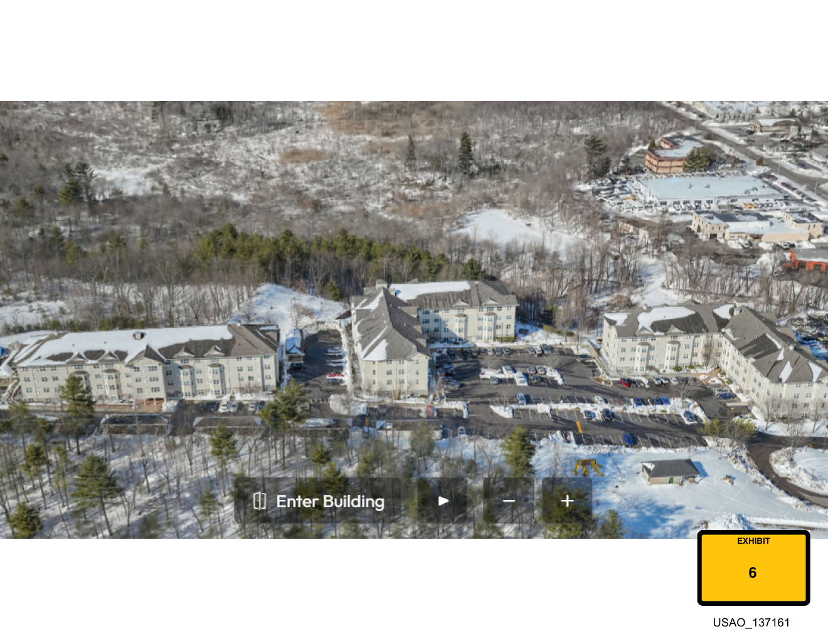
Government Exhibit 6 - Canton Woods apartment complex
Embedded because Grant expressly identifies Exhibit 6 in the recovered October 13 reporting.
Navigation: Back to Exhibit 6 presentation in Grant’s reporting
Sensitive / external-only exhibits: 9, 10, 11, 14, 16, 20, 21, 23, 35, and 60. No image, crop, thumbnail, or preview from these exhibits is reproduced in this archive.

Retrospective Early-Trial Exhibit Set
The following available non-sensitive exhibits are included because they are reasonably associated with the apartment/crime-scene evidence from the first trial days. Exact day-by-day publication is not established for every exhibit. Inclusion here is intentionally broad and is not an editorial judgment about substantive importance.

Government Exhibit 8
Navigation: Back to the reported Exhibits 9-39 crime-scene-photo presentation
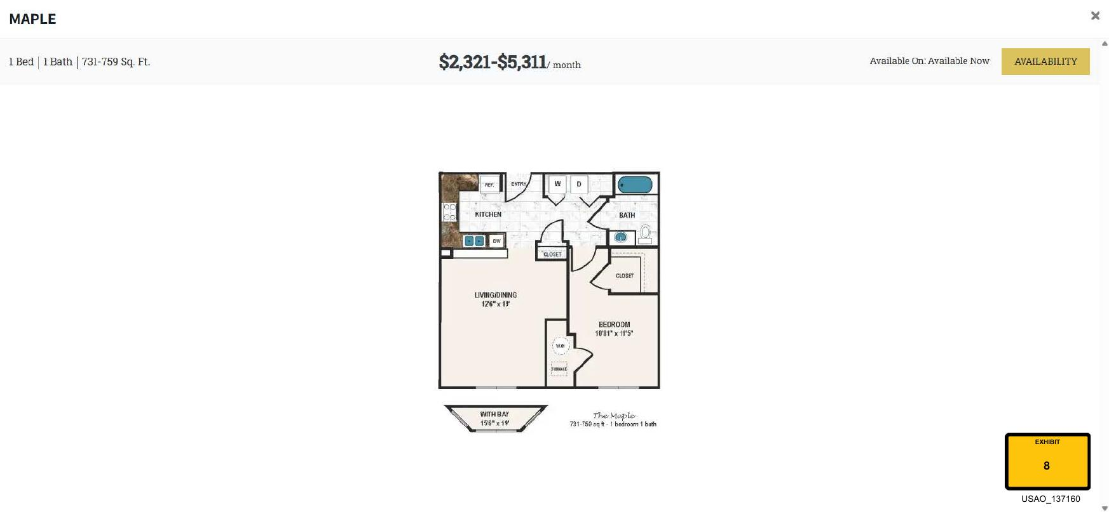
Government Exhibit 8 — retrospective early-trial exhibit set. Exact publication day not established unless separately stated above.

Government Exhibit 12
Navigation: Back to the reported Exhibits 9-39 crime-scene-photo presentation
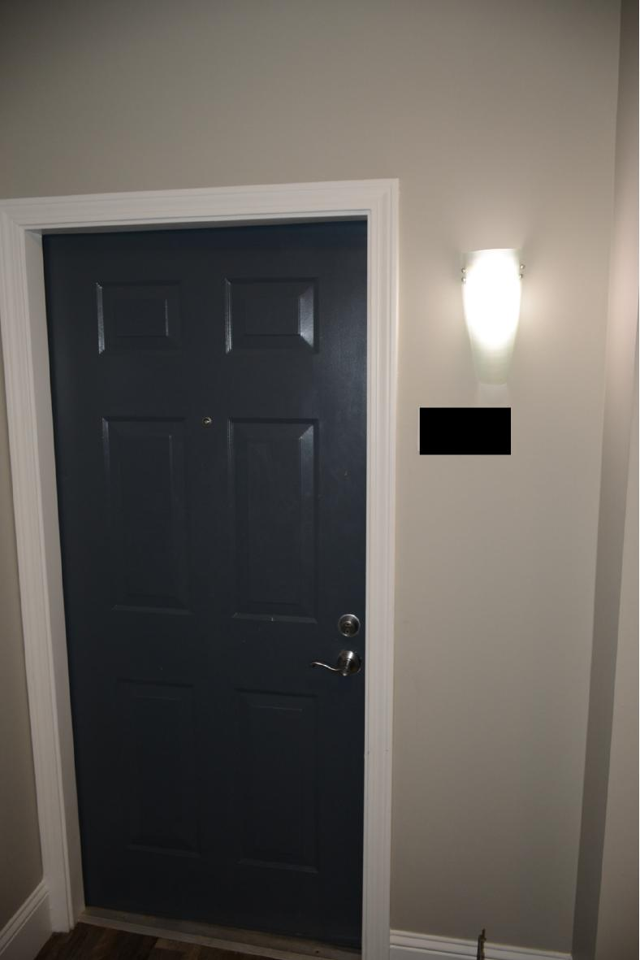
Government Exhibit 12 — retrospective early-trial exhibit set. Exact publication day not established unless separately stated above.

Government Exhibit 13
Navigation: Back to the reported Exhibits 9-39 crime-scene-photo presentation
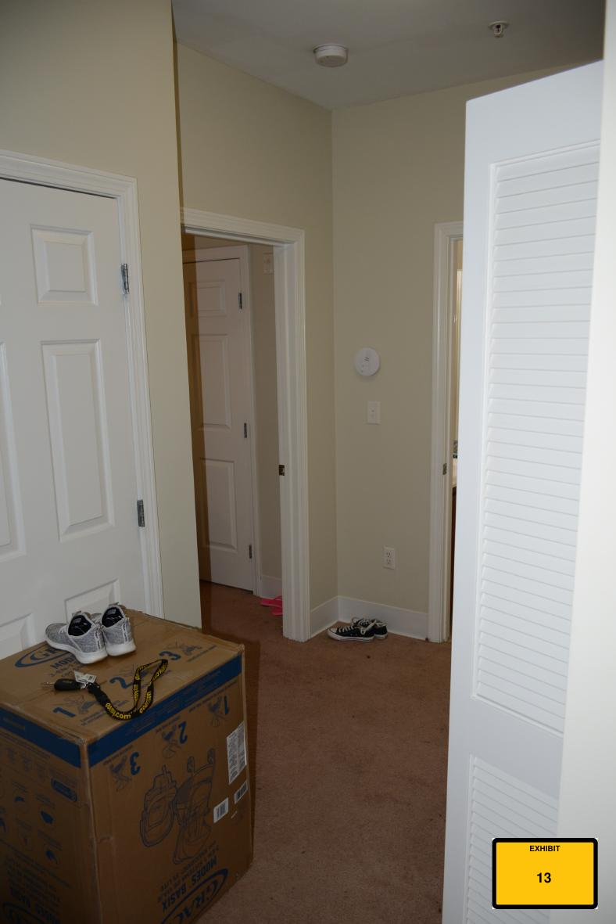
Government Exhibit 13 — retrospective early-trial exhibit set. Exact publication day not established unless separately stated above.

Government Exhibit 15
Navigation: Back to the reported Exhibits 9-39 crime-scene-photo presentation
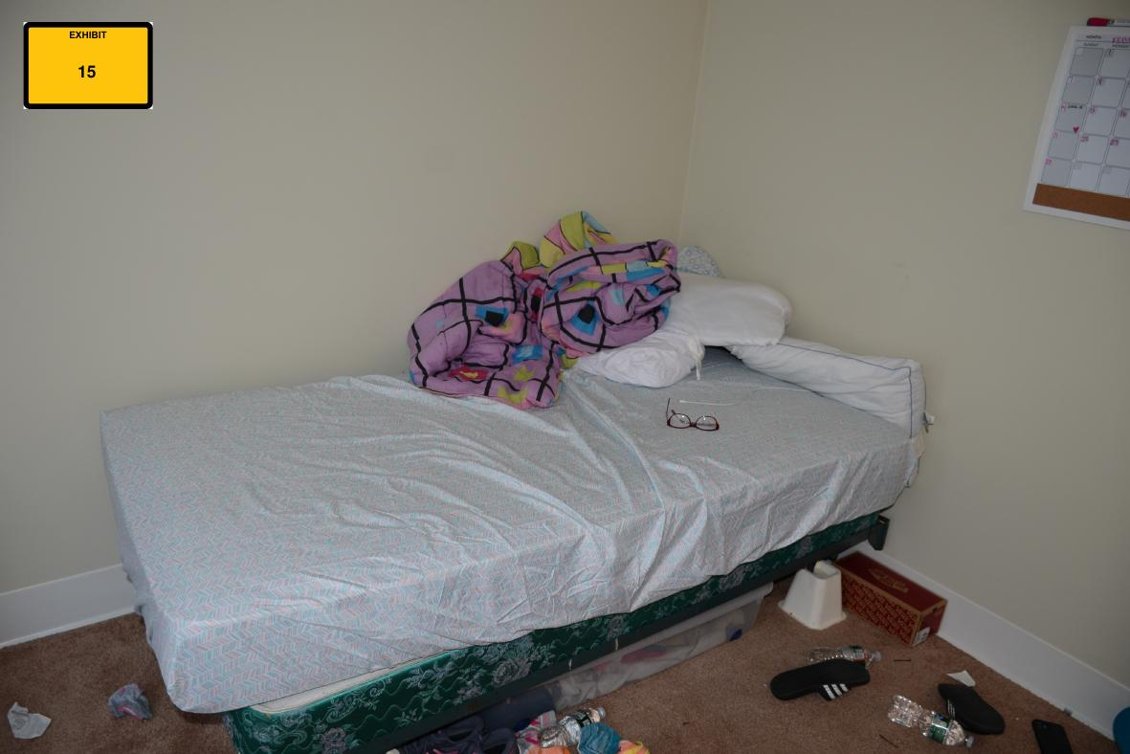
Government Exhibit 15 — retrospective early-trial exhibit set. Exact publication day not established unless separately stated above.

Government Exhibit 18
Navigation: Back to the reported Exhibits 9-39 crime-scene-photo presentation
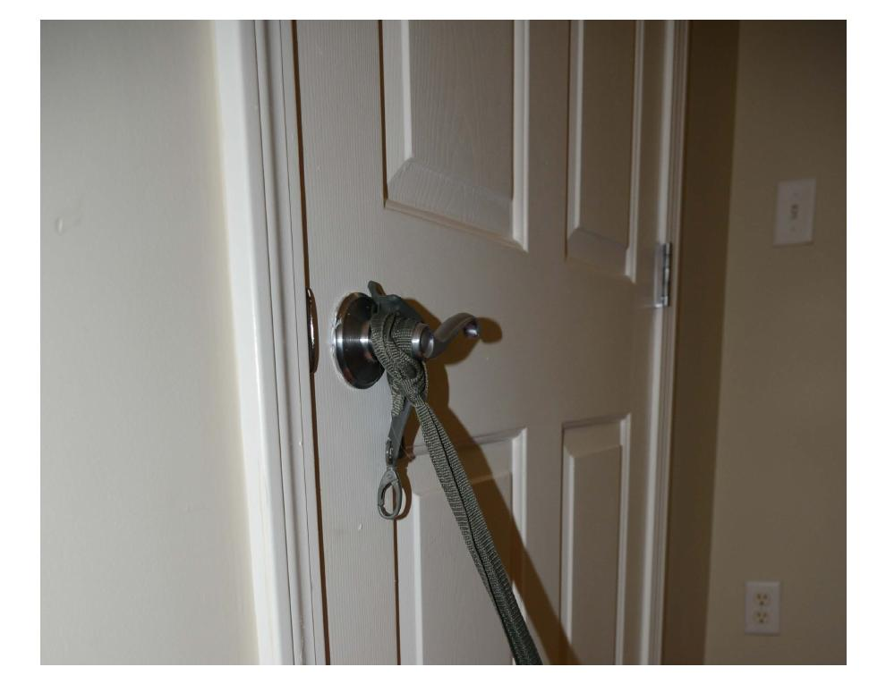
Government Exhibit 18 — retrospective early-trial exhibit set. Exact publication day not established unless separately stated above.

Government Exhibit 24
Navigation: Back to the reported Exhibits 9-39 crime-scene-photo presentation
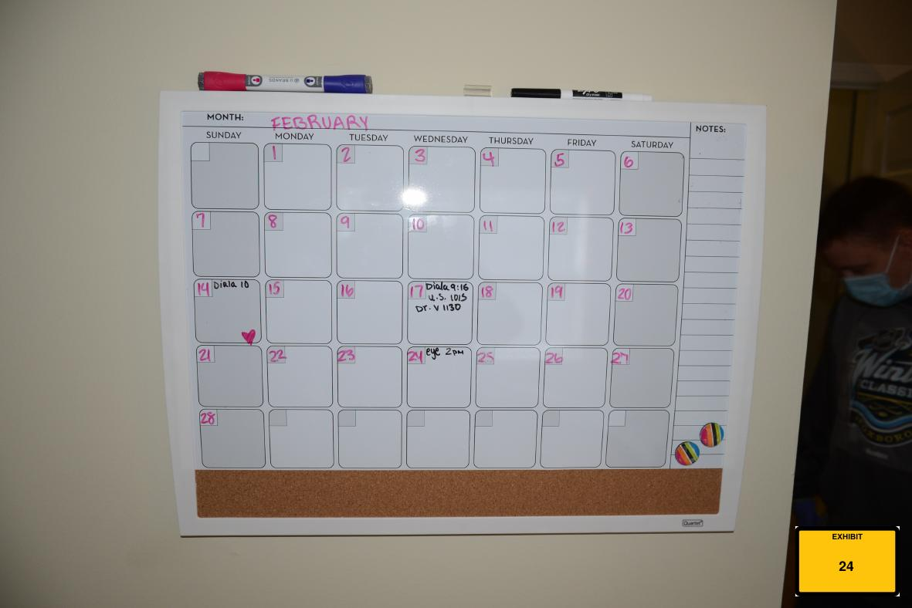
Government Exhibit 24 — retrospective early-trial exhibit set. Exact publication day not established unless separately stated above.

Government Exhibit 25
Navigation: Back to the reported Exhibits 9-39 crime-scene-photo presentation
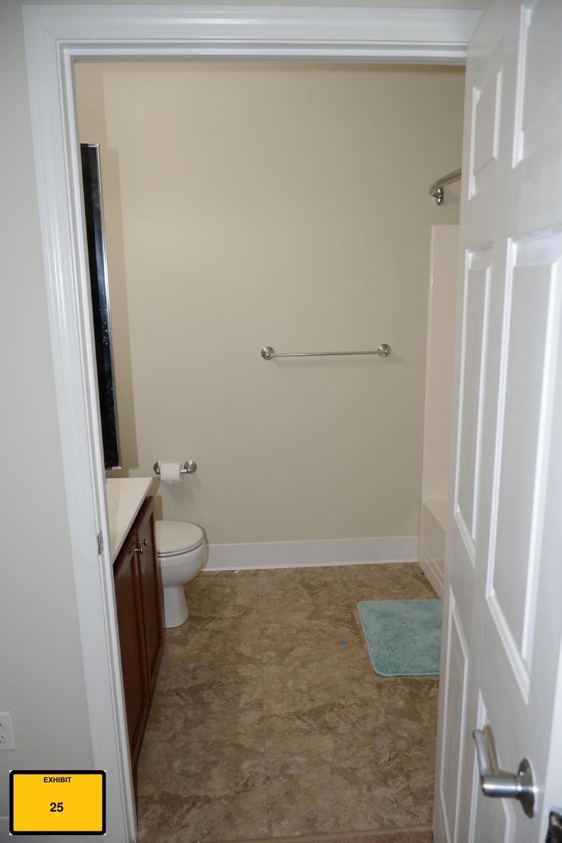
Government Exhibit 25 — retrospective early-trial exhibit set. Exact publication day not established unless separately stated above.

Government Exhibit 26
Navigation: Back to the reported Exhibits 9-39 crime-scene-photo presentation
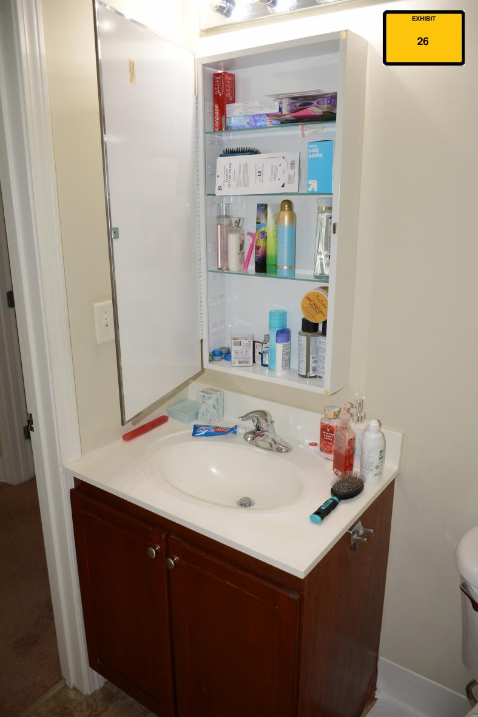
Government Exhibit 26 — retrospective early-trial exhibit set. Exact publication day not established unless separately stated above.

Government Exhibit 27
Navigation: Back to the reported Exhibits 9-39 crime-scene-photo presentation
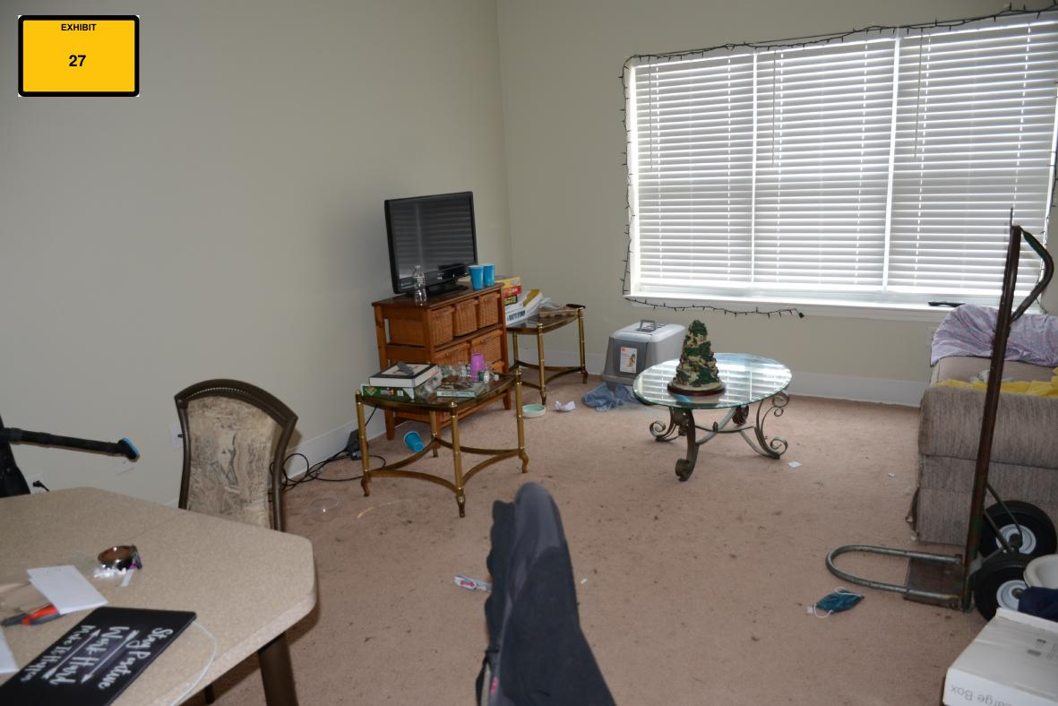
Government Exhibit 27 — retrospective early-trial exhibit set. Exact publication day not established unless separately stated above.

Government Exhibit 28
Navigation: Back to the reported Exhibits 9-39 crime-scene-photo presentation
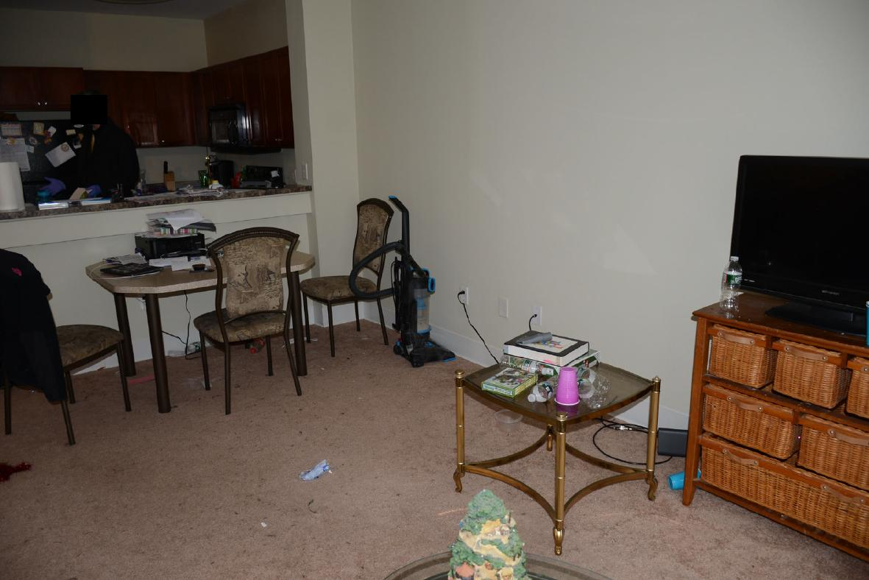
Government Exhibit 28 — retrospective early-trial exhibit set. Exact publication day not established unless separately stated above.

Government Exhibit 29
Navigation: Back to Exhibit 29 presentation in Grant's reporting
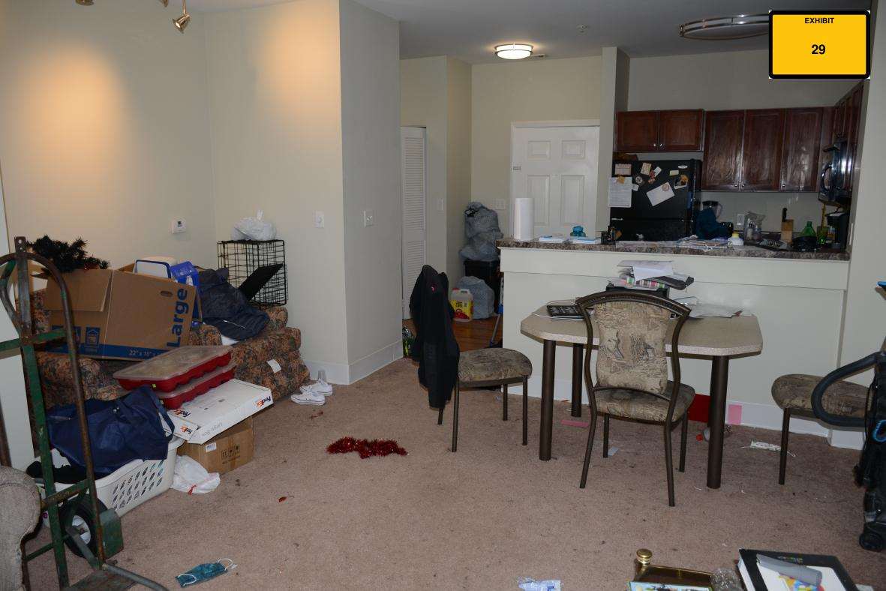
Government Exhibit 29 — retrospective early-trial exhibit set. Exact publication day not established unless separately stated above.

Government Exhibit 30
Navigation: Back to the reported Exhibits 9-39 crime-scene-photo presentation
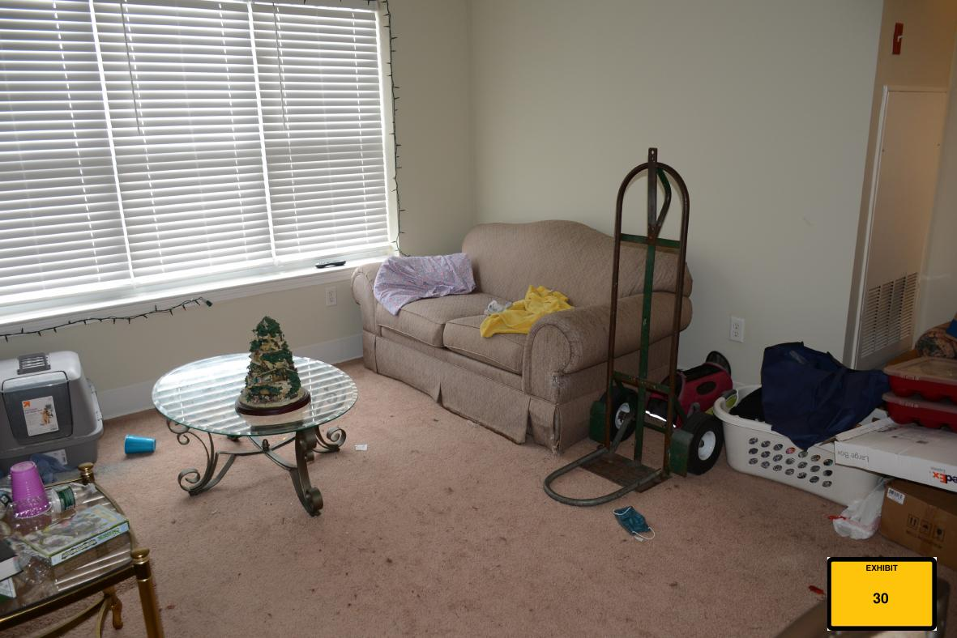
Government Exhibit 30 — retrospective early-trial exhibit set. Exact publication day not established unless separately stated above.

Government Exhibit 31
Navigation: Back to the reported Exhibits 9-39 crime-scene-photo presentation
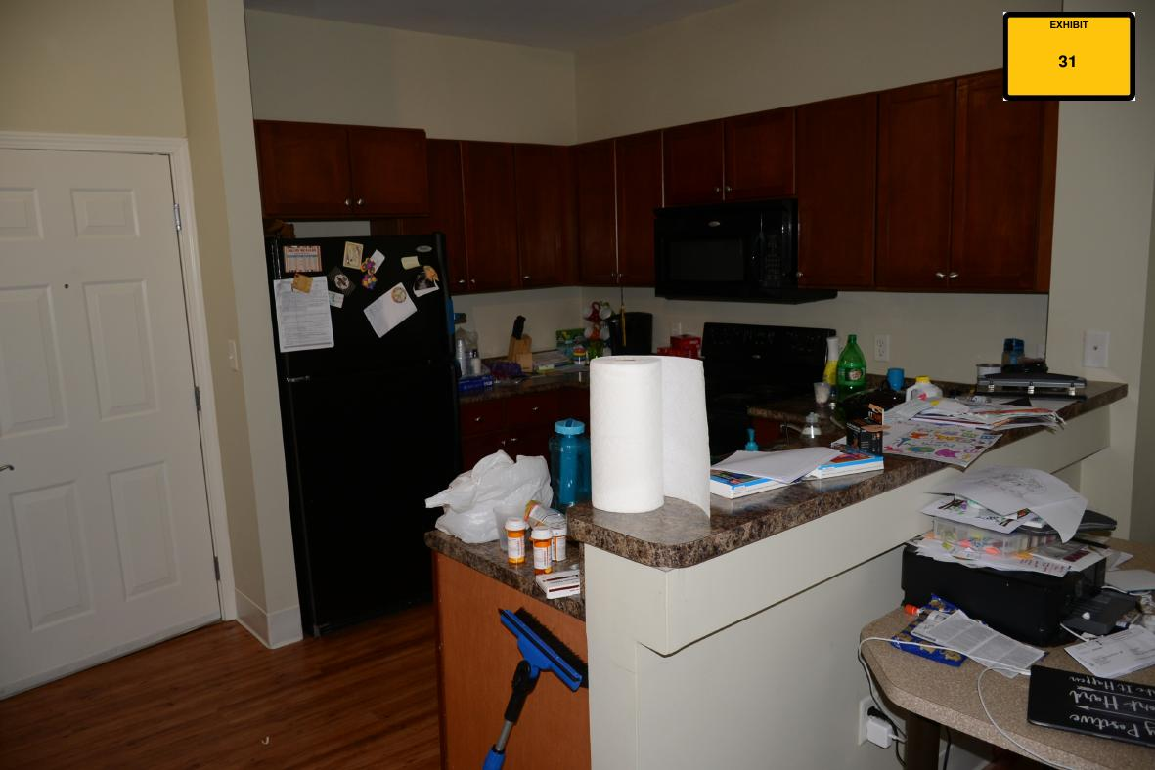
Government Exhibit 31 — retrospective early-trial exhibit set. Exact publication day not established unless separately stated above.

Government Exhibit 32
Navigation: Back to the reported Exhibits 9-39 crime-scene-photo presentation
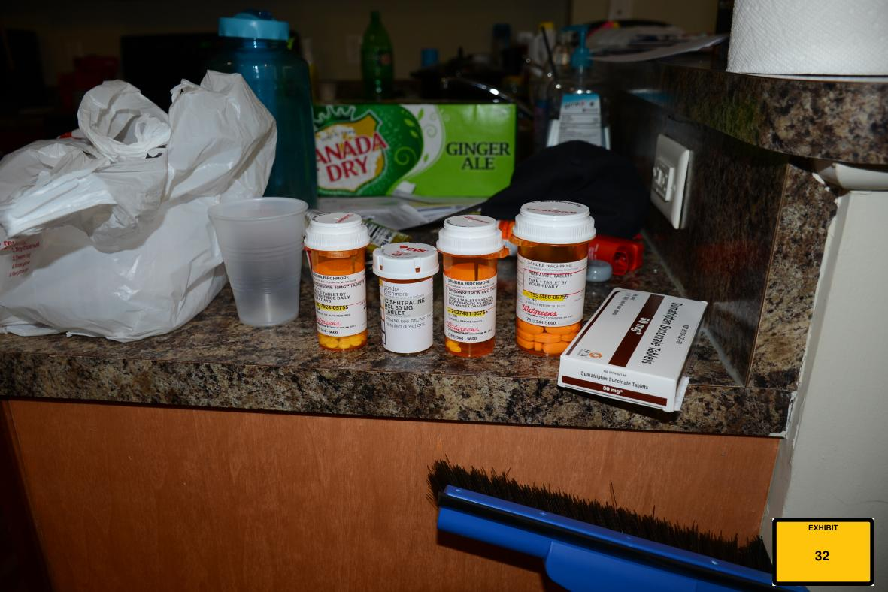
Government Exhibit 32 — retrospective early-trial exhibit set. Exact publication day not established unless separately stated above.

Government Exhibit 33
Navigation: Back to the reported Exhibits 9-39 crime-scene-photo presentation
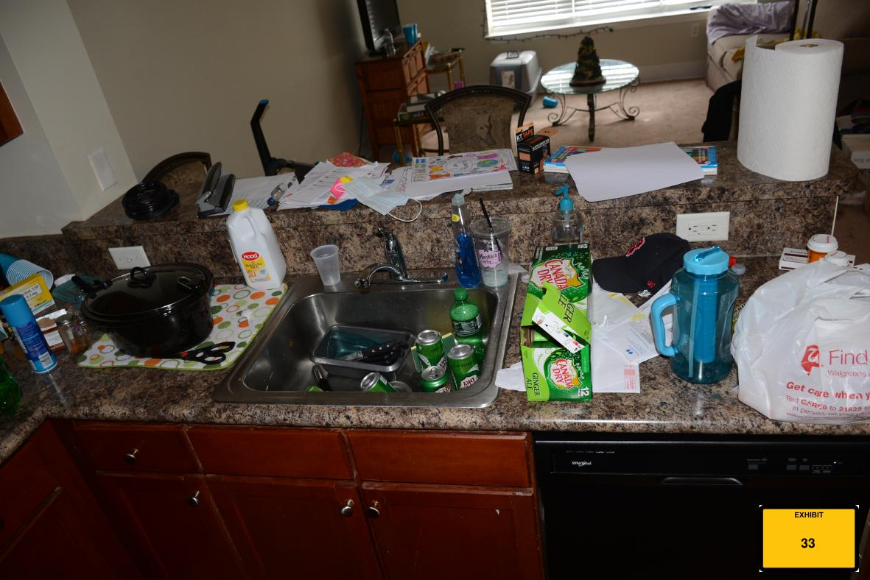
Government Exhibit 33 — retrospective early-trial exhibit set. Exact publication day not established unless separately stated above.

Government Exhibit 34
Navigation: Back to the reported Exhibits 9-39 crime-scene-photo presentation
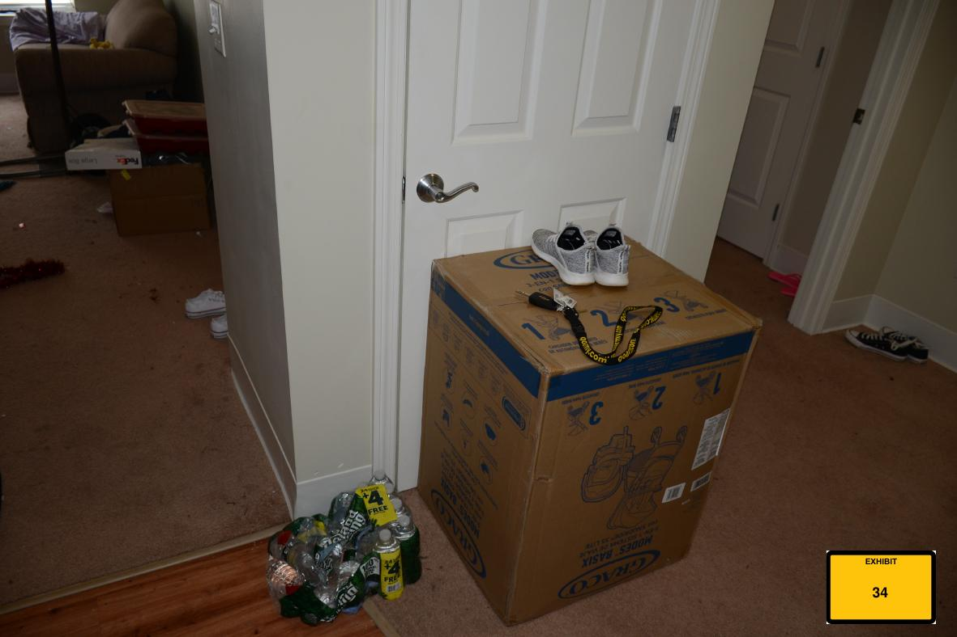
Government Exhibit 34 — retrospective early-trial exhibit set. Exact publication day not established unless separately stated above.

Government Exhibit 36
Navigation: Back to the reported Exhibits 9-39 crime-scene-photo presentation
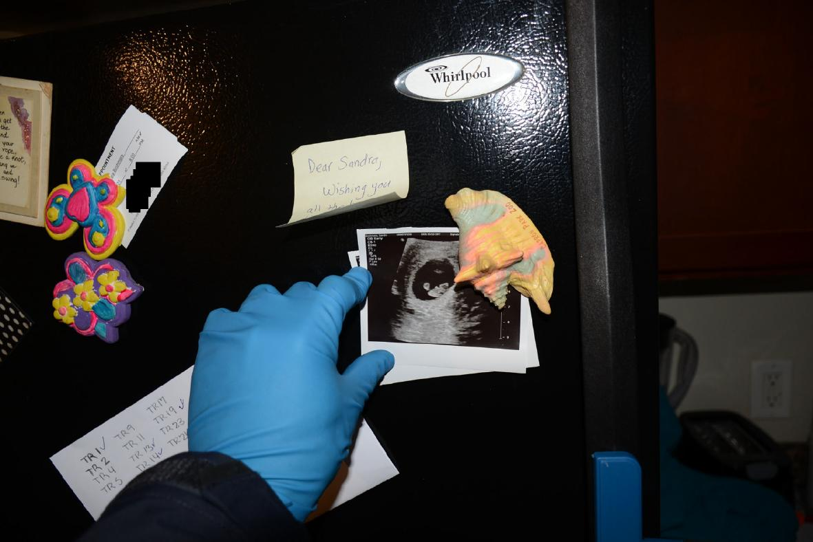
Government Exhibit 36 — retrospective early-trial exhibit set. Exact publication day not established unless separately stated above.

Government Exhibit 37
Navigation: Back to the reported Exhibits 9-39 crime-scene-photo presentation
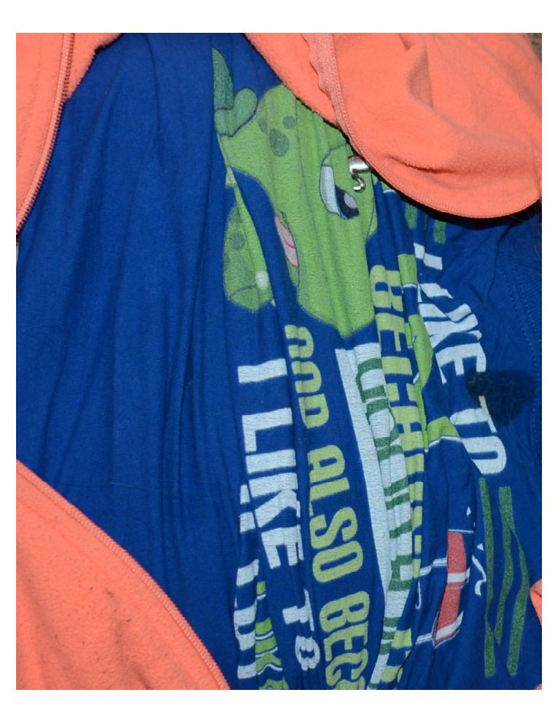
Government Exhibit 37 — retrospective early-trial exhibit set. Exact publication day not established unless separately stated above.

Sensitive Exhibits - External Access Only
Sensitive exhibits in the early-trial set are intentionally not reproduced or previewed here: Exhibits 9, 10, 11, 14, 16, 20, 21, 23, and 35. Open the court-released trial materials folder. Exhibit 60 remains subject to the same sensitivity procedure but is outside the 9-39 crime-scene range discussed above.
——————————————————
Support the reporting
This archive is made possible by Grant Smith Ellis’s excellent on-the-ground courtroom reporting and his permission to use that work in this project. If you’ve found the reporting useful and would like to support his work directly:
Venmo · Cash App · PayPal
All donations go directly to Grant Smith Ellis; this archive is unaffiliated with and receives no proceeds from them.

