Grant Smith Ellis Court Log
United States v. Matthew Farwell
Day 3 • October 14, 2026
Reconstructed from @GrantSmithEllis contemporaneous courtroom reporting

About this report: This document reconstructs Grant Smith Ellis's contemporaneous courtroom reporting from his posts on X. Grant-authored reporting is reproduced as retrieved and organized chronologically by testimony/proceeding; editorial organization and known retrieval limitations are documented in the full Source & Editorial Notes near the end.

Grant’s Court Reporting

Pre-Jury Proceedings
7:39:43 AM ET
Hello from inside Boston's beautiful Moakley Federal Courthouse, where this will be today's live-thread for coverage of day 2 in the Sandra Birchmore and Matthew Farwell trial.
Brian Tully and John Fanning's coverup point-man, Matt Dunne, is up first for the DOJ after 9AM.
Open original post on X
8:16:46 AM ET
Trooper Matt Dunne has arrived to check in outside the courthouse.
He has a blue suit and a pinkish/purple tie.
His hair is gray and he appears stressed.
There are about 10 media members here, along with 15 members of the public.
Mizzy and Barb are 1st in line.
Open original post on X
8:38:40 AM ET
Okay, I have taken my seat in the courtroom.
Farwell's lawyers are here, but the DOJ is not.
Farwell has not yet arrived in the courtroom.
@Estey617, however, has arrived. She is a towel.
Open original post on X
8:43:58 AM ET
@Estey617 The DOJ has arrived with their pushcart.
It has at least 100,000 documents spread across 20 binders on three rows of metal shelving.
We await the arrival of Matthew Farwell.
Judge will take the bench at 8:45AM ET.
Open original post on X
8:45:13 AM ET
@Estey617 Farwell arrives.
He is in a black suit for the second day in a row.
He speaks to Kimberly Stevens. She smiles.
Stevens speaks to Brian Fogerty.
Fogerty is holding packets of evidence in large manila folders that he places onto the witness stand.
Open original post on X
8:45:41 AM ET
@Estey617 All rise!
Judge takes the bench.
We begin a motion hearing.
Clerk calls the case.
Open original post on X
8:47:45 AM ET
Judge says good morning to counsel and Farwell.
Farwell says good morning.
Judge has a few matters.
Judge got the updated disputed exhibit list.
There was one last night and one earlier today. There is some overlap between what came in on Friday and the list that came in today. Judge has reviewed most of the disputed exhibits that will come up today.
There are two new ones. For reasons noted yesterday, as to the prior disputed exhibits, having reviewed the objections and responses, judge expects they will all be admitted.
1 and 3 are relevant here on the disputed list, but Judge will be listening for foundation.
Number 543 is marked which Judge thought was being withdrawn, is that correct?
This is 543 otherwise marked as G-7.
Judge thinks this was a defense exhibit.
Open original post on X
8:48:23 AM ET
@bunnybryson Hi Koffi! Hi Bunny!! Hi Bo!!!
Open original post on X
8:48:44 AM ET
@Estey617 Defense counsel asks for a moment to review her files.
Open original post on X
8:50:40 AM ET
Judge asks if counsel is ready.
Daley, the lawyer for Farwell, continues her search furiously on her computer.
DOJ says 543 and 544 are photos of journal entries drafted 5 years before Sandra died.
Troopers took photos of these entries after Sandra died.
MSP found those but not the computer in Sandra's apartment with all of the evidence of Farwell's grooming and child SA?
Okay, then.
[Towel note; Good work, Brian Tully and John Fanning's MSP unit. Michael Morrissey has some great men around him.]
Open original post on X
8:51:44 AM ET
Okay, counsel as to some things from yesterday;
I sustained the objection during testimony from Officer Cotard when he affirmed his limits to his role at the scene.
Then there was a question about Ms. Isabelle, and my ruling stands there.
This is about the phone call where the Canton Woods staff member was told that Farwell had said "he would take care of the problem himself," if Sandra insisted on carrying her unborn baby to term.
Open original post on X
8:53:11 AM ET
DOJ;
"For the record, we have informed Trooper Dunne that the RO hanging on Sandra's fridge is admissible."
"Okay, thank you counsel."
"Counsel, a few other things, I started to address the DOJ motion, docket 325, about the civil complaint. I have also reviewed 335, the response, as I understood the DOJ started to tell me yesterday that the DOJ is dropping the part of the motion as to seeking an exemption to the sequestration order?
Yes.
Denied as moot as to that point.
I further understand that the parties are still in dispute as to whether the document itself should come, in but there is agreement that witnesses may be impeached on it. I'll wait to we get there.
Open original post on X
8:54:05 AM ET
"Counsel, please raise this issue in the morning or afternoon before it comes up."
"Court denies in part as moot and reserves in part" on the motion.
Docket 352 has been filed under seal. Judge has it.
Judge knows this is not ripe yet so she wants to return to it at the end of the day.
Judge understands it may come up tomorrow.
Open original post on X
8:55:32 AM ET
"Anything else counsel?"
DOJ;
"Two quick things, your honor; there is one extra agreed to exhibit, it is 284, that we expect to come in today. In addition I wanted to flag for the court that if we get to calling Donna McNamara today there was a defense motion regarding a civil complaint that was filed by her, docket 185, and that motion was allowed in docket 285, so I just wanted to flag that for the court and for the reasons set forth in that motion and on the basis of that decision from the court the DOJ won't ask about McNamara's current employment so as to not invade what was restricted in that motion. The defense will do so as well."
Judge; "Okay."
Open original post on X
8:55:57 AM ET
@Estey617 Defense says that is correct and they have no intention of getting into that, and they will only get it into on cross for impeachment.
Judge says alert me first.
Okay.
Open original post on X
8:57:07 AM ET
Judge says, as a housekeeping matter, she thinks it is exhibit 256...this was admitted but was not published given concerns about the header on it.
Judge just asks that the parties confer on redaction of that header. It may need to be printed as slides and done as an old school redaction.
DOJ says it is already done.
Judge says we are waiting on two jurors and then we can get started.
Open original post on X
Exhibit 256: Not embedded: Not available time of document creation.
8:57:42 AM ET
@Estey617 DOJ says they have made some redactions to exhibit 284 because it has some personal phone numbers.
Judge thanks the DOJ for the update.
"Counsel, unless there's anything else, we'll stand in recess until all 16 jurors arrive."
Open original post on X
Exhibit 284: Not embedded: Not available time of document creation.
8:58:31 AM ET
@Estey617 Recess!
We're unsure how long this will take. Boston traffic can be rough on good days.
Open original post on X
9:06:19 AM ET
@Estey617 Matthew Farwell sits silently working on some papers.
He is writing on documents with his head down.
He sits slouched in his seat to appear smaller than he is.
He stands 6'4 to 6'5, but when he sits you would think he is 5'2.
All jurors are here!
Open original post on X
9:07:32 AM ET
@Estey617 The jurors have arrived.
State Trooper Matt Dunne enters the courtroom and takes his place next to the witness box.
We wait the call of the court.
Open original post on X

Trooper Matthew Dunne — Continued Testimony
9:09:07 AM ET
@Estey617 All rise, jurors entering!
We begin.
Brian A. Fogerty up on direct for the DOJ. Picking up from where we left off yesterday.
Towel girlfriend has also just arrived. She is beautiful. She is sitting with Barb, Mizzy and Estey.
Open original post on X
9:10:11 AM ET
@Estey617 Trooper Dunne, you remain under oath.
Counsel begins;
"Trooper Dunne, good morning."
"Good morning, sir."
Open original post on X
9:11:14 AM ET
"Can you pull up exhibit 9, please?"
"Trooper Dunne, when we left off we were talking about your initial approach into the apartment where Ms. Birchmore was found, right?"
"Yes."
"Looking at exhibit 9 in front of you, can you describe what you saw when you walked in to Ms. Birchmore's bedroom?"
"I saw Ms. Birchmore in a partially reclined position, with a ligature around her neck, affixed to the door handle on the right."
Open original post on X
Exhibit 9: sensitive — not embedded. Court-released trial materials folder
9:11:38 AM ET
@Estey617 We are looking at an image of Sandra Birchmore's body hanging from a door.
She is shown from behind.
She is at a 70 degree angle to the floor.
This is very sad.
Open original post on X
9:12:17 AM ET
@Estey617 We see the front view of Sandra, hanging from her closest door.
Her belly is distended. Her baby boy died inside her belly a few days prior.
This is heartbreaking.
Open original post on X
9:13:47 AM ET
"Trooper Dunne, please put on the gloves next to you and open the exhibit bags. This is exhibit 49."
"Do you recognize the device that is in the package that says exhibit 49?"
Dunne slowly opens the envelope.
"This appears to be the same cell phone depicted in the photo."
"This is the same cell phone you found near Ms. Birchmore?"
"Yes."
"Government moves to admit exhibit 49."
Defense objection.
"Overruled, it is admitted."
Open original post on X
Exhibit 49: Not embedded: Not available time of document creation.
9:14:56 AM ET
"Let's look at exhibit 16 now. How close was that cell phone to Ms. Birchmore."
"The phone was six to eight inches from her right knee."
Sandra is literally hanging around a corner of a wall at a 70 degree angle. Her right leg is bent. Her left leg is straight. She is closer to a position on her back than on her behind.
Open original post on X
Exhibit 16: sensitive — not embedded. Court-released trial materials folder
9:15:40 AM ET
@Estey617 We now see a picture of Sandra's bed.
The bed is just feet from where Sandra was hung from her closet door. Her glasses were placed on the bed and they sit in the middle of the bed.
Other than the pillows and sheets and comforter there are no other items on the bed.
Open original post on X
9:16:29 AM ET
@Estey617 Exhibit 32 now.
"Trooper Dunne, do you see these medicine containers lined up on the counter top?"
"Yes."
"Did you line these up?"
"I don't think I did. It was the Canton Police."
"Let's pause," says Judge. The jury screens need to be rebooted.
Open original post on X
Exhibit 32: Not embedded: Not available time of document creation.
9:17:42 AM ET
"Thank you, jurors, counsel go ahead."
"As to the medicine bottles being lined up, can you continue?"
"So, this is a fairly common way that we see medicines. Part of the in take done by the OCME when an unattended death is initially reported, they ask for the medications in the location. So it's common we would see the medicine lined up by the first responders so we can pass that along to the OCME."
Open original post on X
9:18:14 AM ET
@Estey617 "So, lining up the medicine is a common practice by first responders so crime scene can then document them?"
"I don't know about for crime scene documentation purposes, but the OCME usually needs that information."
Open original post on X
9:19:23 AM ET
Now a picture of Sandra's fridge.
"What is in this picture?"
"Someone touching a picture of an ultrasound."
"What did you learn about Ms. Birchmore being pregnant?"
"I learned from the Sharon Schools, and from this photo, and I reviewed Canton reports, and I learned it appears she was pregnant."
"Did you see this ultrasound photo on her fridge?"
"I did, yes."
Open original post on X
SOURCE-RETRIEVAL NOTE — The available primary-source exports do not recover Grant-authored courtroom posts between the 9:19:23 AM entry and the next retrieved court-related entry. This archive does not infer what occurred in that interval.
11:12:11 AM ET
@DoctorTurtleboy That's the vibe in the courtroom, for sure.
Open original post on X
11:40:05 AM ET
@Estey617 @BoozeyBeauty "The OCME is an agency of the Commonwealth?"
"Yes."
"Is there a particular medical examiner assigned to each death?"
"Yes."
Open original post on X
11:41:00 AM ET
"The OCME rendered an initially on may 6th, 2021?"
"Yes."
"And Ms. Birchmore was found on Feb 4th, 2021?"
"Yes."
"Did you ever speak with the OCME's office between those dates?"
"I spoke to investigators who..."
"Did you personally speak to the OCME?"
"So, Fanning did on multiple occasions."
Open original post on X
12:05:02 PM ET
@Estey617 @BoozeyBeauty Sidebah done.
"More simply put, did you learn information that there were issues with regards to Ms. Birchmore's mental health at the early stage of your investigation and entry into the unit at Canton Woods?"
"I don't believe so. Not very much."
Open original post on X
12:05:35 PM ET
@Estey617 @BoozeyBeauty "You are a trained investigator and have been at the scenes of violent deaths?"
"Yes."
"Too many scenes?"
"Probably."
"Suicides?"
"Yes."
"Too many?"
"Yes."
Open original post on X
12:08:58 PM ET
@Estey617 @BoozeyBeauty "Did the officers who made entry at the time of your early investigation that they unlocked the deadbolt to the unit door?"
"I don't know, honestly."
Open original post on X
12:10:45 PM ET
We now see a picture of the door to Sandra's apartment, from inside the unit, along with her kitchen and living room.
"What did you observe...what was important to you...as you walked in?"
"I was making note of the state of the apartment. If anything was knocked over. Any sign of struggle. Any sign of violence. Sign of drug use. Obvious missing valuables. Should I explain anything else in general terms?"
[Towel Note; did he just ask the defense attorney for guidance from the stand?]
Open original post on X
12:11:15 PM ET
@Estey617 @BoozeyBeauty "Did you make note of any vacuum tracks?"
"I'm sorry, did I see any vacuum tracks?"
"Yes, that's my question."
"No, I did not."
Open original post on X
12:24:47 PM ET
"As a trained investigator, why would you be looking for knocked over objects?"
"Those are signs of a struggle."
"What items were not knocked over?"
"The items on the white shelf."
We are now looking at a view from Sandra's bed, towards her table in her room. Her body was hanging half way between her closest door and the table. There is maybe 1-2 feet of room between Sandra's body and these tables.
This entire line of questioning undercuts Farwell's theory that Sandra violently thrashed around after she was hung, thus breaking her hyoid bone.
No way Sandra thrashed and didn't knock into that table.
Open original post on X
12:25:18 PM ET
@Estey617 @BoozeyBeauty "Did you see signs of a struggle in the room?"
"No."
"You've seen the video of Farwell entering the apartment complex, and there's now on the ground?"
"I don't know."
"Can we pull up Exhibit 46 please."
Open original post on X
Exhibit 46: Not embedded: Not available time of document creation.
12:36:47 PM ET
Wow.
Firefighter Daniel Whitley from the Karen Read and John O'Keefe trial pronounced Sandra Birchmore dead just minutes before Brian Tully and John Fanning's state police unit began their coverup of Sandra's death.
This. Is. Wild.
Open original post on X
12:39:53 PM ET
@Estey617 @BoozeyBeauty "For 3 days after she died, no one reported her missing, is that correct?"
"Objection."
"Sustained."
Open original post on X
12:41:01 PM ET
Earlier on direct, you were asked about neighbors reporting a disturbance and you said, "I can explain if you like..."
"What did you want to explain?"
"Objection."
"Overruled."
"We only went back two days, and if there's no sign or report of a disturbance, knocking on doors...we had a good timeline...we weren't going to knock on the neighbors doors."
Open original post on X
12:41:36 PM ET
@Estey617 @BoozeyBeauty "Are you familiar with decomposition?"
"Not in a medical sense, but as someone who has, unfortunately, seen a lot of bodies, I have seen bodies in various stages of decomposition."
Open original post on X
12:47:26 PM ET
"It is important that timing be accurate in the video we're looking at, to draw conclusions, as part of an investigation?"
"Yes, it would be, but there's proof that this video was extracted and that helps with adjustment."
"Okay, now, you gathered information at Ms. Birchmore's apartment...what did you do next in the course of your investigation?"
"In what regard?"
"Did you lock the apartment back up after all investigators left the scene?"
"I didn't personally do so, maybe someone from Canton PD did that. I don't know."
"Did you all leave together?"
"I am not sure. I don't recall. I assume so."
Open original post on X
12:52:24 PM ET
@Estey617 @BoozeyBeauty "You also met with the 3rd grade teacher at the school where Sandra worked?"
"Yes, she reported to us Sandra over shared and, generally, "seemed a little off."
"She over shared on day 1 working there?"
"If that's what the reports say, yes. I don't recall that."
Open original post on X
12:53:11 PM ET
@Estey617 @BoozeyBeauty "Ms. Birchmore told students that she was pregnant, didn't she?"
"Yes, the teacher said that."
"And she said that despite only being 4-5 weeks into the pregnancy?"
"Yes."
"And she told people on the staff she was not close to?"
"Yes that's what the teacher said."
Open original post on X
12:54:03 PM ET
@Estey617 @BoozeyBeauty "You also interviewed a recess monitor didn't you?"
"Yes."
"And she said that Ms. Birchmore asked her for money, and that made her uncomfortable because they had just met?"
"Yes."
"And Sandra told her she had mental health struggles in the past?"
"Yes."
Open original post on X
12:55:46 PM ET
"Sandra had missed 23 days that year?"
"Yes, the principal said that."
"And the principal said he wouldn't bring her back next year?"
"He said that to me, yes."
"When you finished at the school, you then went to interview Ms. Darlene Smith...and on direct you were trying to tell us what Ms. Smith said...what was it?"
"Well, she mentioned a number of things. She was Ms. Birchmore's aunt. I tried to interview her the previous day but by this stage she was in new Hampshire but yes she told me a number of things."
Open original post on X
12:56:36 PM ET
"Ms. Smith told you Ms. Birchmore had a history of mental health issues when she was a child?"
"Yes, she told me she had mental health issues including bipolar when she was younger?"
"And did you learn that an early childhood age Ms. Birchmore was given medication?"
"Objection, foundation."
"Sustained."
Open original post on X
12:57:52 PM ET
"Did an investigator look at her early childhood medical records?"
"We may have had access, but child hood medical history is not something we would really look at."
"But you had people at that time, in 2021, telling you about Ms. Birchmore?"
"Yes."
"Did Ms. Birchmore's aunt tell you that, when her mother died, Ms. Birchmore's condition got worse?"
"I'd have to review the report."
Open original post on X
12:59:00 PM ET
"Ms. Smith shared with that after Ms. Birchmore's mother died, her mental health got worse?"
"Yes, she did."
"In June or July of 2020, six months before her death, Ms. Smith told you that Ms. Birchmore got very upset because the house on Holbrook Street was being sold."
"Yes, that is what Ms. Smith said, but records show it was actually multiple months earlier than that."
Open original post on X
12:59:42 PM ET
@Estey617 @BoozeyBeauty "Was Sandra asked to leave and take her pets?"
"Objection."
"Sustained."
"Sandra made a threat of self harm during one incident?"
"Yes."
"And Sandra was sectioned?"
"Yes."
Open original post on X
1:01:45 PM ET
"Ms. Smith told you the father of Sandra's child was Matthew Farwell?"
"Yes."
"Did you do anything else on Feb 5th, 2021, related to the death of Sandra Birchmore?"
"Yes. I would have to think about it for a minute. There are a number of things that were done in those early stages. I did notify, I think it was on that date, after the interviews at the school and the interview of Ms. Smith, I notified Fanning that day of the relationship between Ms. Birchmore and Mr. Farwell."
Open original post on X
1:03:05 PM ET
"And you took this into consideration, one of your data points, when you sat down with Fanning to decide what steps to take next?"
"I don't know what happened next. There was a lot of information learned in a short amount of time. This was just 24 hours after Sandra was found dead."
"A lot of people did a lot of work to investigate this?"
"Yes, I would say yes."
"Counsel, lunch break."
Back at 2PM ET!
Open original post on X
1:41:18 PM ET
Γ¥ñ∩╕Å ≡ƒÆÖ ≡ƒÆ£ https://t.co/dvKd6AEhqX
Open original post on X
2:12:19 PM ET
@Estey617 @BoozeyBeauty We are back from lunch.
I took a few extra minutes to help give away pizza to the newsmen and, also, some new US citizens outside the courthouse.
I, remain, a towel.
Open original post on X
2:13:10 PM ET
Back on cross of Dunne by Farwell's defense lawyer.
I am in the overflow room so I can type even faster than before.
"There's no cameras anywhere in the Canton Woods apartment complex other than the camera in the lobby?"
"Correct."
"So you don't know exactly when Mr. Farwell left Ms. Birchmore's apartment that evening?"
"Correct, we don't know."
Open original post on X
2:13:50 PM ET
@Estey617 @BoozeyBeauty I'm told that Josh Levy was both intrigued, and astounded, by my typing skills.
This, according to The Queen Of France's description of his reaction to seeing me type the live transcript earlier today.
@BoozeyBeauty is the Queen Of France.
Open original post on X
2:14:24 PM ET
@Estey617 @BoozeyBeauty "If you had any conflict in investigating this case you would have withdrawn, wouldn't you?"
"Yes."
"And you were just randomly assigned to the case based on you being on duty?"
"Yes."
Open original post on X
2:16:09 PM ET
"You brought items from the OCME to the crime lab?"
"Yes, on at least one occasion I brought a tissue sample in this case from the OCME to the crime lab?"
"So, you had a further interaction, with Fanning, at the end of Feb of 2021, with the OCME?"
"Yes."
"You requested further evidence from the OCME about the body?"
"I believe that Fanning spoke with Capo-Martinez on the 11th to request fetal tissue and on Feb 22nd, he asked that hair clippings, finger nails and a rape kit be done."
"And you facilitated this further testing, with Fanning, of Ms. Birchmore's body?"
"I was aware of it, but I don't know how much help I was. I transported one sample from the OCME to the lab."
Open original post on X
2:17:00 PM ET
@Estey617 @BoozeyBeauty "And the state police were continuing their investigation at this point?"
"Yes."
"And the MSP did DNA testing on Sandra's body and her clothes?"
"Yes."
"And on the strap?"
"Yes."
"And on Sandra's undergarments?"
"Yes."
"And was your role to interpret such testing?"
"No."
Open original post on X
2:17:16 PM ET
@Estey617 @BoozeyBeauty "Who would interpret such results?"
"The forensic scientists."
Open original post on X
2:18:36 PM ET
"And you also interviewed Ms. Rebecca Chandler? On Feb 8th?"
"I conducted a number of interviews on Feb 8th."
"Would you like to see this one to refresh your memory?"
"Sure."
"Objection, your honor, there is no question pending."
"What was the question?"
"What was the date of the interview?"
"I said it was Feb 8th."
Open original post on X
2:19:02 PM ET
@Estey617 @BoozeyBeauty "She stated that Sandra felt down because her mom was not going to be around when her baby was born, is that right?"
"Objection."
"Sustained as to form."
Open original post on X
2:20:40 PM ET
"You also interviewed Ms. Jordan Igo?"
"Yes."
"And that interview, Feb 9th, 2021, the next day, we're on Feb 9, 2021, and Ms. Igo...and she told that she told the father of the baby that Sandra would be demanding $4,000 a month and also an additional $300 for daycare?"
"Yes."
"And Ms. Idle said that the baby's father was in denial about being the father?"
"Yes."
"And the father said it was not his child?"
"Yes, that's what Ms. Igo reported."
Open original post on X
2:21:25 PM ET
@Estey617 @BoozeyBeauty "Did you participate in asking Mr. Farwell for his cellphone?"
"No, Fanning did that."
[Of note; Dunne started calling Fanning "Fanning" after lunch, instead of by Fanning's title as he was doing before lunch. Naughty, naughty. No reading towel posts during lunch.]
Open original post on X
2:22:03 PM ET
@Estey617 @BoozeyBeauty "Is it your understanding that Mr. Farwell...that you obtained a cellphone from Mr. Farwell...I won't relay the contents?"
"Yes."
Open original post on X
2:25:06 PM ET
"You said other factors influenced your thinking in the case...what were they?"
"There are far too many for me to mention off the top of my head. Can you ask about something specific?"
"What about Sandra's journals?"
"Among the items we had in our possession there was a treasure trove of information, some of which mentioned mental health."
"Were those important in your investigation?"
"Some did, some did not. Some were just school work. Varying levels of what appeared to be relevance to the investigation."
"And of direct relevance would be direct statements about past attempts of self harm?"
"Exhibit 56 please."
"What is important on the first page of Exhibit 56?"
"Something specific or just in general?"
"It's a self harm note dated July 1st, 2017."
"Her mother passed away in 2016?"
"Yes."
Open original post on X
Jump to Exhibit 56 in appendix
2:25:52 PM ET
@Estey617 @BoozeyBeauty "What is on page 2?"
"On this document, dated June 30th, 2017, it appears to reference to engage in self harm and reasons to do so."
"Does that list include [rape] [rope] (unclear)?"
"Yes."
Open original post on X
2:26:17 PM ET
@Estey617 @BoozeyBeauty "This was in a group of items provided to you?"
"This was provided to us by Mr. Cosgrove...the mom's cousin."
Open original post on X
2:27:03 PM ET
@Estey617 @BoozeyBeauty "What is on the next page?"
"It lists reasons why not to engage in self harm."
Open original post on X
2:28:06 PM ET
@Estey617 @BoozeyBeauty "So you had picked up additional forensic...oh, before I leave the topic, did you learn that Sandra attempted to swallow pills..."
"Objection."
"Sustained."
"Did you learn about a prior self harm attempt?"
"I had no prior or direct knowledge of that."
Open original post on X
2:28:38 PM ET
@Estey617 @BoozeyBeauty "Did you learn that information?"
"I don't know. I don't know how I learned that."
"Did you learn that Sandra's aunt told her to harm herself and bury herself in a dump?"
"I do not know that."
Open original post on X
2:29:52 PM ET
"Okay, August 16th, 2024, were you still working on the case?"
"Yes, the OCME had made a ruling. My involvement as a death investigator, and my understanding was that there was still some kind of investigation into the defendant, Farwell, and we were told the defendant was a target but I was not involved in that investigation...we had come to learn that Farwell, on that day, was the target of at least one open investigation...the state police learned that."
Open original post on X
2:30:49 PM ET
"Were you aware of DNA testing on the baby?"
"Yes, and I became aware Mr. Farwell is not the father of Sandra's baby."
"And, so, when Mr. Farwell was correct when he told Ms. Birchmore he was not the baby's father?"
"Objection!"
"Sustained."
"But he is not the baby's father, is he?"
"DNA testing bore that out."
Open original post on X
2:32:01 PM ET
@Estey617 @BoozeyBeauty "On August 16th, 2024, you had a meeting at the OCME's office and present were FBI Agent Leah Ferrera, an FBI photographer, USAO Riley, Fanning, Dr. Capo-Martinez, legal counsel for the OCME, Mercedes Robinson from the OCME?"
"Yes."
Open original post on X
2:32:15 PM ET
Uh oh, Joe Warren.
Open original post on X
2:32:38 PM ET
Kate Peter, Brian Tully and John Fanning are having a very, very bad day.
Open original post on X
2:33:04 PM ET
@Estey617 @BoozeyBeauty "Did anyone take notes at this meeting?"
"I don't recall."
"Did the federal government tell you not to take any notes at this meeting?"
"I don't recall. I honestly don't."
Open original post on X
2:34:05 PM ET
@Estey617 @BoozeyBeauty "Have you ever attended a meeting with the chief medical examiner, and the ME that performed the autopsy, with this many federal agents involved?"
"No meeting like this, no."
This is wild.
Wild I tell you!
Open original post on X
2:35:16 PM ET
"Were you asked to provide any additional information to the OCME at this point?"
"I know after this meeting, Fanning was in communication with somebody at the OCME...an administrator maybe Dr. Capo-Martinez...and then additional information was made available to the OCME...if there was that additional information it wasn't supplied directly by me. That's the best answer I have, I'm sorry."
Long pause.
Open original post on X
2:35:55 PM ET
@Estey617 @BoozeyBeauty "Did you ever to suggest to the OCME what finding she should make in this case?
"No, never."
"Did you, early on, provide whatever she asked you for to help make her decision?"
"Yes...actually, let me back up, I did not have direct contact with her, Fanning did."
Open original post on X
2:36:54 PM ET
"Did you share your concerns about an officer who was sleeping with Sandra Birchmore on that occasion, or any occasion, with the OCME?"
"I was concerned enough to call the OCME investigator and I gave them whatever information I had, and I took whatever information they gave me, but I don't recall exactly what I told them. But I was sufficiently concerned about something to make that call."
Open original post on X
2:37:19 PM ET
@Estey617 @BoozeyBeauty "Do you know if after that meeting the OCME changed her opinion to underdetermined?"
"After the August 16, 2024, meeting a year and a half later, yes she did change her opinion."
Open original post on X
2:37:44 PM ET
@Estey617 @BoozeyBeauty "Your honor may we be heard at sidebah?"
"Yes."
Sidebah!
Open original post on X
2:40:42 PM ET
"Earlier in our discussion, at the beginning, you talked about how you provided examples of other seated hangings to the government that you responded to?"
"Yes."
"In 2018, a man used a neck tie to tie himself to a post and he died in that manner?"
"Yes."
"In 2019, a person used a bed sheet in a frame to take their own life?"
"Yes, I believe so."
Open original post on X
2:41:14 PM ET
@Estey617 @BoozeyBeauty "Oh, sir, does Fanning still work at the Mass. State Police?"
"Yes."
Oh, yikes, Farwell's lawyers just through the State Police right under the damn bus.
Hello @MassGovernor.
Open original post on X
2:41:43 PM ET
@Estey617 @BoozeyBeauty @MassGovernor "There's no rulebook or guide posts for self harm?"
"Objection."
"Sustained, counsel no commentary."
Open original post on X
2:42:08 PM ET
@Estey617 @BoozeyBeauty @MassGovernor "In your September, 2026, meeting with the federal government [in this building], you told them there is no rulebook or guide posts for self harm?"
"I don't recall my words."
Open original post on X
2:42:31 PM ET
@Estey617 @BoozeyBeauty @MassGovernor "Nothing further."
"May I have one moment, your honor," says Brian Fogerty before re-direct.
This could get fiesty.
Open original post on X
2:42:56 PM ET
@Estey617 @BoozeyBeauty @MassGovernor "Good afternoon, Trooper Dunne."
"Good afternoon, Sir."
Open original post on X
2:43:58 PM ET
"When you talked about the elements of evidence that you said would make something suspicious, you said forced entry was one?"
"Yes."
"And, in a situation where the suspected perpetrator had a key, would that make forced entry less likely?"
"Objection, facts not in evidence."
"Counsel, no speaking objections. Overruled, you can lay foundation first though."
Open original post on X
2:44:26 PM ET
@Estey617 @BoozeyBeauty @MassGovernor "In a situation where a potential suspect has a key to the premises would that be something you would want to know."
"Yes, one would not expect to see forced entry in a situation where a suspect has a key."
Open original post on X
2:45:28 PM ET
"Can we pull up Exhibit 16 please."
"Now, Trooper Dunne, I want to go around the room in this picture and have you point out the things that are on the floor."
This is a picture of Sandra hanging from the door at a 70 degree angle from the front. Her baby-bump is out. She is dead.
Open original post on X
Exhibit 16: sensitive — not embedded. Court-released trial materials folder
2:47:04 PM ET
"I see a yellow sock, a phone charger, a shoe box, a plastic, perhaps a stand for a bed post, sandals, two Poland springs water bottles, Mr. Birchmore's phone and then the things we spoke of earlier."
"Do you also see those lines all over the floor? I see five of them on the floor?"
"Objection."
"Overruled, you may answer."
"Yes sir."
"So you see five to six bobby pins all over the floor?"
"Yes."
"And those items were all strewn about the floor?"
"It's difficult to say."
Open original post on X
2:48:19 PM ET
"Does it appear those items were placed deliberately?"
"It's tough to tell."
"So, it would be important to know where the item came from?"
"You'd want to know if it fell off a surface or came from some place else?"
"As to determining if it's an apparent struggle then yes, but, as you can see, the sheet on top of the bed was laid down as intended...the items on the horizontal surfaces on the white plastic shelves, despite the fact that they are cluttered, do appear to be in their intended locations which is upright."
Open original post on X
2:49:22 PM ET
"Exhibit 45 please."
This is the video of Sandra, the last time she is seen on video alive, after clearing off her car of snow.
"What do you notice about her hair?"
"It's up."
"Now, back to the picture of Sandra inside?"
"How is her hair in this picture?"
"It is down."
Big impact here, as Sandra's hair was down after she was hung.
Open original post on X
Exhibit 45: Not embedded: Not available time of document creation.
2:50:44 PM ET
"How tall is the defendant?"
"He is my height, 6'2, or taller?"
"And you saw Ms. Birchmore's body?"
"Yes."
"And how tall is Ms. Birchmore?"
"5 foot 2 inches."
"How was the defendant's stature in 2021?"
"As you can see his a person of large stature."
"How would you describe his size in 2021?"
"He was easily above 200 pounds. A very large man."
Open original post on X
2:51:10 PM ET
@Estey617 @BoozeyBeauty @MassGovernor "When you were on scene, did you see anyone grab Ms. Birchmore's throat?"
"No."
"Do you think that is something you would have remembered?"
"Yes."
Open original post on X
2:51:45 PM ET
@Estey617 @BoozeyBeauty @MassGovernor "Do you know how long it takes for someone to lose consciousness when pressure is applied to their neck?"
Objection.
Sustained. Scope.
Open original post on X
2:52:58 PM ET
"Trooper Dunne, while you participating in the investigation did you become aware of text messages that revealed the defendant was in a relationship with Ms. Birchmore for many years?"
"And from those text messages, did you learn that they had broke up at times?"
"Yes."
"And Ms. Birchmore didn't kill herself after those breaks up, did she?"
"Objection."
"Sustained."
"Exhibit 56 please."
Open original post on X
Jump to Exhibit 56 in appendix
2:54:03 PM ET
"Exhibit 56 is dated July 1 of 2017, correct?"
"Yes."
"That's three plus years before Ms. Birchmore died?"
"Yes."
"And, of course, Ms. Birchmore was alive until Feb 1, 2021?"
"Yes."
"And this is a journal entry?"
"I don't know what you would call that."
"I am asking you a question. Did you find that in a notebook?"
"It was provided by Mr. Cosgrove. It was in a notebook of some kind."
Open original post on X
Jump to Exhibit 56 in appendix
2:55:09 PM ET
"And you obtained those notebooks from Mr. Cosgrove?"
"Yes."
"And you obtained them from Mr. Cosgrove days, if not weeks, after Ms. Birchmore died?"
"Yes, some were from the house in Stoughton that was being cleaned out and some we obtained from the apartment. This was around Feb 22."
"So, you found it weeks after she died and you obtained them from some place that Sandra did not live when she was alive?"
"That would be a better question for Mr. Cosgrove, the first part, but that second part, that's correct."
Open original post on X
2:55:41 PM ET
@Estey617 @BoozeyBeauty @MassGovernor "Sir, you didn't find that notebook when you searched her apartment?"
"No."
"Because if you did, you would have logged that?"
"Correct."
"And this is dated three years before she actually died?"
"Yes."
Open original post on X
2:56:19 PM ET
@Estey617 @BoozeyBeauty @MassGovernor "Now, you looked through the apartment for an actual self harm note, didn't you?"
"Myself and the other investigators, yes."
"And you didn't find one at the scene?"
"Correct."
"And you didn't find one in her phone?"
"Correct."
Open original post on X
2:56:40 PM ET
@Estey617 @BoozeyBeauty @MassGovernor "And that journal entry, Exhibit 56, the third page says why not to engage in self harm, right?"
"Yes."
Open original post on X
Jump to Exhibit 56 in appendix
2:57:29 PM ET
@Estey617 @BoozeyBeauty @MassGovernor "That journal entry was among hundreds of entries in that journal right?"
"I'm not sure I'd have to see it."
"I'm not trying to trick you. Were there lots of pages in that journal?"
"Yes."
"And were there several journals?"
"Yes."
Open original post on X

Massachusetts State Police Crime Lab — Zimmerman
3:19:47 PM ET
@Estey617 @BoozeyBeauty @MassGovernor Okay, I went outside to try to get footage of Matt Dunne after his direct.
I gave up because he was hiding inside on the second floor.
I am back now as Zimmerman is on the stand from the Massachusetts State Police Crime Lab.
Open original post on X
3:20:17 PM ET
@Estey617 @BoozeyBeauty @MassGovernor The DOJ is going through the accreditations held by the crime lab and, also Zimmerman's educational background and training.
Open original post on X
3:21:45 PM ET
@Estey617 @BoozeyBeauty @MassGovernor "In this case you received post mortem specimens from the OCME?"
"Yes."
"And is that something that happens often?"
"Yes."
"And you are often assigned post mortem specimens?"
"Yes."
Open original post on X
3:22:21 PM ET
@Estey617 @BoozeyBeauty @MassGovernor "If an autopsy is performed, does the OCME always send the crime lab post mortem specimens for further testing, that would indicate that the OCME is still investigating something?"
"Yes."
Open original post on X
3:22:46 PM ET
@Estey617 @BoozeyBeauty @MassGovernor "Do you know when you got the specimens for testing?"
"Feb 9, 2021."
"Did you receive any other materials beyond specimens?"
"No."
Open original post on X
3:24:08 PM ET
"Is that part of the lab's process? You mentioned something about a blind specimen for your certification?"
"Are you not sent materials not-related to toxicology for any reason...what do you do to avoid confirmation bias?"
"Objection."
"Sustained, counsel break it up."
"What is confirmation bias?"
"If you're given a sample, and you already know what's in it, then I'm going to try to make myself make the pieces fit...that would be confirmation bias. Already knowing what you're looking for, and then trying to find out."
Open original post on X
3:25:06 PM ET
@Estey617 @BoozeyBeauty @MassGovernor "No alcohol was detected in Sandra Birchmore's blood."
Open original post on X
3:25:42 PM ET
@Estey617 @BoozeyBeauty @MassGovernor "When it comes to the post mortem specimens, is it possible that a delay in processing time can impact the toxicology testing?"
"Yes, things like decomposition and time can impact testing."
Open original post on X
3:26:42 PM ET
"How do you document chain of custody?"
"It's electronic chain of custody. We tag everything with barcodes and scan them as we work on them."
"And that's because if someone wants to review your method or process it's all documented?"
"Yes."
"The first thing you did was preliminary testing on the hard blood?"
"No."
"Is a preliminary test is ever enough?"
"No, it must always be confirmed."
Open original post on X
3:27:09 PM ET
@Estey617 @BoozeyBeauty @MassGovernor "You did both a preliminary test and a confirmatory test in this case?"
"Yes."
"And someone followed up to confirm your work?"
"Yes."
Open original post on X
3:29:25 PM ET
@Estey617 @BoozeyBeauty @MassGovernor The witness is explaining how that confirmatory testing process works, and how the crime lab uses redundancy and peer review to confirm reports.
They call it batch review at the crime lab.
Open original post on X
3:31:03 PM ET
@Estey617 @BoozeyBeauty @MassGovernor We switched to cross exam before I got in the courtroom.
This feels like a direct, though.
I'm also exhausted from typing Dunne's testimony in real time, in full.
I am trying to push through the end of the day. I got this. For Sandra and her unborn baby boy.
Open original post on X
3:32:27 PM ET
"You didn't detect the sertraline?"
"No, it had not yet built up in her blood stream?"
"What does that mean?"
"It means that the body had not yet started to break down the Zoloft to eliminate it."
"And what does that mean as to the person who is taking the dose? Are they taking too much? Too little?"
"I do not know."
Open original post on X
3:33:06 PM ET
@Estey617 @BoozeyBeauty @MassGovernor "Can you fatally overdose on Zoloft?"
"There is a toxic level. I have not had any cases where sertraline was the cause of death but in the literature there is a toxic level."
"Would it be more than the pills in that picture?"
"I don't know."
Open original post on X
3:34:06 PM ET
"Can you overdose on Zofran?"
"Objection."
"Sustained, on this."
"Back to Zoloft, are you aware it carries a black box warning?"
"I am not."
"Are you aware it has a black box warning?"
"Objection, asked and answered."
"Sustained."
"What is a black box warning."
"Objection."
"Sustained."
Nothing further. No re direct.
Open original post on X

Robert Kuhn — Stoughton Police Department
3:34:17 PM ET
@Estey617 @BoozeyBeauty @MassGovernor Next witness;
The Government calls Robert Kuhn.
Open original post on X
3:35:35 PM ET
@Estey617 @BoozeyBeauty @MassGovernor "Where do you work?"
"The Stoughton Police Department."
"How long have you been there."
"21 years."
"Current rank?"
"Sergeant."
Open original post on X
3:36:45 PM ET
"What are your duties?"
"I supervise the patrol officers, I help them write reports, and I supervise the overall shift."
"What did you do before becoming a sergeant?"
"I was a detective and, before that, a school resource officer."
"Do you know Matthew Farwell?"
"Yes."
"Do you see him today?"
"Identify him please."
"He is wearing a black suit and a purple tie."
"Let the record reflect your honor that the witness identified the defendant."
Open original post on X
3:37:31 PM ET
@Estey617 @BoozeyBeauty @MassGovernor "When did you first meet Matt Farwell?"
"In high school."
"Stoughton High School?"
"Yes."
"Were you the same year?"
"No, we were a year apart."
"At some point did Matthew Farwell join the Stoughton PD?"
"Were you friends with Farwell before he joined the force?"
"No."
Open original post on X
3:38:06 PM ET
@Estey617 @BoozeyBeauty @MassGovernor "Did you become friends after he became a police officer in Stoughton?"
"Yes."
"What did you do outside of work with him?"
"We went to local restaurants. Bars. We had parties at my house. Not parties. Cookouts."
Open original post on X
3:38:52 PM ET
@Estey617 @BoozeyBeauty @MassGovernor "Matthew Farwell is no longer a Stoughton Cop is that correct?"
"Correct."
"In late 2020 and early 2021, were you aware of any injuries he had?"
"He got in a Motorcycle crash on Bay Road."
"What was injured?"
"His legs and back."
Open original post on X
3:39:17 PM ET
@Estey617 @BoozeyBeauty @MassGovernor "At any point in the years that you worked together and socialized, did he tell you he was in a sexual relationship with someone named Sandra Birchmore?"
"No."
Open original post on X
3:40:14 PM ET
"Did you know Sandra Birchmore?"
"Yes, I knew her through the police explorer's program."
"What is the full name of the program?"
"Stoughton Police Department Explorer's Program. It was created by Bob DeVine. It was a community relations kind of thing. We would show kids what we did. Ride-alongs. Those kind of things. Physical fitness as well."
Open original post on X
3:40:42 PM ET
@Estey617 @BoozeyBeauty @MassGovernor "What type of children, in general, were part of the program...how old were they?"
"Middle school aged. 11-15. Also some high school students. A mix of boys and girls."
Open original post on X
3:41:08 PM ET
@Estey617 @BoozeyBeauty @MassGovernor "Did the program cost money or was it free?"
"I don't know."
"You don't know if the kids paid or their families paid?"
"Oh, no, they didn't have to pay."
Open original post on X
3:41:53 PM ET
@Estey617 @BoozeyBeauty @MassGovernor "Were these generally students who were excelling at school?"
"No, not generally. Most came from broken homes. Most did not have a father figure in the home..."
"Objection."
"Overruled."
"...most did not have a father figure in the home."
Open original post on X
3:43:03 PM ET
"How old was Sandra Birchmore when you first met her?"
"11 or 12 I'd say?"
"Did Sandra like the program?"
"Yes, she would talk about it constantly and she would arrive before the program even started. Sandra would be the person who would help me set up the platoon runs. She was a squad leader."
"Did the explorer's program involve tutoring children at the library?"
"No."
"Why?"
"It would be inappropriate. We have a community room in the station. There would be no reason to."
Open original post on X
3:43:51 PM ET
@Estey617 @BoozeyBeauty @MassGovernor We now see another picture of the police explorer's program.
Sandra is in the photo along with Kuhn.
Kuhn says it was some kind of graduation for the class.
Sandra is in the first row, second from the left.
Open original post on X
3:44:32 PM ET
"Was Matthew Farwell involved in the Stoughton Explorer's program?"
"Yes."
"Was he involved prior to being a Stoughton Police Department?"
"Yes, he was part of the program from the onset and it was kind of like they would bring them back to the Police Department as a success story."
Open original post on X
3:45:26 PM ET
@Estey617 @BoozeyBeauty @MassGovernor "To your knowledge, was Matthew Farwell part of the police explorer's program when he was in high school?"
"Yes."
"Were you in that program in high school?"
"No."
"Where did Matt Farwell work before Stoughton?"
"Wellesley Police."
Open original post on X
3:46:12 PM ET
@Estey617 @BoozeyBeauty @MassGovernor "Did Matt Farwell work with the Police Explorer's program in any town other than Stoughton?"
"No."
"Did you interact with Sandra outside the explorer's program?"
"Yes, I was the school resource officer at Stoughton High School when Sandra was there."
Open original post on X
3:47:46 PM ET
"What interactions did you have with Sandra?"
"I had an office that was open to the entire school. I had a nurse and security guard with me in my office. Sandra used to come once a week."
"What would Sandra talk about?"
"She talked with me about joining the military. I was in the military so she asked about that a lot."
"What was Sandra like?"
"She was incredibly impressionable. She really looked up to police and military people. If they said something, she went with every word they said."
Open original post on X
3:48:06 PM ET
@Estey617 @BoozeyBeauty @MassGovernor "At some point, did you learn that Sandra Birchmore had died?"
"Yes. It was announced at roll call."
Open original post on X
3:48:36 PM ET
@Estey617 @BoozeyBeauty @MassGovernor "At any point during Sandra's life when you knew her, did you know her to engage in self harm or be suicidal?"
"No."
"Did you ever respond to her house for an issue related to self harm or suicide?"
"Never."
Open original post on X
3:49:19 PM ET
@Estey617 @BoozeyBeauty @MassGovernor "In your 21 years of law enforcement, have you encountered unattended deaths?"
"Yes."
"Suicides?"
"Yes."
"Have you ever seen a suicide by seated hanging in 21 years?"
"No."
Open original post on X
3:49:41 PM ET
@Estey617 @BoozeyBeauty @MassGovernor "Have you ever referred cases to federal law enforcement?"
"Yes."
Open original post on X
3:49:57 PM ET
@Estey617 @BoozeyBeauty @MassGovernor "What kind of cases?"
"Mostly bank robbery related, at that time."
Open original post on X
3:50:17 PM ET
@Estey617 @BoozeyBeauty @MassGovernor "When did you become a detective?"
"The same day as Matt, in 2017."
"When you say Matt, do you mean the defendant?"
"Yes."
Open original post on X
3:51:03 PM ET
@Estey617 @BoozeyBeauty @MassGovernor "Did you receive any specialized training before becoming a detective?"
"Homicide investigations course, search warrant tracking courses, breaking and entering courses, interrogation and interview training, sexual assault investigations training."
Open original post on X
3:52:17 PM ET
"What kind of cases did you investigate?"
"Everything from robbery to murder to arson."
"Did you ever investigate alongside or with the Norfolk CPAC/SPDU unit?"
"Yes."
"How many troopers are in that unit?"
"8-12, I'm not so sure."
"In 2021, did you know any of the troopers in the Norfolk DA CPAC unit?"
"Yes."
"More than one."
"John Fanning?"
"Yes."
"Did you know John Fanning before he joined the Stoughton Police?"
"Yes, in high school in Stoughton."
Open original post on X
3:53:03 PM ET
"Did you know Trooper Matt Dunne?"
"Yes, only professionally, we flew to Florida together to arrest a larceny suspect."
"Did you ever work with Trooper Dunne on a murder investigation?"
"Yes."
"Did you do interviews during those investigations?"
"Yes."
"Where did the interviews take place?"
"The police station."
Open original post on X
3:53:21 PM ET
@Estey617 @BoozeyBeauty @MassGovernor "Did Trooper Dunne take notes during those interviews?"
"Yes."
"Did you do any interviews in any parking lots?"
"No."
Open original post on X
3:53:46 PM ET
@Estey617 @BoozeyBeauty @MassGovernor "Were you and the defendant on the same shift?"
"No, I was on the day shift and he was on the 4PM to 12AM shift. My shift was 8AM to 4PM."
Open original post on X
3:54:49 PM ET
@Estey617 @BoozeyBeauty @MassGovernor "Did you attend ongoing trainings as a detective?"
"Yes."
"Did that include trainings on homicides?"
"Yes."
"Did you attend trainings in Wellesley related to homicides?"
"Yes."
"May I pull up Exhibit 03 (also 297)?"
"Yes."
Open original post on X

3:55:23 PM ET
@Estey617 @BoozeyBeauty @MassGovernor "Sir, do you recognize this document?"
"It's the 2019 Massachusetts State Police Homicide conference."
"Did you attend this conference?"
"Yes."
"Did anyone attend with you?"
"Yes, Matthew Farwell."
Open original post on X
3:55:51 PM ET
@Estey617 @BoozeyBeauty @MassGovernor "How do you know Matthew Farwell was there?"
"He sat with me at every event and he went with me to lunch every day. He was form Wellesley so he knew where to eat."
Open original post on X
3:56:17 PM ET
@Estey617 @BoozeyBeauty @MassGovernor "This was October 1, 2nd and 3 of 2019?"
"Yes."
"Is this the agenda for that conference?"
"Yes."
Open original post on X
3:56:39 PM ET
@Estey617 @BoozeyBeauty @MassGovernor "Do you remember anything about that conference?"
"Yes, the speaker cold called on someone, and Matt was cold-called. I was in law school at the time."
Open original post on X
3:57:13 PM ET
@Estey617 @BoozeyBeauty @MassGovernor "You have a memory of Farwell answering a specific question?"
"Yes."
"In which session did he answer a question?"
"Objection."
"Counsel, I'll hear you at sidebah."
Sidebah!
Open original post on X
3:59:25 PM ET
@Estey617 @BoozeyBeauty @MassGovernor One of the sessions was hosted by Collen Crawford. She is listed as Norfolk DA.
The exhibit is on the screen.
We are still at sidebah.
It was from 11am to 12pm on October 1, 2019.
Open original post on X
4:00:34 PM ET
"Mr. Farwell answered a question, you said, what was the topic?"
"It was a use of force question."
"Had you heard Farwell talk about that in the past?"
"Yes, he was an instructor in firearms at some level."
"Who ran this October 2019 homicide training?"
"It was the Norfolk DA's unit."
"Did members of the Norfolk CPAC attend that training and run that training?"
"Yes."
"Did you and Matthew Farwell interact with the CPAC investigators at the training?"
"Yes."
Open original post on X
4:00:54 PM ET
@Estey617 @BoozeyBeauty @MassGovernor "Did you typically sit with Matthew Farwell for the conference?"
"Yes."
"Did he miss any segments."
"No."
Open original post on X
4:01:43 PM ET
"What does this session say?"
"Perspectives of the Chief Medical Examiner."
"Did Matthew Farwell attend that with you?"
"Yes."
"Counsel, given the time, is this a good place to stop."
"Yes, Your Honor."
"Sir, you can step down."
Jurors step down and are told they are done for the day.
Open original post on X

Post-Testimony Proceedings
4:02:56 PM ET
@Estey617 @BoozeyBeauty @MassGovernor "Everyone can be seated," says Judge.
"Counsel, lineup for tomorrow?"
"Kuhn, then Leslie Davis, then Chief McNamara, then Nicholas Guarino and that's it."
Open original post on X
4:03:33 PM ET
Tomorrow is going to be a big day in the Sandra Birchmore and Matthew Farwell trial.
Donna McNamara (Stoughton Police Chief) and Nicholas Guarino are both going to testify.
Don't miss this. Don't miss it for the world.
Open original post on X
4:07:53 PM ET
"Any other disputed exhibits counsel?"
"Yes, your honor, we have a list that will come up tomorrow."
"Okay, thank you counsel. Anything else from the government?"
"No, your honor."
"Defense, there is a motion from this morning, #352, you think it might come up tomorrow - to preclude Q-6 from Mr. Farwell's phone?"
"Yes, your honor, I believe they intend to introduce it through Chief McNamara."
"No, we're not going to introduce it through Chief McNamara. We'll introduce it through Beckstrom. He's up after Guarino."
"Okay, so, counsel when can I expect the government's response."
"Your honor, I would ask the court deny the motion on it's face...the defendant's knowledge of use of force and how to render someone unconscious is relevant."
"Your honor, I object, we filed this under seal."
"Well counsel, I want to get the government's response...as it's identified here, there's the subject matter but there is also the second issue as to the form in which the material is on the defendant's phone which sounds somewhat like the "cache" argument that the government was making to me about defense evidence referenced during openings."
"Of course your honor...I'm not sure why this was filed under seal, it's not 404 (b) or 412 evidence, the government intends to discuss the matter in open court to the extent the court feels comfortable doing so."
"That's fine counsel, just file your reply under seal. When should I expect that?"
"Tonight, Your Honor."
"Anything else from the defense?"
"Would the court allow us to provide supplemental case law on FRE 106 as to complete ness and defendant's statement?"
"You can, but I've articulated my view."
Open original post on X
4:08:06 PM ET
@Estey617 @BoozeyBeauty @MassGovernor See you at 8:45AM.
We are done!
Open original post on X

Source & Editorial Notes
- Primary-source basis. The reporting section uses Grant Smith Ellis’s own retrieved X posts. Replies by other users, retweets/reposts, and unrelated conversational material are excluded. Grant’s own replies are retained when they continue, expand, or correct his courtroom reporting.
- Chronology. Timestamps are shown in Eastern Time. Witness/proceeding headings are editorial navigation based on the retrieved posts and are not presented as Grant-authored headings.
- Retrieval limitation. The available exports recover reporting through 9:19:23 AM and later reporting, but do not provide a continuous Grant-authored record for the intervening morning interval. No secondary-source narrative has been inserted to fill that gap.
- Duplicate handling. Exact duplicate retrieved posts are consolidated once. Grant’s wording, spelling, punctuation, and apparent factual/typographical errors are otherwise preserved rather than silently corrected.
- Exhibit treatment. The appendix distinguishes Grant-reported courtroom use from retrospective archival inclusion. Because the first trial days were reconstructed after the fact, available non-sensitive court-released exhibits reasonably associated with the early trial may be included even when the precise day of publication cannot be established. Inclusion does not assert that every retrospectively included exhibit was published to the jury on October 14.
- Sensitivity. Exhibits previously designated sensitive are not embedded or previewed. Exhibit 37 is embedded only in the cropped form released by the court and cleared for this archive; that cropped release should not be read as reproducing any fuller courtroom view. Exhibit 64 is embedded with neutral description and without inferring an identity or evidentiary role not established by Grant’s reporting.
- Unavailable exhibits. Where Grant identifies an exhibit but the corresponding file is not in the archive bank, the appendix uses the phrase “Not embedded: Not available time of document creation.”
Supplemental court materials: court-released trial materials folder

Exhibit Appendix
Retrospective archival note: This appendix preserves available court-released materials without ranking them by evidentiary importance. For early trial days, retrospective inclusion may intentionally overlap with adjacent-day archives where exact publication timing cannot be established.
Exhibit | Grant-reported use / retrospective relationship | Availability / access
7 | Retrospective early-trial exhibit bank; exact October 14 publication not established. | Embedded in full below (43 pages).
9 | Grant reports Exhibit 9 during Dunne’s continued testimony at 9:11 AM. | Sensitive — external access only. Court materials folder
16 | Grant reports Exhibit 16 during Dunne testimony, including later redirect. | Sensitive — external access only. Court materials folder
32 | Grant reports Exhibit 32 while discussing medication containers. | Not embedded: Not available time of document creation.
37 | Retrospective early-trial exhibit; court-released file is cropped. | Embedded below in court-provided cropped form.
45 | Grant reports surveillance video during Dunne redirect. | Not embedded: Not available time of document creation.
46 | Grant calls for Exhibit 46 during Dunne cross. | Not embedded: Not available time of document creation.
49 | Grant reports the packaged cell phone/device and its admission. | Not embedded: Not available time of document creation.
56 | Grant reports the three-page 2017 writing during Dunne cross/redirect. | Embedded in full below (3 pages).
64 | Retrospective early-trial exhibit bank; no exhibit-number linkage is asserted from Grant’s reporting. | Embedded below; neutral description only.
106 | Retrospective early-trial exhibit bank; exact October 14 publication not established. | Embedded below.
256 | Discussed pre-jury as admitted but previously not published pending header redaction. | Not embedded: Not available time of document creation.
284 | DOJ identifies it pre-jury as an agreed exhibit expected to come in that day. | Not embedded: Not available time of document creation.
297 / 03 | Grant reports the 2019 Massachusetts State Police Homicide Conference agenda during Kuhn testimony. | Embedded below as Exhibit 297.
543 | Discussed on the disputed-exhibit list before the jury entered. | Not embedded: Not available time of document creation.
544 | DOJ describes 543 and 544 as photographs of journal entries. | Not embedded: Not available time of document creation.
550 | Referenced in recovered reporting but file not presently in archive bank. Sensitivity undetermined pending acquisition/review. | Not embedded: Not available time of document creation.
551 | Referenced in recovered reporting but file not presently in archive bank. Sensitivity undetermined pending acquisition/review. | Not embedded: Not available time of document creation.

Exhibit 7
Court-released Exhibit 7 — retrospective early-trial archive inclusion.
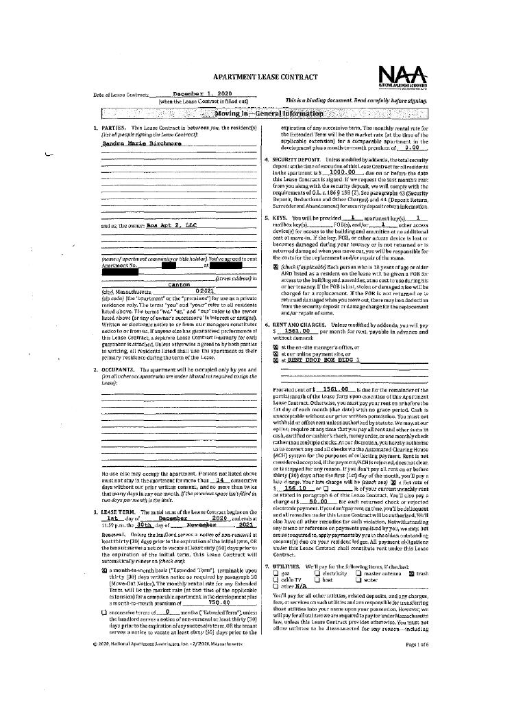
Exhibit 7 — page 1 of 43
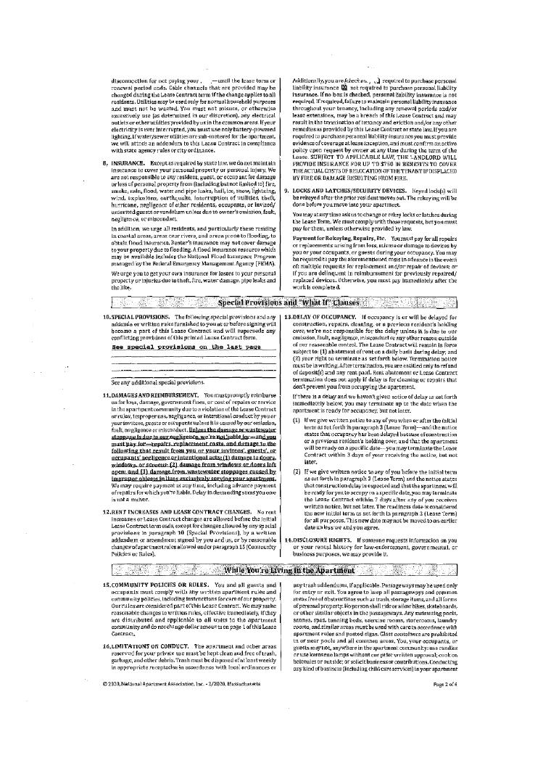
Exhibit 7 — page 2 of 43
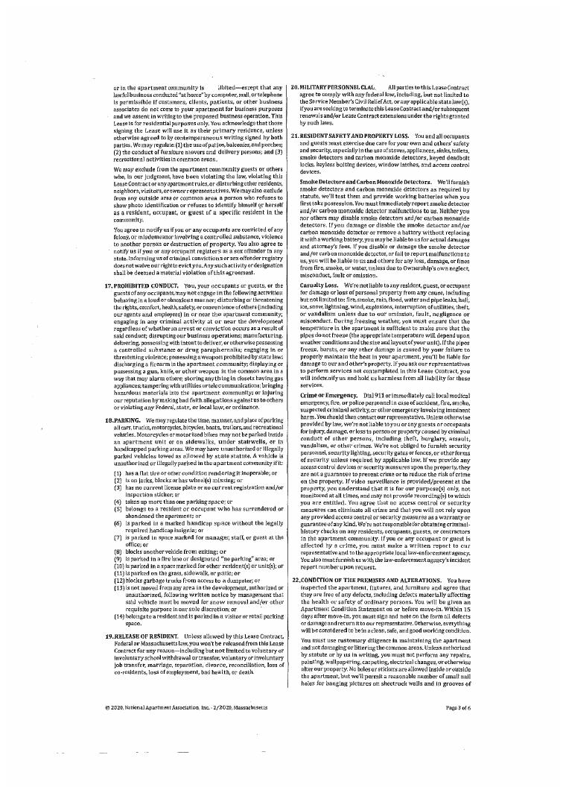
Exhibit 7 — page 3 of 43
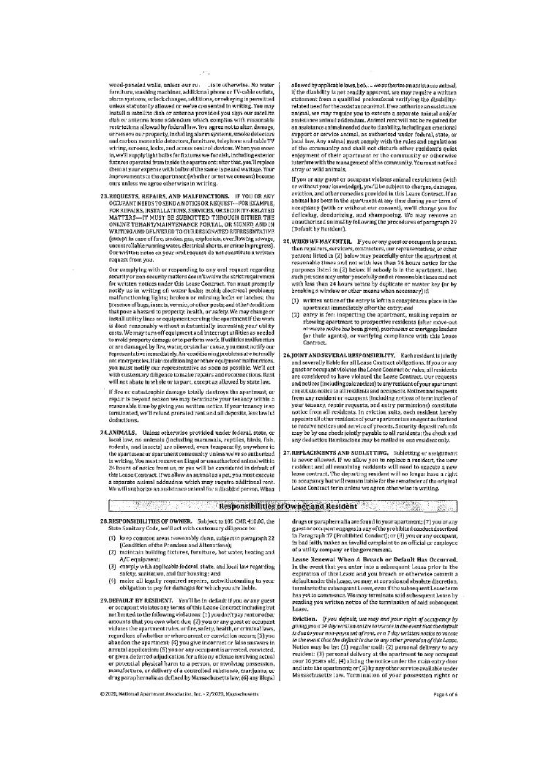
Exhibit 7 — page 4 of 43
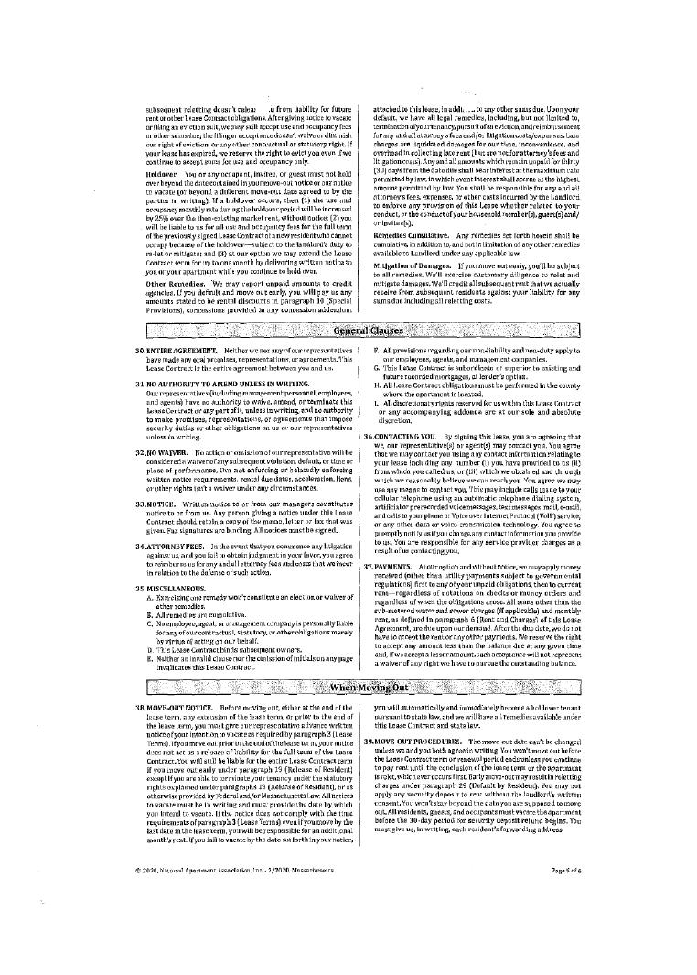
Exhibit 7 — page 5 of 43
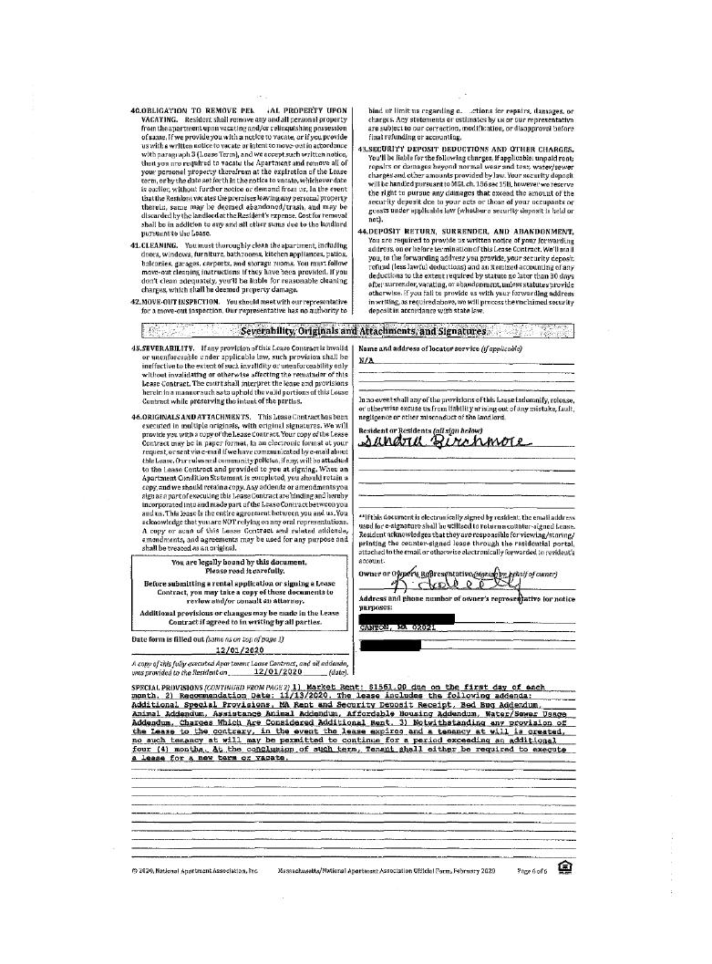
Exhibit 7 — page 6 of 43
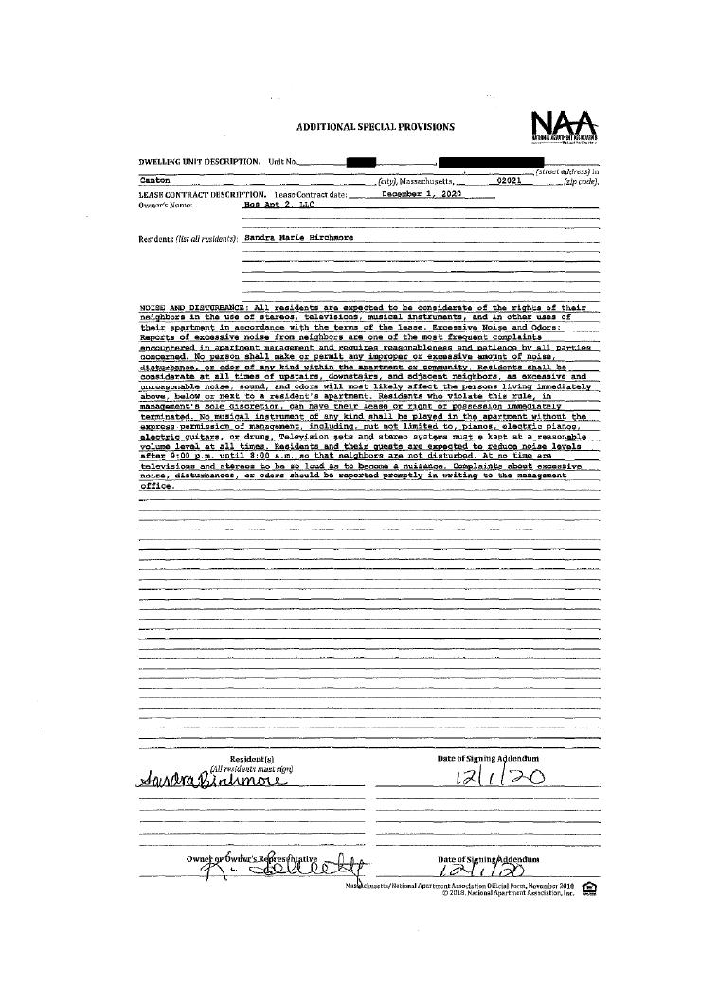
Exhibit 7 — page 7 of 43
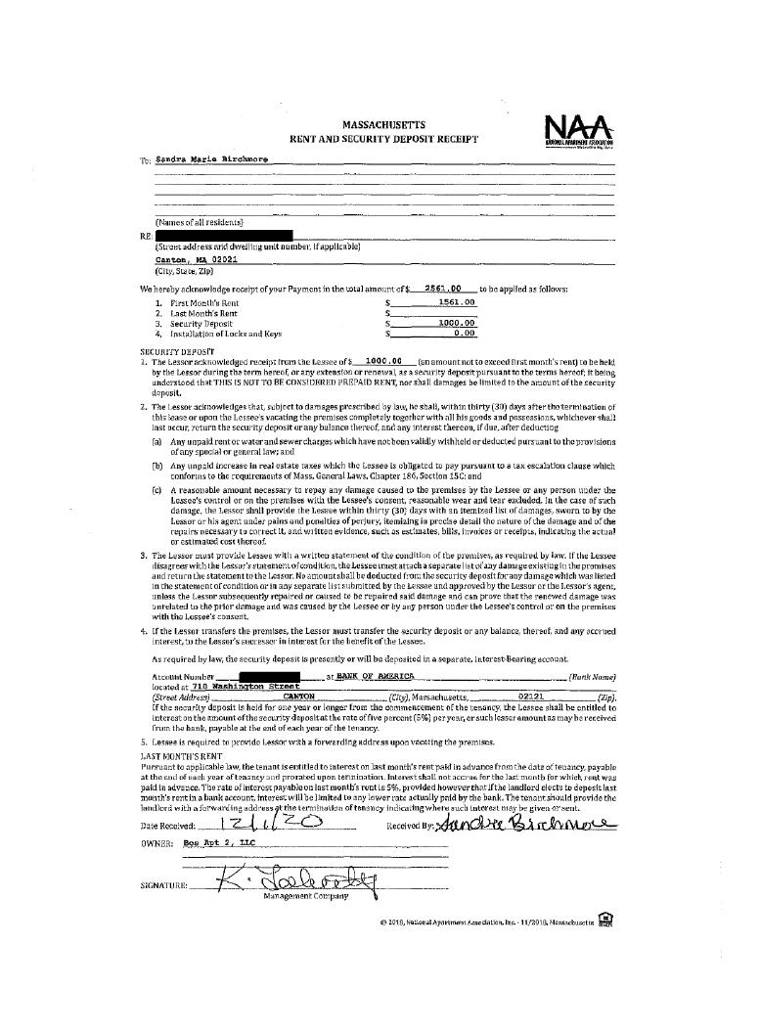
Exhibit 7 — page 8 of 43
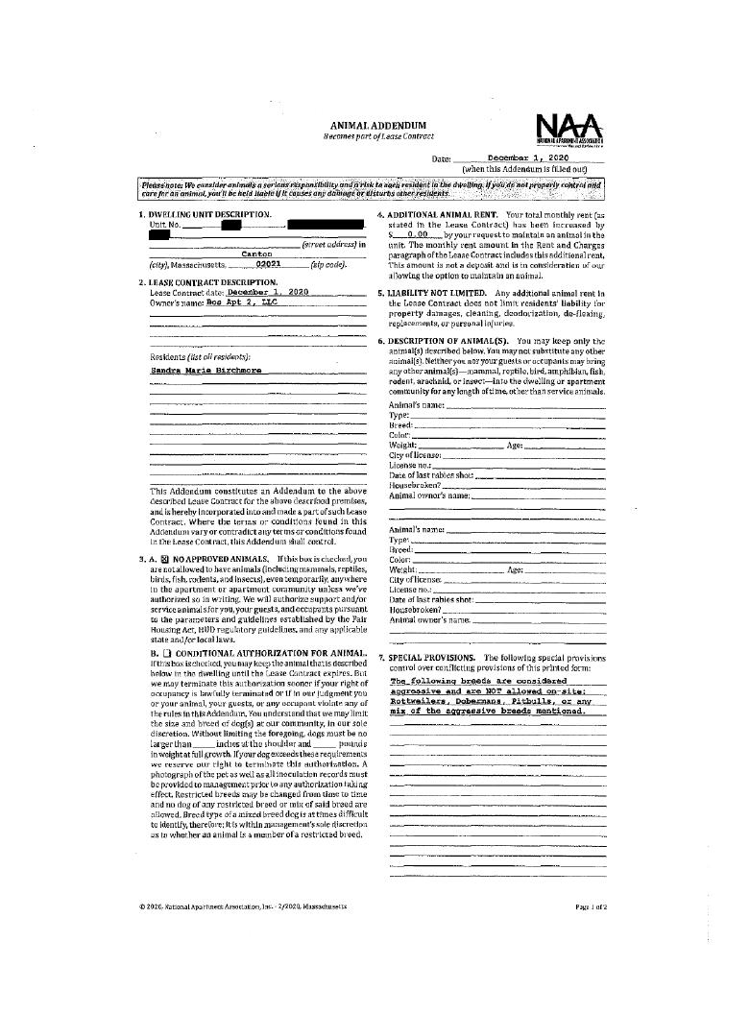
Exhibit 7 — page 9 of 43
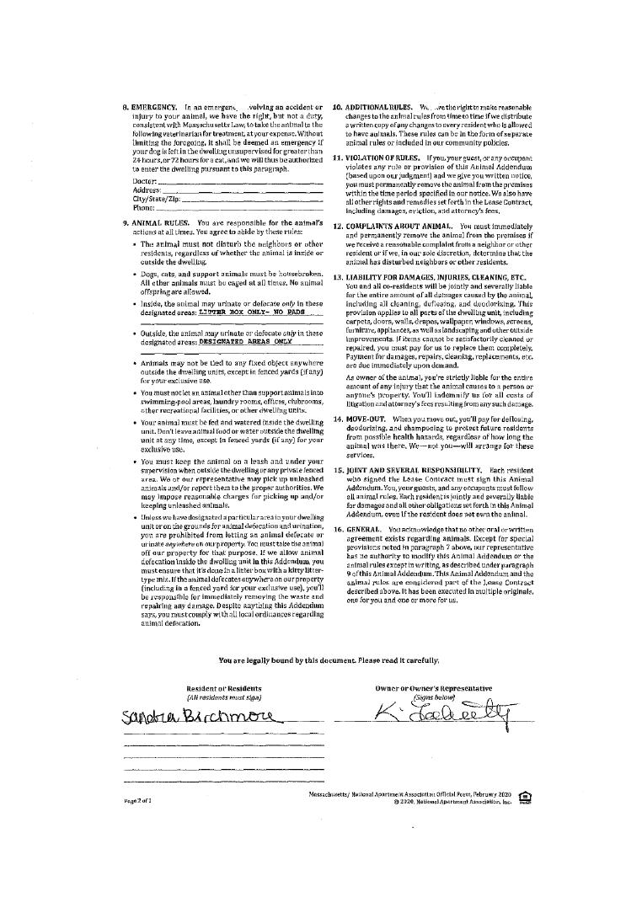
Exhibit 7 — page 10 of 43
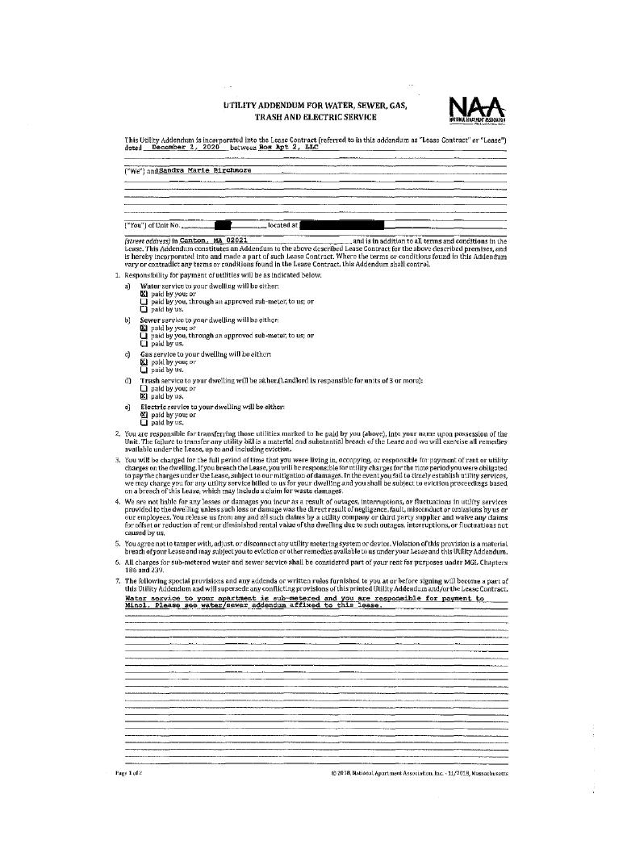
Exhibit 7 — page 11 of 43
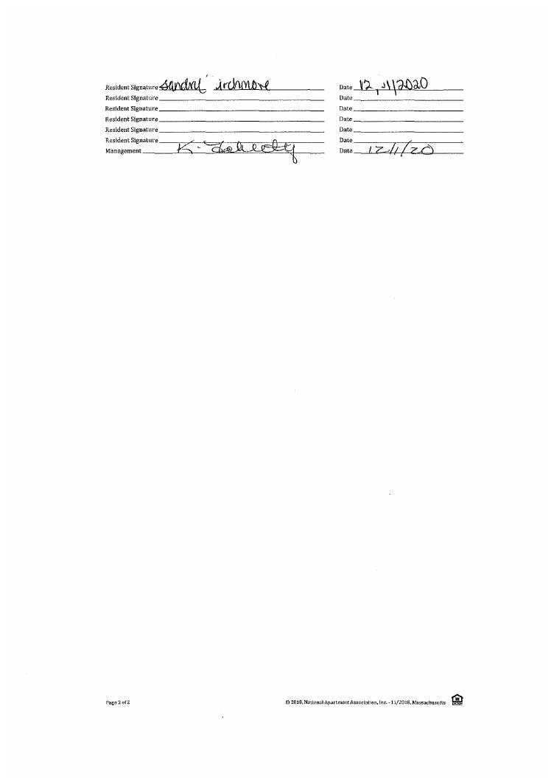
Exhibit 7 — page 12 of 43
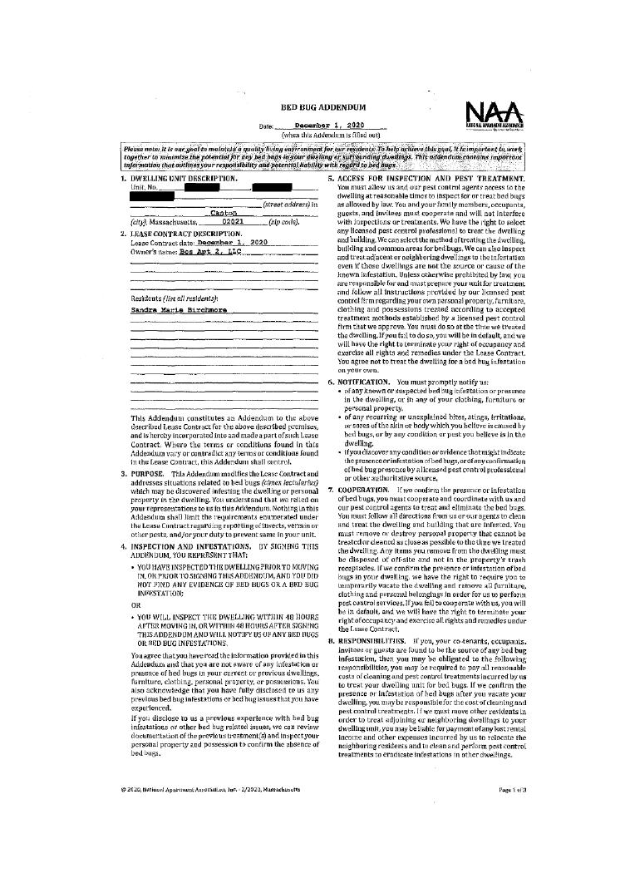
Exhibit 7 — page 13 of 43
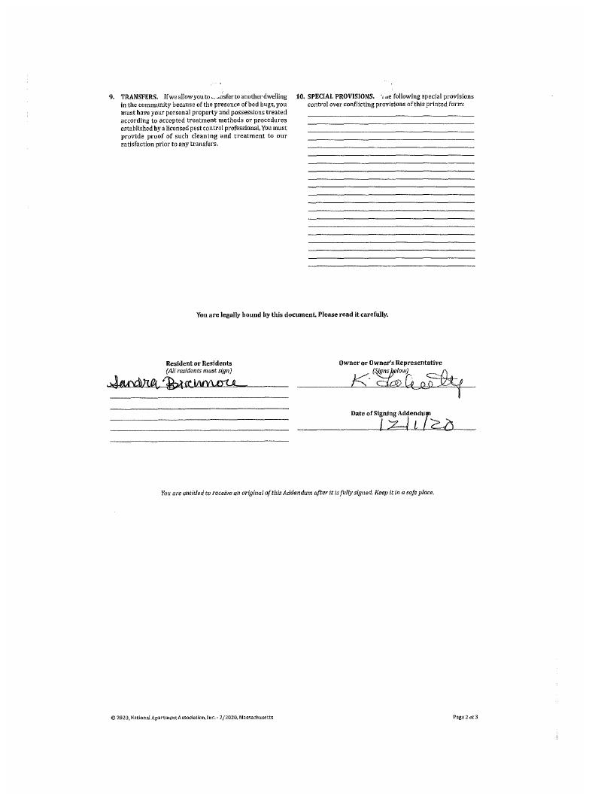
Exhibit 7 — page 14 of 43
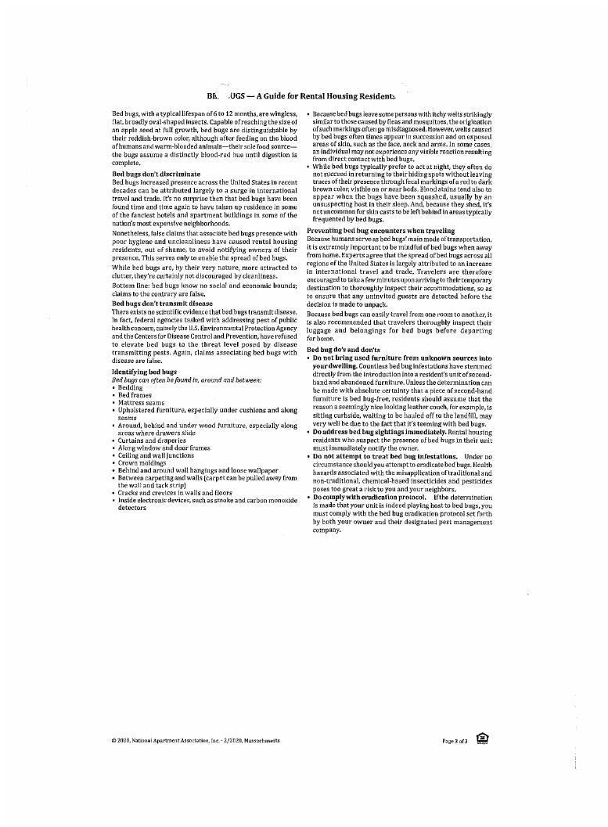
Exhibit 7 — page 15 of 43
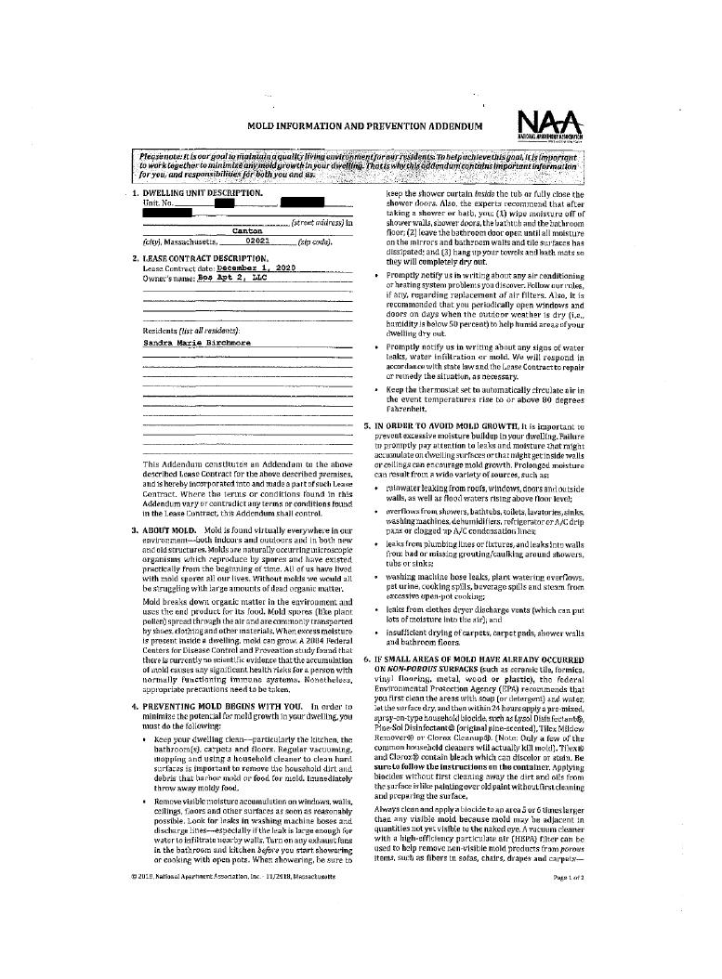
Exhibit 7 — page 16 of 43
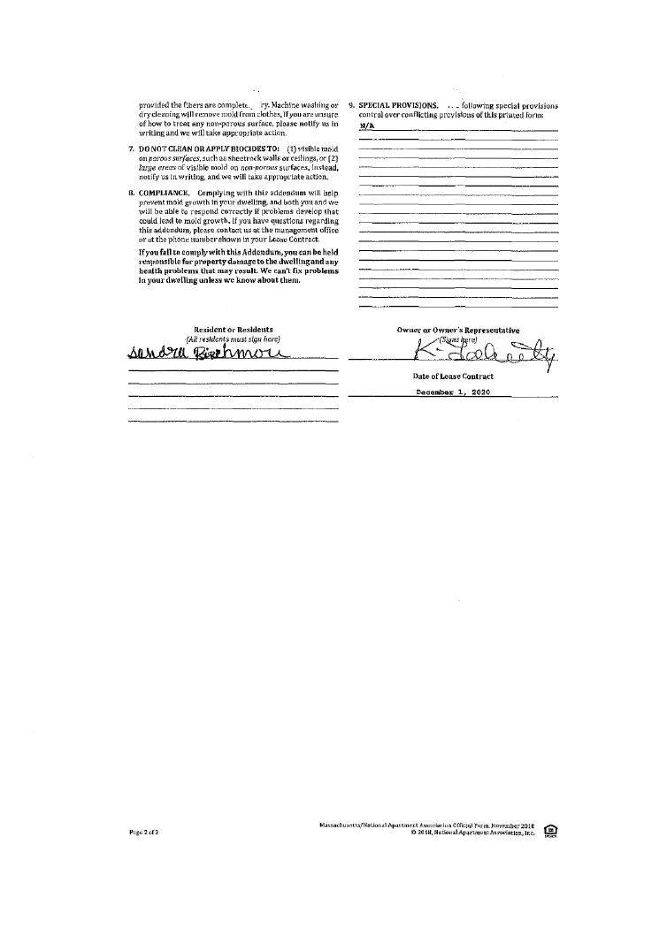
Exhibit 7 — page 17 of 43
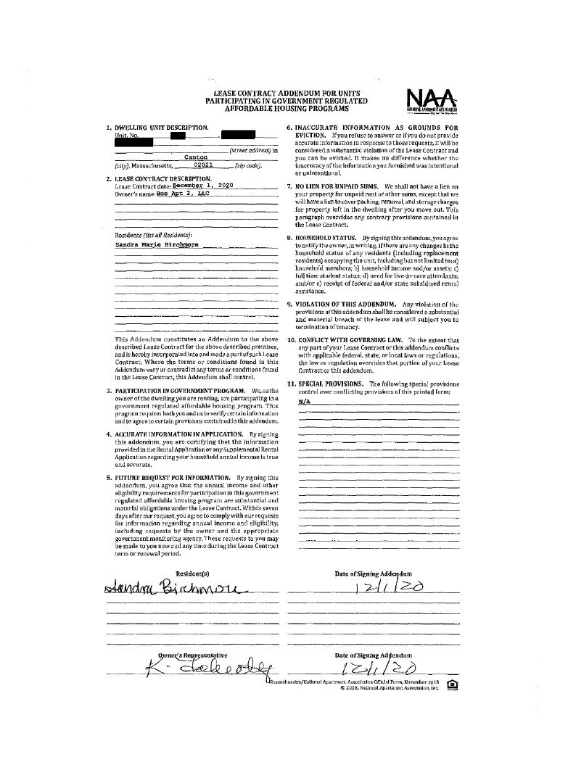
Exhibit 7 — page 18 of 43
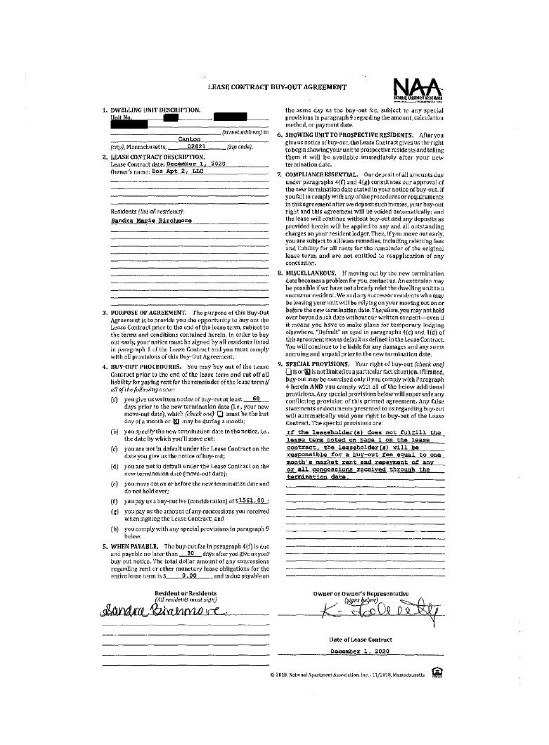
Exhibit 7 — page 19 of 43
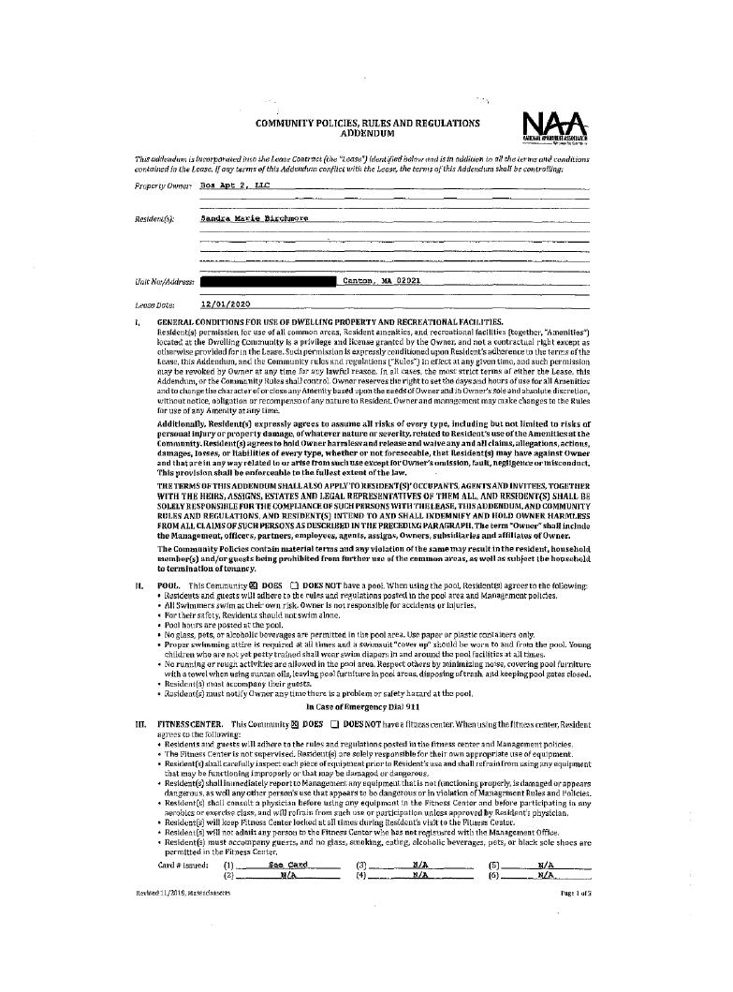
Exhibit 7 — page 20 of 43
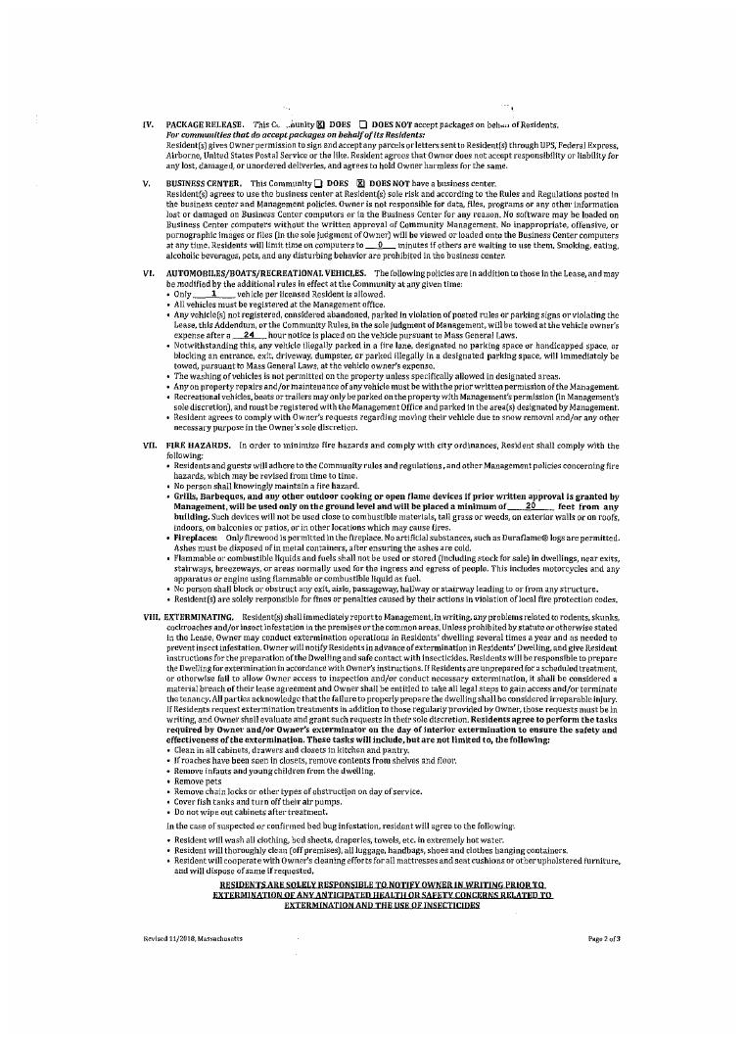
Exhibit 7 — page 21 of 43
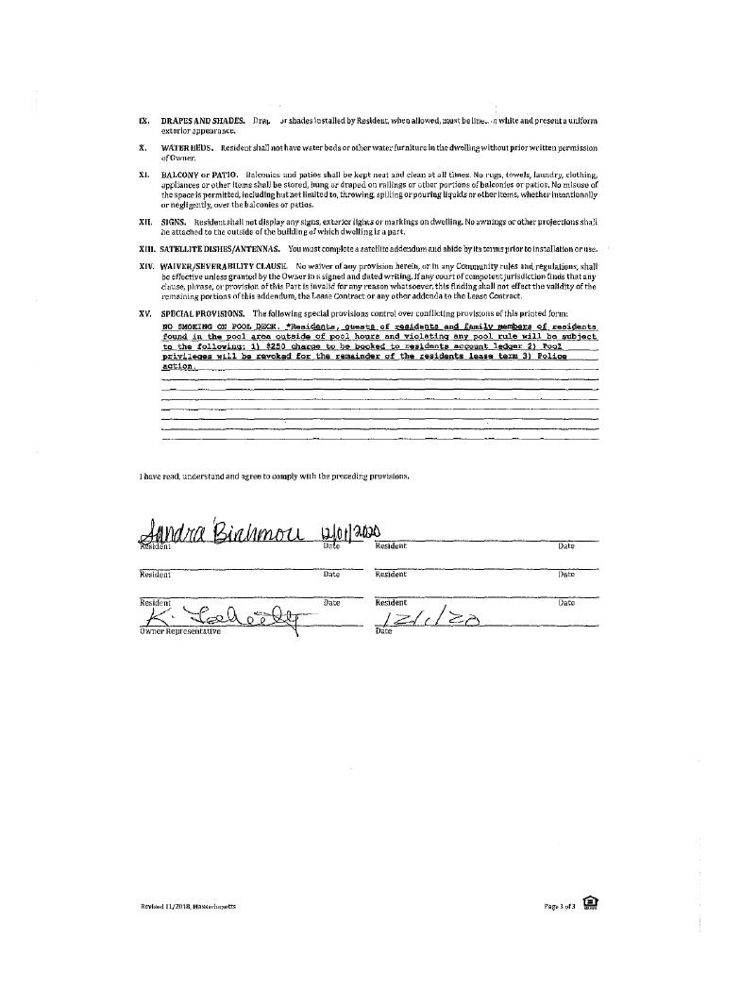
Exhibit 7 — page 22 of 43
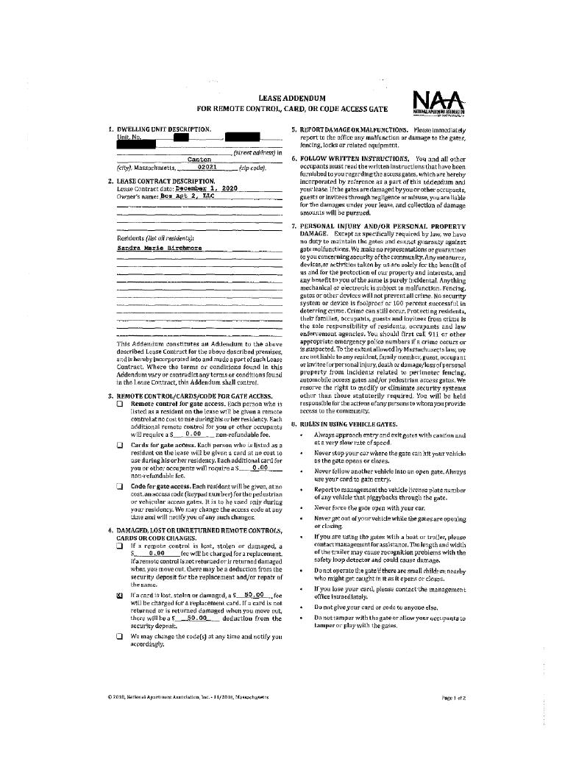
Exhibit 7 — page 23 of 43
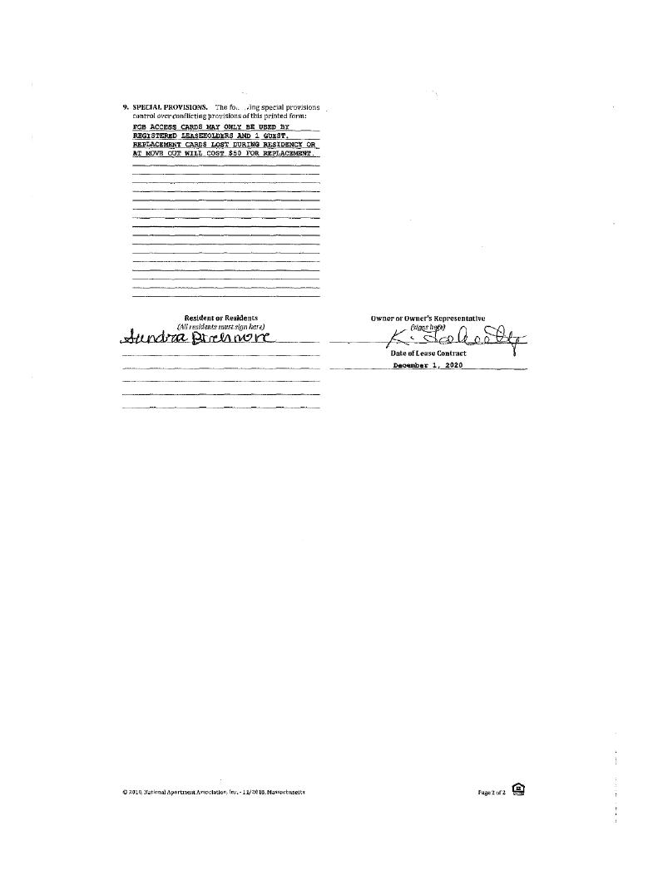
Exhibit 7 — page 24 of 43
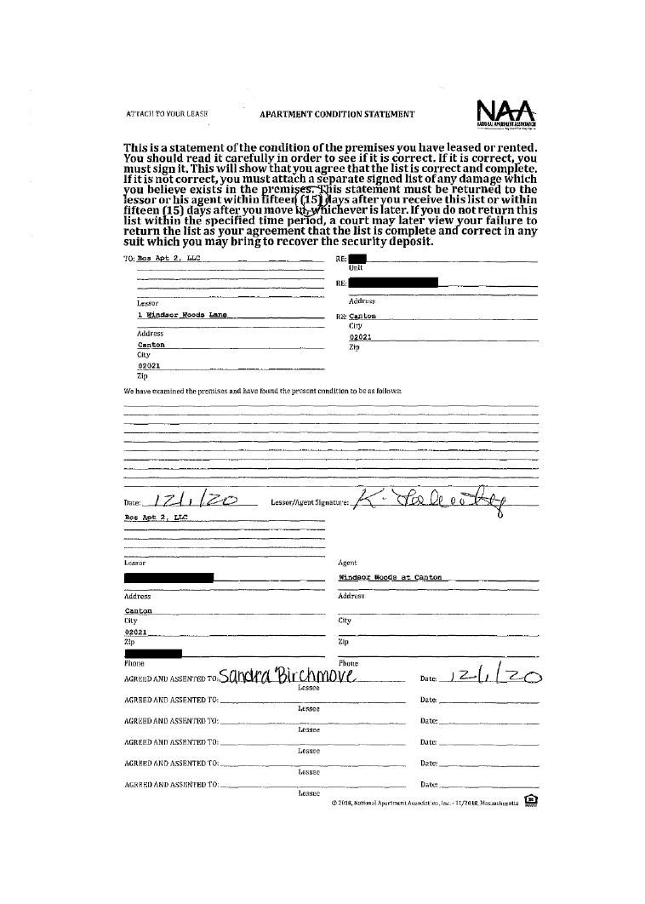
Exhibit 7 — page 25 of 43
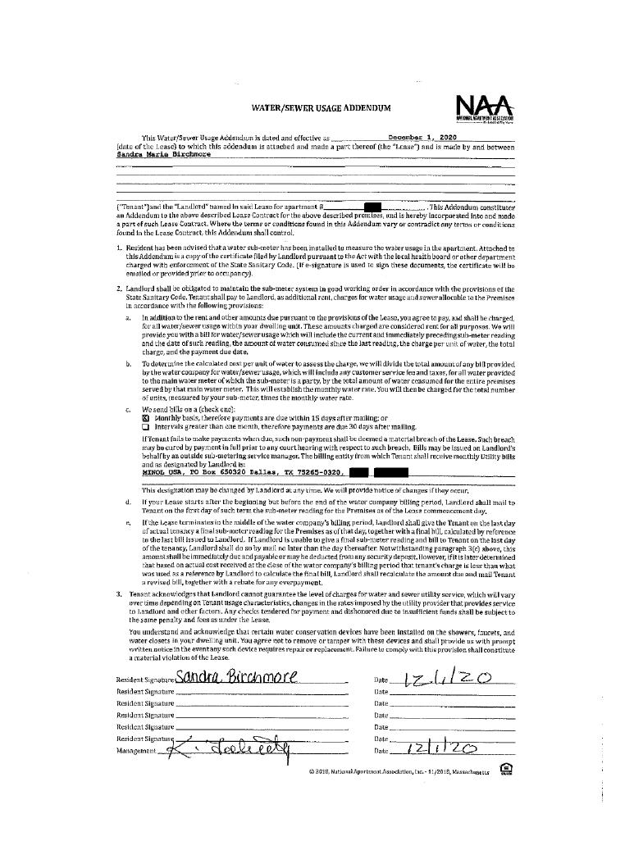
Exhibit 7 — page 26 of 43
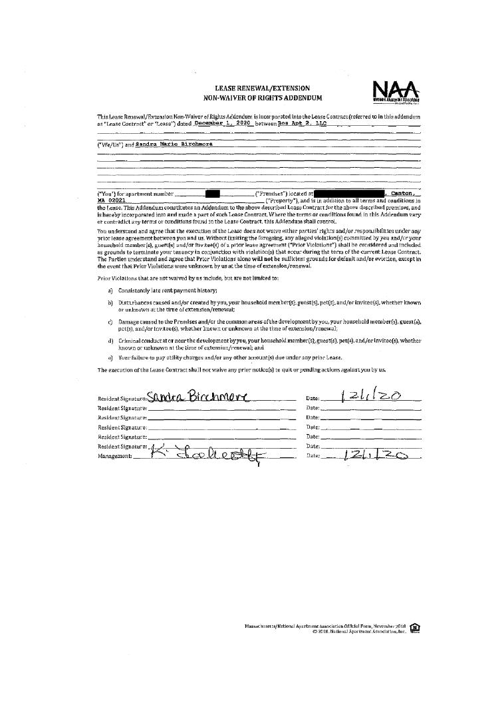
Exhibit 7 — page 27 of 43
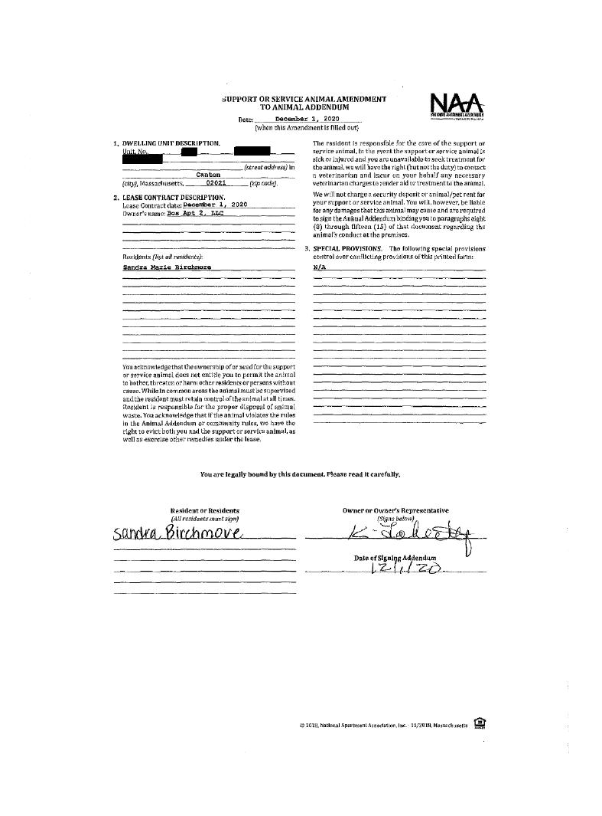
Exhibit 7 — page 28 of 43
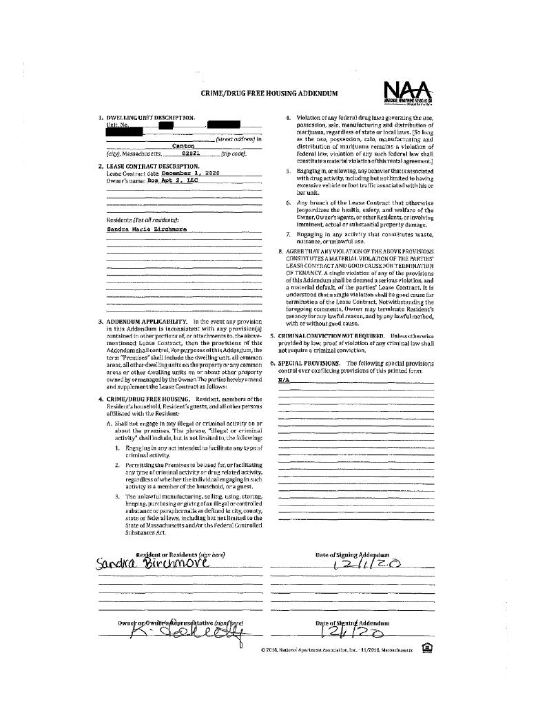
Exhibit 7 — page 29 of 43
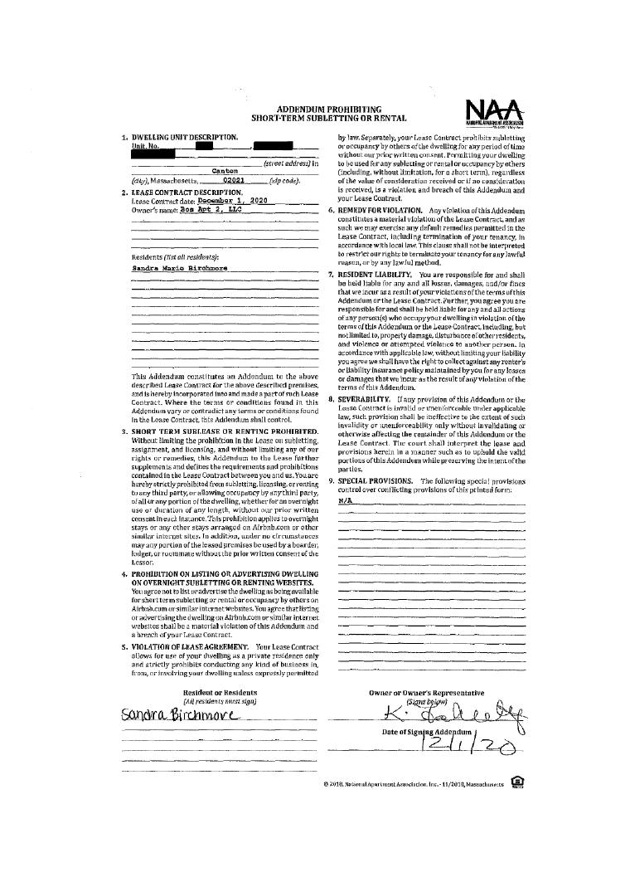
Exhibit 7 — page 30 of 43
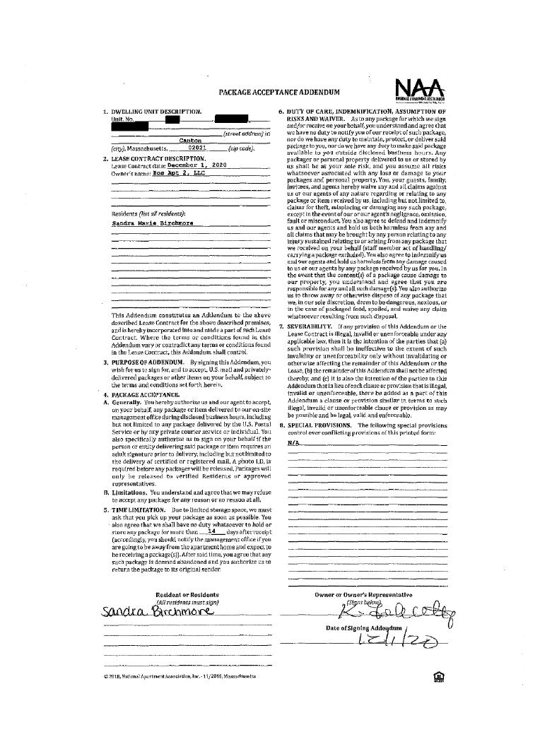
Exhibit 7 — page 31 of 43
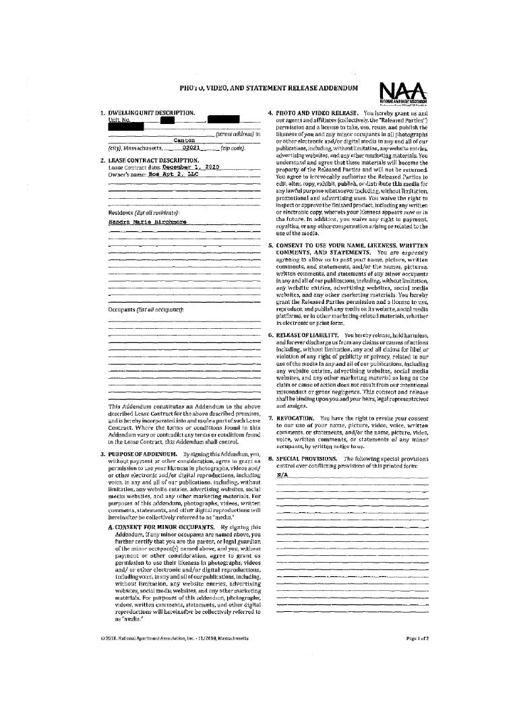
Exhibit 7 — page 32 of 43
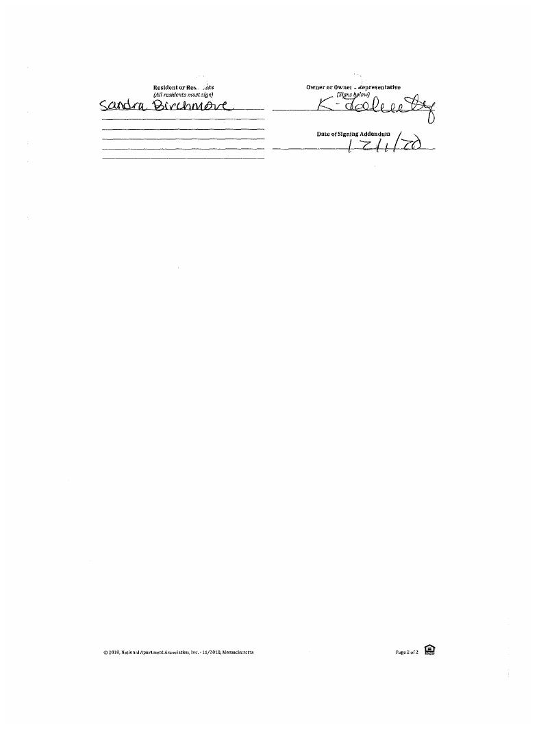
Exhibit 7 — page 33 of 43
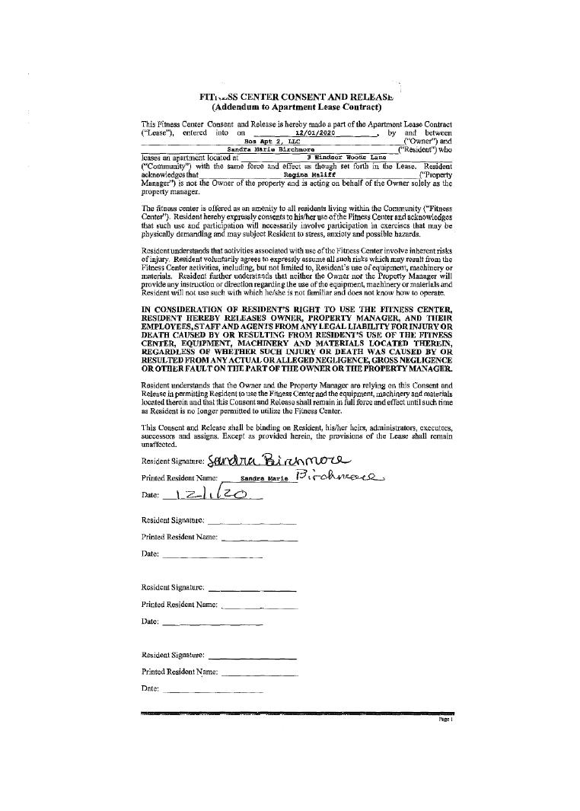
Exhibit 7 — page 34 of 43
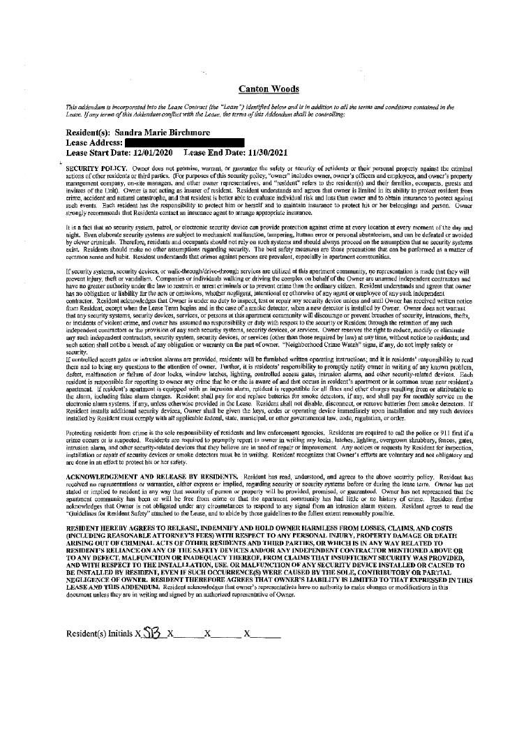
Exhibit 7 — page 35 of 43
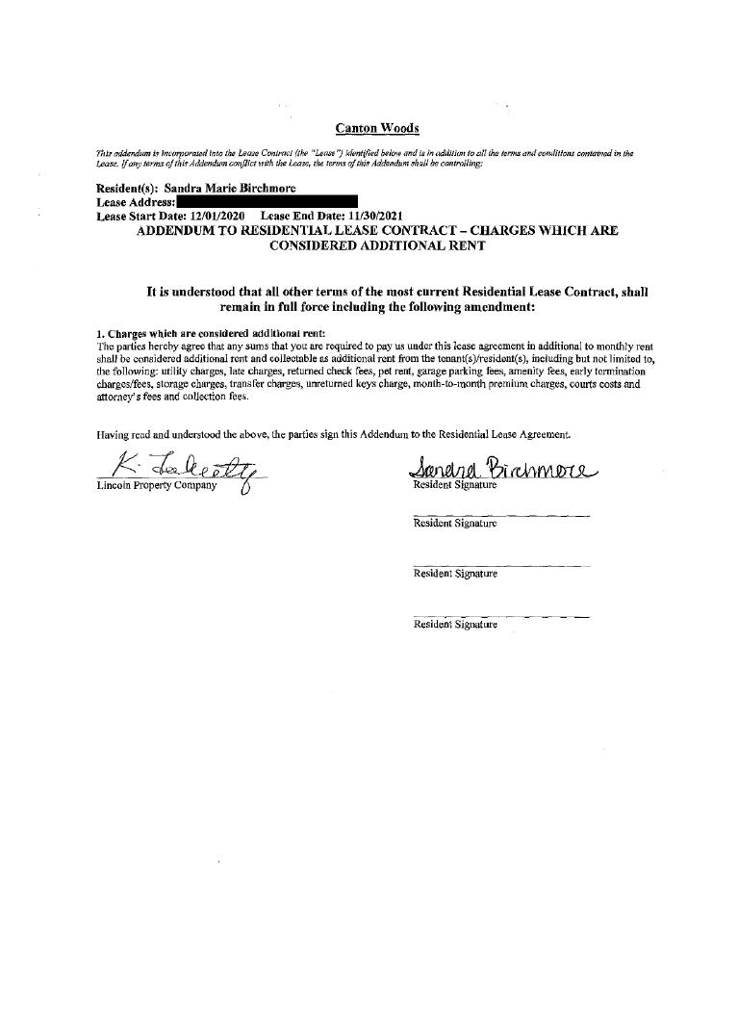
Exhibit 7 — page 36 of 43
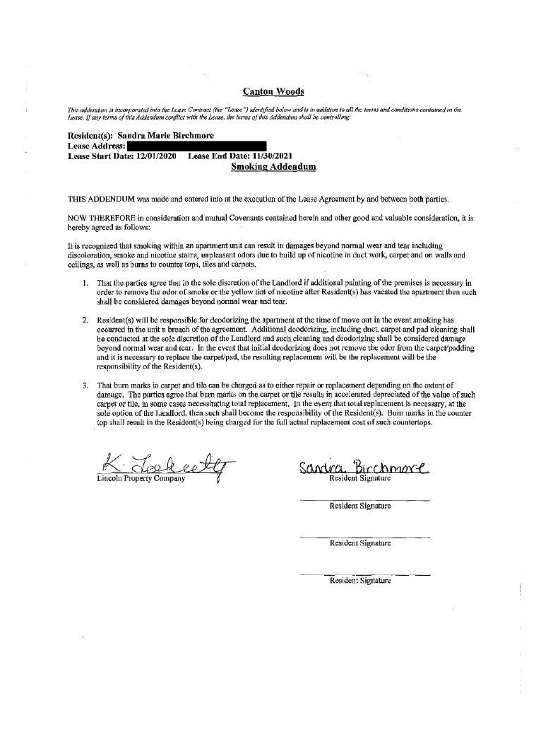
Exhibit 7 — page 37 of 43
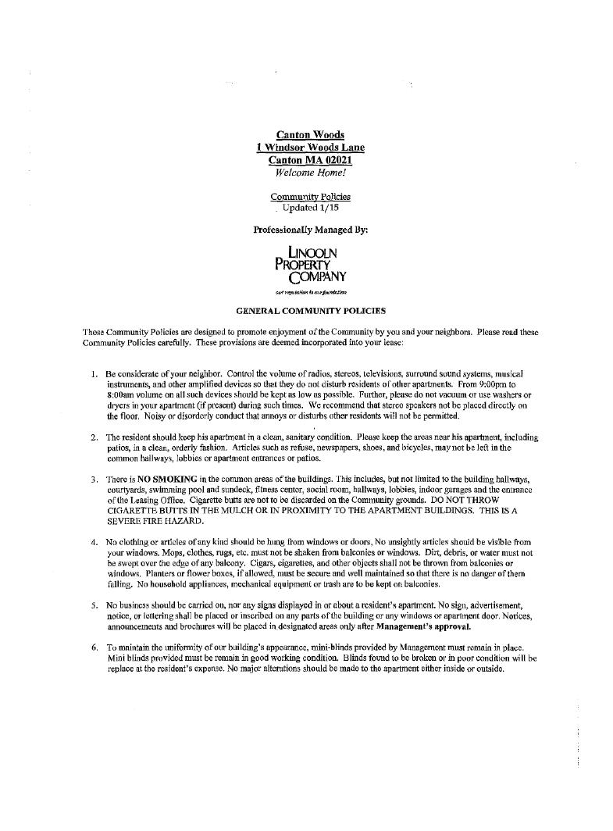
Exhibit 7 — page 38 of 43
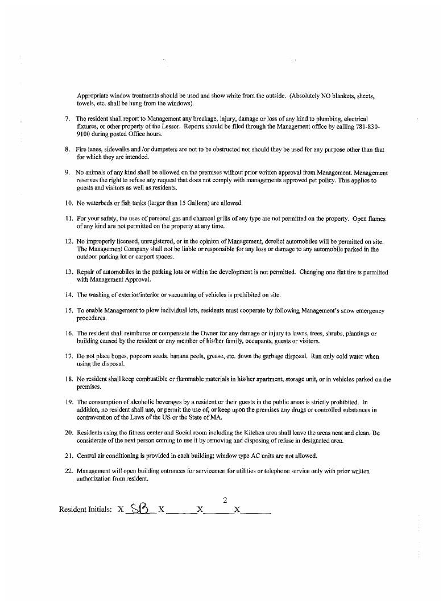
Exhibit 7 — page 39 of 43
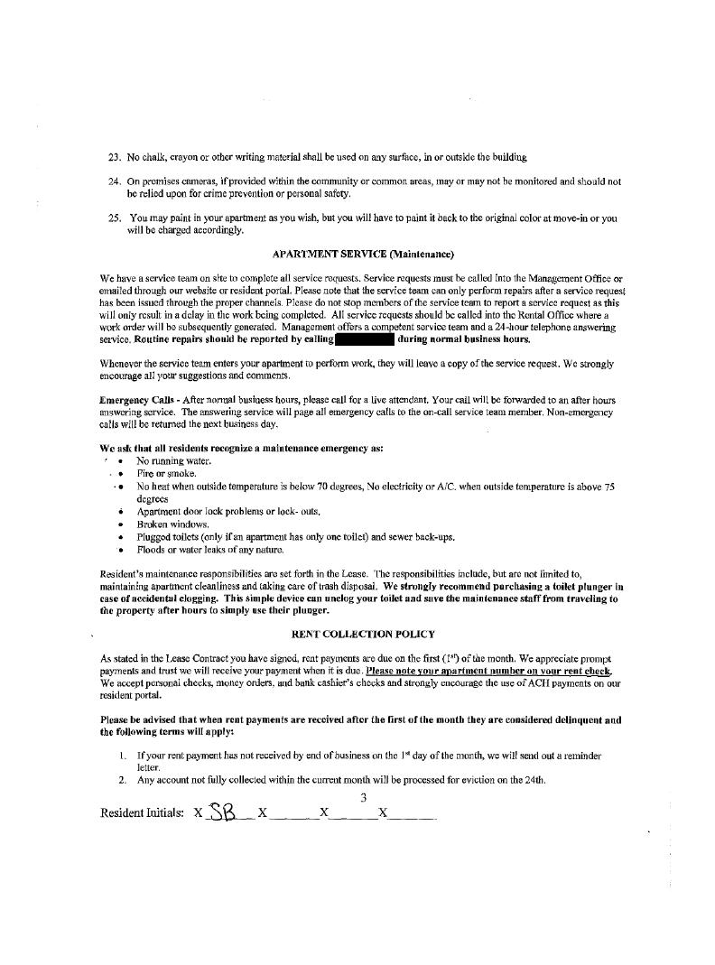
Exhibit 7 — page 40 of 43
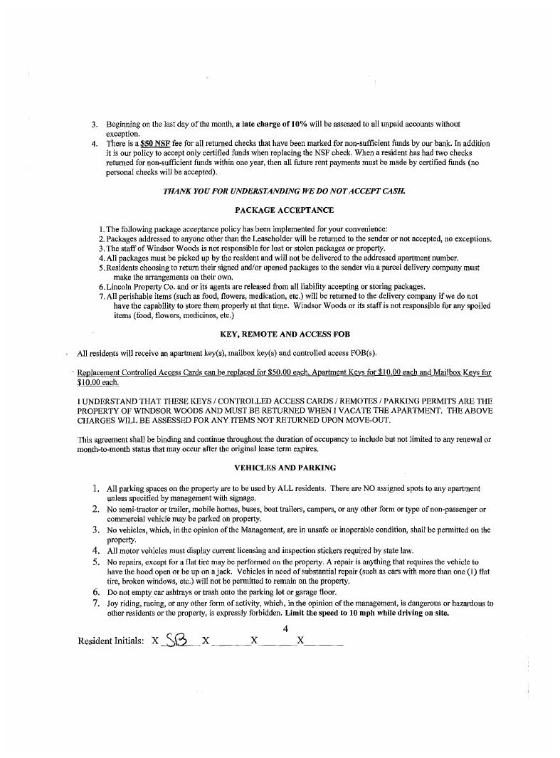
Exhibit 7 — page 41 of 43
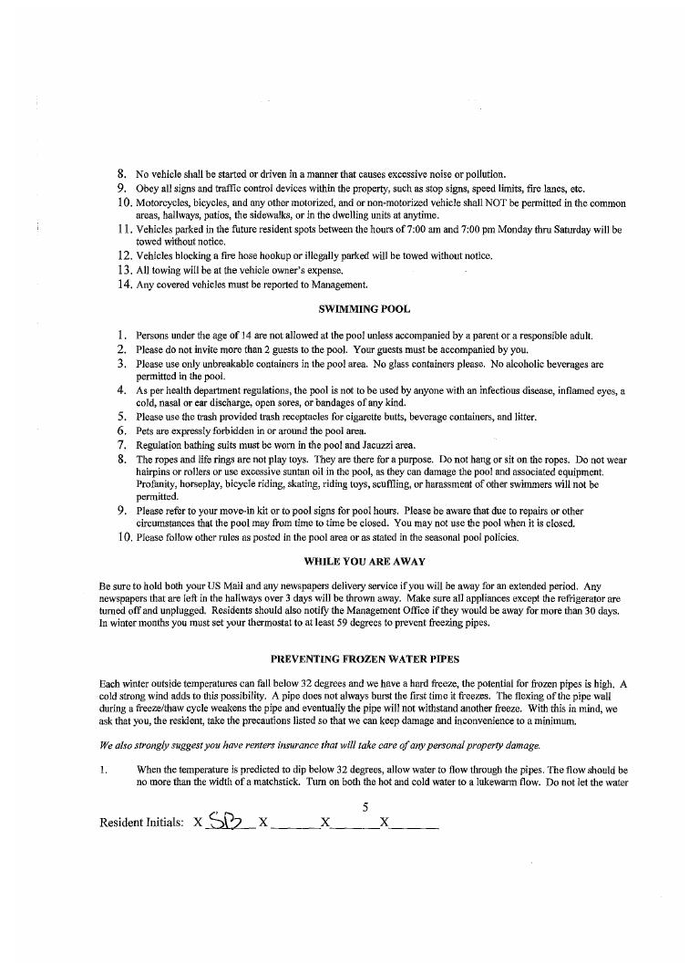
Exhibit 7 — page 42 of 43
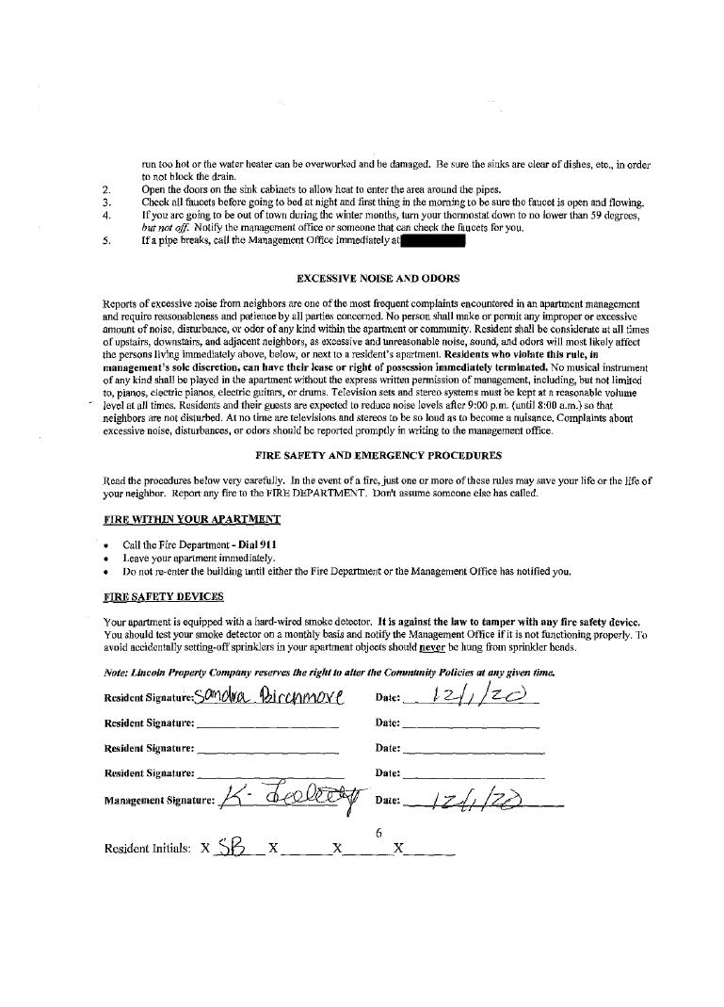
Exhibit 7 — page 43 of 43

Exhibit 37
Court-released Exhibit 37 — cropped form received from the court.
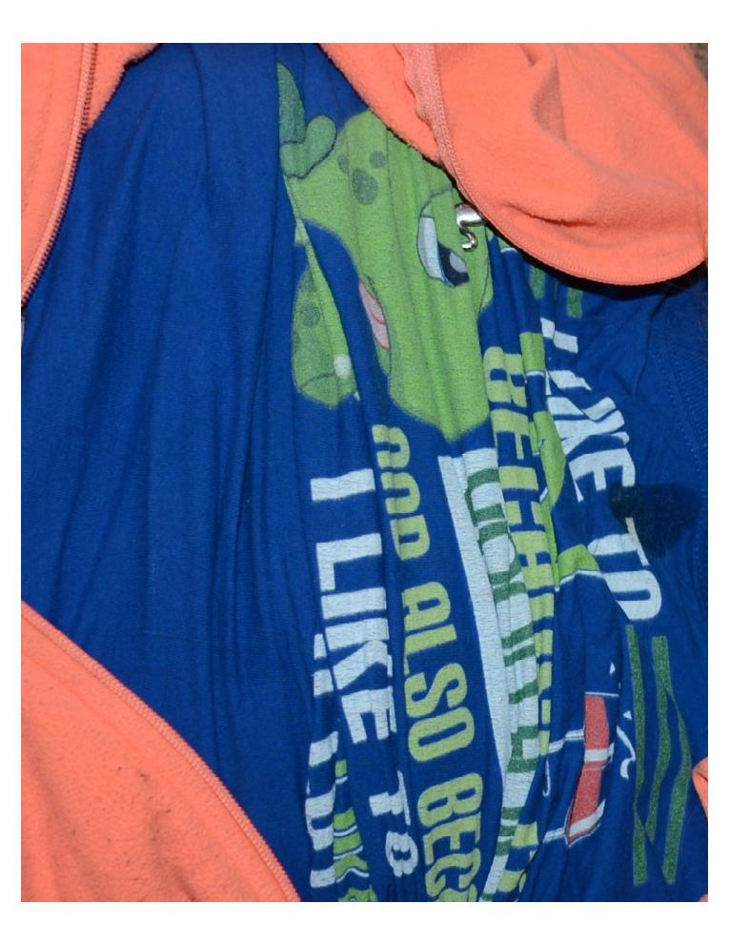

Exhibit 56
Court-released Exhibit 56 — three-page writing referenced during Dunne testimony.
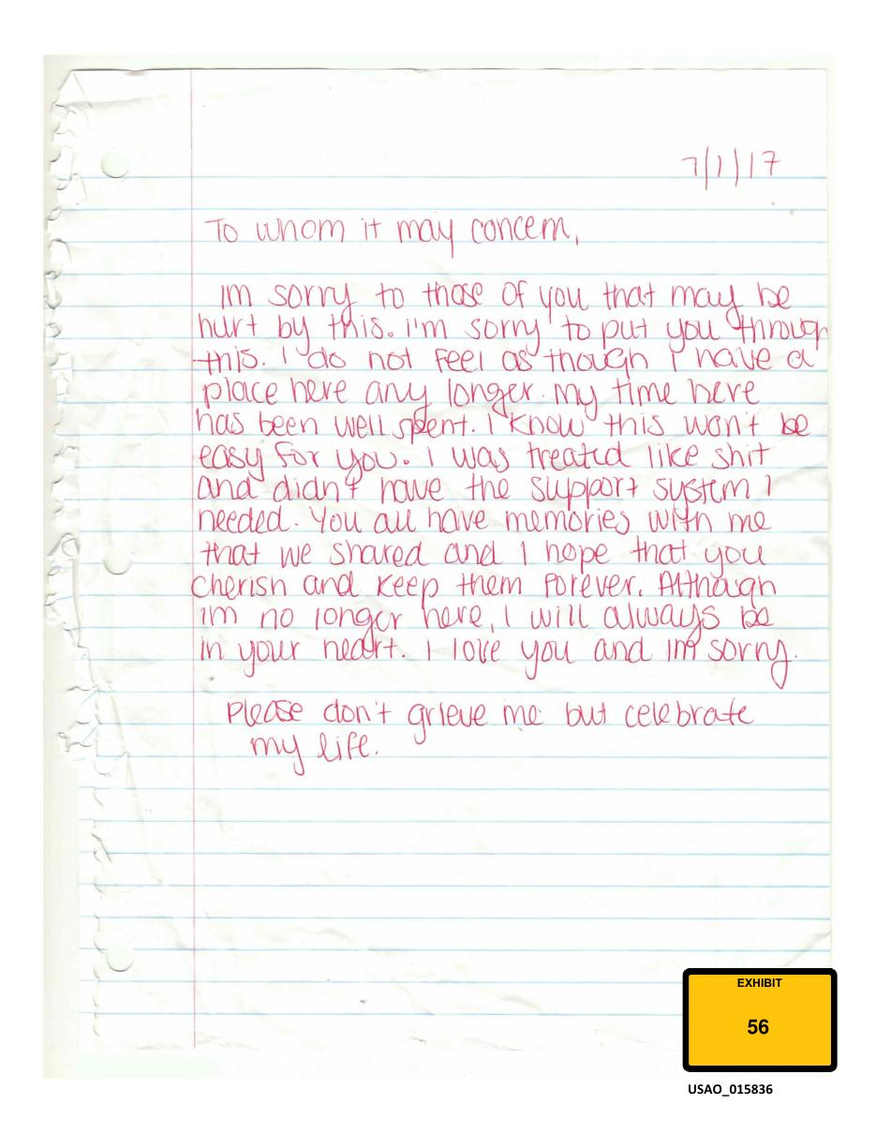
Exhibit 56 — page 1 of 3
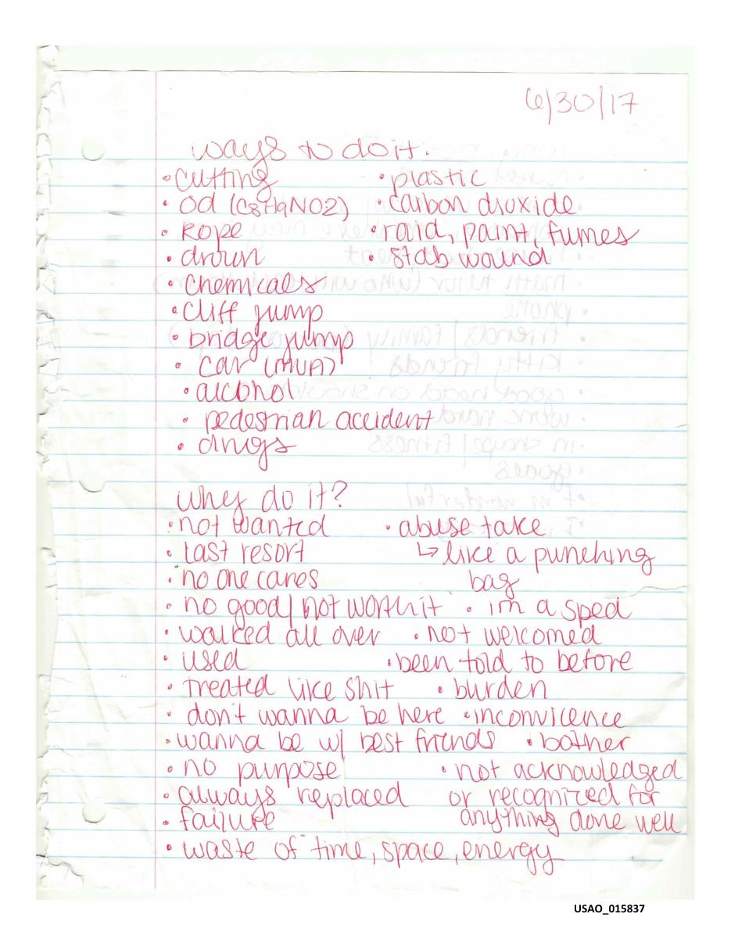
Exhibit 56 — page 2 of 3
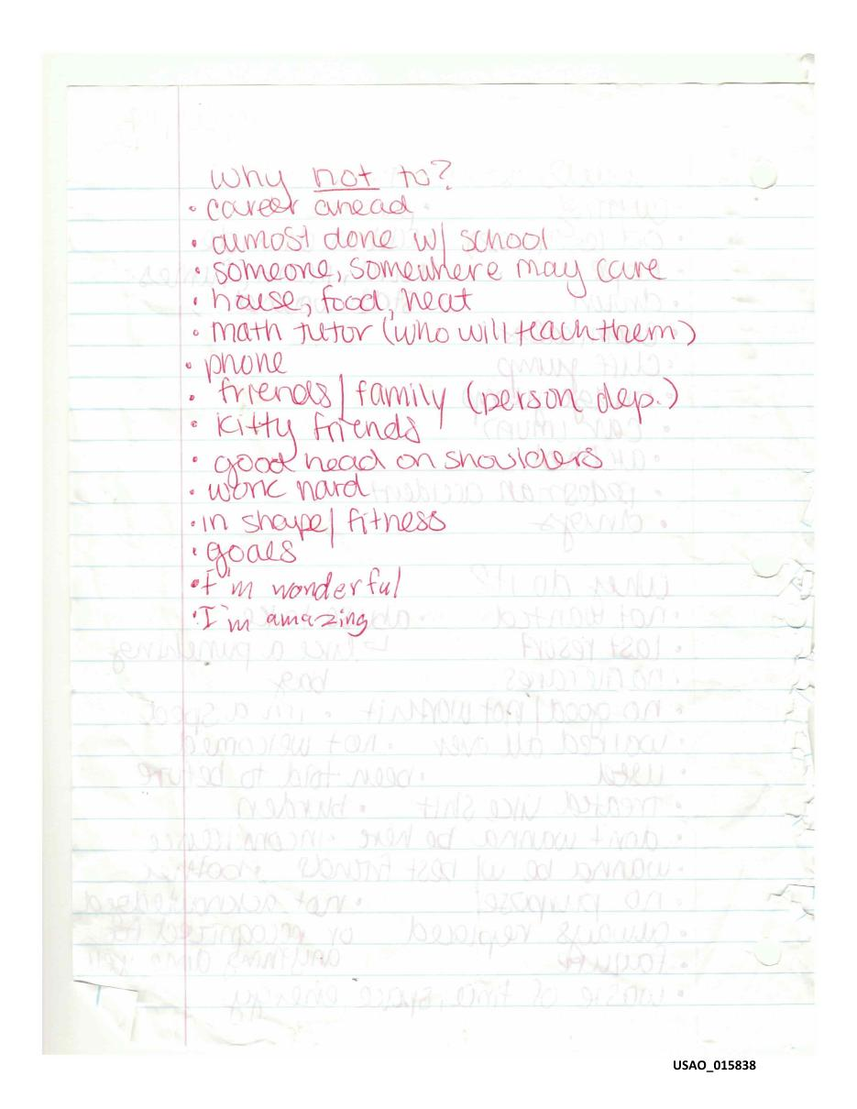
Exhibit 56 — page 3 of 3

Exhibit 64
Court-released Exhibit 64 — neutral archival description; no unsupported evidentiary identification added.
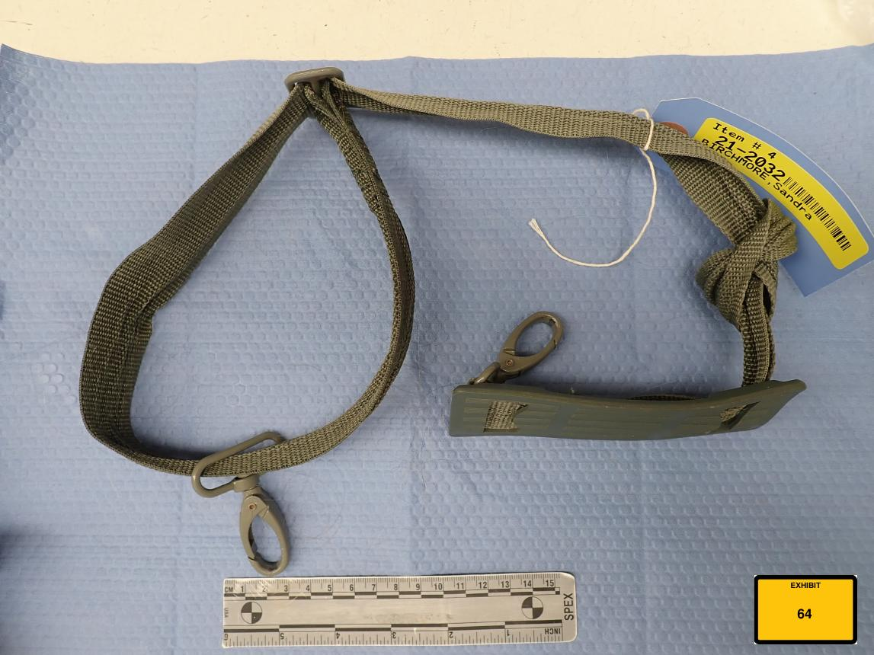

Exhibit 106
Court-released Exhibit 106 — retrospective early-trial archive inclusion.
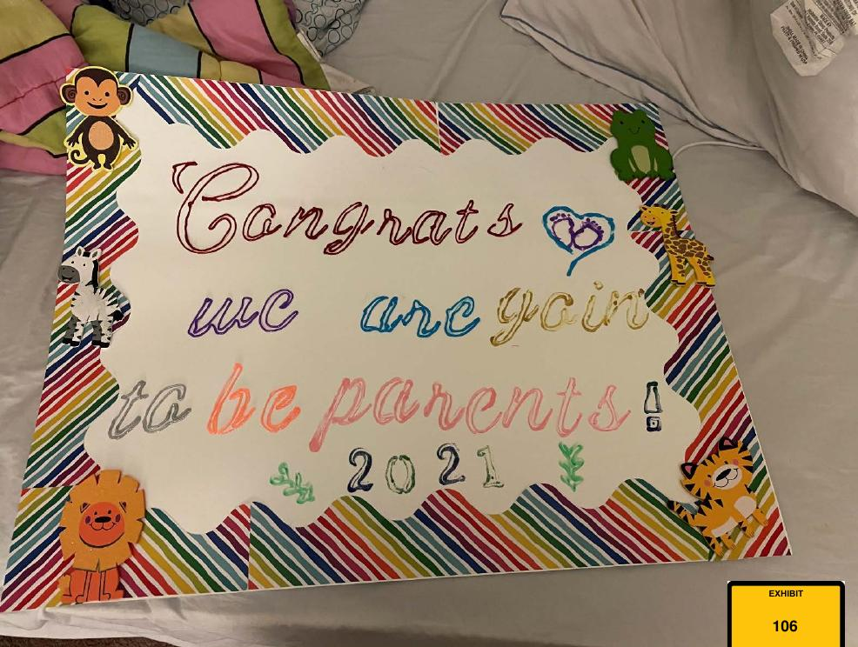

Exhibit 297
Court-released Exhibit 297 — 2019 Massachusetts State Police Homicide Conference agenda.
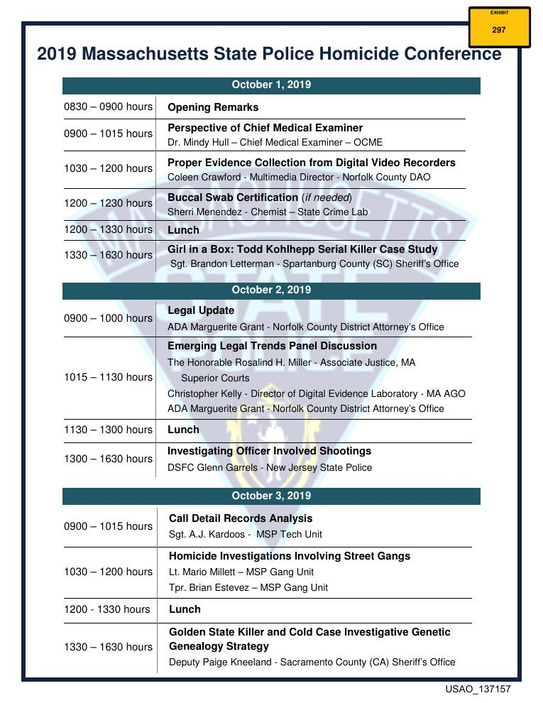

——————————————————
Support the reporting
This archive is made possible by Grant Smith Ellis’s excellent on-the-ground courtroom reporting and his permission to use that work in this project. If you’ve found the reporting useful and would like to support his work directly:
Venmo · Cash App · PayPal
All donations go directly to Grant Smith Ellis; this archive is unaffiliated with and receives no proceeds from them.

