October 30, 2026 | Day’s End Report
United States v. Matthew Farwell • Day 15 • Court-day reconstruction
Reconstructed from contemporaneous courtroom notes by Kristina Rex and courtroom reporting by Amelia Stern and Michele McPhee. Not an official or verbatim transcript.

Defense Witness #5 — Dr. Melissa Piasecki
Dr. Melissa Piasecki, a forensic psychiatrist and professor at the University of Nevada, Reno School of Medicine, testified for the defense. The jury entered at approximately 9:05 a.m. Piasecki testified that she evaluated Sandra Birchmore’s suicide risk by reviewing records from childhood through adulthood, including medical, mental-health, school and emergency-room records, as well as trial testimony. She had not met Birchmore.
Courtroom sources: Rex notes, 1/2 · Rex notes, 2/2 · Stern, jury and witness · Stern, witness background

Direct examination — defense
Piasecki described childhood adversity and its possible long-term effects. She discussed Birchmore’s mother’s chronic illness, the absence of her biological father, changes in schools, and records describing behavioral and mood difficulties beginning around age 10. She referred to diagnoses of attention-deficit disorder and an unspecified mood disorder and to prescriptions for psychiatric medications. She also discussed records of difficulties with peer relationships, alcohol use beginning in adolescence, and attachment-related concerns.
The defense displayed a journal entry from 2017 that Piasecki characterized as a suicide note. She discussed the entry as part of her assessment of future suicide risk. Piasecki testified that once a person begins to consider, plan or communicate suicide as an option, that history remains relevant to later risk assessments. The jury reviewed pages of the note, including a section addressing reasons not to die. Piasecki discussed the importance of reasons for living in psychiatric assessments.

Exhibit 56 · USAO_015836 · Letter dated July 1, 2017
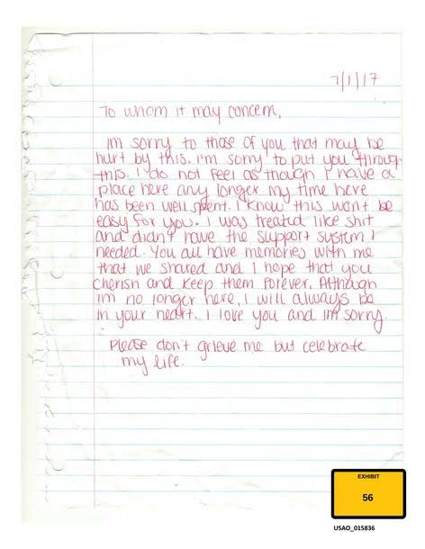

Exhibit 56 · USAO_015837 · Journal page dated June 30, 2017
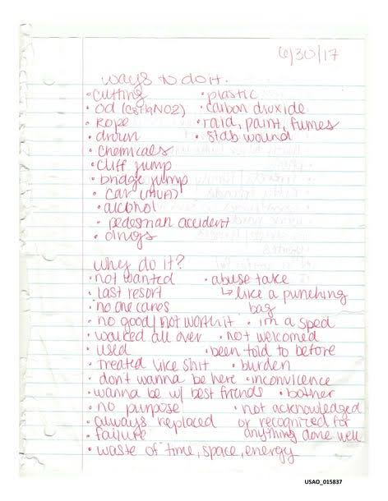

Exhibit 56 · USAO_015838 · “Why not to?” page
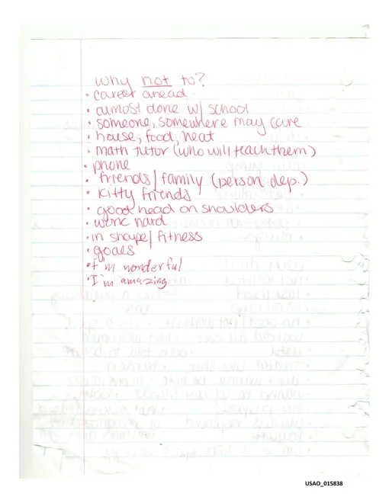

Questioning turned to losses in Birchmore’s family, including the deaths of her mother and grandmother. Piasecki also referred to a stepfather whom she described as having been killed. She discussed bereavement, social support, and the possibility of lasting effects from childhood loss. Other topics included Birchmore’s premature birth and neonatal care, asthma treatment, and psychiatric records. Piasecki discussed factors she considered in reviewing the records, including the use of certain medications, impulsivity and reported risk-taking behaviors.
Piasecki described pregnancy as a period that can involve both positive social engagement and significant difficulties, including hormonal changes, changes in support and renewed grief. She reviewed reports of Birchmore’s prenatal depression screening and her treatment with sertraline (Zoloft). She testified about risks associated with antidepressant treatment, particularly among young people. She also discussed information in records about Birchmore’s anxiety, panic symptoms and relationships.
The defense asked about what Piasecki considered risk-taking sexual behavior, including activity involving rope. She discussed reports of cutting and other statements or writings concerning self-harm. She testified about Birchmore’s sensitivity to separation and abandonment, which she described as “exquisitely sensitive to loss and abandonment.” Piasecki discussed traits consistent with borderline personality disorder but said she was not diagnosing Birchmore.
Piasecki referred to records from therapist Dr. Diala Alkhalil, including recommendations for more intensive care and concerns about Birchmore’s ability to manage distress. She discussed Birchmore’s statements about being afraid that something bad would happen to her and that she would not be found for days. Piasecki said she regarded the statement as potentially significant to her suicide-risk assessment. She also discussed a reported breakup with William Kilroy and her view of the possible impact of losing a relationship with Matthew Farwell.
The court took a morning break at approximately 10:56 a.m. Testimony resumed at approximately 11:19 a.m. Piasecki continued discussing reported self-harm behaviors, interpersonal conflicts, and the factors she considered in assessing suicide risk.
Courtroom sources: Rex notes, 1/2 · Rex notes, 2/2 · Stern, 9:45 · Stern, 10:00 · Stern, 10:30 · Stern, 11:00 · McPhee, journal · McPhee, therapy records

Cross-examination — government
Assistant U.S. Attorney Brian Fogerty began cross-examination by challenging aspects of the information Piasecki had relied upon. He asked about the person she had described as Birchmore’s stepfather, establishing that the person died before Birchmore was born. Piasecki acknowledged that this affected the description she had given. Fogerty also asked whether she was testifying that people with mental-health issues could not be murdered. The defense objected, and Judge Casper sustained the objection.
Fogerty asked about the relationship between childhood risk factors and vulnerability to sexual abuse or intimate-partner abuse. Piasecki said she was not familiar with research supporting some of the propositions put to her. She agreed that therapy can help mitigate suicide risk. Asked whether the attachment issues she discussed involved Farwell, she answered yes.
The government displayed and read text messages between Birchmore and Farwell concerning their early sexual relationship. Fogerty asked about Birchmore’s age at the time of a reported April 10, 2013 encounter. Piasecki said she believed Birchmore was 16 but did not dispute the prosecutor’s suggestion that she was 15. She said an encounter at that age could affect feelings about the defendant. She also said she did not know Farwell’s age at the time.
Fogerty questioned Piasecki about what she knew of Birchmore’s activities and communications on February 1, 2021. Piasecki said she knew Birchmore had been at home and using a computer for part of the day but did not know she had gone to work. Asked whom Birchmore had communicated with after work, Piasecki initially identified Farwell. Fogerty then named numerous other contacts. Piasecki said she did not recall most of them. She agreed with the prosecutor’s statement that Farwell was the last person Birchmore communicated with.
The government questioned Piasecki about Birchmore’s desire to become a mother, her contacts with friends, pregnancy preparations and messages expressing happiness about the pregnancy. Fogerty read messages involving Birchmore and Farwell, including one in which Birchmore described feeling uncomfortable, stressed and scared and thought Farwell might hit her. Piasecki agreed that the conflict she had described in connection with the pregnancy involved Farwell. She also testified that she was unfamiliar with some of Birchmore’s plans, including a proposed gender reveal.
Fogerty asked whether homicide is a leading cause of death among pregnant women. Piasecki answered that it was for some ethnic groups and discussed differences she understood in the data. The prosecutor also asked about friends’ gifts, communications about pregnancy, pregnancy-related internet searches and Birchmore’s discussions with attorney Jessica Katz concerning plans for her child.
The government showed Piasecki a ligature and asked whether it was a rope. She agreed with the prosecutor’s description of it as a duffel-bag strap. Fogerty also returned to the 2017 journal entry and Kilroy’s testimony, asking about what Kilroy had personally observed. Questions concerning “edge play” and its relation to suicide risk drew objections, including sustained objections.
Fogerty questioned Piasecki about a May 2020 incident involving Birchmore and her aunt. He showed a report of a hospital evaluation that recorded negative answers to questions about suicidal thoughts, plans and risk. Piasecki said she did not specifically recall the report and acknowledged the assessment recorded there. The government also displayed text messages exchanged with Farwell while Birchmore was at the emergency room and later that day.
Questions then returned to pregnancy-related symptoms, asthma, sertraline and cutting. Piasecki agreed that sertraline is prescribed to pregnant patients and described its relative safety compared with other antidepressants. She agreed that Birchmore had not reported suicidal thoughts when prescribed the medication. Asked about cutting, Piasecki said it can be a coping mechanism and is not a suicidal act for most people. She confirmed she had not examined Birchmore and had not diagnosed her with borderline personality disorder.
Fogerty also questioned the witness about a search involving the meaning of a purple ribbon and an autocomplete suggestion about a suicide ribbon. Piasecki said she had not reviewed all the surrounding digital evidence and could not recall certain details of Birchmore’s activity on Facebook and messaging services. She agreed with the prosecutor’s questions that Birchmore had not searched for ways to commit suicide or sent suicide messages on February 1. A question about the time Birchmore’s phone stopped moving drew an objection that was sustained.
Courtroom sources: Rex notes, 1/2 · Rex notes, 2/2 · Stern, opening cross · Stern, last-day knowledge · Stern, pregnancy statistics · McPhee, early relationship · McPhee, 2020 report · McPhee, medication · McPhee, digital records

Redirect examination — defense
Defense attorney Kimberly Stevens asked Piasecki about the coexistence of happiness concerning a pregnancy and suicide risk. Piasecki discussed pregnancy-related hormonal changes, concerns about support and the possible reemergence of grief or depression. She also addressed reported difficulty sleeping around January 31 and February 1.
Stevens returned to the breakup with Kilroy and statements he had described to investigators. Asked about Birchmore’s early pregnancy plans and the number of people she told, Piasecki said Birchmore appeared to seek attachment and positive engagement with others and was developing “very detailed and colorful” expectations for the pregnancy, delivery and life afterward.
Stevens posed questions concerning a possible breakup with Farwell on the night Birchmore died and his alleged statement that the baby was not his. The government objected to certain formulations, and Judge Casper sustained the objections. In response to a rephrased question, Piasecki discussed Birchmore’s reported reactions to earlier losses and said the loss of the relationship with Farwell would have been the final relationship she was losing.
Courtroom sources: Rex notes, 2/2 · Stern, 1:15 · McPhee, redirect

Recross-examination — government
Fogerty asked whether Birchmore and Farwell had broken up previously. Piasecki said they had, but not while Birchmore was pregnant. She agreed that Birchmore communicated with many people, adding that she did so selectively. Asked about Birchmore’s final communication, she agreed that her last message to Farwell welcomed him into her home.
Courtroom sources: Rex notes, 2/2 · McPhee, recross · Stern, 1:15

Court schedule and jury instructions
Judge Denise J. Casper told jurors that court would sit for full days Monday, November 2, Tuesday, November 3, and Wednesday, November 4, from approximately 9 a.m. to 4 p.m. There would be no court on Thursday, November 5. Jurors were told to expect closing arguments on Friday, November 6, with possible deliberations that day. The judge reminded them not to discuss or research the case during the weekend.
The court discussed the length of closing arguments. The government requested 90 minutes, and the defense requested the same amount; Judge Casper took the request under consideration. The notes also record that a charge conference for counsel was planned for Monday after court. Proceedings concluded at approximately 1:20 p.m.
Courtroom sources: Rex notes, 2/2 · Stern, adjournment · McPhee, closing arguments · McPhee, jury instruction

