Grant Smith Ellis Court Log
United States v. Matthew Farwell
October 19, 2026
Reconstructed from Grant Smith Ellis’s contemporaneous courtroom reporting on X

About this report
This document reconstructs Grant Smith Ellis’s contemporaneous courtroom reporting from his posts on X. Grant-authored reporting is reproduced as retrieved and organized chronologically by testimony/proceeding; editorial organization and known retrieval limitations are documented in the Source & Editorial Notes near the end.

Pre-Jury Proceedings
8:01:04 AM ET
Good morning from inside Boston's Moakley Federal Courthouse, where this will be today's live thread coverage for testimony in the Sandra Birchmore and Matthew Farwell trial.
I am here so early the media room is still closed.
I am wandering the building looking for Barb.
Reminder; there will be a short mod-morning towel break in coverage due to pre-exisiting medical and personal appointments.
God bless you all and thank you for your understanding.
Open original post on X
8:38:09 AM ET
Okay, I've taken my seat inside the overflow room and I'll be here for the next few minutes until it is time for my towel break.
I have asked @ameliarstern1 to attempt to provide a real-time set of notes while I am gone, and she said she will do her best.
You got this, Amelia!
Open original post on X
8:45:44 AM ET
Chief Judge Casper is very upset this morning about certain folks from the media, and members of the public, posting trial exhibits of Sandra's dead body.
I tried to tell you all not to do that.
No more exhibits may be published.
Full order - https://t.co/6B7dThm10F
Ruling in full;
UNITED STATES DISTRICT COURT
DISTRICT OF MASSACHUSETTS
UNITED STATES OF AMERICA
v.
MATTHEW FARWELL,
Defendant.
Case No. 24-cr-10259-DJC
ORDER
CASPER, C.J.
October 19, 2026
To ensure that the ongoing trial in this case continues to be conducted in a manner conducive to providing a fair and impartial trial for Defendant Mr. Farwell, pursuant to the Local Rules, this Court’s inherent authority and as consistent with applicable law, the Court FINDS and ORDERS as follows:
On Friday, it was brought to this Court’s attention that one party to this case, the government, had posted copies of the exhibits admitted in the course of the ongoing trial on its publicly available website. To this point in the trial, exhibits have included but not been limited to photos of the body of Ms. Birchmore as discovered on February 4, 2021, items seized from the alleged crime scene, journal entries, and data from electronic devices seized in the investigation of the alleged crimes charged against Defendant Mr. Farwell.
During the course of this trial, the jury must be free from outside influences so that they can consider the evidence presented and, at the end of the case, render a verdict based solely on the evidence and the applicable law. Although the Court has advised, and will continue to advise, the jurors of their obligation not to view or consider outside information about the case, it is appropriate for the Court to take additional measures to ensure that jurors remain free of any outside influence about the nature of evidence presented and to ensure that Mr. Farwell receives a fair and impartial trial. In re Globe Newspaper Co., 920 F.2d 88, 97 n. 10 (1st Cir. 1990) (noting the Court’s “needs to protect its essential processes, including the jury system, from . . . influences that threaten the objectivity and independence of jurors”); see United States v. Chin, 913 F.3d 251, 258 (1st Cir. 2019).
Against this compelling interest, the Court has considered the public’s interest in an “open judicial process.” In re Globe, 920 F.2d at 9. This trial is and remains a publicly accessible proceeding. As noted in this Court’s Order of September 30, 2026 (which remains in place and full effect), D. 295, to accommodate the public and media, in addition to the space in Courtroom 10, the Court has provided two, overflow courtrooms with closed circuit video feed to the courtroom. The public, including the media, have been present to hear and see the evidence in the form of witness testimony and exhibits, and the media has been able, and will continue to be able, to report on these proceedings.
Having considered the balance of these interests, particularly in a highly publicized case involving allegations of a killing and predicate acts involving the alleged coercion and enticement and deprivation of the rights of a minor, the Court ORDERS that the government remove and not post or distribute any exhibits in this case before a verdict is rendered in this case. These measures are necessary to ensure a fair and impartial trial for Farwell but are also consistent with this Court’s September 30th Order that attorneys for the parties in this case shall abide by L.R. 83.2.1 regarding the release of information by attorneys, D. 295 ¶ 5, as well with L.R. 83.2.2 (providing that “[i]n a widely publicized or sensational criminal or civil trial, the court may . . . issue a special order governing such matters as (1) extrajudicial statements by parties . . . that are likely to interfere with the rights of the accused or the litigants to a fair trial by impartial jury; . . . and (4) any other matters that the court may deem appropriate for inclusion in such an order”).
This Order shall remain in place and in effect during the duration of the trial proceedings or until further Order of the Court.
So Ordered.
/s Denise J. Casper
Chief United States District Judge
Summary:
In the ongoing federal criminal trial of Matthew Farwell (U.S. v. Farwell, D. Mass., Case No. 24-cr-10259-DJC), Chief Judge Denise J. Casper issued an order on October 19, 2026, directing the government to immediately remove any trial exhibits it had posted on its public website and to refrain from posting or distributing any further exhibits until a verdict is reached.
The order responds to the government having published sensitive materials, including photos of the body of Ms. Birchmore (discovered February 4, 2021), crime-scene items, journal entries, and electronic-device data. The Court emphasized the need to shield the jury from outside influences so it can decide solely on evidence presented in court, while balancing this against the public’s interest in an open judicial process. The trial remains publicly accessible (with overflow courtrooms and closed-circuit video), and the media may continue reporting. The order is grounded in the Court’s inherent authority, Local Rules 83.2.1 and 83.2.2 (on extrajudicial statements in widely publicized cases), and First Circuit precedent protecting juror impartiality. It remains in effect for the duration of the trial or until modified by the Court.
Open original post on X
8:47:01 AM ET
Judge says she has the current witness list.
"Who comes next?
"Dr. Dankitariman or Dr. Roccio.
"Counsel as you may have seen I entered docket 361 as to the posting of the exhibits, so that is the record, counsel I want to talk to you about the disputed exhibits, I did receive two lists counsel. The later list that started with 56 is the correct one?"
"Yes, your honor."
Open original post on X
8:49:29 AM ET
"Just a few things on this list, I under 56 as having been admitted, the majority are medical records and I believe 653 and 658 are journal entries. In regards to E1, and in regards to G11, this may be a defense proposed exhibit, I did not see as falling within my ruling on 412 or mental health, I won't go into the substance of it, this was a like or didn't like this in regards to conduct?"
"Yes, your honor."
"Counsel, just fair warning as to G-11."
"Anything else?"
"No, your honor, we, the defense, will try to lay a foundation through Agent Kelsch and then admit."
"Well, I have 412 concerns so touch base with me. I don't think it falls under any exception of 412."
Good ruling from Judge here. 412 is special character evidence of SA victims.
Open original post on X
8:51:00 AM ET
"What about the 'beyond pissed letter?'"
"Yes, your honor, that goes to financial lssues."
"Okay, I will listen but that is one where I wasn't sure."
"It also may become relevant during the defense's cases-in-chief and it bears on family relationships that may be more relevant later."
"Then government won't object on authenticity ground, it's our position that e-11 and g-11 and inadmissible because they violate a prior court order related to rule 412, but we won't object, other than on relevance, to h-11."
Open original post on X
8:54:40 AM ET
"Counsel, I think e-11 may stand on different ground as it has some references to mental health...on q-10 and r-10, these are Dr. Leonard's records and then a letter...is Dr. Leonard on the witness list? You're not seeking to admit you only want them from cross exam of government witnesses?"
"Yes, your honor, sadly Dr. Leonard has died so he is not on the witness list, but his reports will be relevant during the upcoming witness."
"Your honor, can the government be heard?"
"Yes."
"Your honor, these are not Ms. Birchmore's medical records, it's a letter, so it doesn't fall under the exception. This is a provider for Denise (Sandra's aunt) so it is multiple layers of hearsay. So we don't think the defense can establish that this is a treatment record, or that it is not hearsay, so I would ask the court to review and I don't think it should come in today."
"Okay, I did review...the context of the mother's treatment is relevant..."
"Your honor, it's an older form of medical record, if I may..."
"You may."
"It's an older form of medical record, but it does meet the form of what a medical record looks like and then it is used by later treating doctors."
"Counsel, I'll listen to the foundation and I understand the government's object6ion. At a minimum, if I decide it's coming in, there may be some redaction necessary as it is a wide ranging record."
Open original post on X
8:56:50 AM ET
"Exhibit 751, I think these are Ms. Birchmore's school records?"
"Part of this has already been introduced, her attendance records, but the government's objection here, and this is the problem with exhibits that have multiple areas...if the defense wants to offer Ms. Birchmore's grades, that's fine, but the multiple pages in the middle are not relevant."
"Your honor, the defense wants to show the attendance records from when before Ms. Birchmore met Mr. Farwell, and as to the medical records, we want it for rebuttal but we don't intend to introduce it today."
"I'll listen, counsel, I think some of the attendance records are in. I would expect them to come in anyway, even if they are for a longer period of time. I'll reserve on the other pages for now."
"Counsel, all of the jurors are here."
Open original post on X
8:57:27 AM ET
@ameliarstern1 "Two quick things; for the reasons I articulated on Friday, I will allow, in the limited form I will explain, the government's renewed motion as to the extra martial affairs. There are some parameters I want to discuss with counsel at the end of the day."
Open original post on X
8:58:51 AM ET
"Because Ms. Birchmore's OBGYN might start testifying today, I may give an instruction on hybrid-fact/expert witnesses...is that something the defense wants?"
"Can you preview the instruction for me?"
"I found a pattern instruction out of the 9th circuit that says the person will testify about both facts and opinions, and the fact t6estimony is what they saw heard or did, whereas expert testimony is derived from their education and experience."
Open original post on X
8:59:38 AM ET
BREAKING NEWS:
It is now official, Chief Judge Casper has ALLOWED the DOJ's motion to call Matthew Farwell's mistresses to the stand during the Sandra Birchmore trial.
Farwell fought for months to keep these 3 women off the stand, but his lawyer blew it during openings.
Open original post on X
8:59:54 AM ET
@ameliarstern1 "Okay, the witness can resume the stand."
Open original post on X
9:00:27 AM ET
@ameliarstern1 "Oh, counsel, I received docket 362, is that something that will come up today?"
"Yes, at the end of Agent Kelsch's direct."
"Okay, just remind me please."
"Yes, your honor."
Open original post on X

Special Agent Heidi Kelsch — Continued Direct Examination
9:00:47 AM ET
@ameliarstern1 "All rise for the jury!"
Open original post on X
9:02:44 AM ET
"Morning, jurors we will get started. I remind you, you remain under oath."
"Good morning, Special Agent Kelsch, you talked on Friday about how the defendant talked with Ms. Birchmore about the deletion of messages between them?"
"Yes."
"Your honor, exhibit 157, this is already in evidence."
"Based on the first line, are the two discussing Ms. Birchmore's virginity?"
"Objection?"
"To form?"
"Yes."
"You can rephrase."
Open original post on X
9:03:48 AM ET
"I want to go back to our first time and cum inside, deep inside your virgin pussy."
"Did you like taking my virginity?"
"Yes."
"I am glad you wore a condom. I don't know what you would have done if you came inside me. I miss having you inside me three times a week."
"I remember the first time you let me inside without a condom because I promised to put one on before I came."
Open original post on X
9:04:55 AM ET
"What would you have done if I never used a condom and I never pulled out?"
"I don't know, honestly, I promise I would have still finished school. I probably would have taken things as they came. I loved prom night. It was worth not going to prom."
"You probably would have gotten pregnant the first time, I filled that condom with cum."
"I can't wait until you get me pregnant. We'll have such cute kids. There was a ton of cum."
Open original post on X
9:05:05 AM ET
@ameliarstern1 "Clear out this text." - Farwell
Open original post on X
9:06:57 AM ET
"Now, to exhibit 158."
"Would you have let me fuck you the first time I fingered you?"
"I don't know. Maybe."
"I should have pulled your pants down, fucked you and said baby you're making my dreams come true."
"I wanted it so bad. I knew the day we made eye contact I wanted you to fuck me."
"You should have told me, we could have fucked so much sooner."
"I know."
"Clear that part out, baby."
"I did."
"Good girl."
"It felt so good, you were so nervous, even though we were wearing a condom. I was so happy to be the first."
"You made sure I was okay when I was like, 'Matt, this hurts.'"
Open original post on X
9:08:03 AM ET
Now, to 159 please your honor;
June 5, 2019;
"When was the first time you told yourself you wanted to fuck me?"
"The first time I saw you, but I was scared."
"You should have told me. You should have told me I could have anything I wanted."
"You wouldn't have looked at me weird?"
"I would have, then I would have slid my pants down and slipped my rock hard dick inside you."
Open original post on X

Reporting Break / Interim Updates
Editorial note: At 9:08:40 AM, Grant stated that he was leaving for pre-existing medical and personal appointments and that Amelia Stern would attempt to provide updates. Grant returned to his courtroom seat at 11:25:12 AM. Posts linking to Amelia’s notes are preserved as Grant-authored structural updates, but Amelia’s underlying notes are not reproduced as Grant-authored courtroom reporting.
9:08:40 AM ET
@ameliarstern1 Okay, I am going to my medical appointment and personal appointment.
@ameliarstern1 will try to provide you as many updates as possible.
I will be back soon.
God bless you all. God bless Sandra and her unborn baby.
Open original post on X
9:50:28 AM ET
@triplesaresafe Yes!
Also, @ameliarstern1!
Open original post on X
10:16:26 AM ET
"In a psychologist’s notes, Farwell described reporting that he was happy in his marriage but experienced symptoms affecting impulse control. The notes also document his account of a 2016/2017 affair, including his claim that the woman blackmailed him and later died by suicide in response to the situation."
Oh dear God.
Open original post on X
10:50:04 AM ET
Update;
Towel is on the way back to Moakley and he stands tall.
You lose again, Brian Tully, Michael Proctor and John Fanning.
Tell KP towel said it, and I'm coming for the Discord FOIA next.
I'll be live-posting after the 11am break ends at 11:20am.
God bless America.
Open original post on X
10:51:36 AM ET
I'm going to be on the war path with my live posting today.
Get ready for it.
Open original post on X
11:21:34 AM ET
@ameliarstern1 Towel Girlfriend notes from while I was gone, part 1.
They are very intense. https://t.co/PyhlxS0PVk
Open original post on X
11:23:57 AM ET
@ameliarstern1 Towel Girlfriend notes from while I was gone, part 2.
They are very intense. https://t.co/hTlN7K5dZR
Open original post on X
Embedded source images — Towel Girlfriend courtroom notes
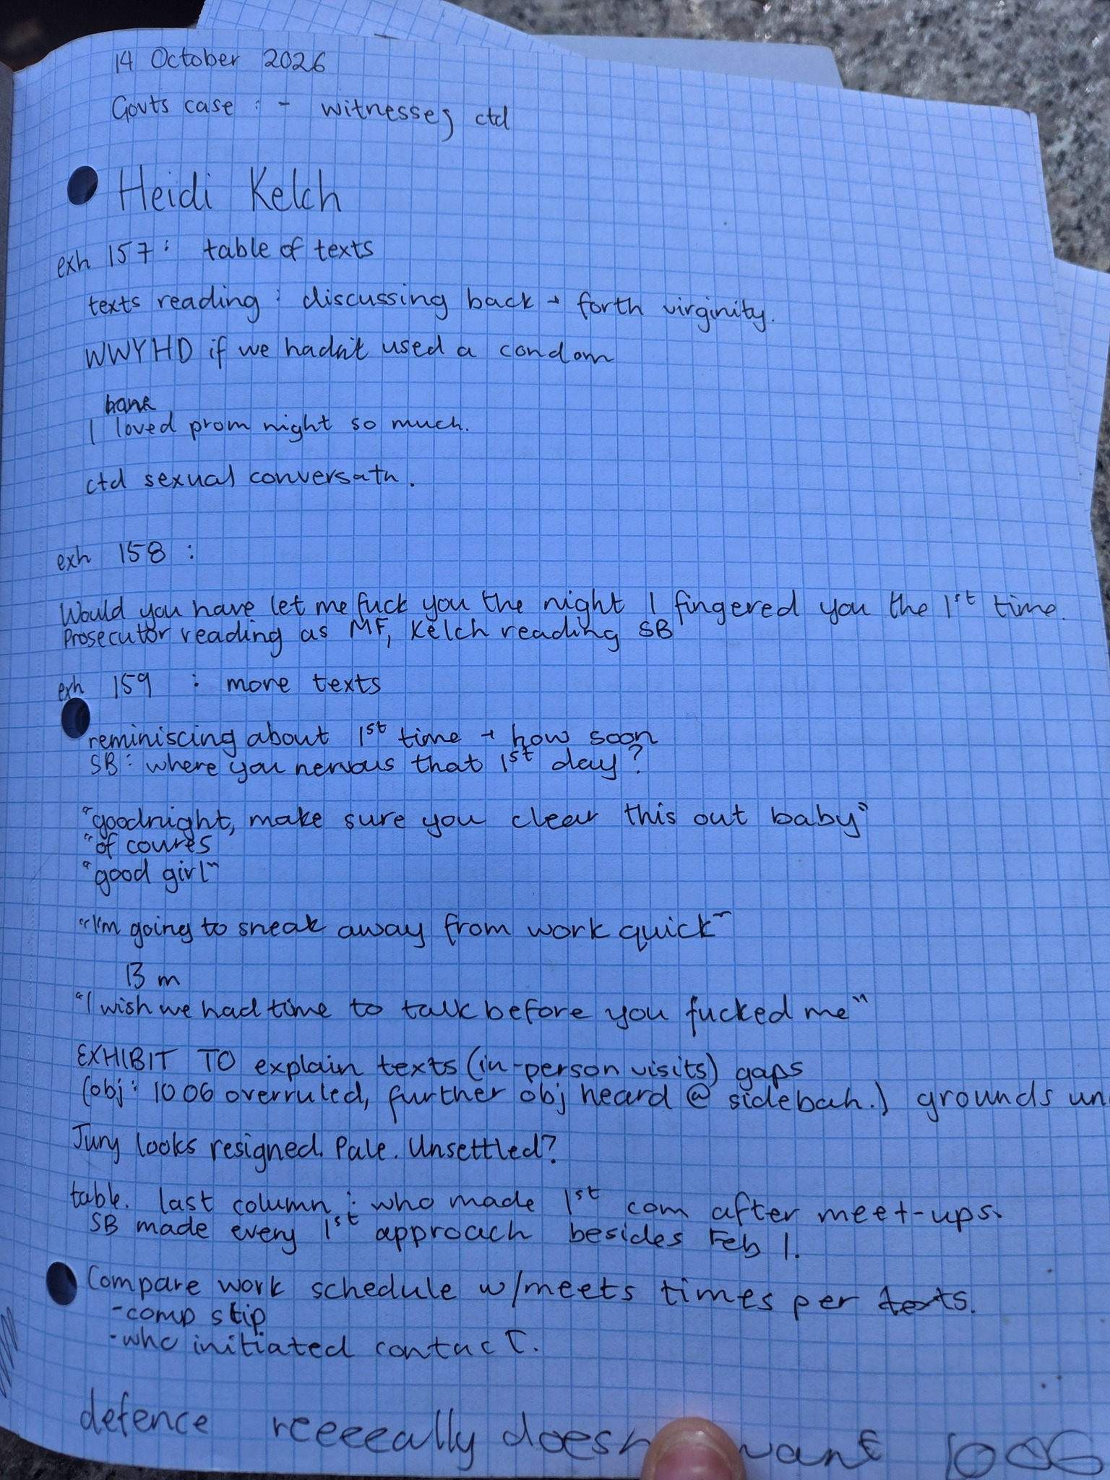

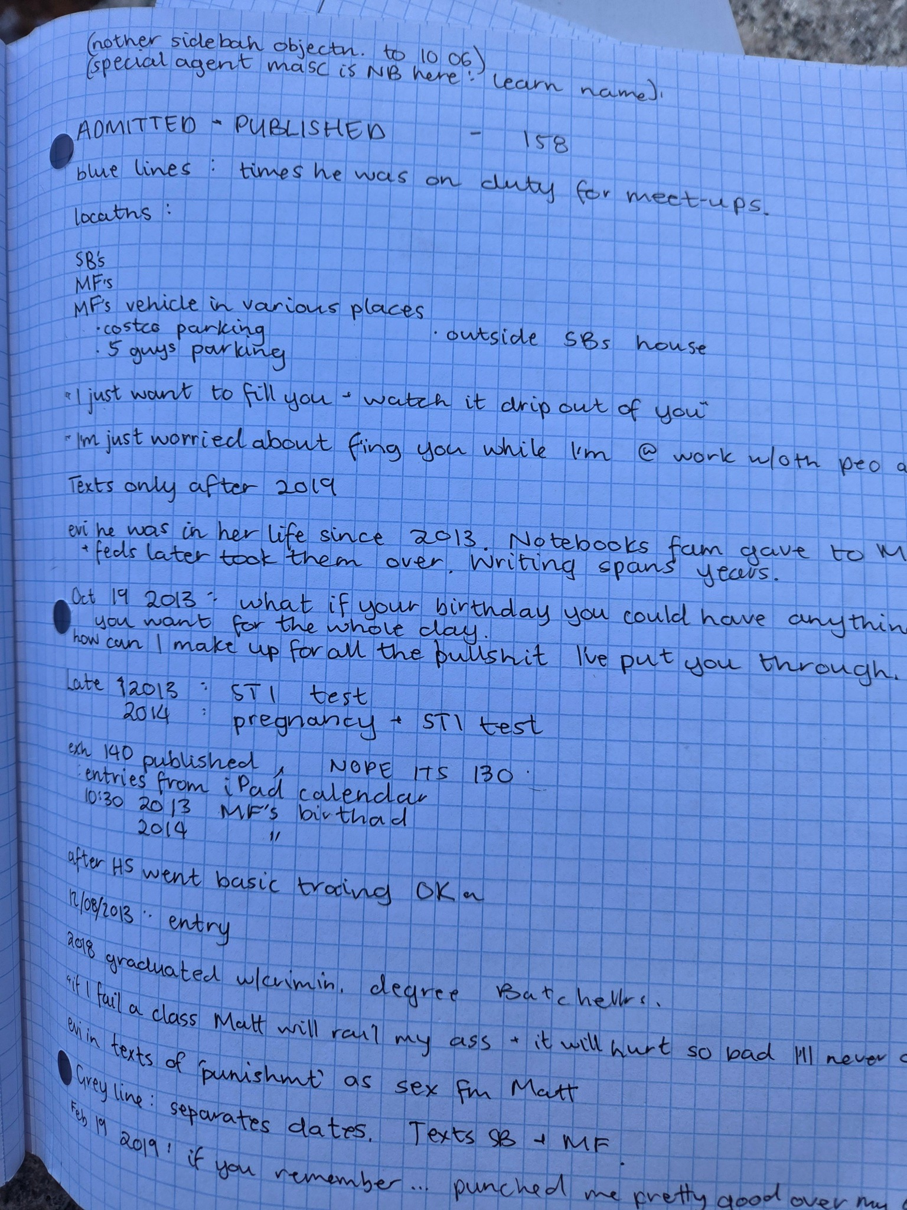

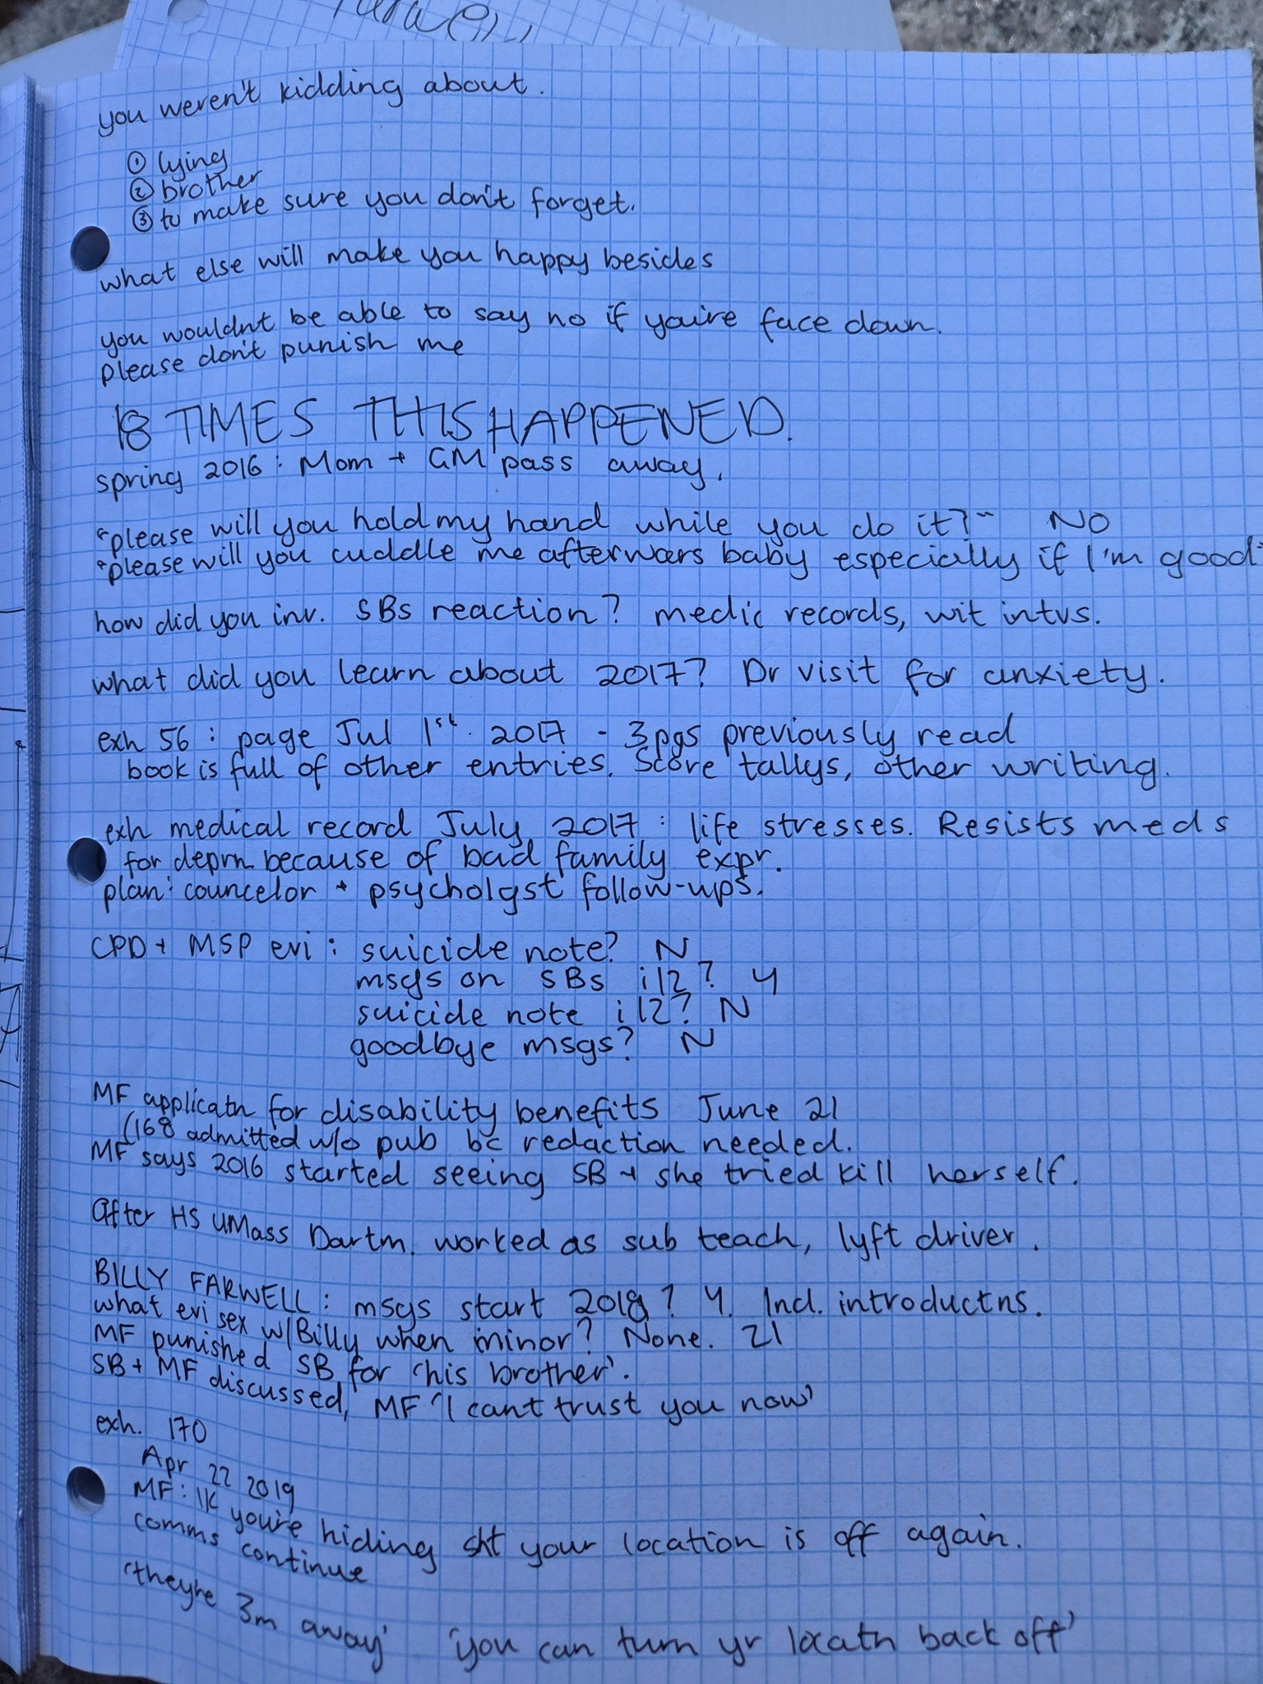

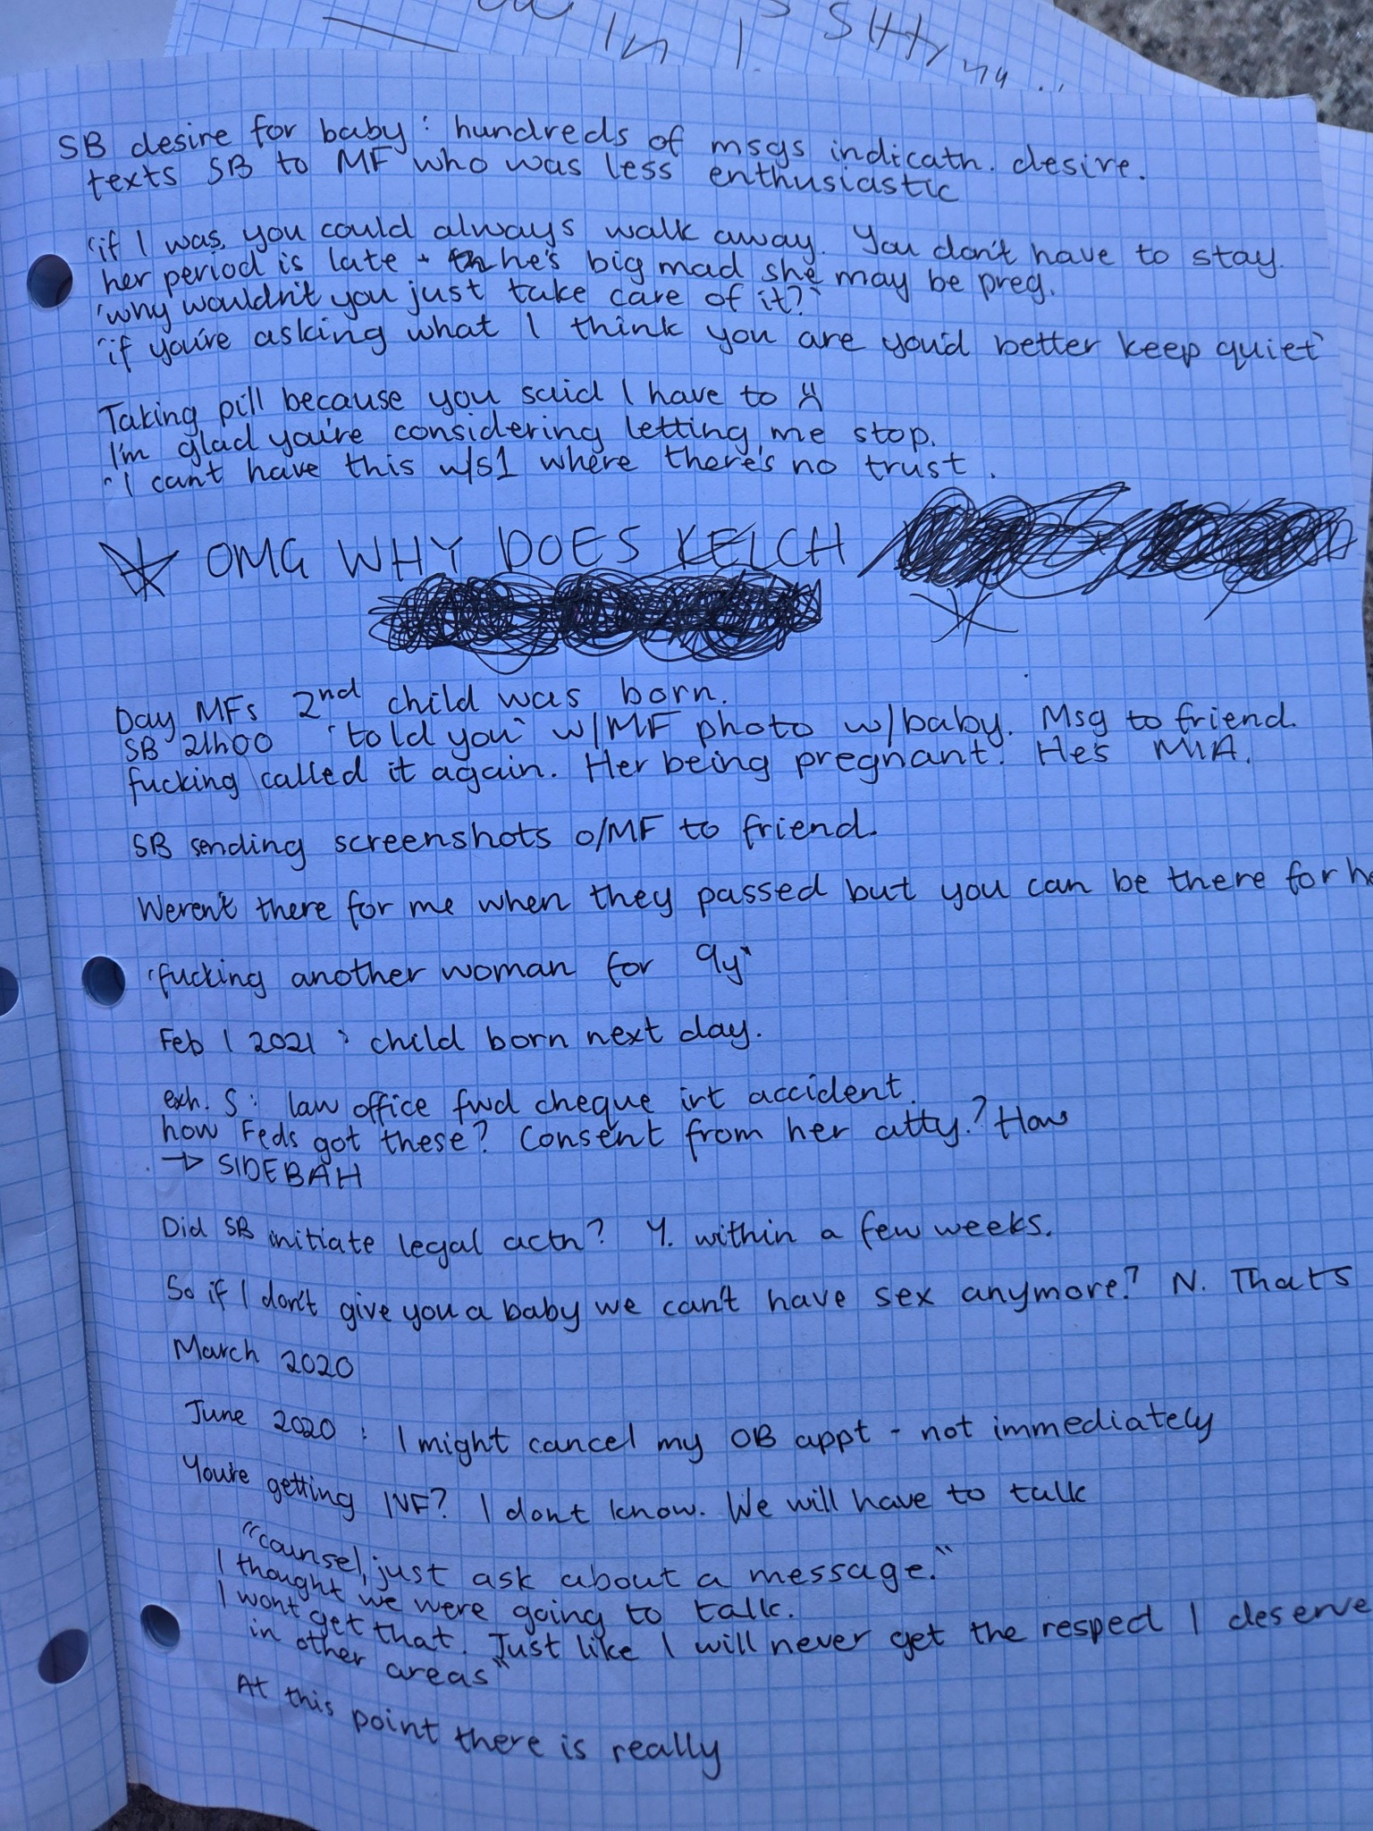

Special Agent Heidi Kelsch — Direct Examination Resumes
11:25:12 AM ET
@ameliarstern1 I have resumed my towel seat in the overflow room at counsel table.
We await Judge Casper and the jurors.
During my break, I stood victorious against a system intent on going down by humiliating itself.
Then [redacted] was screaming in another courthouse.
Victory.
Open original post on X
11:27:28 AM ET
@ameliarstern1 Judge is about to take the bench. I am in the zone.
Witness resumes the stand.
Farwell is at counsel table. Blue suit, light blue undershirt, gold/yellow tie.
Crew cut.
Open original post on X
11:29:56 AM ET
@ameliarstern1 Jurors entering!
Open original post on X
11:34:22 AM ET
"Exhibit 211, please."
"On December 28, at 9,30 pm, defendant says how far are you?"
"Regardless of how far we're keeping it."
"3.5 weeks, okay, which means I convieved this month. When did I ovulate, no idea?"
"Well, we need to talk then."
"No, shit."
"Well, the birth certificate is being signed, or her isn'tthis is about your fucking kid now. I am kind in general, but don't get between a parent and their kid."
"I am not doing this in text."
"Well I am...you act like your kid doesn't matter...next time I won't tell you a damn thing and you can hear it from someone else."
"Dude you are ridiculous."
"I'm mad...your kid should matter. You should be there."
"You are truly the worse person on the face of the earth, you know I am busy at work, and now you know what's going on and you're..."
"I'll be the worst person in the world, I'll tell her [your wife,] right now. I'll tell her right now. I'm the most honest person in the world. You're refusing to 1) be civil and 2) act like what is important matters to you. I demanded what a good father should already do."
Open original post on X
11:38:14 AM ET
"Exhibit 212, now. 28th into the 29th of December, 2020."
"I am not asking this to be a bitch, neither of us are okay."
"Are you okay until we sit down?"
"No, I am not fucking okay. I wish I had just fucking walked away."
"Okay. I am not really sure how to reply to that."
"Yet again you have fucked me."
"I didn't though, thank you for caring."
"You did you, you extorted me to get what you want."
"I want to be your friend, and work through this, but if you don't I understand."
"You blackmailed me to get what you wanted. You think everyone around you is oblivious to how you act. You a re most the most clueless person on earth.""
"Thank you for making me feel like everyone else does. Maybe it would be better if I was never born."
"Well I am tried of bending over backwards for you."
"When do you want to meet tomorrow?"
"I have been there for you, all the time, I helped you pass exams...you literally don't care about anything but your self...you said and did anything to manipulate me into getting what you want...I should have just walk away and let you hurt yourself...also you heard was 'I can't wait to fuck this guy over and get what I want."
"Okay, maybe I will hurt myself then."
Question from the DOJ;
"Did you find any web searches or journal entries. or texts about self harm or suicide at this time?"
Answer;
"No."
Open original post on X
11:38:45 AM ET
@ameliarstern1 "What are these text messages?"
"These are messages between Ms. Birchmore and friends, in gray. The defendant's texts are in white."
Open original post on X
11:39:41 AM ET
"What, if anything, is Ms. Birchmore discussing with third parties?"
"They are discussing baby shower theme ideas."
"That's the same evening as the discussion here with the defendant?"
"Yes."
"Did the defendant call the police when she called the police or offer to come and see her?"
"No."
"Does he express doubt over paternity?"
"No."
Open original post on X
11:40:51 AM ET
"What, if anything, does Ms. Birchmore do the following morning after that discussion with the defendant?"
"She starts to make plans for her maternity shoot and her baby shower."
"Who is this?"
"Ms. Shauna Eck."
"What does Sandra say?"
"We seriously need to book my hair appointment soon because I have maternity pictures coming up...I found out I was pregnant yesterday...do you think I'll need a fresh cut, too? When it's time I'll invite you to the baby shower."
Open original post on X
11:41:30 AM ET
@ameliarstern1 "Did Ms. Birchmore meet the defendant on December 29?"
"Yes."
"How do you know?"
"The messages."
"Did you review anything from Ms. Birchmore's phone on December 29, 2020?"
"Yes."
"Exhibit 215, please."
Open original post on X
11:45:01 AM ET
@ameliarstern1 "How much time elapsed on the 29th after Farwell said he would visit Sandra's apartment and when she followed up by text to say 'good talk?'"
"40 minutes."
Open original post on X
11:46:31 AM ET
Sandra says;
"You fucked up now. I'm not working anything anymore. I'm not going to be around now, neither will your kid."
"I said I was sorry," says Farwell.
"I said goodbye, I love you," says Sandra.
"I said let's talk about this tomorrow, do you want that?"
"Yes, but I need space. I am shaking and not okay at all right now. I'll text you before bed though. I'm sorry, can I be honest with you, it made me very scared when you were next to me because I thought you were going to hit me and take things out of my hand, that is why I was crying."
Open original post on X
11:46:54 AM ET
Sandra Birchmore speaking to Matthew Farwell, December 29, 2020;
"You fucked up now. I'm not working anything anymore. I'm not going to be around now, neither will your kid."
Open original post on X
11:52:38 AM ET
Late morning Sandra Birchmore and Matthew Farwell live thread is continuing here!
Open original post on X
11:56:30 AM ET
@BobRosa359782 &lt;3 &lt;3 &lt;3
Open original post on X
12:01:55 PM ET
@ameliarstern1 "What prenatal care did get in Jan, 2021?"
"She went to the doctor regularly and she was prescribed prenatal vitamins."
Open original post on X
12:02:57 PM ET
"This is from Jan 2, 2021...with Josh Heal?"
"Yes."
"What did Sandra Birchmore say?"
"He comes over all the time when he is on the clock. He was here last week. Ssshhh."
Heal says back;
"He won't once the baby is born, he'll distance himself."
Sandra says back;
"That's what I'm thinking."
Open original post on X
12:03:36 PM ET
@ameliarstern1 Sandra tells Farwell on Jan 3,
"Okay I have a new deal for you, you don't have to sign the birth certificate if the baby can have your last name..."
"I'm not talking about this in text," says Farwell.
Open original post on X
12:04:56 PM ET
"1) You don't have to sign the birth certificate if they can have your name. I won't move to Stoughton or Easton. I want you to see them on holidays, at least a few days before. I want you to see them. I want you to be there for labor. That I am standing my ground on."
"Okay, we can discuss this in person. It's a lot to think about. It's a lot more than you've ever asked for."
"I know before I was actually trying to get you to sign things, but I am trying to work with you, I hope you can come later...and this is less than any other girl would ask for."
Open original post on X
12:05:23 PM ET
@ameliarstern1 "Who did Sandra contact on Jan 27th?"
"An Attorney named Jessica Katz!"
"Objection!"
"Counsel sustained."
Open original post on X
12:06:23 PM ET
"You said Ms. Birchmore spoke with an Attorney Named Jessica Katz?"
"Yes."
"Exhibit 229 please, page 2. What does Ms. Birchmore ask the phone number ending 2389 (Jessica Katz)?"
"By any chance do you do probate court, as of now out of count agreements aren't working. What do you charge? If things keep going this way, I will need you."
Open original post on X
12:07:02 PM ET
Sandra Birchmore did, indeed, seek a lawyer just 4 days before her death in order to bring Matthew Farwell to court over her unborn baby.
She contacted Attorney Jessica Katz.
Open original post on X
12:08:32 PM ET
"When his wife finds out, she's going to go even worse, and that is not my problem. What he doesn't realize is that I have full custody of the child, and he does not, because we're not dating. I've talked to lawyers about this, because we're not dating I have full custody so I can take away visitation at any point."
"This was Jan 8th, 2021?"
"Yes, a conversation with her friend."
Open original post on X
12:09:10 PM ET
@ameliarstern1 "What is this?"
"These are some Google searches from Jan 8, 2021, on Sandra's laptop?"
"Do the numbing needs hurt before the Epidural?"
Open original post on X
12:09:38 PM ET
@ameliarstern1 Someone named Jimmy Newell says;
"How did it go?"
Sandra says;
"It didn't, it's going to end up in a court fight. I just don't care anymore. It is what it is."
Open original post on X
12:10:10 PM ET
@ameliarstern1 "Special Agent what is Ms. Birchmore searching for on jan 11, 2021?"
"Valentines baby announcement, baby onesie, made with love onesie valentines day."
Open original post on X
12:11:18 PM ET
"Exhibit 135 please...Jan 12, 2021...is this someone named Joshua Nee?"
"Yes."
"Does he say, 'let's just hope this doesn't get worse when he tells his wife...or tries to fix anything and leave you.'"
"Let's just say he doesn't want to end up in court with me because of certain things I don't want to go into."
"Yes, but he's not going to leave his kids."
Open original post on X
12:13:10 PM ET
July 16th, Sandra to Farwell;
"What are you thinking?" - Sandra
"I'm coming over in a few. Okay. Here." - Farwell
"You never gave me a hug. Have a nice night. Bye." - Sandra
"I didn't think you wanted one, sorry." - Farwell
"How long went by between when Farwell arrived and when Sandra said 'you never gave me a hug, have a nice night. Bye...'?"
"1 hour."
Open original post on X
12:13:50 PM ET
@ameliarstern1 "Jan 17th Ms. Birchmore to Farwell;
"You're not going top like me, but I'm giving you until the 31st to figure out how many there are. If you don't, I don't know what to tell you. You have to agree to one of the two things. That is okay I'll ever be."
Open original post on X
12:14:34 PM ET
@ameliarstern1 "Does Sandra have any comments in her medical records about the concept of having twins?"
"Yes."
"With her medical providers?"
"Yes."
"Why?"
"She thinks she might be having twins because her mother was a twin and Matthew Farwell was a twin."
Open original post on X
12:14:43 PM ET
"Does Sandra have any comments in her medical records about the concept of having twins?"
"Yes."
"With her medical providers?"
"Yes."
"Why?"
"She thinks she might be having twins because her mother was a twin and Matthew Farwell was a twin."
Open original post on X
12:16:35 PM ET
Jan 18th, 2021, Sandra iPhone searches;
"Baby and yolk, ultrasound at five weeks, ultrasound."
"Why did she google this?"
"The evidence indicates she was having some bleeding."
"Did she try to contact the defendant about that on Jan 18th, 2021?"
"Yes, she said, 'they can't what is next to the baby, another or a yolk sack, so they want to take another look...next Monday at 4:15PM."
"Why like that? I'm working. I already told you I was working all day today."
"You're only acting like this because it's me and not someone else. You've done enough damage to my pregnancy as it is. I'm better off leaving you in the dark."
Open original post on X
12:17:05 PM ET
Wow.
Doctor's suspected that Sandra Birchmore may have been pregnant with twins and, further, Sandra told Matthew Farwell that information just two weeks before Sandra's death.
Open original post on X
12:18:39 PM ET
"What is this?"
"A medical record for Ms. Birchmore dated Jan 15, 2021."
"Exhibit 365 please."
"Admitted and published."
"Could you please zoom in on the findings at the end of the page?"
"Gestational sack present? Yes. Fetal heart rate? 167. Yolk sack present? Yes. Right ovary and left ovary described? Yes Crown length? Yes. Estimated age 7 weeks 6 days? Yes. Estimated due date, 9/9/2021? Yes."
"That's from Jan 5, 2021?"
"Yes."?
Open original post on X
12:19:05 PM ET
The due date of Sandra Birchmore's babies (potentially twins) was September 9, 2021, according to a doctor's visit on Jan 5, 2021.
Open original post on X
12:19:44 PM ET
@ameliarstern1 "Did Sandra talk to the defendant later that day on Jan 18th?"
"I don't know if he responded late at night that day or the early morning the next day."
Open original post on X
12:20:47 PM ET
@ameliarstern1 "Exhibit 241 please. How many messages did Ms. Birchmore send the defendant after her ultra sound?"
"27."
"Did he respond?"
"No. Not until later."
"What did she send him next?"
"The Ultrasound picture."
"Did she threaten self harm after this?"
"No."
Open original post on X
12:21:03 PM ET
@ameliarstern1 "What was she Googling at the time?"
"Baby shower venues."
Open original post on X
12:22:08 PM ET
"What is Ms. Birchmore searching for that day?"
"Plymouth restaurants, Hingham baby shower places, outdoor venues near me, lakeview pavilion, Plymouth restaurants by Plymouth Rock, baby shower Disney theme ideas, baby shower theme ideas, baby shower theme ideas girl, baby girl Disney baby shower scene."
Open original post on X
12:22:16 PM ET
@ameliarstern1 Towel bathroom break!
Open original post on X
12:23:54 PM ET
@ameliarstern1 Towel has returned.
Open original post on X
12:25:54 PM ET
"He'll end up in court with one of us! He's very worried and scared. He told me he doesn't want to end up in court with me because he will lose everything. If I had to guess he will request a DNA test when the time comes."
"I'll stare at him and say take me to court, then everyone will know what he doesn't want them knowing."
"No one will know and they don't attach pay checks unless you're a deadbeat dad."
"They'll only base it on his base salary."
"I know, but he's underestimating me. He's mad I'm cold hearted. Just wish us lock/. My lawyers are ready."
"They won't matter. I wish you luck being a single parent."
"Kind of early to contact lawyers?"
"No, I'm fully ready. If we go to court, she'll know."
"It's almost like you're blackmailing."
"He knows I have lawyers ready."
Open original post on X
12:26:25 PM ET
"He'll end up in court with one of us! He's very worried and scared. He told me he doesn't want to end up in court with me because he will lose everything. If I had to guess he will request a DNA test when the time comes."
Oh uh, Matthew Farwell, the girls were talking!
Fly birdies, fly.
Open original post on X
12:27:12 PM ET
@ameliarstern1 "When did Ms. Birchmore pay her rent in Jan, 2021?"
"I don't recall the exact day, but she did pay her rent."
"Does looking at this remind you of the date?"
"Jan 19, 2021, 1,957.57"
Open original post on X
12:39:56 PM ET
@ameliarstern1 "Have you been to Ms. Birchmore's apartment complex and is there a keypad in her lobby?"
"Yes."
"Who else does Sandra speak with on Jan 23, 2021?"
"Joshua Heal."
"At 11:16PM Sandra says, 'he asked for me for a key tonight for my apartment, not how I expected things to go.'"
Open original post on X
12:40:31 PM ET
@ameliarstern1 On Jan 24, Sandra says to Farwell;
"So, open the downstairs door, it is 4321, I have your key too when you want it."
"Okay, and yes I said we could talk this week."
Open original post on X
12:41:02 PM ET
@ameliarstern1 "What is exhibit 252?"
"A receipt for wal mart for the purchase of a key at 11:10AM on Jan 24, 2021."
"Who paid?"
"Ms. Birchmore."
Open original post on X
12:42:25 PM ET
October 14, 2020 now;
"Once it's all finalized, I'll tell you where I'm going. Did you decide on if you want a key?"
"I just don't think it's a good idea. You're living with someone, right?"
"No, plans changed. I was able to get my own place. My friend was moving."
"I just don't think it's a good idea but it can be discussed in person."
Open original post on X
12:43:57 PM ET
"Exhiibt 254 for the witness now."
"It can be published."
"What does Sandra say to Jayson Pickard?"
"The father came by last night. It was a 180 change. Good but unexpected. It made me a little uncomfortable. He asked me if I would give him a key and said if keep it a secret, then he would be around and see them. Then he looked in my bathroom and closet. IDK why. We started a heart to heart. Then worked called him and he had to leave. He brought me a birth certificate. I think he is singing the birth certificate he is coming back again this week but it was like a complete 180."
Open original post on X
12:45:36 PM ET
Same day, Jan 24, Becca Chandler says;
"Did it go well with him?"
"It went well. He asked if he could have a key. He admitted I have the upper hand in the situation, which isin't a good thing, but I'm not going to be that person."
"Did you make him a copy of the key?"
"Yes, but I didn't give it to him yet. Last night he opened my closest door, and he looked into my bathroom. He looked at my dolly and asked why I had it. It was weird. I'm not mad about it, I fair warned him, I said it's a shit show because I have to re arrange the whole thing because of the baby."
Open original post on X
12:46:23 PM ET
"Have you been to Sandra's apartment building?"
"Yes."
"How did you get in?"
"The front door. The management let us in."
"If management didn't let you in, how would you get in?"
"We'd have to call from the lobby to be buzzed up, or they would have to come down. There is a pin pad and a key fob."
Open original post on X
12:47:05 PM ET
@ameliarstern1 "Was there an elevator?"
"Yes, it was on the left as you come into the lobby."
"Did you travel up to Ms. Birchmore's floor?"
"Yes, the third floor."
"Where was apartment 3307 in relation to the elevator?"
"It was next to the elevator. A few steps from the door."
Open original post on X
12:47:59 PM ET
@ameliarstern1 "Did you take a tour of apartment 3307?"
"No, it was occupied, so we toured 3306. It is the same layout except 3306 has a bay window in the living room."
Open original post on X
12:49:02 PM ET
@ameliarstern1 "Before we review the video, you talked about texts to Ms. Pickard and Ms. Chandler from Jan 24, 2021?"
"Yes."
"Did she also communicate with the defendant on Jan 24?"
"Yes."
"Exhibit 257."
Open original post on X
12:50:43 PM ET
"I am so sorry that I have caused your heart to hurt and that you feel I have been cold hearted to you. We have been cold hearted to each other. I know nothing is prefect, but yesterday gave me some reassurance that we could be okay again. I hope in the coming weeks we can make agreements and be the best people possible for what's to come. I look forward to more hugs in the next week, and I think the next year is going to be a beautiful adventure. I'm so grateful for what is to come, I want to move forward and go back to how we were before. I want to think there will be laughs and we'll have our old friend soon." - Sandra
"Thank you that's very nice." - Farwell
"Can I please surprise you with the gender, please, please, please!" - Sandra
Open original post on X
12:51:13 PM ET
@ameliarstern1 "What is Sandra searching for on Jan 27, 2021?"
"T's practice test."
"What's that?"
"A test for public health and nursing students."
Open original post on X
12:52:09 PM ET
@ameliarstern1 "What is this?"
"This is an order receipt from assessment technologies. Sandra was scheduled for that6 t -test on Feb 6, 2021. She paid 113 and 69 cents. She was not alive on that day."
Heartbreaking.
Open original post on X
12:52:39 PM ET
@ameliarstern1 "Exhibit 261 for the witness please. What was Ms. Birchmore search for on jan 27th, 2021?"
"Girl names, boy names."
Open original post on X
12:52:53 PM ET
@ameliarstern1 "Middle name for Madison or Mackenzie."
Open original post on X
12:53:30 PM ET
@ameliarstern1 "Did she reach out to the defendant after that?"
"Yes, she told him she had a few names in mind that she really liked and she wanted his input."
"Did the defendant ever respond to any texts about baby names from Ms. Birchmore?"
"No."
Open original post on X
12:54:25 PM ET
@ameliarstern1 "What is Ms. Birchmore searching for on Jan 27, 2021 at 8:45PM?"
"Names for baby, 2021"
Same note as the other day shown on screen with the possible baby names.
Open original post on X
12:54:48 PM ET
@ameliarstern1 "How does your uterus shrink after birth," Sandra Google search on Jan 28th, 2021.
Open original post on X
12:56:08 PM ET
"Does she communicate with several people per day during the week of Jan 28th, 2021?"
"Yes.
"Including the defendant?"
"Yes, on the 28th she says;
"What do you think for tonight and did you get my text earlier, LMK if I have to hold off on my medication tonight."
"Not sure, we are at a death."
"Okay, so probably not tonight, I'm sorry you are at that. LMK."
"It's all good. We do them [death responses] all the time. I will let you know."
Open original post on X
12:57:14 PM ET
@ameliarstern1 "What about Jan 29th, 2021?"
"She says, 'hi what is your availability for tomorrow and can I get the valentines package? I'm making my baby announcement on the 14th and I need to get my hair done."
"Can you come at 10:30AM on the 13th?"
"Yes."
Open original post on X
12:58:47 PM ET
Jan 29th, 2021 at 10:07;
Defendant says;
"Still up?"
"Yes, and you can put 4321 in the pin pad?"
"If that your code or a general one?"
"A general one."
"Okay, I'll see you in a few."
"I'm so glad you came."
"How much time elapsed between the messages when he arrived and when she said I'm glad you came?"
"40 minutes."
"What does Sandra say next?"
"She says that she is glad he can fuck her ass now and then she asks if he is happy with that."
Open original post on X
12:59:05 PM ET
@ameliarstern1 "What did Sandra Birchmore search that night?"
"How to make anal hurt less."
Heartbreaking.
Open original post on X
2:10:13 PM ET
Oh, Matthew Farwell was being paid by the state of Massachusetts to plow snow when he took Sandra Birchmore's life on Feb 1st, 2021 (a crime then covered up by Brian Tully and John Fanning's state police unit working for the Norfolk DA)?
I see.
Open original post on X
2:16:35 PM ET
@ameliarstern1 "What did she do at 4:43PM that night?"
"She ordered DoorDash for dinner."
"Who is this conversation between?"
"Ms. Birchmore and DoorDash. She tells the driver I am a the door at 5:01PM."
Open original post on X
2:17:23 PM ET
@ameliarstern1 "Did you review the footage of Ms. Birchmore at the door at that time?"
"I did."
"And this timestamp says 5:14pm but it is, in actuality, 5:01PM?"
"Could you see her typing on the phone at her door?"
"Yes. She is on her phone typing."
Open original post on X
2:34:27 PM ET
"Did you obtain the defendant's work phone and work email?"
"Yes."
"What is this exhibit?"
"This is a list of the attendees for a homicide conference of the Massachusetts State Police. October 2019."
Admitted as 417 (this is an important exhibit).
"Whose name is on the registration list?"
"Matthew Farwell."
Open original post on X
2:34:50 PM ET
@ameliarstern1 "What the FBI do to get the materials from that training?"
"We requested the presentation that the OCME did at that conference."
Open original post on X
2:48:28 PM ET
"I'll grab your thought and say 'he told all of us he would come over any time, so get used to it.'"
All of us!!!!!!!!!!!!!!!!!!!!!!!!!
Open original post on X
2:56:03 PM ET
@ameliarstern1 "What does Ms. Birchmore say at 4:47 on May 14?"
"How is work?"
"It's work."
"You def helped me today."
"I know."
"I'm sorry I worried you today. I know you like when I am bratty and then let you take control."
"I wasn't worried. I know you were fine."
"Nothing further."
Open original post on X

Special Agent Heidi Kelsch — Cross-Examination
2:56:14 PM ET
@ameliarstern1 The cross exam by Ms. Daley begins.
Open original post on X
2:58:16 PM ET
"And, uh, what did, uh, you and the government learn as a result of the DNA test you just testified to?"
"Which DNA tests?"
"The paternity tests."
"That Ms. Pickard was the father of the fetus."
"So Matthew Farwell is not the father?"
"Correct."
Open original post on X
2:59:16 PM ET
"Did Sandra Birchmore ever tell anyone that Matthew Farwell denied being the father?"
"I don't recall that in the messages, and I wouldn't know if she said it else where."
"Did you speak to a woman named Jordan Igo?"
"Yes, she spoke to someone on our team."
"Objection! Hearsay!"
"Counsel, let me hear the proffer."
Sidebah!
Open original post on X
3:02:18 PM ET
@ameliarstern1 Sidebah done.
"You said that Sandra Birchmore told many people Matthew Farwell was the father of her child, right?"
"Yes."
"And she told people that she he was not the father?"
"Yes, at least two people."
Open original post on X
3:03:36 PM ET
"You only learned Matthew Farwell was not the father of Sandra Birchmore's baby after you arrested him?"
"Yes."
"Did your testimony on direct cover the extent of Ms. Birchmore's mental health history?"
"Objection!"
"Overruled, you can have the question."
"We didn't go through every mental or physical health record."
"Exhibit 701 please, just for the witness!"
Open original post on X
3:08:51 PM ET
"This is Feb 19, 2019, at 12:53PM."
"Matthew Farwell says okay then Sandra says, can I tell you something that you have to keep your prof out of entirely. It's not something I haven't told you before. So, the other day I had a really bad night. I marked myself. I had a ton of tears later and then not."
Open original post on X
3:10:11 PM ET
"At 7:27PM that day, what did Sandra Birchmore say?"
"They are related to her mood."
Open original post on X
3:11:41 PM ET
"Next page...would you say that theme continues?"
Note; we can't see the messages, neither can the jury.
"Roughly, yes."
"Can we go to page 726, it is back 3 or 4 pages...your honor I would move to admit the text exchange from October 26."
"I have no objection until page 728, your honor."
"Okay, I don't think that is in this sequence. Admitted as 726 and 727."
Open original post on X
3:12:52 PM ET
"Can we kind of talk now, I can say what is on my mind, I don't know how else to word it. If you don't want me to it's fine. I feel like I just don't have a reason to be here or around anyone anymore. no one would notice. I am not good enough., I am damaged in ways that aren't fixable."
- Sandra Birchmore to Matthew Farwell in 2019.
Open original post on X
3:16:17 PM ET
Sidebah!
Open original post on X
3:17:55 PM ET
"Okay, these pages may be admitted, counsel, go ahead."
"Can we go to the first message on the 28th? Can you start reading?"
"Did you get my text about PT? I'm sorry I didn't approach you better."
"For the last week the doctor wasn't right now she is. You have no idea how to treat people. You have threatened me from the word go, if I didn't give you what you wanted you would ruin me. We will deal with this tomorrow. Earlier you said you don't know why I stuck around, it was because I was worried you would hurt yourself."
Open original post on X
3:19:43 PM ET
"But, again, you stayed because you feared me ending our life, not value our friendship."
"Are you done arguing with me?"
"yes, that I don't want you to die, I'm such a piece of shit."
"What time do you want to sit down tomorrow? I would never want you to feel bad about that."
December 28th, 2020 was the date.
Open original post on X
3:22:08 PM ET
"Next day, December 29th, please. Does this conversation reflect Sandra Birchmore's mental state?"
"Objection."
"Counsel, it's fine to admit them, but these are in."
"Okay, can we go to the Jan 17th, exchange, I don't believe the government has moved that in."
Open original post on X
3:23:08 PM ET
I took a towel stretch break.
Big towel stretch.
They are going through exhibits and admitting them one page at a time from Jan 17th.
Open original post on X
3:39:13 PM ET
"I'm sorry for trying to get you to fix mistakes made. I'm sorry for keeping you in the dark because I didn't want to break a promise. I'm not going to always be around if I keep being treated like shit. I feel like you just used me to get laid. You were my best friend and it feels like you're some stranger now, and you're letting some chick get in the way of a forever friend. Good luck on your journey at Bunker Hill, I wish I could go through this journey with you, but you don't talk to me like you used to. Don't forget your friends when you make new ones."
Open original post on X
3:41:15 PM ET
"Did you take note of this note in Sandra Birchmore's iPhone from 2016?"
"Is this from her iPhone XS?"
"Yes."
"Did you review that phone in full?"
"I reviewed the messages, but I don't recall seeing this note."
"We can take this down, thank you your honor."
Open original post on X

End-of-Day Proceedings and Adjournment
4:09:22 PM ET
James Fitton appears to be the Stoughton Police Dispatcher who told Matthew Farwell, on Jan 21, 2021, that a woman from 1,500 miles away called the Stoughton PD and informed Fitton that Sandra Birchmore was sleeping with Matthew Farwell.
Fitton then told Farwell.
Sandra was dead 11 days later.
Open original post on X
4:20:07 PM ET
"Well, counsel, I'm going to look at this. At the very least, I think the defense has a reasonable basis for asking the question. I'll look at redactions. Anything else?"
"No your honor."
"Thank you, see you in the morning."
We are done!
Open original post on X

Appendix A — October 19, 2026 Order (D. 361)
Full text of the Court’s October 19, 2026 order referenced in the reporting above.
UNITED STATES DISTRICT COURT
DISTRICT OF MASSACHUSETTS
UNITED STATES OF AMERICA
v.
MATTHEW FARWELL,
Defendant.
Case No. 24-cr-10259-DJC
ORDER
CASPER, C.J.
October 19, 2026
To ensure that the ongoing trial in this case continues to be conducted in a manner conducive to providing a fair and impartial trial for Defendant Mr. Farwell, pursuant to the Local Rules, this Court’s inherent authority and as consistent with applicable law, the Court FINDS and ORDERS as follows:
On Friday, it was brought to this Court’s attention that one party to this case, the government, had posted copies of the exhibits admitted in the course of the ongoing trial on its publicly available website. To this point in the trial, exhibits have included but not been limited to photos of the body of Ms. Birchmore as discovered on February 4, 2021, items seized from the alleged crime scene, journal entries, and data from electronic devices seized in the investigation of the alleged crimes charged against Defendant Mr. Farwell.
During the course of this trial, the jury must be free from outside influences so that they can consider the evidence presented and, at the end of the case, render a verdict based solely on the evidence and the applicable law. Although the Court has advised, and will continue to advise, the jurors of their obligation not to view or consider outside information about the case, it is appropriate for the Court to take additional measures to ensure that jurors remain free of any outside influence about the nature of evidence presented and to ensure that Mr. Farwell receives a fair and impartial trial. In re Globe Newspaper Co., 920 F.2d 88, 97 n. 10 (1st Cir. 1990) (noting the Court’s “needs to protect its essential processes, including the jury system, from . . . influences that threaten the objectivity and independence of jurors”); see United States v. Chin, 913 F.3d 251, 258 (1st Cir. 2019).
Against this compelling interest, the Court has considered the public’s interest in an “open judicial process.” In re Globe, 920 F.2d at 9. This trial is and remains a publicly accessible proceeding. As noted in this Court’s Order of September 30, 2026 (which remains in place and full effect), D. 295, to accommodate the public and media, in addition to the space in Courtroom 10, the Court has provided two, overflow courtrooms with closed circuit video feed to the courtroom. The public, including the media, have been present to hear and see the evidence in the form of witness testimony and exhibits, and the media has been able, and will continue to be able, to report on these proceedings.
Having considered the balance of these interests, particularly in a highly publicized case involving allegations of a killing and predicate acts involving the alleged coercion and enticement and deprivation of the rights of a minor, the Court ORDERS that the government remove and not post or distribute any exhibits in this case before a verdict is rendered in this case. These measures are necessary to ensure a fair and impartial trial for Farwell but are also consistent with this Court’s September 30th Order that attorneys for the parties in this case shall abide by L.R. 83.2.1 regarding the release of information by attorneys, D. 295 ¶ 5, as well with L.R. 83.2.2 (providing that “[i]n a widely publicized or sensational criminal or civil trial, the court may . . . issue a special order governing such matters as (1) extrajudicial statements by parties . . . that are likely to interfere with the rights of the accused or the litigants to a fair trial by impartial jury; . . . and (4) any other matters that the court may deem appropriate for inclusion in such an order”).
This Order shall remain in place and in effect during the duration of the trial proceedings or until further Order of the Court.
So Ordered.
/s Denise J. Casper
Chief United States District Judge

Source & Editorial Notes
Primary source: The factual courtroom narrative in this archive is limited to posts authored by @GrantSmithEllis. Other users’ replies, reposts, and commentary were excluded from the reconstructed reporting.
Chronology: Posts are ordered by their recorded creation times converted to Eastern Time. The archive begins with Grant’s designated live-thread root at 8:01:04 AM ET and ends with his 4:20:07 PM ET report that court was finished for the day.
Reporting break: Grant announced at 9:08:40 AM that he was leaving for medical and personal appointments and returned to his courtroom seat at 11:25:12 AM. He linked to notes prepared by Amelia Stern during that interval. Photographs of those handwritten notes are reproduced in the chronology as supplemental source material and are not treated as Grant-authored reporting; Grant’s own posts during the interval are retained where relevant.
Replies: Grant-authored replies are included when they continue, expand, or organize his courtroom reporting. Pure acknowledgments, unrelated conversation, reposts, and emoji-only posts are excluded.
Text fidelity: Grant’s wording, capitalization, punctuation, typos, and characterizations are preserved as retrieved except for repair of obvious character-encoding corruption introduced by the export process.
Exhibits: Grant’s references to exhibits shown, admitted, or discussed in court are preserved as part of his reporting. Following the court’s October 19 order restricting publication of trial exhibits, this archive does not attempt to acquire, reproduce, reconcile, or embed newly referenced trial exhibits.
Editorial headings: Witness and proceeding headings are editorial navigation based on Grant’s own reporting and are not quotations from the court record.

Support the reporting
This archive is made possible by Grant Smith Ellis’s excellent on-the-ground courtroom reporting and his permission to use that work in this project. If you’ve found the reporting useful and would like to support his work directly:
Venmo · Cash App · PayPal
All donations go directly to Grant Smith Ellis; this archive is unaffiliated with and receives no proceeds from them.

