Battleships Demo App — Detailed Design
Version: v2 (includes step-by-step manual implementation guide)
Target: Azure Australia East

1. Architecture Diagrams

1.1 Simple Architecture
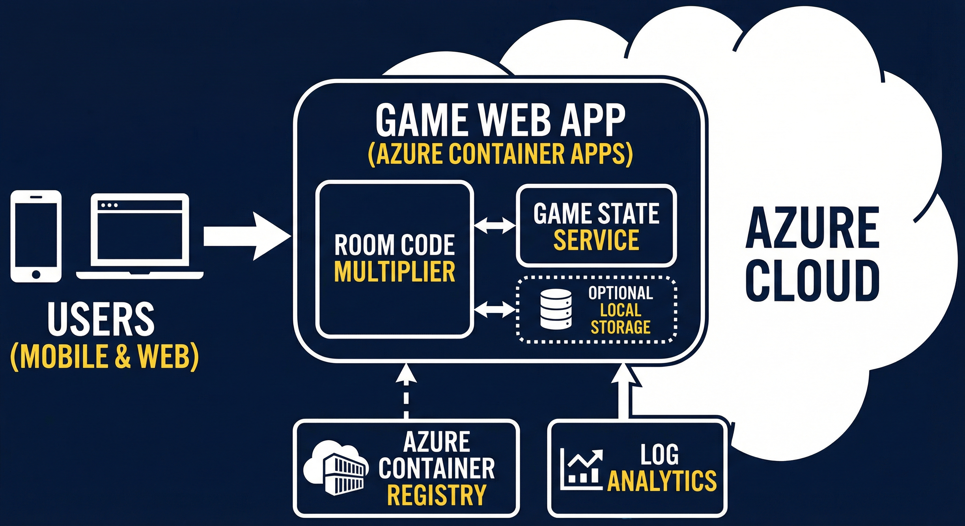

1.2 Technical Architecture
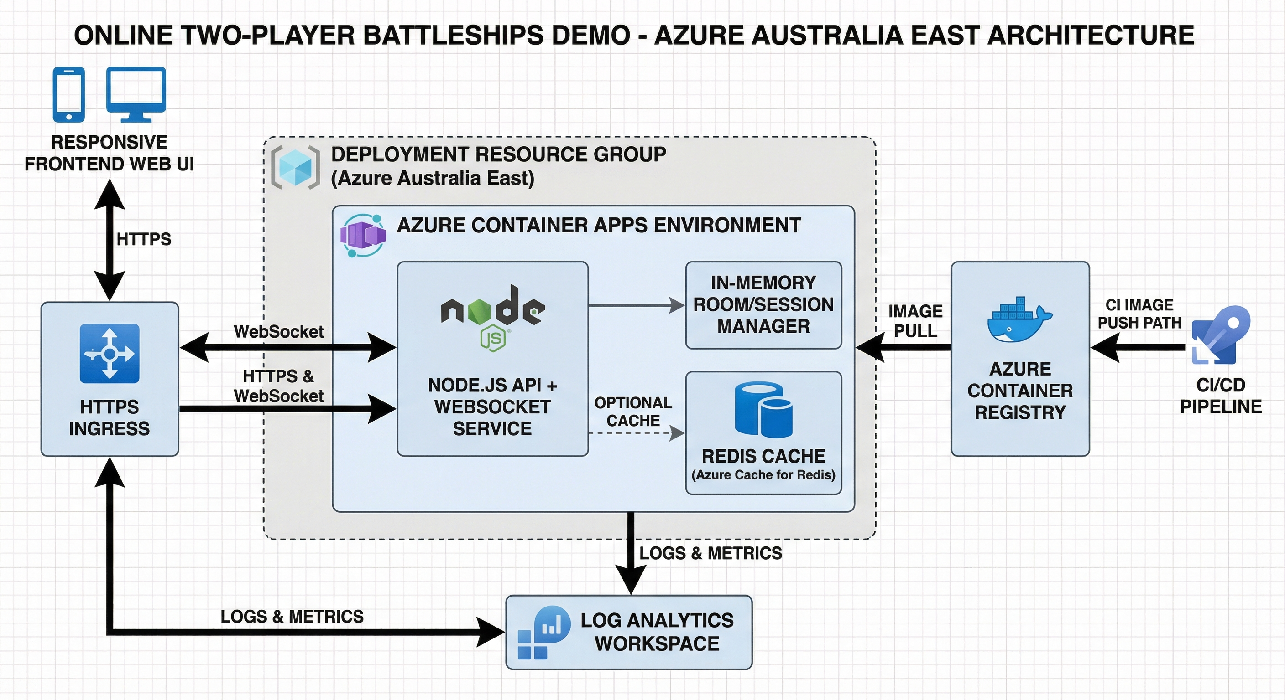

2. Core Components
- Frontend SPA (responsive mobile/desktop)
- Node.js backend with WebSocket real-time gameplay
- Server-authoritative game engine for hit/miss/sunk logic
- Azure Container Apps deployment with ACR image source
- Log Analytics for observability

3. Step-by-Step Manual Rebuild & Install Guide

Prerequisites
az --version
az account show

Project setup
mkdir -p /home/mat/.openclaw/workspace/battleships-demo/public
cd /home/mat/.openclaw/workspace/battleships-demo

Azure setup
RG="rg-mat-ttt-demo-aue"
LOC="australiaeast"
ENVN="env-mat-ttt-demo"
ACR="mattttdemoacr02280946"
az group create -n "$RG" -l "$LOC"

Build and push
TAG="battleships-demo:$(date +%Y%m%d%H%M%S)"
az acr build -r "$ACR" -t "$TAG" /home/mat/.openclaw/workspace/battleships-demo

Deploy
APP="mat-battleships-demo"
USERN=$(az acr credential show -n "$ACR" --query username -o tsv)
PASS=$(az acr credential show -n "$ACR" --query passwords[0].value -o tsv)
az containerapp create -g "$RG" -n "$APP" --environment "$ENVN" --image "$ACR.azurecr.io/$TAG" --target-port 3000 --ingress external --registry-server "$ACR.azurecr.io" --registry-username "$USERN" --registry-password "$PASS" --cpu 0.25 --memory 0.5Gi --min-replicas 0 --max-replicas 1

Update release
az containerapp registry set -g "$RG" -n "$APP" --server "$ACR.azurecr.io" --username "$USERN" --password "$PASS"
az containerapp update -g "$RG" -n "$APP" --image "$ACR.azurecr.io/$TAG"

Get URL
az containerapp show -g "$RG" -n "$APP" --query properties.configuration.ingress.fqdn -o tsv

Rollback
az acr repository show-tags -n "$ACR" --repository battleships-demo --orderby time_desc --top 10 -o table
OLD_TAG="battleships-demo:<previous-tag>"
az containerapp update -g "$RG" -n "$APP" --image "$ACR.azurecr.io/$OLD_TAG"

