Battleships Demo App — Detailed Design
Version: v1
Target: Azure Australia East

1. Overview
Two-player online Battleships demo app for mobile and web, optimized for low-cost deployment.

2. Architecture Diagrams

2.1 Simple Architecture
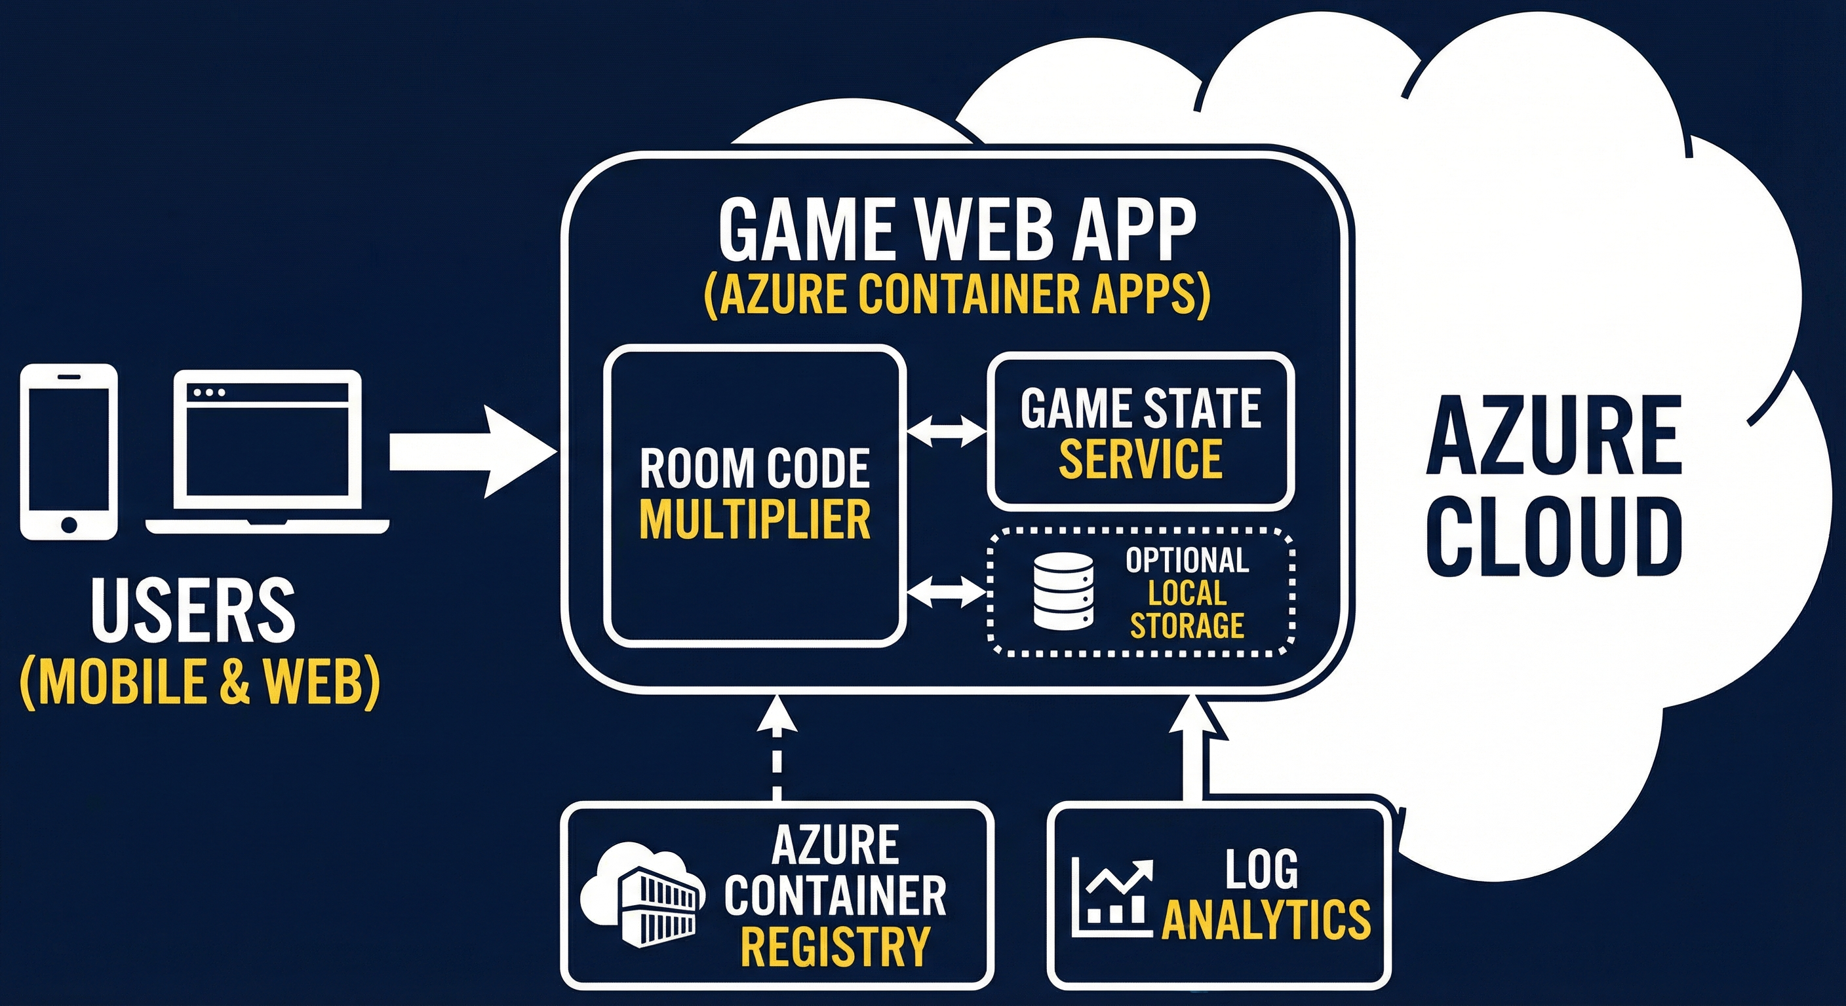
Figure 1: Simple architecture overview.

2.2 Technical Architecture
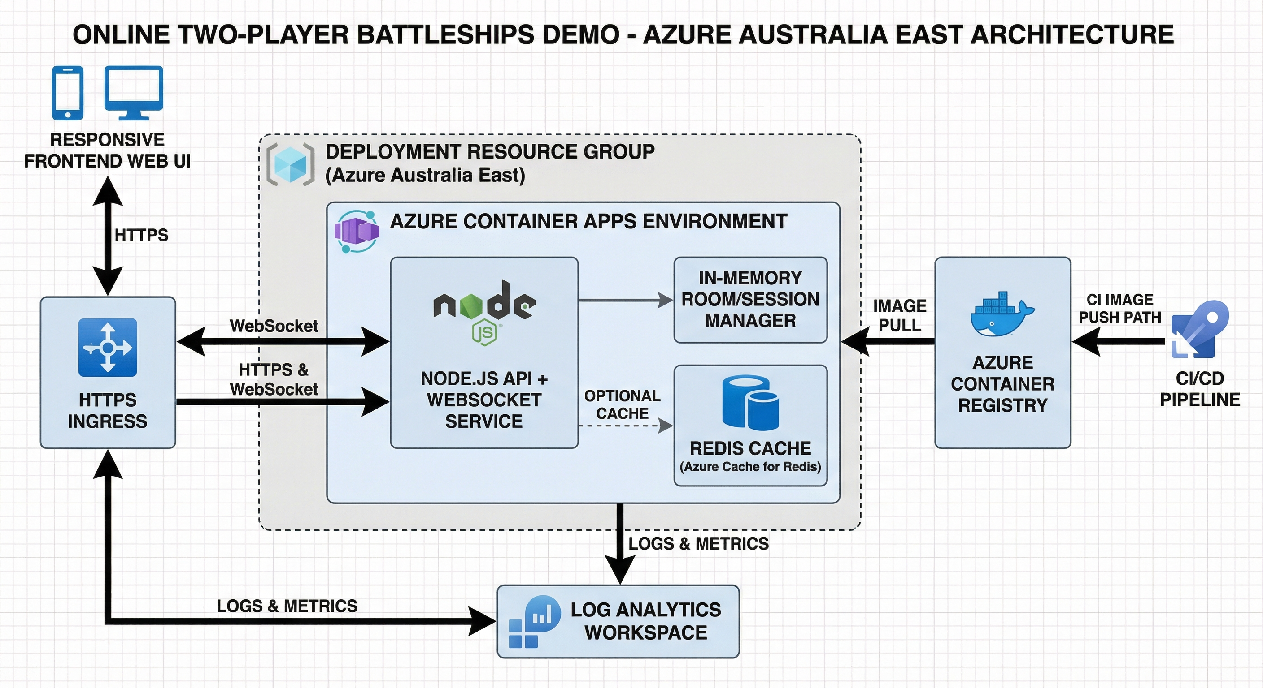
Figure 2: Technical architecture with services and flows.

3. Core Components
- Frontend SPA (responsive mobile/desktop)
- Node.js backend with WebSocket real-time gameplay
- Server-authoritative game engine for hit/miss/sunk logic
- Azure Container Apps deployment with ACR image source
- Log Analytics for observability

4. Gameplay Flow
- Player A creates room code
- Player B joins with room code
- Both place ships and mark ready
- Turn-based firing with server validation
- Win when all opponent ships are sunk

5. Security & Cost Notes
Use HTTPS-only ingress, no hardcoded secrets, low-resource sizing, and scale-to-zero policy for demo cost control.

6. Deployment Summary
Resource group, container app, ACR Basic, and log analytics in Australia East. Rollback via prior image tag.

