Space Scavengers

Game Design Document

##### by Amy brown

A game design document is a living document meant to be updated as the game and its features develop.

Contents

GAME CONCEPT 1

GAME PROGRESSION 1

TARGET PLATFORM 2

UI DESIGN FLOW 2

WEAPONS 2

GAME ASSETS 2

PHASE 1 3

PHASE 2 3

DEVELOPER NOTES 4

## GAME CONCEPT

Space Scavengers will be a top-down space shooter inspired by classic games such as Space Invaders. The player will control a ship where they must evade and destroy incoming enemies. The player will have access to multiple weapons, which can be enhanced using an in-game currency dropped from fallen enemies, as well as additional ships. Fallen enemies also increase the player’s score, with a goal to beat their previous high score. The game will have an infinite game mode where enemies will continue to spawn until the player is destroyed; there will also be a campaign mode with pre-planned levels where a player must reach the end and destroy a boss. The game will have “space scavengers” which are drones that will collect in-game currency while you are away; when active they can be used as a weapon.

## GAME PROGRESSION

Players need goals to stay interested.

* Compete against their own high score.
* Compete against another user’s high score.
* Unlocking and upgrading new weapons.
* Unlocking new ships.
* Beating campaign mode.

## TARGET PLATFORM

This game is being designed for the Android platform and as such will require touch input controls.

## UI DESIGN FLOW

This section shows how each screen is connected. For example, from the Start Menu a player can access Options, Instructions / Help, and the Game Screen. A panel is a pop-up window, whereas a screen is a whole new scene view.

1. Start Menu Screen
   1. Options Menu Panel
   2. Instructions / Help Menu Panel
   3. Upgrades Menu Screen
   4. Game Screen (toggle between single or campaign - tentative)
2. Game Screen
   1. Pause Panel
   2. Game Over Panel
      1. Start Menu Screen
      2. Upgrades Menu Screen
3. Upgrades Menu Screen
   1. Start Menu Screen

## WEAPONS

1. **Lasers** – boring pew pew; up to two lasers; may increase damage and velocity
2. **Shock orbs** – send out with small area of effect that damages enemies near it
3. **Drone army** – size depends on upgraded level, destroying anything it meets; maxed out this will cover entire display screen destroying everything
4. **Shield** – allows player to take more than one hit

## GAME ASSETS

Space Scavengers will use voxel-style art for the end-product. Voxel art may be thought of as 3D pixel art. BirdByte will be creating a lot or most of the game assets in Phase 2 of development. Voxel art is building with blocks. Creating our own game assets will remove limitations on finding free game art and add uniqueness.

Voxel art example:

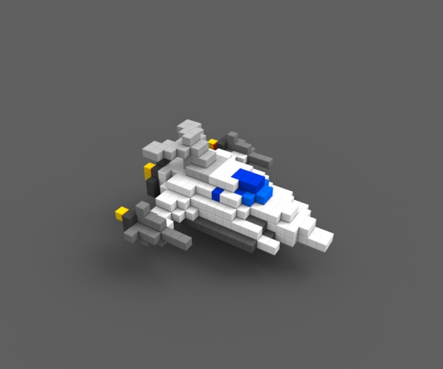

Phase 1 game assets will be free placeholder game assets.

## PHASE 1

Phase 1 is about creating a foundation on which to further expand upon. This phase will use many placeholder assets. Phase 1 is the core of the game.

Minimum Requirements:

* Start Menu (functioning play button)
* Options Menu (placeholder screen / panel)
* Pause Menu (functional)
* Upgrade Menu (placeholder)
* Game Screen
* Gameplay Mechanics
  + Player ship fires lasers.
  + Enemy ship spawns and fires lasers.
  + Collision detection for ships and weapons.
  + Session Score
* Audio (may be placeholder)
  + Sound effects for ship explosion
  + Sound effects for lasers

## PHASE 2

Phase 2 will be adding in proper game assets, polishing, additional features, and thorough testing.

## DEVELOPER NOTES

Just personal TODO notes: (may not be completed in Phase 1)

* Have instructions panel pop-up automatically if player’s first time playing
* Player ship tilt – fix it