SM1d: Supplementary figures
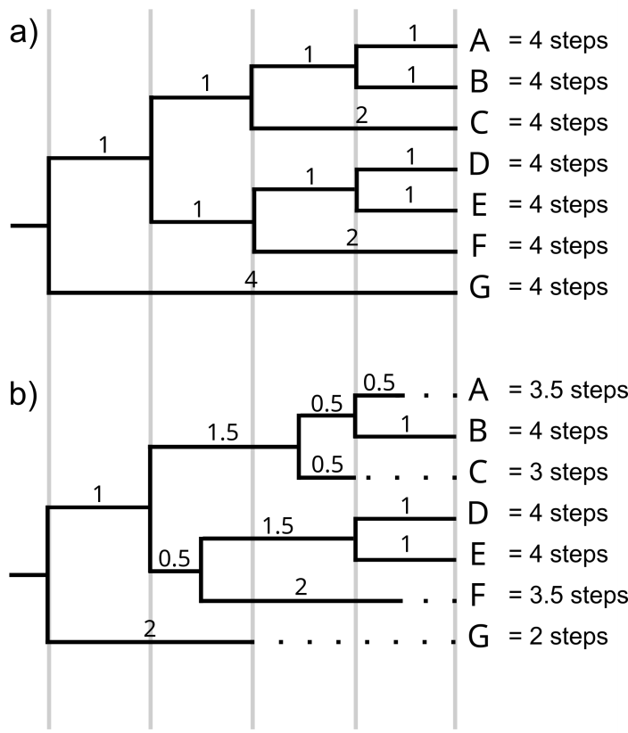
Figure 1: Branch lengths in ultrametric and non-ultrametric trees. a) Ultrametric tree: all taxa are 4 steps away from the root. The most “basal” taxon should be preferentially chosen, i.e., G, to maximise PD_{Faith}. b) Non-ultrametric tree: taxa have different branch lengths. A taxon with the longest branch should be preferentially chosen, i.e., B, D, or E.
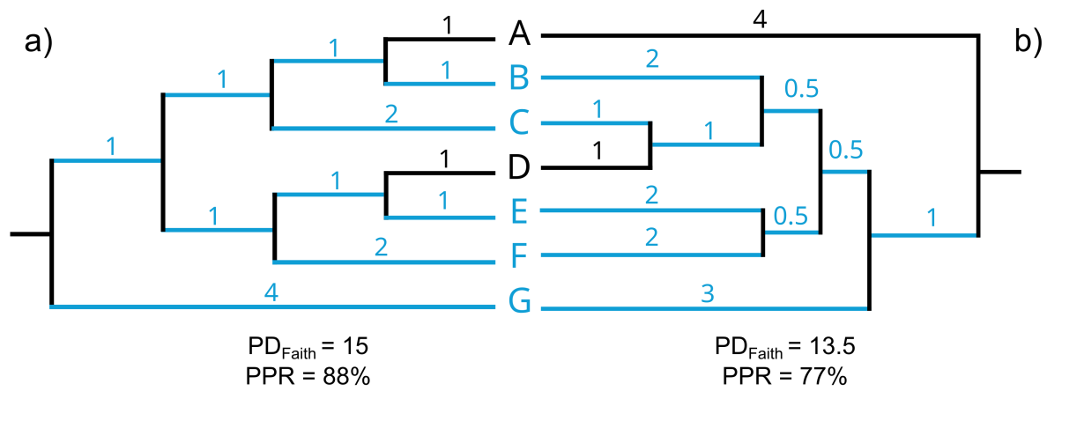
Figure 2: Effect of tree topology on PD_{Faith}. a) Sample BCEFG has the highest possible PD_{Faith} b) The same sample is not phylogenetically optimised and has a poor phylogenetic representativeness. See article’s text for abbreviations.

