Color Mixer：A New Palette

**HCI Project REPORT**

By Group 4

目录

Team Members 1

Project Drivers 2

Project Constraints 3

Mandated Constraints 3

1. Solution Constraint 3

2. Implementation Environment 3

3. Collaborative Applications 3

4. Off-the-Shelf Software 3

5. Anticipated Workplace Environment 3

6. Schedule Constraints 4

7. Budget Constraints 4

Naming Conventions and Definitions 4

1. Definitions of Terms 4

2. Data Dictionary 4

Relevant Facts and Assumptions 4

1. Facts 4

2. Assumptions 5

User Survey 5

User Analysis 5

1. General Characteristics 5

2. Personal Characteristics 5

Questionnaire Design 5

Result 6

Discuss 6

1. Potential Tasks 6

2. Selected Tasks 6

Prototype design 7

Overall Idea 7

Scenarios 7

1. The First Scenario 7

2. The Second Scenario 9

Cognitive Walkthrough 10

1. Photoshop Version Conflict 10

2. Confusing Picture Layers 11

3. Visibility of Color Picker 11

Final Product 11

Result 11

Documentation 11

1. Offline 11

2. Online: 11

# Team Members

|  |  |  |  |
| --- | --- | --- | --- |
| Name | Student ID | Phone Number | Email |
| Meng Wu (Leader) | 3150102426 | 18867135470 | [mengmengzjxs@163.com](mailto:mengmengzjxs@163.com) |
| Yuan Xiao | 3150102459 | 15705845240 | [Birdy.xy97@gmail.com](mailto:Birdy.xy97@gmail.com) |
| Qianru Fang | 3150105592 | 18867106735 | [1914250712@qq.com](mailto:1914250712@qq.com) |
| Yulu Chen |  |  |  |

# Project Drivers

**The Purpose of the Project**

1.Background

（时代背景、项目发挥作用的场景、用户能用它完成什么工作）

2.Goals of the Project

（为什么我们会想要这款产品，开发产品的真正原因（虽然明明就是为了完成作业））

**Stakeholders**

1.The Client

2.The Customer

3.Other Stakeholders

**Users of the Product**

1.Hands-On Users

（描述潜在客户群，下面表格为举例，可增删，详见模板8、9页）

|  |  |  |  |  |  |  |
| --- | --- | --- | --- | --- | --- | --- |
| User Category | Role | Experience | Age Group | Gender | Job | …… |
|  |  |  |  |  |  |  |
|  |  |  |  |  |  |  |
|  |  |  |  |  |  |  |
|  |  |  |  |  |  |  |

2. Priorities Assigned to Users

①Key users

②Secondary users

③Unimportant users

3. User Participation

（我们期望哪些用户能提供什么，比如business knowledge, interface prototyping, or usability requirements，分析这些用户必须花费在产品的最少时间）

4. Maintenance Users and Service Technicians

（分析一下会维护这款产品的人员比如肖鸢的需求）

# Project Constraints

## Mandated Constraints

### 1. Solution Constraint

① Description

The product shall use HTML and JS to communicate with the Photoshop. The customer operates with the mouse.

② Rationale

The Photoshop interface needs to use HTML and CSS. Mouse event needs to use JS.

③ Fit criterion

All operations can be completed by the mouse. The customer only needs to operate on the interface.

### 2. Implementation Environment

The product needs to be installed on the Photoshop with version number from CC to CC 2018. It also can be installed on both Windows and Mac.

The product contains an HTML file, a CSS file and a JS file. Users need to put the files under the corresponding folder, then open the Photoshop can see our product. The HTML file determines product’s structure and content. The CSS file sets product’s presentation style. The JS file controls product’s behavior. They together make up our products.

### 3. Collaborative Applications

As we all know, there are many versions of Photoshop. Each version is different for the extension plug-in interface. Our product is only applicable to the version from Photoshop CC to CC 2018.

Because the users operations are performed on the mouse, mouse events limit the functional diversity of the product.

### 4. Off-the-Shelf Software

We only use the Photoshop as the display interface of the product. The first time we download and install the Photoshop, there is a 30-day trial period. It is legal for us to use Photoshop.

### 5. Anticipated Workplace Environment

In our expectation, the user who uses the product will be a painter. He or she may use the product in the company or at home, may use the product to draw or make posters. In these cases, our products are already competent enough. And the product is relatively small, it will not affect the user when using computer.

### 6. Schedule Constraints

For example, in the summer vacation, students started to read comics and animations etc. These require the painter to draw a part of the manuscript in advance. Therefore, this product is needed when they draw. In this case, we need to complete the product before July. Now we have completed most of the functions.

### 7. Budget Constraints

Because the product is based on Photoshop, the information we used is also open source. There is no budget in our product.

## Naming Conventions and Definitions

### 1. Definitions of Terms

Color mixer: The palette in our product.

Palette: The palette in the Photoshop.

Layers: Like staked, transparent sheets of glass on which you can create images.

Canvas: Images outside the scope of the canvas are not displayed, and portions of the canvas beyond the size of the image are displayed ae transparent areas.

Foreground color: The color to paint, fill, and stroke selections. The default foreground color is black.

Background color: The color to generate gradient fills, and fill in areas where the image is erased. The default background color is white.

CEP: Common Extensibility Platform. A universal development standard for Photoshop extension.

### 2. Data Dictionary

In our product, we do not have a data dictionary. Each data is stored and read directly.

## Relevant Facts and Assumptions

### 1. Facts

Because of the JS interface, brush may have problems if it has transparency.

Every time the user turns off the Photoshop and turns it on again, the colors stored in the product will be cleared.

### 2. Assumptions

If the user uses too many colors, the interface may not be able to fit these blobs.

# User Survey

### User Analysis

### 1. General Characteristics

We select many people who meet the following requirements, and hand out our questionnaire to them.

① Digital Painting Experience: They have used computer or smartphone to paint for some time and know about the use of traditional digital palette.

② Use Photoshop CC: They are 15-40 years old, since we think those people have maximum probability of using Adobe Photoshop CC or more recent versions.

③ Hand Painting Experience: They have drawn a lot of pictures on paper in their life, or will consider drawing pictures on paper for fun.

④ Possibility of Painting in Future: Some of them may work as a painter, designer or other job related to painting now or in the future, some of them just won’t give up painting in near future.

### 2. Personal Characteristics

|  |  |  |  |
| --- | --- | --- | --- |
| User ID | Gender | Age | Description |
| 01 | Female | 21 | Regards painting as a hobby. |
| 02 | Female | 21 | Likes Painting and is good at art. |
| 03 | Female | 26 | Works as a designer now. |
| 04 | Male | 22 | Paint sometimes, not often. |
| 05 | Male | 25 | Use Photoshop just for photo processing. |

### Questionnaire Design

（列出问题样例，最多1页）

### Result

### Discuss

### 1. Potential Tasks

（大概地解释一下我们的产品可能需要有那些功能，最多半页）

### 2. Selected Tasks

（我们打算实现哪些功能以及原因）

①Tasks

（大约半页）

②Reason

（大约半页）

# Prototype design

### Overall Idea

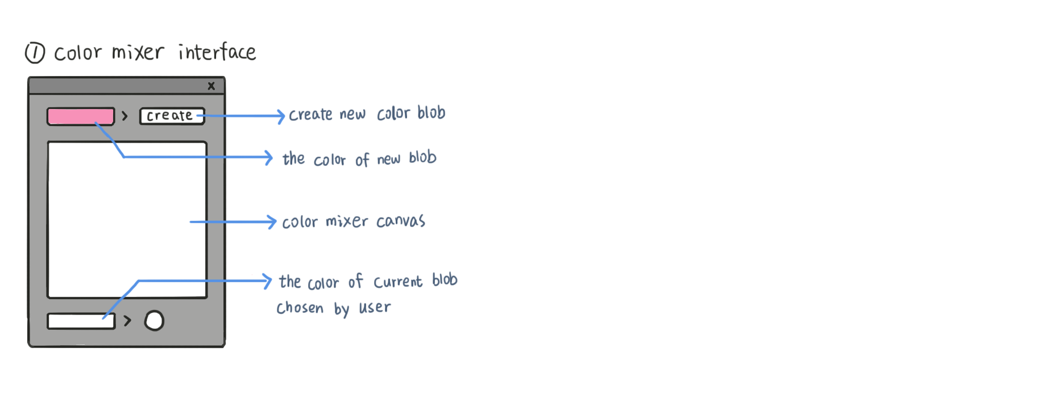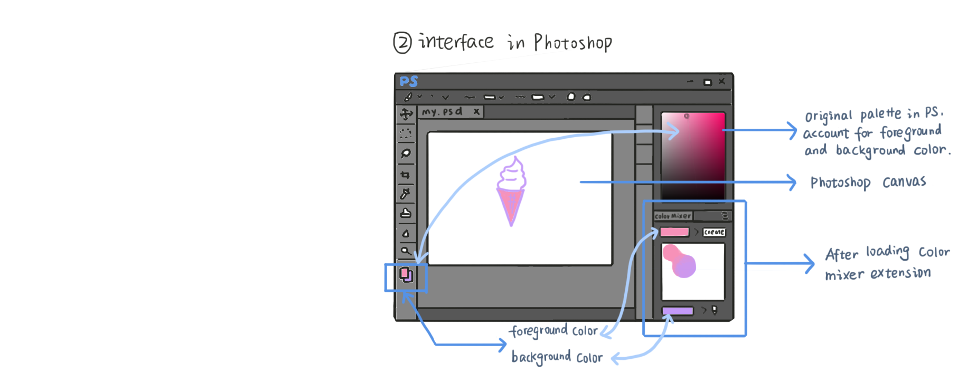

### Scenarios

### 1. The First Scenario

① Description

One day, a girl, we call her Alice, downloads and opens this Photoshop extension package. Curiosity drives her to try this product. It is the first time that she has used Photoshop extension, so the question how to put it in Adobe Photoshop puzzles her. So Alice opens the *readme* and follows the instruction. It’s not difficult, and soon she successfully configures this little tool. She also learns how to use it with mouse and keyboard from this *readme*.

She immediately begins to paint a flower in Photoshop. First, she uses the original palette in Photoshop to pick the color she wants, for instance, yellow. Then she clicks the *create* button, and soon a solid yellow blob appears in the upper left corner of the canvas in this color mixer extension. Next, she creates pink, blue color in the same way, and drag those blobs, with right mouse button, to proper position.

Alice used to draw every color she needed on an individual layer of her picture, in order to record each color she would like to brush. Sometimes she had to mix them manually to obtain a mediate color.

But now, with the new tool, Alice easily maintains three main colors and a series of gradient colors. She picks a purple color between pink and blue on the color mixer, and draws a purple stroke on the Photoshop canvas.

② Illustration

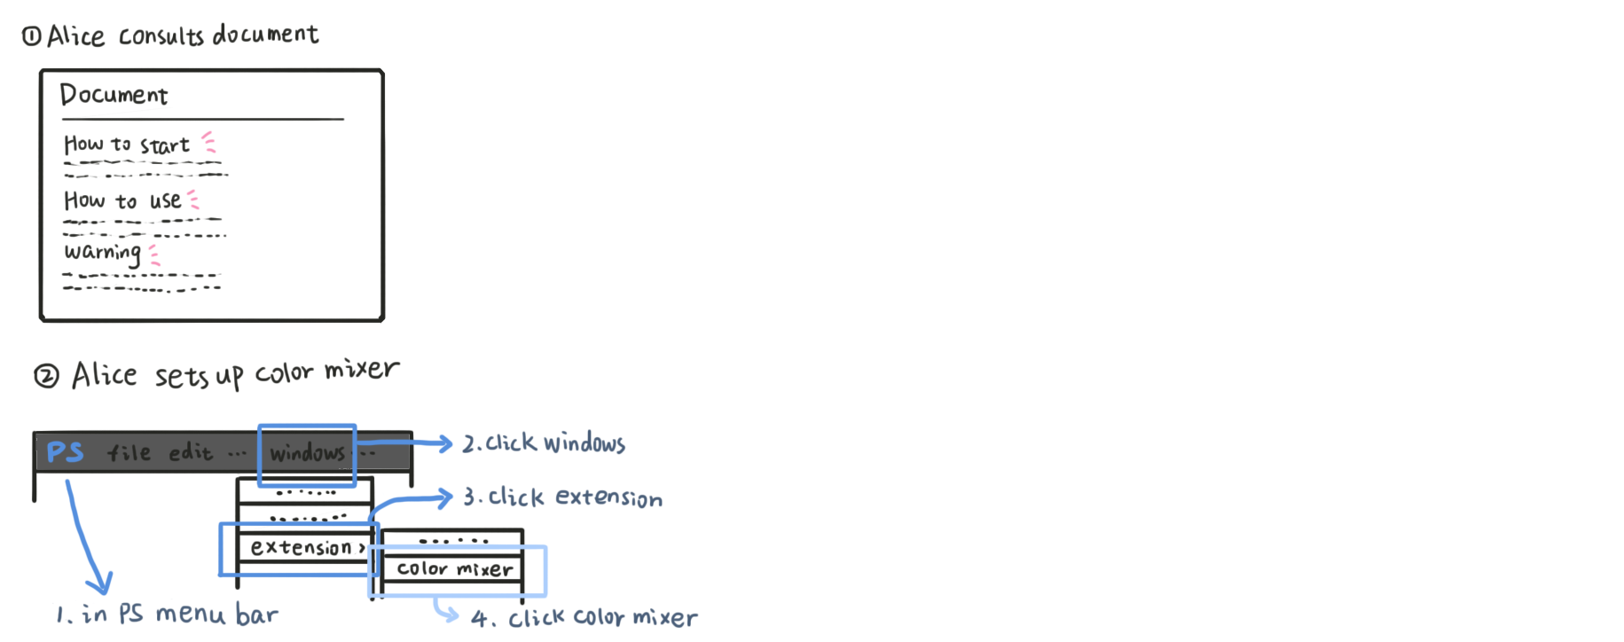　

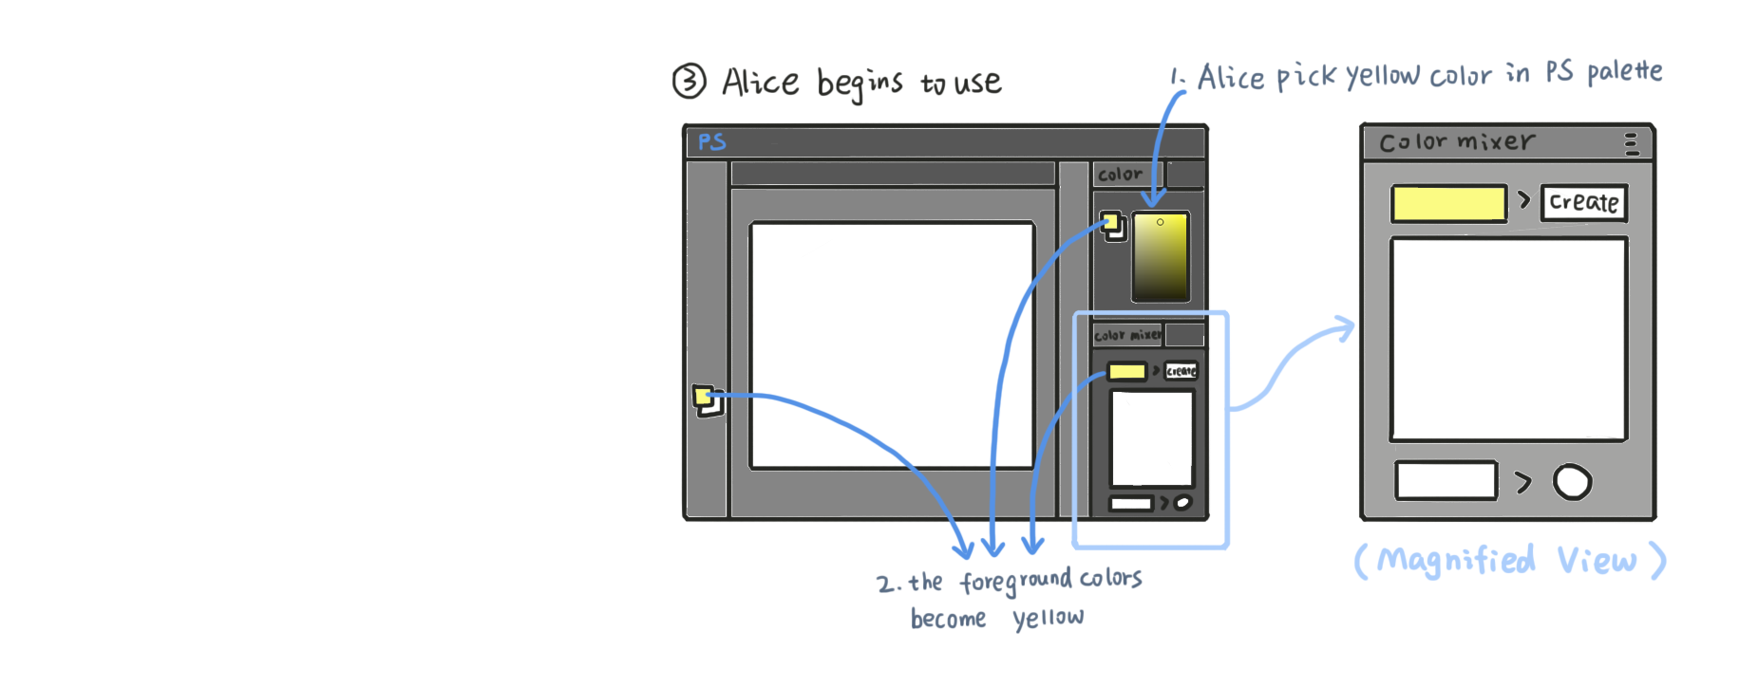

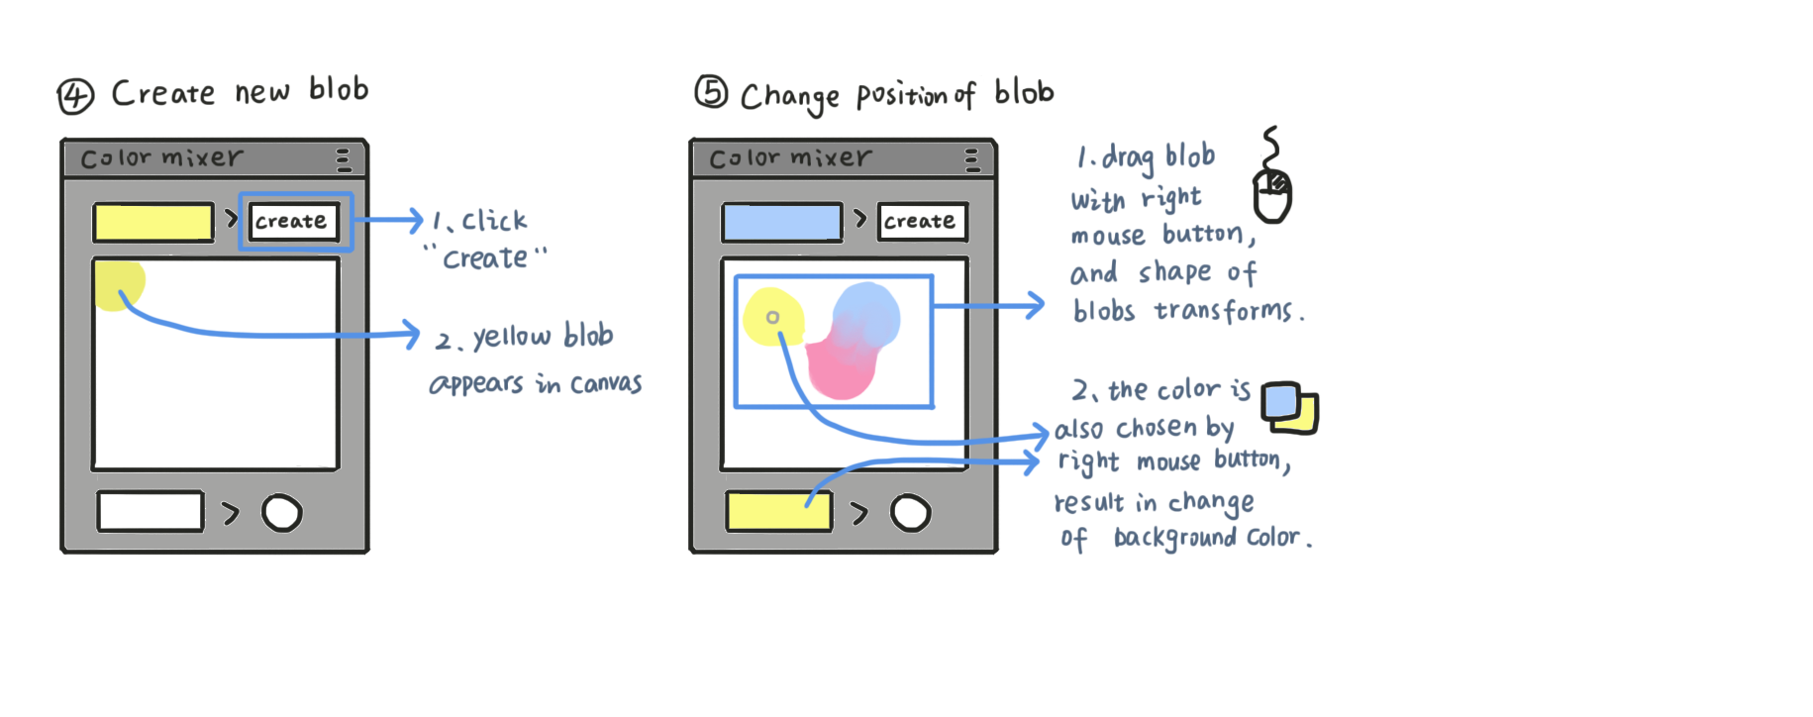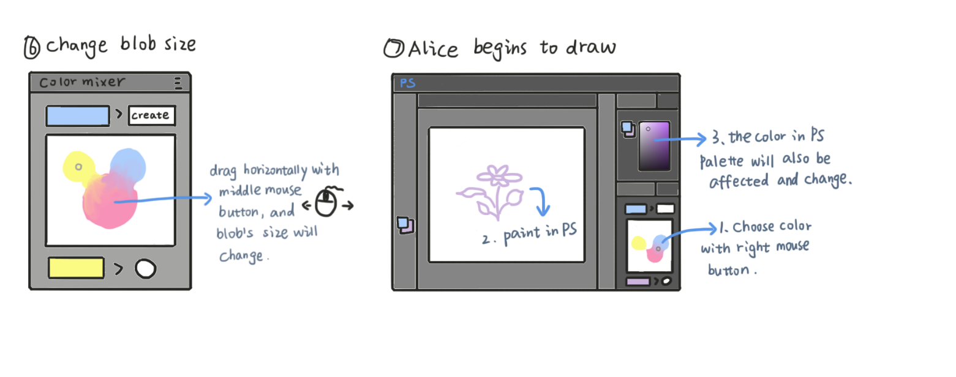

### 2. The Second Scenario

① Description

This time, our Alice, finishes drawing her flower. Unfortunately, she realizes that the yellow color is much too bright for her flower.

In the past, Alice had to erase this color and redraw with another yellow brush, or select the unsatisfactory area with yellow color so that she could adjust the hue value, though it was troublesome since yellow color usually already had spread all over the picture. Moreover, there were some yellow areas blended with other color, thus being no longer the same pure yellow as Alice’s first yellow stroke.

But now, she is able to turn to the color mixer extension for help. Alice selects the yellow blob, and then changes the color in Photoshop’s native palette. As a result, the yellow blob in color mixer starts to change its color, and meanwhile, the yellow color in Alice’s picture also changes. Alice feels OK eventually. She saves her picture, and closes the color mixer with relief.

② Illustration

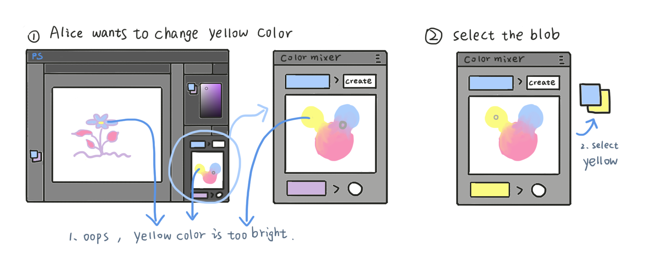

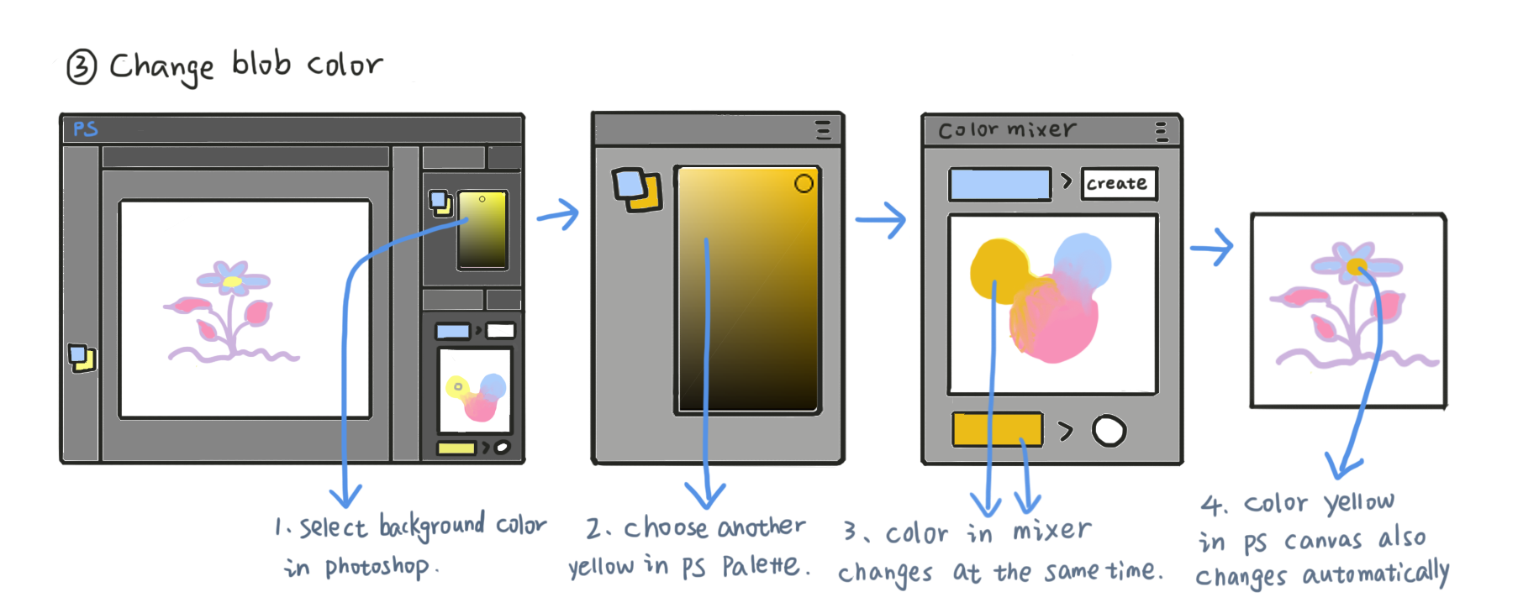

­

### Cognitive Walkthrough

### 1. Photoshop Version Conflict

① Scene

When Alice opens the color mixer package, sets up this extension, she finds it doesn’t work, or works awkwardly because the version of her Photoshop is CS3, which is too old for Photoshop’s extension to exert.

② Solution

We will write down a detailed document which helps user and displays all precautions, including suitable versions of Photoshop. We think it embarrassing to support all versions of Photoshop, since there are too many versions and scripting method of Adobe extension has been continuously developed. On the other hand, our color mixer extension will be well compatible with Photoshop released from 2015 to 2018, which covers most of the recent versions that are commonly used nowadays.

### 2. Confusing Picture Layers

① Scene

We plan to achieve the function of our color mixer by adding a picture layer filled with corresponding color in user’s Photoshop document, so that we can operate every color individually. But this raises a question: Every time when Alice creates a color blob, our color mixer will add layers to Alice’s Photoshop document. And Alice herself may add her own layers in the meantime. How does Alice know which layer is created by herself, and which layer is created by the color mixer?

② Solution

We can give the layers created by the color mixer a special name, in order to prevent user from being confused about all kinds of layers. For example, we may name the color mixer’s layer with a prefix such as CM, the abbreviation of color mixer.

### 3. Visibility of Color Picker

① Scene

Alice wants to pick a color in color mixer. When she clicks color mixer’s canvas with right mouse button, the canvas will draw a small grey circle marking where Alice’s mouse has clicked and indicating that the color in circle is currently in use. However, what if Alice wants to pick a grey color? The grey surroundings will conceal that grey circle. And Alice feels a little annoyed to lose track of her color marking stuff.

② Solution

The marking circle should change its color when staying on a piece of similar color. So the circle is usually black, whereas it will become white while picking a dark color.

# Final Product

### Result

（截图以及一些叙述）

### [Documentation](https://docs.unity3d.com/Manual/index.html)

### 1. Offline

( See the source code folder for detail )

### 2. Online:

[https://github.com/Birdy-C/HCI_ColorMixer/tree/master/Document](%20https:/github.com/Birdy-C/HCI_ColorMixer/tree/master/Document)