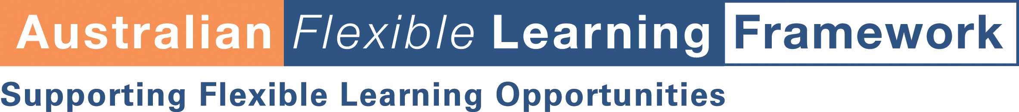

Section B1

Learner profile template

About this tool
This tool will guide you through some questions about your learners.

How to use it
You can change the template to meet your own needs and context. Fill out all the sections and file with your course information.

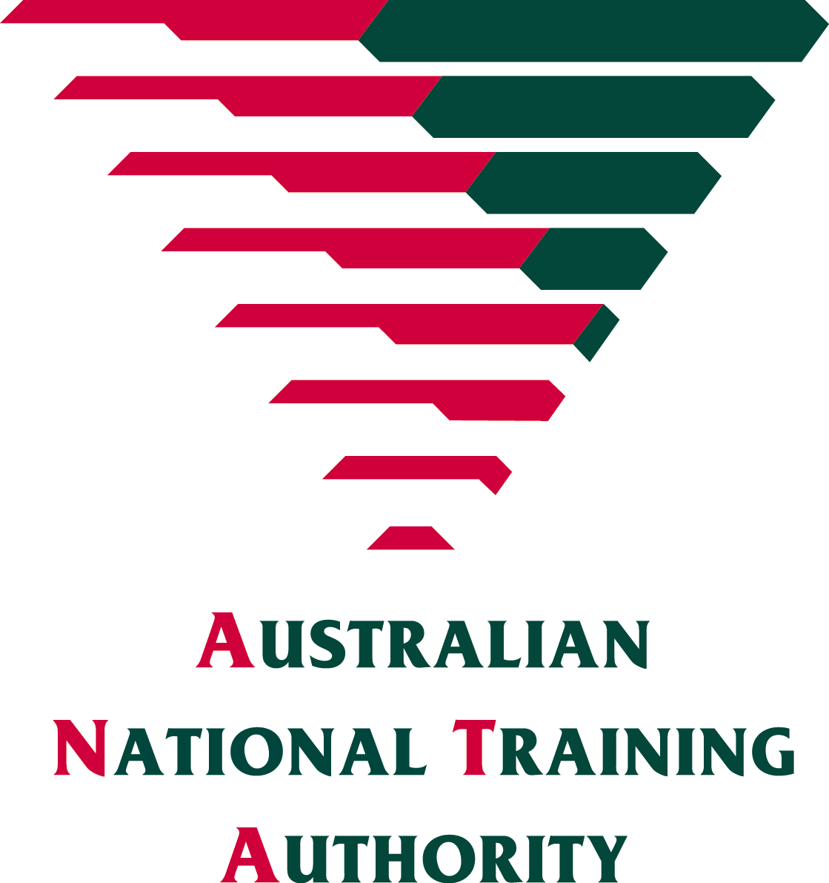

flexiblelearning.net.au

Learner Profile Details
Target learners
- Who are the target learners?
General characteristics
- What is the gender and age range of the learner group?
- What is the cultural background?
- Will the learner have any disabilities?
Previous learning
- What formal qualification(s) will the learner have?
- What informal learning will the learner have?
- What is the likely level of literacy and numeracy?
- What is the likely level of IT skills?
Skills and knowledge
- Will the learner be working in a workplace relevant to the program?
- What skills and knowledge will the learner have of the content in the program?
- Will the learner have any knowledge or practical skills that are out-of-date or inappropriate? Provide examples.
- What generic skills (for example, communication skills, teamwork skills and problem-solving skills) are considered important for this learner group?
Motivation
- Why will the learner undertake the training and assessment program?
- What expectations is the learner likely to have of the program?
Support
- Where is the learning and assessment likely to take place?
- What support will the learner have from their workplace for their learning and assessment program?
- What technology (for example, Internet, email and telephone) will the learner have access to?
Learning styles
- What study skills and abilities is the learner likely to have?
- What is the learner’s preferred method of learning (for example, practical or technology based)?
Other
- What other relevant information will help to ensure the learning and assessment program is appropriate for the needs and characteristics of the target group?

