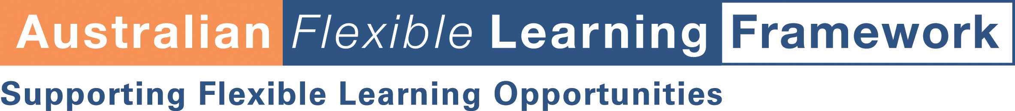

Section F2

Evaluating the assessment process

About this tool
Often developers and deliverers of online programs have concentrated on evaluating the technical aspects of the online learning experience. Whilst this is definitely an area that causes great problems for both learners and teachers it is only one aspect to be considered. Just as important is getting information on the success and richness of the learning and assessment experience. Developing an evaluation strategy that probes this aspect of online assessment is critical.

How to use it
This tool is a checklist for you to modify to suit your own puposes.



flexiblelearning.net.au

To evaluate the educational success of the online assessment program you will may want to critically ask yourself a number of questions.

Comments
Did the learning program support the assessment process?
Which elements of the online program worked best to achieve learning (online materials, links to external sites, conference boards, email, etc)?
Was the content delivered effectively? Did the course content offer support to the learner in the completion of the assessment tasks?

Do the external links offer useful information to the learner to facilitate the assessment process?

Were the individual learning styles of the students adequately met? Was there a reasonable balance of presentation and activities to suit the different styles of the student group?

How clearly do the materials guide learners through the learning and assessment process? Was there a sense of 'teacher's voice' guiding the student through the program. This involves giving clear directions, setting up scenarios, summarising what has been learnt, making links from what has been learnt and where the learner is headed.
How successful were the communication tools in providing:
- Communication with the course tutors
- Communication between online students (peer assessment)
- feedback from the tutor on the learner’s progress?

Did the communication strategies encourage discussion, reflection, review and synthesis to support the assessment process?

The assessment tasks
Was the language used to describe the task appropriate for the audience?
Were the assessment tasks suitable and sufficiently challenging?
Was the balance between online and offline assessment suitable?
Were the assessment tasks sufficiently varied?
Were the assessment tasks delivered using a rage of methods (text, graphics, animations, video, audio, hyperlinks)?
Support for the assessment process
Were the methods for submitting assessment tasks clearly outlined to students?
How effective was the teacher in facilitating the completion of online assessment?
How effective was the teacher in managing all aspects of the online learning environment?
Was the communication in the course satisfactory to ensure requirements for assessment tasks were understood?

Management of the assessment process
Was the teacher given sufficient professional development to ensure effective assessing and teaching took place online?
Were effective systems set up for managing and storing assessment data?
Were effective systems set up to give students feedback on their assessment tasks.

