Facilitated or self-paced? Selecting the right horses for e-courses
One of the continuing difficulties with talking sensibly about e-learning is that is still means so many different things to different people.
Using the initial research from the Australian Flexible Learning Framework's Designing e-learning website (http://flexiblelearning.net.au/designing), we have found it useful to identify six main categories of e-learning:
Types of e-learning
E-learning type | E-training | Blended learning | Virtual classroom | Digital campus | Distance education | Web in class
Description | intranet (in-house) for workforce development | flexible delivery to enrolled or workplace clients | live distance delivery | enhanced face-to-face for enrolled learners on-campus | asynchronous, remote delivery to enrolled learners | enhanced face-to-face for enrolled students
Learning mode | self-paced, individual, self-assessing | highly facilitated group learning | trainer/presenter led team learning | teacher-led group learning | supported individual study | teacher-led
Content | off-shelf, customised | range of content, customised free HTML | custom plus live materials, mostly PowerPoint | range of content, web accessed | purpose-designed materials  team development | user-generated and found material
Delivery | LMS | LMS, information and communication technology (ICT), workplace, some face-to-face | web conferencing | face-to-face, plus LMS | LMS, some face-to-face | mostly face-to-face
Collaboration | no collaboration tools | extensive ICT tools, "online community" | inbuilt tools, interactive peer learning | some collaboration tools | some collaboration tools (forums) | wide range ICT tools
Sector | corporate, some vocational education and training (VET) | VET, mainly TAFE | corporate, some VET | higher education, advanced TAFE | higher education | schools, VET
Drivers | cost reduction, user flexibility, compliance, ease of administration | cost reduction, retention, reach, outcomes, learner ICT/e-learning skills | cost reduction, team building, engagement, flexibility, agility | convenience, consistency, ease of admin, content/intellectual property (IP) management | reach, quality, ease of admin, content management/IP | variety, motivation, engagement, learner ICT and communications skills
Main learning model | information recall | outcomes-based job readiness | situated team learning | various | reflective, knowledge-based learning | socially constructed learning

There are of course overlaps and hybrids of the above, but the types help to clarify the different broad purposes, contexts and approaches of each. There are also other models or types of e-learning emerging. For this article, the focus is on the first two types of e-learning – self-paced e-training and facilitated blended learning – based upon the belief that corporate and public VET training professionals have a lot to learn from each other about what works.
E-training
Most corporate e-learning has traditionally been e-training – self-paced, individualised delivery using highly-designed, ‘interactive’ materials prepared by professional instructional designers and developers and delivered via a LMS. There is no trainer in sight, and no team or group involved. In practice this form of e-learning has proven most effective for an important but quite limited range of training goals – for compliance (eg occupational health and safety), for IT application training, for induction and for product knowledge.
The key limitation of self-paced delivery is that learning and assessment is restricted mostly to information recall, because of the typical individual assessment tools available in the LMS – multiple choice, drag-and-drop and true/false. This means the learning may not always result in improved performance (or competence), because this usually only comes from applying and confirming the knowledge in context with the people and tools you are working with. For example, you can get everything right on a quiz about fire extinguishers, but still freeze up when the fire alarm rings. If the post-training results you want involve licensing or accreditation, then you also need some sort of processes for demonstrating the level of performance reached.
Blended, facilitated learning
Driven by the need to bring performance-based learning and assessment to the online space, Australian training providers have developed facilitated e-learning approaches which are arguably as mature and effective as anywhere in the world. The Designing e-learning site provides some detailed examples of how they do it. Each ‘sample design’ presents a basic business case for the course as a click-and-view digital story, plus a schematic map of the design showing how it ticks.
Below is the map of the first week, a highly successful short course on Medical Terminology at Central Gippsland Institute of TAFE in south-east Victoria:
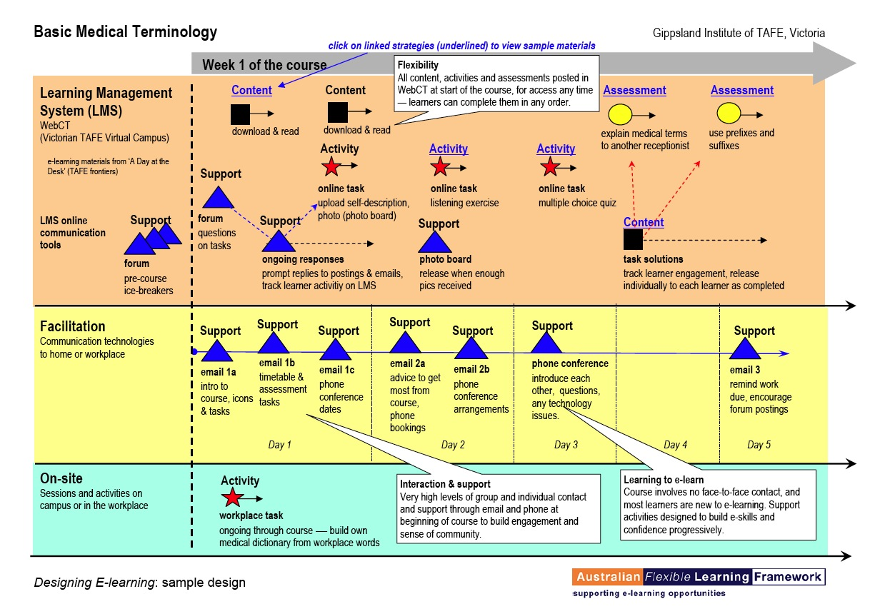
The map shows the key components of the facilitated model:
- the three blended delivery options used (horizontal coloured bands): an LMS, some other facilitation tools and an on-site workplace project
- web-accessible e-learning content (black squares) – often (as for this course) using low-cost, sharable and customisable government-funded materials (such as the popular Flexible Learning Toolboxes (Toolboxes) http://toolboxes.flexiblelearning.net.au/) which are already aligned to national training outcomes (competencies)
- several individual and group learning activities (red stars) provided in the LMS or the workplace
- a whole range of support activities (blue triangles) provided by the facilitator using LMS collaborative tools (forums, chats etc) as well as other communication tools (email, SMS, phone conferencing, mobile etc).
The teacher, Lynn Huguenin, does much of her facilitation work from home. She is a highly skilled online facilitator, using a wide range of techniques to engage the group, provide feedback and build peer-to-peer communication – she calls it ‘building the learning community’. Lynn has also integrated ‘voice tools’, so that learners can record pronunciation of terms and email their assessments, and online forums come in sound clips instead of text.
The results are impressive, with a completion rate in excess of 90% and a high national demand for the course. More significantly, GippsTAFE has now successfully applied this model of delivery to other training needs and other clients. They also conduct a widely-acclaimed e-learning course, Online Facilitation, to meet the growing demand for skilled online facilitators in training organisations and businesses.
Other sample designs on the site showcase the full range of delivery options and communication tools available for e-learning. In each case, ‘design’ means getting the best fit solution to the training need.
So which approach, self-paced or facilitated?
The facilitated approach offers lots of potential training benefits – higher motivation and completion rates, greater range of training outcomes, peer-to-peer learning gains, team or community building, plus upskilling in communication technologies as part of working and learning. But what about the downside? Facilitation means salary and good skills in this new training speciality are scarce.
Brad Beach, Manager of Innovation and Organisational Development at GippsTAFE, lists four key considerations he uses to decide which way to go for a given e-learning initiative:
- Learner readiness
Does the learner group have good self-directed learning and computer skills? If not, they will struggle with self-paced course and will need the support facilitation provides.
- Available content
Is there a cheap or free existing online content available? If not, the development cost and lead-time for quality self-paced materials is a serious barrier – a facilitated approach is much less reliant on online courseware, and can make use of a range of content sources.
- Delivery skills
Do you have a quality online facilitator available for this content area? If not, you're not in the hunt – yet. Better start getting some trainers trained.
- Marketing
Facilitated group learning means enrolments or registrations and minimum numbers. Can you reach the target group easily and cheaply? What are your chances of viable numbers? If it's going to be hard to sell, your great content and even better facilitator will be wasted.
Selecting e-opportunities
What's clear from this is that developing a ‘business case’ for an e-learning proposal or opportunity is the core issue – choosing the technology mix is important, but it comes after.
You can trace e-learning initiatives from a business case right though to completed delivery case studies on the Framework's E-learning for Industry website at http://industry.flexiblelearning.net.au . A stand-out feature of the case studies is the collaboration between businesses and training providers, which means that a wider repertoire of e-learning approaches, and especially facilitated options, are available to select a best-fit e-learning solution.
Nine Lanterns in Melbourne http://www.ninelanterns.com.au/ use an elegant model they call the ’eLearning Landscape‘ to generate questions and guide implementation choices, including looking at factors such as organisational structure, readiness, the physical environment, the technology environment and procurement.
A series of workshops and tools have been developed around the Designing e-learning site by e-Works in Victoria. One is a template called an ’Opportunity Analysis‘ which was prepared initially to assist smaller independent training organisations to step through the planning issues in selecting and developing an e-learning course or initiative, either for their own course offering or for a client. The workshop process includes checking these factors:
- current web and communication technologies and level of use
- learner/client groups and benefits e-learning offers them
- current product range
- new or emerging products
- their competitors and any use they make of e-learning.
They then identify several ‘e-opportunities’ and subject each to a stiff reality check to choose the best option as an e-learning success leader. Workshop findings indicate that enterprises as well as departments in large training organisations can benefit from a similar process and adapt the tool to their context.
Self-paced e-learning may be the best option for a particular training need, but the new models of facilitated blended learning being developed by Australian public and private training organisations are offering a new repertoire of choices.
For more information on Designing e-learning:
Clint Smith
Phone: (03) 9661 8712
Mobile: 0410 569 386
Email: clint.smith@eworks.edu.au
Website: flexiblelearning.net.au/designing

For more information on the Australian Flexible Learning Framework (Framework):
Phone: (07) 3307 4700
Fax: (07) 3259 4371
Email: enquiries@flexiblelearning.net.au
Website: flexiblelearning.net.au
GPO Box 1326
Brisbane QLD 4001

