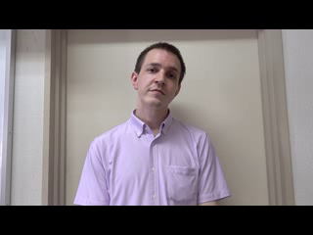**Instructions**

This handsome robot is named Birgir ビルギル. He is designed to help you practice your pronunciation and memorization of certain key English phrases.

Listen to the phrases, say the correct response into the microphone and rack up all the points!

**Activity idea**: If you have many students, you can put them into teams. Have them line up in front of the microphone (whether you have the built in one on the PC, or an external one). One by one, have the front-most student say one phrase, and then go to the back of the line. When the timer runs out, calculate their points. Who will win?!?

|  |  |
| --- | --- |
| **Phrase:** | **Expected answer:** |
| *(as said by Birgir)* | *(say this into the microphone)* |
|  |  |
| This is Manabu.  I am Birgir.  My name is Birgir. | **Nice to meet you.** |
| Nice to meet you. | **Nice to meet you too.** |
| Hello. How are you. | **Fine, thank you**  **Fine.**  **I’m fine.**  **I’m good.** |
| What’s up! | **Nothing much.** |
| Bye | **Bye.**  **Goodbye.**  **Bye bye.**  **See you.** |
| Thank you | **You’re welcome**  **Not at all**  **No problem**  **My pleasure** |
| I’m sorry | **That’s all right**  **No problem**  **Ok**  **That’s ok**  **Don’t worry**  **Never mind** |