# Read me – PEMWE preprocessing and fitting tool

**Table 1**. Abbreviations

|  |  |
| --- | --- |
| CC | constant current |
| GEIS | galvanostatic electrochemical impedance spectroscopy |
| MB | modulo bat |
| CA | chronoamperometry (apply potential 🡪 measure current) |
| CP | chronopotentiometry (apply current 🡪 measure potential) |
| Pol curve | polarization curve |
| HFR | high frequency resistance |

All data was measured on BioLogic VSP-300 with EC-Lab V11.47.

This python tool is structured based on measurement techniques used and analyzes all .mpt files that are in the same folder as the Python script. Exemplary .mpt files are attached in the projects in folder ‘Examples’ in the repository.

## Dependencies

This code is written with:

* Python 3.10.6
* NumPy 1.23.4
* Matplotlib 3.6.2
* SciPy 1.9.3
* pandas 1.5.1
* Impedance.py 1.7.1
* Moreover, pandas depends on xlsxwriter or openpyxl for Excel file writing. During development, xlsxwriter 3.1.9 was used.

## BioLogic Setup and Data Saving

**Note** that the data should be saved as .mpt file via ‘Experiment’

Ein Bild, das Text, Schrift, Reihe, Zahl enthält.

* ‘Export as Text..’
* Choose .mpt as file format
* Add all files you want to export via ‘+’
* Press export

Ein Bild, das Text, Screenshot, Display, Software enthält.

## Code workflow and important parameters

A brief overview of the code structure and its main workflows is given in Figure 1.

This python tool is structured based on measurement techniques used in EC-Lab. It goes through the four measurement techniques implemented in the code by searching for the names (MB, GEIS, CP, CA) in the data file name and performs the designated tasks step by step. The respective high-level functions are named as analyze_XX_data where XX is the technique name according to data file. If one on the measurement techniques does not exist in the folder, it jumps to the next one.

Table 2 explains the measurement techniques’ purpose, the setting needed in EC-Lab software and the individual parameters that can be adapted to the use case.

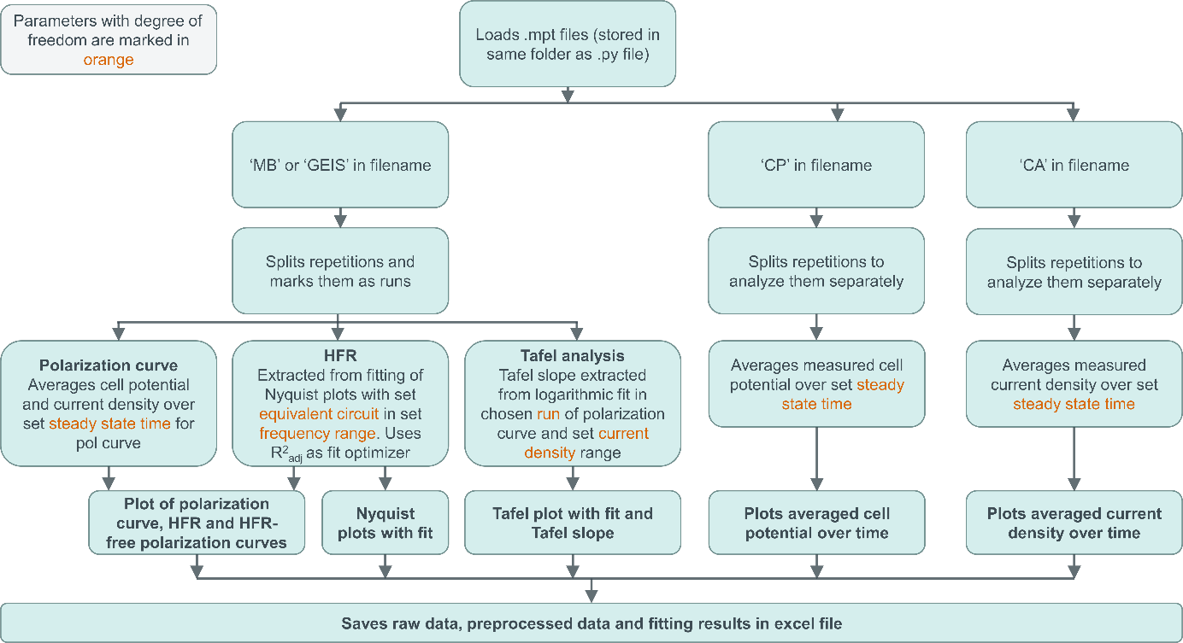

**Figure 1.** Flow chart of code structure

**Table 2.** Overview of parameters with degree of freedom sorted based on measurement technique.

|  |  |  |  |
| --- | --- | --- | --- |
| analyze_MB_data and analyze_GEIS_data  **Modulo Bat (MB):** Aggregated GEIS and CC alternating   * CC for pol curve steps * GEIS at every step of the pol curve for HFR determination   **🡪** yields polarization curve, HFR-free polarization curve and HFR evolution with current density | | | |
| Parameters to choose | Description | Settings in EC-Lab software | Needed for |
| runs | repetition of full pol curve | set either via ‘go back to sequence Ns’ Ein Bild, das Text, Screenshot, Schrift, Reihe enthält.  Automatisch generierte Beschreibung  or via inserting ‘LOOP’ technique) | Splitting of repetitions/loops since .mpt file strings all rep together |
| steady_state  _duration | Time [s] that is used for averaging from end of each pol curve step | Number of averaged data points depend on data acquisition frequency set in | Averaging potential and current density to obtain the final points of pol curve |
| tafel_run | Repetition of pol curve that is used for Tafel analysis | None | Tafel analysis |
| numbers_per  _repetition | Number of current density steps and EIS steps of pol curve | Set via number of CC techniques (In this example, number = 3) | Splitting of repetitions/loops (since .mpt file strings all rep together) for separate pol curves, averaging and fitting |
| Frequency_interval | Interval of frequency from EIS measurements used for fitting | Full measured frequency range can be set via GEIS. Depending on the fit a smaller range must be chosen. | Nyquist fitting |
| Equivalent_circuit | Electrical equivalent circuit model consisting of one or more circuit parameters | None (equivalent circuit model needs to be chosen based on physical phenomena of the analyzed system) | Nyquist fitting |
| initial_circuit_guess | Guessed starting values for circuit parameters After first iteration, output values are taken as starting values. | None | Nyquist fitting |
| hfr_element | Circuit parameter that resembles the HFR | None | Extracting the HFR values per pol curve step |
| area | Active area [cm2] of measured cell | None | Normalizing current to obtain current density and EIS data |
| tafel_plot_max  _current_density | Upper threshold of current density for Tafel fit | None | Tafel fit |
| analyze_CP_data  **Chronopotentiometry (CP):** sets current and measures potential  **🡪** yields potential evolution over time | | | |
| Parameters to choose | Description | Settings in EC-Lab software | Needed for |
| last_second_interval | Time [s] that is used for averaging from end of each CP step | Number of averaged data points depend on data acquisition frequency set in | Averaging potential |
| area | Active area [cm2] of measured cell | None | Normalizing current to obtain current density |
| analyze_CA_data  **Chronoamperometry (CA):** sets potential and measures current  **🡪** yields potential evolution over time | | | |
| Parameters to choose | Description | Settings in EC-lab software | Needed for |
| last_second_interval | Time [s] that is used for averaging from end of each CP step | Number of averaged data points depend on data acquisition frequency set in  Ein Bild, das Text, Screenshot, Schrift, Zahl enthält.  Automatisch generierte Beschreibung | Averaging current |
| area | Active area [cm2] of measured cell | None | Normalizing current to obtain current density |

Raw and processed data is saved as Excel sheet (.xlsx). All compiled plots are saved as .png, .svg, .pdf

**Nyquist fitting**

The Nyquist plot fitting is made as modular as possible. We want to highlight that the equivalent circuit model must be physically reasonable chosen based on the measured technology. An adjusted coefficient of determination *R*2adj is used to improve the fit based on iterations with new initial guesses for the circuit parameters. For complex numbers, we calculate *R*2adj by first separately obtaining an R2adj value for the real and imaginary part of the solution and then building their root-mean-square value:

$$R_{adj}^{2}=\sqrt{\frac{{\left(R_{adj, real}^{2}\right)}^{2}+{\left(R_{adj, imaginary}^{2}\right)}^{2}}{2}}$$

**Tafel fitting**

The Tafel fit is done by fitting the HFR-free potential with a logarithmic function starting from the lowest current density up to the set upper current limit (‘tafel_plot_max_current_density’). *R*2adj is used as quality indicator which should be checked.

## Troubleshooting

* If in your data file the row ‘cycle number’ only contains 0 values, use another counting row like ‘Ns’. Exchange ‘cycle number’ with ‘Ns’ everywhere in the code
* Error message: ‘Numbers per repetition does not match numbers of cycles’
  + Check numbers per repetition matching the number of current density steps. Remember that EC-Lab starts to count at 0.
* Text us. Maybe we can find a solution together.

## License

This project is GNU 3.0 licensed. For more information, have a look at the copy of the license in the repository.