Tab the + button opens Add Movie Screen

Movie item - that shows movie name , category as a small movie card

Main Screen (Home)

Movie Name &

Movie Category

Movie Name &

Movie Category

Movie Name &

Movie Category

14:30

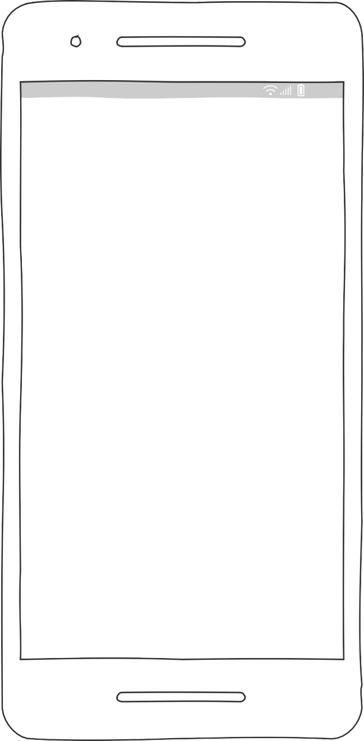

App Logo - Your Movie Tracker on the toolbar as a text

Your Movie Tracker

Toolbar - Which is the place for our logo and <-- get back arrow button from an activity to previous activity

Image - Banner image (pop corn, drink etc)

Image Banne of our Main Screen to makes the app looking stylish and polish

All

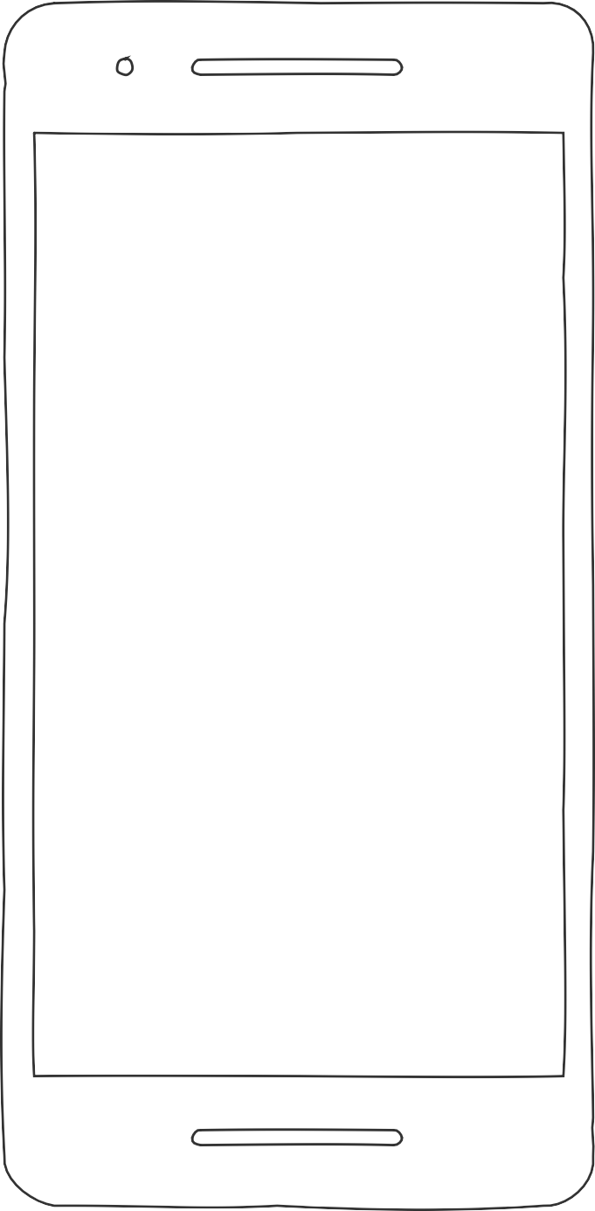

14:30

App Logo - Your Movie Tracker on the toolbar as a text

Left Arrow Butto - on click

,user get back to main screen

Your Movie Tracker

# Movie Detail Item - it is small card that shows movie name and category

Movie Name - John Wick Category : Action

Delete Edit

Delete Button - Delete the movie and take the user to home screen (Main Screen)

Movie Detail Screen and Edit Screen , if a user clcik edit button , they will be able to edit and update the movie

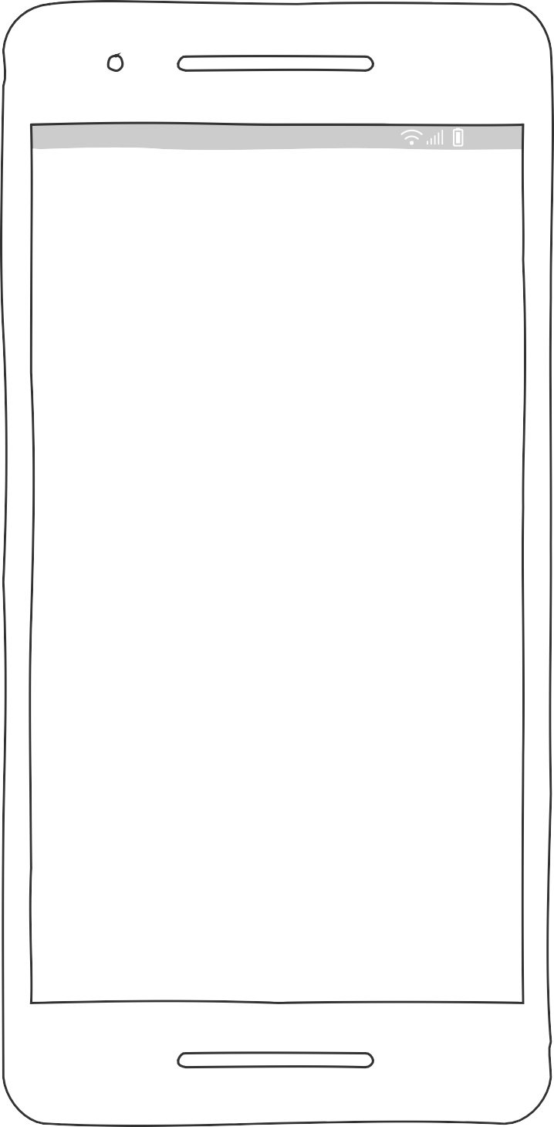

14:30

App Logo - Your Movie Tracker on the toolbar as a text

Your Movie Tracker

Add a New Movie

Left Arrow Butto - on click ,user get back to main screen

Movie Name - John Wick

Movie name entity input field

Category : Action

Add

Movie Category entity input field

Add Button- store the entities on our database and take user to main screen(home page)