**Online Diary**

**Playtesting**

**5.0 Introduction**

This week we assigned the tasks of compiling qualitive and quantitative data of an educational online game. The teams decided what games they wanted to do. My team chose countdown. The reason why we chose countdown is because it tests people with their mental math skills and can improve the vocabulary. As a team we decided to just focus on the math’s side of countdown as it was much more fun to play then the spelling game. We also decided to give people 1 big number as giving more big numbers confuses people as we wanted to only have one independent variable.

**5.1 Rules**

The rules of countdown are, players are given random number. Using these random numbers players will have to add, subtract, divide and multiply to get the number which is displayed. For example, the number displayed is 500, the players are given 25, 4, 1, 2 and 2. 25*4 is 100. 1 plus 2 plus to is 5. 5*100 is 500.

**5.2 questionnaire**

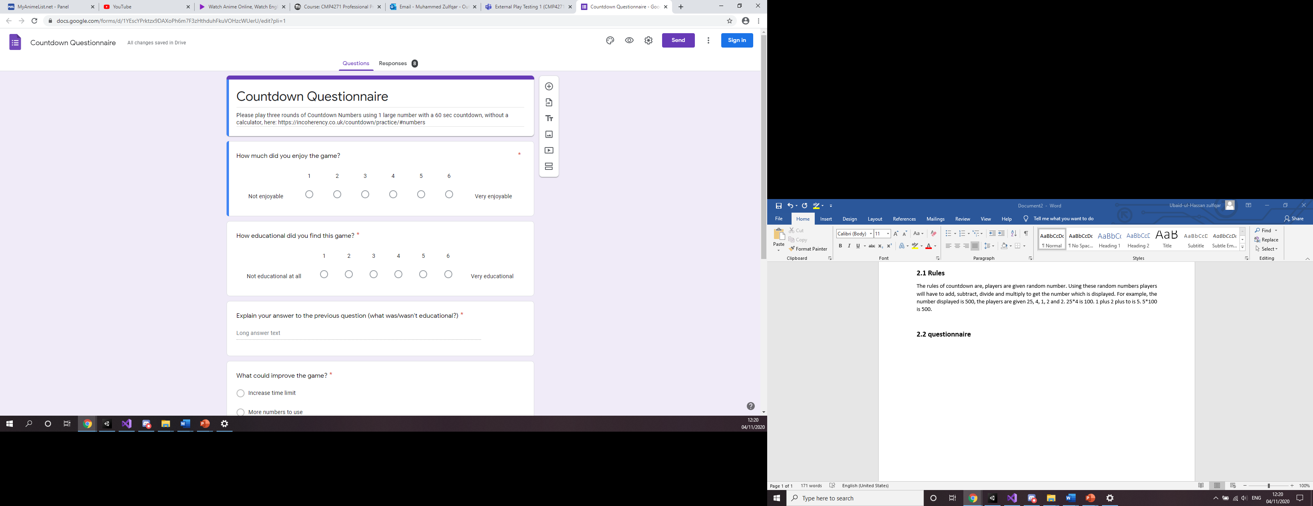

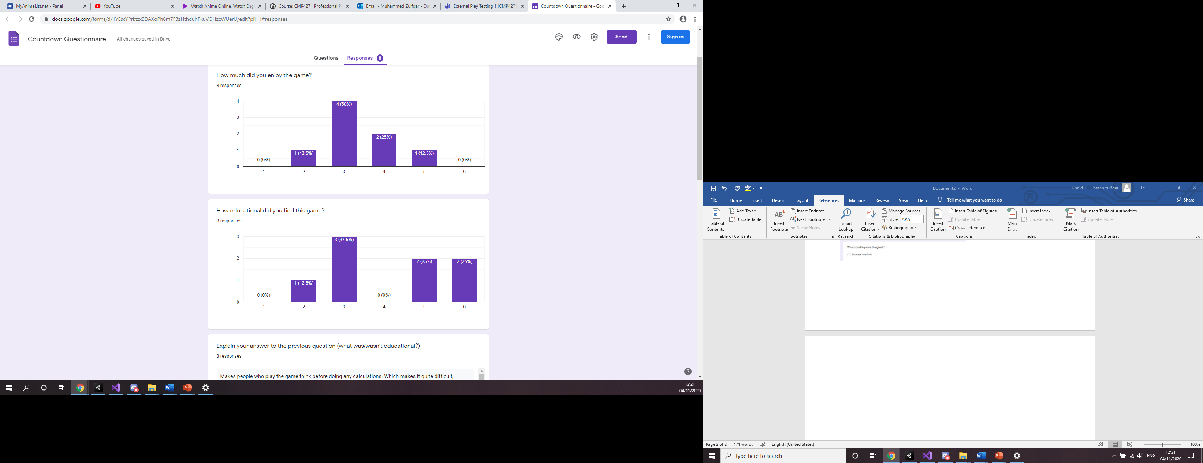

We designed a questionnaire which allowed took which gave us qualitive and quantitative data. We asked questions like what they enjoyed most about this game as well as how much they did enjoy the game. We only had 8 responses but the answers did vary a bit. This gave us a little idea of how the game could be changed as well as well as one didn’t need changing. Most people did like the fact that it was mental math’s but players needed to think outside the box. We also used pie charts and histograms to display the results.

**5.3 Evaluation**

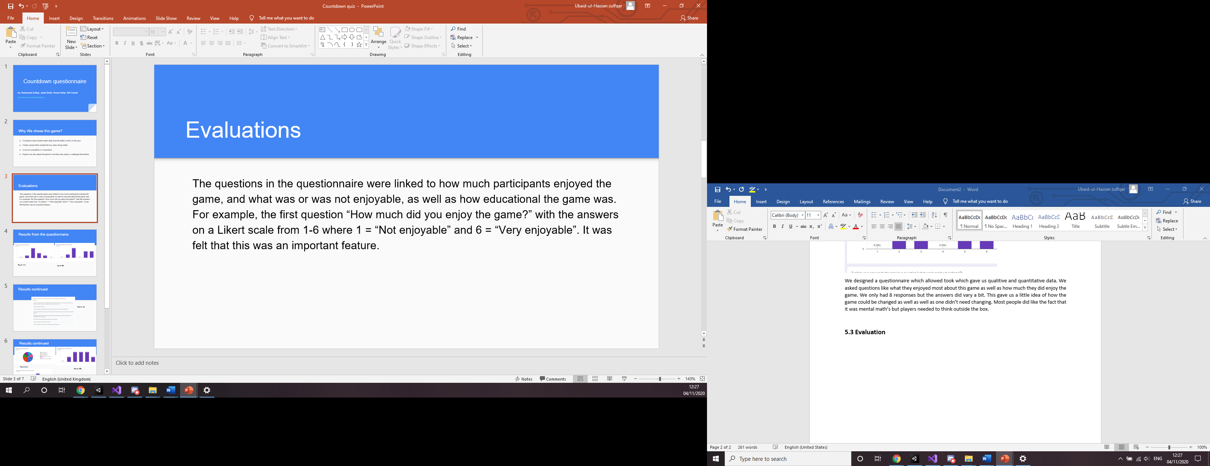

We used Likert scale to get answer for our qualitive data and we used multiple choices to get a quantitative data. Using these kinds of questions helped us and we had a mix of answers. There was a question which allowed players to write out their answer. When looking at the results all players had wrote down similar answers. As a group it made is think that the wording of a question can kind of manipulate the answer the player gives. The question we asked was “what did you find educational about the game” most people put mental math’s meaning that no one thought the game was not educational except for one person.

**5.4 Reflection**

The biggest thing that needed changing was the amount of results. 8 people answered our questionnaire which is not enough to get concrete results. To change this and get more responses we plan do the questionnaire over a longer period of time to get more results and that what give us better results then we got this time round.