Historical Tabletop Educational Game

1. Introduction

The goal of the week 10 was to create an introductory level RPG using a historical video game as the reference point. Its goal was to be used to facilitate student learning.

RPG Campaign based of Assassin Creed: Inspired by historical events.

- 2 - 4 Players recommended

- Turn based combat

- PowerUps in form of items that players could obtain during the campaign

- Story driven, includes stories of characters/game

1. Board Game Lore

Takes place during 18th century in the Golden Age of Piracy when there was seen the rise of several infamous pirates, including [Edward Thatch](https://assassinscreed.fandom.com/wiki/Edward_Thatch), better known as Blackbeard, and [Bartholomew Roberts](https://assassinscreed.fandom.com/wiki/Bartholomew_Roberts).

The game was designed to inform and teach the player about the different types of ships,

Factions and their relationship to each other , tactics and territories (Caribbean Islands).

Battleships - Spanish Galleon, English Frigate, French Man of War & Blackbeard with the French vessel called *La Concorde*. The ship was a 200-ton vessel armed with 56 cannons and a crew of 75.

Factions - Assassins, Spanish & English.

Assassins - Players working together

English - Enemy faction

Spanish - tougher faction + boss

Player is an assassin, tasked with eliminating certain players. They travel around the world gathering weapons and Intel about the person they have to get, ultimately they will have to defeat the enemy factions in order to bring peace to the lands.

1. Mechanics

Attacking - Inspired by D&D mechanics, players use a 20 sided die to roll to attack and a damage die depending on the weapon they use. Players must meet or beat the enemy’s defence value in the attack die in order to deal damage to them

Combat - during combat players and enemies fight in turn based phases, if someone misses their attack then the turn is passed onto the next. Anyone can move,attack or use items in their turn.

In addition, players start and find many weapons that have different attack/damage values. For example, a “sharpened sword” may deal a +1 to damage on top of a 6 sided die.

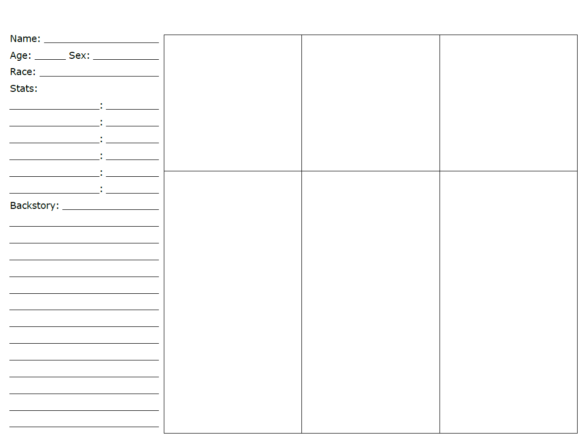

Figure 1: Character sheets showing each player stats and was used to develop ideas for the characters.

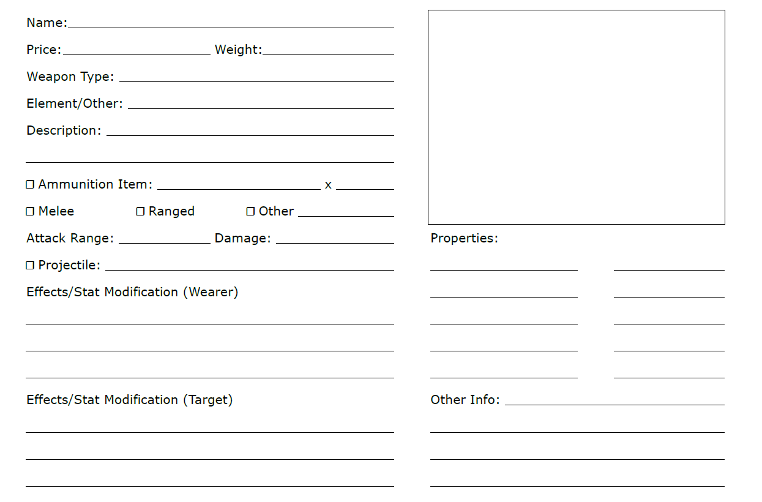

Figure 2: Showing the different items obtainable throughout the game.

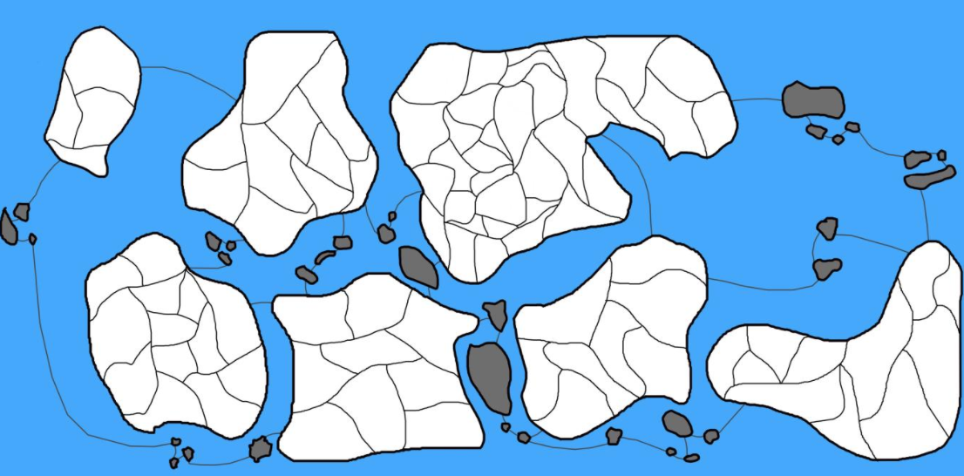

Figure 3: Showing the Board with the description of each island.

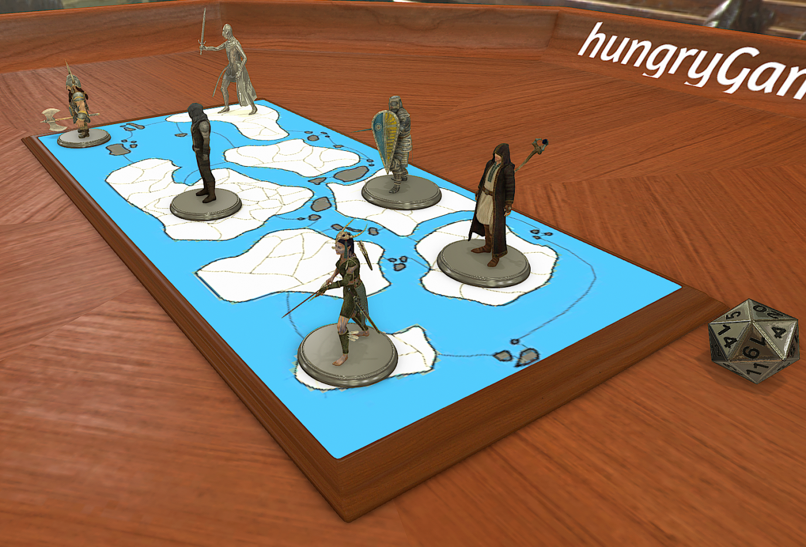

 Figure 3, shows land where you can gain items but has a higher chance of conflict [A], you can hide behind these rocks to avoid being seen [B] and you traverse water with fewer but tougher enemies [C].

Game was developed by: Alexandru Zarnescu, Steven Smith, Zakaria Ahmed and Sean Colbourne.