SERGIO, RICHARD JAN LUIZ A.

2ECE-A

TERMINAL # 23

HANGAROO GAME

TESTING IF FAIL:

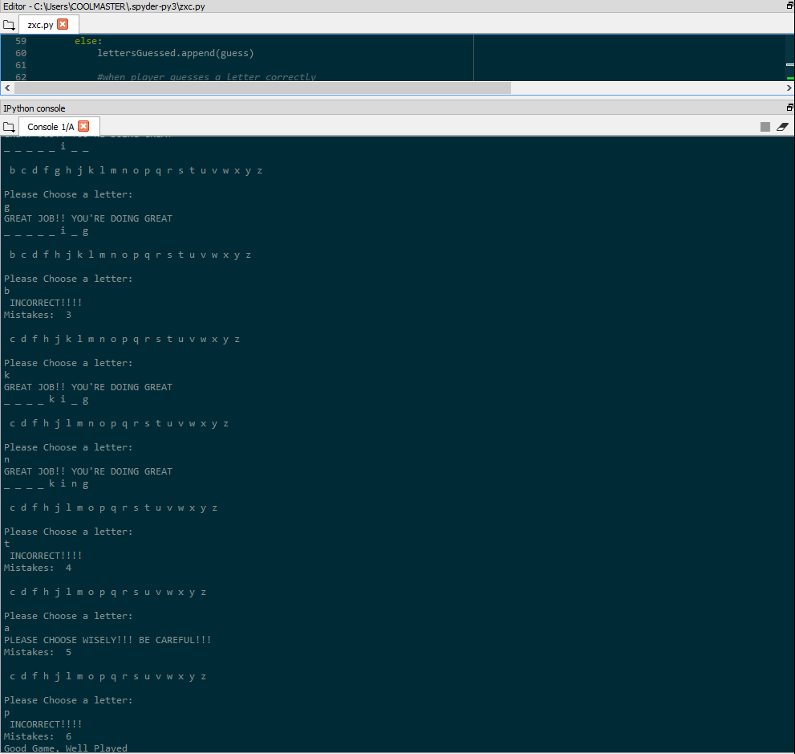

TESTING IF SUCCESS:

