GROUP : 3 2ECE-A

PIOLO ANJOEMAR PEREZ

RICHARD SERGIO

**MACHINE PROBLEM: 1**

**PYTHON**

**CODE:**

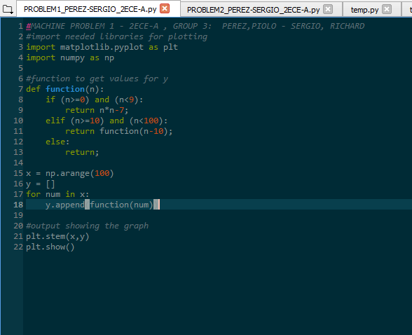

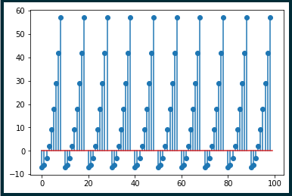**OUTPUT:**

* For every x that meets or satisfies the condition, there will be a formula to find y
* After finding y both (x,y) values are plotted in the graph
* We can see that the points varies its location based on the y value that we get because some -Y values made the point drop below 0 on the graph
* We can also see that the plotting of the graph are uniformly because there is a pattern like image on the graph because of the points.