RICHARD JAN LUIZ A. SERGIO

2ECE-A

TERMINAL # 23

NUMPY PROGRAMMING ASSIGNMENT

PROBLEM 1

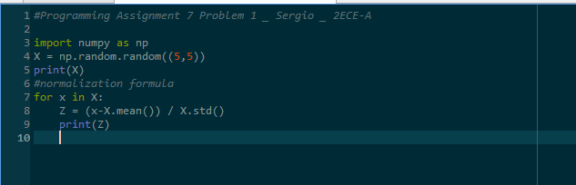

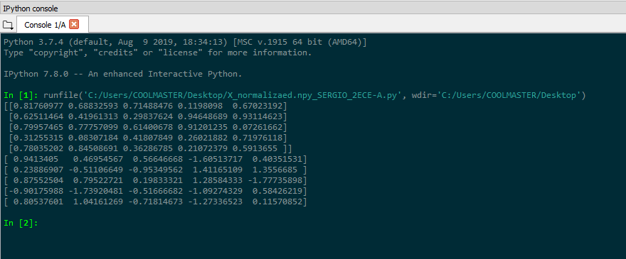

PROBLEM 2

