Images

Graphite

**Part 1**

Test

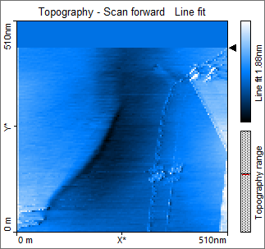

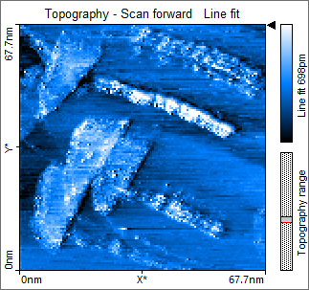

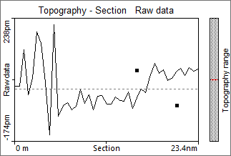

Distance = 367.2 $± 86.75$ pm

**Part 2**

Test

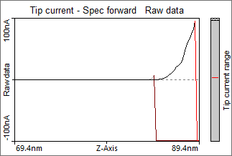

5 repetitions for optimised parameters – (start = =12nm)

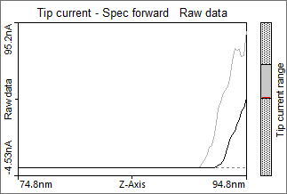

**Part 3**

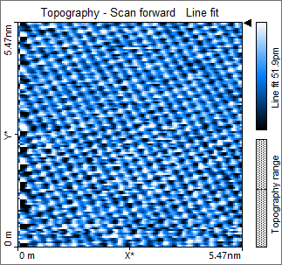

**5 rows = 1.164nm**

**Atom = (1.164 /5) nm**

**(Max = 1.200nm)**

**(Min = 1.082nm)**

**(d = 0.2 … $⋅10^{-10}$ m)**

**Gold**

**Part 1**

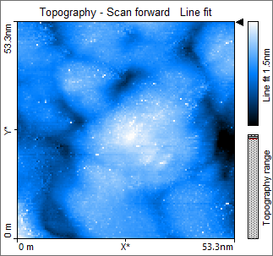

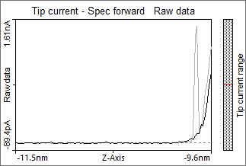xz

Part 2

