**Investigation of the crystal structure of sodium chloride using x-ray crystallography**

**Abstract**

This report seeks to investigate the crystal structure of sodium chloride (NaCl) using x-ray crystallography. Using Laue photographs I determine the symmetry elements present along the **<100>** direction. Further using Bragg-Brentano diffraction, I provide estimates for the interplanar spacing of the planes responsible for promoting diffraction of the x-ray source.

**Introduction**

X-ray crystallography has been a critical method for determining the structure of crystals for over a century. Using x-rays which had only recently been discovered at the beginning of the 20th century, Von Laue was able to produce diffraction patterns with crystals culminating in the Nobel prize in 1914. **[1]** The following year, a father and son pair shared the Nobel prize. Henry and Lawrence Bragg were recognized "for their services in the analysis of crystal structure by means of X-rays". **[2]**

Since this breakthrough, x-ray crystallography has been used in many fields to decipher the hidden structure of materials.

**Theory**

A vital equation for understanding x-ray crystallography is given in Bragg’s Law,

|  |  |
| --- | --- |
| $$2d sin\left(θ\right)=nλ$$ | **equation (1)** |

The consequence of this equation is that if radiation incident upon some regular structure, in particular one that forms planes with interplanar spacing, (d) that is comparable to the wavelength of the incident radiation, $λ$ we will observe **n** maxima on a screen or detector in one chosen direction. These are points at which constructive interference occurs, spaced at angles of $θ$ from the origin.

Considering the face centered cubic structure of NaCl, it is evident that planes will form between ions promoting diffraction. Using the structure factor, $F_{hkl}$ for sodium chloride we can see which planes cause diffraction and estimate their relative intensities, which is given by [3]

$$F_{hkl}=(1+{\left(-1\right)}^{h+k} +{\left(-1\right)}^{k+l}+ {\left(-1\right)}^{h+l})(f_{Na+}+{\left(-1\right)}^{h}f_{Cl-})$$

were **h**, **k** and **l** are the miller indices for the crystallographic planes and $f_{Na+}$ and $f_{Cl-}$ are the scattering factors for the ions contained in the crystal motif. This equation allows us to tabulate the structure factors for each permutation of miller indices and predict which planes are responsible for the diffraction behavior.

|  |  |
| --- | --- |
| **{hkl}** | $$F_{hkl}$$ |
| 100 | 0 |
| 110 | 0 |
| 111 | $$4(f_{Na+}-f_{Cl-})$$ |
| 200 | $$4(f_{Na+}+f_{Cl-})$$ |
| 210 | 0 |
| 211 | 0 |
| 220 | $$4(f_{Na+}+f_{Cl-})$$ |
| 300 | 0 |
| 221 | 0 |
| 310 | 0 |
| 311 | $$4(f_{Na+}-f_{Cl-})$$ |
| 222 | $$4(f_{Na+}+f_{Cl-})$$ |

**Table 1) Structure factors for sets millers indices in the NaCl crystal structure.**

Points of relatively strong constructive interference are denoted by $4(f_{Na+}+f_{Cl-})$ and weaker constructive interference by $4\left(f_{Na+}-f_{Cl-}\right)$, the reflection conditions. This table will be useful when identifying the peaks produced in the Bragg-Brentano segment of my analysis.

It is important to note that planes with “mixed parity”, that is planes that have sets of miller indices that are not all even or all odd (i.e 100 or 110) produce zero diffracted intensity. These are referred to a systematic absences and will not be present in any diffractogram produced.

Additionally, we can determine the distance, **d** between planes in the cubic structure using the relation

|  |  |
| --- | --- |
| $$d=\frac{a}{{(h^{2}+l^{2}+k^{2})}^{\frac{1}{2}}}$$ | **equation (2)** |

were **a** is the lattice parameter.

**Symmetry elements of NaCl**

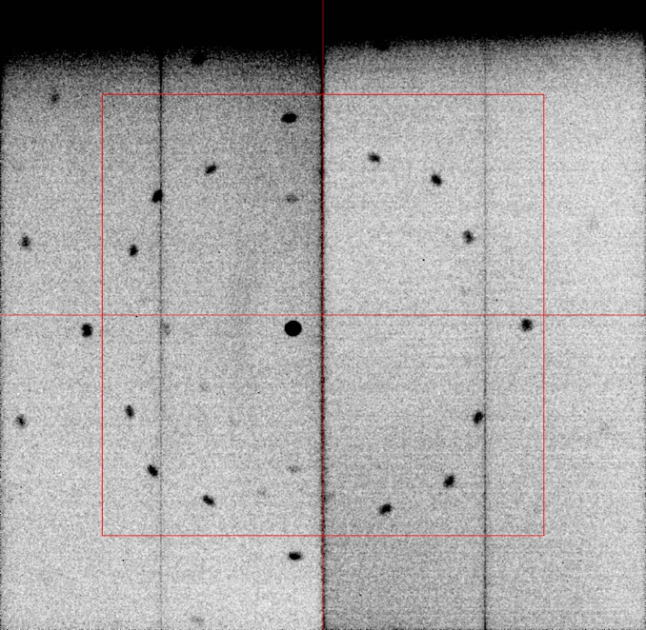Using a Laue photograph of the NaCl crystal in the <100> direction allows the observation of any symmetry elements. This can be illustrated in the figure below.

**Figure 1) Laue photograph of the NaCl sample with a polychromatic x-ray source containing energies of 9.7keV, 11.5keV and 13.4keV**

From the figure it evident that there is a fourfold axis of symmetry. Further there exists two sets of mirror planes, one set horizontal and vertical to the origin and a further set each inclined at ${±45}^{∘}$ to the vertical. It is then possible to assign the point group **4mm** to the crystal**.**

By constructing a 2D reciprocal lattice with the **b*-c\*** axis we can overlay various Ewald spheres. These Ewald spheres have radii corresponding to the inverse of the wavelengths that constitute the polychromatic source. We can then determine the planes responsible for the diffraction maxima by noting the intersections on the spheres with the lattice points.

**Figure 2) Ewald sphere in the reciprocal axis b*-c*. The points of intersection are labelled. These correspond to planes producing the maxima observed in figure 1).**

**Bragg-Brentano diffraction of the NaCl crystal**

**Figure 3) Diffractogram for NaCl sample across orders of diffraction. The n=0 maxima is from the {111} plane highlighted in red on the far left. It has a weaker intensity due to the scattering difference between the ions.**

**n = 1**

Using an automated scan of the crystal, it was possible to plot the diffractogram shown in figure 3 above. The orders of diffraction n = 1,2,3 are labelled at $θ= {7.2}^{∘}± {0.1}^{∘}, {14.6}^{∘}± {0.1}^{∘} and {22.3}^{∘}± {0.1}^{∘}$. These are in line with the expected theoretical values given by Bragg’s law in equation **(1)** using the known incident x-ray wavelength of $λ=0.71Å$.

The peak at n = 1 corresponds to the **{200}** plane from **table 1**. Using equation **(2)** it possible to calculate the distance between consecutive **{200}** planes with $d_{\{200\}}=2.82 Å .$ Similarly, the plane responsible for the n = 2 maxima corresponds to the **{220}** planes with interplanar spacing of $d_{\{220\}}=1.99 Å$. Finally, we can calculate $d_{\{222\}}=1.63 Å$ for the n=3 maxima.

We can illustrate these planes on a face centered cubic unit cell:

**Figure 3)c) Sketch of the {220} plane**

**Figure 3)b) Sketch of the {200} plane**

**Figure 3)a) Sketch of the {222} planes**

Constructing a lattice on the **a*-c\*** axis we can overlay an Ewald sphere. We can get confirmation that the **{200}** planes will produce diffraction as shown by the intersection of the Ewald sphere with the 200 point in reciprocal space, highlighted in red.

**Figure 4) Ewald sphere in the a*-c* reciprocal lattice axis. The sphere notably cuts the {200} plane as expected from the diffractogram.**

**References**

[1] The Nobel Prize in Physics 1914. NobelPrize.org. Nobel Prize Outreach AB 2022. Sun. 13 Mar 2022. <https://www.nobelprize.org/prizes/physics/1914/summary/>

[2] The Nobel Prize in Physics 1915. NobelPrize.org. Nobel Prize Outreach AB 2022. Sun. 13 Mar 2022. <https://www.nobelprize.org/prizes/physics/1915/summary/>

[3] https://physicsopenlab.org/2018/01/22/sodium-chloride-nacl-crystal/