Contents

Overview 3

Introduction 3

Features at a Glance 3

License 3

Legal Disclaimer 3

Found a bug 3

Installation 4

Install required package 4

Install plugin 5

Using in your application 6

Configuration Settings 8

Return Data 8

Maximum Rows 8

Download when click on (JQuery Selector) 8

Custom Width 9

Installing sample application 9

FAQ (How To) 9

Replace default file name (Excel.xlsx) to the custom file name 9

Easy implement this functionality to all Interactive report in your application 9

Adding custom download button 11

How to exclude reports columns from export/make columns that are visible in Excel but not visible in Interactive Report 11

How to set Maximum Rows property for certain pages when plugin functionality are implemented to all Interactive report in your application. 12

How to Enable Download-XLS Icon . 14

Overview

Introduction

The "**GPV Interactive Report to Excel**" APEX plugin provide simple export of IR-data into Microsoft Excel.

Features at a Glance

These Interactive Reports features are supported:

* Correct export of data types (String/Date/Number)
* Filtering and Sorting
* Control Break
* Computations
* Aggregations
* Highlighting
* Auto adjustable Column Width
* Date/Number Formats
* Custom downloaded file name (see FAQ)
* Can be easy implemented for all Interactive reports in application (see FAQ)

License

The "GPV Interactive Report to MSExcel" APEX plugin and IR_TO_XML, XML_TO_XSLX, IR_TO_MSEXCEL packages are currently available for use in all personal or commercial projects under both MIT and GPL licenses. This means that you can choose the license that best suits your project and use it accordingly. Both licenses have been included with this software.

Legal Disclaimer

The program(s) and/or file(s) are supplied as is. The author disclaims all warranties, expressed or implied, including, without limitation, the warranties of merchantability and of fitness for any purpose. The author assumes no liability for damages, direct or consequential, which may result from the use of these program(s) and/or file(s).

Found a bug

If you have found a bug, please send us debug information. To do this, set **Return Data** plugin options to **“Debug Information”.** Try to get your XML data again. You’ll get text a file with debug information.

Please send this file to [pavelglebov@outlook.com](mailto:pavelglebov@outlook.com). We’ll try to fix this error as soon as possible.

Installation

Install required package

This plugin requires IR_TO_XML, XML_TO_XSLX, IR_TO_MSEXCEL and AS_ZIP packages. To install these packages, please use install_all_packages.sql all-in-one installation script.

To do this, navigate to the “SQL-Workschop > SQL-Scripts”. Upload file **install_all_packages.sql**.

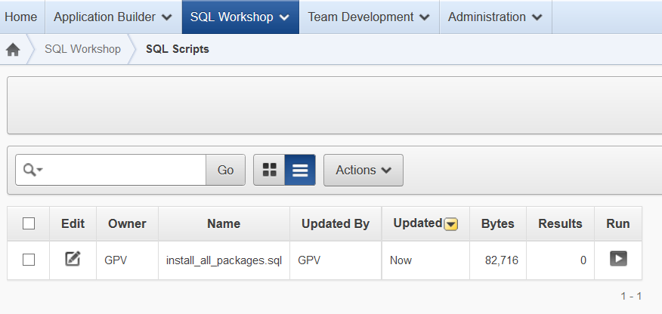

This script will be created all required packages. Run this script by pressing Run-icon.

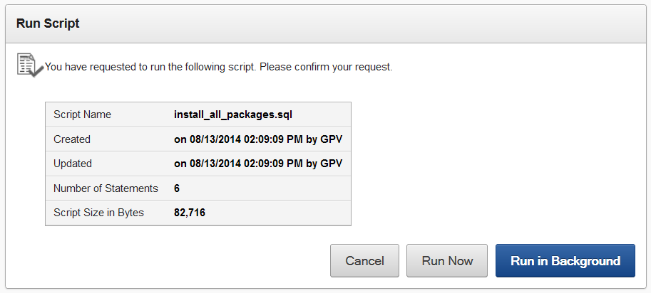

Press “Run Now” button.

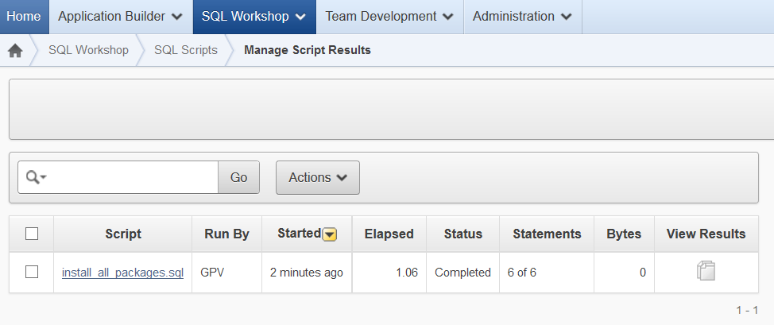

After execution take a look at execution results. At first open “*Manage Script Results*” tab by pressing on link in **View Results** column.

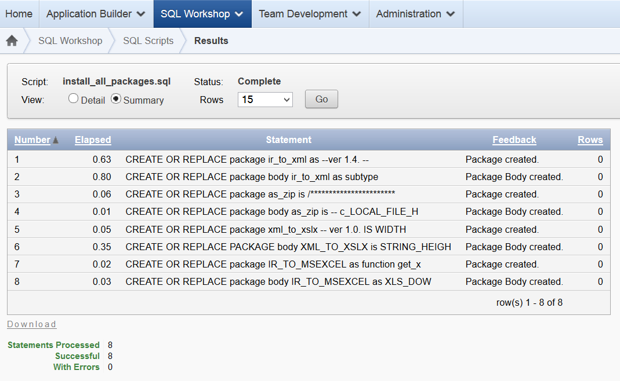

There should be no errors.

Install plugin

Navigate to “*Shared Components > Plug-ins*” and click **Import**. [Herefrom](http://docs.oracle.com/cd/E37097_01/doc/doc.42/e35125/deploy_import.htm#HTMDB26010) you can follow the menu to upload plugin-file “**process_type_plugin_gpv_ir_xml.sql**” and to install the plug-in using the file above.

Using in your application

1. Create “*On Load - Before Regions*”*-*process “**Plug-Ins**” type.

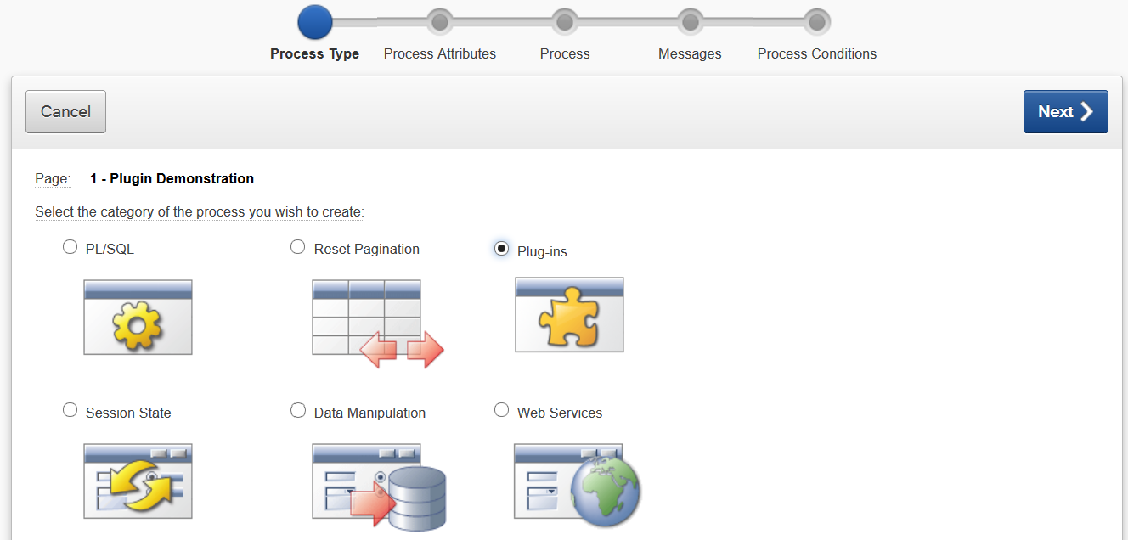

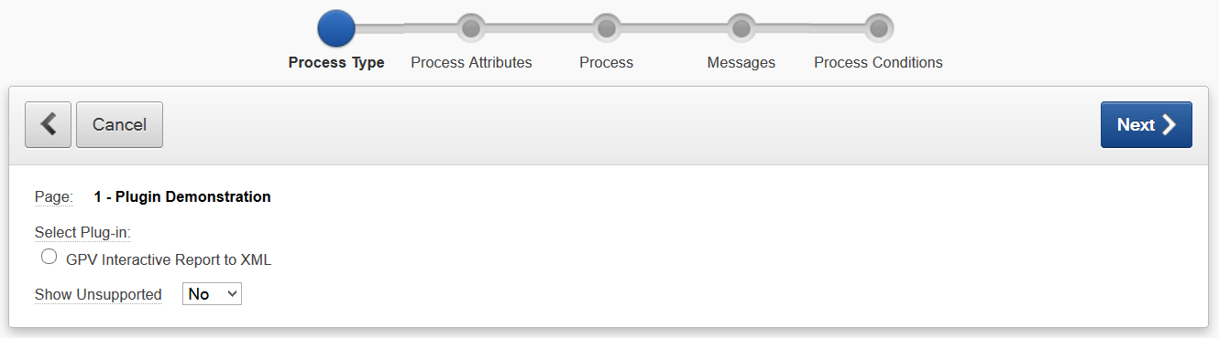

Select “**GPV Interactive Report to XML”**.

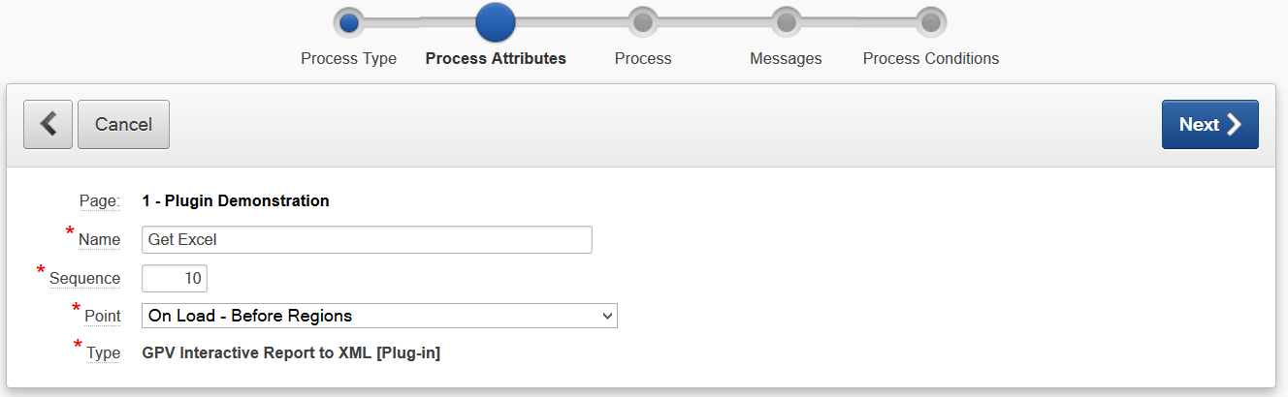

Give this process a name (for example “*Get Excel*”).

Select execution “*Point*”: “***On Load - Before Regions***”

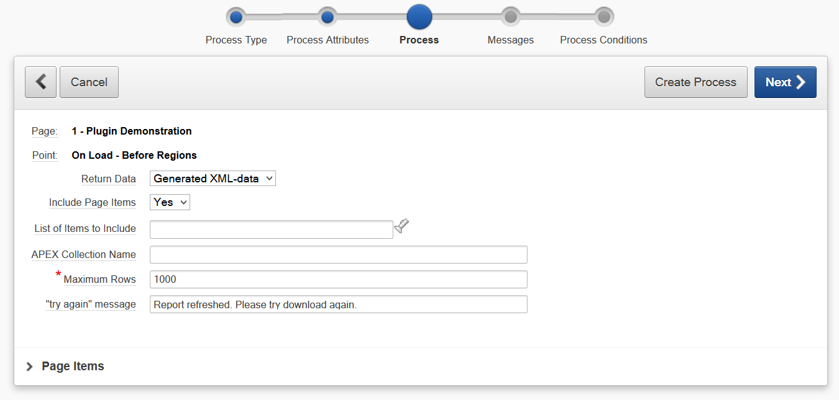

Press “**Create Process**”.

Configuration Settings

Return Data

Choose "Excel XLSX" to return result of Interactive Report as MS-Excel file.

Choose "XML (Debug)" to return result of Interactive Report in XML format.

Choose "Debug TXT" to view debug information.

Maximum Rows

Rows greater than this value will not be exported.

To export all the rows set the value to 1000000000.

When empty - value from Interactive Report Attributes-> Maximum Row Count will be used.

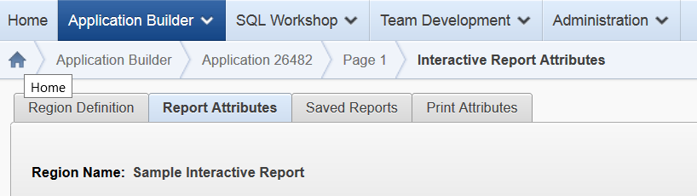

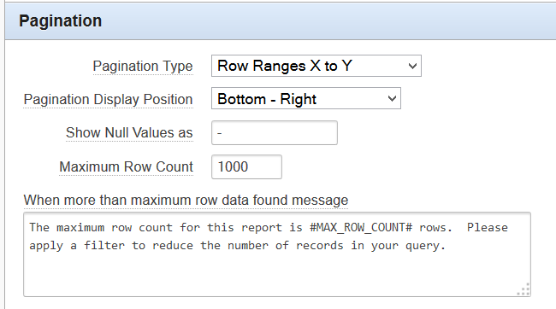

Download when click on (JQuery Selector)

Download starts when clicking on objects that are selected with this JQuery selector.

**Replace standard IR XLS download**

Replace standard IR download XLS menu functionality to download XLSX feature.

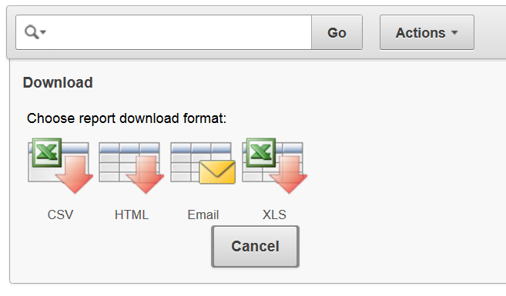

This functionality will be replaced

Custom Width

Comma-delimited string with values, each value consist of column name and column width.

So, this string

PROJECT=151,TASK_NAME=319,START_DATE=133,

sets

width = 151 to the column with name = “PROJECT”,

width = 319 to the column with name = “NAME”,

width = 133 to the column with name = “START_DATE”

**Please do not forgive comma at the end of the string!**

Width are set in special units that are **approximately** equal to pixels.

Installing sample application

You can find sample application in SAMPLE_APPLICATION folder in plugin archive.

To install sample application please follow this [Instructions](http://docs.oracle.com/cd/E37097_01/doc/doc.42/e35125/deploy_import.htm#HTMDB25833).

FAQ (How To)

Replace default file name (Excel.xlsx) to the custom file name

When not empty, value from *Report Attributes*-> *Download*-> *Filename* field will be used.

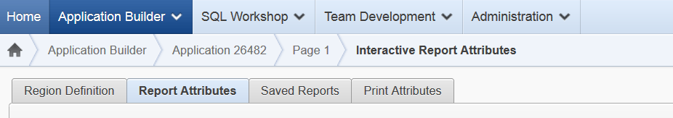

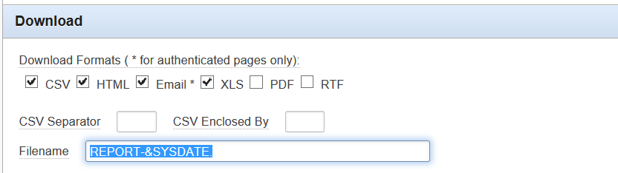

Easy implement this functionality to all Interactive report in your application

1. Install plugin and required packages.
2. Create “**On Load: After Header**” application process.

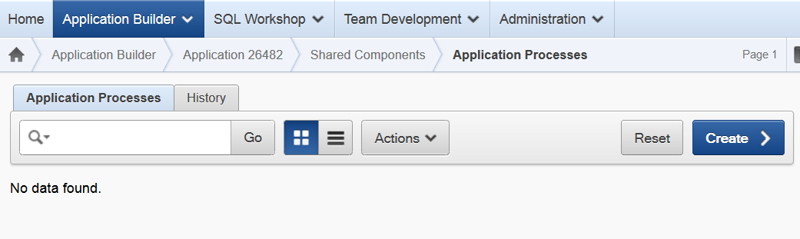

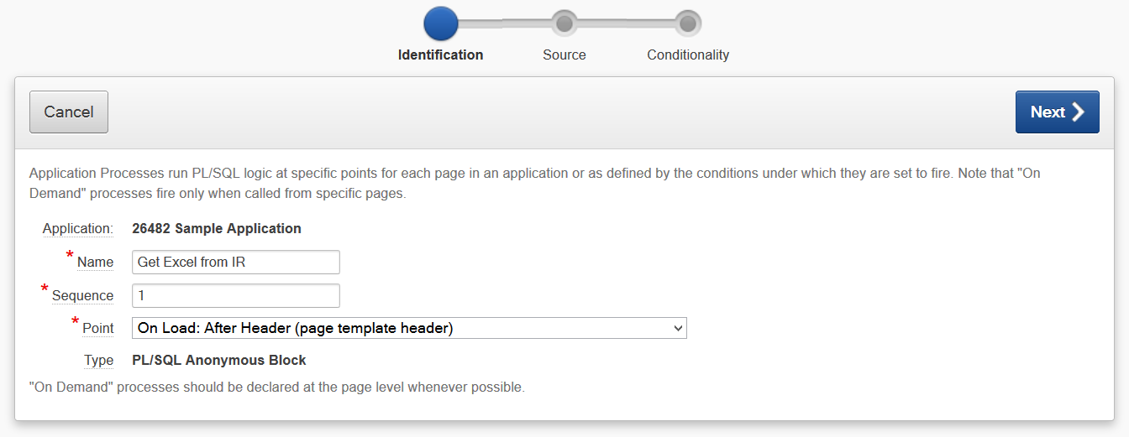

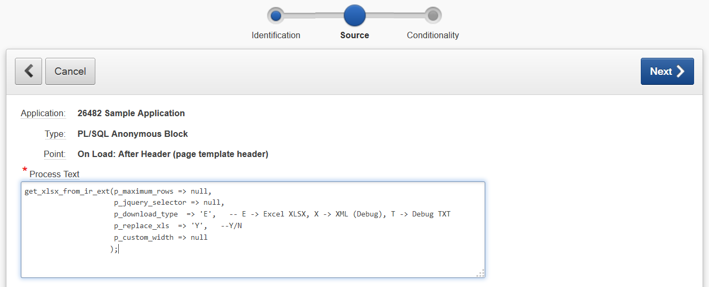

Please set your custom parameters or leave default settings.

get_xlsx_from_ir_ext(

p_maximum_rows => null,

p_jquery_selector => null,

p_download_type => 'E', -- E -> Excel XLSX,

-- X -> XML (Debug),

-- T -> Debug TXT

p_replace_xls => 'Y', --Y/N

p_custom_width => null

);

Parameters description:

* p_maximum_rows - see *Maximum Rows* plugin parameter
* p_jquery_selector - see *Download when click on (JQuery Selector)* plugin parameter
* p_download_type - see *Return Data* plugin parameter
* p_replace_xls - see *Replace standard IR XLS download* plugin parameter
* p_custom_width - see FAQ

When you want to exclude this functionality from couple of pages, use **Conditions**.

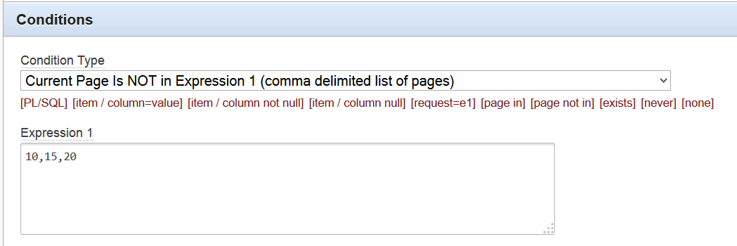

Adding custom download button

1. First create a button with certain **Static ID** and Action “**Defined by Dynamic Actions**” 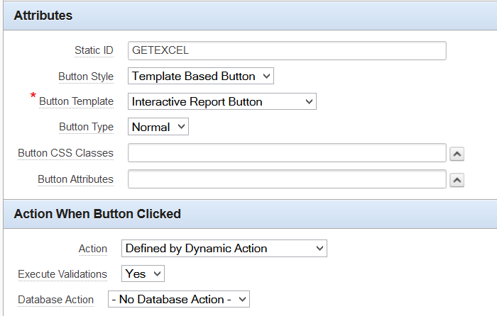
2. Edit “*Download when click on (JQuery Selector)”* property of Process with type “*GPV Interactive Report to MSExcel [Plug-in]*”. Add **Static ID** of the button with ‘#’-prefix. 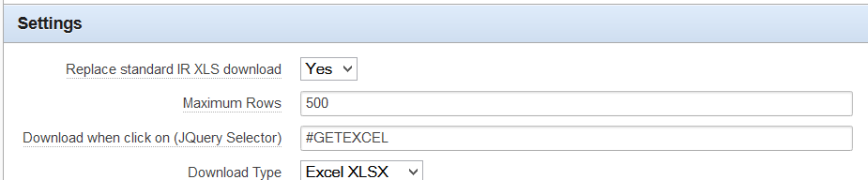

How to exclude reports columns from export/make columns that are visible in Excel but not visible in Interactive Report

Use **Conditional Display** column property for this. 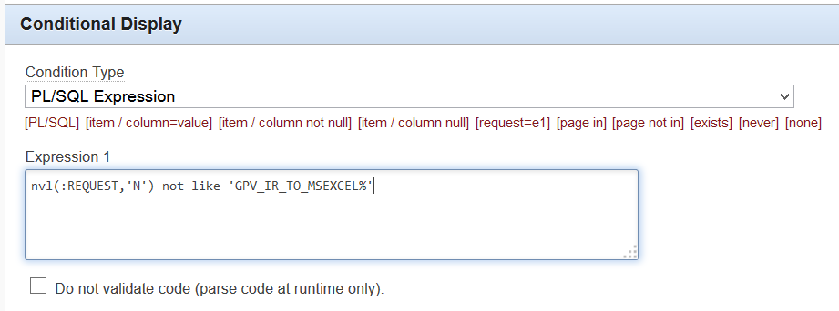

Use ***nvl(:REQUEST,'N') not like 'GPV_IR_TO_MSEXCEL%'*** Expression to exclude column from export,

and ***nvl(:REQUEST,'N') like 'GPV_IR_TO_MSEXCEL%'***  Expression to make column visible on export only.

How to set Maximum Rows property for certain pages when plugin functionality are implemented to all Interactive report in your application.

! This hint references to ***“Easy implement this functionality to all Interactive report in your application”*** paragraph. Please read this paragraph first.

Typical task is to get users with special rights an ability to download unlimited data from Interactive Reports on certain pages.

If you use “**On Load: After Header**” application process to use functionality of this plugin on all Interactive report, parameter **p_maximum_rows** is the same for all pages in application. You need to find easiest way to modify this parameter for certain page. Firs you need to create protected hidden items on this pages. This items should have specific names (P23_DOWNLOAD_MAX_ROWS for page 23) and contains count of maximal downloaded rows depending on user rights (10000000000 for unlimited). To fill this items you need to create “**After Header**” calculation process.

For example:

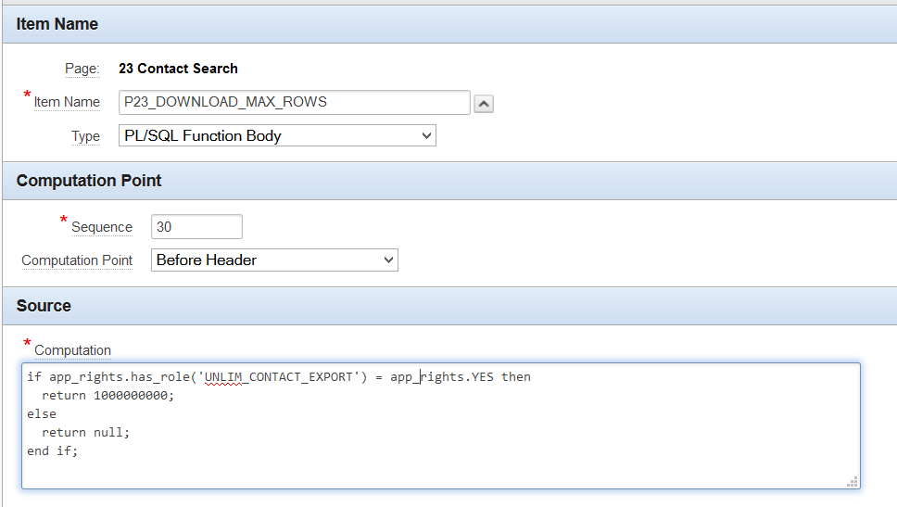

This calculation process gives limit of 100000000 rows users with **UNLIM_CONTACT_EXPORT** role,

and set default value for others.

Now you need modify your “**On Load: After Header**” application process to use this variable automatically when it exist on page. Use a little hack: use substitution string in item name.

get_xlsx_from_ir_ext(

~~p_maximum_rows => null,~~

p_maximum_rows => :P&APP_PAGE_ID._DOWNLOAD_MAX_ROWS,

p_jquery_selector => null,

p_download_type => 'E', -- E -> Excel XLSX

p_replace_xls => 'Y', --Y/N

p_custom_width => null

);

Now, when current page is 23 and page item P23_DOWNLOAD_MAX_ROWS exist, it will be used. Otherwise will be used default value, Maximum Row Count of current Interactive Report.



How to Enable Download-XLS Icon .

1. Access the Administration Services home page (see <http://docs.oracle.com/cd/E11882_01/appdev.112/e12512/adm_login.htm#AEADM168>)
2. Select Manage Service
3. Select Instance Settings, under Manage Environment Settings
4. Click Report Printing to focus on just the Report Printing attributes
5. Now, specify the following attributes: Oracle BI Publisher: Advanced Support
6. Apply Changes.

**! You dot’need installed BI Publisher, you just need to set this setting.**