Anotações

**SAT-1**

**T**

np.arange(1000, 500, -10)

alpha

np.arange(0.01, 0.99, 0.05

n_its1 = 1000

n_its2 = 5

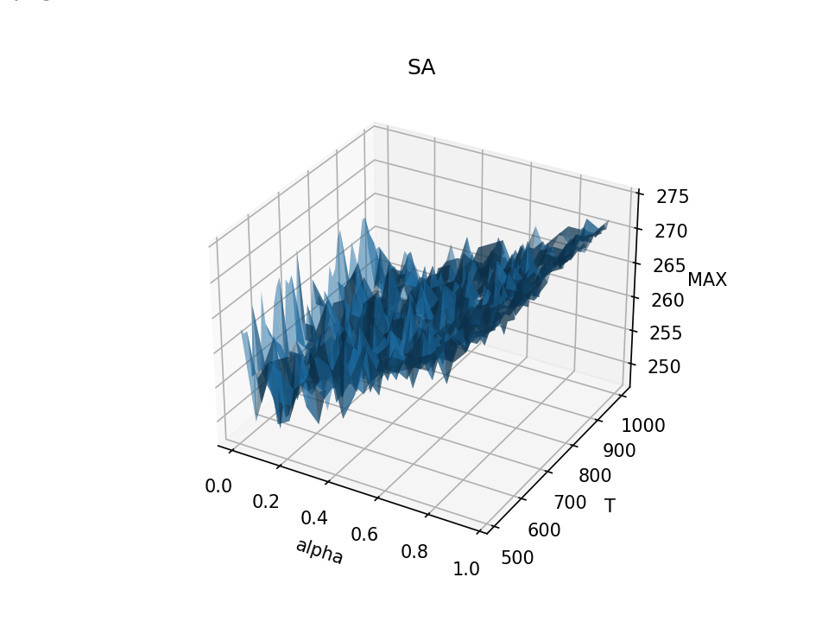

SAT-1

3 melhores

n_its1 = 3000

n_its2 = 30

MAX - 275

T - 650

Alpha - 0.9600000000000001

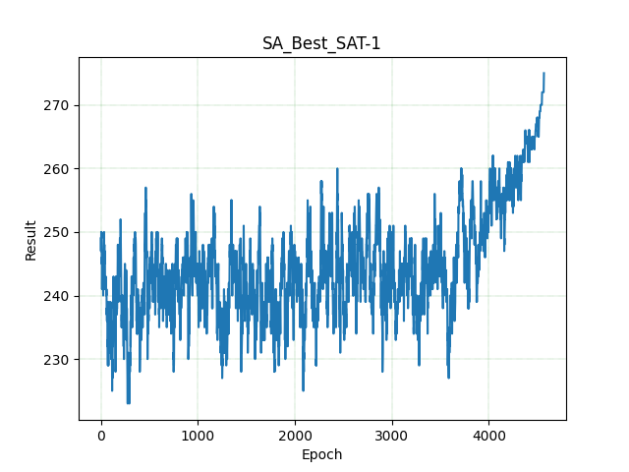

-----------------------

MAX - 275

T - 640

Alpha - 0.9600000000000001

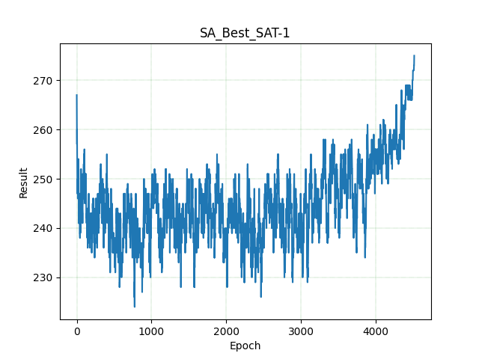

-----------------------

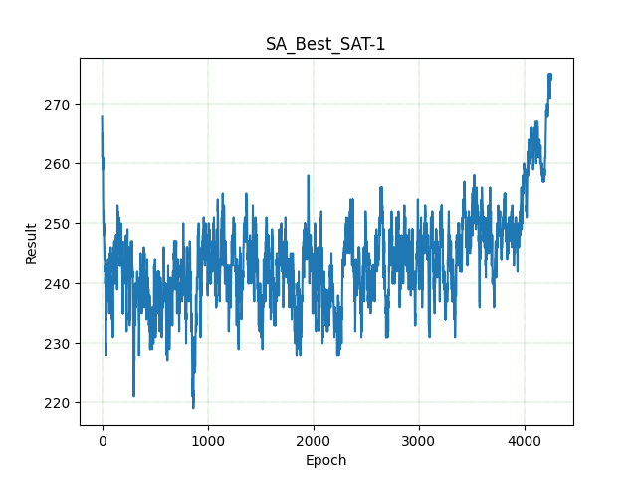

MAX - 274

T - 570

Alpha - 0.9600000000000001

-----------------------

**SAT-2**

**n_its1 = 2000**

**n_its2 = 5**

**T**

**for T in np.arange(1000, 700, -1):**

**Alpha**

**for alpha in np.arange(0.01, 0.99, 0.05):**

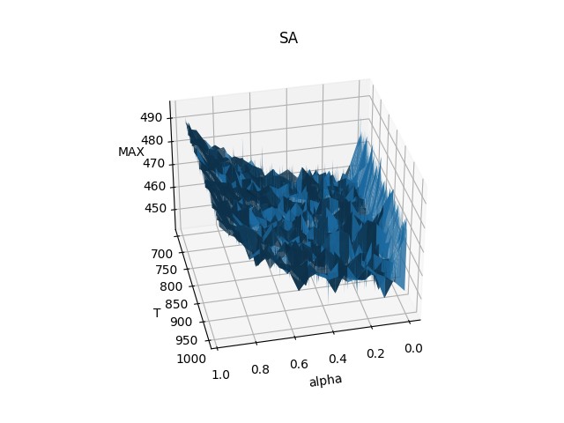

**------------------------------------------------**

**3 melhores sat-2**

n_its1 = 3000

n_its2 = 30

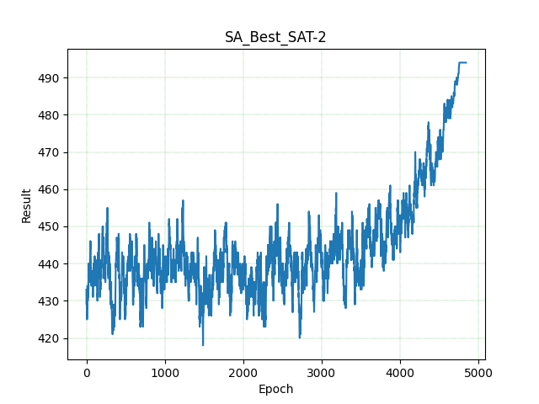

**MAX - 494**

**T - 808**

**Alpha - 0.9600000000000001**

**-----------------------**

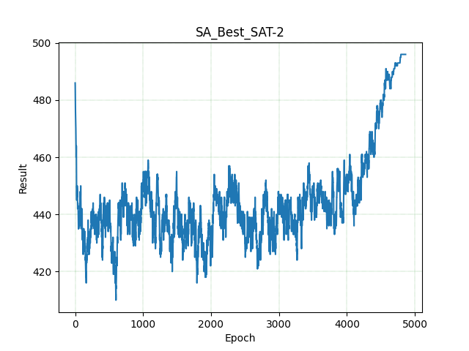

**MAX - 496**

**T - 785**

**Alpha - 0.9600000000000001**

**-----------------------**

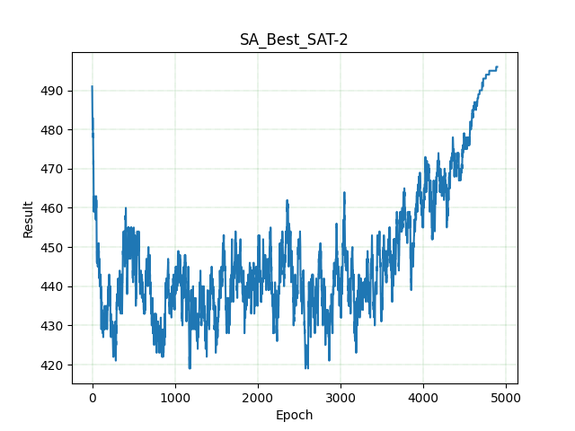

**MAX - 494**

**T - 730**

**Alpha - 0.9600000000000001**

**-----------------------**

**SAT-3**