

DEPARTMENT OF COMPUTER TECHNOLOGY
MIT CAMPUS, ANNA UNIVERSITY, CHENNAI-600044
CS23604 - CREATIVE AND INNOVATIVE PROJECT
AUTOMATED EMAIL CLASSIFICATION AND
AUTO-FORWARDING SYSTEM
TEAM - 50
TEAM MEMBERS | GUIDE’S SIGNATURE
BIRUNDHA B – 2023503509 | TEAM MENTOR:
KAVIN K S – 2023503305 | DR.K KOTTILINGAM,
PRANESH R V – 2023503309 | ASSISTANT PROFESSOR,
 | COMPUTER TECHNOLOGY

Abstract
Large organizations, government institutions, and enterprises receive a significant volume of emails daily through centralized communication channels. These emails include complaints, service requests, administrative queries, financial issues, and technical support requests. Manual processing of such emails leads to delays, human errors, and inefficient routing.
This project proposes an AI-powered secure automated email routing system using machine learning and distributed queue architecture. Incoming emails are securely fetched using OAuth-based authentication and processed through an encrypted asynchronous messaging pipeline using RabbitMQ.
The system performs spam detection and department classification using trained machine learning models. Based on prediction confidence, emails are automatically routed to respective departments or forwarded for manual review. The system supports attachment forwarding, retry mechanisms, idempotency, and audit logging to ensure reliability and security.
Problem Statement
Organizations handling large volumes of emails face difficulties in manual email sorting and routing. Manual processing increases operational workload and delays response time. Important emails may be misrouted or missed due to human error.
Existing automation systems lack scalability, reliability, and security. There is a need for a secure, intelligent, and scalable system capable of automatically analyzing email content, detecting spam, classifying emails, and routing them appropriately while ensuring data security and reliability.

Proposed Solution
The proposed system implements a secure AI-based email routing architecture using distributed system design principles.
Incoming emails are securely fetched using OAuth authentication via IMAP. Emails are serialized and encrypted before being sent to RabbitMQ message queue. Multiple worker services consume messages asynchronously.
The system performs spam detection followed by department classification using trained machine learning models. Based on classification confidence, emails are automatically forwarded or sent for manual review.
The system supports attachment forwarding, retry mechanisms, idempotency, audit logging, and scalable multi-consumer architecture.
Objectives
- To securely fetch emails using OAuth authentication
- To detect spam emails automatically
- To classify emails into departments using ML
- To route emails automatically
- To support attachment forwarding
- To implement retry mechanism for failed emails
- To prevent duplicate processing using idempotency
- To ensure secure message encryption
- To implement scalable queue architecture
- To maintain audit logging for monitoring

Methodology
Incoming emails are fetched using OAuth-authenticated IMAP connection. Email contents including subject, sender, body, and attachments are extracted and converted into structured format.
The email data is encrypted using Fernet symmetric encryption and published to RabbitMQ queue. Multiple consumer workers asynchronously process messages from the queue.
The consumer decrypts the message and performs spam detection. Non-spam emails are classified into departments using trained machine learning models. Based on classification confidence, emails are forwarded automatically or routed for manual review.
Retry mechanisms ensure reliable delivery and idempotency prevents duplicate processing. Audit logs maintain system monitoring and transparency.

LITERATURE SURVEY:
S.NO | PROJECT  TITLE | YEAR &  PUBLICATION |  | PROPOSED SYSTEM | LIMITATIONS
1 | Real-Time,  Evidence-Based  Alerts for  Protection From  Phishing Attacks | 2025 –  Transactions  Dependable  Secure  Computing | IEEE on and | Proposes real-time phishing detection system using machine learning and semisupervised learning to identify suspicious content. The system highlights persuasive phishing text and applies deep learning with data augmentation.. | Focuses only on phishing alert generation and lacks spam classification or routing. Requires labeled dataset for training and lacks scalable queue architecture. Does not support automated email management.
2 | PRIME: A Phishing  Detection  Framework With Quantitative and Fuzzy-Based Dual  Validation | 2025 – IEEE  Transactions on  Knowledge and  Data Engineering |  | Proposes PRIME framework using LLM and fuzzy logic for phishing detection.  Evaluates emails using multiple criteria and provides multilevel risk classification. | Focuses only on phishing detection and lacks routing features. High dependency on LLM models and lacks scalable architecture.  Does not support automated email processing.
3 | E-mail  Classification with Machine Learning and Word  Embeddings for  Improved Customer  Support | 2021 – Neural Computing and  Applications  (Springer) |  | Proposes ML-based email classification using word embeddings and models like SVM, ANN, and LSTM.  Automatically categorizes customer emails to improve routing. LSTM achieved best performance. | Focuses only on classification accuracy and lacks spam detection. Does not support secure email handling or real-time processing. Lacks scalable queue architecture.

4 | A Combined  Feature Selection  Approach for  Malicious Email  Detection | 2025 –  Cybersecurity  Journal (Springer) |  | Proposes malicious email detection using static and NLP features. Extracts multiple features from email header and content. Uses ML models to achieve high detection accuracy. | Focuses only on malicious detection and lacks routing system. Does not support real-time architecture. High feature engineering complexity.
5 | Trouble Ticket Routing Models and  Their Applications | 2018 –  Transactions  Network  Service  Management | IEEE on and | Proposes automatic ticket routing using text mining and routing networks. Analyzes historical ticket data to recommend experts. Improves routing accuracy. | Focuses on ticket routing not email classification. Requires large historical dataset. Lacks spam detection and automation.
6 | Emotion-Based  Email Notification System Using AI and Google OAuth2 | 2025 –  International  Conference  Artificial  Intelligence  Knowledge  Discovery  Concurrent  Engineering | IEEE on and  in | Proposes emotionaware email notification using transformer models. Detects emotional content and prioritizes emails. Uses OAuth2 and reinforcement learning. | Focuses only on emotion detection. Requires complex models and high computation. Lacks spam filtering and routing.
7 | Enabling (End-toEnd) Encrypted Cloud Emails With  Practical Forward  Secrecy | 2022 –  Transactions  Dependable  Secure  Computing | IEEE on and | Proposes encrypted cloud email system with forward secrecy. Supports secure key update and encrypted storage. Improves email security. | Focuses only on encryption. No classification or routing features. Lacks automation and scalability.
8 | Machine Learning Algorithm for  Detecting  Suspicious Email Messages using  NLP | 2025 – Alexandria  Engineering  Journal, Elsevier |  | Proposes suspicious email detection using  NLP and SVC. Uses BERT and TF-IDF for feature extraction.  Achieves high detection accuracy. | Focuses only on spam detection. High computational cost. No routing architecture.
9 | Semantic Analysis and Classification of Emails | 2023 – ACM IC3 |  | Proposes CNN, BiLSTM, and GRU hybrid model. Uses NLP preprocessing and ensemble learning. Achieves high accuracy. | High computational complexity. No routing architecture. Requires large dataset.
10 | Email Automation and Alert System for Email  Management and  Deadline Tracking | 2025 – IEEE i-  PACT |  | Proposes email automation system using Llama-3 summarization and deadline extraction. Uses OAuth and SMS alerts. Improves email productivity. | Focuses on summarization not classification. No spam detection. No scalable architecture.

List of Modules
- Secure Email Acquisition Module
This module is responsible for fetching incoming emails securely using OAuthbased authentication and IMAP protocol. The system connects to the organizational mailbox and retrieves unread emails. Email components such as sender address, subject, body, attachments, and message ID are extracted and converted into structured format for further processing. This module ensures secure email retrieval without exposing user credentials.
Files involved:
  - producer/fetcher.py
  - producer/imap_oauth_client.py
  - producer/token_manager.py
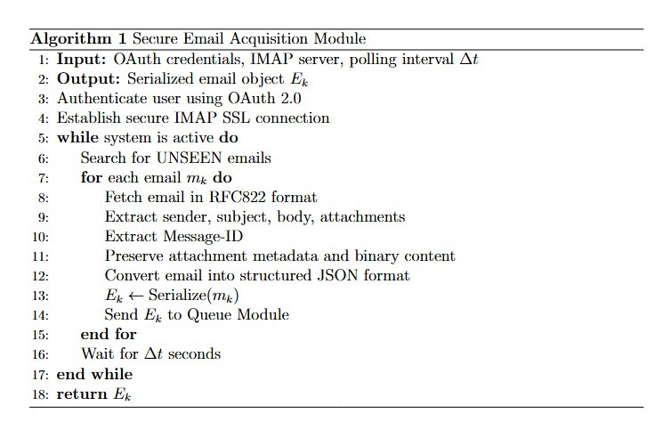
- Encrypted Queue and Messaging Module
This module handles secure message transmission using RabbitMQ message queue. The extracted email data is encrypted using Fernet symmetric encryption and sent to RabbitMQ durable queue. This module ensures asynchronous processing and decouples email acquisition from processing layer. It also improves scalability and reliability of the system.
Files involved:
  - message_queue/rabbitmq.py
  - message_queue/rabbitmq_setup.py
  - common/encryption.py
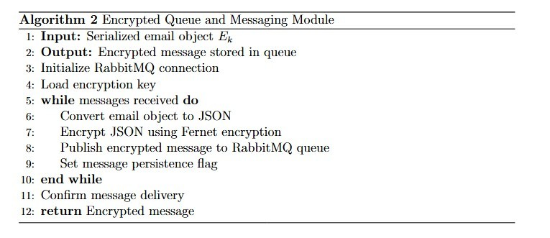
- Parallel Consumer Processing Module
This module consists of multiple consumer workers that read encrypted messages from RabbitMQ queue. The consumer decrypts messages, performs idempotency checks, and processes emails asynchronously. This module supports retry mechanisms for failed email delivery and ensures reliable processing using multiple workers.
Files involved:
  - consumer/worker.py
  - common/idempotency.py
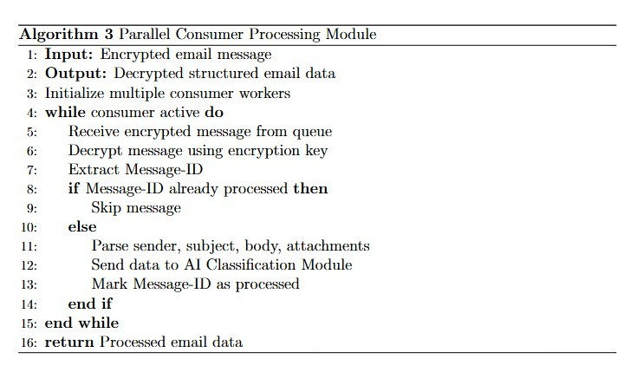
- AI Classification and Decision Module
This module performs spam detection and department classification using trained machine learning models. The system calculates prediction confidence and determines routing decision. Based on confidence level, emails are automatically forwarded or routed for manual review.
Files involved:
  - orchestrator/orchestrator.py
  - models/spam_model.pkl
  - models/department_model.pkl
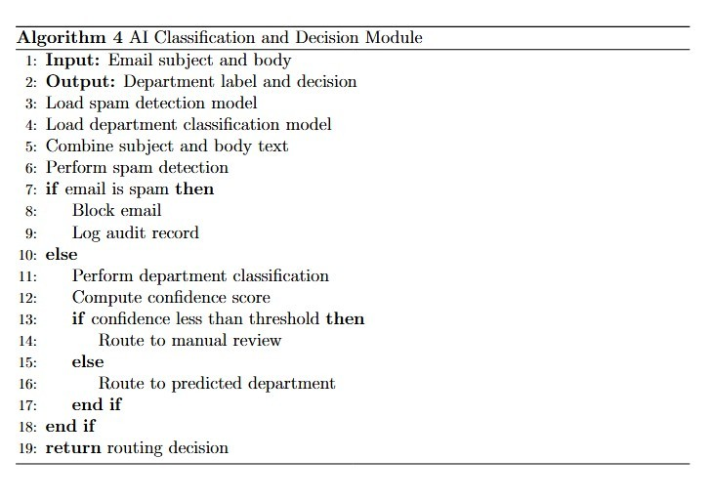
- Intelligent Routing and Audit Module
This module forwards classified emails to appropriate departments using SMTP protocol. Attachments are forwarded securely along with email content. Retry mechanisms ensure delivery reliability. Audit logging records all processing activities for monitoring and tracking.
Files involved:
  - consumer/worker.py
  - common/audit_logger.py
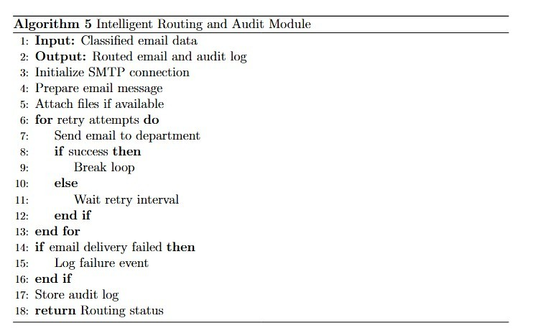
Block diagram
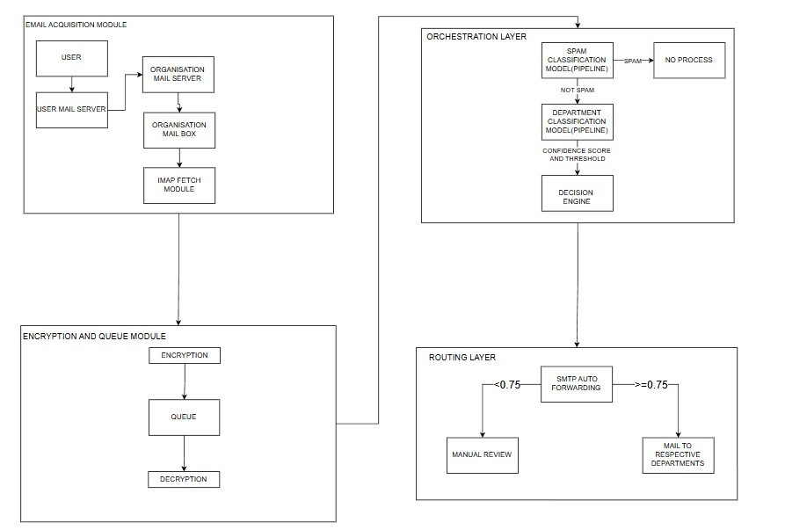
Figure 1: Block Diagram
Technologies Used
• Python
- Machine Learning
- RabbitMQ
- OAuth 2.0
- SMTP / IMAP
- Cryptography (Fernet Encryption)
Machine Learning Models
Spam Detection Model
Used to detect spam emails using trained classifier.
Department Classification Model
Used to classify emails into departments.
Evaluation Metrics
- Accuracy
- Precision
- Recall
- F1-Score

Conclusion
The proposed AI-based secure email routing system automates email classification and routing using machine learning and queue architecture. The system improves efficiency by reducing manual email handling and ensuring accurate routing. Security is enhanced through encryption,OAuth authentication,andidempotency mechanisms.The scalable architecture supports reliable processing using multiple consumers and retry mechanisms. Overall, the system provides a robust and intelligent solution for automated organizational email management.

References
[1] S. Baki, S. Das, and R. Verma, “Real-Time, Evidence-Based Alerts for Protection From Phishing Attacks,” IEEE Transactions on Dependable and Secure Computing, 2025.
[2] X. Tian, Y. Li, and J. Zhao, “PRIME: A Phishing Detection Framework With Quantitative and Fuzzy-Based Dual Validation,” IEEE Transactions on Knowledge and Data Engineering, 2025.
[3] Y . Zhang, L. Chen, and H. Wang, “A Combined Feature Selection Approach for Malicious Email Detection Based on a Comprehensive Email Dataset,” Cybersecurity Journal, Springer, 2025. [4] A. K. Sharma et al., “Negative Review Complaint Detection Using Explainable Deep Learning,” IEEE Transactions on Computational Social Systems, 2024.
[4] M. Alkhodhairy and M. Saleem, “Machine Learning Algorithm for Detecting Suspicious Email Messages Using Natural Language Processing,” Alexandria Engineering Journal, Elsevier, 2025.
[5] P. Raghavendra, K. Venkatesh, and R. Suresh, “Email Automation and Alert System for Email Management and Deadline Tracking,” IEEE International Conference on Innovations in Power and Advanced Computing Technologies (i-PACT), 2025.
[6] A. Sharma, R. Kumar, and S. Verma, “Emotion-Based Email Notification System Using AI and Google OAuth2,” IEEE International Conference on Artificial Intelligence and Knowledge Discovery in Concurrent Engineering, 2025.
[7] S. Sachan, A. Sharma, and R. Gupta, “Semantic Analysis and Classification of Emails Through Informative Selection of Features and Ensemble AI Model,” ACM International Conference on Intelligent Computing and Control Systems, 2023.
[8] X. Wei, J. Zhang, and L. Wang, “Enabling End-to-End Encrypted Cloud Emails With Practical Forward Secrecy,” IEEE Transactions on Dependable and Secure Computing, 2022.
[9] A. Borg, M. Zaki, and T. Mahmoud, “E-mail Classification With Machine Learning and Word Embeddings for Improved Customer Support,” Neural Computing and Applications, Springer, 2021.
[10] J. Xu, L. Chen, and K. Li, “Trouble Ticket Routing Models and Their Applications,” IEEE Transactions on Network and Service Management, vol. 15, no. 2, pp. 456–468, 2018.

