|  |  |  |  |  |
| --- | --- | --- | --- | --- |
| Ibest:DNA_SEQ_CORE:Pictures:iBestteeBack9-17.png | The Institute for  Bioinformatics and  Evolutionary Studies | | | Macintosh HD:Users:msettles:Downloads:02UI_Seal-cmyk.jpg |
| **Genomics Resources Core Facility**  **Standard Operating Procedure** | | |
| *TITLE:* | | | | |
| **Short Fragment Removal Procedure for GS FLX Titanium Amplicon Sequencing** | | | | |
| *AUTHOR (S):* | | | *REVIEWER (S):* | |
| Suresh Iyer, Dan New | | | Gertrud Schneider | |
| *SOP #:* | | *REVISION #:* | *EFFECTIVE DATE:* | *NUMBER OF PAGES:* |
| GRC\_0001 | | 3 | August 1, 2011 | 5 |

**1. PURPOSE**

Some 454 amplicon library preparation methods may result in an unacceptably high amount of short, undesirable DNA fragments that are amplified along with the target amplicons. This will lead to poor sequencing results, as the shorter fragments will preferentially amplify, resulting in poor substantially lesser Passed Filter Reads of the desired target. This document describes a purification procedure that may be employed by the user on any 454-amplicon-library preparation for removing short undesirable fragments to generate the desired target for GS FLX titanium sequencing.

**2. EQUIPMENT**

* Agilent Bioanalyzer 2100 (Agilent Technologies, Cat no. G2940CA)
* TBS-380 (now QuantiFluor™-ST fluorometer, Promega) or equivalent
* DynaMag™-2 Magnetic particle concentrator (Invitrogen, Cat no. 123-21D)
* Horizontal gel apparatus (e.g. VWR, Cat no. 89032-290, 89032-288)
* UV transilluminator (e.g. VWR, Cat no. 89131-446)
* Thermocycler (e.g. Applied Biosystems, Cat no. 4314445 and N8050200)

**3. CONSUMABLES**

* 1.5ml microcentifuge tubes (e.g. USA Scientific, Cat no. 1615-5510)
* Gloves, Nitrile or Latex (e.g. Kimberly-Clark, Cat no. KC300)
* Tris-EDTA buffer (100 mM Tris-HCl and 10 mM EDTA (pH 8.0).
* OmniPur® Agarose (EMD, Cat no. 2120-OP)
* QIAquick® Gel Extraction Kit (QIAGEN, Cat no. 28706)
* Agencourt AMPure XP beads (Beckman Coulter, Agencourt Cat no. A63881)
* Quant-iT™ PicoGreen® dsDNA Assay Kit, 2000 assays (Invitrogen, Cat no. P7589)
* Agilent DNA 1000 Kit (Agilent, Cat no. 5067-1504)
* GelRed Nucleic Acid Gel Stain, 10,000x in Water (Phenix Research Products, Cat no. RGB-4103) or Ethidium Bromide (Fisher Scientific, Cat no. BP1302-10)
* Razor blades (e.g. VWR, Cat no. 55411-050)
* Gel extraction tips (e.g. Phenix Research Products, Cat no. TX-140)

**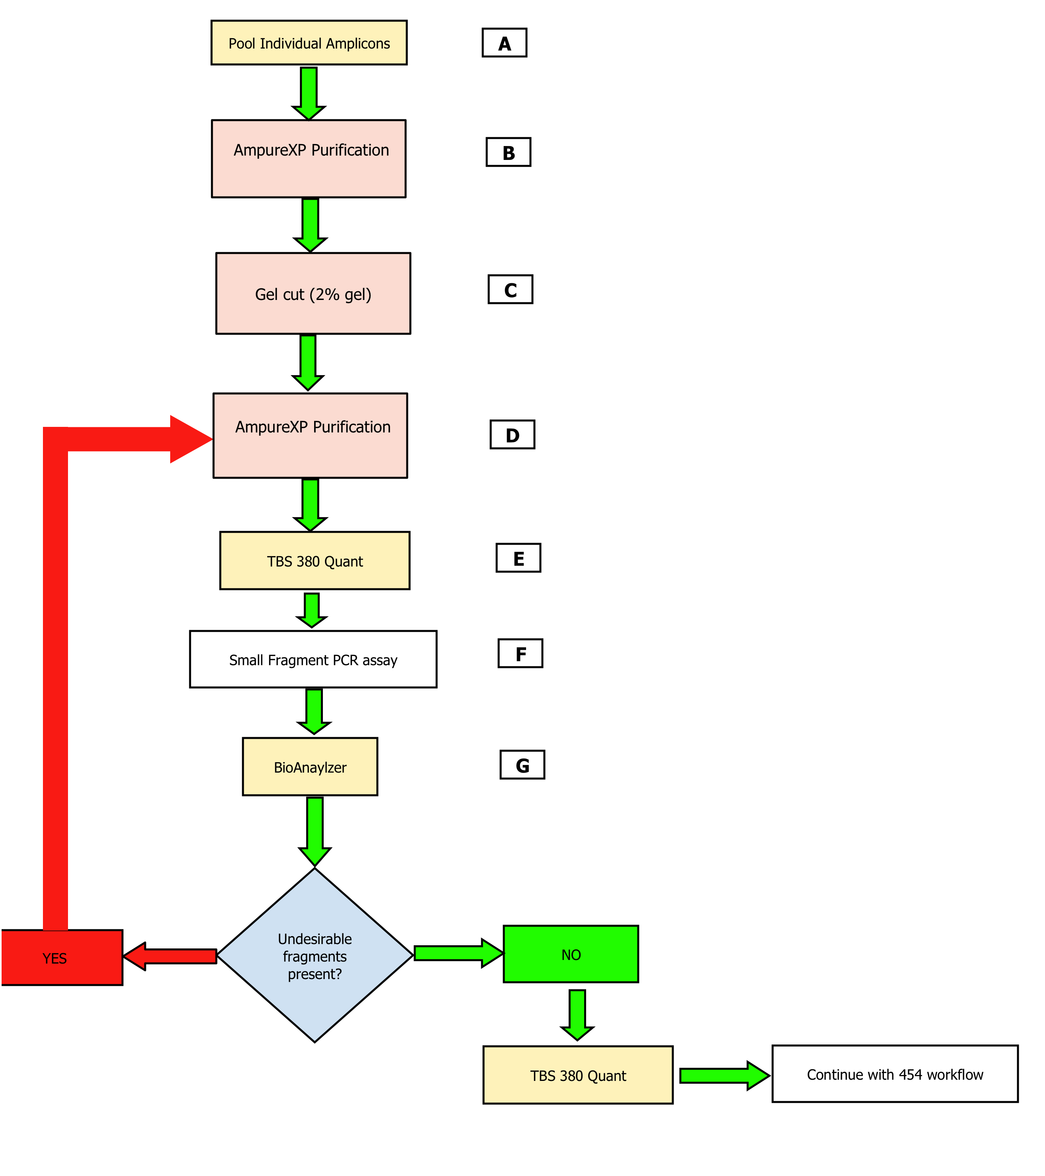**

***Figure 1: A flow diagram of the procedure for removal of short undesirable fragments***

**4. GENERAL LAB CONSIDERATIONS**

* Laboratory benches need to be wiped clean with 70% ethanol.
* Work with amplicons must be done on designated bench only, away from laboratory areas where genomic DNA or PCR work is generally done.
* Gloves must be worn at all times during the work.
* Work must be done carefully to minimize the risk of aerosols.
* Eating, drinking, smoking, chewing gum, or application of lip balms is prohibited.

**5. QUALITY CONTROL PROCEDURES**

* Decontaminate all surfaces with 70% ethanol, before and after use.
* Always use fresh, dedicated tip boxes.
* Use only aerosol-resistant pipette tips to minimize contamination of pipette shaft.
* Discard the pipette tips after each use to avoid cross-contamination.
* Use a fresh, clean razor blade or gel excision tips for each sample during gel excision..
* Gloves must be changed frequently, and between sample pools, to avoid cross-contamination.
* The pipettes used need to be calibrated annually.

**6. SAFETY CONSIDERATIONS**

* Wear UV protective glasses and gloves during exposure of gels to the UV transilluminator.
* Minimize the DNA exposure to UV by working quickly while cutting gel slices.
* Work carefully and properly dispose off used razor blades in appropriate sharps containers.
* Always have a waste disposable container.
* If ethidium bromide is used to visualize DNA in agarose gels, be aware that ethidium bromide is a potent mutagen. Take proper precaution while handling the solution. Handle only with gloves. Dispose off the ethidium bromide solution properly.
* Make sure to dispose ethidium bromide- containing gels in proper biohazard trash containers.
* Try to use an environmentally safe fluorescent nucleic acid dye, like GelRed Nucleic Acid Gel Stain, to replace the highly toxic Ethidium Bromide to stain DNA on gels.

**7. PROCEDURE**

**NOTE:** This procedure has seven main steps, as shown in Figure 1. It will take ~9-11 hrs to perform the entire procedure. If necessary it is possible to stop after each step, but it is generally recommended to complete the entire procedure without any stops.

**A. Pool Individual Amplicons**

Pool each amplicon into a 1.5ml microcentifuge tube at 100 ng per amplicon (or use a tube of larger volume depending on size of pool volume).

**B. AMPure Bead Purification** *CRITICAL STEP*

Take 45 µl from the DNA pool and purify with a volume of calibrated AMPure XP beads (according to the manufacturer’s recommendations). The volume of Ampure beads required is based upon the ratio of Ampure beads to DNA as given below.

The calibration protocol is provided in the 454 GS FLX Library preparation Method Manual (Roche or www.454.com). Once the AMPure XP beads have been properly calibrated, it is possible to choose a bead to DNA ratio that targets a specific size range of short, undesired fragments for removal. For example, a volume of 27µl (or a ratio of 0.6x) will remove short DNA fragments 300bp and less, 33.75µl (or a ratio of 0.75) will remove short fragments 400bp and less, 40.5µl (or a ratio of 0.90) and 72µl (or a ratio of 1.6x) will remove short fragments 500bp and less or 600bp and less. So, depending on the desired amplicon you want to retain, you can use any one of the ratios given.

Elute the desired DNA with 15µl of 1xTris-EDTA buffer, pH 8. Store the remaining DNA pool in -20°C.

**C. Gel extraction and purification *CRITICAL STEP***

(1) Run the entire eluate (15µl) from the above step in a 2% agarose gel, taking care to maintain at least two lanes of separation between samples. Stain gel for 30 min with gel-red or ethidium bromide in a plastic container. Incubate in dark with periodic gentle shaking.

(2) Use a UV transilluminator and view the gel using UV-safe glasses. With a clean razor blade or gel extraction tip, remove only the desired band of the correct size from the gel and place it into a 1.5ml microcentifuge tube.

(3) Purify the DNA containing gel slice using the QIAquick® gel extraction kit (QIAGEN) following the manufacturer’s protocol. Elute with 45µl of 1xTris-EDTA buffer, pH 8.

***PAUSE POINT:*** If necessary, the purified DNA sample can be stored overnight at 4°C, or longer at -20°C.

**D. AMPure Bead Purification *CRITICAL STEP***

Repeat step **B**. Elute with 15µl of 1xTris-EDTA buffer, pH 8.

**E. Determine the quantity (ng/µl) and average amplicon length (bp)**

(1) Quantify purified amplicon sample in a TBS-380 fluorometer using the Quant-iT™ PicoGreen® dsDNA Assay Kit.

(2) Run 1 µl on the Agilent Bioanalyzer using the Agilent DNA 1000 Kit. After the chip has completed running, open the report and determine the amplicon peak(s) by looking at the electropherogram. The results table below the electropherogram will also show the amplicon length(s). If there is more than 1 amplicon peak then determine the average (in bp).

(3) Use the quantification values and the Bioanalyzer values obtained in the steps above, to determine the concentration of amplicon library in molecules/ul. Use the following formula (also given in 454 GS FLX library preparation method manual)

Molecules/ul = (sample conc. in ng/ul) x (6.022 x 10E23)  
                       (656.6 x 10E9) x (avg. amplicon length in bp)  
  
sample conc (in ng/ul) is determined in step (1); and avg. amplicon length (in bp) is determined in step (2). 6.022 x 10E23 = Avogadro’s number (in molecules/mole); 656.6 x 10E9 = average molecular weight of nucleotides (in gm/mole)  
  
After determining the concentration of the amplicon library (in molecules/ µl), prepare dilutions with 1xTris-EDTA buffer, pH 8, to get 2x108 molecules/µl. Store at -20°C. This will be the library dilution stock.

***PAUSE POINT:*** If necessary, the purified gel extract can be stored overnight at 4°C, or longer at -20°C.

**F. PCR Assay**

Run a PCR assay to determine short fragments, with 2µlof the cleaned PCR product (from the 2x108 molecules/µl stock). The primer used in the PCR assay is the amplification primer from the emPCR kit (Roche; www.454.com). The emPCR primer is specific to a portion of the 454-fusion primer that is one part of each amplicon that will be amplified during emPCR whether is a desired amplicon or not.

PCR assay components:

Water = 37.75µl

10x Standard Taq Reaction buffer (Mg-free) = 5.0µl

(BioLabs, Cat no. B9014S)

50mM MgSO4 (Invitrogen, Cat no. 52044) = 3.0µl

dNTP Mix, 10mM each (Fermentas, Cat no. R0192) = 2.0µl

Amplification Primer (Roche, Cat no. 05923255001) = 1.0µl

Amplicon, 2x108 = 1.0µl

Taq Polymerase, 5000U/ml (BioLabs, Cat no. M0320S) = 0.25µl

\_\_\_\_\_\_\_\_\_\_\_\_\_\_\_\_\_\_\_\_\_\_\_\_\_\_\_\_\_\_\_\_\_\_\_\_\_\_\_\_\_\_\_\_\_\_\_\_\_\_\_\_\_\_\_\_\_\_\_\_\_

TOTAL REACTION VOLUME = 50µl

\_\_\_\_\_\_\_\_\_\_\_\_\_\_\_\_\_\_\_\_\_\_\_\_\_\_\_\_\_\_\_\_\_\_\_\_\_\_\_\_\_\_\_\_\_\_\_\_\_\_\_\_\_\_\_\_\_\_\_\_\_

Thermocycling conditions for the PCR assay:

1. 94°C = 2min
2. 30 cycles of 94°C = 1min, 55°C = 1min, and 72°C = 1min
3. 72°C = 10min
4. 4°C = ∞

**G. Bioanalyzer assay with DNA 1000 Kit *CRITICAL STEP***

After the PCR assay is complete, spin the tubes down briefly and run 1 µl of the PCR product on the Bioanalyzer using the Agilent DNA 1000 Kit. After the chip has completed running, open the report and determine the amplicon peak(s) by looking at the electropherogram. If there are shorter peaks than those of the desired amplicon peak(s), and if it is less than 10% of area under the desired amplicon peak(s), then the samples can proceed to titration. If, on the other hand, the area under the undesirable peaks is greater than 10% of the area under the desired peak(s), then the short fragments removal procedure should be repeated from step **D** (see flow diagram in Figure 1).

Just prior to performing titration of the 454 amplicon library, make two further dilutions with Tris-EDTA buffer, pH 8, from the library dilution stock (from step E), to get 1xE6 and 1xE5 molecules/µl.