

Department of Computer Science Course Code: CSC204
Course Title: Database Systems
Fall 2026

Lab 03

Objective:
Single-row and multiple-row functions in SQL

Student Information

Student Name | Bilal Ahmed Malik
Student ID | 25sp-14-cs
Date
Assessment
Marks Obtained
Remarks
Signature

Lab tasks:
- Write down the result of the function calls in the first column to the second column.

Function Call | Result
SUBSTR(CONCAT(‘HIGH’, ‘SALARY’), 4, 6)
CONCAT(SUBSTR(‘INFORMATION’, 3, 4), ‘TECH’)
INSTR(CONCAT(‘GET’, ‘ING’), ‘TIN’)
ROUND(69.476, 1)
TRUNC(’13-MAR-90’, ‘MONTH’)
TRUNC(’13-MAR-90’, ‘YEAR’)
MOD(90, LENGTH(‘SEVENTY’))
MONTHS_BETWEEN(’14-AUG-96’, ’23-MAR-95’)

- Write down SQL queries to perform following functions: -

  - To show the current date. Label the column Current Date.
  - To display the employee number, name, salary, salary increase by 15% expressed as a whole number (labeled as New Salary), the difference between old salary and new salary (labeled as Increment).
  - To display the employee’s name and calculate the number of months between today and the date the employee was hired (Labeled as Months_Worked). Order the results by the number of months employed and round the number of months up to the closest whole number.
  - Write a query that produces the following for each employee:
<employee name> earns <salary> monthly
  - To display the employee’s name (labeled name) with the first letter capitalized and all other letters lowercase and the length of their name (labeled length), for all employees whose name starts with J, A or M.
  - To list the name, hiredate, and day of the week (labeled DAY) on which job was started. Order the result by day of week starting with Monday.
  - To display the job-wise count of employees in each department as follows: -
DEPTNO JOB NUM_EMP
  - To display the department name, location name, number of employees and the average salary for all employees in that department. Label the columns DNAME, LOC, NUMBER OF PEOPLE and SALARY, respectively. Round the average salary to two decimal places.
  - To display the employee’s name, department number and job title for all employees whose department location is Dallas.
  - To display the difference between the highest and lowest salaries (Labeled as DIFFERENCE)
  - To show the manager’s name, MANAGER, and the number of employees, NUM, working under him.

Lab task 1
Function Call | Result
SUBSTR(CONCAT(‘HIGH’, ‘SALARY’), 4, 6) | HSALAR
CONCAT(SUBSTR(‘INFORMATION’, 3, 4), ‘TECH’) | FORMTECH
INSTR(CONCAT(‘GET’, ‘ING’), ‘TIN’) | 3
ROUND(69.476, 1) | 69.5
TRUNC(’13-MAR-90’, ‘MONTH’) | 01-MAR-90
TRUNC(’13-MAR-90’, ‘YEAR’) | 01-JAN-90
MOD(90, LENGTH(‘SEVENTY’)) | 6
MONTHS_BETWEEN(’14-AUG-96’, ’23-MAR-95’) | 16.7096774

Lab task 2:

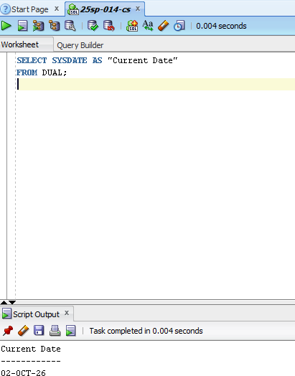

Show the current date

