Day 5 - Testing and Backend Refinement – QuickBite

Testing Report (CSV Format):

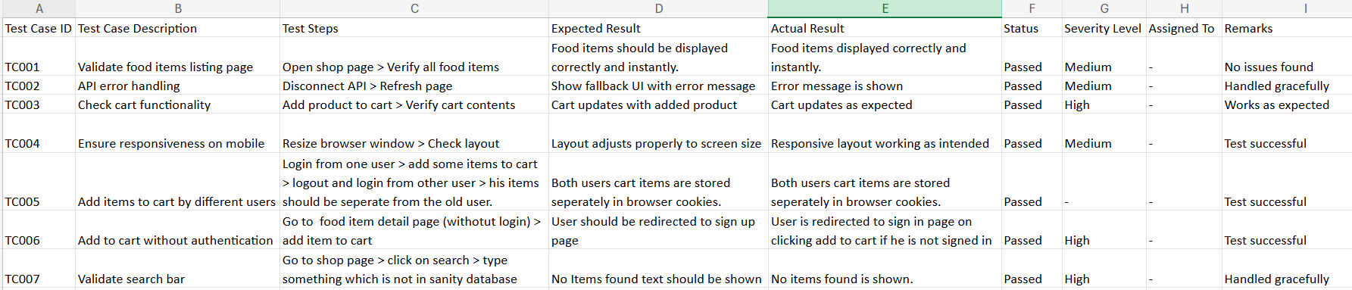

Functional Deliverables:

**Details Of All Test Cases:**

**Test Case:** TC001 – Validate Product Listing Page

* Test Steps:

1. Open shop page
2. Verify all food items with sanity studio

* Expected Result: Food items should be displayed correctly and instantly.
* Actual Result: All food items are displayed correctly and instantly loaded.
* Status: Passed.
* Severity Level: High.
* Remarks: No issues found.

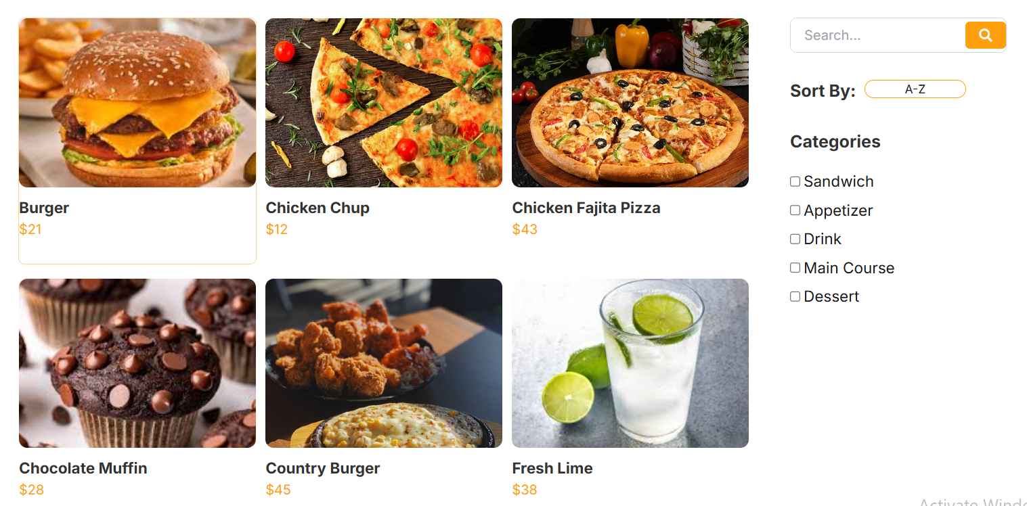

**Test Case:** TC002 – API Error Handling

* Test Steps:

1. Disconnect internet.
2. Refresh page.

* Expected Result: Show fallback UI with error message.
* Actual Result: Error message is shown.
* Status: Passed.
* Severity Level: Medium.
* Remarks: Handled gracefully.

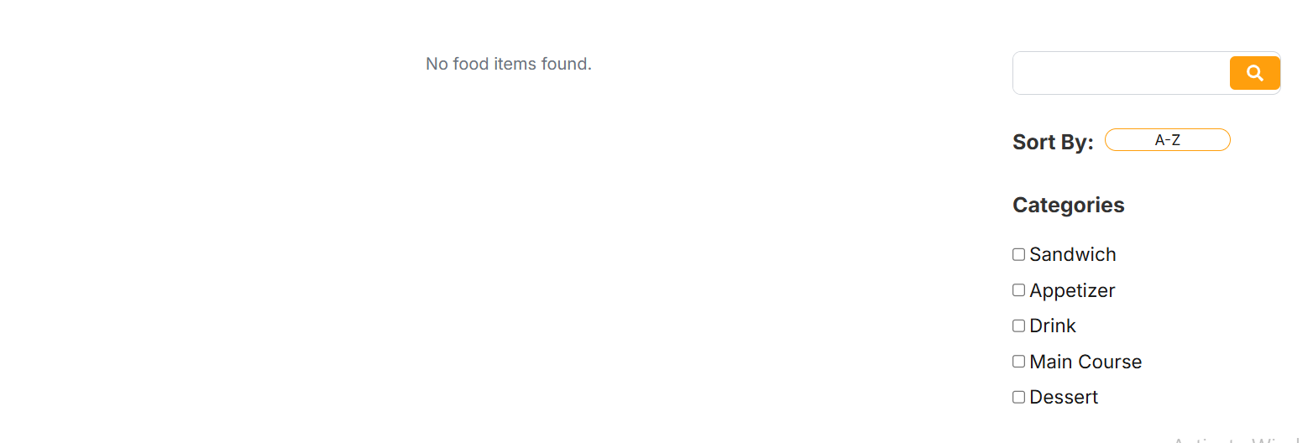

**Test Case:** TC003 – Check Cart Functionality

* Test Steps:

1. Add product to cart.
2. Verify cart items.

* Expected Result: Cart updates with added product.
* Actual Result: Cart updates as expected.
* Status: Passed.
* Severity Level: High.
* Remarks: Works as expected.

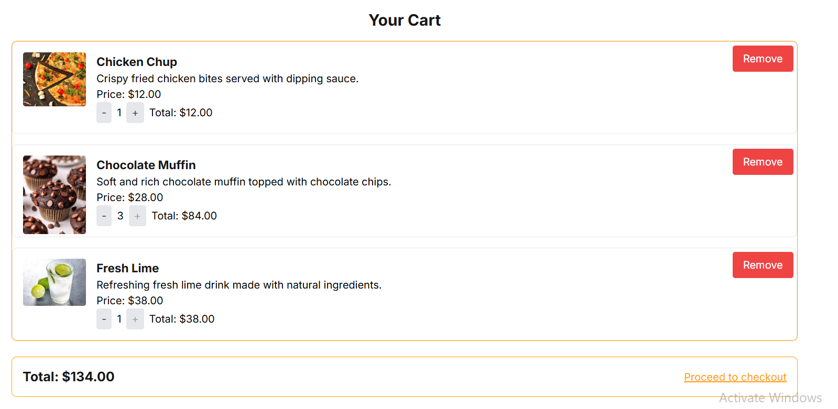

**Test Case:** TC004 – Ensure Responsiveness on Mobile

* Test Steps:

1. Resize browser window.
2. Check layout.

* Expected Result: Layout adjusts properly to screen size.
* Actual Result: Responsive layout working as intended.
* Status: Passed.
* Severity Level: Medium.
* Remarks: Test successful.

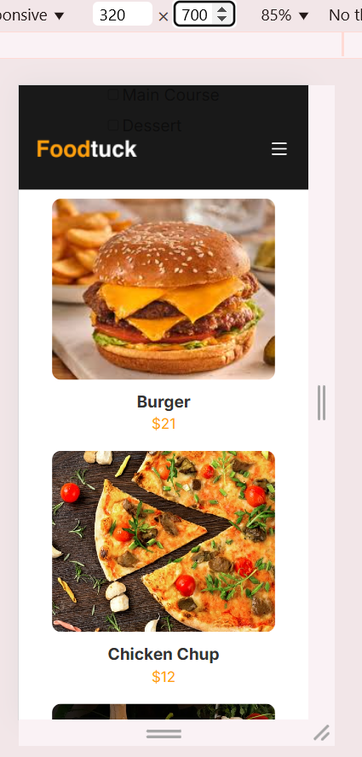

**Test Case:** TC005 – Add Items to Cart by Different Users

* Test Steps:

1. Login from one user.
2. Add some items to cart.
3. Logout and login from another user.
4. Add some items again to this user’s cart.
5. All users cart items should be separate from each other.

* Expected Result: Both users cart items should be stored separately in browser cookies.
* Actual Result: Both users cart items are stored separately in browser cookies.
* Status: Passed.
* Severity Level: Low.
* Remarks: Test successful.

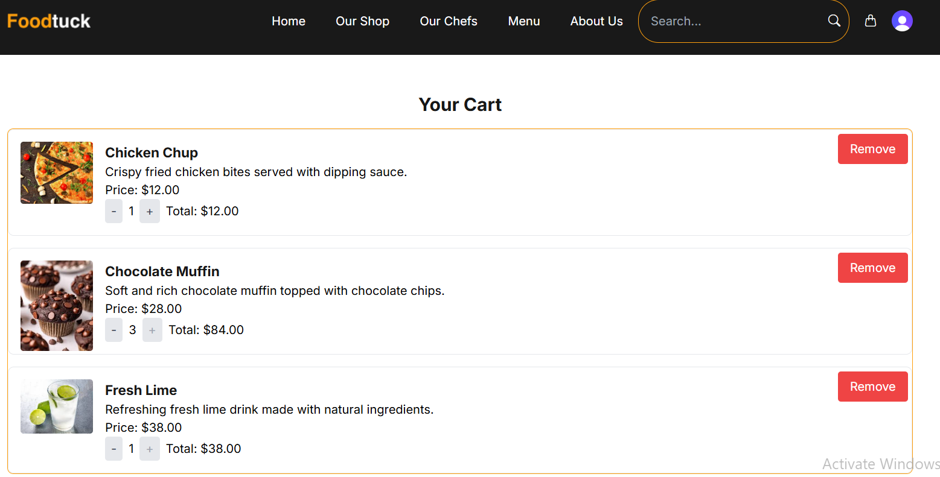User 1 Cart.

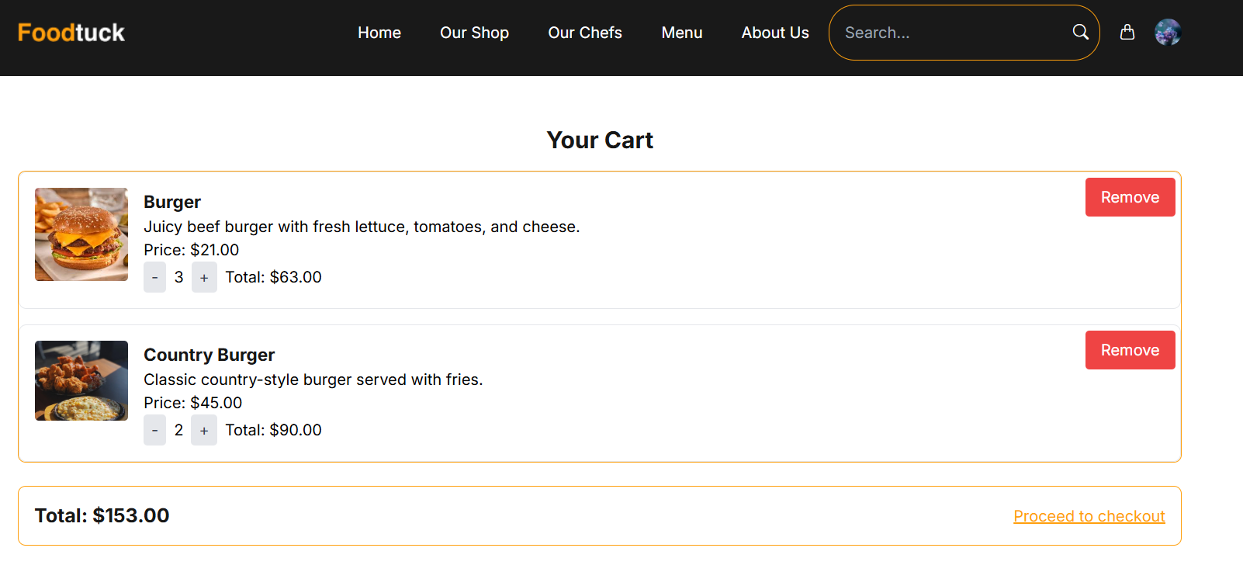User 2 Cart.

**Test Case:** TC006 – Add to cart without authentication

* Test Steps:

1. Go to food item detail page without login
2. Add item to cart.

* Expected Result: User should be redirected to sign up page.
* Actual Result: User is redirected to sign in page on clicking add to cart if he is not signed in.
* Status: Passed.
* Severity Level: High.
* Remarks: Test successful.

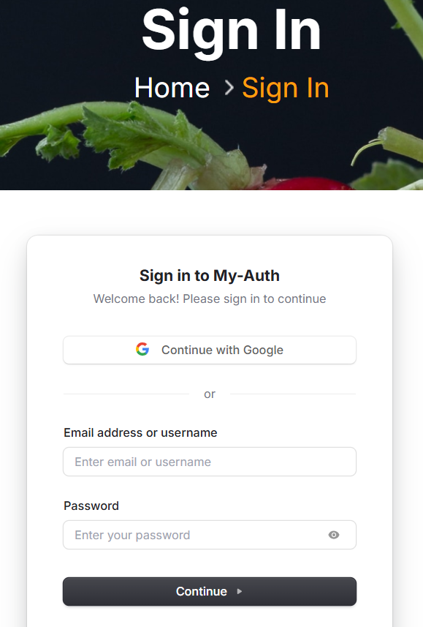

**Test Case:** TC007 – Validate search bar

* Test Steps:

1. Go to shop page.
2. Click on search.
3. Type something which is not in sanity database

* Expected Result: No Items found text should be shown.
* Actual Result: No items found is shown.
* Status: Passed.
* Severity Level: High.
* Remarks: Handled gracefully.

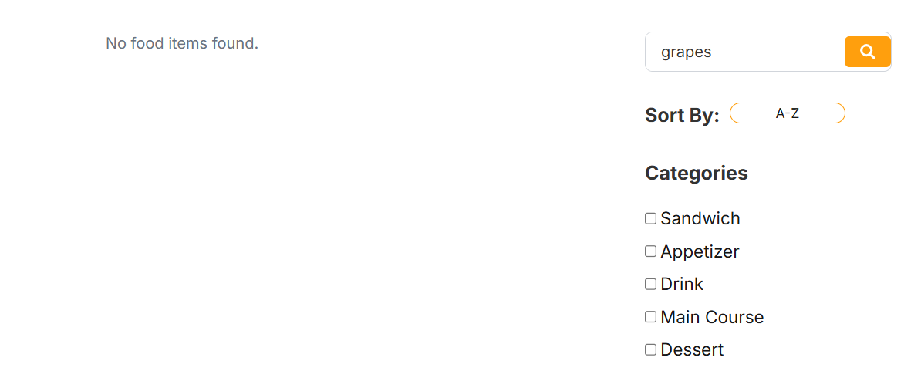

**Website Performance & SEO Using Lighthouse Developer Tool:**

