

SQE-project

AI-Based Test Automation for Application Testing



December 1, 2024

BSSE-(5B)

BISAM AHMAD 22F-3623

IMAN FATIMA 22F-3715

**AI based Test Automation for application testing**

# **Task 1: TestOps Report**

1. **Needs of TestOps**:
   * **Real-time Testing Insights**: Tools like TestCraft already provide visual dashboards for test execution. TestOps centralizes such insights across teams.
   * **Test Automation Optimization**: Automates test suite management and defect identification for better CI/CD integration.
   * **Scalability**: Facilitates scaling test environments, essential for large projects.
2. **Framework Coverage**:
   * **Features Addressed by TestCraft**:
     + AI-powered test creation and maintenance.
     + Visual test modeling, reducing manual effort.
     + Seamless integration with CI/CD pipelines for continuous testing.
   * **Alignment with TestOps**:
     + Real-time reporting and collaboration features support TestOps principles.
3. **Missing Aspects**:
   * **Advanced Test Management**: Limited compared to tools like Katalon TestOps for strategic test planning.
   * **Deep Analytics**: Add-on tools might be needed for deeper analytics and root cause identification.
   * **Integration Gaps**: Explore complementary tools (e.g., Testkube for Kubernetes-based environments).
4. **Suggestions for Improvement**:
   * Integrate **Katalon TestOps** for advanced test reporting.
   * Use tools like **TestRail** for comprehensive test case management.
5. **Deliverable**:
   * Provide a comparative analysis with tools like Katalon TestOps and Testkube.
   * Diagrammatically represent TestCraft’s integration with your framework.

# **Report:**

**1. Introduction to TestOps:**

**TestOps** refers to the practice of managing testing as a strategic operation within DevOps, focusing on optimizing test planning, execution, and analytics. It combines testing automation, continuous integration/continuous delivery (CI/CD), and real-time collaboration to ensure software quality throughout the development lifecycle.

**2. Needs of TestOps:**

TestOps is essential for modern software projects because it:

* **Optimizes Collaboration**: Bridges gaps between QA, development, and DevOps teams.
* **Ensures Scalability**: Manages large-scale testing efficiently with automation.
* **Provides Real-Time Insights**: Offers dashboards and analytics for proactive decision-making.
* **Enables Continuous Testing**: Supports rapid feedback loops in CI/CD pipelines.

**3. Role of AI in Test Automation:**

AI enhances test automation by:

* **Self-Healing Tests**: Adapts to changes in application UI without manual intervention.
* **Predictive Analytics**: Identifies patterns in defects and predicts test failures.
* **Smart Test Generation**: Automates test case creation based on user behaviour and application flows.

**4. TestCraft Overview:**

**TestCraft** is a powerful AI-based test automation tool that simplifies test creation, execution, and maintenance:

* **Features**:
  + Visual test modeling with no-code/low-code interfaces.
  + AI-driven self-healing tests that adapt to application changes.
  + Integration with CI/CD pipelines for seamless continuous testing.
  + Real-time reporting and analytics for actionable insights.
* **Benefits**:
  + Reduces test maintenance costs.
  + Accelerates test execution cycles.
  + Provides robust integrations with development tools (e.g., Jenkins, Selenium).

**5. Framework Coverage with TestCraft:**

TestCraft supports key TestOps features in the following ways:

* **Test Planning**:
  + Offers visual modeling for quick test creation.
  + Facilitates collaboration among stakeholders through centralized test management.
* **Test Execution**:
  + Enables AI-driven test execution, reducing the need for manual intervention.
  + Provides seamless integration with CI/CD tools for continuous testing.
* **Analytics and Reporting**:
  + Generates real-time reports and dashboards for test insights.
  + Tracks test coverage, execution trends, and defect patterns.

**6. Gaps and Missing Aspects:**

While TestCraft is robust, certain TestOps aspects need complementary solutions:

1. **Comprehensive Test Management**:
   * Limited strategic test planning tools compared to platforms like **Katalon TestOps**.
   * Suggestion: Integrate **TestRail** for test case management.
2. **Deep Root Cause Analytics**:
   * Lacks advanced analytics to identify root causes of recurring defects.
   * Suggestion: Use AI-driven analytics tools like **SeaLights** for in-depth analysis.
3. **Infrastructure Testing**:
   * TestCraft focuses on functional UI testing but does not natively support Infrastructure as Code (IaC) testing.
   * Suggestion: Combine with tools like **Terraform** and **Terratest**.

**7. Recommendations:**

To fully embrace TestOps, enhance TestCraft’s capabilities by:

* **Integrating Complementary Tools**:
  + Use **Katalon TestOps** or **Testkube** for advanced reporting and test orchestration.
  + Employ tools like **Allure Report** for visually enriched test results.
* **Expanding Test Scope**:
  + Incorporate non-functional testing using tools like **JMeter** for performance testing.
  + Add security testing through **OWASP ZAP** or similar platforms.
* **Scaling AI Capabilities**:
  + Explore external AI solutions for predictive defect analysis (e.g., **Deepchecks**).

**8. Conclusion:**

By leveraging TestCraft’s AI-driven capabilities and integrating complementary TestOps tools, organizations can achieve seamless, scalable, and efficient test automation. This approach ensures rapid feedback loops, reduced maintenance overhead, and superior application quality.

**9. Visual Diagram: TestCraft in a TestOps Framework:**

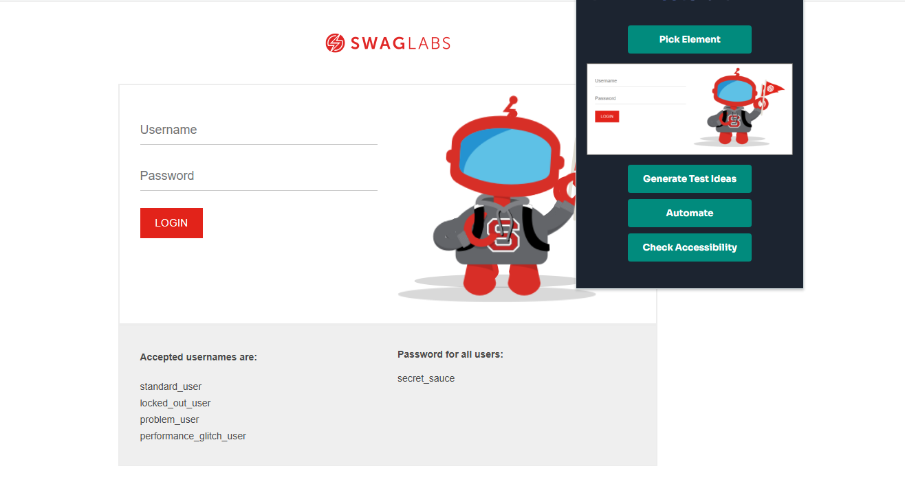

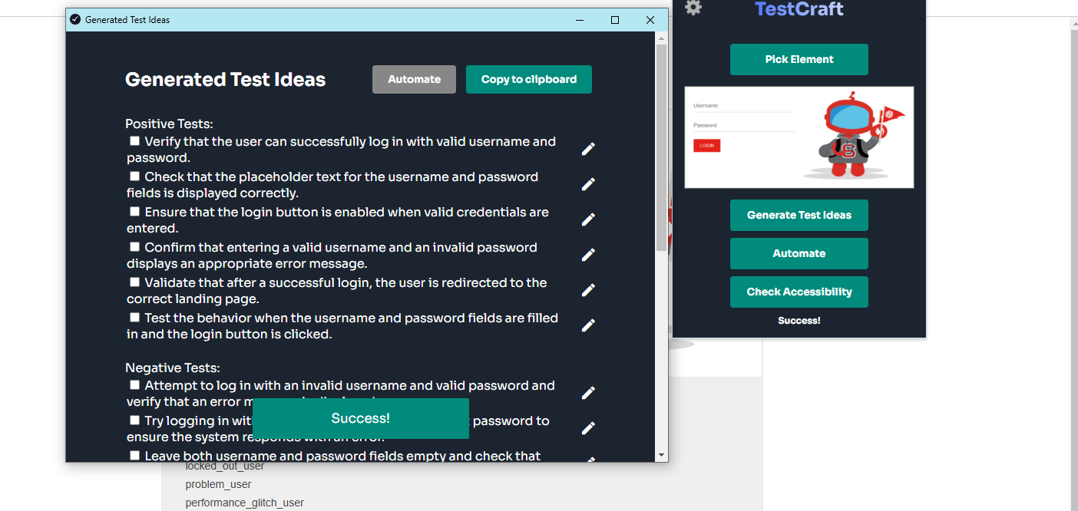

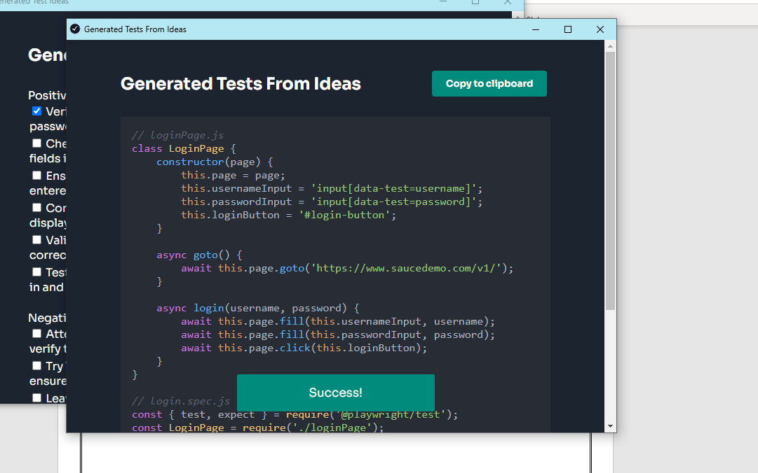

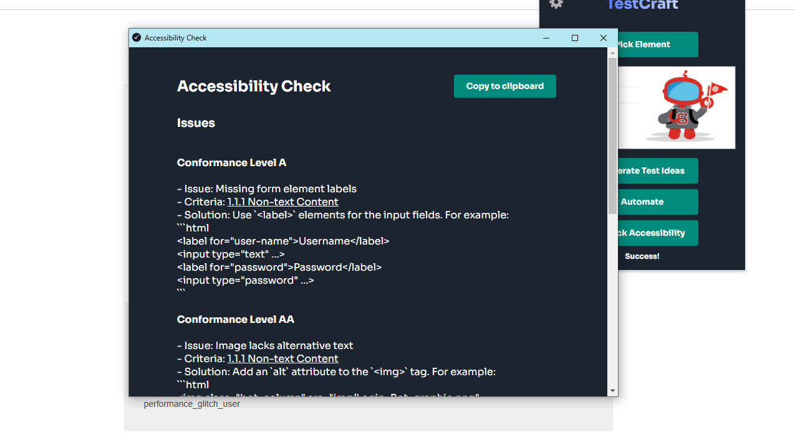

# **Task 2: Exploring Current and Future Testing Needs**

**Topic: AI-Based Test Automation for Application Testing**

**1. Current Testing Needs for AI-Based Automation:**

1. **Efficient Test Maintenance**:
   * Frequent application updates require adaptive testing.
   * AI-driven self-healing ensures test scripts automatically adapt to changes in the UI or workflows.
2. **Comprehensive Test Coverage**:
   * Need for broader coverage of test scenarios, including edge cases.
   * AI tools can simulate real-world user behavior to enhance test coverage.
3. **Rapid Feedback Cycles**:
   * In agile and CI/CD environments, quick feedback is critical.
   * AI accelerates test execution and result analysis.
4. **Intelligent Test Prioritization**:
   * Identify high-risk areas and prioritize them during regression testing.
5. **Test Data Management**:
   * Generate meaningful and diverse test data sets using AI to mimic real-world scenarios.

**2. Future Testing Needs for AI-Based Automation:**

1. **Autonomous Testing**:
   * Fully automated pipelines with minimal human intervention.
   * AI systems autonomously generate, execute, and evaluate test cases.
2. **Predictive Analytics in Testing**:
   * AI predicts potential defects and areas prone to failure based on historical data.
3. **Enhanced Test Collaboration**:
   * AI-powered dashboards enable seamless communication among QA, developers, and stakeholders.
4. **Testing Beyond Functional Aspects**:
   * Incorporate AI for non-functional testing like security, performance, and usability testing.
5. **Integration with Emerging Technologies**:
   * Testing capabilities for AI/ML models, blockchain applications, and IoT systems.
   * Adaptation to new frameworks and platforms.

**3. Findings for the Project:**

1. **Tool Used**: TestCraft
   * **Strengths**: Visual modeling, AI-driven self-healing, seamless CI/CD integration.
   * **Limitations**: Lacks built-in capabilities for non-functional and AI/ML model testing.
2. **Enhancements Implemented**:
   * AI-based prioritization of test cases.
   * Advanced reporting using complementary tools.
3. **Recommendations**:
   * Extend TestCraft integration with predictive analytics tools like **Deepchecks**.
   * Combine with non-functional testing frameworks (e.g., **JMeter**, **OWASP ZAP**).

**4. Basic Project Implementation:**

**Objective**: Demonstrate AI-based test automation using TestCraft with an example project.

1. **Setup**:
   * Automate testing for a sample e-commerce web application.
   * Implement CI/CD pipeline integration for continuous testing.
2. **Features**:
   * **TestCraft**: Visual test modeling for login, cart operations, and checkout workflows.
   * **AI Features**: Self-healing tests to handle UI changes.
   * **Reporting**: Integration with a reporting tool like **Allure** for enhanced analytics.
3. **Steps**:
   * Create and execute a suite of functional tests.
   * Showcase dynamic adaptation of tests with UI modifications.
   * Generate and analyze test reports.

**5. Loom Recording:**

* Recording is attached in the given folder.

**Git Repository**:

<https://github.com/Bisam-27/SQE_Project.git>