LogSys Documentation for the Support Team

Overview

LogSys is a powerful tool for collecting information about a reported problem. It saves users time by automatically collecting information from their computer irrespective of their knowledge of how their system works. A report which might, unaided, be described as “the program crashed”, could instead be followed up a log file showing which program crashed, what it was doing when it crashed, the error message displayed when it crashed, what other programs were running at the same time, and much more. The presence of this extra information can remove a lot of unnecessary time spent on discussing the issue over the phone.

Multiple methods of getting the information to the support staff

When a user requests a report to be sent, LogSys tries a series of methods to get that report to the support staff. LogSys will first try to use an active internet connection to send the report. If it can’t find an active internet connection it will look for an installed e-mail application that it recognises and prepare an email containing the report. If it can’t find an e-mail application that it recognises, LogSys will allow the user to save the report to a file; the user can later transfer that file by any means they have at their disposal to the support team.

The development staff configures the software which uses LogSys to send email to the support staff’s address. Whether the file is sent by internet connection, this actually causes a web service to turn it into an email for the support staff.

Reporting a problem

Information is only logged when logging has been enabled. Not all applications are installed with logging enabled, because logging will slow the system down very slightly.

If the user reports a problem in software that uses LogSys, but doesn’t attach log details, the support staff should help guide the end-user through the process of creating a log.

The first step is to ensure logging is enabled for the software in question.

Depending on the software, there will be one or more options for enabling logging and reporting the problem.

Next to the shortcut in the Start menu for your software:

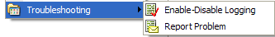
In the Help menu of your software:

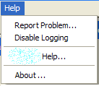

Or, if the software doesn’t have either of these options but LogSys is running, it will have an icon in the system tray:

or

From which it is possible to enable logging for each individual piece of software that uses LogSys by right-clicking on the icon, selecting the About box from the menu shown and then advanced options from the About box.
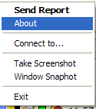

To get to here:

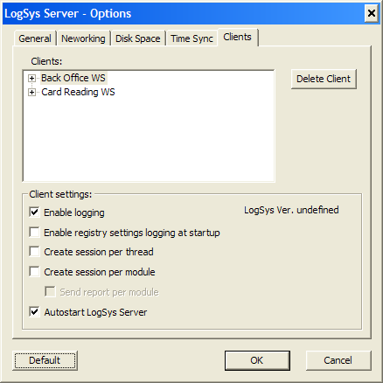

Collecting the report information

Once logging is enabled, the user can send a report. If the development staff has created a menu item in your software for “Help – Report Problem …” then this should be used in preference to all others. The menu item in the application may be configured to pull in extra information that LogSys wouldn’t otherwise be aware of, and may be able to use additional techniques for transmitting data back to the support team.

The user will be offered a series of options, which you may have to guide them through.

Which files to include: always err on the side of too many files rather than too few. There’ll be an option later for the user to tell the support team when the error occurred.

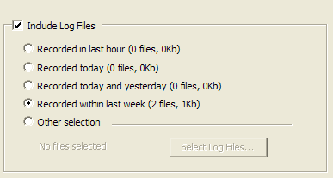

PC Info: It is useful to collect PC Information, but it does take about ten seconds to collect. It describes the operating system, the locale settings, what applications are currently running, how much space is left in memory and on disk, etc.

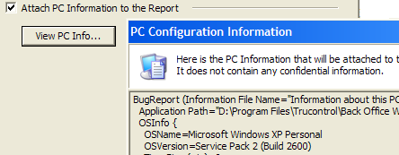

Screenshots: A screenshot of an error message can be taken, quickly and easily. If a window snapshot is chosen, the user simply has to click on a window to take a snapshot of it. The window under the mouse pointer is highlighted with a red border to suggest this.

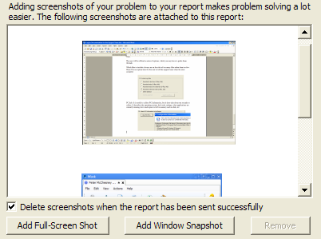

E-mail address: This isn’t required, but if the support team know the end-users email address, they can more easily contact them.

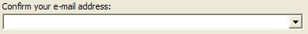

Description: Ideally, a description will contain a description of what the user was trying to accomplish, what actually happened, and when the problem occurred. If the software in question is a .NET application, and an error message is involved, then the development staff will need only a little description. If no error message was involved but the software performed unexpectedly, greater detail will be needed.

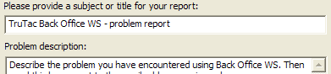

Attached files: If the problem relates to a file the user was working on or a file that was an input to the system, attaching that file can be extremely useful.

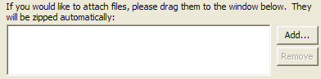
Method of sending: Unless the end-user knows they have no internet connection, have them attempt to send the report directly. The help for manual collection is quite comprehensive. It gives the user a zip file that contains all the information collected.

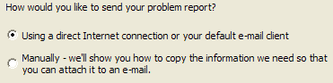

LogSys configuration

There is only one setting that is likely to be of interest to the support team that are available from the advanced options. Most advanced options are only of interest to development staff.

Disk space usage – The most common problem in collecting logs is that there was too little disk space allocated to LogSys. When LogSys is collecting logs it is consuming disk space. Rather than fill the customers’ hard drives, Logsys will delete older log information in favour of more recent log information. If there is a long duration between the software causing an issue and the end user noticing or reporting the issue, LogSys may overwrite the log of the problem. If this happens, have the end-user increase the maximum disk space usage. If this happens frequently the development staff should be asked to change the default disk space usage.

