LogSys Documentation for the End-User

Overview

LogSys is a simple, easy to use tool for reporting problems in software. It saves you time by automatically collecting information from your computer and it knows who supports the software.

User friendly operation

The program requests information from you through an on-screen form which is designed to have a friendly appearance. LogSys automatically captures information from the PC that might be useful to support staff – e.g. the operating system type, free space on disk drives, etc. You can view this information to confirm that LogSys is not sending private information.

Multiple methods of sending the information to the support staff

When you want to send a report, LogSys tries a series of methods to get that report to the support staff. LogSys will first try to use an active internet connection to send the report. If it can’t find an active internet connection it will look for an installed e-mail application that it recognises and prepare an email containing the report. If it can’t find an e-mail application that it recognises, LogSys will allow you to save the report to a file; you can later transfer that file by any means you have at you disposal to the support team.

Where to start

Not all software makes use of LogSys. If your program uses LogSys you will see one (or more) of the following things:

Next to the shortcut in the Start menu for your software:

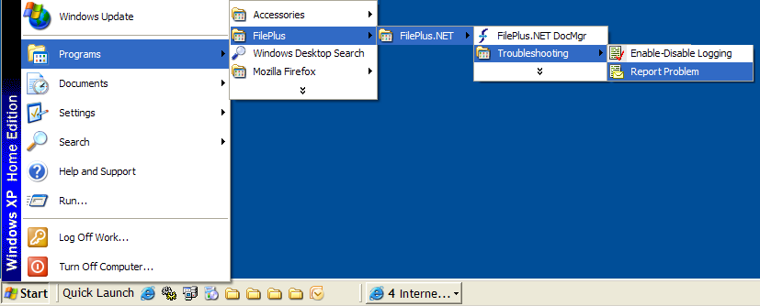

In the Help menu of your software:

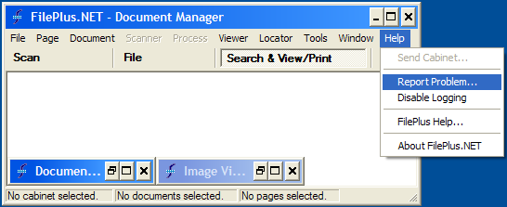

LogSys may also be accessed as a shortcut on your desktop:

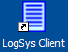

Or, if it is running, by its icon in your system tray (usually the bottom right of your screen):

or

If you access LogSys through its own shortcut or by its icon in the system tray, it will ask you for which application you want to send a report.

Reporting a problem

To be able to send a record of its recent execution, the software needs to have logging enabled. Depending on the needs of the software some software will be installed with logging enabled and some will be installed with logging disabled.

When reporting a problem the information recorded in the logs is very useful. If logging wasn’t enabled when the problem occurred, enable logging and try to reproduce the problem.
Equally as useful as the logs themselves is a description of the problem experienced. The logs can tell the support team what happened but only you can definitively tell the support team what you were trying to achieve when the problem occurred.
Note: we have a page on the bbconsult site that describes step-by-step how to send a problem report with LogSys, including file and screenshot attachment.
http://www.bbconsult.co.uk/support/SendingProblemReport.aspx

Sending Attachments

LogSys allows you to attach a screenshot of what you’re seeing – this could save you from copying down a long error message.

You can also add additional files - the file that you were working on when you encountered your problem is often useful.

If you have a copy of Flashback (see http://www.bbsoftware.co.uk/ ) you could send us a movie recording your screen as your error happens – these screen recordings are very useful removing many possibilities for confusion between you and your support team. But do be aware: if you use the ‘Report Problem’ menu from within Flashback you will send your reports to the Flashback support team – this may not be the team that needs to see your report. Instead you should make your recording, save it as a file, and then use the ‘Report Problem’ menu from the program that has the problem.

