

software development life cycle

INTERNATIONAL SCHOOL OF MANAGEMENT AND TECHNOLOGY



Bisesh Shrestha (HND/ Second Semester)

Contents

Part 1 4

Introduction 7

SDLC 7

P1: Describe two iterative and two sequential software lifecycle models. 8

Iterative Models: 9

Agile model 9

Advantages: 10

Disadvantages 10

Prototype model 11

Prototyping Model Phases 11

Advantages of the Prototyping Model 12

Disadvantages of the Prototyping Model 12

Sequential model 13

Waterfall model 13

Advantages of waterfall model: 14

Disadvantage of waterfall model: 14

V-model 14

V-Model - Verification stages 15

Business Requirement Analysis 15

System Design 15

Architectural Design 15

Module Design 15

Coding Phase 15

Validation Phases 16

The advantages of the V-Model : 16

The disadvantages of the V-Model: 16

Risks in Software Development Life Cycle 17

Risks involved in Prototype Model 17

Risks involved in Agile Model 17

Risks involved in Waterfall model 18

Risks involved in V-model 18

P2:How risk is managed in the Spiral lifecycle model. 18

Spiral development supports risk management 19

Conclusion 20

Part: 2 21

Introduction: 21

Types of Feasibility Study 22

P3:Purpose of Feasibility Study: 23

P4: Comparison of Technical Solutions 24

Performance and efficiency 24

Part: 3 25

1. P5:Undertake the software investigation to meet the business need 25

Introduction 26

Identify Stakeholders: 26

Identify Client Requirements: 27

Software Scope: 27

Process Descriptors: 28

Consideration of Alternative Solution: 28

Software Security: 28

System Quality Assurance 29

Constraints 29

Cost: 30

Organizational Policy: 30

Legacy System: 31

Hardware Requirements 31

P6:Software Analysis Tools: 31

Data Flow Diagram (DFD) 31

Entity relationship diagram 32

Er diagram of college management system: 33

Summary: 33

Conclusion: 34

Part: 4 34

Introduction 34

P7: Documentation on user and system documentation 34

Conclusion 36

Bibliography 37

Part 1

**As a part of your responsibility you are required to prepare a report that describes different software development cycles. Your report must include the following:**

**1. Description of predictive and adaptive software development models considering at least two iterative and two sequential models.**

**2. The risks involved in each of the models and how the risk can be mitigated /managed in each model by taking a reference of the spiral model.**

**Report:**

**Description of different software development life cycle**

**Bisesh Shrestha**

**Content**

1. **Introduction**
2. **Software development life cycle(SDLC)**
3. **Predictive model**
4. **Adaptive model**
5. **Iterative model**
6. **Sequential model**
7. **Waterfall model**
8. **Spiral model**
9. **Agile model**
10. **V model**
11. **Conclusion**

Introduction

I am going to explain the software development lifecycle models. We have given a scenario where we have to develop the software about college management system. I am going to explain two models under predictive and adaptive models considering iterative and sequential model. I am also going to give some of the advantages and disadvantages of each model.

SDLC

SDLC (Software Development Lifecycle) is the process that the software industry follows to design, build and test quality software. The SDLC approach to software design, development, and testing aims to produce high-quality, budget-based software as well as deadlines expected. It is defined as the tasks performed at each and every stage of the lifecycle of the software, from initiation to deployment

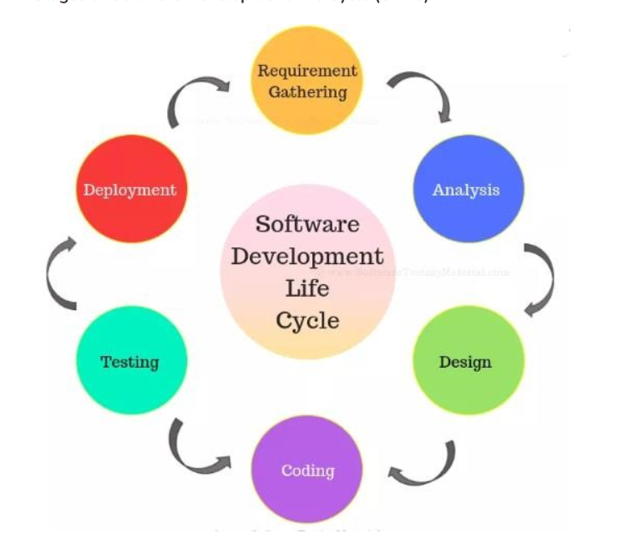

1. Requirement Phase:

Requirement gathering and analysis is the most vital phase within the software development lifecycle. Business Analyst collects the necessity from the Customer/Client as per the client’s business needs and records the necessities within the Business Requirement Specification (document name varies depends upon the Organization. A few cases are Customer Requirement Detail (CRS), Business Specification (BS), etc., and gives the same to Development Team.

1. Analysis phase:

Once the requirement gathering and analysis is done the another step is to define and document the item requirements and get them approved by the client. This can be done through the SRS (Software Requirement Specification) record. SRS consists of all the item necessities to be planned and developed during the extend life cycle. Key individuals included in this stage are Project Manager, Business Analyst and Senior members of the Group. The result of this stage is the Software Requirement Specification.

1. Design phase:

It has two steps:

HLD – High-Level Design – It gives the architecture of the software product to be developed and is done by architects and senior developers

LLD – Low-Level Design – It is done by senior developers. It describes how each and every feature in the product should work and how every component should work. Here, only the design will be there and not the code

The outcome from this phase is High-Level Document and Low-Level Document which works as an input to the next phase

1. Development phase:

Developers of all levels (seniors, juniors, fresher) involved in this phase. This is the phase where we start building the software and start writing the code for the product. The outcome from this phase is Source Code Document (SCD) and the developed product.

1. Testing phase:

When the software is ready, it is sent to the testing department where Test group tests it completely for different defects. They either test the program manually or utilizing automated testing tools depends on the method characterized in STLC (Software Testing Life Cycle) and guarantee that each and each component of the software works fine. Once the QA makes sure that the software is error-free, it goes to another stage, which is Implementation. The result of this phase is the Quality Item and the Testing Artifacts. After the successful test of the application we need to coordinate the different modules like login, signup, upload, claim, services.

1. Deployment and maintainace phase:

After successful testing, the product is delivered/deployed to the client for their utilize. Deployment is done by the Deployment/Implementation engineers. Once when the clients begin utilizing the created system then the actual issues will come up and must be solved from time to time. Fixing the issues found by the client comes within the maintenance stage. 100% testing isn't possible – since, the way analyzers test the item is different from the way clients utilize the item. Support should be done as per SLA (Service Level Agreement)

P1: Describe two iterative and two sequential software lifecycle models.

## Iterative Models:

The iterative models are particular implementation of a software development lifecycle that focuses on a beginning, simplified implementation, which at that point progressively picks up more complexity and a broader feature set until the final system is complete. In this sort of model’s enhancements can be recognized rapidly with implementation throughout each iteration. The two iterative models which I am planning to describe are prototype and agile models.

### Agile model

“Agile SDLC model is a combination of iterative and incremental process models with focus on prepare versatility and client satisfaction by quick delivery of working software product. Agile Methods break the product into small incremental builds. These builds are given in iterations.” (n.d, 2018) In this model each project is taken care of in an unexpected way and existing strategies are custom fitted to best suit necessities of project. All assignments are divided in small time frames for delivering specific features in release. It gives priorities to working software and client collaboration over comprehensive documentation and contract arrangement. This model also allows proper response to change than taking after the project plan and each cycle includes cross functional group working at the same time.

Agile model is iterative and team-based way to development. This model gives importance in rapid delivery of system in complete functional components. All time is time boxed in phases known as sprints rather than creating tasks and schedules for system development. While starting each sprint has defined duration although time may vary according to project and also the running list of deliveries. Sometime if planned work for sprint cannot be completed then work is reprioritized again and information is used for further sprint planning. When the work is completed then it is reviewed and evaluated by team and customers. This model relies in high level of customer involvement throughout development process and it is more especially during reviewing the system. Agile model is iterative and team-based way to development. This model gives importance in rapid delivery of system in complete functional components. All time is time boxed in phases known as sprints rather than creating tasks and schedules for system development. While starting each sprint has defined duration although time may vary according to project and also the running list of deliveries. Sometime if planned work for sprint cannot be completed then work is reprioritized again and information is used for further sprint planning. When the work is completed then it is reviewed and evaluated by team and customers. This model relies in high level of customer involvement throughout development process and it is more especially during reviewing the system.

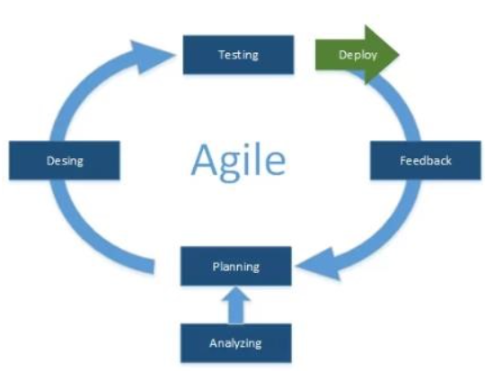

There are various phases in agile model which are illustrated below:

* Requirements: The initial step in this model is to gather the system requirements. As this model doesn’t need the full documentation to rather software requirements meeting is held and all decision are implemented.
* Design: In this stage with the help of various software designing tools the design of software is prepared. It can be prepared as the demo version and other important featurescan be added further while continuing project. Here also the clients provide their feedback to system and system is altered according to their need.
* Development: Here the designed demo version is brought into implementation for the user feedback and in end of this phase system will almost be ready. Customer collaboration and feedback plays important role in this stage.
* Testing and feedback: In this ending phase the overall system wrapping is done with all the testing required. After the customer is satisfied with the developed system it is handed to client.

### Advantages:

* It is very easy, realistic approach that provides flexibility to developers. And promotes teamwork and cross training.
* It provides continuous attention to technical excellence and good design.
* Minimum rules and documentation can be easily employed.
* It is best suitable for environment where requirements may change during development process.
* Resource requirements are minimum and only little planning is required.

### Disadvantages

* There will be high individual dependency as minimum documentation is generated.
* As there are strict delivery management adjustments can be dictated to meet deadlines.
* It is very difficult to implement this model without overall plan, an agile leader and agile project manager.
* If customer representative is not clear about the outcome of project then team can easily get off the track.
* During the development transfer or recruiting of new member in project will be quite challenging due to lack of documentation.

## Prototype model

Prototyping Model is a software development model in which model is built, tested, and adjusted until a worthy model is achieved. It too creates base to produce the ultimate system or software. It works best in scenarios where the project’s requirements are not known in detail. It is an iterative, trial and error strategy which takes put between developer and client.

### Prototyping Model Phases

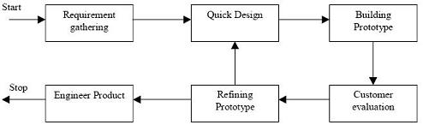

Prototyping Model has following six SDLC phases as follow:

**Step 1: Requirements gathering and analysis**

A prototyping model starts with requirement analysis. In this phase, the requirements of the system are defined in detail. During the process, the users of the system are interviewed to know what their expectation from the system is.

**Step 2: Quick design**

The second phase is a preliminary design or a quick design. In this stage, a simple design of the system is created. However, it is not a complete design. It gives a brief idea of the system to the user. The quick design helps in developing the prototype.

**Step 3: Build a Prototype**

In this phase, an actual prototype is designed based on the information gathered from quick design. It is a small working model of the required system.

**Step 4: Initial user evaluation**

In this stage, the proposed system is presented to the client for an initial evaluation. It helps to find out the strength and weakness of the working model. Comment and suggestion are collected from the customer and provided to the developer.

**Step 5: Refining prototype**

If the user is not happy with the current prototype, you need to refine the prototype according to the user’s feedback and suggestions. This phase will not over until all the requirements specified by the user are met. Once the user is satisfied with the developed prototype, a final system is developed based on the approved final prototype.

**Step 6: Implement Product and Maintain**

Once the final system is developed based on the final prototype, it is thoroughly tested and deployed to production. The system undergoes routine maintenance for minimizing downtime and prevent large-scale failures.

### Advantages of the Prototyping Model

* Users are actively involved in development. Therefore, errors can be detected in the initial stage of the software development process.
* Missing functionality can be identified, which helps to reduce the risk of failure as Prototyping is also considered as a risk reduction activity.
* Helps team member to communicate effectively
* Customer satisfaction exists because the customer can feel the product at a very early stage.
* There will be hardly any chance of software rejection.
* Quicker user feedback helps you to achieve better software development solutions.
* Allows the client to compare if the software code matches the software specification.
* Prototypes can be changed and even discarded.
* A prototype also serves as the basis for operational specifications.
* Prototypes may offer early training for future users of the software system.

### Disadvantages of the Prototyping Model

Here, are important cons/drawbacks of prototyping model:

* Prototyping is a slow and time taking process.
* The cost of developing a prototype is a total waste as the prototype is ultimately thrown away.
* Prototyping may encourage excessive change requests.
* There may be far too many variations in software requirements when each time the prototype is evaluated by the customer.
* Poor documentation because the requirements of the customers are changing.
* It is very difficult for software developers to accommodate all the changes demanded by the clients.
* The client may lose interest in the final product when he or she is not happy with the initial prototype.

## Sequential model

In this type of model developer need to follow a few rules, regulations and defined orders for completing the project. Here I am going to describe two sequential model of software development which are waterfall model and V model

### Waterfall model

Waterfall model also known as linear sequence life cycle model which is the first model used in software engineering to achieve project performance. Linear sequence flow is used by waterfall model to illustrate the software development process. In this model, each phases must be completed to start new phase. It is simple to understand and use.

Phases in waterfall models are:

* 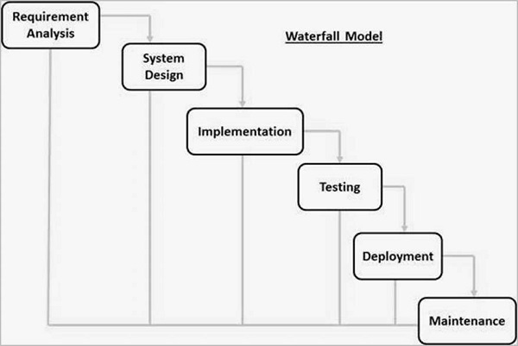Requirement Analysis: during this process all the requirements to develop the software are collected
* System Design: After collection of requirement, the system design helps determine the specifications of the hardware and system, and helps define the overall system architecture.
* Implementation: After system design, Each unit is developed and tested for its functionality, which is referred to as unit testing
* Testing: After implementing those unites in system the entire system will be reviewed for any defects and errors.
* Deployment: Once testing is done, the product is deployed in real field or released into the market
* Maintenance: After deployment of the product there may be some issues which may come up. To fix those issues, patches are released and some other versions are also released.

### Advantages of waterfall model:

This model is simple and easy to understand and use. In this model, requirements are well defined so it is suitable for smaller projects. Phases in this model are clearly defined and do not overlap because it is processed and completed one at a time.

### Disadvantage of waterfall model:

This model is not a good model for complex and object-oriented project because of high risk and uncertainty. Final software is not produced until last phase of the life cycle. Once an application is in the testing phases, returning back to modify something in previous phase can’t be done.

## V-model

The V-model is an SDLC model where execution of processes happens in a sequential manner in a V-shape. It is additionally known as Verification and Validation model. The V-Model is an extension of the waterfall show and is based on the association of a testing phase for each corresponding development stage. This means that for every single phase within the development cycle, there's a specifically related testing phase. This is often a highly-disciplined model and the next phase begins only after completion of the past phase.

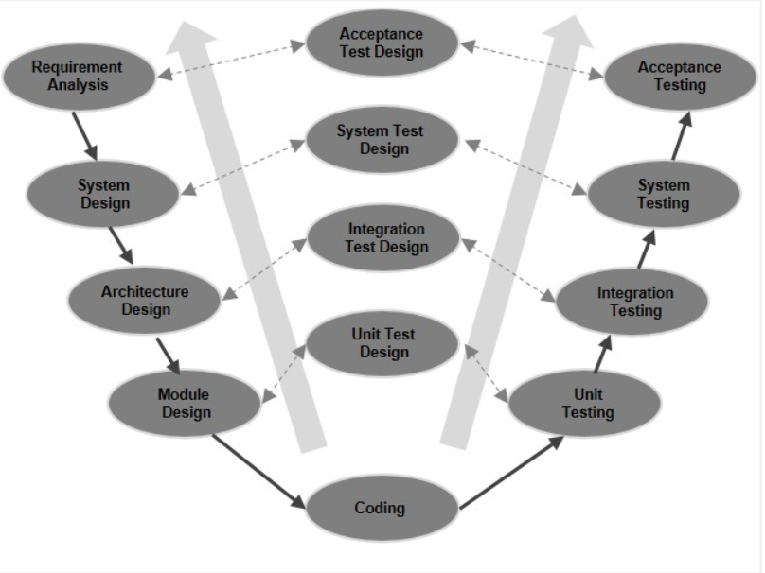

### V-Model - Verification stages

There are several Verification stages in the V-Model, each of these are explained in detail below:

### Business Requirement Analysis

This is the first stage in the development cycle where the item requirements are understood from the customer’s point of view. This stage includes detailed communication with the customer to understand his desires and exact requirement. This is a really important action and needs to be managed well, as most of the clients are not sure about what exactly they require. The acceptance test design planning is done at this arrange as business requirements can be utilized as an input for acceptance testing.

### System Design

Once you've got the clear and detailed product requirements, it is time to plan the total system. The system plan will have the understanding and detailing the complete hardware and communication setup for the product under development. The system test plan is created based on the system plan. Doing this at an earlier stage takes off more time for the actual test execution afterward.

### Architectural Design

Architectural specifications are understood and designed in this phase. Usually more than one technical approach is proposed and based on the technical and financial feasibility the final decision is taken. The system design is broken down further into modules taking up different functionality. This is also referred to as High Level Design (HLD).The data transfer and communication between the internal modules and with the outside world (other systems) is clearly understood and defined in this stage. With this information, integration tests can be designed and documented during this stage.

### Module Design

In this phase, the detailed internal design for all the system modules is specified, referred to as Low Level Design (LLD). It is important that the design is compatible with the other modules in the system architecture and the other external systems. The unit tests are an essential part of any development process and helps eliminate the maximum faults and errors at a very early stage. These unit tests can be designed at this stage based on the internal module designs.

### Coding Phase

The actual coding of the system modules designed in the design phase is taken up within the Coding stage. The most excellent reasonable programming language is chosen based on the system and architectural requirements. The coding is performed based on the coding guidelines and standards. The code goes through various code audits and is optimized for best performance some time recently the final build is checked into the repository.

### Validation Phases

The different Validation Phases in a V-Model are explained in detail below.

#### Unit Testing

Unit tests designed in the module design phase are executed on the code during this validation phase. Unit testing is the testing at code level and helps eliminate bugs at an early stage, though all defects cannot be uncovered by unit testing.

#### Integration Testing

Integration testing is associated with the architectural design phase. Integration tests are performed to test the coexistence and communication of the internal modules within the system.

#### System Testing

System testing is directly associated with the system design phase. System tests check the entire system functionality and the communication of the system under development with external systems. Most of the software and hardware compatibility issues can be uncovered during this system test execution.

#### Acceptance Testing

Acceptance testing is associated with the business requirement analysis phase and involves testing the product in user environment. Acceptance tests uncover the compatibility issues with the other systems available in the user environment. It also discovers the non-functional issues such as load and performance defects in the actual user environment.

### The advantages of the V-Model :

* This is a highly-disciplined model and Phases are completed one at a time.
* Works well for smaller projects where requirements are very well understood.
* Simple and easy to understand and use.
* Easy to manage due to the rigidity of the model. Each phase has specific deliverables and a review process.

### The disadvantages of the V-Model:

* High risk and uncertainty.
* Not a good model for complex and object-oriented projects.
* Poor model for long and ongoing projects.
* Not suitable for the projects where requirements are at a moderate to high risk of changing.
* Once an application is in the testing stage, it is difficult to go back and change a functionality.
* No working software is produced until late during the life cycle

Risks in Software Development Life Cycle

“Risk is an expectation of loss, a potential issue that will or may not happen within the future. It is generally caused due to lack of data, control or time. A possibility of suffering from loss in software development process is called a software risk. Loss can be anything, increase in production cost, development of poor-quality software, not being able to complete the project on time.” (Hilson, 2011) Those types of risks exist on our project or developing system as long-term is uncertain and there are numerous already unknown and known actualities which we cannot incorporate in extend arrange. Whereas creating system those risks can be of two types first one is internal risks which can be controlled by the project manager and second one is outside dangers which are beyond the control of project manager. Whereas we use different models for developing software there are too different risks connected with those particular models. Below I have given those different models with risks included in them:

## Risks involved in Prototype Model

Although using prototyping model decreases the probability of software development project failure apart from rewards this model has its own risks. The biggest risk is that anyone who is interested in the project after facing a working prototype will decide that the final product is almost ready or not. Another risk involved using prototype model is that after seeing the early prototype end users demand delivery of actual system and even if he is unsatisfied with the initial built prototype, he may lose interest in the project. While using this model in software development process, without proper management iterative process of prototype refinement can take long durations and while developer hurry to build prototype it may end up to sub-optimal solutions. Practically, using this model might increase the complexity of the system as scope of the system may expand beyond the initial plans on software development. Various risks can be encountered as this model leads to implementing and then repairing the way of creating software.

## Risks involved in Agile Model

There are various risks involved in the agile model and while developing the software we have to be aware about those risks before starting our project. Among those various risks the very first common risk is lacking details in task descriptions. We have to make sure that all details are present and clear for the team so they know exactly what they are creating and the best way to write these out are in the form of user stories or technical requirements. Another risk usually encountered while going through agile model is priorities or directions change. Sometimes the priorities of the project changes and thus features that were not originally planned take top priority over the others.

When this happens, it’s important to make sure the clients know about the effect of those changes on the developing system and even also the timeline and budget of project as mentioned in earlier meetings. Another risk which many companies faces while adapting agile model in their software development process is lack of documentation which leads to misunderstanding among the developers. Because of poor documentation in this model when the current programmer or any other member of development team leaves then it will be very difficult for the new recruiters to get adapted with development scenario as there will be less documentation and he won’t be able to grab the speed with other members. If the customer representative isn’t clear about the outcome of project then team can easily get off the track so this risk should not be underestimated while developing team and client representative should be well known about the features that clients wants to get in system. So, there would be both Advantage and Disadvantage of The Agile Method.

## Risks involved in Waterfall model

As there is very less customer interactions involved in software development and product can only be demoed once it is ready therefore once the software is developed and if any failure once then cost of fixing such issues are very high and we have to update everywhere from document till the logic. Another risk is that if the documentation of software development isn’t done well then there is high chance of getting off the track while developing software. There is always lack of project suitability using this model where requirements are at a moderate to high risk of changing. There is high chance of project failure if we use this model for complex and object-oriented projects.

## Risks involved in V-model

As, it is too simple to accurately reflect the software development process, and can lead managers into a false sense of security. The V-Model reflects a project management view of software development and fits the needs of project managers, accountants and lawyers rather than software developers or users. Although it is easily understood by novices, that early understanding is useful only if the novice goes on to acquire a deeper understanding of the development process and how the V-Model must be adapted and extended in practice. If practitioners persist with their naive view of the VModel they will have great difficulty applying it successfully. It is inflexible and encourages a rigid and linear view of software development and has no inherent ability to respond to change

P2:How risk is managed in the Spiral lifecycle model.

Spiral model was proposed as a risk driven software development prepare model by Boehm in 1988 wherein the development prepare is guided by included risks. This model points to recognize and evaluate the software project risks and also makes a difference to reduce those risks. In this show the major sources of chance in spite of of its risk driven nature is due to high reliance on human factor and detailed risk management process. According to Boehm, nearly the 25% time in this model is taken in risk investigation and it is generally outlined to known risk in the project. It doesn’t only give the adaptability in project but too makes a difference us to know around the up and coming risks.

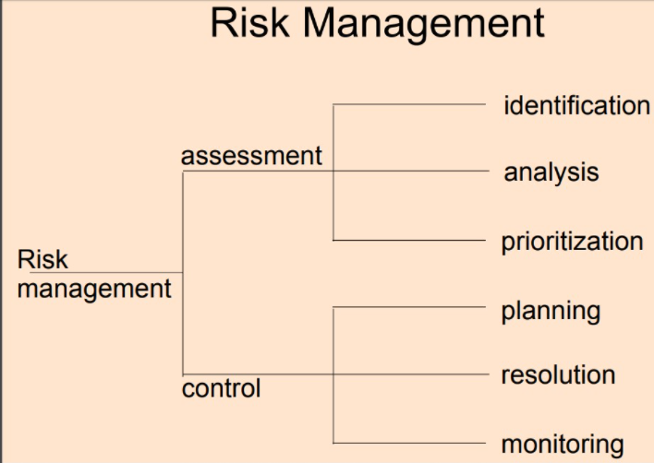

Spiral development supports risk management in software projects in a few ways summarized below:

* The starting risk analysis that acts as a look-ahead step and points at:
  + Identifying most risks threaten the project.
  + Classifying risks into user interface risks and development risks
  + Evaluate these risks to choose upon the risks to handle through each cycle.
  + Additionally, this classification makes a difference developers in implementing risk resolution methods such as prototyping and benchmarking.
* The evolutionary prototyping spirals that aim at resolving performance and user interface related risks. These spirals help in reducing major risks before proceeding into the development process.
* The risk analysis stage at each cycle that precedes each phase of the waterfall phases in purpose of:
  + Resolving program development and interface control risks inherent from the start of the project.
  + Evaluating and resolving the new risks that might arise after changing any of the objectives, alternatives, or constraints at the beginning of the cycle.
* The iterative feature of the spiral which allows the development process to go back to the first quadrant at any point in progress which allows:
  + Objectives, alternatives and constraints to change as more attractive alternatives exist.
  + New technology to be incorporated easily during the development process.
  + The maximum optimization of project resources usage.
  + To deal with poorly done activities in the earlier phases.
* The review conducted at the end of each cycle with main stakeholders as a decision point to avoid the lack of commitment risks during the next cycle.
* Time and cost overrun risks are best managed using spiral development due to the risk analysis stage conducted at each cycle. In this stage, the cost and time required for each cycle are analyzed in advance to give a clear picture about the critical state of the project.

This helps the project manager and the developers get more control over these risks.

• Risks related to the increased complexity of the project are also managed using spiral.

This is achieved by the partitioning activity conducted at the planning phase.

* Decomposing the project into portions to be developed in parallel spirals obviously reduces time contention related risks, since more work could be achieved during the same interval.

Major Sources of Risk in the Spiral Model Despite its risk driven nature, spiral has its own sources of risks which are summarized in the following:

• High reliance on the human factor

All the activities related to identifying, analyzing, and resolving risks rely on the experience of developers and their abilities in identifying and managing risks. If these abilities are unavailable, major risks might remain hidden for several lifecycles and discovered late when it matured into real problems. At that time, the cost of rework to recover from these risks becomes very high.

• Detailed risk management process

Cost and schedule risks might increase using spiral due to its iterative feature, especially for low risk projects wherein risk assessment is not required to be at this level of granularity.

Conclusion

The SDLC process gives us the reason to follow client order in successful and organized way whereas guaranteeing the better time of delivery and efficiency. It too includes arrange for how to deliver, modify, maintain and replace software system. Spiral model gives us the various steps through which we are able eliminate the present and possible risks and total development process successfully. It gives us the feature like risk evaluation which makes a difference in risk identification, analyzing the consequences and effects and prioritizing risk to eliminate them. Another feature was risk control with which we are able plan and develop different methodologies to resolve the risk and gain our total control over system.

Part: 2

1. You are required to produce a documentation that explains the purpose of the feasibility report and describe how technical solutions can be compared.

## Introduction:

“A feasibility study is an analysis used in measuring the ability and probability to total a project effectively including all important factors. It must account for variables that influence it such as financial, innovative, legitimate and planning components. The feasibility study makes a difference to “frame” and “flesh-out” specific trade scenarios so they can be examined in-depth. Extend managers utilize feasibility studies to decide potential positive and negative results of a project some time recently contributing a significant sum of time and money into it.” (Don Hofstrand, October, 2009) It tests the practicality of opinion, a project or even modern business. It is the preliminary study undertaken before the real work of project begins to discover the probability of the project’s success. The most reason of feasibility study is the issues which may happen if one seeks after project and decides if, after considering all noteworthy variables, the project may be a great thought.

A feasibility report is a document that assesses potential solutions to business problem or opportunity and determines which of these are viable for further analysis. The main benefits it provides is that it helps to present the project parameters and define the potential outcomes to the defined problem, need or opportunity. The report is an analysis of possible solutions to a problem and a recommendation on the best solution to use and it contains extensive data related to financial and operational impact including advantages and disadvantages of both the current situation and the proposed plan. The report generated after doing the feasibility study outlines and analyzes several alternatives or ways of achieving success in that project. It helps to narrow the scope of project to identify best scenario while completing it. We have to perform the feasibility study in the planning phase of any project and after the report is generated then it helps to know if the project is worth doing or not. It helps for our confident buildup and it can also be costly sometimes but it is better to know if project will be successful or not by doing feasibility study before. Feasibility report allows companies to determine and organize all the details to make business work. It helps in identifying logistical and business problems and also their solutions. It can also lead to the development of various strategies so that we can invest our time and money in right project.

## Types of Feasibility Study

A feasibility analysis assesses the project’s likelihood of success; hence, perceived objectivity is a significant aspect of the study’s credibility for possible investors and financing institutions.

There are five sorts of feasibility studies—individual topics that a feasibility study investigates, as indicated below.

**Technical Feasibility**

This assessment focuses on the organization’s technological resources. It assists companies in determining whether technical resources are enough and whether the technical team is capable of translating ideas into workable systems. Technical feasibility also includes an assessment of the proposed system’s hardware, software, and other technological needs. As an extreme example, a company would not want to risk installing Star Trek transporters in its building—this project is presently not physically viable.

**Economic Feasibility**

This evaluation often includes a cost/benefit analysis of the project, which assists businesses in determining the viability, cost, and advantages of a project before allocating financial resources. It also functions as an impartial project evaluation and enhances project credibility by assisting decision-makers in determining the positive economic advantages that the proposed project would give to the business.

**Operational Feasibility**

This evaluation entails researching to establish whether—and how well the organization’s needs can be addressed by finishing the project. Operational feasibility studies also look at how a project plan meets the criteria specified during the system development requirements analysis phase.

**Legal Feasibility**

This evaluation looks at if any component of the planned project violates any regulations, such as zoning regulations, data protection legislation, or social media legislation. Assume a company wishes to develop a new office building in a specified area. A feasibility study may discover that the desired site for the company is not designated for that sort of business. That organization has just saved a lot of time and effort by discovering that their project was not possible from the start.

**Scheduling Feasibility**

It is the most critical assessment for project success; after all, a project will fail if it is not completed on time. An organization predicts the length of time it will take to finish a project in scheduling feasibility. When all of these areas have been thoroughly investigated, the feasibility study may assist identify any obstacles that the proposed project may encounter, such as:

* Internal Project Constraints: Technical, technological, financial, and resource constraints, among others.
* Financial, marketing, export, and other internal corporate constraints
* External limitations include logistics, the environment, laws and regulations, and so on.

## P3:Purpose of Feasibility Study:

The significance of feasibility study is based on organizational desire to “get it right” before implementing resources, budget and time in project. It might uncover new ideas that could completely change a project’s scope. It is always beneficial to make those determinations before rather to jump in and starting the project that won’t work. The outcome of feasibility study gives us and our stakeholders a clear picture of the proposed project and is always beneficial. While doing some project or creating software feasibility study is the second document that is created following business case and this report helps us to determine the factors that will make the business opportunity which was presented in project success.

Another purpose for feasibility report is to explore the different markets where a target audience might be located. For example, if we want to create the online payment system then doing feasibility study helps us to find out where this system can be implemented. It provides us guidance to launch our system in such places where number of our audience is high such as big cities. We can analyze existing competitors to see if our new product will be able to break into the market. If our feasibility study reveal that our college doesn’t have resources to compete then we can focus our mind on other products. In this case feasibility report stops us from making costly mistake and cripple our product before it become establish. It provides us the best response so that we can create the right product for the right customers. Along with the target audience other purpose of feasibility report is to investigate how acceptable the product is to the target audience. While doing the feasibility study we have to be based on certain criteria such as technical, social, law, economical etc. So, the main purpose of feasibility report is to find if our product fits in those criteria. If the outcome of our research doesn’t fit in any of those criteria then there is high chance of encountering problems in future so feasibility report provides us the valuable information for go/no-go decision. It helps us to find out the success or failure chance of any idea. If the feasibility report shows a likely failure then we can save our budget and time for another better opportunity instead of wasting it in developing projects that never had chance of success. A feasibility study is designed to provide an overview of the primary issues related to business idea. The purpose is to identify any "make or break" issues that would prevent your business from being successful in the marketplace. In other words, a feasibility study determines whether the idea makes sense. A thorough feasibility analysis provides a lot of information necessary for project plan.

P4: Comparison of Technical Solutions

Technical solutions evaluate the current resources such as effectiveness, performance, legacy system and innovation which are required to achieve client requirements within the system inside the designated time and budget. Similar to the feasibility study of the project the execution of the specialized arrangement within the project can be wither before the project is begun or after the project is been begun. Technical solution can be compared with the feasibility study since feasibility study is done for the way better decision and technical solution is the solution with the great decision that can make the business/project productive. Able to compare the technical solutions based on such criteria like end of human errors, execution, budget, legacy system, performance, effectiveness etc. Planning and actualizing the solution of the technical issues like money related issue, machinery issues etc. amid the lifecycle of the project implies Technical solution.

I am going to show the technical solution of cell phone and landlines and compared with the following key drives:

* Performance and efficiency
* Legacy systems upgrade
* Automation
* Elimination of human errors
* Budget/ economic

Performance and efficiency:

Cell phones are mobile which means portable and can be taken from one place to another and are operational anywhere the user can get a signal from a wireless network whereas landline phones are not mobile and customers can only use it in a single location where there is a presence of wired connection to telephone network. A cell phone can be very useful during the emergency that arise when you’re away from home. Cell phones have the capacity and advanced technology. Cell phones can also give you a chance to take live pictures or videos camera whereas landline cannot. Cell phones are more fashionable and comfortable than landline.

**Legacy system upgrade**

One of the clearest benefits you will see is an immediate drop in both service charges as well as call costs. It helps in the business continuity and employees still have access to core communication systems like phones, sending and receiving messages, video-clips conversation etc. it also make able to add features to your lines for easier conferencing and communication.

**Automation**

The both system typically play a message, then ask the caller to either press a button or speak a response. Depending on the caller’s input the automated phone system may play some information, route the caller to another prompt or connect the caller with a human operator.

**Elimination of human errors**

Human error is an imbalance between what the situations requires, what the person interacts and what he/she does. It happens when people plan to do the right thing but with the wrong outcome. Cell phone have GPS technology that can find your exact location or where you trying to go.

**Budget / economic**

The similarity of landline and cell phone is the fact that they are both used for communication. The most common reason to choose a cell phone is that in most areas, the cost of a cell phone plan is lower than the cost of a landline, especially when you count the cost of a long distance calling plan. Nowadays, we see many people on the streets with their cell phones, as many people know that it’s easier and cheaper.

Part: 3

1. P5:Undertake the software investigation to meet the business need using appropriate software analysis tools/techniques to carry out a software investigation and create a supporting documentation. You may submit this task in the form a report structured with background information, problem statements, data collection process and summary etc.

In order to carry out the systems investigation you are required to identify the stakeholders, identify the requirements of the client, specify the scopes like inputs, outputs, processes and the process descriptors, consideration of alternative solutions and security considerations and the quality assurance applied. You are also required to identity the constraints like costs, organizational policies, legacy systems, hardware requirements etc. For software analysis you may use the following tools:

• Data Flow Diagram up to second level

• Entity Relationship Diagram

## Introduction

While I am working in New Republica College as the system analyst, recognizing the stakeholder and to know the client requirements from the project is critical task for me. In this part I am aiming to attempt software examination to meet the business need utilizing suitable software analysis tools to carry out a software investigation and make supporting documentation. I am moreover reaching to recognize the stakeholders, identify the necessities of clients, and indicate the scopes like inputs, outputs, processes and the method descriptors, consideration of alternative solutions and quality assurance applied.

## Identify Stakeholders:

A stakeholder is either a person, group or organization who is affected by the result of a project. They have an interest within the success of the project and can be inside or outside the organization that's sponsoring the project. A stakeholder could be a person, like every other part of the project, and a few will be less demanding to manage than others. There are a lot of people included in getting a project from initiation to successful completion. We are aiming to have to know how to manage each and everybody, indeed those who don’t work specifically beneath us. One such individual is the project stakeholder. Stakeholder and Community Engagement can have a positive or negative impact on the project.

It is very important to identify the partners of our project as the success of project depends upon it. We have to be meet up with the prerequisites of project stakeholders and we need to figure this out as soon as our project begins. Able to identify our stakeholders by checking on our project charter which are the reason for the project and appoints the project manager. We are able too observe the stakeholders among the information almost objects, budget, assumptions and limitations, project sponsor and best management plan. In the table below I have given the stakeholders of our project.

|  |  |  |
| --- | --- | --- |
| Project Leader | Consultants to Project | Line managers |
| Clients | Project team members | Senior management |
| Project User Group | Group impacted after completion | Group impacted in progress |
| Resource Managers | Subcontractors to project | Product testers |

## Identify Client Requirements:

Clients have certain needs and requirements for the system and they need to establish the relationship between the organization and the clients. We can’t forward the project without knowing the requirements of clients and project success depends only when the requirements of clients are met so it is very important to know the client’s requirements and fulfill them. Each of the clients might have different requirements for the software they want and identifying the requirements of the client helps us to accomplish the development of the software.

|  |  |
| --- | --- |
| Client Requirements | Software Functions |
| User Friendly | Separate login for administrator and normal users |
| Fast in data storage | Stores client information |
| Retrieval | Proper guidance to new clients |
| Windows, Mac OS X, or Linux operating system | Online service of organization |
| Web browser supportive such as Chrome,  Safari, Firefox, Internet Explorer | Direct connection with client’s bank |
| Proper designing/Attractive | 24/7 customer service |

## Software Scope:

“Software scope is a well-defined boundary, which encompasses all the activities that are done to develop and deliver the software product. The software scope clearly defines all functionalities and artifacts to be delivered as a part of the software. The scope identifies what the product will do and what it will not do, what the end product will contain and what it will not contain.” (Bhatia, 2017) It describes the functions and features which are meant to be delivered to end users and this is where we have to list out the tasks which needs to be done given the project goals and estimate how much time will be required to do them. The software which we develop will be used by the New Republica College to save data about their clients, stakeholders, employees and it will make their work easier. We have defined the input, process and output of the software which is given in table below: -

|  |  |  |
| --- | --- | --- |
| Input | Process | Output |
| Login Module | Verify if Username and Password is valid | Show the home page |
| Search | Look for searched name in database | List out clients’ detail |
| User’s | Profile Search for user name | Show the user profile details |
| Data entry | Connect to database | Save data in database |
| Records Module | Verify if user name is in the system | Show the details made by user |
| Contact us | Look for details in database | Provide school contact details |
| Reports Module | Verify if user’s transaction is recorded in system | Show the report |
| Customer Care | Look if college customer care is currently available | Connect to college customer care employee |

## Process Descriptors:

Our system has various functionality and activities which are performed within the software and it works on many forms. The system which we created for the college has numerous features which was created according to our necessities. When we instruct a few input to the system at that point it appears a few particular outcomes of the activity as input are prepared and after that output is shown. While we try to login to the system then first the login board will show up where we have to provide username and password then system will confirm those login credentials and only at that point we get access to the main page of system. Moreover, when we try to look the details within the search box then system looks for the searched name in database at that point as it were it lists out the details. Whenever we try to save its details in system then first it'll get connected to the database then only the information are stored.

## Consideration of Alternative Solution:

Due to competitiveness in the software industry and also because of today’s online market it is always better to have alternative solution for any software. Creating software for such College with all required features isn’t an easy task and it is necessary that it is computationally supported since everyday projects are larger and these should be developed in shortest time and within given budget. Although the College told us to create software but while considering the alternative solution, we can also use web application. Web application also helps the college to work securely and prevents from uncertain and sudden problems for college such as system failure, crash of software, system hang due to load; so, in such case web application can be alternative solution. Also, in the current scenario many college prefer to build web application then software as it is little cheap then creating software, easy and nowadays most of those college are moving to online market.

## Software Security:

“Software security is about building secure software: designing software to be secure, making sure that software is secure and educating software developers, architects and users about how to build secure things. On the other hand, application security is about protecting software and the systems that software runs in a post facto way, after development is complete. Issues critical to this subfield include sandboxing code (as the Java virtual machine does), protecting against malicious code, obfuscating code, locking down executable, monitoring programs as they run (especially their input), enforcing the software use policy with technology and dealing with extensible systems.” (Gary, 2011) We have to provide integrity, authentication, availability and accountability to the system to protect it from attacks like buffer overflow, command injection and SQL injections. We can prevent our software from these type of attacks by following good programming techniques while creating the software and then after we can provide the system level security using firewalls, intrusion detection and prevention which might help us in stopping attackers from easy access to our software. Moreover we have also tried to make user password strong, unique and hard to guess by using password policy.

## System Quality Assurance

“Software quality assurance (SQA) systematically finds patterns and the actions needed to improve development cycles. Finding and fixing coding errors can carry unintended consequences; it is possible to fix one thing, yet break other features and functionality at the same time. SQA has become important for developers as a means of avoiding errors before they occur, saving development time and expenses. Even with SQA processes in place, an update to software can break other features and cause defects commonly known as bugs.” (Rouse, 2015) For implementing the quality assurance system first we have to set goals for the standard and then we have to consider the advantages and trade-offs of each approach. We can do this by maximizing efficiency, reducing cost or minimizing errors and for this management must be willing to implement process changes and work together to support quality assurance and establish standards for quality. System quality assurance is organized into goals, commitments, measurements, verifications and abilities. For example for the quality assurance of our software we hired highly skilled developers, and skilled testing team so that we can find out bugs in testing phase and it might not create problems further. Testing was done in each phase to ensure that nothing is missed in the development of the software. Proper documentation was done before the developing process where we enlisted everything like things needed to be done in each phase, requirements, etc. We have made sure that the quality of our developed software will meet the requirement of the clients.

## Constraints

The constraints in system development are anything that restricts the action of development team which can cover a lot of territory. The main constraints for project or software development are time, resources and quality and most of the projects in IT industry are driven by those triple constraints i.e. time, resources and quality. All the projects are carried out under the certain constraints and it is the budget or cost available to be used toward the development of system. Constraints have direct impact on how the system development is planned and tracked and what can be developed by a specific point in time. Below I have identified the constraints for our project like costs, organizational policies, legacy systems, hardware requirements etc.

### Cost:

This is the estimation of the amount of money that will be required to complete the project. Cost itself encompasses various things, such as: resources, labor rates for contractors, risk estimates, bills of materials etc. All aspects of the project that have a monetary component are made part of the overall cost structure. We were given the total budget of 10 lacs while developing system and below I have provided my feasibility report which shows total of 7 lacs and remaining 3 lacs we are going to use in case of emergency.

|  |  |
| --- | --- |
| **Services and products** | **Cost in rupees (approx.)** |
| Planning and requirement gathering | 1,00,000 |
| Data analytics | 50,000 |
| Feasibility study | 50,000 |
| Database designing | 1,00,000 |
| Hardware components | 1,00,000 |
| System investigation | 1,00,000 |
| Training | 1,00,000 |
| System implementation and installing | 1,00,000 |
| **Total** | **7,00,000** |

### Organizational Policy:

“An organizational policy is a set of guidelines and best practices put in place to protect the college, employees, and students. Organizational policies may cover employment practices, employee conduct, disciplinary procedures, Internet and e-mail use. Customer policies provide guidelines on working with customers and outline what customers can expect from the organization. In general, organizational policies define what is or is not permitted within the organization. By doing this, they establish expectations and limitations related to behavior.” (Dawson, 2013) The main purpose for our organizational policy is to provide clear definition or boundaries within which to work, define what acceptable and unacceptable behavior is and provide guidelines and set customer expectations. There shouldn’t be inclusion of any other external policy while developing system. Also, while developing the system we are going to pay attention to different countries rules and regulations.

### Legacy System:

A legacy system, in the context of computing, refers to outdated computer systems, programming languages or application software that are used instead of available upgraded versions. There might an outdated system which could still be working well. So, the developed software will be made compatible with old system. Older system may require added compatibility layers to facilitate device functionality in incompatible environments. In our development team we have also hired the developers of New Republica College development team so that they can tell us about old system and we can make new system compatible with old system.

### Hardware Requirements

The system was developed for the hardware like Personal Computers, Laptop, MacBook and Mobile. It can be used in mobile like android, IOS and windows phone. Software can be used in computers. Various hardware was required in building the system Personal computers, Laptop, MacBook, storage disks, etc. Below I have provided the hardware requirements for software.

Hardware Requirement

Operating system (i.e. Windows, or Mac OS X 10.3.8, Ubuntu)

Min processor speed (i.e. Pentium 4, 3.2 GHz or Power PC G5, 2.0 GHz)

Memory i.e. RAM (i.e. min 512 MB)

Graphics Card (i.e. ATI Radeon 9800 w/ 256 MB video memory)

Hard Disk Space (i.e. 80 GB available)

I/O Ports (i.e. USB, Fire wire, Serial, Parallel, SCSI, VGA, DVI ports)

P6:Software Analysis Tools:

For software analysis, we used various tools such as Data flow diagram (DFD) and entity relationship diagram (ERD). The software analysis tools are discussed briefly below:

## Data Flow Diagram (DFD)

A data flow diagram (DFD) maps out the flow of data for any process or system. It employments characterized symbols like rectangles, circles and arrows, additionally brief content labels, to show information inputs, outputs, storage points and the routes between each destination. Data flowcharts can run from simple, even hand-drawn process overviews, to in-depth, multi-level DFDs that dig continuously deeper into how the data is handled. They can be utilized to analyze an existing system or demonstrate a new one. Like all the best diagrams and charts, a DFD can often visually “say” things that would be difficult to clarify in words, and they work for both technical and nontechnical audiences, from developer to CEO. That’s why DFDs stay so well-known after all these years. Whereas they work well for data flow software and systems, they are less applicable nowadays to visualizing interactive, real-time or database-oriented program or systems.

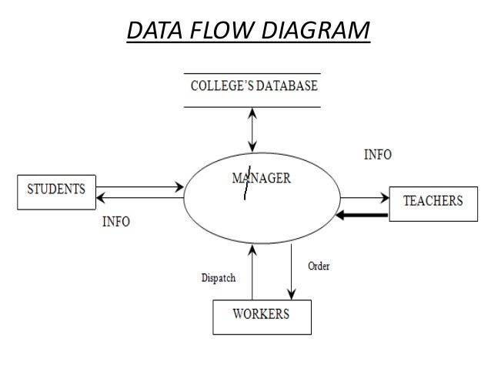

Entity relationship diagram:

ER Diagram stands for Entity Relationship Diagram, too known as ERD is a diagram that shows the relationship of entity sets stored in a database. In other words, ER diagrams help to clarify the logical structure of databases. ER diagrams are made based on three fundamental concepts: entities, attributes and relationships. ER Diagrams contain different symbols that use rectangles to speak to entities, ovals to define attributes and diamond shapes to represent relationships. At first look, an ER chart looks very similar to the flowchart. However, ER Diagram includes numerous specialized symbols, and its meanings make this model special. The reason of ER Diagram is to represent the entity system infrastructure.

Following are the main components and its symbols in ER Diagrams:

* Rectangles: This Entity Relationship Diagram symbol represents entity types
* Ellipses : Symbol represent attributes
* Diamonds: This symbol represents relationship types
* Lines: It links attributes to entity types and entity types with other relationship types
* Primary key: attributes are underlined
* Double Ellipses: Represent multi-valued attributes

## Er diagram of college management system:

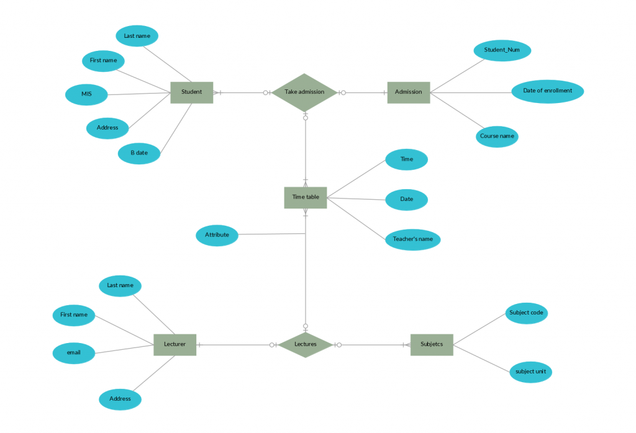

### Summary:

Developing the new system for college with inclusion of all its features is very difficult project to do. When the project was first given then first of all we decided to perform the feasibility study on this new system development and when the report of study was good then we dived into the software development process. To develop any system first we need to choose the best system development model and be clear about the reasons for choosing that specific model in this project. We analyzed the various system development models like Waterfall, Agile, Prototype, v-model etc. We designed the Data Flow Diagram and ER-Diagram for the system which helped the developer and any other project member to get overview of whole system and how it will work once it is completed. We hired the top designer from our country to design the system layout using various technologies and after the completion of this step we moved toward the development phase. In the development phase we used top technologies and popular language for proper coding to make the software fast, reliable and accurate. We also used various technologies to provide security for the software using firewall and popular web hosting company. Different constraints were listed out such as costs and organizational policy. We also find out the reason behind developing a new system and problem that had in their old system. We went through a data collection process where we held workshop, formed groups, took an interview and asked questions. We also arranged face to face interaction so that we can show them the ongoing process in system development and get quick feedback which helped us to increase the software quality.

Conclusion:

In this way to complete this part I undertake out the software investigation to meet the business need utilizing appropriate software analysis strategies to carry out a computer program examination and made a supporting documentation for this. I identified the stakeholders included within the development of software and client’s requirements that needed to be addressed within the software. Moreover, described about the scope of the software and process descriptors on how software will work in output, input and process. Thought of alternative solutions were created in case of any emergency.

Part: 4

1. Prepare a documentation that explains how user and software requirements have been addressed. You may tabulate this task with the columns that has the expected client requirements and the actual output of the product to be developed after the appropriate analysis.

Introduction

The section is about the system's documentation. The documentation here discusses how the specifications of users and system have been dealt with. To compare client and software necessities, I will make a tabular type.

P7: Documentation on user and system documentation

“User requirements, often referred to as user needs, describe what the user does with the system, such as what activities that users must be able to perform. User requirements are generally documented in a User Requirements Document (URD) using narrative text. User requirements are generally signed off by the user and used as the primary input for creating system requirements. System requirements are the building blocks developers use to build the system. These are the traditional “shall” statements that describe what the system “shall do.” System requirements are classified as either functional or supplemental requirements. A functional requirement specifies something that a user needs to perform their work.” (Parker, 2012) In our project of developing software for college it was very important for us to address user and software requirements. Without the user and software requirements it was impossible for us to develop the required software for college. The best way to know the user requirements was documentation.

Developing the new system for college with inclusion of all its features and user requirements is very difficult project to do. When the project was first given to our company then first of all we decided to perform the feasibility study on this new system development and when the report of study was good then we dived into the software development process. To develop any system first we need to choose the best system development model and be clear about the reasons for choosing that specific model in this project. We analyzed the various system development models like Waterfall, Agile, Prototype, Spiral etc. We designed the Data Flow Diagram and ER-Diagram for the system which helped the developer and any other project member to get overview of whole system and how it will work once it is completed and what are the user requirements from this system. We hired the top designer from our country to design the system layout using various technologies and after the completion of this step we moved toward the development phase. In the development phase we used top technologies and popular language for proper coding to make the software fast, reliable and accurate. We also used various technologies to provide security for the software using firewall and popular web hosting company. Different constraints were listed out such as costs and organizational policy. We also find out the reason behind developing a new system and problem that had in their old system. We went through a data collection process where we held workshop, formed groups, took an interview and asked questions. We tried our best for the quality assurance of system and for this we used highly skilled developer, testing in each phase, proper documentation although it is not highly required in agile model. We also arranged face to face client interaction so that we can show them the ongoing process in system development and get quick feedback which helped us to increase the software quality.

We can add requirements whenever clients ask for new requirements in software. Moreover, below I have tabulated this task with columns with the expected client requirement and actual output of the product: -

|  |  |
| --- | --- |
| Expected Client Requirements | Actual Output |
| Memory Constraints adaptable with customer’s environment | Made system requirements adaptable with today’s technology i.e. 50 GB available space & Min processor speed (i.e. Pentium 4, 3.2 GHz or Power PC G5, 2.0 GHz) |
| Backup & Recovery of Clients datav | All client’s data will be stored in center server and they can backup when necessary. |
| Separate accounts according to individual level | System available with 3 administrator account & various normal account for company customer. |
| Update & Maintenance | Agreement for updating system in 6 months and regular monitor for proper system functioning |
| Supported in any latest OS | Supports Operating system (i.e. Windows version higher than Windows XP, or Mac OS X 10.3.8, Ubuntu version higher than 14) |
| High Security | Implemented strong coding methods, proper firewalls |
| Online Service | Can contact to company through online messages and customer service |

Conclusion

So lastly, I have explained how the specifications of users and system have been handled.

Bibliography

<https://www.guru99.com/software-engineering-prototyping-model.html>

<https://www.tutorialspoint.com/sdlc/sdlc_v_model.htm>

<https://www.freestudy.com/feasibility-study-in-sdlc/>

<https://www.quora.com/What-are-the-advantages-of-waterfall-lifecycle-in-large-software-development-project-1>

<https://www.learnpick.in/prime/documents/ppts/details/253/cms-content-management-system>

<https://padakuu.com/article/17-feasibility-study-and-its-importance>

<https://enfocussolutions.com/business-user-and-system-requirements/>

<https://www.tutorialspoint.com/sdlc/sdlc_waterfall_model.htm>

<https://www.investopedia.com/terms/f/feasibility-study.asp>

<https://www.lucidchart.com/pages/data-flow-diagram>

<https://www.guru99.com/er-diagram-tutorial-dbms.html>