

MANAGING A SUCESSFUL COMPUTING PROJECT

INTERNATIONAL SCHOOL OF MANAGEMENT AND TECHNOLOGY



Bisesh Shrestha (HND/ Second Semester)

Content s

PART 1 3

LO1 Establish project aims, objectives and timeframes based on the chosen theme 3

P1 Devise project aims and objectives for a chosen scenario. 3

INTRODUCTION 4

Aims and objectives of the project 4

P2 Produce a project management plan that covers aspects of cost, scope, time, quality, communication, risk and resources. 5

Project management plan 5

Project costs 6

The project's scope 7

Project time 7

Communication 8

Resources and risk 8

Literature Review 8

Project Quality 8

P3 Produce a work breakdown structure and a Gantt Chart to provide timeframes and stages for completion. 9

Work Breakdown Structure 9

Gantt Chat 10

P4 Carry out small-scale research by applying qualitative and quantitative research methods appropriate for meeting project aims and objectives. 11

Research Methodologies 11

Qualitative Analysis 11

One to One Interviews 11

Focus Group 12

Observation 12

Record analysis 13

Quantitative research 13

Methods used in quantitative methods: 13

Online polls 13

Surveys 13

Questionnaire 14

Conclusion 18

Part2 19

P5 Analyze research and data using appropriate tools and techniques. 19

Tools and technique for research 19

Appropriate tools and techniques used in research 19

Software tools 19

Bar graph of collected data 20

P6 Communicate appropriate recommendations as a result of research and data analysis to draw valid and meaningful conclusions. 23

Communication 23

Verbal Communication 23

Non-Verbal Communication 23

Recommendations related to data analysis: 24

P7 Reflect on the value of undertaking the research to meet stated objectives and own learning and performance. 24

Achievement of my project 26

Conclusion 27

References 28

# PART 1

# LO1 Establish project aims, objectives and timeframes based on the chosen theme

# P1 Devise project aims and objectives for a chosen scenario.

# INTRODUCTION

As I work in the research and development department of an organization. I am responsible for doing small-scale research in many areas as part of my employment at the organization in order to recognize and find current trends and breakthroughs in IT and computer science. My senior boss has requested me to do a small-scale digital market research study. In this work, I'll investigate if digital technologies benefit or detract from life. In addition, I'm researching the effectiveness of items and features that are expressly meant to boost health and wellness.

Health professionals, researchers, and device makers use the phrase "digital wellbeing" to describe the concept that when people are engaged with technology, the experience should support mental and/or physical health in a measurable way. The goal of increasing digital wellbeing is to build technology in such a manner that it encourages healthy behavior and actively supports users in leading healthy lives. In response to a request for applications and technologies that respect a person's time, several firms built less disruptive features or included the ability to turn off irritating notifications. In addition, businesses have created new applications that measure digital wellbeing and keep track of things like screen time spent on various apps. They help the user in decreasing unwanted sorts of screen time or being more intentional in their use of technology.

## Aims and objectives of the project

We all know that each task has a goal, therefore we should keep working until we achieve it. So, in order to achieve this task, I've established certain objectives for myself, as seen below:

* To know how much technology has affected our daily life.
* What impact does technology have on sleep? What kind of impact does this have on learning?
* To find out what kinds of activities are commonly associated with excessive internet use.
* To determine if social networking sites help or harm our social skills.
* To determine the efficacy of products and features aimed at enhancing health and well-being.

# P2 Produce a project management plan that covers aspects of cost, scope, time, quality, communication, risk and resources.

## Project management plan

Project management is a difficult task that involves rigorous planning and timing. I can more successfully meet the project's aim with a better project plan. A project management plan describes the method through which management will carry out, monitor, and control the project. In other terms, a project management plan is a structured and recognized approach of project management. The purpose of this document is to define, integrate, prepare, and coordinate various planning processes. It also specifies out how the project will be monitored, evaluated, performed, managed, and completed. The process of planning, organizing, and managing the effort necessary to accomplish a successful project is known as project management. The first stage in project management is to decide how a project will be carried out. The purpose, cost, quality, risk, communication and timing, and available resources are the most significant aspects to consider while selecting a project. There are numerous methods to attain a project's aim, but not all of them are realistic given the time and financial limits, therefore we must weigh all of our alternatives before selecting the best one. My project's purpose is to analyze how a vulnerability in an existing system may affect end users and provide a viable remedy and strategy to educate them. A good project management plan includes the following elements:

* Costs
* Scope
* Time
* Quality
* Communication risk
* Resource

A project management plan is the primary instrument for illustrating the path to completing the project's task. As a result, the project manager must establish a project management strategy in order for the project to be successful. The following is the project management strategy:

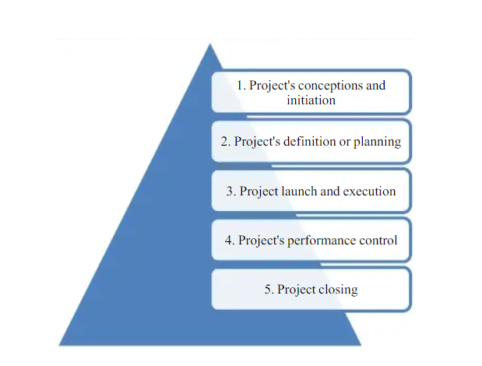

### Project costs

To take a project and finish it, the project manager must consider certain crucial elements of the project, the most significant of which is cost, therefore as the manager of the Leon restaurant, I must examine the project's cost. The overall cost of a project may be broken down into the following categories:

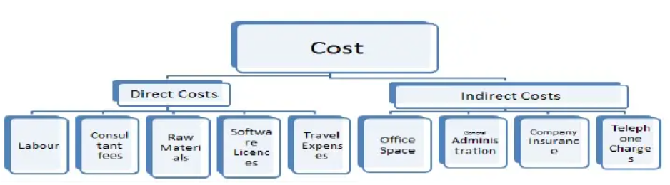

The project manager's first concern is the estimated cost of the project. As a result, I've estimated the project's cost. The following is a list of the project's costs:

|  |  |  |
| --- | --- | --- |
| NO. | Items | Cost |
| 1 | Planning | RS 10,000 |
| 2 | Research and questionnaire | RS 8,000 |
| 3 | Data analysis/ combination | RS 5,000 |
| 4 | Transportation/ other | RS 3,000 |
| 5 | Printing and Stationary | RS 5,000 |
| 6 | Employees | RS 80,000 |
|  | Total | RS 1,11,000 |

### The project's scope

As a manager, I must examine the scope of the project in order to accomplish it effectively. The project's scope covers crucial areas such as project planning, project design, development, hypothesis testing, and the introduction of hardware and software that are required to complete the project. Along with the project's success, it's also important to evaluate the project's flaws, which might be detrimental to the project. Changes in planning, altering the target market, and implementing new plans on a regular basis should be avoided by Leon Restaurant.

### Project time

A time frame must be specified for a business project. Without a fixed time, the project manager will be unable to complete the project's tasks. As the manager, I've set the time to begin and finish the job on time. As a result, I've established the project's critical path. The critical path network is shown in the diagram below.

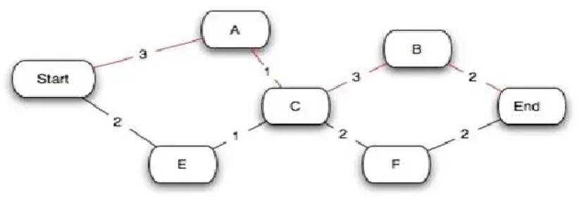

|  |  |
| --- | --- |
|  |  |
| Project initialization | 1 day |
| Planning | 5 days |
| Making Questions | 5 days |
| Visit and Interview(For 10 companies) | 10 days |
| Data analysis | 5 days |
| Data Combination | 5 days |
| Data Study | 3 days |
| Conclusion of Data 2 day | 2 day |
| Total | 36 days |

We predicted that this project would take 35 days to complete in total. The planning will take about 5 days. And then I have to meet with the appropriate persons to obtain the data that is necessary, which will take the most time out of the other tasks, which might take up to ten days. My project may take 13 days and 2 days to complete due to data analysis, combination, and research.

### Communication

The most important aspect of every project is communication. The project manager must keep in touch with all of the project's stakeholders on a regular basis. The project manager devised a plan for communicating with the company's stakeholders. Those who are involved in the project and have the potential to effect its completion should be taken into account by the manager. As the manager, I will keep in constant contact with the project's stakeholders as well as the general public.

### Resources and risk

Every business project comes with its own set of risks and resources. The project to gain competitive advantages through CSR activities is not without issues, dangers, or resources. The project's risks include a lack of sufficient time, money, and volunteers, as well as important national political conditions. And the project's resources include trained labor, the project manager's expertise, sufficient investment, and the management's good attitudes. As a manager, I am certain that the project will be completed on schedule since it has more resources than the dangers involved.

### Literature Review

Because it helps us to broaden our viewpoints on the study issue, the literature review is an important aspect of project management. I was unfamiliar with digital wellbeing and its components, and before I could question someone about it, I wanted to learn more about it, so I spent five days reading various articles and conducting research to gain a basic grasp. I was able to build an awareness of digital wellbeing thanks to papers authored by several lecturers. As part of the study, I needed to learn more about implementation, so the literature review was really informative. However, having a view of practical implementation would be even more beneficial, so following the literature review, we went on field visits to several sectors.

### Project Quality

The term "quality assurance" refers to the project's quality. Quality assurance is defined by the American Society for Quality (ASQ) as "the planned and systematic actions done in a quality system to ensure that quality criteria for a product or service are met." It is the task of managing and regulating the project's goods and services in order to guarantee that they fulfill the specified quality standards. This procedure is essential for preserving not just product and service quality, but also consistency.

The most crucial issue that the project manager must consider is project quality, since if I am unable to maintain the project's quality, the project's completion will be threatened. The project quality assurance plan assures that the work is being monitored and prepared in a sensible manner, and that the project's expectations are of worthy quality, before the project's expectations are conveyed to the clients. When conducting any project, it is vital to assure quality since the quality will have a direct impact on the project's advantages to consumers when it is done. As a researcher, I will examine the time constraints and resources available to me in order to make the best option for the organization.

# P3 Produce a work breakdown structure and a Gantt Chart to provide timeframes and stages for completion.

## Work Breakdown Structure

Tasks are divided into five stages in a project management strategy. As a result, a project manager must split the overall assignment into five parts. So, I’ve taken the effort to break down an entire process. The five stages of work will be completed within the time frame provided in the project plan. If all of the allocated tasks are completed on schedule, the project will be a success for the organization. As a result, the following is a list of project tasks:

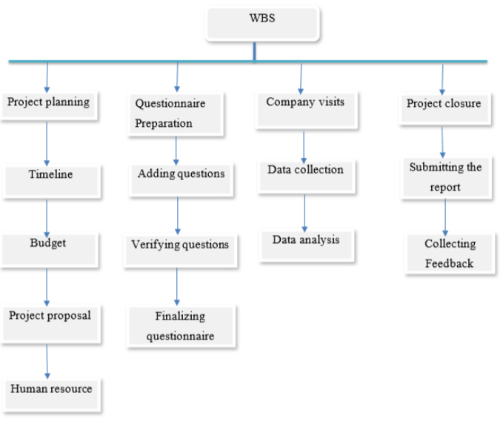

## Gantt Chat

One of the most common and practical techniques of presenting activities (tasks or events) against time is a Gantt chart, which is frequently used in project management. On the left side of the chart is a list of the activities, and at the top is a time scale. Each action is represented as a bar, stakeholders, and teams with a more comprehensive view of each task and activity across multiple projects. with the length and location of the bar representing the start, duration, and finish dates of the activity. Everyone on the team knows who is working on what, how long it will take to finish a research, and which projects are likely to fall behind schedule thanks to Gantt.

Improved communication is another key benefit of adopting a Gantt chart for project management. It's no secret that finishing a project effectively necessitates the collaboration of all team members. To put it another way, it's vital that everyone in the team is on the same page and has access to all of the information needed to complete a project successfully. 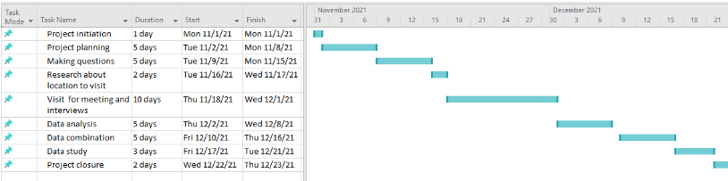

The Gantt chart seen above illustrates the project's Gantt chart, which helped me manage and plan the project. I projected that the full project would take 36 days, including 1 day to start it, 5 days to prepare, 10 days for the first field visit, and 5 days to review the meeting's efficacy and manage future meetings. After that, I have the work of evaluating, processing data, and creating the final report to complete. As a consequence, my assignment would be finished in a timely manner. I produced a report and submitted it after performing all of the research and gathered all of the material.

# P4 Carry out small-scale research by applying qualitative and quantitative research methods appropriate for meeting project aims and objectives.

## Research Methodologies

Research methodology might involve publishing inquiry, interviews, reviews, and other research procedures, as well as current and historical data, to aid in the collecting of information and data for the determination of creating business judgments. As part of the study, I chose to conduct research using both quantitative and qualitative methods.

## Qualitative Analysis

Qualitative research is a type of study that focuses on how individuals feel, think, and why they make specific decisions. If you're thinking of changing you’re branding, for example, you may perform some qualitative research to discover about people's emotional reactions to your new identity and what they identify it with. The qualitative technique relies on open-ended and conversational interactions to obtain information. It is used to gain a better understanding of the underlying reasons, beliefs, and motivations. It contributes to the creation of ideas or hypotheses for future quantitative research by providing insights into the topic. Qualitative research is also used to uncover trends in thinking and opinion and to go further into a topic. Unstructured or semi-structured qualitative data collecting approaches are available. Individual interviews, focus groups, and participation or observation are all typical ways. The approaches for performing qualitative research are as follows: -

### One to One Interviews

Conducting in-depth interviews is one of the most prevalent qualitative research approaches. The interview is one-on-one with just one respondent at a time. This is simply a conversational strategy that encourages the responder to provide extensive information. This strategy has the advantage of allowing for the collecting of exact data regarding people's beliefs and motives. Asking the correct questions can help a researcher collect useful data if he or she has prior experience. If the researchers want further information, they should ask follow-up questions to aid in the acquisition of additional data. These interviews can last anything from 30 minutes to two hours or more and can be performed in person or over the phone. It is simpler to read the respondents' body language and match the replies when the in-depth interview is performed face to face.it has a significant advantage in that it allows me to obtain additional information from the interview. Following are some of the points I made during my interviews with the companies:

* How much has digital technology helped your life?
* Do you believe that digital technologies have more benefits than drawbacks, or vice versa?
* What do you believe the impact has been on children?
* Do you believe businesses will be able to thrive without digital technologies?
* What do you know about digital health and wellness?
* Have digital wellbeing tools helped you in living a healthy lifestyle?

### Focus Group

Another popular qualitative research tool for data collecting is a focus group. A focus group is made up of a small group of people (6-10) from your target market. The fundamental purpose of the focus group is to obtain answers to the questions "why," "what," and "how." You don't have to engage with the group in person, which is one perk of focus groups. Focus groups may now be emailed an online survey to complete on a range of devices, and results can be gathered with a single click. Focus groups are more costly than other techniques of online qualitative research. They're frequently used to clarify complicated procedures. This technique is ideal for doing market research on new items and putting fresh ideas to the test.

### Observation

Qualitative observation is a research approach that collects systematic information or data using subjective methodologies. The research process of acquiring information or data using subjective approaches is the focus of qualitative observation. The primary purpose of qualitative observation is to compare and contrast quality differences. The following are some of the observations I've made as a result of this project: -

* In today's world, digital technologies are extremely important. It has been ingrained in everyone's lives.
* Technology offers many benefits, but it has also made humans more lazy and reliant on it.
* The internet has provided individuals with a wealth of knowledge, and technological advancements have made their lives simpler.
* People are increasingly engrossed in the internet and social media.
* It has also had an impact on youngsters. They are more engaged in gaming and other activities.
* It has harmed people's health, such as their vision and sleep.

Due to the health affect because of digital technologies there comes digital wellbeing. Some of its features I have observed are:-

* Physical exercise and nutrition are being emphasized more as a result of Digital Wellbeing. Many technology gadgets have been developed to help people improve their fitness levels, check their heart rate, record their daily step count, and keep track of their food.
* Setting a daily or weekly screen time limit of a certain number of minutes or hours.
* Supporting healthy sleep habits, especially for those who sleep with their gadgets. Users may program their smartphones to turn off particular functions, modify the screen contrast, or convert to grayscale to alleviate eye strain before going to bed. For example, the iPhone includes a built-in function that reminds users to go to bed at a certain hour.

## Record analysis

This is secondary research conducted to determine the project's quality. For record analysis, I read through various books, articles, and newspapers, and from their written statements, I deduced some similar terms such as machine learning, neural network, and so on.

## Quantitative research

Quantitative research entails generating numerical data or data that may be translated into useable statistics in order to quantify an issue. Quantitative data collection methods are significantly more structured than qualitative data collection approaches. In quantitative research, numerical data is used to generate facts and reveal patterns. Online surveys, paper surveys, mobile surveys, face-to-face interviews, telephone interviews, online polls, and other approaches were used to acquire quantitative data. There are numerous options for conducting the research program, such as questionnaires, interviews, and observations. I had limited time to conduct the research program, so I used a questionnaire as a research instrument because it was convenient and less time consuming, and all of the respondents cooperated with the questionnaire because it was simple to fill out and all of the questions were objective.

In marketing, quantitative research is a stimulating and highly educational technique for gathering information from existing and potential customers through sampling methods and the distribution of online surveys, online polls, questionnaires, and so on, the results of which can be analyzed using statistical methods.

## Methods used in quantitative methods:

### Online polls

For my project I have made online polls through social media and emails. I have collected the data from questionnaire done from mails and made polls.

### Surveys

The most basic tool for all quantitative outcome research approaches and studies is survey research. Online polls, online surveys, web-intercept surveys, and other sorts of surveys were utilized to pose questions to a sample of respondents. Every company, large or small, wants to know what their consumers think about their products and services, how new features are doing in the market, and other such facts.

An organization can perform survey research by asking several survey questions, collecting data from a pool of clients, and analyzing the data to provide numerical findings. It is the first phase in any research project's data collection. This type of study can be undertaken with a specific target audience group, as well as across numerous groups with comparison analysis. The sample of respondents must be randomly selected, which is a requirement for this type of study. Because a large variety of respondents will be addressed utilizing random selection, a researcher can easily maintain the accuracy of the obtained data. Traditionally, survey research was conducted in person or over the phone, but as internet mediums such as email and social media have advanced, survey research has moved online as well.

Example:

|  |  |  |  |  |
| --- | --- | --- | --- | --- |
| **Survey questions** | **Strongly agree** | **Agree** | **Neutral** | **Disagree** |
| Has technology has influenced our living? |  |  |  |  |
| Do u think any sector can survive without digital technologies? |  |  |  |  |
| Do u think using technology influence our health? |  |  |  |  |
| Is this worth using digital wellbeing tools? |  |  |  |  |

### Questionnaire

A questionnaire is a written or printed structured form that consists of a defined collection of questions designed to collect information from one or more respondents on a certain issue or Subjects. It is a data collection approach in which a large number of people are asked a series of questions and a solution is developed based on the responses.

A questionnaire is a research tool that consists of a series of questions designed to collect data from respondents. Questionnaires are similar to written interviews in that they collect information. They can be done in person, over the phone, on the computer, or by mail. Questionnaires are a low-cost, rapid, and effective approach to collect significant amounts of data from a big number of people. Because the researcher is not required to be present while the surveys are completed, data can be obtained fast. When conducting interviews with large groups of people is impractical, this method is useful.

I used the questionnaire as a research instrument during my project since it offers both a qualitative and quantitative method and is appropriate for primary research. Because the questionnaire was short and sweet, I asked that all representatives take 5 to 10 minutes to complete it. The questionnaire assisted me in gathering real data and completing the assignment.

**Characteristics of good questionnaire**

* It addresses a topic that is vital or significant.
* Its importance is expressed clearly on the questionnaire or in the cover letter.
* It only looks for information that can't be found in traditional sources like books, reports, and records.
* It is as brief as possible, lasting only long enough to obtain the necessary information.
* It has a pleasing appearance, is well-organized, and can be easily replicated or printed.
* Directions are clear and comprehensive, with key concepts defined.
* There are no clues, hints, or suggestions in the questions.
* The questions are presented in a simple to complex order.

**Advantages of Questionnaire**

* It’s very economical.
* It covers the research in wide area.
* The research was rather simple to analyze.
* It takes less time.
* It is a dependable and valid research method. It is more scientifically and objectively assessed than other data collection methods.

**Disadvantages of Questionnaire**

* We only receive a few responses this way.
* There is a lack of human interaction.
* There's a higher chance of doing it wrong.
* The likelihood of receiving an incomplete response is higher.
* It's possible that some replies will be illegible.
* It may be ineffective in a variety of situations.

I've created some sample questions that will be used to gather data. In this sample questionnaire, I've highlighted several questions that can be asked to an individual, a corporate member, or the general public, as well as a review.

**Questionnaire**

**Name: Position:**

**Office: Email:**

**Contact no:                                                                         Date:**

1. **Define Digital Wellbeing**
2. Promoting positive relationships with technology
3. Enabling happiness and satisfaction in a measurable way
4. Connecting health and exercise in a digital way
5. Being aware of the impact that digital technologies have on our health and wellbeing
6. All of the above
7. **On average, how many hours do you think teens spend on social media platforms a day?**
8. 3 hour
9. 5 hour
10. 7 hour
11. 8 hour
12. **What is said to be the number one factor that has increased mental health issues amongst youth?**
13. Lack of sleep
14. Social media
15. Poor diet
16. Sedentary lifestyle

* 1. **Have digital well-being tools helped you live a healthy lifestyle?**

1. Yes
2. No

* 1. **What are some of the features to help assist with personal wellbeing on a digital device? (Select all appropriate answers)**

1. Wind down - Do not disturb (Night time)
2. Pedometer
3. Ability to turn on/off blue light screen filter
4. In app feature "You are all caught up" with news feed
5. Screen time monitor feature
   1. **What’s the first step to developing a better relationship with technology?**
6. Raise self-awareness of how you interact with technology
7. Stop using technology
8. Set a vision for your tech usage
9. Make changes to our digital habits

* 1. **Which of the following could you gain from having a healthy and balanced relationship with technology?**

1. Be more productive and focused at work
2. Increased popularity with others
3. Cheaper energy bills
4. Discounts on some mobile apps

* 1. **Are you more aware now about Digital wellbeing after taking this quiz?**
  2. Yes
  3. No
  4. Undecided

----------------------------------------------------------------------------------------------------------------

______________________   _______________________

Signature of IT administrator                                                                        Collected by

I have created a questionnaire by asking the same set of questions to several employees and collecting data that can be summarized in the form of numbers, such as the number of persons who agree and disagree on the same subject.

# Conclusion

In this task, I established my goals and objectives and put them into action using a project management plan and various tools and techniques. I created a timetable, a Gantt chart, a work breakdown structure, and many other documents. Furthermore, I used a variety of research methods, which resulted in a reliable and accurate output. Overall, I had a lot of fun and learned a lot about digital wellbeing while conducting this research. I also collected a lot of data that will be useful for my project.

# Part2

# P5 Analyze research and data using appropriate tools and techniques.

## Tools and technique for research

A researcher must be able to collect data using a variety of instruments and procedures. Tests are measuring instruments that help researchers gather and analyze data. Tools might differ in terms of their complexity, interpretation, design, and administration. Each tool is tailored to a unique data collecting task. From the various tools, one must select those that will offer the data required to test a hypothesis. In certain cases, current research tools may not be suitable for the task, in which case the researcher should alter or construct his own. Qualitative and quantitative data analysis are two types of data analysis methodologies. At my research, data analysis approaches play a key part in digital technology project management. Data analysis enables data to be received in a systematic and planned manner. Project management makes use of a number of techniques to help the business achieve its objectives. A checklist is a data gathering and assessment tool that may be adopted from a range of sources and prepared or in an organized format. I've used a variety of tools to collect and analyze data, including the following:

## Appropriate tools and techniques used in research

Small-scale research is less expensive, but it has far-reaching consequences for the company. Various tools and approaches are required for the data collecting and processing procedures. I used a number of tools to collect and analyze data, including the following:

### Software tools

It was difficult, if not impossible, to complete the investigation without the assistance of software tools, because in this digital age, all information cannot be saved on paper. There were recordings recorded, and Microsoft's office suite, especially MS Excel and MS Project, were quite helpful.

* **MS Excel**: MS Excel was used to construct the bar graph as well as the analysis. It is Microsoft's spreadsheet software that has been officially launched. It is a valuable tool in a variety of disciplines, and it assisted in the completion of the project by capturing data, allowing for data analysis, and aiding in the production of the bar graph. I used it for a number of things, including budgeting and keeping track of expenses, as well as graphing data.
* **MS Project**: Managing the time plan on paper is tough, but I was able to do it on a Gantt chart using Microsoft Office's project tool. I used a Gantt chart to help me plan my schedule and manage the entire job.
* **Electronic devices**: All technological gadgets, such as mobile phones, telephones, laptop computers, and so on, tremendously supported me in obtaining information and correctly preserving it for analysis because software would not be available if the hardware did not exist.
* **Communication and transportation**: Communication and transportation were critical in the research since I had to visit numerous firms to question about Digital Wellbeing. While I was conducting my research, I had to phone numerous companies and set up meetings where my communication skills were strengthened and developed, and having a field tour delighted me and lightened my load.

## Bar graph of collected data

* During the investigation, a large amount of data was collected and examined. We evaluated and developed graphs based on several aspects of digital well bring. We examined the data and developed a graph based on the following criteria.
* Does digital technology has positive or negative impact in our daily life

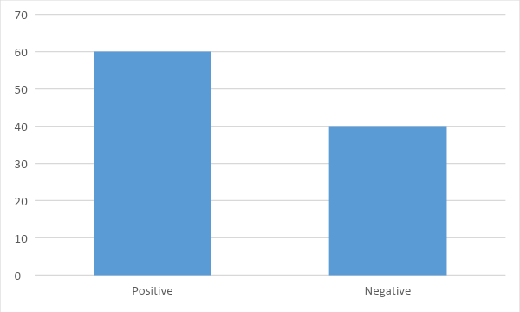

* Are social network sites helping or hindering our social skills?

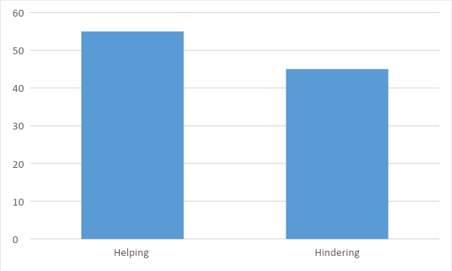

* Is the internet rewiring our brains and should we be concerned?

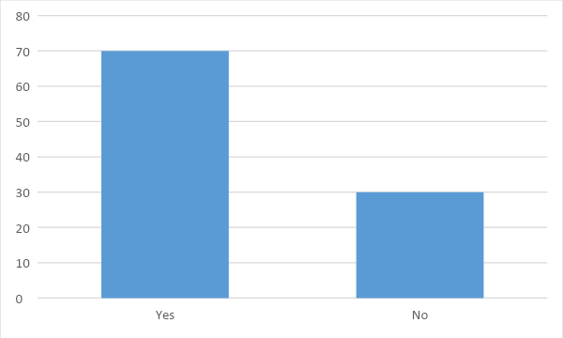

* Do we know more technology means less exercise?



* Have digital well-being tools helped you live a healthy lifestyle?



I used the collected data to evaluate and construct graphs that showed the variations in satisfaction, dependability, speed, and other characteristics. I used a graph to convey mathematical facts so that everyone could comprehend it. The results of my qualitative study are examined and displayed in the form of a graph or a statistics table. This technique of study takes a long time to complete, but it is logical and statistically significant.

# P6 Communicate appropriate recommendations as a result of research and data analysis to draw valid and meaningful conclusions.

## Communication

It's nearly impossible to go a day without engaging with other people. Communication is the act of sending and receiving information between two or more people. The person who transmits the message is the sender, and the one who receives the information is the receiver. It is possible to convey facts, ideas, thoughts, views, beliefs, attitudes, directions, and even emotions.

**Written Communication**

Your writing quality is a vital aspect of your professional presentation. Many people who struggle to write well are skilled in other areas, but their failure to write well is sometimes misinterpreted as a lack of intelligence. Poor writing not only stifles effective communication of ideas and information, but it also makes you seem bad faster than almost anything else. Because clear, legible writing is also well-organized, straightforward, and succinct, learning to write well has an important side effect: learning to write enhances your ability to communicate and think. Written communication examples include: Memos, reports, bulletins, emails, and instant messaging are all examples of written communication.

### Verbal Communication

Employees who work in a typical office setting or whose tasks include considerable phone use must be able to communicate vocally. While those in sales, customer service, and public relations are more likely to need vocal communication skills, everyone who has to speak with employers and coworkers face to face has to be able to communicate effectively and clearly. Verbal communication example: Interviews, questionnaires, and speeches.

### Non-Verbal Communication

Nonverbal communication includes vocal tone, eye contact patterns, body language, and other aspects of nonverbal communication. Nonverbal communication frequently provides more information than verbal communication and has a far greater influence on rapport and trust than verbal communication. Learn how to read nonverbal signs to make a positive first impression. If you have non-standard body language (for example, if you're on the autistic spectrum or have a physical limitation), you'll need to develop ways to avoid or correct misconceptions. Nonverbal communication examples include: Gestures, signs, symbols, eye contact, and speech are all examples of nonverbal communication.

Communication is more effective when it is spontaneous rather than formulaic. A speech that is read has a far lesser effect than one that is spontaneously given (or appears to be). Developing these qualities, of course, requires time and effort. As you put in more work and practice, your communication abilities will become more automatic and successful.

## Recommendations related to data analysis:

It can be assumed from the information presented that a range of strategies and approaches were employed. We observed that a questionnaire was designed and a survey was conducted in order to accomplish this. After the survey was finished, the results were collated and examined. For a successful project, management must make optimal use of resources such as capital and raw materials. The manager may generate judgments and thoughts based on thorough study, which assists in the identification of both negative and good information. Based on the facts and conclusions established, the research makes the following recommendations:

* **Take a good look at your digital habits**: It might be difficult to form new habits, but taking little steps and adjusting to a new way of using your digital gadgets can help you become happier and more present.
* **Monitor your digital activity:** The first step toward bettering your digital health is to gain a thorough grasp of how you use technology. It's critical to be conscious of how much time you spend on digital gadgets and how you interact with them.
* **Define the parameters**: We are surrounded by digital devices. We live on a world that is highly sophisticated. On the other side, we are failing to set technical limitations that are suitable. You may set daily constraints on the applications and websites you use. Apps and websites halt and alerts are turned off when you approach the limit.
* **Create a digital set of ground rules**: For your children's digital safety, it's critical to establish digital ground rules. On most digital devices, parents can set up parental controls. This implies that parents may protect their children from inappropriate information, online transactions, applications, and screen time.

# P7 Reflect on the value of undertaking the research to meet stated objectives and own learning and performance.

It's a challenging and time-consuming task to keep track of all progress, achieve all milestones, and meet all project criteria. It's a challenging chore to deal with the project. If we accept a research project, the project executive's tasks are completed calmly and efficiently in accordance with the specifications. The researcher's learning cycle is also aided by the research since he or she may get a wealth of information on diverse skills as well as useful experience that may be applied in the future. A little scope research measure was taken to lead the weakness assessment inquiry. Both quantitative and subjective research methodologies were used to properly finish the study. This study approach was effective in establishing if the project plan could be carried out within the budget constraints or not utilizing the existing resources. Many dangers and roadblocks have been identified. The following are some of the advantages of delivering the research to meet the objectives:

**Focus on the project**: Research helps to focus the project's goals. The development of the project may be closely monitored by the researcher. The study acts as a reminder of the project's aims and ambitions. The researcher can focus on all of the tasks that must be accomplished in order for the project to be finished. It's simpler to stay on track when the project's goals are emphasized. It is verified that the project's goals are clear and that they can be achieved with easily accessible resources and processes.

**Proper Planning**: After the study is completed, realistic project planning may begin. The project's many key components are reviewed. Cost, time, and resources may all be established throughout the research. The purpose of research is to see if the suggested concept is both economically and technically feasible. A defined method with achievable deadlines is produced via research, allowing everyone engaged in the project team to work within reasonable parameters.

**Clear focus and objectives**: The project's objectives are chosen and targeted during the research phase. The project's objectives are held in high regard throughout the investigation. It's simpler to stay on track when the project's goals are emphasized. It is verified that the project's goals are clear and that they can be achieved with easily accessible resources and processes. The technique that needed to be followed in order to achieve all of the project's aims and objectives was clearly identified through research.

**Developing innovative concepts**: Through investigation, the many project requirements, hazards, and obstacles are identified. Innovative and pioneering ideas, options, strategies, and alternatives are generated. The techniques for distributing project points, as well as a number of additional alternatives for boosting project efficiency, can be separated. It is quite useful to do pioneering research. The researcher has a lot of promise and might one day be a reliable source of knowledge. While directing research, I felt lost amid new objects. I gained a lot of affability and had the chance to practice a range of different relationship skills, including communication, organizing and influencing talents, critical thinking, and dynamism.

**Recognizing threats and obstacles**: There are several risks and issues that arise during the implementation of each project. It's vital to identify such risks and problems early on, which may be done through research. It assists in the detection of a variety of risks, including scheduling risk, economic risk, and so on. During the vulnerability assessment to learn about the numerous security dangers and treatments, there was a chance that sensitive information may be disclosed. Companies were afraid to offer details about their systems for fear of tarnishing their brand. These roadblocks had already been recognized, thus questionnaires were designed to meet the needs and were deemed an effective data gathering tool.

**Improve your skills and knowledge**: It's one of the investigation's most important findings. The study is quite helpful in the learning process. A number of strategies were used to obtain and collect data. It was necessary to be familiar with all of the tools and procedures in order to conduct research and analyze data. Without a solid grasp of the tools and methodologies, doing research is difficult. The researcher might further develop his or her skills and knowledge as a result of the research. Furthermore, because the worker must be mentally concentrated when getting information from the organization, research broadens mental talents.

# Achievement of my project

I learnt new things on a regular basis during the project, such as how to manage my time, meet new people, and get information from them. Because I would have failed the project if I had missed the deadline, time management is a vital component of the endeavor. Because I am unable to complete this job on my own, I have learned leadership qualities as well as the need of listening to others. I've been thinking a lot about digital wellness and its significance in our lives. Although digital technologies have certain drawbacks, they also offer several advantages, as long as we utilize them properly and do not abuse the resources we have been given. We live in a technologically developing era, and we must keep up with the times in our everyday life. When we are faced with serious issues that must be solved promptly, the information obtained from such experience sharing would be tremendously beneficial. The most essential thing I took away from this assignment was that you had to work hard to prove yourself during this time period, and it was really tough for me to travel and conduct research every day. I ran into a lot of roadblocks and had a lot of trouble controlling my time for it. But I did it, and my confidence has grown as a consequence of interacting with such fascinating individuals from whom I have learnt a lot. Now I can confidently assert that memorizing a textbook is no longer adequate in this century, and it is time to do something that will benefit everyone.

From the start till the finish, the methods and courses to follow are laid forth in the project management plan. It's a crucial approach that demands knowledge or information in order to get experience in a certain field. With the use of research, management may study the material and assess the positive and bad repercussions. Both qualitative and quantitative data may be used to acquire knowledge. Graphs, diagrams, and other visual aids can be used to visualize this data. It is critical for the researcher to acquire data from reliable and accurate sources. It enhances the sources that assist in data analysis and are based on prior experience. It is the manager's obligation to thoroughly study the facts and make an accurate assessment.

# Conclusion

To summarize, visiting several firms during my study program and doing all of the work myself, such as drafting questionnaires, data collection, analysis, and logbook maintenance, presented me with an interesting part of my life and taught me a lot of new things. In line with the company's visit, the questionnaire and logbook were completed. In order to achieve the greatest results, I've visited a number of firms and obtained a variety of data. While working on the assignment, I built my project's aims and objectives using tools such as a Gantt chart to manage my time plan and a project tool to further task breakdown. I used Excel as an analytical tool and studied the data to build a bar graph to show how the data from the research was analyzed. In addition, I set project goals and utilized a project management tool to assess research methods such as surveys, as well as the instrument's advantages and offer recommendations using a project management tool. In a similar context, I've talked about the information I gained from the experience.

# References

<https://www.itu.int/en/ITU-D/Cybersecurity/Documents/01-Introduction%20to%20Cryptography.pdf>  
<https://www.synopsys.com/blogs/software-security/cryptographic-hash-functions/>

<https://www.cisco.com/c/en/us/support/switches/catalyst-2960-24tt-l-switch/model.html>

<https://www.geeksforgeeks.org/cryptography-and-its-types/>

<https://www.clickssl.net/blog/different-security-protocols-that-secures-your-data-integrity>

<https://blog.logix.in/network-security-devices/>

<https://www.w3schools.in/cyber-security/network-protocols-and-its-security/>

<https://www.cs.unibo.it/babaoglu/courses/security/resources/documents/intro-to-crypto.pdf>  
<https://www.auvik.com/franklyit/blog/network-devices/>

<https://blog.netwrix.com/2019/01/22/network-security-devices-you-need-to-know-about/>

<https://whatis.techtarget.com/definition/digital-wellbeing>

<https://apan.net/meetings/apan47/files/36/36-01-01-01.pdf>  
<https://www.cisco.com/c/en/us/products/collateral/routers/4000-series-integrated-services-routers-isr/data_sheet-c78-732542.html#ProductSpecifications>

<https://www.cisco.com/c/en/us/products/collateral/security/asa-firepower-services/datasheet-c78-742475.html>