

INTERNATIONAL SCHOOL OF MANAGEMENT & TECHNOLOGY

**ASSIGNMENT COVER SHEET**

|  |  |  |  |
| --- | --- | --- | --- |
| STUDENT DETAILS | | | |
|  | | | |
| Student ID |  | **Reg No.** |  |
| Family Name | Shrestha | **Given Name** | Bisesh |
| Enrolment Year | 2019 | **Section** | N4 |
| Semester | 4th | **Email** | bisesh@ismt.edu.np |

|  |  |  |  |  |
| --- | --- | --- | --- | --- |
| UNIT DETAILS | | | | |
| Unit Title | Computing Research Project | **Unit Code** | T/615/1639 | |
| Assessor Name | Niraj Khadka | **Issued Date** |  | |
| Assignment Title | Digital Wellbeing | | | |
| Assignment No | **1/1** | **Submission Date** | |  |
| Qualification | BTEC HND IN COMPUTING | **Campus** | | **ISMT** |





**STUDENT ASSESSMENT SUBMISSION AND DECLARATION**

When submitting evidence for assessment, each student must sign a declaration confirming that the work is their own.

|  |  |  |  |
| --- | --- | --- | --- |
| Student Name | Bisesh Shrestha | Assessor Name | Niraj Khadka |
| Issue Date |  | Submission Date |  |
| Programme | Networking | | |
| Unit Name | Computing Research Project | | |
| Assignment Title | Digital Wellbeing | | |

**Plagiarism**

Plagiarism is a particular form of cheating. Plagiarism must be avoided at all costs and students who break the rules, however innocently, may be penalized. It is your responsibility to ensure that you understand correct referencing practices. As a university level student, you are expected to use appropriate references throughout and keep carefully detailed notes of all your sources of materials for material you have used in your work, including any material downloaded from the Internet. Please consult the relevant unit lecturer or your course tutor if you need any further advice.

**Student Declaration**

I certify that the assignment submission is entirely my own work and I fully understand the consequences of plagiarism. I understand that making a false declaration is a form of malpractice.



Pearson Education 2018  
Higher Education Qualifications

Contents

Part 1 4

LO1 Examine appropriate research methodologies and approaches as part of the research process 4

P1 Produce a research proposal that clearly defines a research question or hypothesis supported by a literature review. 4

P2 Examine appropriate research methods and approaches to primary and secondary research. 4

Chapter1:Introduction 4

The study's goals and objectives 5

Chapter 2: Reason for choosing this research project 5

This study project was chosen for a variety of reasons 5

Chapter 3: Review of Related Literatures 6

Chapter 4: Activities and timescales (milestones and target date) 6

Chapter 5: Research approach and methodologies 7

Conclusion 9

Part2 10

LO2 Conduct and analyse research relevant for a computing research project 10

P3 Conduct primary and secondary research using appropriate methods for a computing research project that consider costs, access and ethical issues. 10

P4 Apply appropriate analytical tools analyses research findings and data. 10

Introduction 10

Digital Wellbeing 10

Benefits of digital wellbeing challenge 11

Positive impacts 12

Negative impacts: 13

Computer research project 14

Cost 14

Scope 15

Time 15

Methodology of Research 17

Objective of research 17

What is the purpose of research? 18

The importance of research 18

Questionnaires for research 18

Conclusion 18

Part3 20

LO3: Communicate the outcomes of a research project to identified stakeholders 20

P5 Communicate research outcomes in an appropriate manner for the intended audience. 20

Presentation slides: 20

Part 4 26

LO4: Reflect on the application of research methodologies and concepts 26

P6 Reflect on the effectiveness of research methods applied for meeting objectives of the business research project. 26

P7 Consider alternative research methodologies and lessons learnt in view of the outcomes. 26

Introduction 26

Research Philosophy: 26

Research approach: 27

Research strategy: 27

Research group: 27

Time Horizon 28

Data gathering and analysis 28

Evaluation of the Project 29

Recommendations 29

Conclusion 30

# Part 1

# LO1 Examine appropriate research methodologies and approaches as part of the research process

# P1 Produce a research proposal that clearly defines a research question or hypothesis supported by a literature review.

# P2 Examine appropriate research methods and approaches to primary and secondary research.

# Chapter1:Introduction

I should complete the research project under the topic "Digital well-being" as a research manager for an IT company. I am choosing a research subject on the theme of Digital Wellbeing, namely, the impact of digital technology on student wellbeing. The term "digital well-being" is used by health practitioners, researchers, and device makers to convey the concept that when people engage with technology, the experience should improve mental and/or physical health in a measurable way. The purpose of fostering digital well-being is to develop technology that encourages positive behavior and actively supports users in leading healthy lives. Our lives are growing increasingly reliant on technology. We now do a lot of our communication online, and we spend a lot of our leisure and entertainment time on the internet and playing video games. Our mobile phones have become an essential part of our connectivity and day-to-day organization for many of us. As a result of these lifestyle changes, questions about what technology is doing to us have arisen. Limiting screen time, reducing eye strain, being aware of unintended mental consequences, fostering good sleep patterns, and increasing emphasis on physical exercise and nutrition are all critical parts of digital wellness, especially for users who bring their devices to bed. I intend to do study into the effects of digital wellness. Some of these fears are based on the possibility of undesirable effects, which have been the subject of countless frightening journalistic accounts. Some opponents argue that we are in the middle of a "unprecedented crisis" in which "the human brain... is threatened by the modern environment."

Our children, particularly our teenagers, are at the center of this new world's evolution. We know that a child's growing brain is more plastic than an adult's, and that it is more malleable in its responses to experience. This helps to explain why our children are becoming increasingly concerned about their constant access to technology, and we should think about what this implies for their development and education. As a result, while this review covers adult research, it focuses primarily on child and adolescent research. In addition, among the numerous types of technology reviewed, video games will receive increased attention. This reflects their rising reputation in the scientific literature as a one-of-a-kind instance of environmental influence on the mind and brain.

## The study's goals and objectives

The project's goal and objective is to find out:

* To understand how reliant humans have gotten on technology.
* Technology has both positive and harmful effects.
* How it affects human well-being, particularly among youth.
* To find out what kinds of activities are commonly associated with excessive internet use.
* To determine if social networking sites aid or harm our social abilities.
* To determine the source of human suffering, we rely on technology far too much.

# Chapter 2: Reason for choosing this research project

This is the most significant part of the research proposal. In this chapter, I'll describe why I chose this research project in the first place.

## This study project was chosen for a variety of reasons

The purpose of picking this issue is to see how reliant people have gotten on technology. Although technology can help students learn, some apps can be distracting, suggesting that parental supervision of younger children's digital use might help them study more effectively. Adult students who use instant messaging often, for example, consider it a distraction, and such "multitasking" does not appear to increase the capacity to switch focus between applications. As a student, I have become increasingly reliant on technology, whether consciously or unconsciously. Technology has provided me with extensive assistance in every field. As an IT student, I've learned a lot from the internet, but I've also wasted a lot of time on social media, gaming, and YouTube, which has harmed my sleep. Although internet/gaming addictions have not been proven to constitute mental disorders, they are distressing when they interfere with everyday life and are difficult to manage. Although no particular limit for excessive screen time has been set, data suggests that youngsters should have no more than two hours of total screen time each day. Problematic internet use has been related to a number of psychosocial disorders, but it may also aid mental health by providing online therapy treatment for a range of mental diseases.

Although there is mixed data linking technology-based activity to a reduction in physical activity, sleep appears to be affected by how and when technology is used. Late-night technology usage, in particular, has been linked to a loss of sleep and sleep quality, with teens who use their phones after "lights out" being substantially more likely to feel sleepy throughout the day. Games, like most other types of technology, may have a different influence on neurobiological processes, with some evidence suggesting they can disrupt children's sleep and learning even when played late at night.

I believe that the findings of this study will assist individuals in understanding the effects of excessive use of technology, why people are so reliant on technology, and how to reduce the risks associated with excessive use of technology. They can increase their performance and take use of technology by employing a feasible strategy to control overuse of technology. These are the factors that influenced my decision to pursue this study project.

# Chapter 3: Review of Related Literatures

This chapter summarizes the findings gathered from a number of sources. These studies will serve as a guide and source of information for our study. Our connected literature starts with facts about technology and its consequences. Multiple studies released in the second half of the 1990s revealed that greater internet use among teens was associated with lower social connection and wellbeing. However, fewer teens had internet access at this time in the internet's growth, making it more difficult to keep established social networks online. Furthermore, newer technologies (such as Facebook and instant messaging) have been developed to increase contact among existing friends. Furthermore, cyberbullying is a poorly understood and extensively reported issue, with most polls stating that 10-35 percent of 18-year-olds have been victims of cyberbullying. Youngsters with less involved parents on the internet are more likely to become abusers, whereas children who take more risks online are more likely to become victims.

I learned about the good and bad effects of technology on human wellness from past projects, which will be extremely useful in my current research.

# Chapter 4: Activities and timescales (milestones and target date)

The research activities, the study setting, the study respondents, the research instruments, the data collection procedure to be used for the research, and the activities to be carried out during the research project, which include research development, idea analysis, writing, data collection, numerical analysis, tutor meetings, and product development, are all described in this chapter.

1. The study's context

So, for this initiative, I'll begin with my school student. My school has around 1000 students. My intended audience is around 100 pupils.

1. Students who responded to the survey

One hundred of my school's students are involved in this study. Around fifteen (15) survey questions were sent to each of the two gender groups, male and female. Because of the lesser number of female respondents at the institution, there were 40 female respondents and 60 male respondents out of a total of 100 students.

1. Research Instruments

Interviews and research questionnaires were the primary research tools employed in the study. The surveys will be constructed to suit all of the study's key goals, which include determining the impact of excessive use of technology on human wellbeing.

1. Procedure for gathering data

To conduct the research in my school, I will seek permission from the administration. After receiving authorization, my team will conduct the interview and personally deliver the surveys to the respondents, assuring them of secrecy in order to obtain truthful responses.

1. Timelines and activities (milestone and target date)

I did eleven various sorts of activities to meet the research's goal and purpose, which was to learn about the influence of technology on human wellbeing. We predicted that this project would take 36 days to complete in total. The planning will take about 5 days. And then I have to meet with the appropriate persons to obtain the data that is necessary, which will take the most time out of the other tasks, which might take up to ten days. My project may take 13 days and 2 days to complete due to data analysis, combination, and research.

# Chapter 5: Research approach and methodologies

In order to do research, we require a variety of objects, which may be obtained in a variety of methods. In this part, I'll discuss how I approached my research and the strategy I used to complete it. In line with these, we must examine elements and methods, which may be expressed as a description of the research region, population and sampling used for data collection, and the relevance of the research study.

* Area of research description

My school, NJES, is the study area (Naulo Jyoti English School). It is one of Nepal's most prestigious schools. NJES (Naulo Jyoti English School. More than 1000 students has attended the NJESchool. Almost all students, in my opinion, utilize technology, and it has both a beneficial and bad influence on their academic performance. As a result, this is the ideal location for my study project, which aims to raise awareness among a wide number of students about the harmful effects of excessive use of technology.

* Design of the Study

Because the study questions involve both qualitative and quantitative characteristics, a hybrid strategy was used to attain the intended aims. Furthermore, mixed approaches are thought to give more information to characterize a specific phenomena under inquiry than a single method, because one method's failure may be compensated for by the other. Because the current study aims to answer both quantitative and qualitative research issues, data collecting and analysis procedures from both approaches have been used. As a result, the descriptive research design is chosen since it allows the researcher to determine the existing state of the subject field. In the framework of their study analysis, a researcher is simply concerned in expressing the scenario or case in a succinct manner. It is a theoretically based design method that is developed by the collection, evaluation, and presentation of data. This enables a researcher to explain why and how research is carried out. Because of its descriptive character, we may better grasp the necessity for analysis. You could undertake some exploratory work if the problem description isn't evident.

* Sampling and population
  + The study's target population was: My school’s students are the target population. The students from computer-based studies will be the primary target. We'll communicate with the students through a variety of channels. This gives us insight into their perspective on the project.
  + The Research Methodology Employed: Descriptive data gathering approaches are employed in this study. Which is beneficial for obtaining data and information required to tackle significant and minor difficulties. Using survey questionnaires to identify participants and the comparison and contrast approach to sift, appraise, and locate important information for this study.
  + Questionnaires for research: Some questions are used to guide our study and help us reach the project's goal. These are also the areas in which our study is focused.
    - How much has technology influenced your day-to-day life?
    - Is it having a positive or negative impact?
    - What impact does technology have on sleep? What kind of impact does this have on learning?
    - What kinds of activities are commonly associated with excessive internet use?
    - Is it true that social networking sites assist or hamper our social skills?
    - Is it possible to grow addicted to video games and, if so, what is the safe limit? Why are video games so appealing, and what effects do they have on the brain?
    - What are the most serious health hazards associated with the use of digital technology? How might these dangers be minimized?
    - So, what's the next step? How can we assist users, especially children and parents, in making technology-related decisions that benefit their health, learning, and development?

# Conclusion

When the research on the issue of the influence of digital technology on human welfare is finished, I believe the research will have accomplished our project's principal goal. To raise awareness of the internet's potential to benefit people's lives and communities.

# Part2

# LO2 Conduct and analyse research relevant for a computing research project

# P3 Conduct primary and secondary research using appropriate methods for a computing research project that consider costs, access and ethical issues.

# P4 Apply appropriate analytical tools analyses research findings and data.

# Introduction

Teenagers nowadays use the Internet to do their schoolwork, submit papers to Google Docs, Facebook with friends, listen to music, watch movies, and browse. They also use the internet to submit their school homework. At times, it appears that every aspect of their existence has a digital component. Is it possible to have too much technology or to be too digital, despite the fact that all of these devices, apps, and technologies have made their life simpler, more efficient, and more connected? Experts are divided on the answer. They're also divided on what this signifies for the country's student’s future well-being. Social connection is now mainly undertaken through various types of technology, thanks to the digital transformation, which has changed the face of relationship-building. Technology now connects us to the rest of the globe, and any new or old social, family, or romantic contact is just a click away. Technology also makes it possible to build a community of individuals who have similar interests and preferences, which may help people feel more confident about themselves. Although technology makes it easier to create relationships online, the growing move to machine connection sometimes lacks the sensibility and responsiveness of face-to-face engagement, making the depth and quality of face-to-face interaction simpler.

## Digital Wellbeing

Health practitioners, academics, and device makers use the phrase "digital wellbeing" to convey the concept that when people engage with technology, the experience should enhance mental and/or physical health in a quantifiable way. The goal of increasing digital wellness is to build technology in such a manner that it encourages healthy behavior and actively supports users in leading healthy lives. In response to a request for applications and technologies that respect a person's time, several firms built less disruptive features or included the ability to turn off irritating notifications. In addition, businesses have created new applications that measure digital wellbeing and keep track of things like screen time spent on various apps.

## Benefits of digital wellbeing challenge

Digital wellbeing challenges are a new evolution of workplace health initiatives. Challenges such as Fit24 operate as both team-building and health-building exercises, bringing together a group of employees that can help each other meet health goals. This replaces older health initiatives, which were often met with reluctance and resentment. Here are some of the principle advantages of a digital challenge:

* It’s easy to integrate into your daily routine

From maintaining your grocery list to paying your bills, technology is now a part of your life in many ways. Modern employees are used to tracking an exceptional number of day-to-day tasks through their email, smartphone, and other devices. A digital wellbeing challenge takes advantage of this propensity to schedule out and track our days through technology.

* When it comes to health and fitness, the most significant hurdle is simply building bad habits.

A digital wellbeing challenge leverages technology to integrate fitness and health into an employee’s daily routine. In Fit24, employees are automatically given goals at intervals and can log their results online. It is convenient, easy to use, and easy to keep track.

* You can drive positive change through gamification

Gamification is one of the most effective methods of driving real, long-lasting change. Gamification provides positive feedback to a set of tasks, creating a positive reinforcement loop that encourages specific behaviors. Nearly every popular app, from Candy Crush to Facebook, uses a system of gamification to encourage users to engage. For employees, gamification gives them direct, specific goals to work towards. Fit24 creates new goals at intervals, all designed to improve different aspects of employee health. As employees progress, they are visibly rewarded through points that they’ve earned. They can easily compare their success to those in their team or many others, so they know how well they’re doing at a larger scale.

* Increase collaboration and team work

How do you get your employees to work productively together? Team work. And though many businesses do engage in team building exercises, the focus of these team building exercises are usually on the organization itself rather than where it should be â€” the employees. Team work centered on health has some major advantages. Employees are already interested and invested in their own health. Working with others to improve their health is a bonding experience, as others are helping them with a personal task. Ultimately, it helps employees grow closer, learn more about each other, and care about each other’s needs â€” all within a structure provided by Fit24. This type of collaboration can be especially challenging because it does require that all employees work together to be as successful as possible, and these skills will ultimately translate into their work.

* A stronger company culture and a transformed workforce

By investing in your employees, you can create an improved, health-conscious environment that is essential to every modern employee. Even large organizations such as Woolworths are now attempting to engage their employees and transform their company culture. At the end of their digital challenge, employees will be more aware of what they need to do to eat better, exercise more, and sleep well. This doesn’t just translate to happier, healthier employees; it translates to happier, healthier people. Businesses need to take a holistic approach to their employee satisfaction, as so much of an employee’s life is wrapped up in their work. The more a business asks of their employees, the more they must also be prepared to give back â€” and in so doing, they’ll be able to improve the top and bottom lines of their business

Here are a few positive and negative effects technology can have on children to consider:

## Positive impacts

* Enhances Learning: Over the past few years, technology has become integrated into the classroom to enhance the learning experience for children. Technologies such as Smart boards, document cameras, Apple TVs, and even 3D printers are now incorporated into educational lessons to boost collaboration and engage students in the learning process. With increased collaboration in the classroom, teachers and students have increased creativity and project-based learning opportunities that make academic instruction more meaningful. In addition, at-home educational technologies have assisted toddler-aged children in learning numbers, letters, colors, and other foundational skills before they enter formal schooling. Mobile device apps like Avokiddo ABC Ride, Moose Math, and Metamorphabet have been recommended by parents to introduce math, the alphabet, and even the arts before kids enter school!
* Fosters Problem-Solving Skills: Have you ever heard of the term “survival mode?” It’s a gameplay function in many kids’ video games where the player is tasked with staying alive as long as possible to outlast opponents. For example, in the popular video game Minecraft, players are dropped into new and different environments and must immediately build shelter and collect items like food, in order to survive and outlive their opponents. Not to mention, an entire day in Minecraft lasts just 10 minutes, so players must make good decisions quickly. With these types of technologies, kids must work independently to achieve a specific goal. In the process, they’re posed with different types of roadblocks and challenges, which they must learn to navigate and overcome. In turn, they’ll be encouraged to come up with their own problem-solving solutions when facing real-life issues such as homework trouble, disagreements with friends, or personal hardship, as well as technology-based obstacles.
* Develops Future Technological Leaders: its common knowledge that our future lies in many of today’s emerging technologies. In the years to come, technical skills will be more important in the workplace, as well as the growing impact it’ll have on day-to-day life. One of the greatest benefits of exposing kids to technology is the fact that they’ll be well-prepared to jump into a pool of available, high-paying tech jobs. With large tech companies like Amazon consistently adding hundreds of new jobs around the country, introducing technology skills to children at an early age can prepare them for a career with a positive outlook. Tech jobs are here today. Tech jobs will be here tomorrow. Some of today’s tech will be tomorrow’s tech, and some of tomorrow’s tech will be completely brand new and something our world has never seen before. Who’s going to be best equipped to fill those positions? The ones who start learning now.

## Negative impacts:

* Diminishes Relationships and Social Skills: As children use mobile devices more and more, they’re more apt to be virtually connected with family and friends, rather than spending time together physically; they’re more likely to text, chat on social media, or connect through online gaming than actually meeting them in person. “Social communication skills are also in jeopardy due to tech overuse. These skills are developed and honed through daily interaction and include knowing how to take turns during a conversation, using facial expressions, changing the way you speak based on the listener—such as how you talk to a baby versus an adult—and making appropriate eye contact. Such personal interactions are limited as children passively view a screen.”
* Stimulates Health Issues: The overuse of mobile devices can be harmful to children’s health, as the more they use mobile devices, the less physical activities they do. In addition, when children choose to play on their devices over physical activity, they often couple their activity with mindless snacking and other unhealthy habits. As children spend more time in front of those screens—most of the time on the couch—the less time they spend outside playing, running, and burning off calories. Over time, those habits can lead to significant weight gain and other associated health problems.
* Reduces Sleep Quality: A study from JAMA Pediatrics found that children and adolescents who use media before bed were two times more likely to not get enough sleep at night. Even further, having access to a media device in their sleeping environment, even if the device was not being actively used near bedtime, was also associated with an inadequate amount of sleep. Children under the age of 13 typically require 11-14 hours of sleep, depending on their age. Sleep is immensely important for children, as it promotes growth, helps heart health, affects weight, increases attention span, and even boosts learning. However, when children don’t get the proper amount of sleep each night, these ever-important qualities can suffer. Like many of the things children love, like pizza or candy, technology can be great—but only in moderation. The problems associated with technology come with misuse and lack of attention around how much technology is “too much.” Be sure to regulate and limit your children's technology use, and they’ll be able to reap its positive effects.

# Computer research project

In order for the study to be done efficiently, there must be some norms and regulations that the researcher must follow. It favors both primary and secondary research for studies on the influence of globalization on business. As a result, the final result should be more precise. These issues must be considered by researchers prior to undertaking research. There are numerous methods to attain a project's aim, but not all of them are realistic given the time and financial limits, therefore we must weigh all of our alternatives before selecting the best one. My project's purpose is to analyze how a vulnerability in an existing system may affect end users and provide a viable remedy and strategy to notify them. The following aspects are related to completing the project:

## Cost

To take a project and finish it, the project manager must consider certain crucial elements of the project, the most significant of which is cost, therefore as the manager of the Leon restaurant, I must examine the project's cost. The overall cost of a project may be broken down into the following categories:

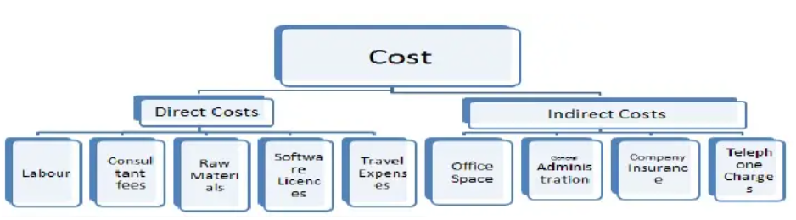

The project manager's first concern is the estimated cost of the project. As a result, I've estimated the project's cost. The following is a list of the project's costs:

|  |  |  |
| --- | --- | --- |
| NO. | Items | Cost |
| 1 | Planning | RS 10,000 |
| 2 | Research and questionnaire | RS 8,000 |
| 3 | Data analysis/ combination | RS 5,000 |
| 4 | Transportation/ other | RS 3,000 |
| 5 | Printing and Stationary | RS 5,000 |
| 6 | Employees | RS 80,000 |
|  | Total | RS 1,11,000 |

## Scope

As a manager, I must examine the scope of the project in order to accomplish it effectively. The project's scope covers crucial areas such as project planning, project design, development, hypothesis testing, and the introduction of hardware and software that are required to complete the project. Along with the project's success, it's also important to evaluate the project's flaws, which might be detrimental to the project. Changes in planning, altering the target market, and implementing new plans on a regular basis should be avoided by Leon Restaurant.

## Time

A time frame must be specified for a business project. Without a fixed time, the project manager will be unable to complete the project's tasks. As the manager, I've set the time to begin and finish the job on time. As a result, I've established the project's critical path. The critical path network is shown in the diagram below.

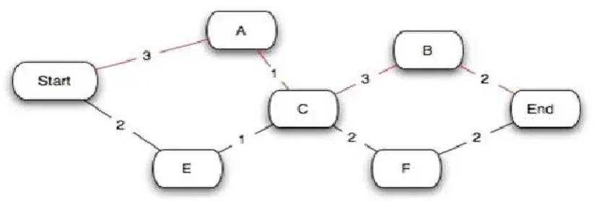

|  |  |
| --- | --- |
|  |  |
| Project initialization | 1 day |
| Planning | 5 days |
| Making Questions | 5 days |
| Visit and Interview(For 10 companies) | 10 days |
| Data analysis | 5 days |
| Data Combination | 5 days |
| Data Study | 3 days |
| Conclusion of Data 2 day | 2 day |
| Total | 36 days |

We predicted that this project would take 35 days to complete in total. The planning will take about 5 days. And then I have to meet with the appropriate persons to obtain the data that is necessary, which will take the most time out of the other tasks, which might take up to ten days. My project may take 13 days and 2 days to complete due to data analysis, combination, and research.

Ethical issues

The ethical considerations are the guidelines that a researcher should follow when performing research. It is used to collect data as a guideline. Some ethical standards are legally binding, while others are only suggestions. When conducting research, a researcher must consider the following elements.

* Honesty: - This refers to the researcher's obligation to do the research in an open and honest manner, without altering any of the facts. Data, techniques, processes, and outcomes must all be genuine to the researcher. It must guarantee that the information is not tampered with.
* Objectivity: - When reviewing data, conducting interviews, making personal choices, and obtaining expert opinion on any misunderstanding, the researcher must be objective. The term "objectivity" refers to the researcher's lack of bias in any of the aforementioned areas of the study.
* Carefulness: When gathering data, the individual performing the research must be cautious. He must evaluate events and facts rigorously, making certain that no fact or data is misrepresented or distorted.
* Confidentiality:-Confidential communications, such as papers or grants that have been submitted for publication, employee records, commercial or military secrets, and medical records, must all be kept confidential.
* Intellectual Property Must Be Respected: -Patents, copyrights, and other kinds of intellectual property must all be respected. Without authorization, unpublished data, techniques, or findings should not be used. Where credit is due, credit should be given. Plagiarism is never, ever acceptable.

Every study project must take into account a number of aspects, including expenses, accessibility, and ethical considerations. The costs of research must be kept within the researcher's budget while still complying to academic ethical norms. This study relies on qualitative data, which is both affordable and sufficient to pay the researcher's costs. Furthermore, participants may be contacted with ease. Before asking participants questions for the study, the researcher will email them a consent form to complete in order to guarantee that ethical requirements are satisfied.

## Methodology of Research

Research is the process of gathering information. It facilitates in the discovery of the truth within the data obtained via investigation. The fact-finding method supports in knowledge acquisition and information collection. The majority of research is focused on a particular issue and use a variety of approaches. Deductive reasoning will be used to perform the research for this project. This form of study is founded on hypotheses, which are then used to draw conclusions that range from general to particular. This type of research technology may also help with the creation of research techniques that can be used to test theories. Similarly, I will do study on the projects throughout the project utilizing applied research approaches. It's a form of research technology that facilitates the application of ideas and subsequently the application of new methodologies to a topic. It also assists in the completion of tasks and the consequences of the outcomes.

### Objective of research

* To learn new information,
* To verify and test essential facts,
* To examine an event, process, or phenomena in order to discover cause and effect links, and so on.
* In order to address and grasp scientific and nonscientific problems, new scientific instruments, concepts, and theories must be developed.
* To conquer or solve challenges that emerge in our daily lives, including scientific, nonscientific, and societal issues.

### What is the purpose of research?

* To address challenging and unresolved issues,
* To garner respect, to be intrigued about an event's undiscovered details,
* To help society by resolving issues.

### The importance of research

* Existing ideas and notions are studied to determine their scope and applicability.
* The rules are what help with the settlement of organizational issues.
* It helps to boost organizational efficiency, which can only be done with the help of research.
* It assists in the discovery of new things that generate new possibilities, as well as the resolution of issues that produce new chances.

### Questionnaires for research

* How much has technology influenced your day-to-day life?
* Is it having a positive or negative impact?
* What impact does technology have on sleep? What kind of impact does this have on learning?
* What kinds of activities are commonly associated with excessive internet use?
* Is it true that social networking sites assist or hamper our social skills?
* Is it possible to grow addicted to video games and, if so, what is the safe limit? Why are video games so appealing, and what effects do they have on the brain?
* What are the most serious health hazards associated with the use of digital technology? How might these dangers be minimized?
* So, what's the next step? How can we assist users, especially children and parents, in making technology-related decisions that benefit their health, learning, and development?

# Conclusion

Various research approaches, such as collecting main or secondary research articles, were utilized throughout the study process to help in the acquisition of a huge quantity of data. Conducting interviews, employing questionnaires, and other primary data gathering methods were used, while secondary data was collected from various periodicals, journals, and books, which aided in the conclusion of papers.

# Part3

# LO3: Communicate the outcomes of a research project to identified stakeholders

# P5 Communicate research outcomes in an appropriate manner for the intended audience.

## Presentation slides:

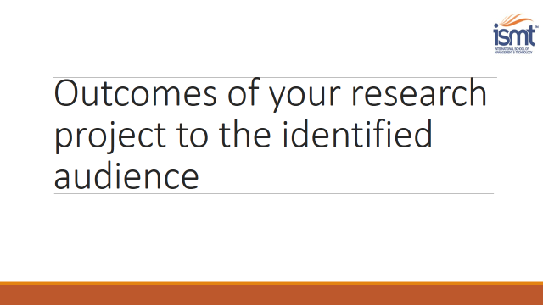

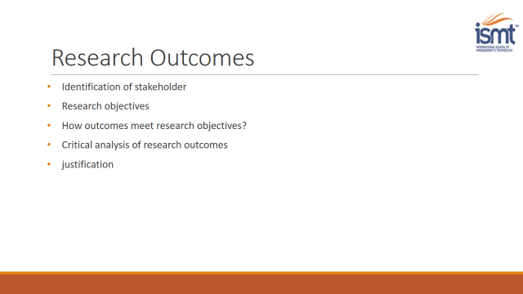 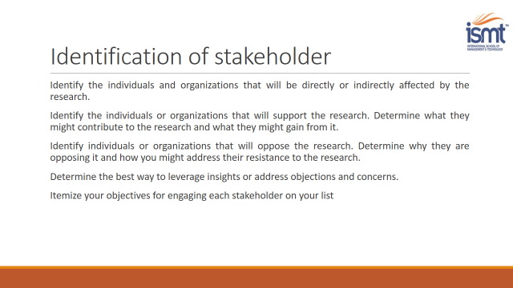 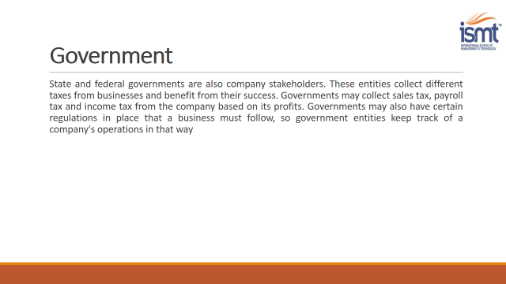 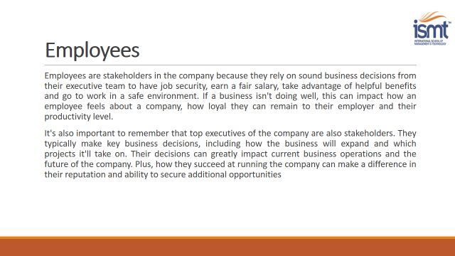 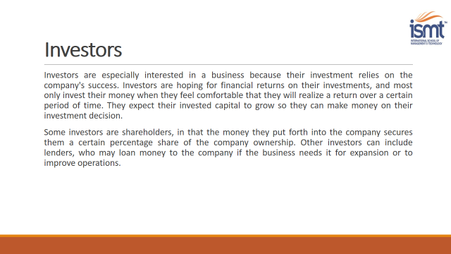

 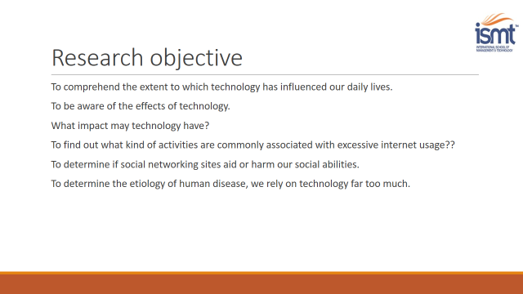 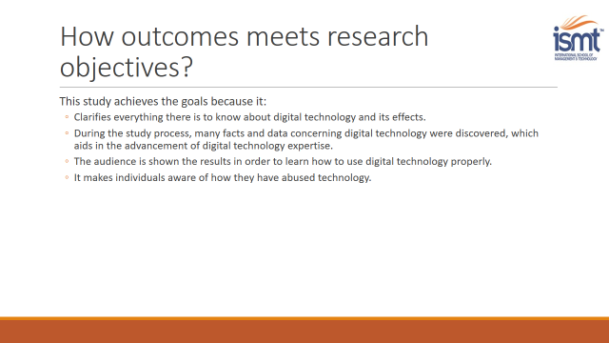 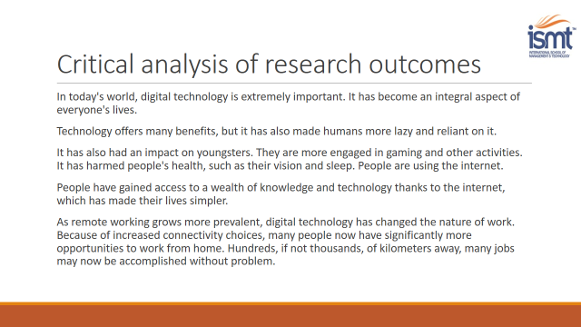

# Part 4

# LO4: Reflect on the application of research methodologies and concepts

# P6 Reflect on the effectiveness of research methods applied for meeting objectives of the business research project.

# P7 Consider alternative research methodologies and lessons learnt in view of the outcomes.

## Introduction

Research technique is the act of finding better ways that help in locating, selecting, and evaluating information on a certain issue. The fundamental advantage of employing research technique in research papers is that it enables for the faster collection of data/information, which can then be used to address the problem. Surveys, questionnaires, and interviews are just a handful of the research methods and approaches available. Overall, research methodology assists in the assessment and acquisition of data utilizing numerous methodologies. When doing research, research technique is employed to ensure that the study and its applications are of a high grade. They aid in determining whether or not the research is true, deal with the actual concept of the research paper, how progress is measured, and so on.

## Research Philosophy:

The method of data collection used in research philosophy aids in the analysis of how the data can be used. The first layer of Research Onion is research philosophy. The semantic and detailed presentation of the research process is known as the research onion. It was created in 2007 by Saunders et al to create the standards for the proper research strategy. There are six layers to onion research, and each layer contributes to a more detailed description of the research process and progress. Research philosophy, as the initial layer of onion research, helps to justify how research will be totally overwhelmed. Depending on the nature of study, the research philosophy will be different. A research philosophy is a collection of ideas and assumptions that will help the researcher generate knowledge about a particular issue. It also assists in the comprehension of various data gathering methods. There are many various approaches to researching philosophy, and we will employ the pragmatism technique in this assignment. The technique is concerned with the notion that no single approach can address every circumstance in the world. It is a source of concern that a same problem can be handled in a multitude of ways. Furthermore, this approach is focused with merging all of the previous research and aiding in the creation of conclusions based on it. This approach also allows you to assess the subject from one or both views, which assists in establishing the study effect of both sides. This form of study adds to a more practical research strategy. It assists in the formation of the conclusion as well as the answer to the study challenge.

## Research approach:

The research strategy is the second layer of the onion, and it assists in the practical conduct of research. Data gathering, data analysis, and data interpretation are their primary concerns. It's also influenced by the nature of the issues that have surfaced. There are two types of research methodologies that may be applied at this layer: inductive and deductive investigation. In this study assignment, we'll take a logical method. Deductive reasoning is based on predetermined hypotheses and conclusions that have previously been tested. Someone has already demonstrated certain hypotheses to be true or wrong, and the results can be utilized to undertake research. Because we only have a limited amount of time to accomplish our assignment, this is dependable. It will take us a year to do our own study, which is not realistic for our research project. Collecting theory, collecting hypotheses, observing those hypotheses, and drawing conclusions/conformations are the four stages of deductive research. If the theory is accurate, then the study findings must likewise be valid, according to this method. Deductive research's fundamental goal is to generalize data from wide to narrow.

## Research strategy:

The research strategy layer is the third layer of onion research. It's the layer that helps to define how research is conducted. Various approaches, such as the experimental method, action research, case study, survey, questionnaires, and so on, are used to examine the research aim at this stage. This makes it easier to come up with project findings and recommendations. We employed questionnaires as a research approach in our study project, which is linked at the conclusion of the text. This assists in the establishment of a research method that permits experiment outcomes to be compared to predicted results. It may be applied to any research study with a small number of variables.

## Research group:

The research circle/choice is the fourth layer of the research onion, and it uses either a quantitative or qualitative approach for research. Mono method, mixed method, and multimethod research circles are the three types of research circles. We employ a hybrid way of research methodology in our research strategy, which allows us to do research on a certain issue utilizing both qualitative and quantitative approaches. The quantitative technique looks at facts in terms of amount and measurement, whereas the qualitative approach looks at explorers' descriptions, views, and reports.

* Quantitative approach: This data collection method emphasizes gathering a huge amount of data, i.e. data quantity and measurement. This approach just collects numerical data, which may be studied using mathematical forms. In our research method, we employ the questionnaires attached at the conclusion of the project to do quantitative data analysis. This form of data collecting is more systematic, which helps with project completion by evaluating the data obtained.
* Qualitative approach: The qualitative approach is centered on identifying the outcomes of the research project's viewpoint, and data cannot be concluded in numbers in qualitative research. It facilitates data collecting by giving specifics and a description of the data. This kind of data gathering yields a wealth of information that helps to explain how and why things transpired throughout the study process, thus it was used in our project as well. Interviews, focus groups, and other qualitative data collecting approaches are examples.

## Time Horizon

The fourth layer of onion research is the Time Horizon, which aids in outlining time management throughout research procedures. Cross-sectional and longitudinal time horizons are the two types of time horizons. Short-term studies employ the cross-sectional technique, whereas long-term research use the longitudinal method. Because we need to complete the project in a timely way, we will employ the cross-section approach in this research paper. Because time is of the importance in research, it is the most critical factor. This aids in displaying time constraints in chart form, with graphical representations of the tasks that must be completed. Graphs are used to represent various activities. 

Data gathering and analysis

This is the final layer of onion research, which assists in data collecting by employing various approaches like as interviews, questionnaires, observation, surveys, and so on. These techniques help in the gathering of data from a large number of individuals as well as the analysis of that data. Data gathering and analysis are helpful in getting reliable study findings and summarizing the information gathered. Data may be collected and analyzed in a variety of ways. Two of them are primary data collecting and secondary data gathering. Secondary data collecting refers to information obtained through other people's works and ideas, whereas primary data collection refers to information gathered from first-hand sources. During our research, we mostly used secondary data gathering methods to gather information. Many studies have been undertaken on the same issue, which helps us build the conclusion of our research paper. The activities and procedures performed on data to characterize facts, find patterns, establish explanations, and test hypotheses are referred to as data analysis. Data quality assurance, statistical data analysis, data modeling, and result interpretation are all included.

## Evaluation of the Project

I am glad for the chance to do research on "The Impact of Digital Technology on student Wellbeing: A Case Study on Digital Wellbeing," which is a fascinating and well-researched topic. I was able to strengthen my researcher abilities by learning about numerous tools and approaches that can be utilized to conduct good inquiries with the aid of this inquiry. These tools aid in the successful collection, evaluation, analysis, and interpretation of data in order to portray it in a more trustworthy manner. In addition, I am now able to broaden my understanding of how globalization might aid a company's efforts to enhance its procedures. In addition to these benefits, I ran into several challenges while doing my inquiry. The time and resources I had available for performing my inquiry were huge obstacles for me, both of which had an influence on my work. But I tried my hardest to do it well while also presenting the facts in a more ethical and trustworthy manner. I utilized a questionnaire to gather data for this, with a variety of questions posed by corporate personnel as responders. This saves time and money on research since interviews take a long time, but questionnaires take less time because they may engage with a big number of respondents at the same time.

However, while conducting a questionnaire survey, I noticed a number of concerns, one of which is that numerous respondents submit false information in answer to the questions. Apart from that, some of them refuse to complete the questionnaire; nonetheless, in light of these obstacles, I have endeavored to convey facts more properly and honestly in order to prevent any unethical practices such as deceiving readers.

# Recommendations

It can be assumed from the information presented that a range of strategies and approaches were employed. We observed that a questionnaire was designed and a survey was conducted in order to accomplish this. After the survey was finished, the results were collated and examined. For a successful project, management must make optimal use of resources such as capital and raw materials. The manager may generate judgments and thoughts based on thorough study, which assists in the identification of both negative and good information. Based on the facts and conclusions established, the research makes the following recommendations:

* Examine your digital behaviors carefully. New habits can be tough to acquire, but taking little steps and adopting to a new way of using your digital devices can help you become happier and more present.
* Keep an eye on your online behavior. Gaining a detailed understanding of how you use technology is the first step in improving your digital health. It's vital to keep track of how much time you spend on digital devices and how you use them.
* Define the parameters. We are surrounded by digital devices. We live on a world that is highly sophisticated. On the other side, we are failing to set technical limitations that are suitable. You may set daily constraints on the applications and websites you use. Apps and websites halt and alerts are turned off when you approach the limit.

# Conclusion

The study's goal was to determine both the good and negative effects of digital technology. Gaining a detailed understanding of how you use technology is the first step in improving your digital health. It's vital to keep track of how much time you spend on digital devices and how you use them.

References

<https://www.thesilverlining.com/westbendcares/blog/the-positive-and-negative-effects-of-technology-on-children>

<https://www.digitalwellbeing.eu>

<https://blog.vantagefit.io/digital-wellness/>