5Times Testing

# Search Over-all expectation

Must be fast, well filtered.

# Date & Time selection - Not working

# Page: I want to be a Trainer

Main concept here is to allow a Trainer to create multiple courses he teaches in one institute or different multiple Institute.

* **What’s working:**
  + Search box - is working for Course list
* **What’s NOT working:**
  + Register course -button
  + Add/delete/update buttons
  + Course row in the list is not selectable -
  + Register available time button
  + Back button not working

# Page: I want Training

* **What’s working:**
* **What’s NOTE working:**

Register Skills button

Register Available time

* **Expected Requirement:**

Student should be allowed to add multiple available slots of date & time in combination of selected ranges of dates as well as selective dates. For example-

Slot1: Mar 5-Mar 10 Time 18:00-20:00

Slot2: March 5- April 12 Time 09:00-11:00

Slot3: April 2 10:00-16:00 (Same as April 2 10:00 to April 2 16:00)

Slot 4: April 5 10:00- April 6 16:00

# Page: I want Support

Can’t enter

# Page: Admin

[kbpassedtest@gmail.com](mailto:kbpassedtest@gmail.com)

Kb@123456

* **What’s working:**
* **What’s NOT working:**
  + Search is not working
  + Loading information into page taking longer time
  + Should be able to add Institute name, office time & date available and features.
* **Required Expectation:**
  + Logout button in Admin page

# Over All Expectation

Allow to Teacher only those date & time when Institute is open and during operating hour.

And then Allow to Student only those date & time when teacher's course is available.

So, if student select a location/Institute and then select a course from a teacher and that course only happen on week-end- don't allow student to select other than week-end.

First Institute level then Course level then time & date.

Institute can be added by admin or support.

Teacher only can select an institute and then can create courses

Students only can browse Courses/Institute, choose courses that matches with his/her available time slots to courses’ times.

## Tooltip

Tooltip now is very big- expected only

* Use Simple Tooltip- for mouse over- take reference from Google Map. When mouse is over the symbol or text keep the tooltip open, if mouse move out close the tooltip.
* Tooltip shouldn’t overlap/Hide symbol or text over which mouse is pointed. (see the image below)
* Tooltip should be able display small image of Institute or courses that set to display by admin/support.
* ToolTip should Display name of the Institute, Review-stars like google map, Two lines of summery text.

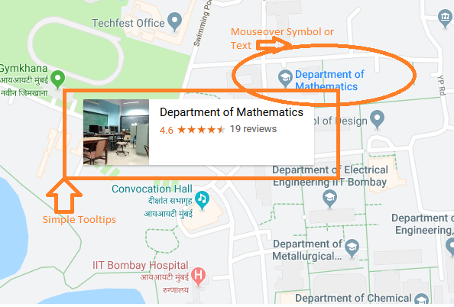

* After clicking open details-view, now details are opening by mouseover that’s not correct.