

Website application requirement specification document

https:5times.co.in



March 12, 2019

5times.co.in

INDIA

Website application requirement specification document

# Updates

|  |  |  |  |
| --- | --- | --- | --- |
| **Section Name** | **Section Number** | **Status** | **Notes** |
|  |  |  |  |
|  |  |  |  |

# Changelog

|  |  |  |  |  |  |
| --- | --- | --- | --- | --- | --- |
| **Date** | **Owner** | **Version** | | **[Author| Reviewer| Approver]** | **Description** |
| 12-Mar-2019 | KB | 0.1 | Author | | Drafting SRS |
|  |  |  |  | |  |

Contents

Updates 1

Changelog 1

**Chapter1: Overview** 4

**Introduction** 4

What is difference between Appointment and Meetings? 5

Website overview of 5times.co.in 5

Website Users type 5

What are the resources that require Calendar? 6

**User Login** 7

Login (user: Admin/Support/Teacher/Student) 7

Name: 7

Goal: 7

Input: 7

Output: 7

Main Scenario: 8

Pre-condition: 8

Steps: 8

Post-condition 8

Exceptional Scenario 1 8

**User Log out** 8

Logout (user: Admin/Support/Teacher/Student) 8

Name: 8

Goal: 9

Input: 9

Output: 9

Main Scenario: 9

Pre-condition: 9

Steps: 9

Post-condition 9

Exceptional Scenario 1 9

**Navigation** 10

**Main Navigation & Local Navigation** 10

Students 10

Admins 10

**User Types** 11

Types of users 11

Students 11

Admins 12

Supports 13

Teachers 13

**Forms Types** 14

Institute 14

Training Room 15

Teachers 16

Course by Teacher 16

Room Booking by Teacher 17

Student Sign-up 17

Course Booking by Student 18

Profile /CV 18

**Map & Tooltips** 19

Users Live position 19

Share Live Position Enable/Disable 19

Tooltip at Position 19

Profile of Students 20

# **Chapter1: Overview**

## **Introduction**

There are many apps which does the job which we are trying to do. So, doing it again doesn’t benefit unless we give some advantage over other. That’s uniqueness to the application we are trying to deliver. Some of the features of Outlook is that we can use it to create **meeting** like this one. Notice there is ‘To’ field because this time block is for invites in the ‘To’ field as well as for self.

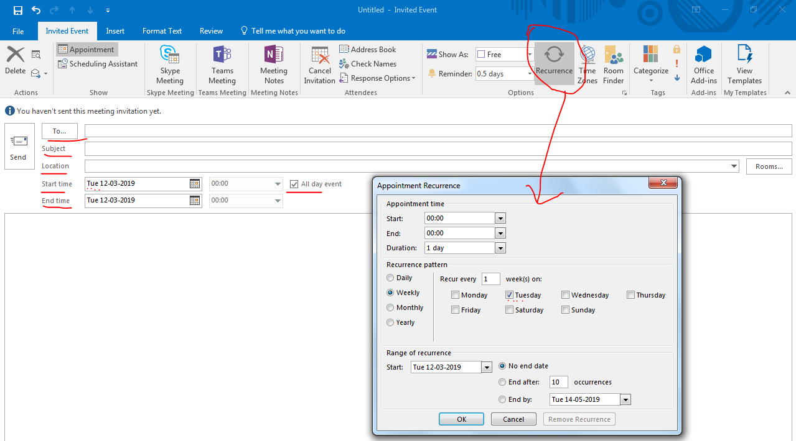

We also can create **appointment** such like this one. Notice there is no ‘To’ field because this time block is for self.

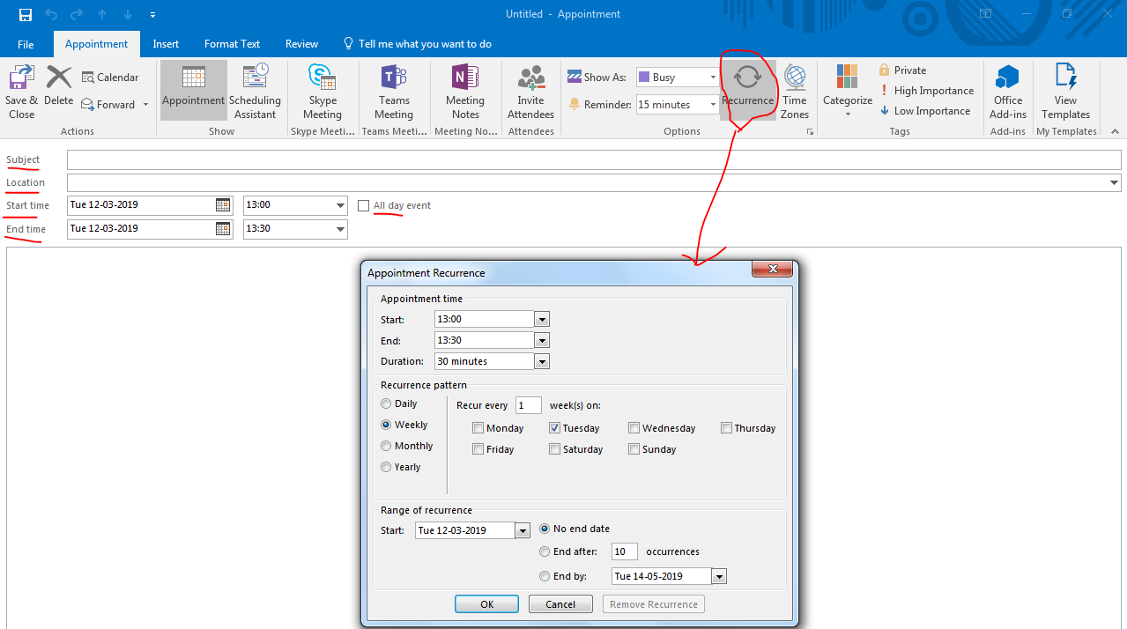

### What is difference between Appointment and Meetings?

**Appointment**

An appointment is a scheduled block of time that only involves you. The hours are blocked out on your schedule, but it does not include other attendees or resources. Your calendar will show the appointment framed between the start and end times. This is text. This is text.

**Meeting**

A meeting is an activity that involves you and others during the same block of time. Outlook allows you to set meetings that affect the calendars of other people. A meeting may also schedule resources, such as meeting rooms. A meeting is an appointment, but more. You reserve a period of time, invite people to, or reserve resources for a meeting.

### Website overview of 5times.co.in

So, what is unique we are going to build if it is already there? We are building for special purpose: Focus is on Institute, Support, Teacher and Students. Institute will have teaching-rooms, Support is who is able to work for institute to update activity for institute’s rooms availability, Teacher who will book the rooms & time slots and then create courses and finally those students who are searching for training courses find them online and book the course. Everything online, except that the actual training [ as of now] is offline inside real building premises. [Future scope is to include online training feature once we are successful with this one]

### Website Users type

Following types of users will operate on website, each with independent credentials.

1. Super-Admin and Admins
2. Supports
3. Teachers
4. Students

### What are the resources that require Calendar?

Following are the resources needs personal calendar to fulfil the time-slot booking of individuals.

* Institute: An institute will have a master calendar [ or Support will have a calendar]
  + Room: Each Rooms of an institute will have individual calendar.
* Teacher: Each Teacher will have one calendar
* Student: Each Student will have one calendar

When a user sign-up a calendar should be created. When Support creates a room a calendar for that room should be created.

Note1: Support doesn’t need calendar as support is just for institute only to allow him to do job of an institute. So, calendar of Institute is calendar of Support.

Note2: Like Outlook, Google Calendar also can create Events. Please check <https://support.google.com/calendar/answer/41207>

<https://support.google.com/calendar/answer/190998?hl=en>

<https://developers.google.com/calendar/>

Specially check Google Calendar API.

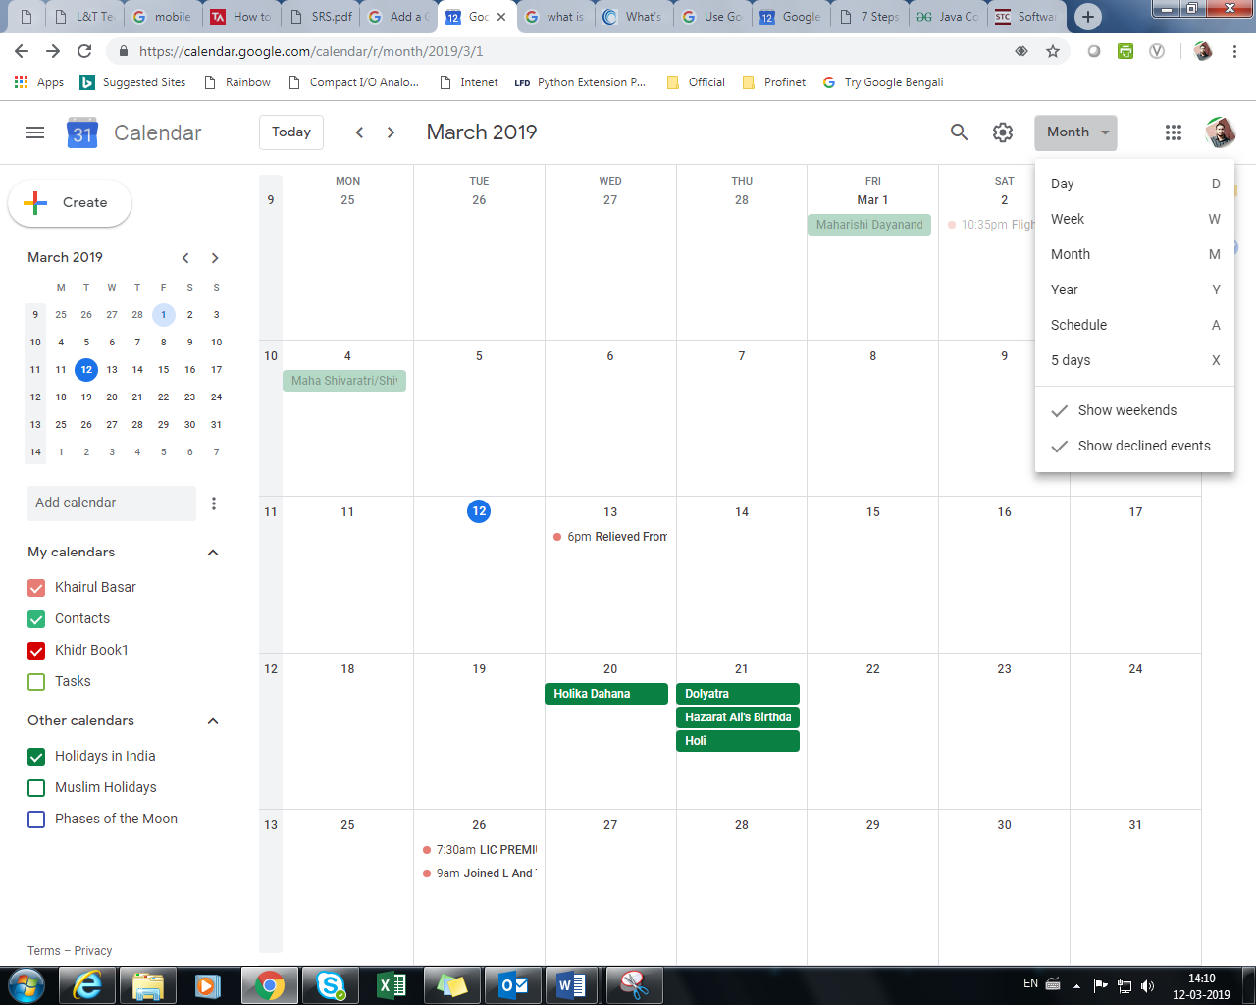

|  |  |  |
| --- | --- | --- |
|  |  |  |
|  |  |  |

# **User Login**

### Login (user: Admin/Support/Teacher/Student)

### Name:

Login

### Goal:

The purpose of this feature is to grant valid users access to system resources.

### Input:

The user inputs a username and a password.

### Output:

The user is either told that they were successful in logging into the system or that their username and password combination was invalid.

### Main Scenario:

A user connects to the website application wishing to use its features. Before he or she can access the system, however, he or she must log into the system using a valid account.

### Pre-condition:

The user must be connected to the system with a supported web browser. The user must also have a valid account.

### Steps:

#### Step 1: The user is shown a log in/create account screen.

#### Step 2: The user chooses ‘Login’ option.

#### Step 3: The user enters requested details (username and password).

### Post-condition

The user is granted access to the system.

### Exceptional Scenario 1

In the case that the user does not have a valid account, or the user inputs invalid data, he or she will be denied access to the system. The error message will only specify that the combination of username and password provided was invalid.

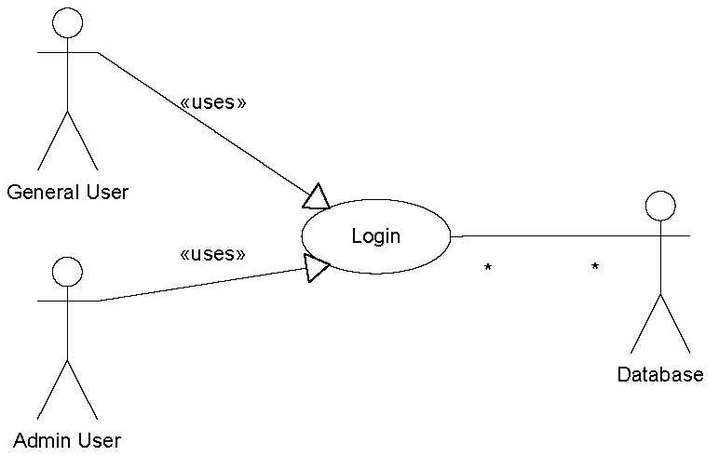

Consider General users are other than admin.

# **User Log out**

### Logout (user: Admin/Support/Teacher/Student)

### Name:

Logout

### Goal:

The purpose of this feature is to close the current user’s session, allowing him or her to leave and not grant other people access to his or her account.

### Input:

The user clicks on the ‘logout’ button.

### Output:

The screen is returned to the main login/create account screen.

### Main Scenario:

A user has finished monitoring the cluster and wishes to leave. To prevent unauthorized access, the user wants to return the current computer to its initial state.

### Pre-condition:

The user must be connected to the system with a supported web browser and logged in with a valid user account.

### Steps:

#### Step 1: The user clicks the ‘logout’ button.

### Post-condition

The user is no longer logged in.

### Exceptional Scenario 1

N/A

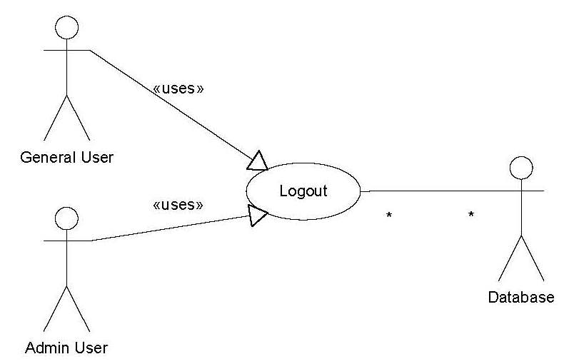

Consider General users are other than admin.

# **Navigation**

## **Main Navigation & Local Navigation**

Navigation for different users will be partially different, some will common for all.

### Students

Table : Students

|  |  |  |  |
| --- | --- | --- | --- |
| **Req** | **Topic** | **Description** | **Comments** |
| 3.1 | Sign-up & Sign-in | Home page should display option for Sign-up and Sign-in buttons. |  |
| 3.2 | Logout | After Sign-in user should be able to Log out using logout button. |  |
| 3.3 | Search | Search Field & Search button should be displayed above the main area over Map |  |
| 3.4 | Profile | Profile settings button to allow users to add/edit profile settings details. |  |
| 3.5 | Map | Map to Tooltips, display Institutes, Training courses |  |
| 3.6 | List of courses | Show up list of courses in displayed map |  |
| 3.7 | Booking | Select a course and book |  |

### Admins

Table 2: Admins

|  |  |  |  |
| --- | --- | --- | --- |
| **Req** | **Topic** | **Description** | **Comments** |
| 3.1 | Sign-up & Sign-in | Home page should display option for Sign-up and Sign-in buttons. |  |
| 3.2 | Logout | After Sign-in user should be able to Log out using logout button. |  |
| 3.3 | Search | Search Field & Search button should be displayed above the main area over Map |  |
| 3.4 | Profile | Profile settings button to allow users to add/edit profile settings details. |  |
| 3.5 | Map | Map to display Institutes, Training courses |  |
| 3.6 | List of courses | Show up list of courses in displayed map |  |
| 3.7 | Add/Modify/Delete  Institute | Admin should be able to add institutes |  |
| 3.8 | Add/Modify/Delete  Institute’s Room | Admin should be able to add institute’s rooms |  |
| 3.9 | Add/Modify/Delete  Courses | Admin should be able to add courses, create schedule for the courses [course timing] and assign course to a teacher. |  |
| 4.0 | Remove Users | Admin should be able to remove users |  |
| 4.1 | Search/Find | Search user/Institute/Room/Course/Teacher/Students |  |

# **User Types & User Logic**

## Types of users & Logic

1. Super-Admin and Admins: Supper admin can add another account for admin by creating an account and assigning username (email ID) and password. Website link and Password then sent to the email address. He should then onwards will be able to reset password. Supper-admin can assign access to admin and support for what they can or can’t access. Admin can also assign/remove access to support.
2. Supports, Supporters need Admin approval to be able to support. Admin first adds email ID and creates user account for support. Website link and Password then sent to the email address of supporter of an institute. He should then onwards will be able to reset password.
3. Teachers: Teachers can book rooms and then create courses. Or create courses and then later book a room.
4. Students: Student can book courses. Student also can book a room and then add courses or add a course and then book a room.

Difference between Student and teacher:

* Any user (other than admin & support) who has room booked and has a course will be considered teacher. If user has created course but not booked any room will not be teacher yet- but will be considered Student. Once he/she booked a room & he has a course then only he becomes a teacher.
* Any user (other than admin & support) who doesn’t have any course will be considered Student. If he booked a room but doesn’t have any course, then also he is Student (special case – might have booked the room for someone else or for special purpose)

### Students

Table : Students

|  |  |  |  |
| --- | --- | --- | --- |
| **Req** | **Topic** | **Description** | **Comments** |
| 3.1 | Sign-up & Sign-in | Home page should display option for Sign-up and Sign-in buttons. |  |
| 3.2 | Logout | After Sign-in user should be able to Log out using logout button. |  |
| 3.3 | Search | Search Field & Search button should be displayed above the main area over Map |  |
| 3.4 | Profile | Profile settings button to allow users to add/edit profile settings details. |  |
| 3.5 | Map | Map to Tooltips, display Institutes, Training courses |  |
| 3.6 | List of courses | Show up list of courses in displayed map |  |
| 3.7 | Booking | Select a course and book |  |

### Admins

Table 2: Admins

|  |  |  |  |
| --- | --- | --- | --- |
| **Req** | **Topic** | **Description** | **Comments** |
| 3.1 | Sign-up & Sign-in | Home page should display option for Sign-up and Sign-in buttons. |  |
| 3.2 | Logout | After Sign-in user should be able to Log out using logout button. |  |
| 3.3 | Search | Search Field & Search button should be displayed above the main area over Map |  |
| 3.4 | Profile | Profile settings button to allow users to add/edit profile settings details. |  |
| 3.5 | Map | Map to display Institutes, Training courses |  |
| 3.6 | List of courses | Show up list of courses in displayed map |  |
| 3.7 | Add/Modify/Delete  Institute | Admin should be able to add institutes |  |
| 3.8 | Add/Modify/Delete  Institute’s Room | Admin should be able to add institute’s rooms |  |
| 3.9 | Add/Modify/Delete  Courses | Admin should be able to add courses, create schedule for the courses [course timing] |  |
| 4.0 | Remove Users | Admin should be able to remove users |  |
| 4.1 | Search users/Institutes/Courses | Admin should be able to search users, Institutes and courses and display information |  |

### Supports

Table 3: Supports

|  |  |  |  |
| --- | --- | --- | --- |
| **Req** | **Topic** | **Description** | **Comments** |
| 3.1 | Sign-up & Sign-in | Home page should display option for Sign-up and Sign-in buttons. |  |
| 3.2 | Logout | After Sign-in user should be able to Log out using logout button. |  |
| 3.3 | Search | Search Field & Search button should be displayed above the main area over Map |  |
| 3.4 | Profile | Profile settings button to allow users to add/edit profile settings details. |  |
| 3.5 | Map | Map to display Institutes, Training courses |  |
| 3.6 | List of courses | Show up list of courses in displayed map |  |
| 3.7 | Add/Modify/Delete  Institute | Supporter should be able to add institutes |  |
| 3.8 | Add/Modify/Delete  Institute’s Room | Supporter should be able to add institute’s rooms |  |
| 3.9 | Add/Modify/Delete  Courses | Supporter should be able to add courses, create schedule for the courses [course timing] |  |
| 4.0 | Search Institutes/Courses/Registered users for the courses of the supporter’s institute | Supporter should be able to search Institutes, rooms and courses and display information |  |

### Teachers

Table 4: Teachers

|  |  |  |  |
| --- | --- | --- | --- |
| **Req** | **Topic** | **Description** | **Comments** |
| 3.1 | Sign-up & Sign-in | Home page should display option for Sign-up and Sign-in buttons. |  |
| 3.2 | Logout | After Sign-in user should be able to Log out using logout button. |  |
| 3.3 | Search | Search Field & Search button should be displayed above the main area over Map |  |
| 3.4 | Profile | Profile settings button to allow users to add/edit profile settings details. |  |
| 3.5 | Map | Map to display Institutes, Training courses |  |
| 3.9 | Add/Modify/Delete  Courses | Teachers should be able to add courses, create schedule for the courses [course timing] |  |
| 4.0 | Search Institutes/Rooms/Courses | Teachers should be able to search Institutes, rooms and courses and display information |  |

# **Forms Types**

## Institute

Admin/Support will be able to create institutes

|  |  |  |  |
| --- | --- | --- | --- |
| Institute/Location information | | | |
| # | Item Description | Options | Default |
| 1 | Training Institute Name | Text |  |
| 2 | Institute Images | Images carousel | [Sample Image] |
| 3 | Training Institute Address Embed it in Map | Address Form | Address Form |
| 4 | List of Training Rooms/Hall [+] | Add New Room, Modify, Delete room |  |
| 5 | Room/Hall Name-1 | Not Available | Not Available |
| 6 | Room/Hall Name-2 | Not Available | Available |
| 7 | Room/Hall Name-3 | Not Available | Available |
| 8 | Office Time | Date: From - To Time: From - To |  |
| 9 | Make Institute Available/Not Available | Not Available | Not Available |
| 10 | Notes | Text | Null |
| 11 | Street View of Institute [Future] |  |  |
| [+] | Add button to allow to add more lines online | Input Type | (Future requirement) |
|  |  |  | Save |
| Admin/Support will be able to create institutes | | | |
|
| [+] button will be accessible by admin only to edit/create new Institute Template | | | |

## Training Room

|  |  |  |  |
| --- | --- | --- | --- |
| Training Room/Hall information | | | |
| # | Item Description | Options | Default |
| 1 | Institute Name | Name of the insitute this room belongs to | Parent Institute name |
| 2 | Room/Hall Name | Text | Training Room/Hall/Location |
| 3 | Room/Hall Images | Images carousel | [Sample Image] |
| 4 | Available Date & Time | Date: From - To Time: From - To | Same as Institute Office time |
| 5 | Maximum participants | Integer | 5 |
| 6 | Chair | Not Available | Available |
| 7 | Teacher's Table | Not Available | Available |
| 8 | Student's Table | Not Available | Available |
| 9 | Whiteboard | Not Available | Available |
| 10 | Markers | Not Available | Available |
| 11 | PC/Laptop for Teacher | Not Available | Not Available |
| 12 | PC/Laptop for Students | Not Available | Not Available |
| 13 | Projector | Available on request | Not Available |
| 14 | Projector-Screen | Available on request | Not Available |
| 15 | Sound systems | Available on request | Not Available |
| 16 | Wi-Fi Internet | Not Available | Available |
| 17 | Electrical extension cord | Available on request | Not Available |
| 18 | HDMI adaptor | Available on request | Not Available |
| 19 | Air conditioning system | Available on request | Not Available |
| 20 | FAN | Not Available | Not Available |
| 21 | Food & Beverages | Available on request | Not Available |
| 22 | Notes | Text | Null |
| 23 | Rental Price (INR. per hour) | Float | 500.00 |
| 24 | Enable/Disable This Room | Not Available | Available |
| 25 | Street View of Room [Future] |  |  |
| [+] | Add button to allow to add more lines online | Input Type | ( Future requirement) |
|  |  |  | Save |
| Admin/Support will be able to create institutes | | | |
|
| [+] button will be accessible by admin only to edit/create new room Template | | | |

## Teachers

|  |  |  |  |
| --- | --- | --- | --- |
| Teachers Sign-up Info | | | |
| # | Item Description | Options | Default |
| 1 | Teacher's Name* | Text |  |
| 2 | Teacher's Images | Images carousel | [Sample Image] |
| 3 | Company Name | Text | Independent |
| 4 | Phone Number* | Phone Number |  |
| 5 | Email Address* | Not Available | Not Available |
| 6 | Available Date & Time | Date: From - To Time: From - To |  |
| 7 | Training Course [+] | Add/modify/Delete Course Forms |  |
| 8 | CV /Profile | Profile Forms |  |
| [+] | Add button to allow to add more lines online | Input Type | (Future requirement) |
| Teachers will be able to create Teacher Profiles | | | |
|
| [+] button will be accessible by admin only to edit/create new Teacher Template | | | |

## Course by Teacher

|  |  |  |  |
| --- | --- | --- | --- |
| Training Course Form by Teacher | | | |
| # | Item Description | Options | Default |
| 1 | Courses Name* | Text |  |
| 2 | Course Descriptions* | Text Documents |  |
| 4 | Pre-requisite for Participants* | Text |  |
| 7 | Note | Text |  |
| [+] | Add button to allow to add more lines online | Input Type | (Future requirement) |
| Teachers will be able to Book a Room where he would like to give training. | | | |
|
| [+] button will be accessible by admin only to edit/create new Room Booking Template | | | |

## Room Booking by Teacher

|  |  |  |  |
| --- | --- | --- | --- |
| Room Booking by Teacher | | | |
| # | Item Description | Options | Default |
| 1 | Courses Name* | List of Self-registered Courses |  |
| 2 | Select Institute Name* | List of Institutes |  |
| 3 | Select Room/Hall* | List of Rooms |  |
| 4 | Teacher's Email Address* | Email Field | Not Available |
| 5 | Number of Participants* | Int | 5 |
| 7 | Course Date & Time* | Date: From - To Time: From - To |  |
| 8 | Note | Text |  |
| [+] | Add button to allow to add more lines online | Input Type | (Future requirement) |
| Teachers will be able to Book a Room where he would like to give training. | | | |
|
| [+] button will be accessible by admin only to edit/create new Room Booking Template | | | |

## Student Sign-up

|  |  |  |  |
| --- | --- | --- | --- |
| Student Sign-Up information | | | |
| # | Item Description | Options | Default |
| 1 | Student's Name* | Text |  |
| 2 | Student's Images | Images carousel | [Sample Image] |
| 2 | Company/Institute Name | Text | Independent |
| 3 | Phone Number* | Phone Number |  |
| 4 | Email Address* | Not Available | Not Available |
| 5 | Available Date & Time | Date: From - To Time: From - To |  |
| 7 | CV /Profile | Profile Forms |  |
| [+] | Add button to allow to add more lines online | Input Type | (Future requirement) |

## Course Booking by Student

|  |  |  |  |
| --- | --- | --- | --- |
| Course Booking by Student | | | |
| # | Item Description | Options | Default |
| 1 | Courses Name* | Show List of Courses |  |
| 2 | Select Institute Name* | Show List of Institutes |  |
| 4 | Student's Email Address* | Email Field |  |
| 5 | Number of Accompanying Participants? | Int | 0 |
|  |  |  |  |
| 7 | Course Date & Time (Read Only - displayed automatically when course is selected) | Date: From - To Time: From - To |  |
| 8 | Note | Text |  |
| [+] | Add button to allow to add more lines online | Input Type | (Future requirement) |
| Teachers will be able to Book a Room where he would like to give training. | | | |
|
| [+] button will be accessible by admin only to edit/create new Room Booking Template | | | |

## Profile /CV

|  |  |  |  |
| --- | --- | --- | --- |
| Profile /CV | | | |
| # | Item Description | Options | Default |
| 1 | Male/Female | List: Male, Female |  |
| 2 | Date of birth (DOB) | Date | 1998 |
| 3 | Age | Calculate from DOB |  |
| 4 | Current residing address | address form |  |
| 5 | Office address | address form |  |
| 6 | Parental residential address | address form |  |
| 7 | Family Background | Text |  |
| 8 | Education: Play & Nursery | Text |  |
| 9 | Education: Primary (IV) | Text |  |
| 10 | Education: School (X) | Text |  |
| 11 | Education: High School (12/XII) | Text |  |
| 12 | Education: Graduation | Text |  |
| 13 | Education: Post Graduation | Text |  |
| 14 | Hobby | Text |  |
| 15 | Language | Text |  |
| 16 | Career Objective | Text |  |
| 17 | Skills | Text |  |
| 18 | Experience/Projects | Text |  |
| [+] | Add button to allow to add more lines online | Input Type | (Future requirement) |

# **Map & Tooltips**

## Users Live position

Any user can see his own position on the Map. Position can be shared among public if **Share Live Position** is enabled. if **Share Live Position** disabled then his live position will not be displayed to public instead his registered address position will be displayed to public. Example is given below for clear understanding.

### Share Live Position Enable/Disable

Case1a: Student1 **shares** share Live position1

Case1b: Student1 **doesn’t** share Live position1

Case2: Student2 **shares** Live position2

Case3: Student3 **doesn’t** share Live position3

**results**

Case1a: Student1 **shares** share Live position1

1. Student1 **can see** Live position1 of self
2. Student1 **can see** Live position2 of Student2
3. Student1 **can’t see** Live position3 of Student3

Case1b: Student1 **doesn’t** share Live position1

1. Student1 **can see** Live position1 of self
2. Student1 **can’t see** Live position2 of Student2; instead sees registered address of Student2
3. Student1 **can’t see** Live position3 of Student3; instead sees registered address of Student3

### Map Location Pin

Use something like following colour code for Pins as per users’ type.



No Need

/Institute

Teacher

Admin

Supporter

Student

### Tooltip at Position of Student

Position of any student will be displayed by pin symbol (RED). Tooltips will be shown by mouse-over event to pin-symbol. Tooltip will have following format:

Name

Image

Skills: (Skills added in Profile)

### Tooltip at Position of Teacher

Position of any Teacher will be displayed by pin symbol (Green). Consider any user which has courses enlisted will be considered Teacher, even he might also be student. Tooltips will be shown by mouse-over event to pin-symbol. Tooltip will have following format:

Teaching: Courses

Name

Image

Skills: (Skills added in Profile)

### Tooltip at Position of Supporter/Institutes

Position of any Supporter will be displayed by pin symbol (Yellow). Consider any user which has access to institutes/Rooms considered as support. Tooltips will be shown by mouse-over event to pin-symbol. Tooltip will have following format:

Courses available: list few courses

Name of the institute

Image

### Profile of Students

|  |  |  |  |
| --- | --- | --- | --- |
| Profile /CV | | | |
| # | Item Description | Options | Default |
| 1 | Male/Female | List: Male, Female |  |
| 2 | Date of birth (DOB) | Date | 1998 |
| 3 | Age | Calculate from DOB |  |
| 4 | Current residing address  *(To be displayed when Live Location not shared)* | address form |  |
| 5 | Office address | address form |  |
| 6 | Parental residential address | address form |  |
| 7 | Family Background | Text |  |
| 8 | Education: Play & Nursery | Text |  |
| 9 | Education: Primary (IV) | Text |  |
| 10 | Education: School (X) | Text |  |
| 11 | Education: High School (12/XII) | Text |  |
| 12 | Education: Graduation | Text |  |
| 13 | Education: Post Graduation | Text |  |
| 14 | Hobby | Text |  |
| 15 | Language | Text |  |
| 16 | Career Objective | Text |  |
| 17 | Skills | Text |  |
| 18 | Experience/Projects | Text |  |
| [+] | Add button to allow to add more lines online | Input Type | (Future requirement) |

### Profile of Teacher

|  |  |  |  |
| --- | --- | --- | --- |
| Profile /CV | | | |
| # | Item Description | Options | Default |
| 1 | Male/Female | List: Male, Female |  |
| 2 | Date of birth (DOB) | Date | 1998 |
| 3 | Age | Calculate from DOB |  |
| 4 | Current residing address  *(To be displayed when Live Location not shared)* | address form |  |
| 5 | Office address | address form |  |
| 6 | Parental residential address | address form |  |
| 7 | Family Background | Text |  |
| 8 | Education: Play & Nursery | Text |  |
| 9 | Education: Primary (IV) | Text |  |
| 10 | Education: School (X) | Text |  |
| 11 | Education: High School (12/XII) | Text |  |
| 12 | Education: Graduation | Text |  |
| 13 | Education: Post Graduation | Text |  |
| 14 | Hobby | Text |  |
| 15 | Language | Text |  |
| 16 | Career Objective | Text |  |
| 17 | Skills | Text |  |
| 18 | Experience/Projects | Text |  |
| 19 | Courses Teaching | Text |  |
| [+] | Add button to allow to add more lines online | Input Type | (Future requirement) |

### Profile of Support/Institute

|  |  |  |  |
| --- | --- | --- | --- |
| Profile /CV | | | |
| # | Item Description | Options | Default |
| 1 | Name of the institute | Text |  |
| 2 | Date of birth (DOB) of Institute | Date | 1982 |
| 3 | How old is the Institute | Calculate from DOB |  |
| 4 | Address  *(To be displayed when Live Location not shared)* | address form |  |
| 5 | Head Office address | address form |  |
| 6 | Courses available | Text |  |
| 7 | Number of Rooms / Hall available | List |  |
| 8 | Teachers available | Number |  |
| 9 | Certification Authority | Text |  |
| 10 | Owner / CEO /Head /Manager | Text |  |
| 11 | Email ID for contact | Email |  |
| 12 | Operating hours | Time |  |
| [+] | Add button to allow to add more lines online | Input Type | (Future requirement) |