Software Requirements Specification
for
Cluster Management - GUI
Version 1.0 approved
Prepared by
Robert Clowers
Kevin Dedon
Matt Rice
The GUI Team
October 1, 2006
Table of Contents
Table of Contents ii
Revision History ii
1. Introduction 2
1.1 Purpose 2
1.2 Document Conventions 2
1.3 Intended Audience and Reading Suggestions 2
1.4 Product Scope 2
1.5 References 2
2. Overall Description 2
2.1 Product Perspective 2
2.2 Product Functions 2
2.3 User Classes and Characteristics 2
2.4 Operating Environment 2
2.5 Design and Implementation Constraints 2
2.6 User Documentation 2
2.7 Assumptions and Dependencies 2
3. External Interface Requirements 2
3.1 User Interfaces 2
3.2 Hardware Interfaces 2
3.3 Software Interfaces 2
3.4 Communications Interfaces 2
4. Domain Model 2
5. System Features (Use Cases) 2
5.1 Use Case Overview 2
5.2 Create Account 2
5.3 Login 2
5.4 Logout 2
5.5 Remove User 2
5.6 Update User 2
5.7 List Users 2
5.8 Retrieve Node Status 2
5.9 List Nodes 2
5.10 Add Node 2
5.11 Update Node 2
5.12 Remove Node 2
5.13 Power Up Node 2
5.14 Power Down Node 2
5.15 Reboot Node 2
5.16 Identify Node 2
5.17 Modify Sensor Thresholds 2
6. Other Nonfunctional Requirements 2
6.1 Performance Requirements 2
6.2 Safety Requirements 2
6.3 Security Requirements 2
6.4 Software Quality Attributes 2
7. Other Requirements 2
Appendix A: Glossary 2
Appendix B: Analysis Models 2
Appendix C: To Be Determined List 2

Revision History
Name | Date | Reason For Changes | Version
GUI | 10/1/2006 | Initial Introduction | 1.0
GUI | 10/6/2006 | Integrate two versions | 1.0.1

Introduction

Purpose
The cluster management project version 1.0 is designed to monitor and manage a cluster of computers at the hardware level. The requirements in this document are specified by the GUI programming group. This document predates any implantation or development and used to primarily represent our goals, intentions, and proposed plans.

Document Conventions
None

Intended Audience and Reading Suggestions
This document is for the Customer Representative, Project Architect, Consultant, the Database Team, and the Cluster Control Team. It contains a detailed description of the GUI used as the front-end for the Cluster Management System, the GUI’s relation to the other components of the Cluster Management System, and the foundation requirements and external expectations used in the GUI development.

The Customer Representative should read sections 1 and 2 to make sure that we have a complete understanding of the project. The Architect should read this entire document to insure that our requirements are feasible. The Consultant should read this entire document to ensure that our representation and proposed implementation is accurate. The Database and Cluster Control Teams should read this entire document while focusing mainly on sections 3, 4, and 5 in order complete project integration.

Product Scope
The GUI component will provide the User with an aesthetically pleasing and easy-to-use web-based interface to the actual computer hardware cluster. The User will be able to monitor the cluster’s current status including availability and control the cluster by issuing commands such as “turn off” and “turn on”. (Other functionality will be further defined later in this document.) To accomplish this, the GUI will integrate with the Database and Cluster Control components by issuing commands and requests in a black-box type fashion. This will keep the GUI component modular and reusable for future growth and deployment.

References
Title | Author | Version | Date | Source Location
GUI Project Plan | The GUI Team | 1.0 | 9/29/2006 | Please request a copy via email from The GUI Team at any of the following email addresses: rjclowers@gmail.com; kdedon@gmail.com; mjrice007@gmail.com

Overall Description

Product Perspective
This product is an enhancement to a previous Cluster Management System authored by Sunil Sudhakar. Mr. Sudhakar’s methods of cluster control will be maintained; however, new database features will be added along with a reconstruction of his Graphical User Interface. In the end, there will not be much deviation from Mr. Sudhakar’s original system architecture; however, there will be a distinction between the GUI representation and database structure. The following graph offers an abstract overview of the three components that comprise the Cluster Management System.
GUI
DB
Cluster Control

Product Functions
- User Account Creation
- Modify User Account Properties
- Delete User Account
- List User Accounts
- User Login
- User Logout
- Retrieve Node Status
- List Nodes
- Add Node
- Modify Node Properties
- Delete Node
- Turn On Node
- Turn Off Node
- Restart Node
- Identify Node
- Monitor Sensor Thresholds

User Classes and Characteristics
A user/function cross-reference matrix will be implemented to govern what functions are available to the requesting User. Currently, there are two user classes: Global and Admin. The following table represents the functionality guidelines of these user classes.

Function | Global User | Admin User
User Accounts
Create | * | *
List |  | *
Modify Account Properties | * | *
Modify ALL Account Properties |  | *
Delete |  | *
Login | * | *
Logout | * | *
Cluster Monitor
List Nodes | * | *
Retrieve Node Status | * | *
Cluster Control
Add Node |  | *
Modify Node Properties |  | *
Delete Node |  | *
Turn On Node |  | *
Turn Off Node |  | *
Restart Node |  | *
Identify Node |  | *
Modify Sensor Thresholds |  | *

The Admin User class has full control and utilization of the Cluster Management System as well as full control of all user accounts. The Global User only has control of his/her individual user account and full Cluster Monitoring capability. This is an example of an application user of the cluster system.

Operating Environment
Due to its modular design, the GUI is intended to run independently from the actual DB and Cluster Control components. It is a web-based subsystem and therefore must reside on a computer capable of supporting and hosting web-based applications. With this said, it is quite possible that all three components can reside together although this is not necessary. Currently, there is a proposal to use AJAX (Asynchronous Javascript And XML) as the method of implementation; therefore, the computer system must support and facilitate these technologies. Mr. Sudhakar’s system utilized PHP and HTML for his GUI and MySQL for DB storage. The assumption is that the DB Team will continue the usage of MySQL with expansions.

Design and Implementation Constraints
This section will be completed upon the acceptance of our proposed usage of AJAX. As development begins, expected constraints are expected to arise which will be then listed here.

User Documentation
At the completion of development, a user manual and implementation guide will be made available to the Customer. It will also be available on-line as a feature of the GUI.

Assumptions and Dependencies
- The foundation of the whole project will be Mr. Sunil Sudhakar’s previous work and that he will serve as the Co-Architect for this project.
- Dr. Box will serve as the Architect and Customer.
- The DB Team will provide all interactions with the database thus enforcing our black-box expectations. This will consist of receiving requests from the GUI, formatting these requests to the database supported queries/commands, and returning the results in the format specified by The GUI Team.
- The Cluster Control Team will likewise provide a black-box approach to cluster manipulation by receiving commands from the GUI, formatting them to the specific cluster-recognizable commands, and forwarding the results to the appropriate subsystem i.e. the GUI or the database.

External Interface Requirements

User Interfaces
The Graphical User Interface (GUI) will be the User’s portal to managing the cluster. Upon a successful login, all users will be presented with a graphical representation of the list of nodes in the managed cluster. There will also be user account identifying information such as username of the logged-in user. The GUI will then be used to interface with both the Database Subsystem and the Cluster Control Subsystem. GUI navigation will follow common standards very similar to most web pages so the User can expect certain understood functions such as hyperlinks, buttons, and HTML formatting.

Hardware Interfaces
The Cluster Management System is independent from the physical hardware meaning it only manages the cluster hardware that is put in place. The hardware platform this software requires to run on must have a web server with PHP enabled. The database, MySQL, can be installed on a machine of its own or the same machine as the web server. The client must have JavaScript enabled.

Software Interfaces
The GUI will transmit to both the Database and Cluster Control Subsystems by sending a parameterized command in the following format: DB_Subsys(<command name>, <param 1>, <param 2>, …); and CC_Sussys(<command name>, <param 1>, <param 2>, …);. The GUI may receive results via XML files generated by the Database and Cluster Control Subsystems. This will satisfy the AJAX model intended for the fundamental methodology of the GUI.

Communications Interfaces
The proposed methodology for implementing the GUI Subsystem is Asynchronous Javascript And XML (AJAX). This technology uses client-side JavaScript, cascading style sheets (CSS), and HTML for the actual user interface with a server-side scripted back-end. The combination of the front-end and back-end allows for a near seamless user interface experience. The overall goal is to present a more standard application feel versus the typical page loading of traditional web applications.

Domain Model
N/A

System Features (Use Cases)

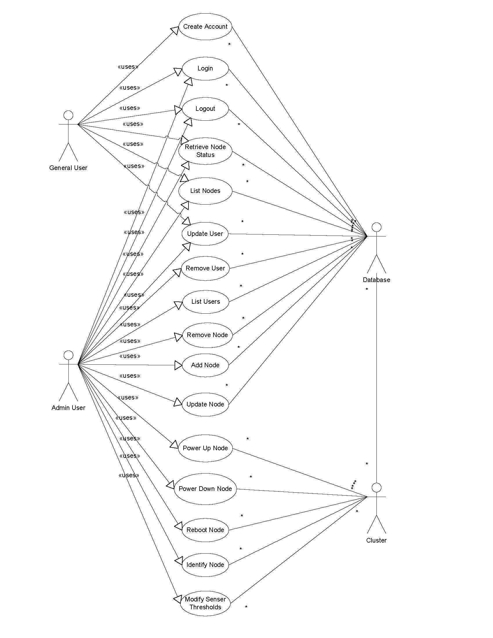
Use Case Overview

Create Account

Name:
Create account.

Goal:
The purpose of this feature is to create a valid account for a user to log into the system.

Input:
The user inputs a username, password, e-mail, and demographic information.

Output:
The user is either told that the account creation was successful or that it failed.

Main Scenario:
A user connects to the cluster monitoring system wishing to use its features. Before he or she can access the system, however, he or she must have a valid account.

Pre-condition:
The user must be connected to the system with a supported web browser.

Steps:

Step 1: The user is shown a log in/create account screen.

Step 2: The user chooses ‘Create Account’ option.

Step 3: The user enters requested details (i.e. username and password).

Post-condition
The user receives his or her account.

Exceptional Scenario 1
In the case of an error, the user will be told that the account creation was unsuccessful.

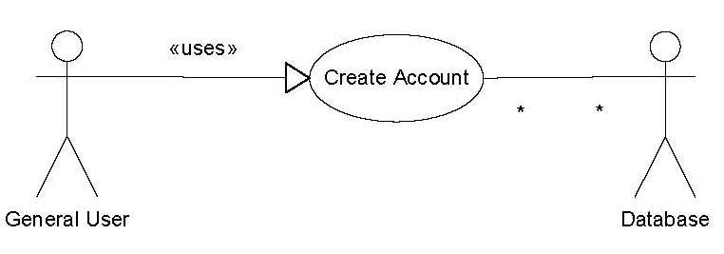
Example

Login

Name:
Login

Goal:
The purpose of this feature is to grant valid users access to system resources.

Input:
The user inputs a username and a password.

Output:
The user is either told that they were successful in logging into the system or that their username and password combination was invalid.

Main Scenario:
A user connects to the cluster monitoring system wishing to use its features. Before he or she can access the system, however, he or she must log into the system using a valid account.

Pre-condition:
The user must be connected to the system with a supported web browser. The user must also have a valid account.

Steps:

Step 1: The user is shown a log in/create account screen.

Step 2: The user chooses ‘Login’ option.

Step 3: The user enters requested details ( username and password).

Post-condition
The user is granted access to the system.

Exceptional Scenario 1
In the case that the user does not have a valid account, or the user inputs invalid data, he or she will be denied access to the system. The error message will only specify that the combination of username and password provided was invalid.

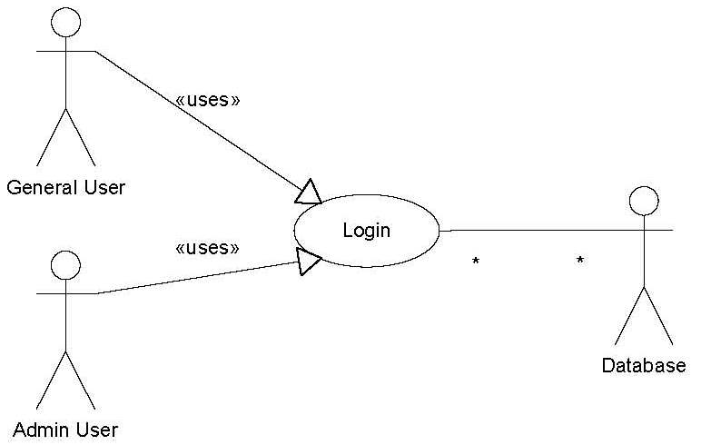
Example

Logout

Name:
Logout

Goal:
The purpose of this feature is to close the current user’s GUI session, allowing him or her to leave and not grant other people access to his or her account.

Input:
The user clicks on the ‘logout’ button.

Output:
The screen is returned to the main login/create account screen.

Main Scenario:
A user has finished monitoring the cluster and wishes to leave. To prevent unauthorized access, the user wants to return the current computer to its initial state.

Pre-condition:
The user must be connected to the system with a supported web browser and logged in with a valid user account.

Steps:

Step 1: The user clicks the ‘logout’ button.

Post-condition
The user is no longer logged in.

Exceptional Scenario 1
N/A

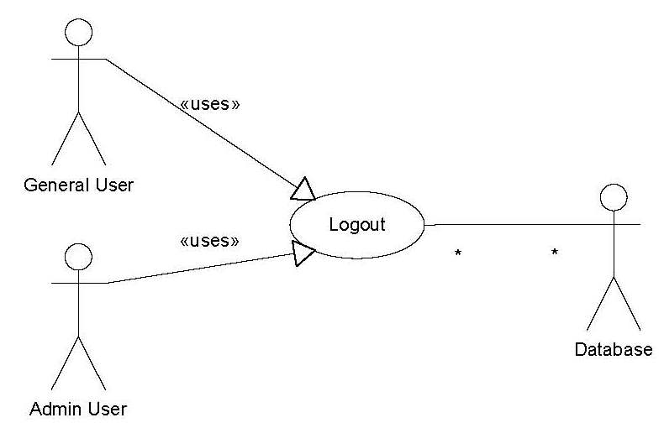
Example

Remove User

Name:
Remove User

Goal:
The purpose of this feature is to allow an administrative user the ability to remove other users’ access to the cluster monitoring software.

Input:
The administrative user is presented with a list of user accounts. The administrative user can then click on the account that he or she wishes to remove.

Output:
The administrative user is either told that the account removal was successful or that it failed.

Main Scenario:
A company member no longer needs access to the system due to a change in job position. To prevent further access, his or her login rights must be revoked.

Pre-condition:
The user that is the target of the removal must have a valid user account.

Steps:

Step 1: The administrative user selects the list user option.

Step 2: The administrative user selects the ‘delete user’ option next to the name of the user he or she wishes to delete.

Post-condition
The targeted user no longer has access to the system.

Exceptional Scenario 1
N/A

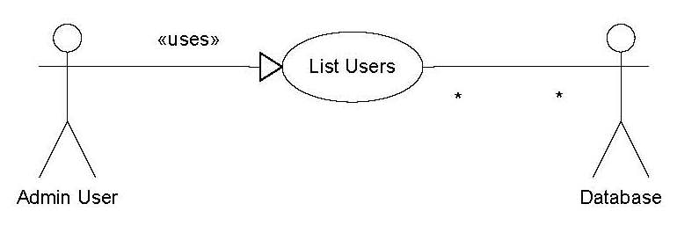
Example

Update User

Name:
Update User

Goal:
The purpose of this feature is to allow the user to update his or her demographic information, or to allow an administrator user to change general user’s access level.

Input:
The user or administrative user clicks the ‘update user’ button.

If an administrative user selects this button, he or she will be given a list of users. Once the administrative user selects a user to modify, he or she will be presented with that user’s demographic info and access level. The administrative user will then be able to modify this content.

If a general user selects this button, he or she will bypass the list of users and be brought to his or her own information. The general user will not, however, be presented with his or her access level. The general user will then be able to modify this content.

Output:
A user is either told that the account update was successful or that it failed.

Main Scenario:
A user either wishes to change details that he or she entered incorrectly at account creation or modify values that have changed since.

An administrative user wishes to give a general user administrative user access.

Pre-condition:
The user must be connected to the system with a with a valid user account.

Steps:

Step 1: The user clicks on the ‘Update User’ option.

Step 2: If the user is an administrative user, then he or she must select a user to modify. A general user will bypass this step and be taken instead to step 3 as if he selected his or her own account.

Step 3: The user modifies stored details.

Post-condition
N/A

Exceptional Scenario 1
N/A

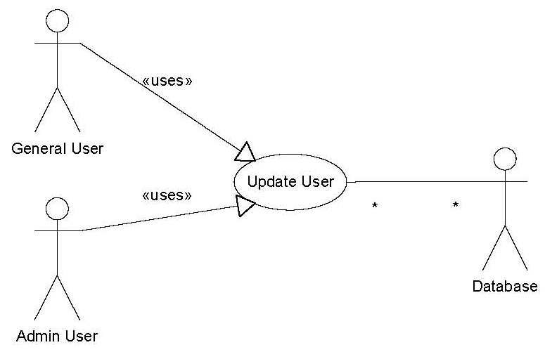
Example

List Users

Name:
List Users

Goal:
The purpose of this feature is to list all valid accounts.

Input:
The administrative user clicks the ‘List Accounts’ button..

Output:
A list of all user accounts is displayed.

Main Scenario:
An administrative user wishes to see everyone who has access to the system.

Pre-condition:
The user must have a valid account with administrative privileges.

Steps:

Step 1: The administrative user clicks the ‘List Accounts’ button.

Post-condition
N/A

Exceptional Scenario 1
N/A

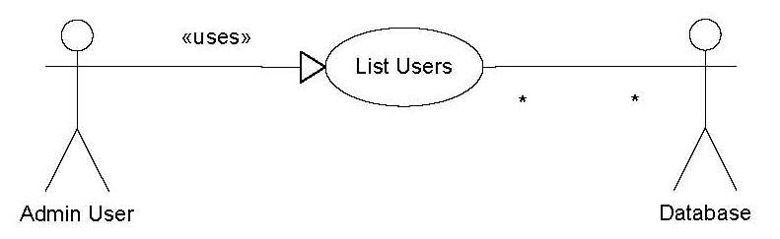
Example

Retrieve Node Status

Name: Retrieve Node Status

Goal: To retrieve the status of the following properties of a cluster node:
- IP Address
- MAC Address
- Hostname
- Availability
- Up/Down Status
- CPU Speed/Usage
- CPU Temperature
- Memory Size/Usage
- Disk Size/Usage
- Fan Speeds
- Voltage
- IPMI Compatibility
- Check Point

Input: The GUI will provide a graphical representation of the nodes in the managed cluster. Each node will be identified in the list by its Hostname, IP Address, and MAC Address. The User may click a specific node to retrieve the status of the above properties. The GUI will then format a command to be passed to the DB Team’s Database Subsystem.

Output: The DB Team’s Database Subsystem will return the current database values of the requested node’s properties (listed in 5.1.2). The GUI will display these properties in an easily understandable tabular format for the User’s review.

Main Scenario: The User peruses the list of nodes belonging to a cluster and wishes to see more specific details than what is provided by the node-identifying list so he/she clicks on the node and a new browser window opens identifying the node clicked on and contains the current properties listed in 5.1.2.

Pre-condition: The managed cluster node list is individually identified by each node’s Hostname, IP Address, and MAC Address. Each node will be graphically represented and the mouse-over will turn the cursor from a default arrow to a pointing-finger.

Steps:

The User will visually locate the node of interest.

Using the mouse, the User will left click the node of interest.

A GUI client-side script will format a command with the parameters of the node that was clicked.

The GUI will then pass this command to the DB Team’s Database Subsystem.

Upon receipt of the results from the DB Team’s Database Subsystem, the GUI will open a new browser window and populate the window with results.

Post-condition: The result will be a new browser window with the requested node’s property status. The User may review this window for any length of time and may terminate the window just like any other browser window.

Exceptional Scenario(s): This process may not succeed due to any of the following reasons:
- The User’s browser does not allow pop-up windows.
- The Database Subsystem is non-responsive.
- The Cluster Control Subsystem is non-responsive. (This subsystem is responsible for updating the Database Subsystem with each node’s property status on a routine basis.)

Example:
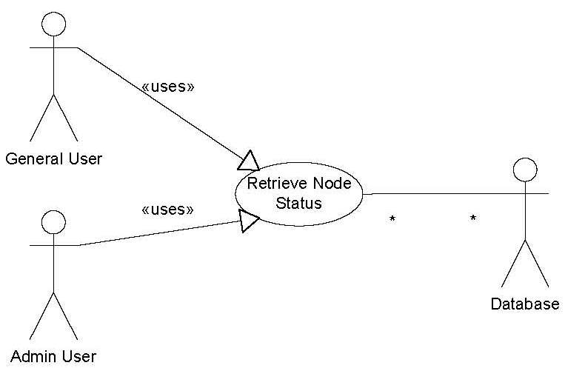

List Nodes

Name: List Node

Goal: To list the current nodes in a managed cluster.

Input: Successful user login.

Output: The GUI will present a graphical representation of the nodes in the managed cluster.

Main Scenario: The User login to the Cluster Management System.

Pre-condition: The main page of the web-based GUI presents the User with a login form.

Steps:

The User enters his/her corresponding username and password and left clicks the “Submit” button.

A GUI client-side script will format a command with the parameters of the user requesting access.

The GUI will then pass the command to the Database Team’s Subsystem.

The DB Team’s Subsystem will then validate the User’s username and password against the User Table.

Upon success, the GUI will refresh the graphical representation with the current nodes in the managed cluster.

Post-condition: A graphical representation of the current nodes in the managed cluster.

Exceptional Scenario(s): This process may not succeed due to any of the following reasons:
- The User does not provide the correct username and/or password.
- The Database Subsystem is non-responsive.

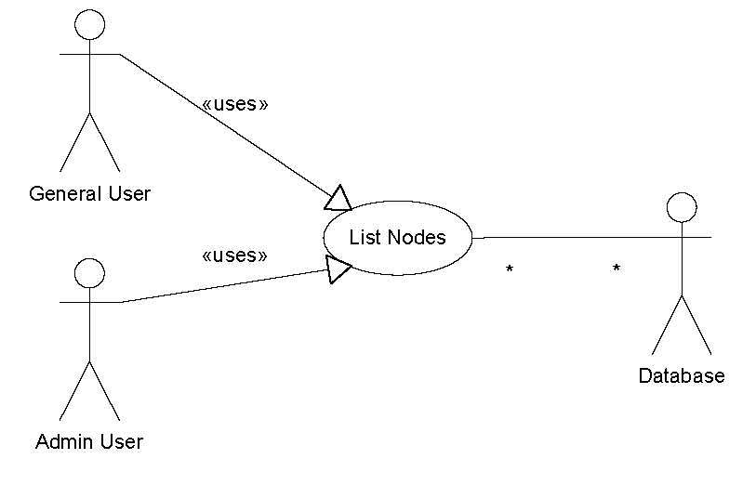
Example:

Add Node

Name: Add Node

Goal: To add a new node to a cluster.

Input: The GUI will provide a button labeled “Add Node” and when left clicked, a new browser window will open where the new node’s identifying properties such as Hostname, IP Address, and/or MAC address will be keyed in. The information will be passed to the Database Subsystem where the new node will be added.

Output: The GUI will provide a graphical representation of the nodes, including the newly added node, in the managed cluster.

Main Scenario: The User wishes to add a new node to the cluster.

Pre-condition: A graphical representation of the current nodes in the managed cluster.

Steps:

The User left clicks on the GUI button labeled “Add Node”.

A new browser window opens with a form for the User to provide the Hostname, IP Address, and/or MAC Address of the new node and clicks the “Submit” button.

A GUI client-side script will format a command with the parameters of the new node to be added.

The GUI will then pass the command to the Database Team’s Subsystem and automatically close the window opened in Step 5.2.7.2.

The DB Team’s Subsystem will then update the database with the new node entry.

The GUI will refresh the graphical representation of the current nodes in the managed cluster.

Post-condition: A graphical representation of the current nodes in the managed cluster that includes the newly added node.

Exceptional Scenario(s): This process may not succeed due to any of the following reasons:
- The User’s browser does not allow pop-up windows.
- The Database Subsystem is non-responsive.

Example:
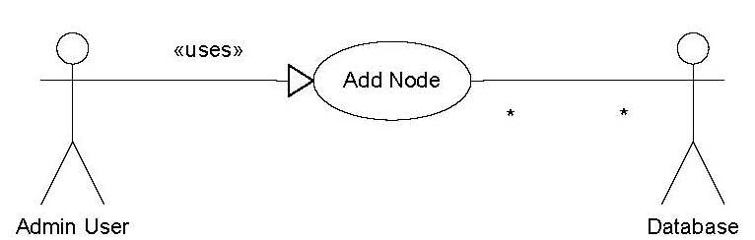

Update Node

Name: Modify Node Properties

Goal: To modify a cluster node’s properties.

Input: The GUI will provide a button labeled “Update Node” and when left clicked, a new browser window will open where the node’s identifying properties such as Hostname, IP Address, and/or MAC address will be changed. The information will be passed to the Database Subsystem where the node properties will be modified.

Output: The GUI will provide a graphical representation of the nodes, including the modified node, in the managed cluster.

Main Scenario: The User wishes to change any and/or all of the node’s properties such as Hostname, IP Address, and/or MAC Address.

Pre-condition: A graphical representation of the current nodes in the managed cluster.

Steps:

The User selects a node of interest.

The User left clicks the GUI button labeled “Modify Node”.

A new browser window is opened listing the selected node’s properties.

The User changes the current properties and clicks the “Submit” button.

A GUI client-side script will format a command with the parameters of the node properties.

The GUI will then pass the command to the Database Team’s Subsystem and automatically close the window opened in Step 5.3.7.3.

The DB Team’s Subsystem will then update the database with the new node property information.

The GUI will refresh the graphical representation of the current nodes in the managed cluster.

Post-condition: The managed cluster node list is individually identified by each node’s Hostname, IP Address, and MAC Address. The modified node is represented by the User changes.

Exceptional Scenario(s): This process may not succeed due to any of the following reasons:
- The User’s browser does not allow pop-up windows.
- The Database Subsystem is non-responsive.

Example:
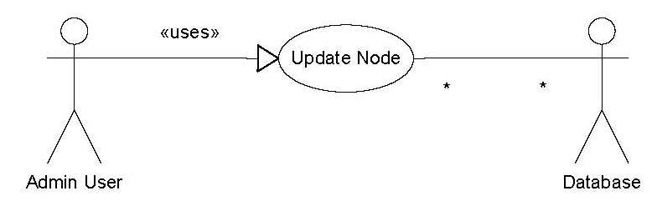

Remove Node

Name: Remove Node

Goal: To delete an existing node in the managed cluster.

Input: The GUI will provide a button labeled “Delete Node” and when left clicked, a new browser window will open where the node’s identifying properties such as Hostname, IP Address, and/or MAC address will be displayed. The User will be prompted to confirm deletion.

Output: The GUI will provide a graphical representation of the nodes, excluding the deleted node, in the managed cluster.

Main Scenario: The User wishes to delete an existing node to the managed cluster.

Pre-condition: A graphical representation of the current nodes in the managed cluster.

Steps:

The User selects a node of interest.

The User left clicks on the GUI button labeled “Delete Node”.

A new browser window opens identifying the selected node by Hostname, IP Address, and/or MAC Address. The User is then prompted to confirm this node’s deletion.

If the “Yes” button is left clicked, a GUI client-side script will format a command with the parameters of the node to be deleted.

The GUI will then pass the command to the Database Team’s Subsystem and automatically close the window opened in Step 5.4.7.3.

The DB Team’s Subsystem will then delete the node from the database.

The GUI will refresh the graphical representation of the current nodes in the managed cluster.

Post-condition: A graphical representation of the current nodes in the managed cluster that excludes the deleted node.

Exceptional Scenario(s): This process may not succeed due to any of the following reasons:
- The User’s browser does not allow pop-up windows.
- The Database Subsystem is non-responsive.

Example:
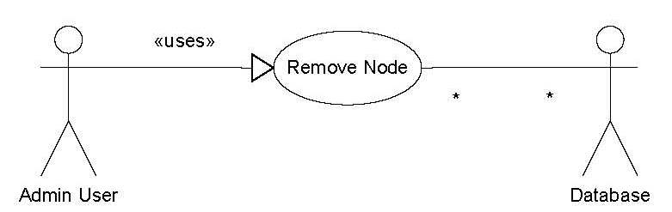

Power Up Node

Name: Power Up Node

Goal: To power on a node in the managed cluster.

Input: The GUI will provide a button labeled “Turn On Node” and when left clicked, a command will be passed to the Cluster Control Team’s Subsystem.

Output: The GUI will graphically indicate the selected node is now “On”.

Main Scenario: The User notices a node in the managed cluster that is graphically indicated as being powered off and wishes to the turn the node on.

Pre-condition: A graphical representation of the current nodes in the managed cluster.

Steps:

The User selects a node of interest.

The User left clicks on the GUI button labeled “Turn On Node”.

A GUI client-side script will format a command with the parameters of the node to be turned on.

The GUI will then pass the command to the Cluster Control Team’s Subsystem.

The Cluster Control Subsystem will then retrieve a list of all current cluster nodes and pass this list to the DB Team’s Subsystem.

The DB Team’s Subsystem will then update the database with the current list of cluster nodes.

The GUI will refresh the graphical representation of the current nodes in the managed cluster.

Post-condition: A graphical representation of the current nodes in the managed cluster that also indicates the selected node is now “On”.

Exceptional Scenario(s): This process may not succeed due to any of the following reasons:
- The selected node is non-responsive.
- The Cluster Control Subsystem is non-responsive.
- The Cluster Control Subsystem can not locate the node with the User selected parameters.
- The Database Subsystem is non-responsive.

Example:
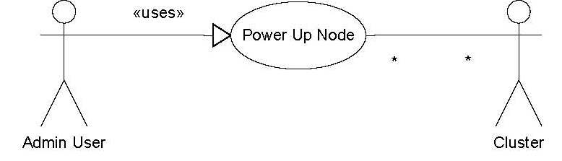

Power Down Node

Name: Power Down Node

Goal: To power off a node in the managed cluster.

Input: The GUI will provide a button labeled “Turn Off Node” and when left clicked, a command will be passed to the Cluster Control Team’s Subsystem.

Output: The GUI will graphically indicate the selected node is now “Off”.

Main Scenario: The User notices a node in the managed cluster that is graphically indicated as being powered on and wishes to the turn the node off.

Pre-condition: A graphical representation of the current nodes in the managed cluster.

Steps:

The User selects a node of interest.

The User left clicks on the GUI button labeled “Turn Off Node”.

A GUI client-side script will format a command with the parameters of the node to be turned off.

The GUI will then pass the command to the Cluster Control Team’s Subsystem.

The Cluster Control Subsystem will then retrieve a list of all current cluster nodes and pass this list to the DB Team’s Subsystem.

The DB Team’s Subsystem will then update the database with the current list of cluster nodes.

The GUI will refresh the graphical representation of the current nodes in the managed cluster.

Post-condition: A graphical representation of the current nodes in the managed cluster that also indicates the selected node is now “Off”.

Exceptional Scenario(s): This process may not succeed due to any of the following reasons:
- The selected node is non-responsive.
- The Cluster Control Subsystem is non-responsive.
- The Cluster Control Subsystem can not locate the node with the User selected parameters.
- The Database Subsystem is non-responsive.

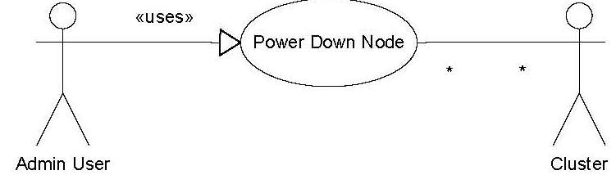
Example:

Reboot Node

Name: Reboot Node

Goal: To restart or reboot a node in the managed cluster.

Input: The GUI will provide a button labeled “Restart Node” and when left clicked, a command will be passed to the Cluster Control Team’s Subsystem.

Output: The GUI will graphically indicate the selected node is now “On”.

Main Scenario: The User wishes to restart a node in the managed cluster.

Pre-condition: A graphical representation of the current nodes in the managed cluster.

Steps:

The User selects a node of interest.

The User left clicks on the GUI button labeled “Restart Node”.

A GUI client-side script will format a command with the parameters of the node to be restarted.

The GUI will then pass the command to the Cluster Control Team’s Subsystem.

The Cluster Control Subsystem will then retrieve a list of all current cluster nodes and pass this list to the DB Team’s Subsystem.

The DB Team’s Subsystem will then update the database with the current list of cluster nodes.

The GUI will refresh the graphical representation of the current nodes in the managed cluster.

Post-condition: A graphical representation of the current nodes in the managed cluster that also indicates the selected node is “On”.

Exceptional Scenario(s): This process may not succeed due to any of the following reasons:
- The selected node is non-responsive.
- The Cluster Control Subsystem is non-responsive.
- The Cluster Control Subsystem can not locate the node with the User selected parameters.
- The Database Subsystem is non-responsive.

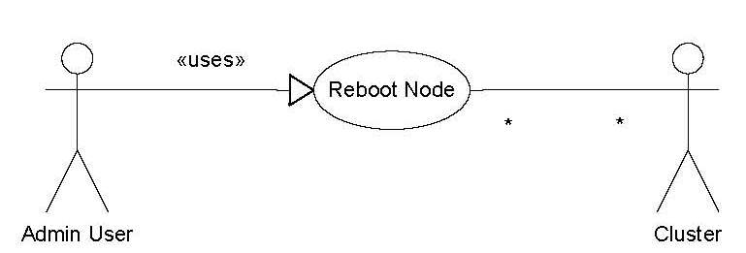
Example:

Identify Node

Name: Identify Node

Goal: To identify a selected node by causing an LED on the physical node to flash.

Input: The GUI will provide a button labeled “Identify Node” and when left clicked, a command will be passed to the Cluster Control Team’s Subsystem.

Output: The GUI will provide a graphical representation of the nodes in a managed cluster.

Main Scenario: The User wishes to identify a node in the managed cluster’s actual rack setting.

Pre-condition: A graphical representation of the current nodes in the managed cluster.

Steps:

The User selects a node of interest.

The User left clicks on the GUI button labeled “Identify Node”.

A GUI client-side script will format a command with the parameters of the node to be restarted.

The GUI will then pass the command to the Cluster Control Team’s Subsystem.

The Cluster Control Subsystem will then retrieve a list of all current cluster nodes and pass this list to the DB Team’s Subsystem.

The DB Team’s Subsystem will then update the database with the current list of cluster nodes.

The GUI will refresh the graphical representation of the current nodes in the managed cluster.

Post-condition: A graphical representation of the current nodes in the managed cluster that also indicates the identified node by flashing an LED in the GUI and on the actual physical node.

Exceptional Scenario(s): This process may not succeed due to any of the following reasons:
- The selected node is non-responsive.
- The Cluster Control Subsystem is non-responsive.
- The Cluster Control Subsystem can not locate the node with the User selected parameters.
- The Database Subsystem is non-responsive.

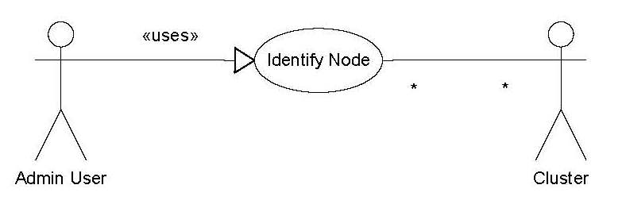
Example:

Modify Sensor Thresholds

Name: Modify Sensor Thresholds

Goal: To modify the following subset of a node’s sensor thresholds:
- Power Supply Voltage
- CPU Temperature(s)
- Fan Speed(s)

Input: The GUI will provide a button labeled “Modify Sensor Thresholds” and when left clicked, a new browser window will be opened listing the sensors that are available to be modified by the User. For a list of sensors, please reference Sectin 3.9.2.

Output: The physical node will have an LED that flashes for physical identification and also on the GUI representation of the node.

Main Scenario: The User wishes to modify any/all of the sensors specified in Section 5.9.2 for a selected node.

Pre-condition: A graphical representation of the current nodes in the managed cluster.

Steps:

The User selects a node of interest.

The User left clicks on the GUI button labeled “Modify Sensor Thresholds” which will open a new browser window with the current values of the sensors.

The User will make changes to these values and left click the GUI button labeled “Submit”.

A GUI client-side script will format a command with the parameters of the node to be restarted.

The GUI will then pass the command to the Cluster Control Team’s Subsystem.

The Cluster Control Subsystem will then retrieve a list of all current cluster nodes and pass this list to the DB Team’s Subsystem.

The DB Team’s Subsystem will then update the database with the current list of cluster nodes.

The GUI will refresh the graphical representation of the current nodes in the managed cluster.

Post-condition: A graphical representation of the current nodes in the managed cluster.

Exceptional Scenario(s): This process may not succeed due to any of the following reasons:
- The selected node is non-responsive.
- The Cluster Control Subsystem is non-responsive.
- The Cluster Control Subsystem can not locate the node with the User selected parameters.
- The Database Subsystem is non-responsive.

Example:
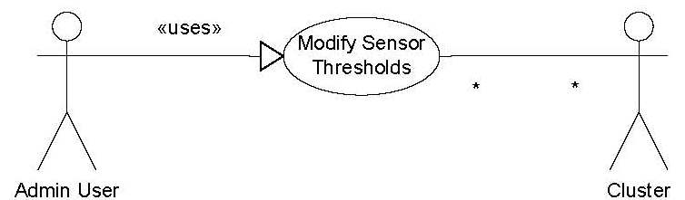

Application Management

Name: Application management

Goal: User must be able to add, delete, edit and check application status as well as checkpoint any jobs currently running on a cluster

Input: TBD.

Output: Status (successful, failed).

Main Scenario: User wants to checkpoint the jobs currently running on a node

Pre-condition: Node has to exist on the system and the jobs must be running. Only system administrator can perform this operation.

Steps:

Post-condition:

Exceptional Scenario 1: If the node is not found on the system, the error message will be given.

Example:
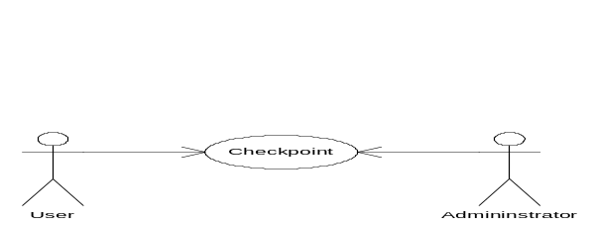

Bulk update database

Name: Bulk update databas

Goal: Admin user must be able to add, delete, edit users, nodes and their related database to/from files

Input: TBD.

Output: Status (successful, failed).

Main Scenario: TBA

Pre-condition: TBA.

Steps:

Post-condition:

Database Migration

Name: Database migration

Goal: Admin user must be able to migrate from a current OSCAR database to a new schema that supprts the CMS project.

Input: TBD.

Output: Status (successful, failed).

Main Scenario: TBA

Pre-condition: TBA.

Steps:

Post-condition:

Other Nonfunctional Requirements

Performance Requirements
The performance of the whole system is directly dependant upon the mechanisms that are used to automatically update the Database. Current conceptual design is for the Cluster Control Subsystem to autonomously poll for the cluster nodes and update the Database and for the GUI to autonomously “refresh” its cluster node listing by routinely polling the Database. Both of these automatic updates must work flawlessly to make sure that the User is supplied with most current node listing.

Safety Requirements
The Cluster Management Subsystem actually issues IPMI commands to a node in the managed cluster. Such tasks as modifying sensor thresholds could possibly push the hardware to its limits possibly causing faulty and/or undesirable behavior from the node.

Security Requirements
In order to control access to the monitoring and manipulating of the managed cluster’s nodes, user account validation involving a username and password prior to granting access will be strictly governed and mandated. The User must be registered in the Database in order to gain access to any GUI functions outside of Create Account and Login.

Software Quality Attributes
Due to the overall simplistic approach to cluster management, the software quality will be measured by the actual representation of the nodes of the managed cluster. The GUI should merely present the physical cluster arrangement in a visually pleasing manner to the User.

Other Requirements
N/A
Appendix A: Glossary
AJAX – Asynchronous Javascript And XML.

Cluster Control Team – the group of individuals responsible for the design, development, implementation, and maintenance of the Cluster Control Subsystem.

Cluster Management System – the overall system that monitors and manages all of the IPMI compatible nodes of a cluster. The System is comprised of three subsystems: GUI, Cluster Control, and Database.

Database – a centralized collection of data. In this System, the Database holds all of the data for each node represented in the managed cluster.

Database Team – the group of individuals responsible for the design, development, implementation, and maintenance of the Database Subsystem.

GUI – Graphical User Interface

GUI Team – the group of individuals responsible for the design, development, implementation, and maintenance of the GUI Subsystem.

User – any individual who is registered in the Database and is granted access to the Cluster Management System.
Appendix B: Analysis Models
N/A
Appendix C: To Be Determined List
N/A

