Voice-based User Interface

(M00738633, Bishaka Gurung)

INTRODUCTION
This report includes a design, prototype and evaluation of a Voice-based User Interface that is designed to support Computer Science students access information and services relevant to their studies and to university life.

DESIGN
The targeted audience for my voice-based User Interface are for the students studying computer science. I will be making a binary number conversion VUI which would help students to convert binary numbers into decimal numbers and also decimal numbers into decimal. When I was doing my first-year degree study the first class I attended in the workshop was to learn binary numbers. We used to learn the conversion of binary and decimal numbers in a piece of paper. I still remember some students really struggling to learn those things. Taking that into consideration I thought of making a VUI platform which could help students do their binary calculation faster and in easy way. The platform I created might be no near perfection, but it is as a sample to show that if a system like this is created in future how would it demonstrate itself and how would it help the student in their studies.
I started making my design ideas through state diagrams we learned in class. Made multiple diagrams, to get what the system will respond in certain conditions. After doing diagrams, I did state diagrams for different case terms. Figure 1 below is the case diagram representation of my rough design.
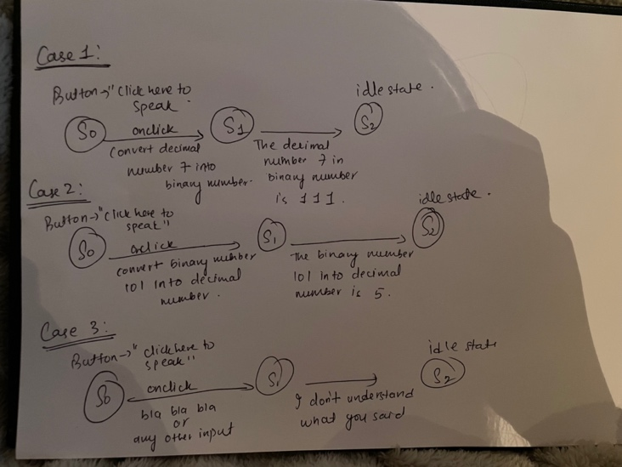

Fig 1: case diagram for different state.

So, my VUI system would be having 3 different case state for user inputs. The first case would be user giving commands to convert binary numbers into decimal numbers. My website will be having a button written “click here to speak “so the user doesn’t get confused when he first approaches the site. The user has to click the button to speak. The voice input for changing binary numbers would be like “convert binary number 101 into decimal number”. After hearing the user, system would be responding giving solution to the problem by responding “The binary number 101 into decimal number is 5.” The second case for giving user commands would be converting decimal numbers into binary numbers. Following the pattern process as a first one, the user would be asking questing like “convert decimal number 7 into binary numbers”. Likewise, the system would. be responding giving solutions like “The decimal number 7 in binary number is 111.”. The third case would be system giving error messages to the user if they give incorrect inputs or irrelevant inputs to system. Any inputs that are not stored in coding or out of context of the topic the system will be giving error messages. Now the last case which I thought about it later, because of that it’s not included in diagram as well. When the user inputs half statement, like gives half information the system would ask the user again to input the remaining input. Similarly, all the back programming to make the system work will be done using JavaScript language.

PROTOTYPE

The created VUI system will be needing certain inputs for it to operate. All of the inputs and their messages are written below.
Case 1: For welcoming.
User: “Hi system”
System: “Hi how can I help you”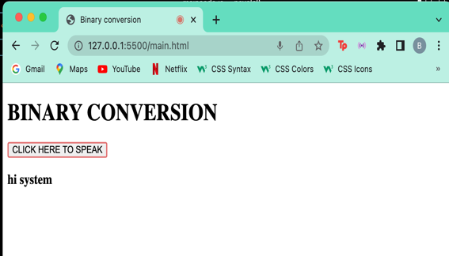

Case 2: Conversion of binary numbers into decimal number.

User: “convert binary number 101 into decimal number.”
System: “The binary number 1 0 1 into decimal number is 5.”
User: “convert binary number 1010 into decimal number.”
System: “The binary number 1 0 1 0 into decimal number is 10.”

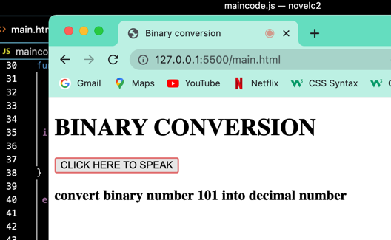

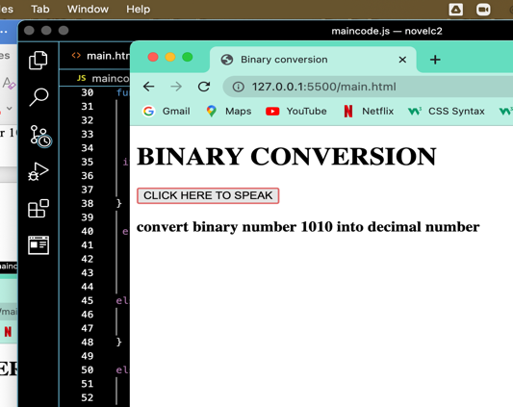

Case 3: Conversion of decimal number into binary number.
User: “convert decimal number 7 into binary number”
System: “The decimal number 7 in binary number is 1 1 1”
User: “convert decimal number 14 into binary number”
System: “The decimal number 14 in binary number is 1 1 1 0”

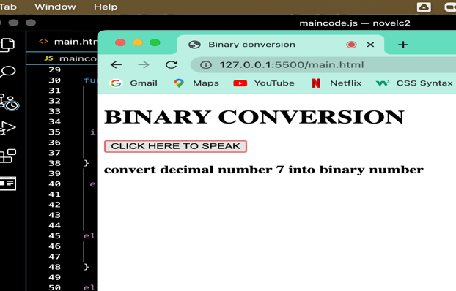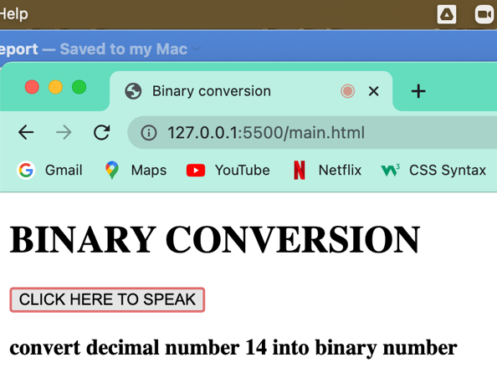

Case 4: Completing the user input messages.
User: “convert binary number”
System: “Complete yourself convert binary numbers into”
User: “convert decimal number”
System: “Complete yourself convert decimal numbers into”
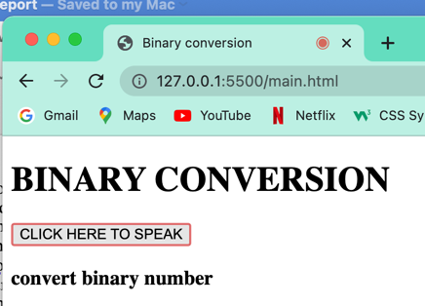

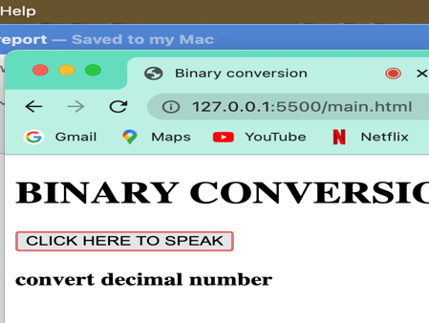

Case 5: Displaying error messages in wrong input.
User: “he he he”
System: “I don’t understand what you said” 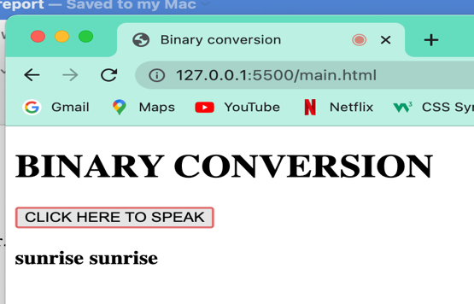
All the user inputs are shown in the webpage, so the user knows what input did he gave. The system responses are given only by voice not in text form.

EVALUATE
The evaluation of my system was conducted through a testing of my system online with my university course friends. Because of the current restricted situation, the testing had to be conducted online. The testing was done with 3 people. I send them my code file through email and called upon a zoom meeting for their feedback. At first, I made it clear to them what my system does and what should they do when they use it. When they were using my system, I tried to observe how they use or react to it. I tried doing evaluation focusing into different factors. At first, I asked them about the visibility and understanding the system by the look of it. All of them said it was basic, and the design could have been better if it had more color on the website. The next approach for my evaluation was running of the system according to user approach. Since everyone was explained about their input dialogues so they had no asking problems, but one of the participants said it could have been more interactive if the system had greeted the user first example saying like “Hi, this is system how can I help you.”. The most issue raised by my participants was the communication or the system solutions were too limited. Every problem it could do or solve was limited to few inputs and they were expecting if they could do more calculations for different numbers. Also, they also pointed that it could have been better if I had my system voice interaction be written in text form in the page. Because I had my page showing the text of only user speaking , they said it would be very useful for user who could see their solution just written there instead of asking the same question to the system again and again. Also they commented that it was very good idea of mine to make the system that does binary and decimal conversion.
Right now I think I’m quite satisfied with my project but there are still lots of places where I could the system better. If given opportunity in future I would have changed my webdesign and made it more attractive. Also I would have extended my user input functionality so that user can interact with it for more purposes .

